HZSF-CZ
SF6 Gas Vacuuming And Refilling Device

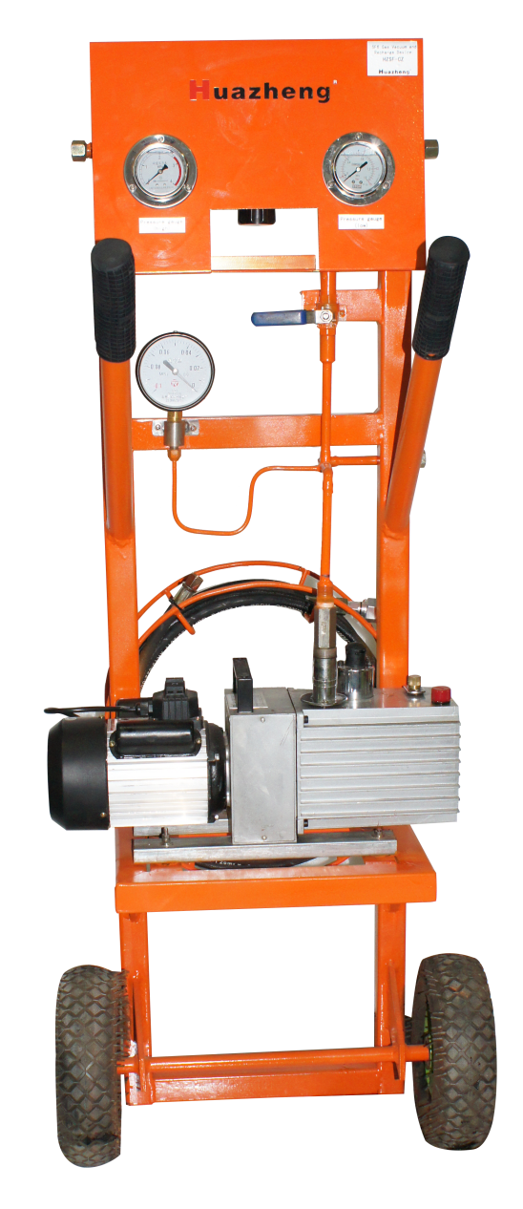

Huazheng Electric Manufacturing (Baoding) Co., Ltd

Contents

I. Product Description 1
II. Device Performance 2
III. Device principle 2
IV. Operation process 3
V. Packing List 6

I. Product Description
With the rapid development of the power industry, and the power industry infrastructure and equipment investment. SF6 electrical equipment continues to increase, so the requirements for installation, commissioning, overhaul and maintenance of SF6 electrical equipment are getting higher and higher. Relevant departments have put forward higher quality and time requirements for vacuuming and refilling gas during the construction and maintenance of SF6 electrical equipment (especially GIS). Over the years, our company has continuously accumulated experience in SF6 gas electrical equipment testing, testing and professional technology. In order to meet the needs of this development, we have developed the SF6 Gas Vacuum and Refill Device which can not only meet the technical index requirements of foreign advanced equipment, but also meet the price requirements of domestic users based on the latest and most advanced foreign maintenance equipment analysis.
SF6 Gas Vacuum and Refill Device is mainly used in power supply companies, power engineering companies, power plants, ultra-high voltage transmission substations, SF6 electrical switch manufacturers and other departments. This equipment is used as auxiliary equipment for installation, adjustment and maintenance of SF6 electrical products such as GCBP, GCBT, and GIS. Use this device to vacuum and refill SF6 gas for the above-mentioned electrical products. At the same time, this device can also be used as equipment for vacuuming and refilling other departments.
In addition to all the functions required for SF6 gas vacuuming and recharging, this device also has the following characteristics:
- Electronic vacuum display (other vacuum gauges can be configured according to user requirements);
- Equipped with various imported and domestic SF6 electrical equipment connection connectors (optional);
- According to the time or vacuum degree set by the user, automatic vacuuming (optional);
- Multiple protection functions to effectively ensure the safe operation of the vacuum pump;
- It is easy to maintain, and the device adopts high-performance components, and it does not need to be repaired after long-term use.

II. Device Performance
Model | Vacuum pump rate（l/s） | Ultimate vacuum（pa） | Vacuum time（m）
Model | Vacuum pump rate（l/s） | Ultimate vacuum（pa） | 30L | 60L | 180L | 300L | 600L | 1200L
SG2004 | 4 | ≤6*10⁻² | 8 | 16 | 48 | 80 | 160 | 320

- Size: 520cm×300cm×1300cm (length × width × height)
- Weight：About 65Kg
- Supply power：220V 50Hz AC
- Noise level：<62dB(A)

III. Device principle
Figure 1 Principle of the device：
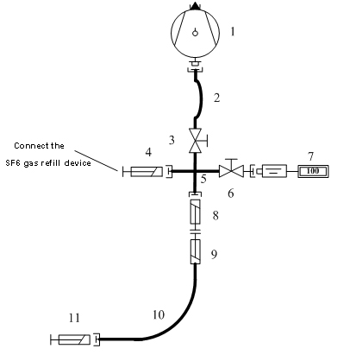
Figure 1 SF6 Schematic diagram of vacuuming and recharging device
Basic configuration of the device：
NO. | Name | Model | Quantity
1 | Vacuum pump* | Rated rate 4L/s, final vacuum <10pa | 1
2，3 | Ball valve, one-way valve | Vacuum Ball Valve, one-way Valve | Each for 1
4 | Connecting groove | Used to connect SF6 gas refilling device | 1
6 | Vacuum port | Connector | 1
10 | Hose | Length 5m/3m, composed of hydrophobic material | 2
8-11 | Inflatable Connector | Various types of electrical equipment interfaces are optional | 1

IV. Operation process

4.1 SF6 Vacuuming electrical equipment
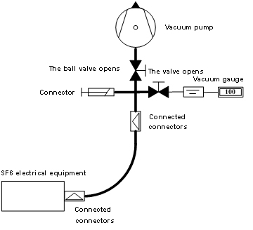
Figure 2
Step 1: Connect the device and SF6 electrical equipment through hoses.
Step 2: Press the green vacuum button on the control panel to start the vacuum function.
Step 3: Slowly open the vacuum pump ball valve and the pipe connection ball valve.
Step 4: Evacuate the SF6 electrical equipment until a stable vacuum is reached.
Note: This device is an optional accessory.
Initial value：O1H=5000Pa；O1L=30Pa；O2H=200Pa；O2L=200Pa。

4.2 Refilling gas for SF6 electrical equipment
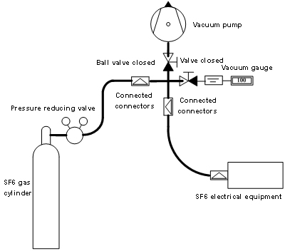
Figure 3
Step 1: Close the vacuum pump ball valve and vacuum gauge valve after ensuring that the device is connected to the pipeline vacuum.
Step 2: Connect the SF6 cylinder to the SF6 refilling device.
Step 3: Open the SF6 gas cylinder, adjust the pressure reducing valve to the required pressure, open the device to connect the pipeline valve, and refill the gas.
Step 4: When the required inflation pressure is reached, close the SF6 cylinder again, close all valves, and complete the refill operation.

Appendix 1 Pressure Unit Conversion Table
 | Pascal | bar | kg/cm² | lb/in² | ATM | mm Hg | in Hg
Pascal | 1 | 10⁻⁵ | 1.02*10⁻⁵ | 1.45*10⁻⁴ | 9.869*10⁻⁶ | 7.501*10⁻³ | 2.953*10⁻⁴
bar | 10⁵ | 1 | 1.020 | 14.5 | 0.9869 | 750.1 | 29.53
kg/cm² | 9.807*10⁴ | 0.9807 | 1 | 14.22 | 0.9678 | 735.6 | 28.96
lb/in² | 6.895*10³ | 6.895*10⁻² | 7.031*10⁻² | 1 | 6.805*10⁻² | 51.71 | 2.036
ATM | 1.013*10⁵ | 1.013 | 1.033 | 14.7 | 1 | 760 | 29.92
mm Hg | 1.333*10² | 1.333*10⁻³ | 1.36*10⁻³ | 1.934*10⁻² | 1.1316*10⁻³ | 1 | 3.937*10⁻²
in Hg | 3.386*10³ | 3.386*10⁻² | 3.453*10⁻² | 0.4912 | 3.342*10⁻² | 25.4 | 1

Vacuum pump technical parameters
Model | Pumping rate L/S | Ultimate pressure (off gas town) | Continuous working allowable pressure≤Pa | Maximum working temperature  ⁰C | Noise(A) | Oil consumption L | Adaptive power KW | Rotating speed r.p.m. | Inlet diameter  mm | Total weight KG
2XZ-4D | 4 | ≤6*10⁻² | ≤4000 | 100 | ≤62 | 1.5 | 0.55 | 1450 | 25 | 30

V. Packing List
No. | Item | Qty
1 | Vacuum pump | 2
2 | SF6 special valve | 1
3 | Pressure gauge | 2
4 | Electrical box | 1
5 | Wheels | 1
6 | 5 meters dedicated hose | 1
7 | 3 meters dedicated hose | 1
8 | Sealing ring | 1
9 | Cylinder connector | 1

