HZSF-801
SF6 Purity Analyzer

User Manual

Huazheng Electric Manufacturing (Baoding) Co., Ltd

Precautions
Dear instrument users：
If you are using this product for the first time, please note the following：
- Please open all the flow valves on the instrument, and slowly open the needle valve on the measuring pipe to regulate the flow before measuring.
- Please control the gas flow at about 0.5LPM when measuring.
- This instrument has self-test and sensor preheating function, please do not skip the process during normal use to avoid affections of the measurement effect.

Contents

I. Technical Characteristics And Parameters 1
II. Technical Parameters 2
III. Instrument Panel Instruction 3
IV. Measurement 3
V. Menu Operation 5
VI. Informations 7

- Technical Characteristics And Parameters
- Technical characteristics
This SF6 gas purity detector adopts infrared principle sensor, which has the characteristics of fast measurement speed, high precision and stable performance. At the same time, the Chinese color LCD touch screen is used, which is more convenient to operate and use.

- Fast and gas efficient: After booting and entering into the measurement state, the measurement time is about 2min.
- Self-locking joint: Adopts Germany imported self-locking joint, safe and reliable, no air leakage.
- Data storage：High capacity design, up to 250 sets of test data can be stored.
- High-definition display: 4.3-inch touch screen is used to display the measured parameters directly.
- Built-in power supply: Large capacity lithium battery, a sufficient time can work for 10 hours continuously.
- Electronic flow: Built-in electronic flow meter, can digital display the flow, with flow limit alarm function.
- Open calibration: This instrument has calibration function, only need to operate on the instrument to complete the entire calibration work.
- Data processing：The saved data can be uploaded to the computer.

- Technical Parameters
Measurment range | 0～100%
Resolution | 0.01
Precision | ±0.5%
Repeatability | ≤±0.05%
Gas flow rate | 0.5LPM ±0.1
Ambient temperature | －30℃～＋60℃
Ambient humidity | 0～100％ RH
Power supply | AC 220V
Power supply | Built-in rechargeable battery
Battery property | Charging time: 10 hours; Use time: 10 hours or more.
Weight | 6kg
Size | 350×150×300mm³
Working temperature | －40℃～＋80℃
Calibration period | One time per year

- Instrument Panel Instruction
1、Front

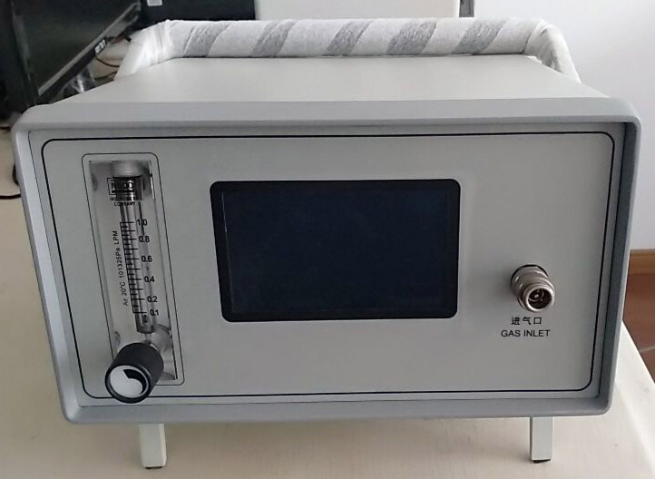
Air inlet
Flow vavle
barcket adjusting button
LCD

2、Back panel
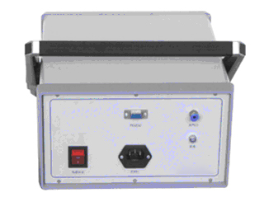
Power switch
Air outlet
RS232
This model has an optional printer
AC220V

- Measurement
1、Connect to SF₆ Instrument
Connect the upper threaded end of the measuring pipe to the switch connector, tighten it with a wrench, and close the needle valve at the other end of the measuring pipe;
Then insert one end of the quick connector on the test pipe into the sampling port on the tester; Connect the exhaust pipe to the outlet;
Finally, connect the switch connector with the SF6 electrical equipment measurement interface and tighten it with a wrench.
2、Preheat and Self-test
Turn on the power switch of the instrument, and the instrument enters the process of preheating and self-test.
3、Check the Electric Quantity
Direct current is recommended for this instrument.
When using direct current, please check the battery power displayed in the upper right corner, if the power is less than about 30%, please shut down and continue to use after charging.
4、Start measuring
After the instrument is preheated and self-checked, it will automatically enter the "main menu" and press the "Data measurement" button to enter the measurement interface and measure automatically. At this time, open the flow valve on the front panel of the tester, and then adjust the flow rate to about 0.5LPM by adjusting the needle valve on the measurement pipe.
5、Store Data
After the device measurement is completed, you can save the data in the instrument and press "Save" to bring up the operation menu. For details, see the following section.
6、After the measurement is complete, close the needle valve on the measuring pipe and the regulating valve on the instrument.
Remove the adapter from SF6 electrical equipment. If you need to continue measuring other devices, do not turn off the power of the instrument and follow the steps above for the next measurement.
7、After the measurement, turn off the power supply of the tester.

- Menu Operation
After the startup preheating is complete, enter the following main menu：
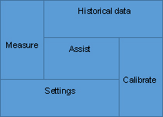
1、Measurment
Click to enter the "Measurement" interface and automatically measure. The purity of the current SF6 gas is directly displayed on the screen, and the current ambient humidity and temperature are displayed below. The functions of several buttons on the right are as follows:
Save: Click "Save" button to enter the save interface, "OK" button to save data;
History: Click the "History" button to enter the historical data interface.
Help: Click the "Help" button to enter the help interface.
Back: Press the Back key to return to the main menu or the upper-level menu.
2、Settings
Click to enter the "Setting" interface, and click the white data section to change the current value:
Time: Changes can be made to the previous year, month, day, hour and minute;
Flow alarm value: can set the flow warning upper limit when measuring, when the flow exceeds this value will alarm;
3、Historical data
Press the left or right button to select the data you want to view, press Delete to delete the current data, press Delete All to delete all data, press Print to print out the current data, and press Export to export the data to the USB flash drive.
- Data Calibration
This function can be used to calibrate the configured sensor. The instrument has been calibrated before delivery. Do not operate this function lightly, otherwise it will lead to inaccurate measurement. Operate only when the instrument has exceeded the calibration life and needs to be re-calibrated. If you need to re-calibrate, please assign the company professionals to perform and according to the following methods:
5.1After the preheating, click "Calibration box" in the "Preview mode" of the instrument to enter the component selection page, and click "purity box" for 8 consecutive times to enter the purity calibration page. The default data is as follows:
NO. | Calibration voltage | Calibration value  Back  CT/℃  27.1  U:/V  0.300  PUR/%  0.00  Resetting  Verify
0 | 0.299 | 0.0
1 | 0.0 | 0.0
2 | 0.0 | 0.0
3 | 0.0 | 0.0
4 | 0.0 | 0.0
5 | 0.739 | 99.99
Observe the data in the red part on the right, record the value without any gas, record as 0.300 (0), and then pass in 99.99% of the standard gas, and the record after it is stable is 0.739（99.99%）；Other standard gases are passed in the same way and recorded, assuming the recording data are as follows：0.699（90.0%）、0.620（85.0%）、0.582（80.0%）
5.2 Fill in the above recorded data in the form below：
NO. | Calibration voltage | Calibration value  Back  CT/℃  27.1  U:/V  0.300  PUR/%  0.00  Resetting  Verify
0 | 0.300 | 0.0
1 | 0.0 | 0.0
2 | 0.582 | 80.0
3 | 0.620 | 85.0
4 | 0.699 | 90.0
5 | 0.739 | 99.99
After pressing the "OK" key, the calibration data will be saved. The red number in the upper right corner is the purity value of the current gas. Once the calibration data is modified and saved, the data here will be changed, and there is no need to return to the measurement page to check. If there is still a large deviation after calibration, please repeat until the data is qualified.
- Instrument helps
This function mainly explains some steps and precautions for the use of the instrument

- Informations
- The instrument should be placed in a safe position to prevent falling and avoid severe vibration.
- The instrument should be charged in time before use.
- When charging, just connect the power cord to the 220V socket, without turning on the power switch, the instrument will automatically charge, and the charging time generally takes more than 10 hours.
- When the instrument is not in use, it should be put into a special packing box and placed on the test bench or instrument rack to prevent dust and moisture.
- The instrument is calibrated with standard gas once a year. It can be sent to the manufacturer or authorized unit for calibration to ensure accuracy.
- If the instrument is not in use, clean the SF6 gas in the instrument pipe with nitrogen.
- Due to individual differences in the sensor, if the measurement process results are unsatisfactory or repeated measurement.

