HZSF-631
SF6 Comprehensive Aanlyzer

USER MANUAL

Huazheng Electric Manufacturing (Baoding) Co., Ltd

Warning
Dear user
If this is your first time using this product, please note the following:
To start the measurement, first open all the flow valves on the panel, and then use an instrument to measure the needle valve on the pipeline and adjust the flow rate. If the measurement is completed, perform the opposite operation.
This device is equipped with a large capacity lithium battery, which can work continuously for more than 10 hours after being fully charged.
When the comprehensive tester is left unused for a long time, there will be some air left in the testing pipeline and chamber. Therefore, during the first test, the high humidity gas in it will affect its testing speed (for micro water detection), because the moisture in the air needs to be taken away before the tested SF6 gas reaches saturation. So we will find that the speed of testing the second SF6 electrical equipment and subsequent measurements will be very fast (3-5 minutes).

Thank you for your cooperation!

Technical Characteristics And Parameters
1. Technical characteristics
The SF6 comprehensive tester is a combination of SF6 micro water analyzer, SF6 purity analyzer, and SF6 decomposition product analyzer. It combines the functions that originally required three instruments to achieve into one instrument. With one on-site measurement, three indicators can be detected, greatly saving gas in the equipment. One measurement saves 2/3 of gas usage, while reducing user workload and improving work efficiency.
Fast gas saving: After the startup enters the measurement state, the measurement time of each SF6 gas dew point is about 5min, and the measurement time of SF6 purity and SF6 decomposition is about 2min.
◻ self-locking joint: The original self-locking joint imported from Germany, safe and reliable, no air leakage.
◻ Data storage: Large capacity design, up to 200 groups of test data can be stored.
◻ Curve function: Large screen curve shows the dew point measurement process.
◻ Clear display: the LCD screen directly displays the dew point, ppm, SF6 purity, SO2, content, ambient temperature, ambient humidity, time and date.
◻ Built-in power supply: built-in 4Ah rechargeable lithium battery, a sufficient time can work for 10 hours.
2、Technical parameter
purity | Measuring range | 0%~100%
purity | Measurement accuracy | ±0.5%
purity | Measuring time | <2 minutes
dew-point | Measuring range | －80 ℃～+20 ℃
dew-point | Measurement accuracy | ±1℃
dew-point | Response time | 63% take 5 seconds, 90% take 45 seconds (-60℃ ~ +20℃)  63% takes 10 seconds, 90% takes 240 seconds (-80℃ ~ -60℃)
SO2 | Measuring range | 0~100ppm
SO2 | Minimum detection amount | ≤0.1ppm
SO2 | accuracy | ±0.5%
SO2 | stability | 0~100ppm
SO2 | repeatability | ≤2%
Ambient temperature | －40℃～＋60℃
Ambient humidity | 0～100％ RH
Power supply  Battery performance | AC 220V
Power supply  Battery performance | Built-in rechargeable battery
weight | Charging time: 20 hours; Use time 10 hours or more.
dimension | 5 kilograms
Operating temperature | 250×150×300mm³
Ambient temperature | －40℃～＋80℃

Instrument Panel Description
1、Front panel
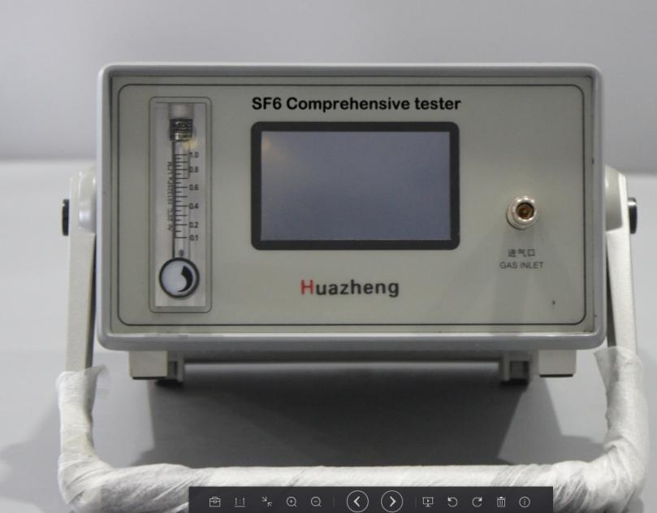

2、Rear panel
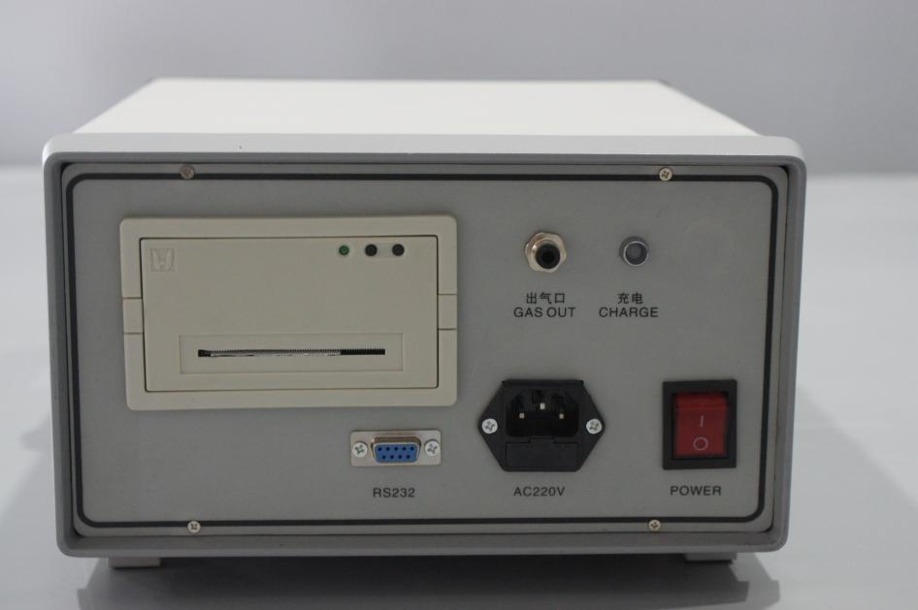

Measurement
1、Connect the SF6 device
Connect the upper threaded end of the measuring pipe to the switch connector, tighten it with a wrench, and close the needle valve at the other end of the measuring pipe;
Then insert one end of the quick connector on the test pipe into the sampling port on the comprehensive tester; Connect the exhaust pipe to the outlet;
Finally, connect the switch connector with the SF6 electrical equipment measurement interface and tighten it with a wrench.
2、initialize
Turn on the power switch of the instrument and the instrument enters the process of initialization and self-calibration.
3、Check the electricity
Direct current is recommended for this instrument.
When using DC, please check the battery power displayed in the upper right corner, if the power is less than about 20%, please shut down and continue to use after charging.
4、Start measuring
After the instrument is initialized and self-checked, it will automatically enter the measurement state (press the "left" and "right" keys to switch the main measurement page and dew point measurement page). At this time, open the flow valve on the front panel of the comprehensive tester, and then adjust the needle valve on the measurement pipe.
The first measurement (sf6 moisture) takes 5 to 10 minutes, and each subsequent measurement takes 3 to 5 minutes.
When measuring, adjust the flow rate to about 0.5L/min.
5、Store data
After the device measurement is completed, you can save the data in the instrument and press "OK" to bring up the operation menu. For details, see the following section.
6、After the measurement is completed, close the needle valve on the measuring pipe and the regulating valve on the comprehensive tester.
Remove the adapter from SF6 electrical equipment. If you need to continue measuring other devices, do not turn off the power of the instrument and follow the steps above for the next measurement.
7、After the measurement, turn off the power supply of the comprehensive tester。

Menu Operation
In the measurement state, the function menu can be entered through the OK key, as shown in Figure 1.
- Save the record
- View record
- Delete record
- Time of modification

1、Save data
In the measurement state, press the "OK" key to enter the function menu, press the "Up" and "Down" keys to select the "Save Record" menu, and press the "OK" key to enter the save data page. Data can be numbered according to the device when saving.The device number can be a maximum of five digits. You can use the Up and Down keys to increase the value, and the Left and right keys to adjust the data bit.
After entering the number, press "OK" to automatically return to the measurement page after data saving. Press "Cancel" to return to the function menu without data saving at this time.
2、View record
In the measurement state, press "OK" to enter the function menu, press "Up" and "Down" to select the "View records" menu, press "OK" to enter the view records page.The display starts with the last saved data.
You can press the Up and Down keys to view the data.
3、Delete record
In the measurement state, press the "OK" to enter the function menu, press the "Up" and "down" to select the "Delete Record" menu, and press "OK" to delete all data. You can press Cancel to return to the function menu without deleting data.
4、Modification time
In the measurement state, press "OK" to enter the function menu, press "Up" and "Down" to select the modification time, and press "OK" to enter the Modification time page. In this case, you can modify the year, month, day, hour, and minute as follows:
The Up and Down keys can increase or decrease the value, and the Left and right keys can move the value left or right.
After the modification is complete, press "OK" to save the modified value and return to the measurement page automatically. Press "Cancel" to abandon the modified value and return to the function menu automatically.
5、Clear zero (cancel + left button combination, this function is only used before measurement)
Press "OK" to enter the function menu, and press "Cancel" and "Left" to enter the data zeroing page. Press "OK" to return to the menu page automatically, and then press "Cancel" to return to the measurement screen to check and verify whether the initial data is zeroing. If it fails, you can perform the above steps several times (this function should be used when there is no corresponding gas in the pipeline).
6、Calibration (Cancel + right-click combination use, this function is only for special operation)
7, dew point value calibration (cancel + up key combination use, this function is only for special operation)
In the measurement interface, press "OK" to enter the function menu, press "Down" once, when the second item is selected, press "Cancel" and "Up" at the same time to enter the calibration interface.Input the measured value of the machine on the left, input the calibration data on the right, and press the OK key to save it (the two sets of data must be input from small to large).

Matters Needing Attention
The instrument should be placed in a safe position to prevent falling and avoid severe vibration.
The instrument should be charged in time before use.
 When charging, just connect the power cord to the 220V socket without turning on the power switch, the instrument will automatically charge, charging time generally takes more than 20 hours.
● When the instrument is not in use, it should be put into aluminum alloy packing boxes and placed on the test bench or instrument rack to prevent dust and moisture.
 The instrument is calibrated with standard gas once a year. It can be sent to the manufacturer or authorized unit for calibration to ensure accuracy.
 When the concentration of SO2 in the detected gas is high, the remaining gas in the airway should be removed before the next measurement.
 When the concentration of SO2 in the detected device exceeds the normal value, it is recommended to measure twice to confirm the result.

Common Faults And Troubleshooting Methods
Malfunctioning | Possible cause | Treatment method
The dew point value does not change | Gas did not enter the detector | Check the gas connection to see if the needle valve and flow valve are open
The dew point value does not change | The sensor connection cable is open | Send to factory for inspection
The dew point value is high | Air leakage in the air path | Use a leak detector to check whether the gas line is leaking
The dew point value is high | The device is placed for a long time | Clean the gas line with high-purity nitrogen for 30 minutes to activate the sensor
The dew point value is high | desensitization | Send to manufacturer for calibration
The dew point value is high | Sensor failure | Send to manufacturer for repair
Low dew point value | Too sensitive | Send to manufacturer for calibration
No change in SO2 | Gas did not enter the detector | Check the gas connection
No change in SO2 | The sensor connection cable is open | Check connection
No change in SO2 | Sensor failure | Replace the sensor
No change in SO2 | There are no decomposition products in the gas | normal
The SO2 detection value is low | There is a leak in the internal gas path of the instrument | Check air circuit
The SO2 detection value is low | desensitization | Send to manufacturer for calibration
The SO2 detection value is low | Sensor failure | Send to manufacturer for repair
The SO2 detection value is high | Too sensitive | Send to manufacturer for calibration
The SO2 reading is unstable during detection | Filter failure | Send to manufacturer for repair
The SO2 reading is unstable during detection | Filter failure | Send to manufacturer for repair
The SO2 reading is unstable during detection | Circuit fault | Send to manufacturer for repair
The charging indicator light is off | Circuit fault | Inspection circuit
The charging indicator light is off | Battery voltage is too low | charging
The buzzer didn't go off | The buzzer is faulty | Replace the buzzer
The buzzer didn't go off | Circuit fault | Check the buzzer circuit
The buzzer went on and on | Circuit fault | Inspection instrument
The buzzer went on and on | The sensor output cable is loose | Check the sensor cable
The buzzer went on and on | The alarm is set too low | Recalculating setting
LCD no display | LCD connection is not good | Check the cable plug-in
LCD no display | The battery voltage is lower than 5.8V | Charge or replace the battery
LCD no display | Circuit fault | Send it to my company for repair

Appendix: (Sulfur hexafluoride circuit breaker moisture measurement requirements)
Test the contents | standard（μl/l, 20℃）
Sulfur hexafluoride circuit breaker factory and overhaul (before the whole installation) should be measured respectively the breaking unit and pillar unit moisture value. | ≤150
The water value of the circuit breaker is measured by the inflatable interface at the lower part of the pillar. | ≤150
The water value of the circuit breaker is measured by the inflatable interface at the lower part of the pillar. The test period is specified in the "pre-test procedure". | ≤200
In operation, if necessary (air leakage in the breaking unit, disintegration of the over-breaking unit) sulfur hexafluoride circuit breaker should be measured separately by the self-sealing junction in the connecting box. | ≤300

