HZJB-II
Single Phase Relay Protection Tester

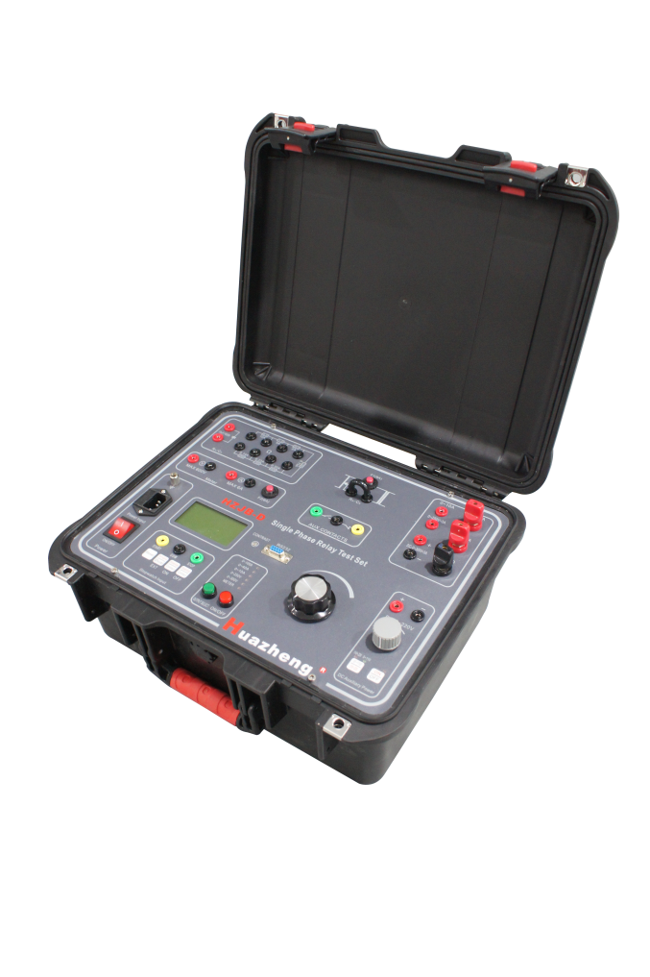

Huazheng Electric Manufacturing (Baoding) Co., Ltd

Dear user:
Thank you for choosing HZJB-II Single Phase Relay Protection Tester.
We hope that this instrument can make your work easier and more enjoyable, so that you can get the feeling of office automation in the test and analysis work.
Before using the instrument, please read this manual, and operate and maintain the instrument according to the manual to prolong its service life.
"Just a light press, the test will be completed automatically" is the operating characteristics of this instrument.
If you are satisfied with this instrument, please tell your colleagues; if you are not satisfied with this instrument, please call (0312) 6775656 to tell you to serve you at all times-Baoding Huazheng Electric Manufacturing Co., Ltd., our company will definitely make you satisfied !
Contents

I. General 1
II. Main Features 1
III. Main Technical Parameter And Functions 1
IV.Panel And Function Instruction 3
V.Usage Method 5
VI.Caution 7
VII.Packing List 7

I. General
HZJB-II Single Phase Relay Protection Tester is a portable field testing equipment with excellent performance; Elegance and polished appearance with aluminum alloy chassis and PC panel, within the ARM chip control, LCD screen display voltage and current output stopwatch, it could output a full isolation way for adjustable AC/DC voltage, and AC/DC current and a way for adjustable DC voltage; the output loop with double overload protection with large output capacity ,small volume, light weight, high reliability ,It Suitable for field calibration and test for various relay.

II. Main Features
1.Output a full isolation way for adjustable DC voltage, Automatic protection for short circuit, overload and out range.
2.Maximum Output Current:0~150A.
3.Equipped with LCD digital AC/DC volt-ampere meter, can show the AC and DC voltage and current values, stopwatch, potential, contact state.
4.Internal electric stopwatch; Available electrical contacts, maximum potential 250V; Dual channel measurement.
5.Light-weight design, small-volume, and fully-functional.

III. Main Technical Parameter And Functions
1.Rated input power: AC:220V±10%·1000VA·50Hz
2.AC Output
Range(A) | No-load Voltage  (Minimum)V | Full-load Voltage  (Minimum)V | Full-load Current  (Maximum)A
0~10 | 90 | 80 | 10
0~40 | 25 | 22 | 40
0~100 | 10 | ＜8 | 150
Range(V) | No-load Voltage  (Minimum)V | Full-load Voltage  (Minimum)V | Full-load Current  (Maximum)A
0~250(AC) | 250 | 240 | 3
0~300(DC) | 320 | 250 | 3
3.DC auxiliary Output
Range V | Voltage V | Maximum current A
0~110 | 120 | 0.5
110~220 | 220 | 0.5
4.Stopwatch:
Range: 0.0000~999999S,Resolution: 0.1mS,
Accuracy: ±5
With electrical contacts and potential input, the maximum input voltage: DC 250V
5.Ammeter:
Range: internal: 0.000~150.0A;
External: 0.000~6.000A(AC or DC)
Accuracy: 0.5%, Measurement methods: AC: True RMS value DC: Average
6.Voltmeter:
Range: 0.0~600.0V(AC OR DC);
Accuracy: 0.5%, Measurement methods: AC: True RMS value DC: Average
7.Resistors and Capacitors:
Resistance: 0.5 ohm to 2.5k ohm
Capacitor: 10uF, maximum voltage AC 450V
8.Division / combination of auxiliary contacts
Maximum current: 1A, Maximum voltage: AC250V or DC120V
9.Using Environment: Temperature: -10 ~ 40 ℃,
Relative humidity must less than 80%
10.Volume: 320mm×260mm×230mm
11. Weight: 16kg

IV.Panel And Function Instruction
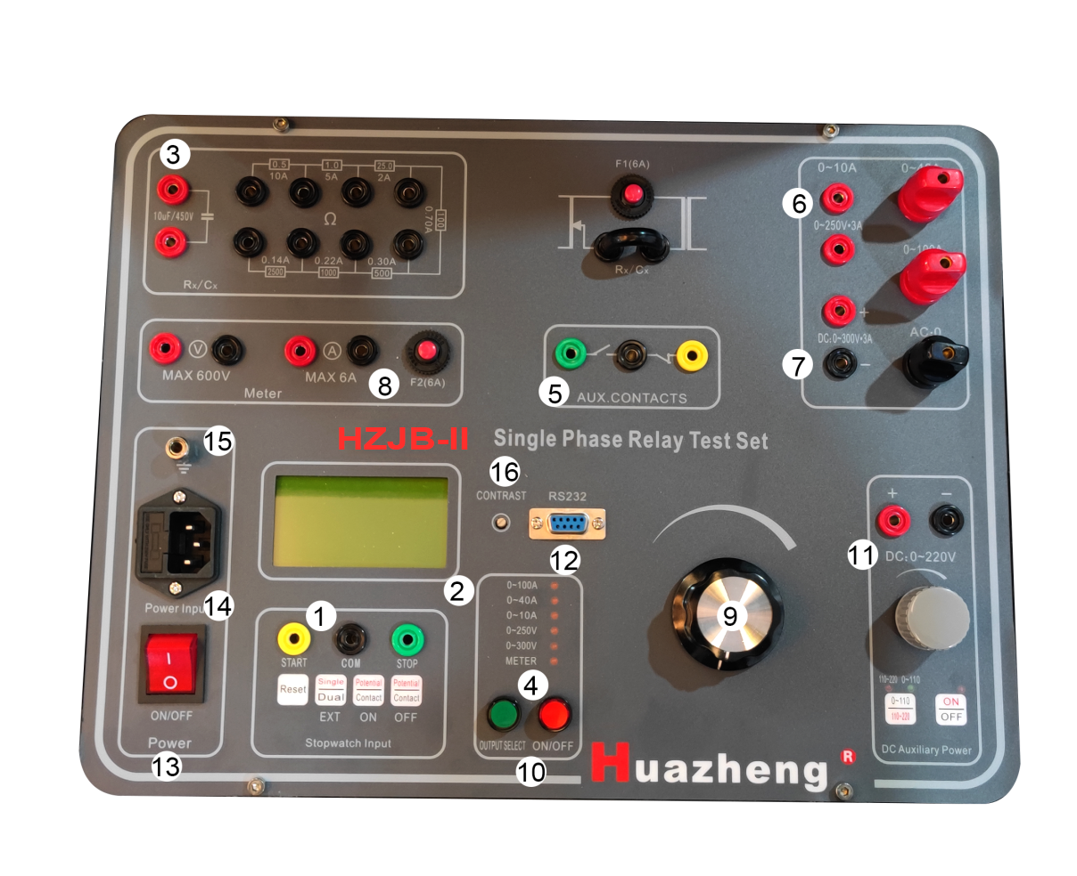
1.Stopwatch input terminal and stopwatch operation button:
Stopwatch input terminal: The Red terminal is START, The green terminal is STOP, The Black terminal is COM.
The buttons show “Reset”, “Single / Dual”, Press and hold more than 3 seconds shows (External start or external start, Default is external start), “(ON) Electric potential /Contact”, “(OFF) Electric potential /Contact”;
“Reset” for time reset, check if the stopwatch reset to zero before counting each time;
“Single / Dual Channel” for choosing stopwatch status (On default external dual channel), Press and hold more than 3 seconds could choose external start or internal start. Internal start means synchronization start, contacts or potential stop when internal output or removal. External single channel means OFF terminal contact or potential start/end, External dual channel means ON terminal contact or potential start/end.
“(ON) Electric potential /Contact” use for Electric potential on or Contact on.
“(OFF) Electric potential /Contact” use for Electric potential off or Contact off.
2.LCD can display the measured output voltage and current, action time and contact or potential state;
Line 1: Select Grade display output voltage and current value;
Line 2: Stopwatch measured value Select Grade display output voltage and current value; Stopwatch measure value display on the left, current status of stopwatch input terminal display on the right;
Line 3: Left:Display external start or internal start, Right: And the table state;
Line 4: Left:Display the current states are single or dual , Right: The stopwatch state.
3.Resistors and Capacitors:
（1）Resistance: 0.5Ω·10A、1Ω·5A、25Ω·2A、100Ω·0.7A、500Ω·0.3A、1000Ω·0.22A、2500Ω·0.14A; Obtain the resistance by select different terminal; accurately adjust the required value of voltage and current by string into the voltage and current output grade;
（2）Capacitor: 10uF/AC450V.
4.Measure selection indicate: 0~100A、0~40A、0~10A、0~250V、0~300V、external input; Led Indicator Lights Up shows output value in LCD.
5.Split/join the auxiliary contact; the contact synchronize with 10 point "ON/ OFF" button.
6.AC voltage and current output terminal: 0~10A·90V、0~40A·25V、0~100A·10V、0~250V·3A，The black terminal is COM.
7.DC current output terminal: 0~300V·3A,the terminal is independent output Red + Black -.
8.External input VOLTMETER & AMMETER; display measure value by select external input grade of “Output selection”button.
9.Current and voltage output Knob: Adjust output value by match “ON/ OFF” of 10 contact button.
10.“Output Selection” and “ON/ OFF” button: “Output Selection” button is only used in the removal state match measure selection indication; “ON/ OFF” button is used for controlling output and removal, Top left LED light up when output, lights out when removal.
11.Auxiliary DC voltage power: can finely adjust voltage value independently, Select grade 0~110V/ 110~220V by control “ON/ OFF” button.
12.Computer interface: for debugging device, downloading programs and updating software.
13.Power switch: Device power switch.
14.Power outlet.
15.Grounding terminal.
16.Contrast adjustment: adjust the brightness of LCD.

V.Usage Method
1.Voltage and current
Power on, select output current terminal or voltage terminal, Press “Output selection”terminal, press “ON/ OFF”button,Device shows simulation failure state, you can adjust knob to control AC/DC voltage and current output.
2.Auxiliary Output DC voltage and current
First, cycles the potentiometer to zero, connect the output line, select the required voltage value(0V or 110~220V),then press output button, adjust potentiometer ,you will find voltage and current output; You only need press “Output Selection” to external input, and connect output to external input voltage and current terminal, or to external Voltmeter and Ammter.
3.Resistance ( single resistor 50w ), capacitors usage
First, disconnect the U - shaped short tab on the Rx, then select the appropriate value resistance or capacitance in series, and connect as following three figures.

Figure 5-1 String into a resistor 500 ohm/50W
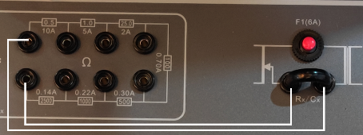
Figure 5-2 String into seven 50W resistors 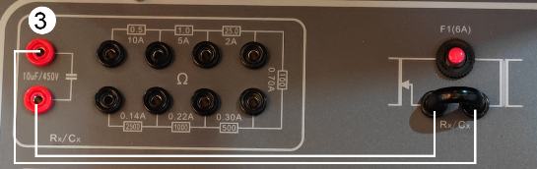
Figure 5-3 String into capacitors
4.Stopwatch
（1）Input signal
Default contact converts On to Off or Off to On.
With 5V-250V positive DC contact converts On to Off or Off to On.
（2）Signal input way
Whether single or dual input, the measurement is, the two input terminals generally should be directly connected to the two contact of switch when measuring not charged or charged contact switch signal, Figures 1 (1) - (4) are shown
Note: Regardless of the figure 1 (3) - (4) connection way, the black terminal of stopwatch should always connect to LOW level.
（3）Application examples
Measure action time and feedback time:
Test connection as shown in Figure 2, set internal dual channel of “single / dual” button.
① Measure action time: Press ON button, adjust the required voltage/current value, Press OFF, Reset stopwatch, then press ON, stopwatch LCD will display the momentary lag from power on moment to connect normally (or normally closed contact to disconnect) of the relay coil.
②Measure feedback time: after measuring action time, reset stopwatch, then press OFF, LCD will display the momentary lag from power off to the normally open contact and disconnected (or normally closed contact and close moment), of the relay coil.

VI.Caution
- Device should be reliable grounding when operation to keep safety;
- Please adjust the "contrast adjustment", if the display shows dark or black;
- The measuring selection button is invalid after the current outputting.

VII.Packing List
No. | Item | Qty
1 | Main engine | 1
2 | Power line | 1
3 | Test lead package | 1
4 | test lead(2.5mm²-2.5m) | 2
5 | test lead(2.5mm²-0.5m) | 2
6 | test lead((8mm²-2m) | 2
7 | test lead(1.2mm²-2.5m) | 3
8 | Double core sheathed wire(2×1.2mm²-2.5m) | 1
9 | Transparent ground wire(2.5mm²-2m) | 1
10 | Insert(6mm) | 4
11 | Dedicated clip | 12
12 | Transition post | 4
13 | Pin plug | 4
14 | Fuse tube | 4

