HZ-384D
Automatic Calorific Value Tester

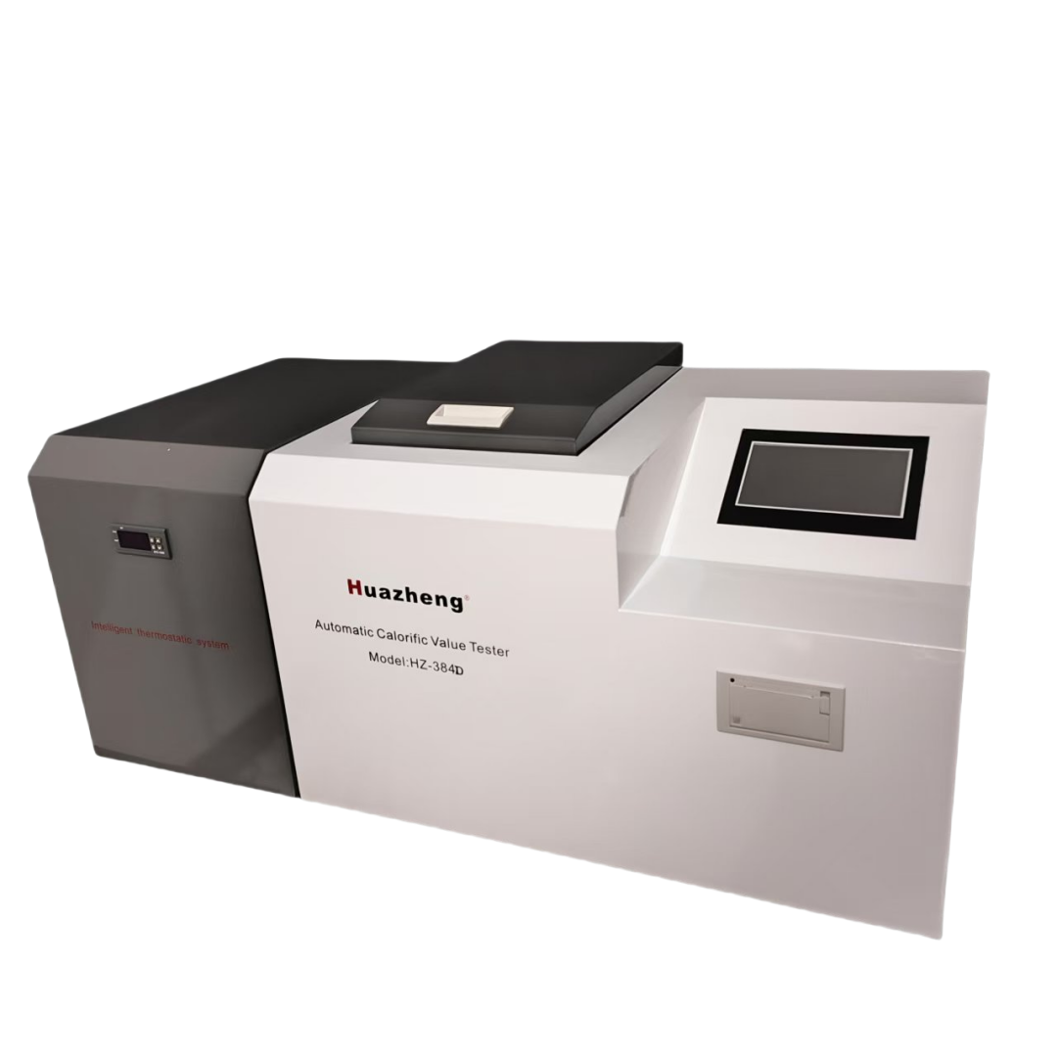

Huazheng Electric Manufacturing (Baoding) Co., Ltd

Dear user:
Thank you for choosing HZ-384D Automatic Calorific Value Tester.
We hope that this instrument can make your work easier and more enjoyable, so that you can get the feeling of office automation in the test and analysis work.
Before using the instrument, please read this manual, and operate and maintain the instrument according to the manual to prolong its service life.
"Just a light press, the test will be completed automatically" is the operating characteristics of this instrument.
If you are satisfied with this instrument, please tell your colleagues; if you are not satisfied with this instrument, please call (0312) 6775656 to tell you to serve you at all times-Baoding Huazheng Electric Manufacturing Co., Ltd., our company will definitely make you satisfied !
Contents

I. Summary 1
II. Technical Features 1
III. Working Principle 1
IV. Technical Index 1
V. Instrument Structure And Auxiliary Equipment 2
VI. How To Use The Instrument 2
VII. Common Faults And Troubleshooting 9
VIII. Packing List 10

Summary
This instrument is used to measure the calorific value of solid, liquid and other combustible materials (coal, petroleum food, wood, biomass).
The instrument is a new type of energy-saving analysis instrument developed by our company. The calculation program carefully compiled improves the measurement accuracy greatly. Color and touch display, all Chinese display, good user interface. The measurement process is automatically controlled to reduce human error. Print cartridge, dry base high position
The results are clear and clear.

Technical Features
- It has the advantages of simple structure, reliable performance and strong anti-interference ability.
- The test steps such as flushing, discharging, water level setting, mixing, ignition, temperature recovery, correction, calculation and printing are completed automatically to avoid human error and improve the accuracy and precision.
- 3The unique calibration technology makes the requirements of the instrument to the environment relatively relaxed. The accuracy of the test is improved while the stability of the long-term operation is ensured.

Working Principle
0.9-1.1g of the substance to be tested is put into a heat crucible (heat-resistant and anti-corrosion), and the crucible is placed in an oxygen bomb added with 2.8-3.2mpa oxygen, and put into the inner cylinder of the calorimeter. The inner cylinder is added with quantitative distilled water. The heat output of the combustible can be calculated according to the rise of water temperature and the heat capacity of the calorimetry system.

Technical Index
Heat capacity: About 10500 J / K
Oxygen bomb capacity: 300ml
Oxygen charging pressure: 2.8 ~ 3.2 MPa
Pressure resistance: water pressure 20MPa
Weight: 2.5 kg
Overall dimension: 650 * 450 * 500 mm
Temperature range: 0 ~ 40 ℃
Response time: < 4 S
Resolution: 0.0001 ℃
Linearity: < 0.08% per 5 ℃ temperature rise range
Temperature measurement error: ± 0.003 ℃ for every 5 ℃ temperature rise range
Power supply voltage: AC220V ± 10%
Humidity: ≤ 80%
Power: 30W
Ignition voltage: AC24 V
Ignition time: 5S

Instrument Structure And Auxiliary Equipment
1.Main structure of calorimeter
The host of calorimeter includes: shell, water tank, control system, user interface and so on
2.The water tank is made of stainless steel and plastic.

How To Use The Instrument

1.Preparation before use
Open box inspection: after unpacking, check whether the appearance of the instrument is damaged and whether the accessories are complete. If there are any problems mentioned above, please contact the manufacturer in time. The calorimeter should be installed in the room without strong air convection, direct sunlight, and temperature change should not exceed 1 ℃. The room temperature should be within 15 ~ 30 ℃.
Place the calorimeter on the horizontal ground or on the workbench, and connect the power supply. Add distilled water with water temperature equal to room temperature until water overflows at the overflow port.
Rear view of instrument

Power Power supply base

Water outlet Spillway

2.Instructions for use of the instrument
The main interface of the instrument is as follows
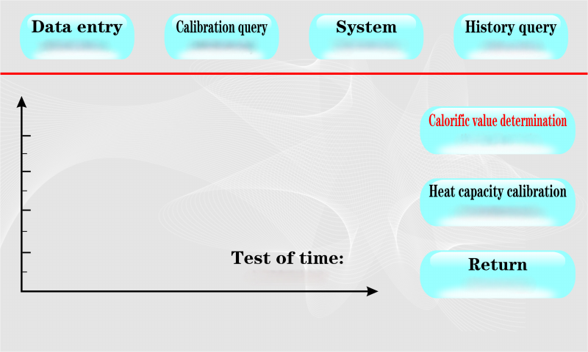
Figure 1
(1)：system
[system]: click "system setting" to enter the system setting menu, as shown in the figure below
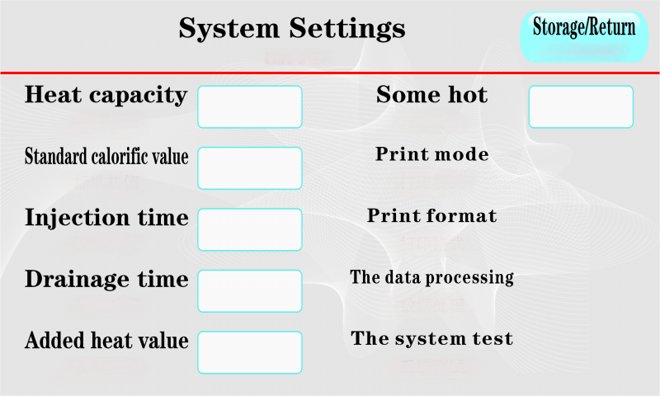
Figure 2
[heat capacity]: click the display box behind the heat capacity to pop up the keyboard and input the heat capacity
The heat capacity of the system is positively proportional to the measured calorific value. Input the average value of the calibrated heat capacity, click return, save and return to the main interface of the system.
[standard calorific value]: click the display box behind the standard calorific value to pop up the keyboard and input the standard calorific value.
The calorific value of the reference material used in the calibration of the instrument is directly input according to the data on the package of the reference material used. Click return to save and return to the main interface of the system.
[water injection time]: click the display box behind the water injection time to pop up the keyboard and input the water injection time.
The water injection time of the inner cylinder is related to the experimental accuracy, and it is generally set as submerged oxygen bomb. According to the volume and voltage of oxygen bomb, input the appropriate value, click return, save and return to the upper menu
[drainage time]: click the display box behind the drainage time to pop up the keyboard and input the drainage time.
Set appropriate drainage time to drain water for inner cylinder test.
[ignition heat]: click the display box behind the ignition heat to pop up the keyboard and input the ignition heat.
The heat generated by ignition is set at 150j when leaving the factory. If the length of ignition wire and cotton thread is not changed, it is generally not necessary to change. To change, enter a new value, click return, save and return to the upper menu
[additive value]: click the display box behind the additive value to pop up the keyboard and input the additive value.
For coal or other combustibles with low calorific value, auxiliary combustion materials should be added to ensure that the sample can be fully burned. Enter the calorific value of the additive (unit: J / g), click return, save and return to the upper menu
[print mode]: click print mode, and the following numbers will switch between 0 and 1
0: it means automatic printing, that is, the test results will be printed automatically after the test
1: It means manual printing. The result will not be printed after the test, but can be printed by clicking
Print manually.
[print format]: click print format, and the following numbers will switch between 0 and 1
0: standard format 1: compact format
Effective for calorific value only
[data processing]: click data processing to enter Figure 3
Hydrogen sulfide water directly affects the calorific value of high and low points. Input sulfur hydrogen water and cartridge heat (unit: J / g). Click processing to calculate high and low heat. Click unit to switch between kcal, Joule / g and MJ / kg.With this function, the calorific value can be measured before hydrogen sulfide water is made. After the data of hydrogen sulfide water is made, data processing is carried out under this function.
Input the heat of cartridge, click process, and the corresponding results will be displayed in the calculation result box. Click Print to print the data you have processed. Click calorific value record to switch to database and view historical records.
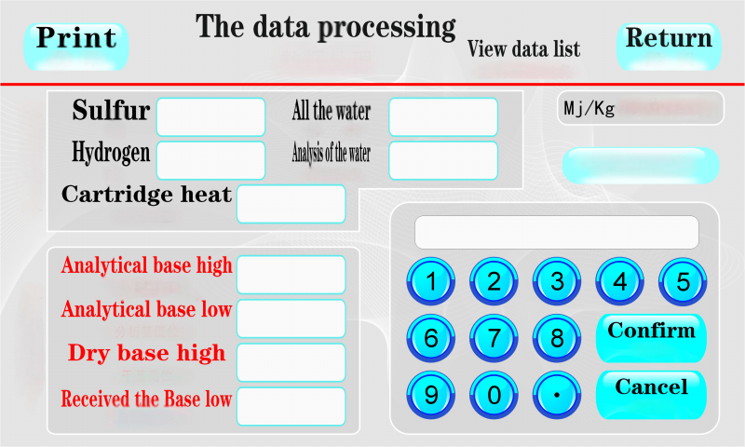
Figure 3
[system test]: click system test to enter the test interface, as shown in Figure 4
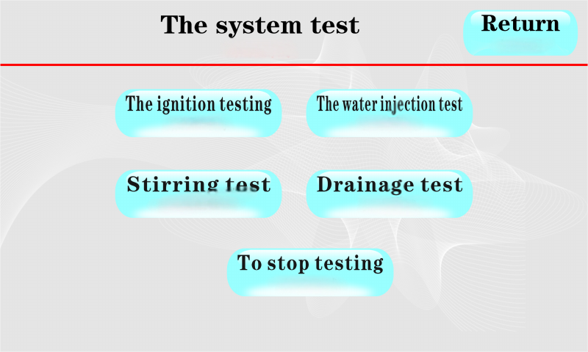
Figure 4
Click the ignition test, MCU sends out the ignition command and turns on the ignition circuit. To detect the ignition circuit.
Click the mixing test, and the MCU sends out the mixing command to switch on the mixing. It is used to detect the stirring circuit.
Click water injection test, MCU sends water injection command to drive water injection pump.
Click the drainage test MCU to send out the drainage command to drive the drainage pump to work. It can be used to add water to the outer cylinder of the instrument.
Click stop test to finish all functional tests.
(2). [calorific value determination]
Click the calorific value measurement button, the calorific value test starts, and the interface switches to the following:
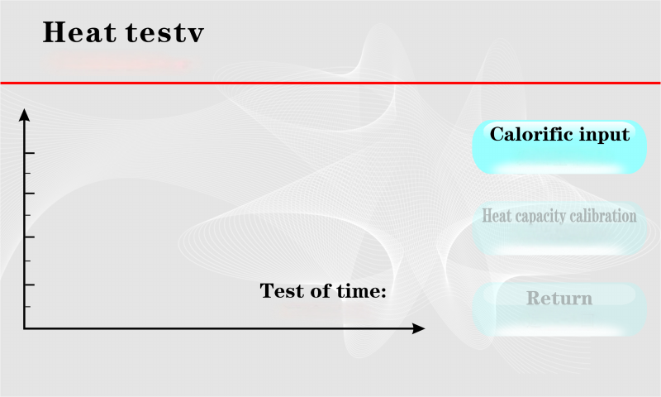
Click calorific value input as follows:
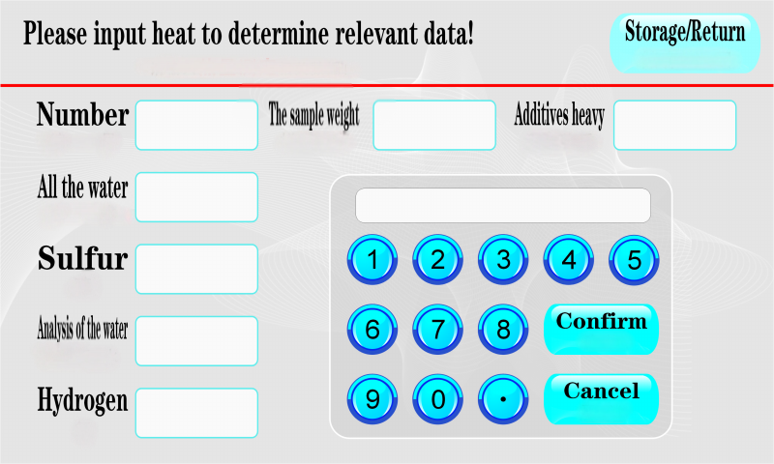
Input the weight of the sample (if no additives are used, you can input 0), serial number, hydrogen sulfide, water and other experimental data, and click back to return to the calorific value measurement interface.
(3). [calibration]
Click the thermal capacity calibration, the calibration test starts, and the interface switches to the following:
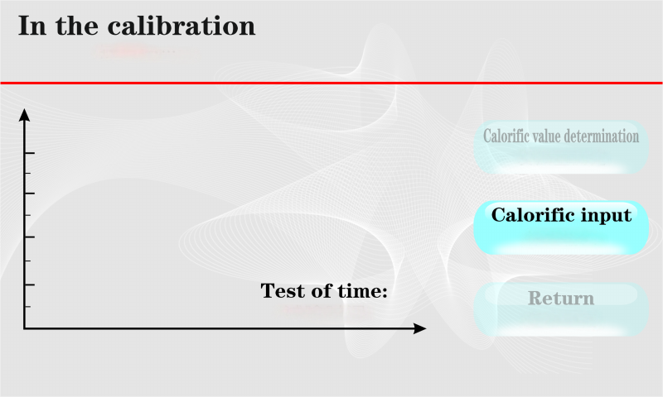
Click the calibration input as follows:
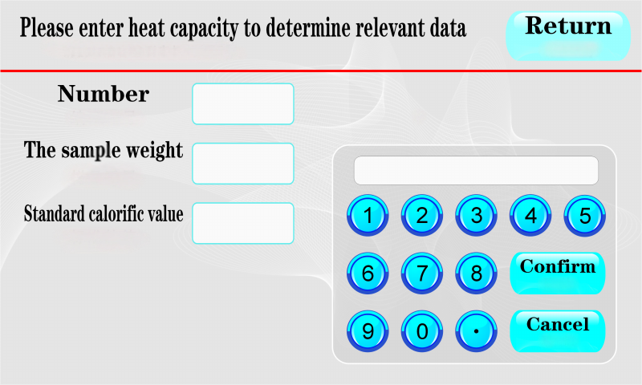
Input the sample weight, number and other test data, and click return to return to the heat capacity measurement interface.
(4). [return]
When the test is over and ignition fails, press this key to clear the test information and curve and return to the standby state.
Note: after using the data processing, click this key to clear the processing trace, so as not to affect the print results.
(5). [reset]
Press this key and the instrument will return to the power on state.
(6). Thermal capacity calibration
Weigh benzoic acid (0.9 ~ 1.1g), load oxygen bomb, charge oxygen for 15 ~ 45 seconds, pressure is 2.8 ~ 3.2Mpa, put it into the inner cylinder, click "thermal capacity measurement", input the weight of benzoic acid, more than ten minutes later, the instrument will print out the calibrated heat capacity e, repeatedly make 5 ~ 6 pieces, calculate its average value, input and save in the system, The calorific value of 1 ~ 2 benzoic acids is calculated and compared with the standard calorific value, and the error is less than 120J, which means that the calibration is successful.
(7). Calorific value measurement
Weigh the sample (0.9 ~ 1.1g), load the oxygen bomb, charge oxygen for 15 ~ 45 seconds, pressure is 2.8 ~ 3.2Mpa, put it into the inner cylinder, click "calorific value test", the instrument will start calorific value measurement, input the weight of weighed sample, input the weight of additive, if there is no additive, you can input 0. The results are displayed and printed after the test.

Common Faults And Troubleshooting
phenomenon | reason | handle
1、Oxygen bomb leak | Aging or wear of rubber sealing ring | Replace the sealing ring
2、Ignition failure | ① The circuit is blocked or the ignition wire is in poor contact  ② The sample is wet  ③ Poor contact between ignition wire or cotton thread and sample  ④ The two electrodes are too dirty  ⑤ Oxidation of ignition cap  ⑥ The two electrodes are short circuited with the crucible (it is easy to burn the crucible and electrode at this time) | ① Check whether the wiring is well connected, whether the oxygen warhead is in good contact with the ignition cap, and whether the oxygen bomb is placed properly  ② The sample is splashed with oxygen too fast  ③ Re sample  ④ Sand the electrode with sandpaper  ⑤ Sand the ignition cap oxide with sandpaper  ⑥ Replace the electrode or crucible and re load the sample
3Incomplete combustion of sample | The sample is not flammable  Insufficient oxygen or insufficient oxygen pressure | Wrap the sample with lens wiping paper, extend the oxygen filling time, and replace the oxygen cylinder
4、After ignition, the temperature rises too high and the calorific value is too high | ① Agitator does not work  ② Mixing blade falling off | ① The mixing shaft is stuck and the line is blocked  ② Insert a cotton into the nylon rod connected with the mixing shaft and insert it again
5、The test did not end for a long time | The ambient temperature is too high | Adjust the water temperature of the outer cylinder to the room temperature, or lower the indoor temperature
6、Air leakage of oxygenator | Aging or wear of sealing ring of oxygenator | Replace the sealing ring

Packing List
NO. | Name | Quantity
1 | Calorimeter host | 1
2 | Power cord | 1
3 | Oxygen bomb | 1
4 | Oxygen flushing instrument | 1
5 | Pressure gauge | 1
6 | Ignition wire | 2
7 | Cotton | 1
8 | Benzoic acid | 1
9 | Tweezers | 1
10 | Sample injector | 2
11 | Printing paper | 2
12 | Oxygen bomb support | 1
13 | crucible | 3
14 | Oxygen bomb sealing ring | 2
15 | Small scissors | 1
16 | Circulating cold bath
17 | Instructions | 1

