HZJS-1B
Oil Particle Counter

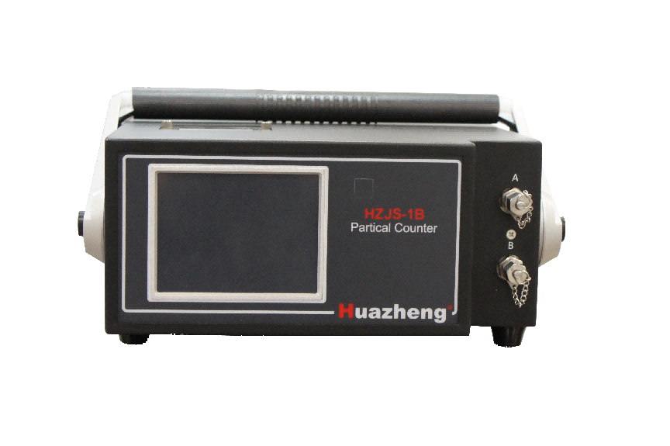

Huazheng Electric Manufacturing (Baoding) Co., Ltd

Contents

1. Description 1
2. Technical Data 1
3. Instrument Structure 2
4. Instrument Installation 3
5. Notice Points 3
6. System Menu 3
7. Menu Function 4
7.1 Main Interface 4
7.2 Setup 4
7.3 Measurement 13
7.4 Data 16
7.5 Calibration 17
7.6 Flush 22
8. Maintenance 23
9.Packing List 24

1.Description
HZJS-1B Oil Particle Counter adopts Laser Extinction Technology, is designed to measure the particles’ size and quantity in oil liquid. It is Suitable for tests of pollution degree of solid particles in hydraulic oil, lubricating oil, fire resistant oil, insulating oil, turbine oil, organic liquid and polymer solution, etc. So our instrument can be used in aviation, spaceflight, electric power, petroleum, chemical industry, transportation, port, metallurgy, machinery, automobile manufacturing and many other fields.

2.Technical Data
Size Range 1μm-600μm
Channel 8 channel(size can be set free in the range of selected curve)
Sample Volume ≥0.2ml
Sample Speed 5ml/min~80ml/min
Resolution ＜10%
RSD ＜2%
Coincidence deviation limit 10000/ml
Range of Pressure low: 0~6bar High:3~400bar
Viscosity ＜350cst
Storage Space 100 set
Power Supply AC220V±10%；50Hz；≤200W
Battery 5200mA； 6~8h
Data Output RS232 and printer inside

3. Instrument Structure
3.1 Front Panel
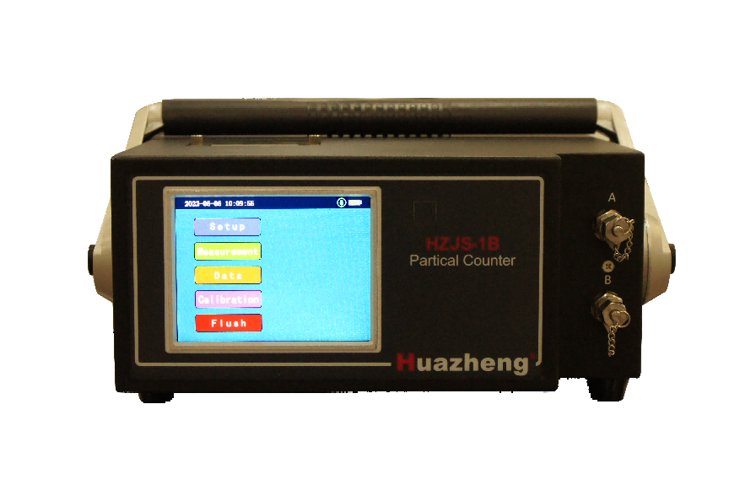

3.2 Back Panel
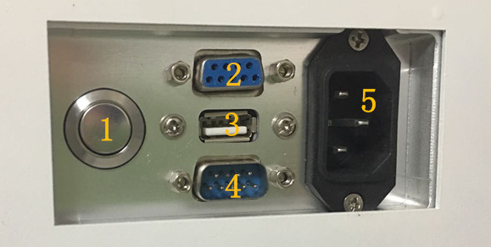

3.2.1Power Button 3.2.2PC Port 3.2.3USB Port
3.2.4Pressure Sampler Port 3.2.5Power Port
- Instrument Installation
4.1 Power Choice: External power or Battery.
4.2 Connect in and out liquid pipe, put out liquid pipe into waste liquid container.
4.3 Printer Paper Installation:
Before install or replace paper, open the lid of printer and take the paper core out. Confirm the installation direction of thermal paper then put it back.( See the printer manual for details)
4.4 Connection of pressure sampler or cabin:
If select pressure sampler, make sure it is connected to the sampler serial port in the back of instrument.(you can get more from 7.3.1)
  - PC Connection: If you need PC to transfer data, make the serial port wire matched with the PC port in the back of instrument.

- Notice Points
5.1 Preheat ten minutes after power on before test.
5.2 Use suitable solvent such as light petroleum to wash pipeline and sample slit to ensure test accuracy before testing.
5.3 After testing or before replacing other sample, must use suitable solvent such as light petroleum to wash to make sure that pipeline clean, then you can turn off the instrument or continue next test.
5.4 High voltage, high frequency and electromagnetic interference should be far away while testing.
5.5 When the battery is low, it should be charged in time and Charge regularly unless you often use it.

- System Menu
Main Interface | Setup | time settings, print settings, measure settings, pressure settings, system settings, administrator settings, reset all settings
Main Interface | Measurement | Online, Offline
Main Interface | Data | View data, Blank data
Main Interface | Calibration | Volume calibration, Size calibration, Noise level test
Main Interface | Flush | Flush, Drain out, Back flush

- Menu Function

7.1 Main Interface
Press the power button back of the instrument leading to the power-on interface, after a while self-check, the instrument will show main interface as Fig 7.1.2.
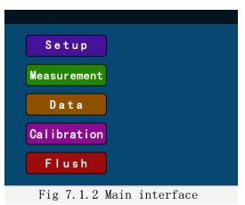

7.2 Setup
Press the ‘Setup’ button as Fig 7.2, you can choose time settings, print settings, measure settings, pressure settings, system settings, administrator settings, reset all settings. Press ‘home’ button back to main interface.
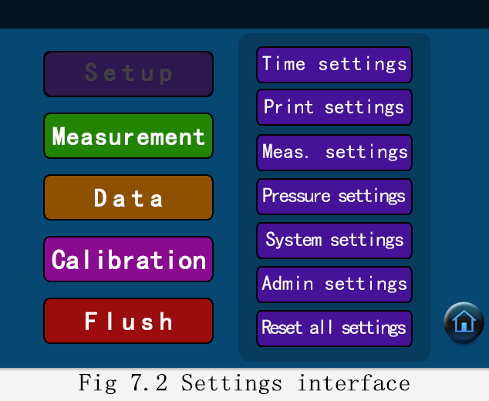

7.2.1 Time settings
Press the ‘Time settings’ button on the setting interface as Pic 7.2.1.1, you can modify the system time. Choose ‘year’‘month’‘date’‘hour’‘min’ button to edit them dependently, and press “OK”to save new settings and back to the last menu; press “ESC”to back to the last menu. But this operation is done in the case you get administrator right.
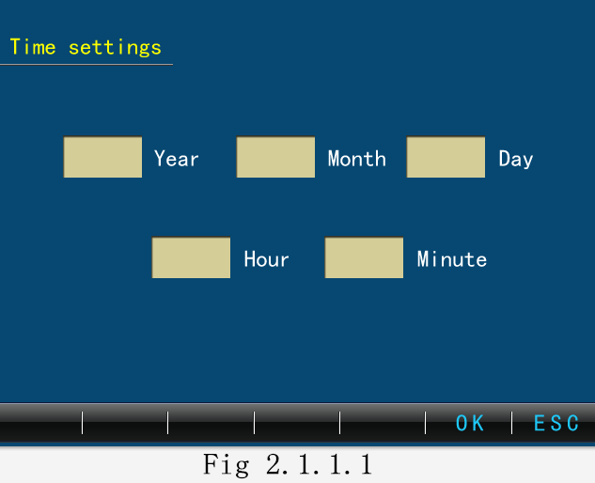

7.2.2 Print settings
Press the ‘print settings’ button on the setting interface as Pic 7.2.2.1, you can modify the print information including print format, sample name and batch name. Click the check box to choose print contents you need.
Name code: from 0 to 499. Common sample setting information can be saved with the specified name code. Once needing to make new sample print-setting, you can call it out by its name code saved.
Batch name: you can save 16 characters at most.
Sample name: you can save 40 characters at most.
Click ‘download’ as Pic 7.2.2.2, you can modify the name code and name of the testing sample by Communication between PC and instrument. Back to the printer settings interface when it is finished
press ‘OK’ to save new settings and back to the last menu; press ‘ESC’to back to the last menu .
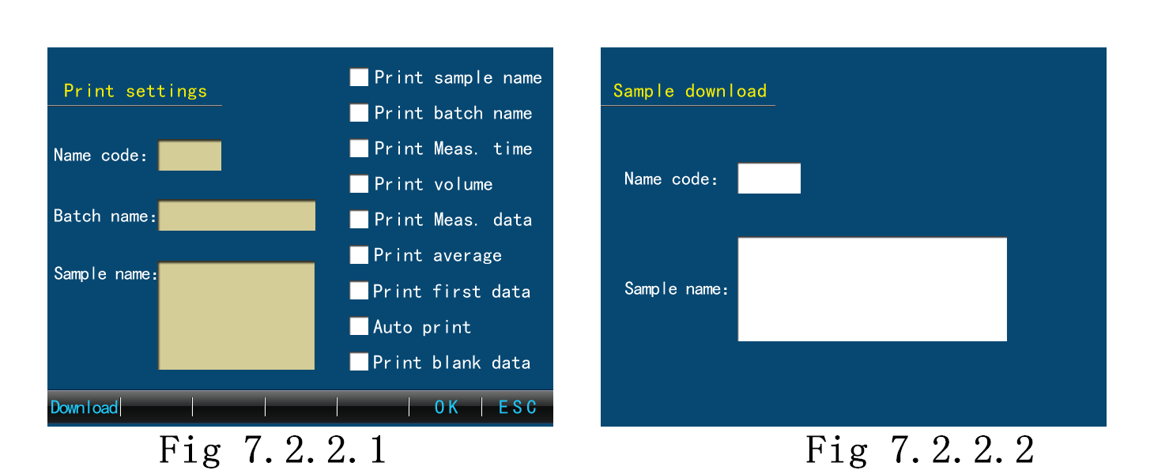

7.2.3 Measurement settings
Press the ‘Meas. setting’ button on the setting interface as Pic 7.2.3.1, it includes offline settings and online settings.
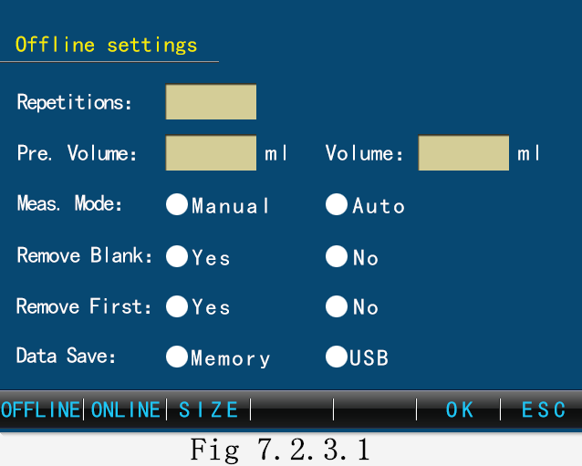
Offline settings
- Repetitions: only for auto test;
- Pre. Volume: it is defined before real-measure(0~9.9ml). Pretest means testing for washing pipes before useful test, one time for auto test, or every time needed when manual.
- Volume: sample volume for every test (0.2~999.9ml).
- Measure Mode: manual and auto. Manual needs pressure in and out by operator, auto just do pressure work according to preset. The former conducts one test, but you can get a team of data by the latter way when you start testing.
- Calibration curve: When you customize your test, select one curve for testing.
- Remove blank: Automatically removes stored blank data in standard test status if you choose.
- Remove First: Automatically removes the data for the first time of each set of test data.
- Data Save: Select to save the date at Internal storage(Memory)or external USB storage.
Press the ‘SIZE’ button as Fig 7.2.3.2, you can set particle size by yourself when do custom test. It is worth noting that particle size must not be out of the range of calibration curve, or it means nothing.
Press the ‘ESC’ button back to the interface 7.2.3.1. Press ‘OK’ to save or back to setting main interface.
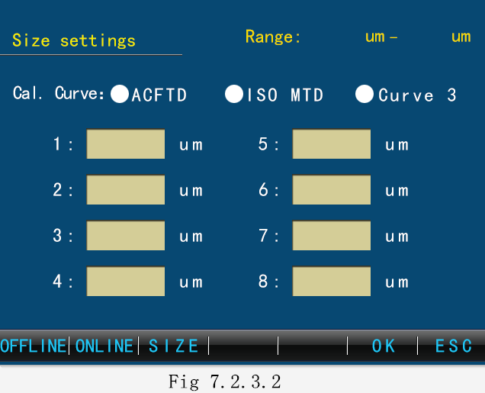

7.2.4 Online settings
Press the ‘online’ button on the setting main interface as Fig 7.2.4.1. you can set online measurement parameter here. Tip: choose instrument with online function.
Data save: Select to save the date at Internal storage(Memory)or external USB storage.
Auto upload: Select if upload data to upper PC in the online test state.
Interval Time:Select time interval in the online test state between two testing group. Press ‘OK’ to save setting or ‘ESC’ not to save and back to setting main interface.
Other function settings similar to offline.
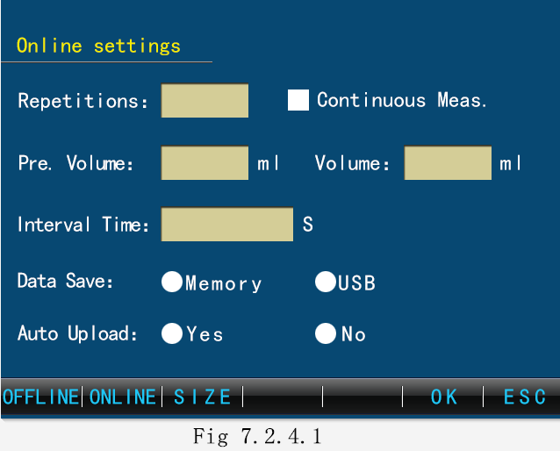

7.2.5 Pressure settings
Press ‘pressure settings’ button as Fig 7.2.5.1 to set pressure data.
Positive pressure:Set the pressure required when connecting the pressure sampler.
Vacuum: Set the pressure required when degassing.
Press ‘OK’ to save settings or ‘ESC’ not to save and back to setting main interface.
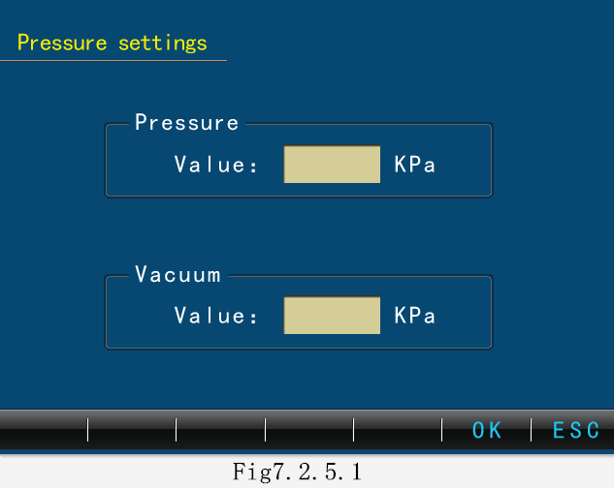

7.2.6 System settings
Press ‘system settings’ button as Pic 7.2.6.1 to set screen intensity and system language.
Screen intensity: lighter or darker.
Language: Chinese, English (switching without restarting machine).
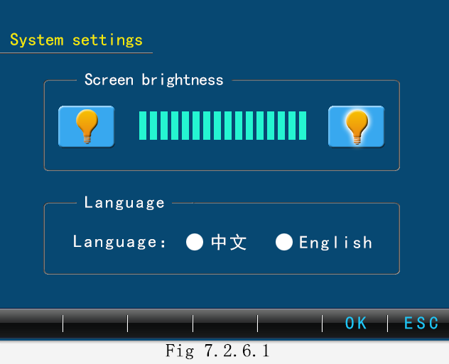

7.2.7 Administrator settings
Press ‘admin settings’ button as Pic 7.2.7.1.You can log in or log out of the administrator here.
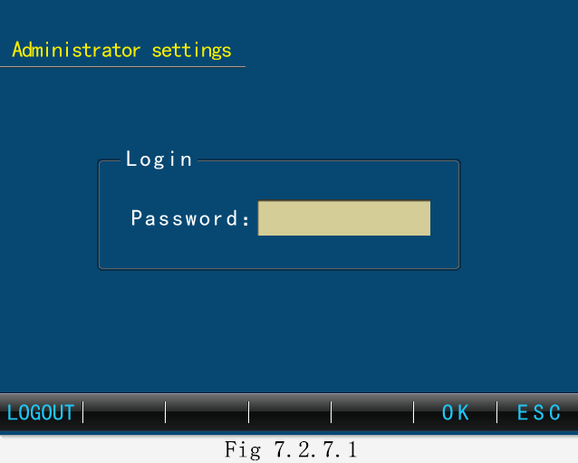
Time setting, factory resetting, volume calibration, volume error calibration, path calibration, noise setting and clearing history data all need administrator right.
Input administrator key number, press ‘OK’ switching to administrator user or cancel administrator to common user. Booting defaults common user.

7.2.8 Reset all settings
Press ‘ Reset all settings’ button lead you to Pic 7.2.8.1. An administrator can recovery all data and settings saved to factory. Press ‘OK’ to finish factory resetting not back.
ESC button to give up reset.
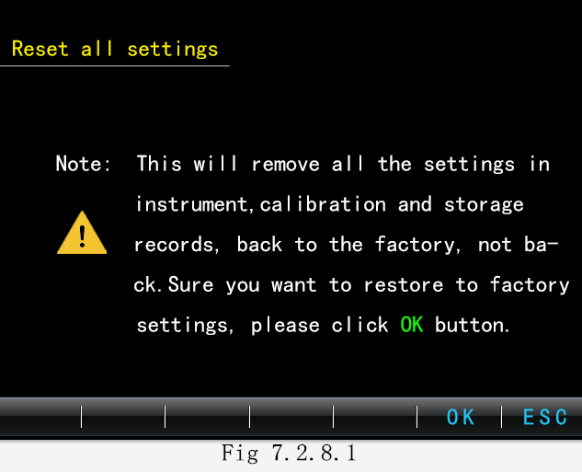

7.3 Measurement
Press the button ‘Measurement’ in the main interface . The instrument will test according to Measurement settings parameters. You can choose online or offline model, and select test standards and custom tests according to test requirements. Measurement standards include NAS1638, GJB420B, ISO4406 and SAE4059E:
NAS1638 standard: 5-15μm, 15-25μm, 25-50μm, 50-100μm, ＞100μm;
GJB420B Standard: ＞4μm, ＞6μm, ＞14μm, ＞21μm, ＞38μm, ＞70μm;
ISO4406 Standard: ＞4μm, ＞6μm, ＞14μm;
SAE4059E Standard: ＞4μm, ＞6μm, ＞14μm, ＞21μm, ＞38μm, ＞70μm;
Custom testing can set the number of channels and the size of the particles according to the test requirements. (See settings for details)
Test operation:
Use suitable solvent to wash pipeline and sample slit. Measurement in condition of pipeline filled with liquid to be tested.
Choose online 7.3.1 or offline 7.3.2.
7.3.1 offline measurement
Press the button ‘Measurement’ in the main interface into test version, choose offline test and select standard test or custom test according to test requirements.
Choose ‘Standard’ into the interface as Fig 7.3.1.1. You can switch standards on the right, before testing choose one of them, then press the button ‘sample’, The instrument will test according to the setting parameters.
The test process is shown in Figure 7.3.1.2. Test information is displayed on the right including measurement times, measurement volume, measurement standard, measurement state and measurement time as well as pressure sampler connected or not. Click the ‘end’ button to stop the current test.
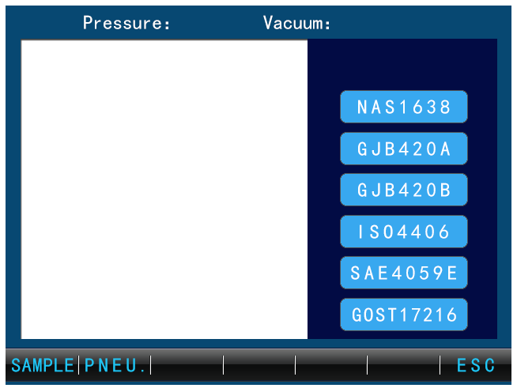
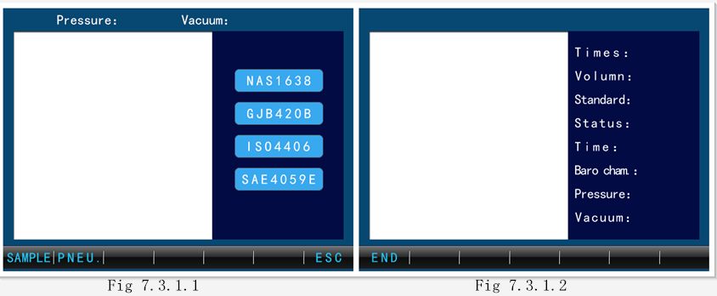
If the sample viscosity is too large, pressure sampler is necessary before test. Press the button ‘Pneumatic-positive’ before test, automatic addition of a certain pressure will assist injection. Press ‘Pneumatic’, it will automatically add a certain negative pressure to help remove the bubbles in the oil. Press ‘Pneumatic-air out’ on the pressure sampler to release pressure in the sampler. (See pressure sampler for details)
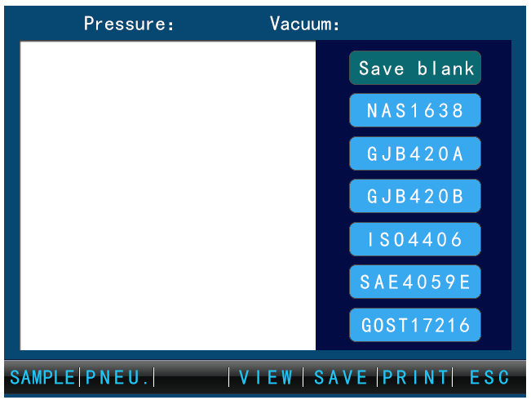
Picture 7.3.1.3 is shown after the test, switch standards to get different standard result. ‘sample’ to continue next test, ‘save blank’ to record space data. Press ‘print’ into Fig 7.3.1.4, ‘print settings’ to set print content, ‘print data’ to finish data printed out, ‘save’ to save the current measurement data.
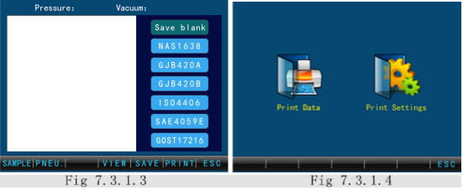
Press ‘view’ button, 7.3.1.5 to review the measurement data for the current group, choose ‘average’ to see the Average of each particle size and the rank of pollution degree. The manual test view add the delete function, user can delete a certain group of test data.
Choose ‘customer test’ into the interface as Pic 7.3.1.6. Press the button ‘test’, The instrument will test according to the setting parameters. The test process is shown in up Figure 7.3.1.2.
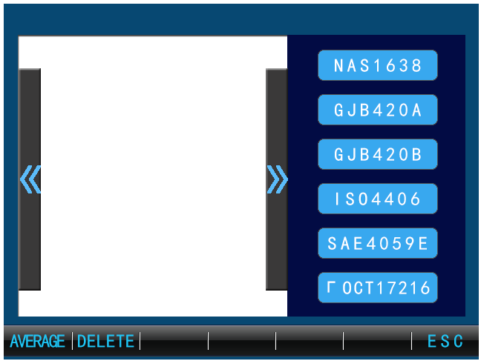
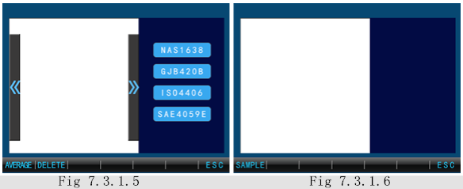
After each kind of test, you should use suitable solvent to wash 10 times at least. Then you can turn off the instrument or continue next test.
7.3.2 online test
The difference between online and offline tests is the high voltage system, the test process does not require manual interference, automatic testing based on set parameters as shown in the figure 7.3.2.1.

7.4 Data
Press the ‘Data’ button as Fig 7.4. User can see and print saved measurement data, blank data and relevant information saved here.
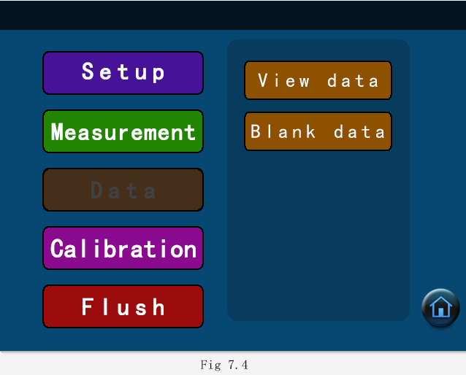
7.4.1 view data
Press ‘View data’ to choose offline data, online data and all data as 7.4.1.1. Every data includes standard data, custom data and all data as Figure 7.4.1.2.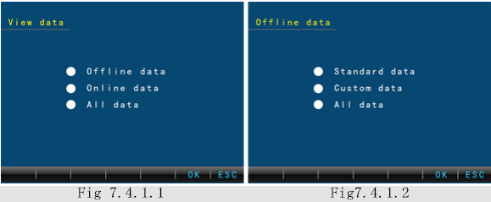
Figure 7.4.1.3 show you that you can view the last and the next data of the current group and view data under different standards on the right. Click ‘message’ to see sample name, batch name, test time, test volume, remove blank and print information.
Press ‘print’ to print current saved data.
Press ‘upload’ to upload current group of data to upper PC.
Press ‘search’ to find data message according to ‘year’ ‘month’ ‘date’ ‘hour’ ‘min’ input as Fig 7.4.1.4. Each page displays ten sets of data at most, you can flip through the upper page and the next page, Use the right arrow to change the number of times in this group. Press ‘print’ to print current group of data or ESC to back.
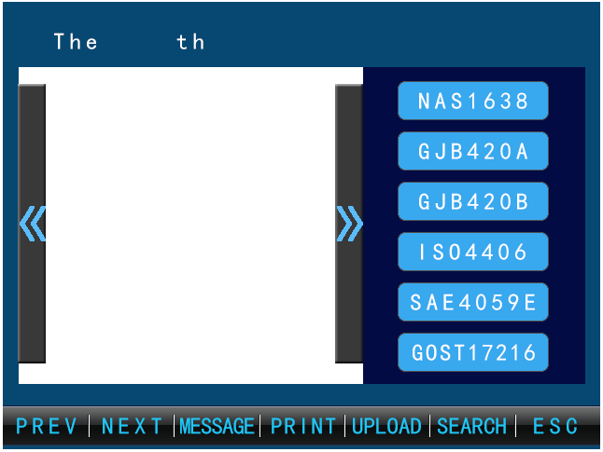
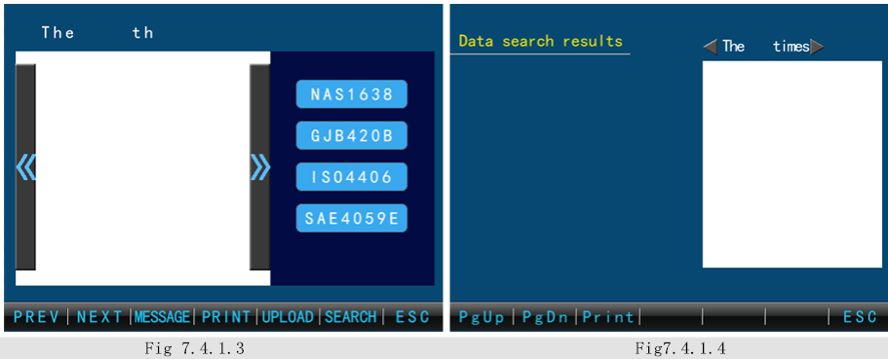
7.4.2 blank data
Press ‘blank data’, choose different measurement standard to view blank data correspondingly.

7.5 Calibration
Press ‘Calibration’ into calibration interface , you can make Volume calibration, Size calibration and Noise Level Test as Fig 7.5. Click on the corresponding calibration to enter the corresponding calibration interface.
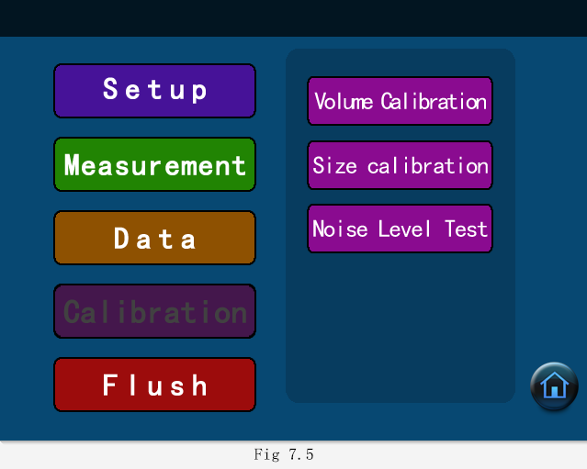
7.5.1 volume calibration
Press ‘volume calibration’ into calibration interface, sampler will reset and make fore sample, then it show volume calibration Fig 7.5.1.1.
Pipeline shall be filled before the calibration of the volume. According to the prompt, weigh the calibration fluid first. Press ‘OK’ to start volume. You will see screen tips: wait for sampling and this operation cannot be shut down in process. When sampling is over come to Fig 7.5.1.2, weigh the calibration fluid again. Input volume difference between two times. Press ‘OK’, it will finish auto check. After volume calibration is completed, it will go back to the calibration home page. If difference is out of 10ml, go back to Fig 7.5.1.1and press ‘restore’ and then make volume calibration.
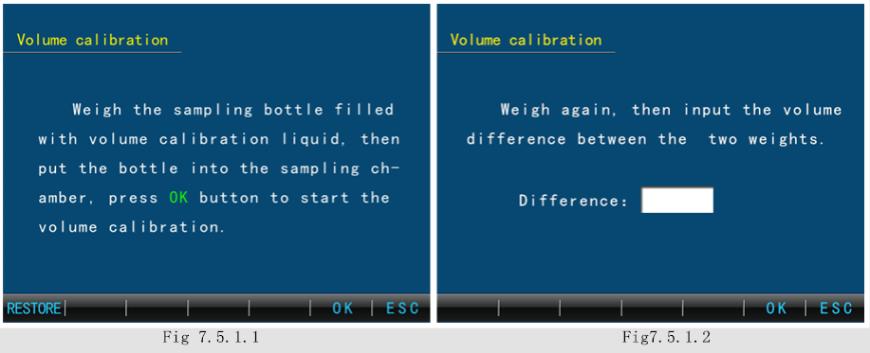
7.5.2 Size calibration
Press ‘Size calibration’ into calibration interface 7.5.2.1, it includes ACFTD, MTD and curve 3 calibration.
Click size and threshold to edit value level; Click SAMPLE to start calibration; Click settings to set parameters; Click ‘view’ to review calibration points saved; Click save to storage calibration points; ESC back to calibration main interface.
Settings as Fig 7.5.2.2: Sample volume(1-9ml); Sample speed; curve to calibrated(ACFTD, ISOMTD, Curve3); Click ‘OK’ to save settings and back to calibration main interface. Click ESC back to calibration main interface without saving.
Press the button ‘Sample’ in the calibration main interface to begin calibration according to particle size set and its threshold value. It will shown that counting and differential counting of corresponding threshold values and in process of course user can choose to end sampling.
If data is biased, modify the particle size and the corresponding threshold in 7.5.2.1 and test until the requirements are met. Press ‘print’ to print out channel calibration data value.
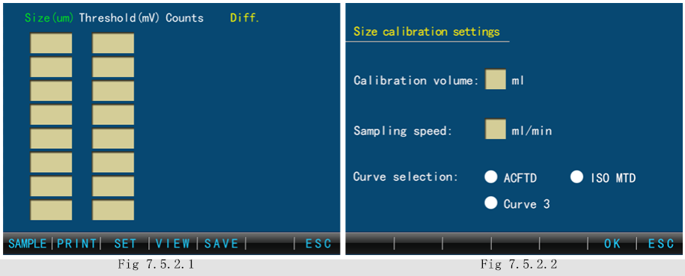
Press the button ‘Save’ in the calibration main interface as Fig 7.5.2.3, choose the calibration points of calibration curve to save with buttons of ‘ALL’ and ‘NONE’. Click ‘Save’ for storage and back to main interface.
Press the button ‘View’ in the calibration main interface as Fig 7.5.2.4, user can delete calibration particle size chosen clear all at the current page. Press ‘calibration’ to start calibration according to the current particle sizes and threshold value at least 4 calibration points. After calibration back to the size calibration main interface.
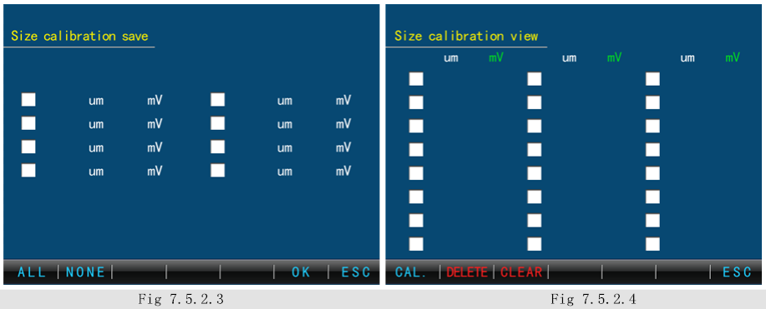
7.5.3 Noise level test
Press ‘Noise level test’ into calibration interface 7.5.3. Four groups of noise level inputs can be made. The sensor should be full of liquid before testing(one time washing operation or test). Stand still for five minutes, press ‘sample’,it will last about 60s. If data is not satisfied, modify the size threshold and test until the requirements are met. Now the size threshold is right the noise level.
You can press ‘Sample’ to continue noise level test after test, Click ‘OK’ to save noise level and back to calibration main interface. Click ESC back to calibration main interface without saving.
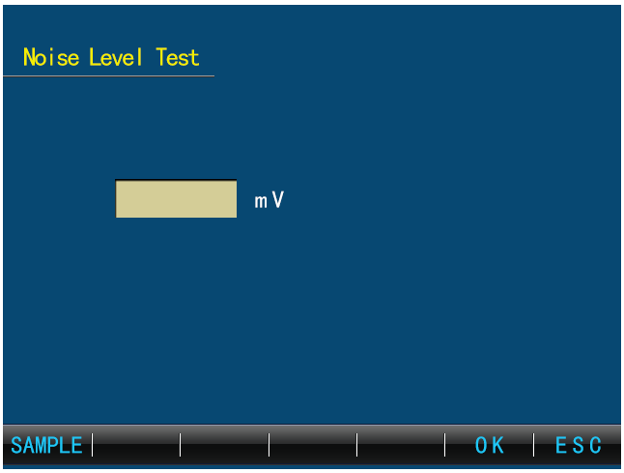
Fig 7.5.3

7.6 Flush
Flush as Fig 7.6 includes: flush, drain out, back flush.
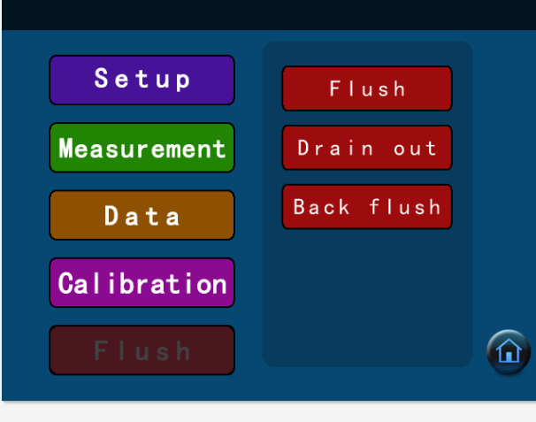
7.6.1 flush
Press ‘flush’ into flush interface fig 7.6.1. Input flush times at most 9, then start flushing. Back to flush main interface after flush and you can stop it any time.
7.6.2 drain out
Press ‘drain out’ into flush interface fig 7.6.2. The sampler needle should be above of the liquid surface. Press ‘start’, the instrument will finish one time. User can drain out as more times as the pipe is completely drain.
7.6.3 back flush
Place the drain pipe in a beaker filled with cleaning liquid and Inlet pipe in the waste liquid bottle before back flush. Then press ‘start’ to begin back flush.
Attention: Back flush must go after drain out operation.
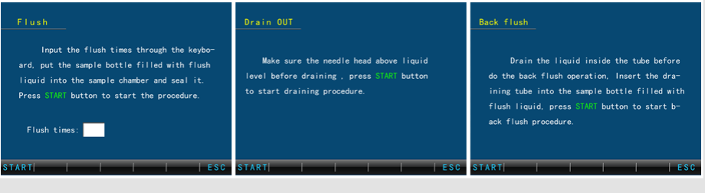
- Maintenance
- The laser sensor parts must not be disassembled under any circumstances;
- The casing should be kept dry in case of inspection corrosion;
- The power should be off when the instrument is not in use in order to extend service life of the laser sensor.
- The instrument often detects specimens of greater consistency or with larger size particles, may easy to cause sample slit blockage. Behave as: sample time extending, much bubbles coming in; data out of control and so on. The solution is as follows:
A: Back flush refer to 7.6.3;
B: Alternate flush: Go to the cleaning interface and select a test method. Release the liquid level into the fluid pipe while sampling to alternate air and sample into slits. Repeat several times until blockages removed, pipeline free meanwhile.
Appendix Cleanliness Class
NAS1638 (particles/100ml)

Code | Size（/μm）
Code | 5-15 | 15-25 | 25-50 | 50-100 | >100
00 | 125 | 22 | 4 | 1 | 0
0 | 250 | 44 | 8 | 2 | 0
1 | 500 | 89 | 16 | 3 | 1
2 | 1000 | 178 | 32 | 6 | 1
3 | 2000 | 350 | 63 | 11 | 2
4 | 4000 | 712 | 126 | 22 | 4
5 | 8000 | 1425 | 253 | 45 | 8
6 | 16000 | 2850 | 506 | 90 | 16
7 | 32000 | 5700 | 1012 | 180 | 32
8 | 64000 | 11400 | 2025 | 360 | 64
9 | 128000 | 22800 | 4050 | 720 | 128
10 | 256000 | 45600 | 8100 | 1440 | 256
11 | 512000 | 91200 | 16200 | 2880 | 512
12 | 1024000 | 182400 | 32400 | 5706 | 1024

GJB420A (particles/100ml)

Code | Size（/μm）
Code | >2 | >5 | >15 | >25 | >50
000 | 164 | 76 | 14 | 3 | 1
00 | 328 | 152 | 27 | 5 | 1
0 | 656 | 304 | 54 | 10 | 2
1 | 1310 | 609 | 109 | 20 | 4
2 | 2620 | 1220 | 217 | 39 | 7
3 | 5250 | 2430 | 432 | 76 | 13
4 | 10500 | 4860 | 864 | 152 | 26
5 | 21000 | 9730 | 1730 | 306 | 53
6 | 42000 | 19500 | 3460 | 612 | 106
7 | 83900 | 38900 | 6920 | 1220 | 212
8 | 168000 | 77900 | 13900 | 2450 | 424
9 | 336000 | 156000 | 27700 | 4900 | 848
10 | 671000 | 311000 | 55400 | 9800 | 1700
11 | 1340000 | 623000 | 111000 | 19600 | 3390
12 | 2690000 | 1250000 | 222000 | 39200 | 6780

GJB420B-2006(particles/100ml)

Code | A | B | C | D | E | F
Size | >1μm | >5μm | >15μm | >25μm | >50μm | >100μm
Size | >4μm_{(c)} | >6μm_{(c)} | >14μm_{(c)} | >21μm_{(c)} | >38μm_{(c)} | >70μm_{(c)}
000 | 195 | 76 | 14 | 3 | 1 | 0
00 | 390 | 152 | 27 | 5 | 1 | 0
0 | 780 | 304 | 54 | 10 | 2 | 0
1 | 1560 | 609 | 109 | 20 | 4 | 1
2 | 3120 | 1220 | 217 | 39 | 7 | 1
3 | 6250 | 2430 | 432 | 76 | 13 | 2
4 | 12500 | 4860 | 864 | 152 | 26 | 4
5 | 25000 | 9730 | 1730 | 306 | 53 | 8
6 | 50000 | 19500 | 3460 | 612 | 106 | 16
7 | 100000 | 38900 | 6920 | 1220 | 212 | 32
8 | 200000 | 77900 | 13900 | 2450 | 424 | 64
9 | 400000 | 156000 | 27700 | 4900 | 848 | 128
10 | 800000 | 311000 | 55400 | 9800 | 1700 | 256
11 | 1600000 | 623000 | 111000 | 19600 | 3390 | 512
12 | 3200000 | 1250000 | 222000 | 39200 | 6780 | 1020

ISO4406（particles/ml）
/ml |  | Code | /ml |  | Code
＞ | ≤ | Code | ＞ | ≤ | Code
2500000 |  | >28 | 80 | 160 | 14
1300000 | 2500000 | 28 | 40 | 80 | 13
640000 | 1300000 | 27 | 20 | 40 | 12
320000 | 640000 | 26 | 10 | 20 | 11
160000 | 320000 | 25 | 5 | 10 | 10
80000 | 160000 | 24 | 2.5 | 5 | 9
40000 | 80000 | 23 | 1.3 | 2.5 | 8
20000 | 40000 | 22 | 0.64 | 1.3 | 7
10000 | 20000 | 21 | 0.32 | 0.64 | 6
5000 | 10000 | 20 | 0.16 | 0.32 | 5
2500 | 5000 | 19 | 0.08 | 0.16 | 4
1300 | 2500 | 18 | 0.04 | 0.08 | 3
640 | 1300 | 17 | 0.02 | 0.04 | 2
320 | 640 | 16 | 0.01 | 0.02 | 1
160 | 320 | 15 | 0.00 | 0.01 | 0

SAE4059E（particles/ml）
Size | >1μm | >5μm | >15μm | >25μm | >50μm | >100μm
Size | >4μm_{(c)} | >6μm_{(c)} | >14μm_{(c)} | >21μm_{(c)} | >38μm_{(c)} | >70μm_{(c)}
Code | A | B | C | D | E | F
000 | 195 | 76 | 14 | 3 | 1 | 0
00 | 390 | 152 | 27 | 5 | 1 | 0
0 | 780 | 304 | 54 | 10 | 2 | 0
1 | 1560 | 609 | 109 | 20 | 4 | 1
2 | 3120 | 1217 | 217 | 39 | 7 | 1
3 | 6250 | 2432 | 432 | 76 | 13 | 2
4 | 12500 | 4864 | 864 | 152 | 26 | 4
5 | 25000 | 9731 | 1731 | 306 | 53 | 8
6 | 50000 | 19462 | 3462 | 612 | 106 | 16
7 | 100000 | 38924 | 6924 | 1224 | 212 | 32
8 | 200000 | 77849 | 13849 | 2449 | 424 | 64
9 | 400000 | 155698 | 27698 | 4898 | 848 | 128
10 | 800000 | 311396 | 55396 | 9796 | 1696 | 256
11 | 1600000 | 622792 | 110792 | 19592 | 3392 | 512
12 | 3200000 | 1245584 | 221584 | 39184 | 6784 | 1024

GOST17216-71
Code | Particles ≤the number below in 100+0.5 cm³（particles/100ml） |  |  |  |  |  |  |  |  | Quality of impurities≤%
Code | >0.5-1 | >1-2 | >2-5 | >5-10 | >10-25 | >25-50 | >50-100 | >100-200 | Fibre | Quality of impurities≤%
00 | 800 | 400 | 32 | 8 | 4 | 1 |  | A.O | A.O
0 | 1600 | 800 | 63 | 16 | 8 | 2 |  |  | A.O
1 |  | 1600 | 125 | 32 | 16 | 3
2 |  |  | 250 | 63 | 32 | 4 | 1 |  | A.O
3 |  |  |  | 125 | 63 | 6 | 2 |  | A.O
4 |  |  |  | 250 | 125 | 12 | 3 |  | A.O
5 |  |  |  | 500 | 250 | 25 | 4 | 1 | A.O
6 |  |  |  | 1000 | 500 | 50 | 6 | 2 | 1 | 0.0002
7 |  |  |  | 2000 | 1000 | 100 | 12 | 4 | 2 | 0.0002
8 |  |  |  | 4000 | 2000 | 200 | 25 | 6 | 3 | 0.0004
9 |  |  |  | 8000 | 4000 | 400 | 50 | 12 | 4 | 0.0006
10 |  |  |  | 16000 | 8000 | 800 | 100 | 25 | 5 | 0.0008
11 |  |  |  | 31500 | 16000 | 1600 | 200 | 50 | 10 | 0.0016
12 |  |  |  | 63000 | 31500 | 3150 | 400 | 100 | 20 | 0.0032
13 |  |  |  |  | 63000 | 6300 | 800 | 200 | 40 | 0.005
14 |  |  |  |  | 125000 | 12500 | 1600 | 400 | 80 | 0.008
15 |  |  |  |  |  | 25000 | 3150 | 800 | 160 | 0.016
16 |  |  |  |  |  | 50000 | 6300 | 1600 | 315 | 0.032
17 |  |  |  |  |  |  | 12500 | 3150 | 630 | 0.063

9. Packing List
No. | Item | Qty
1 | Oil Particle Counter | 1
2 | User Manual | 1
3 | Certificate of Qualification | 1
4 | Warranty Card | 1
5 | Installation List | 1
6 | Inlet Tube | 1
7 | Drain Pipe | 1
8 | Printer Paper | 1
9 | Power Cable | 1

