HZRC8100B
Transformer Core Grounding Current Tester

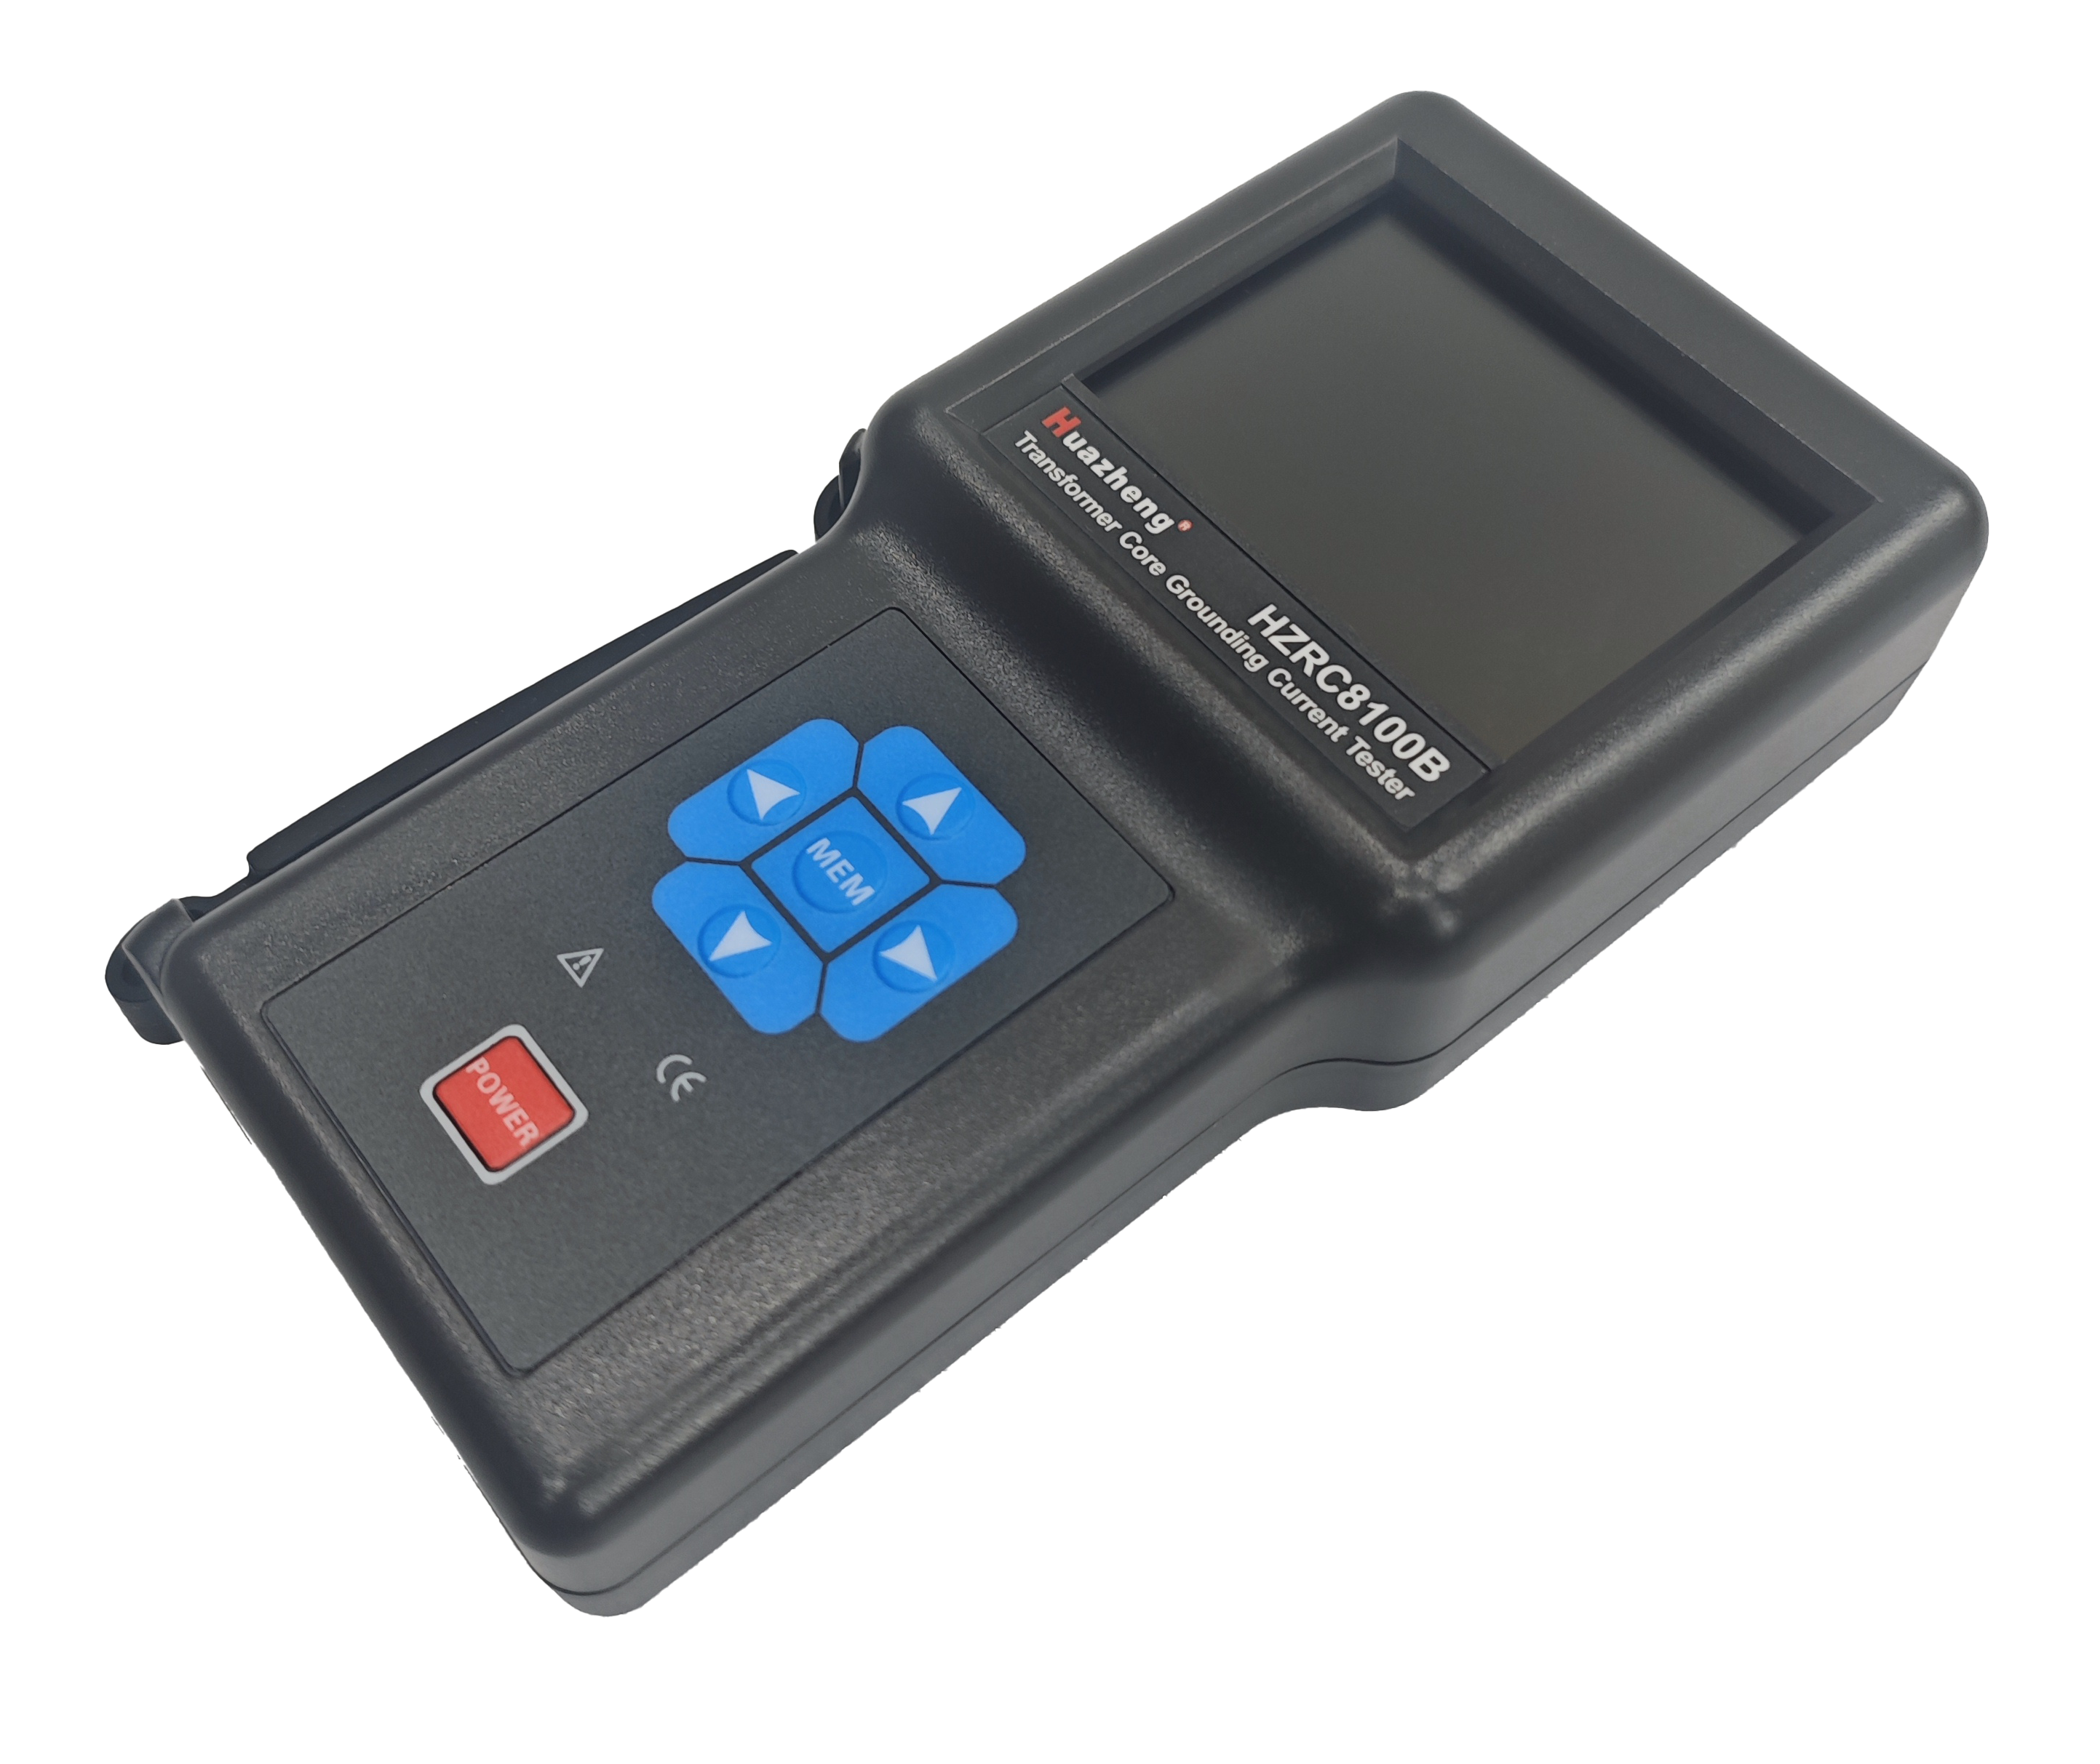

Huazheng Electric Manufacturing (Baoding) Co., Ltd

Precaution For Use

Thank you for purchasing HZRC8100B Transformer Core Grounding Current Tester manufactured by our company. In order to better for use of the product, please be certain:
——Read this user manual in detail.
——Comply with the operating cautions in this manual.
- Under any circumstance, shall pay special attention on safety in using this meter.
- Pay attention to the text labeled on the panel and backplane of the meter.
- Battery voltage is low, the meter will restart constantly, please replace the battery.
- Don not use the instrument to measure the line voltage over 600V.
- Prohibition of use when the back cover of the meter and the battery cover plate are not properly covered.
- The instrument in usage, the case or test wire is broken and lead to the metal is exposed, please stop using.
- Do not place and store the meter in high temperature and humidity, dewy places and under direct sunlight for a long time.
- The instrument and current clamp should be maintained regularly and kept clean. It should not be wiped with corrosives or rough materials.
- Avoid the current clamp iron core chip deformation, iron core chip deformation to closure will affect the accuracy of the test.
- Please attention the battery polarity when replace the battery. If long time not use this instrument, please take out the battery.
- Use, disassembly and maintenance of this leakage current meter shall hand by authorized personnel.
- Due to the reason of this instrument, if it is dangerous to continue using, should stopped and sealed immediately ,and handled by an authorized institution.
- The meter manual with the danger mark "  ", users must follow instructions to operate safely.
- The meter manual with the extremely dangerous mark "  ", users must in strict follow instructions to operate safely.
Contents

I. Introduction 1
II. Electrical Symbols 2
III. Technical Specification 2
IV. Instrument Structure 4
V. Host Operation 5
1.1. Start Up/Shut Down 5
1.2. Data Measurement 5
1.3. Clock Setting 5
1.4. Date Store 6
1.5. Data Access 6
1.6. Sample Numbering 6
1.7. Data Delete 6
1.8. Touch Screen Calibration 6
1.9. Shutdown Setting 7
1.10. Alarm Setting 7
1.11. Current Waveform Test 7
1.12. Real Time Monitoring 9
1.13. Data Download 9
VI. Replace Battery 9
VII. Packing List 10

Introduction
- 2 -
- 2 -
HZRC8100B Transformer Core Grounding Current Tester is specially designed and manufactured for testing grounding current and leakage current of transformer core in power system on site. The instrument is composed of host meter, current clamp, monitoring software and communication cable. The power transformer is an important electrical equipment in the power system, once the fault occurs in the running, it will cause serious consequences to the power system. The normal running of the transformer core is a single grounding point, if there are two or more points grounding at the same time, the iron core and the earth will form a current circuit loop, the maximum current can up to dozens of amperes, will cause the core local overheating or even burned. This instrument can find transformer latent faults as soon as possible, which is the main tool to ensure transformer safe running and normal maintenance.The instrument has anti-interference ability and can be used in the environment of strong magnetic field interference near the transformer. It is mainly apply to the leakage current test of iron core and clamps comment of electrical equipment such as the substations and power station as transformers and reactors. It can also be used for current and leakage current test of lines or equipment in electric power, communication, meteorology, railway, oil field, construction, measurement, scientific research and teaching units, industrial and mining enterprises and other fields.
The host adopts high-speed microprocessor, 3.5 inch color touch LCD screen, intelligent touch operation, convenient and fast. It can display the magnitude and waveform of the measured current in real time. Adopt FFT transform and digital filter technology to make the test data more accurate. With alarm threshold setting and alarm indication function; Date clock and setting function; Automatic shutdown time function; the function of setting sample number;With USB interface, the stored data can be imported into the computer, and the instrument can store 200 groups of data and waveform.
The current clamp core is made of Permalloy alloy and adopt magnetic shielding technology, which has little influence on the external magnetic field and strong anti-interference ability, ensuring the high precision, high stability and high reliability of uninterrupted measurement all year round. Its clamp jaw diameter is 80mm×80mm, can clamp the cable or grounding line below 80mm, or clamp 96mm×4mm flat steel grounding line, portable clamp design, do not have to disconnect the tested line, non-contact measurement, safe and fast.
Monitoring software has on-line real-time monitoring and historical query function, dynamic display, waveform indication; With alarm value setting and alarm indication; With historical data reading, consult, save, print and other functions.

Electrical Symbols
 | Extremely dangerous! The operator must strictly follow the safety rules, otherwise there would be danger of electric shock, causing personal injury or injury accident.
 | Dangerous! The operator must strictly follow the safety rules, otherwise there would be danger of electric shock, causing personal injury or injury accident.
 | Warning! Operators must strictly follow safety rules , otherwise personal injury or equipment damage may occur
 | Double insulation
 | AC
 | DC

Technical Specification
Function | Grounding current test ,AC leakage current and current online test of transformer core
Power Supply | DC9V alkaline batteries（1.5VX6 PCS）
Test Mode | Clamp CT
CT Size | 80mmX80mm(can clamp φ80mm cable or 96mmX4mm steel flat grounding line )
Current Range | AC 0mA~100A
Resolution | AC 0.00mA~9.99mA; resolution: 0.01mA;
Resolution | AC 10.0mA~99.9mA; resolution: 0.1mA;
Resolution | AC 100mA~999mA; resolution: 1mA;
Resolution | AC 1.0A~100.0A; resolution: 0.1A;
Accuracy | ± (0.5%+5dgt)
Frequency Range | 10Hz~1000Hz
Display Mode | 3.5 inch color touch LCD(320dotsX240dots)
Operation Mode | Simultaneously with the intelligent touch mode and the button control mode
Host Size | 198mmX100mmX45mm
Current Clamp Size | 194mmX145mmX40mm
Weight | About 1230(include battery)
LCD Size | Display area: 71mmX53mm
Interference Field | The external electric field 100A close to 10mm about 10mA.
Sampling Rate | About 2 times/second
Data Store | 100 groups(power down or replace battery will not loose the data)
Date & Clock | With date and clock setting function
Sample Numbering | With testing point numbering setting function
Auto Shutdown | With automatic shut down or not setting function, after start up 5 minutes will shuts down automatically without any operation
Touch Screen Calibration | With touch screen calibration function
USB Interface | With USB interface, the stored data can imported into the computer
Alarm Setting | Alarm threshold setting range: 10mA～99.99A
Alarm Indication | When the test value exceeds the alarm threshold, the LCD flashes and the buzzer make out sound.
Line Voltage | Line test below AC 600V
Overflow Indication | Over range overflow function: “OL” symbol display
Battery Voltage | When battery voltage drop to 7.2V±0.1V, low battery voltage symbol will display and remind to replace battery. the measurement data still accurate in this time.
Rated Current | Max 180mA
Test Cable Length | Clamp current cable length is 2m
Working Temperature and Humidity | -10℃~40℃; below 80%RH
Storage Temperature and Humidity | -10℃~60℃; below 70%RH
Insulation Strength | AC 2KV/rms (between the screws and shell)
Suitable Safety Standard | IEC1010-1, IEC1010-2-032, Pollution 2, CAT Ⅲ 600V,IEC61326

Instrument Structure
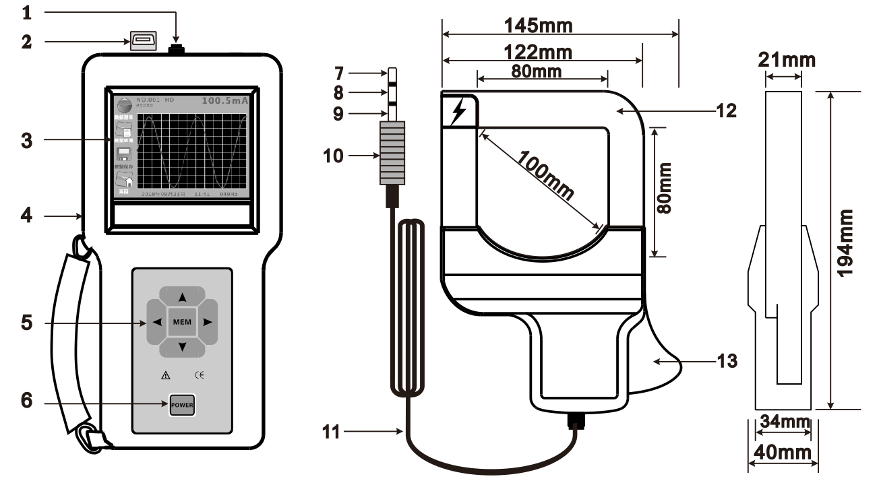
4.1. Current clamp interface | 4.2. USB interface
4.3. 3.5 inch color touch screen | 4.4. Host
4.5. Up,down,left,right arrow key and MEM control key | 4.6. POWER key(on/off)
4.7. Current clamp coil tap | 4.8. Current clamp coil tap
4.9. Output lead shielding layer | 4.10. Audio plug
4.11. Output lead | 4.12. Current clamp
4.13. Trigger(control the clamp jaw)

Host Operation

Start Up/Shut Down
Press POWER key to start up, LCD display function menu page . If the LCD constantly flashes and black screen after starting up, the battery voltage may be low, please replace the battery. Press the POWER key to shut down. This instrument has the function of automatic shutdown time setting. The automatic shutdown time setting range is from 000 to 999 minutes. When the time set for 000 minutes, it will not shut down.By default, the instrument will shut down automatically after 5 minutes of starting up without any operation.

Data Measurement
In the function menu page, press left or right arrow key move the cursor to “TEST” icon, and press the MEM key or click the LCD “TEST” icon enter into data measurement page, press UP or DOWN arrow key move cursor to “BACK” icon, and then press MEM key or click LCD “BACK” icon return to function menu page.
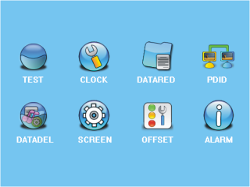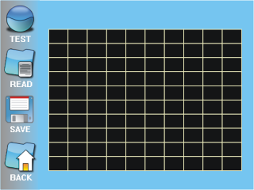

Clock Setting
In function menu page, press left or right arrow key move the cursor to “ CLOCK” icon, press MEN key or click LCD “CLOCK” icon enter into clock setting page, press LEFT or RIGHT arrow key or click LCD “ , ” icon can move cursor to year, month, day, hour, minute, press UP or DOWN arrow key or click LCD “ / ” arrow icon change the date and time. Press UP or DOWN arrow key move the cursor to “BACK” icon, then press MEM key or click LCD “BACK” icon reback to function menu page.

Date Store
In data measurment page, press left arrow key or click LCD ”SAVE” icon enter into data save, and LCD will display “NO.XXXHD” word, The instrument stores the current, waveform, time, and sample number in memory, NO.XXX indicate the stored groups, press key again or click LCD others icon to exit.

Data Access
In function menu state, press / key move cursor to “DATARED” icon, press MEM key again or click LCD “DATARED” icon enter into data access page, press / key to browse, press / arrow key move cursor to “BACK” icon, press MEM key or click LCD “BACK” icon return to function menu page.

Sample Numbering
In function menu state, press LEFT / RIGHT key move the cursor to “PDID” icon, press the MEM key or click LCD “PDID” icon enter into sample numbering page, press LEFT / RIGHT arrow key or click LCD / icon can move the cursor, press / key or click LCD screen / icon to change the sample number, press / arrow key move the cursor to “BACK” icon, then press MEM key or click LCD “BACK” icon return back to function menu page.

Data Delete
In function menu state, press / arrow key move the cursor to “DATADEL” icon, then press MEM key or click LCD “DATADEL” icon enter into data delete page, the cursor at the position of “YES” press MEM key or click LCD “YES” icon will delete the stored data, the cursor at the position of “NO” press MEM key or click LCD “NO” icon will not delete, and return back to function menu page, press up / down arrow key move cursor to “BACK” icon, then press MEM key or click LCD “BACK” icon return back to function menu page.
After deleting the data, it cannot be restored. Please operation be carefully.
Delete operation is deletes stored data all at once.

Touch Screen Calibration
In function menu state, press / arrow key move the cursor to “Touch Screen Calibration” icon, then press MEM key or click LCD “Touch Screen Calibration” icon enter into the touch screen calibration page, and click the LCD “+” icon in turn, after calibrating return back to the function menu page.

Shutdown Setting
In function menu state, press / arrow key move the cursor to “OFFSET” icon, then press MEM key or click LCD “OFFSET” icon enter into shutdown setting page, press / key or click LCD / arrow icon can nove the cursor, press / arrow key or click LCD screen / arrow icon to change shutdown time, the time setting as 000 is will not shutdown, press / arrow key move cursor to “BACK” icon, and then press MEM key or click LCD “BACK” icon return back to function menu page. Automatic shutdown time can setting the range from 000-999 minutes, The instrument will shut down automatically by default after 5 minutes without any operation of start up.

Alarm Setting

In the function menu stage, press / arrow key move the cursor to “ALARM” icon, then press MEM key or click LCD “ALARM” icon enter into setting alarm page, press / / arrow key or click LCD / arrow icon can move the cusor, press / arrow key or click LCD / arrow icon to change the alarm value, press / key move the cusor to “BACK” icon, then press MEM key or click LCD “BACK” icon return back to function menue page. Alarm threshold setting range is : 0.00A~99.99A.
The default alarm threshold value for each start up is "00.00" A, that is, without alarm.
If the current exceeds the alarm threshold, the buzzer will make out the sound.

Current Waveform Test
Electric, dangerous！Must be operated by trained and authorized personnel. The operator must strictly follow the safety rules, otherwise there would be danger of electric shock, causing personal injury or injury accident.
Cannot be used to measure voltage line over 600V, otherwise there is a danger of electric shock, causing personal injury or equipment damage.
(1) Connect the current clamp and host, start up the instrument and enter into “Data measurement” mode;
(2) Clamp the current clamp on the tested circuit and observe the reading. If the instrument display "OL" symbol, indicate that the measured current exceeds the upper limit of the instrument.
(3) The instrument waveform has the function of automatic amplification and reduction, and the current magnitude cannot be judged according to the waveform amplitude.
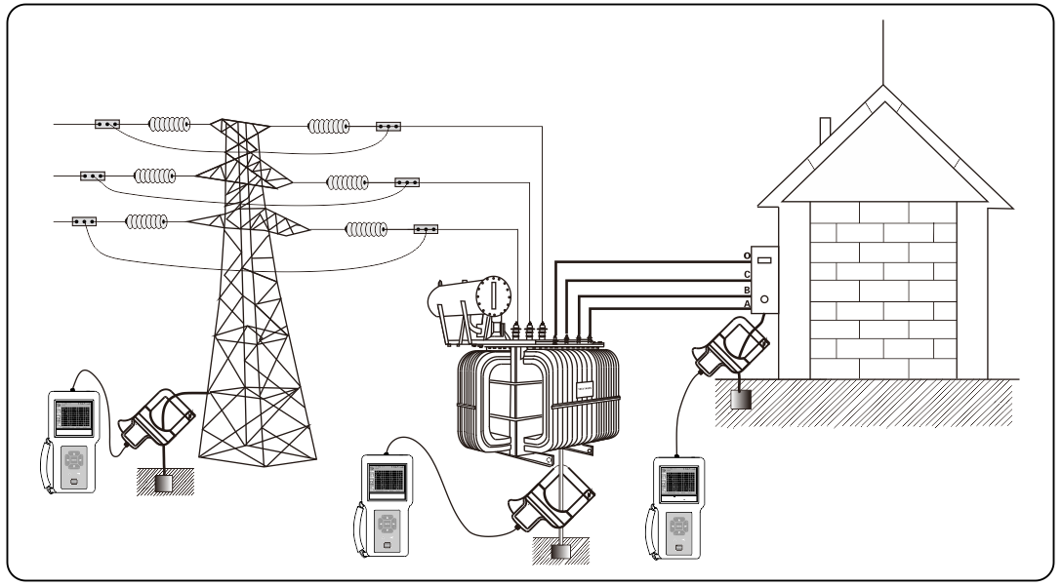
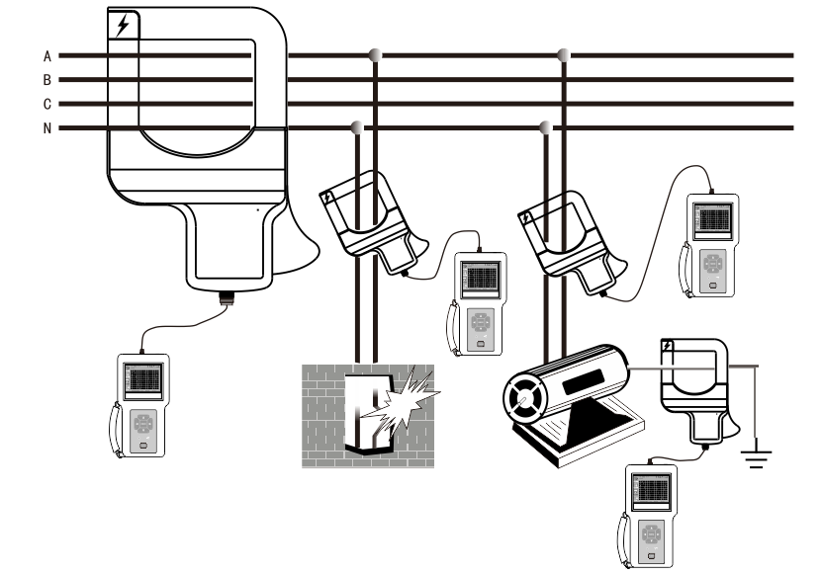
Clamp the grounding wire, that is, measuring the leakage current of electrical equipment`s grounding wire (pay attention to clamp one wire).
Clamp the live line or null line separately to measure the current of the line (pay attention to clamp one line).
Clamp the live line and null line together to measure the leakage current of single phase (pay attention to clamp two line).
Clamp the three-phase 3 wire together to measure the leakage current of the three-phase 3 wire (pay attention to clamp three line).
Clamp the three-phase 4 wire together to measure the leakage current of the three-phase 4 wire (pay attention to clamp four line).
Clamp the three-phase 5 wire together to measure the leakage current of the three-phase 5 wire (pay attention to clamp five line).
For safety, when measuring high voltage and high current, please move the meter away from the tested wire after confirming the operation correct.

Real Time Monitoring
Start up the host and enter the test state. Connect the computer to the host with a randomly configured USB communication cable. Run the monitoring software installed in the computer, if the communication is normal working, the computer can real time monitoring the on-line current.
The monitoring software with online real-time monitoring, historical query, dynamic display and waveform indication;With alarm setting and alarm indication; and with historical data read, consult, save, print and other functions.

Data Download
Connect the instrument to the computer with the randomly configured USB communication cable. Start up the instrument, run the monitoring software, select the history consult, and then reading the data.

Replace Battery
Please pay attention to the battery polarity, otherwise damage the meter.
Battery power low, please replace the battery in time
Mixing old and new batteries is not allowed
6.1. When the power voltage of the meter is lower than 7.2V±0.1V, and display a battery symbol, indicating insufficient battery power. Please replace the battery in time.
6.2. Press the POWER button to shut down the instrument and confirm that is in the state of shutdown. Open the battery cover and replace it with new and qualified battery. Pay special attention to the battery polarity, cover the battery cover well and restart the instrument to confirm whether the replacement is completed. (as shown in figure)
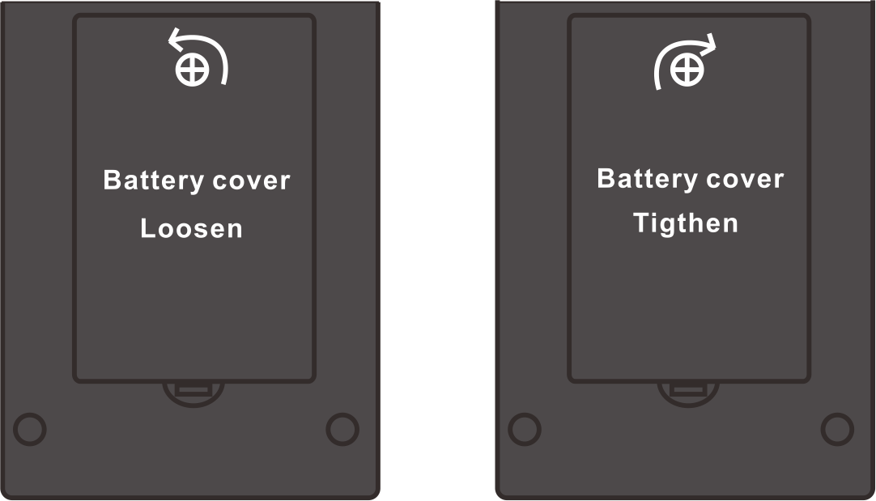

Packing List
No. | Item | Qty
1 | Host | 1
2 | Current Clamp | 1
3 | USB Communication Cable | 1
4 | Monitoring Software(CD) | 1
5 | Alkaline dry battery(LR6) | 6
6 | Instrument Bag | 1
7 | User Manual | 1
8 | Calibration Certificate | 1
9 | Warranty Card | 1

