HZ-R30
Intelligent Cable Comprehensive Detector

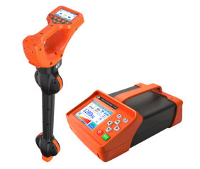

Huazheng Electric Manufacturing (Baoding) Co., Ltd

Dear user:
Thank you for choosing HZ-R30 Intelligent Cable Comprehensive Detector.
We hope that this instrument can make your work easier and more enjoyable, so that you can get the feeling of office automation in the test and analysis work.
Before using the instrument, please read this manual, and operate and maintain the instrument according to the manual to prolong its service life.
"Just a light press, the test will be completed automatically" is the operating characteristics of this instrument.
If you are satisfied with this instrument, please tell your colleagues; if you are not satisfied with this instrument, please call (0312) 6775656 to tell you to serve you at all times-Baoding Huazheng Electric Manufacturing Co., Ltd., our company will definitely make you satisfied !
Contents

I. Product Introduction 1
II. HZ-R30 Handcart Cable Fault Tester: Advantages and Features 1
III. High-voltage unit 2
IV. Distance measuring unit 2
V. Fixed-point unit 4
VI. Packing List 5

- Product Introduction
HZ-R30 cable path detector is a multi-functional cable path identification and detection instrument. It features multiple functions including cable path detection, cable identification, and cable grounding fault location (optional) . The instrument consists of a transmitter, transmitting current clamp, receiver , receiving flexible current clamp, connecting test leads, stethoscope (optional), and A-frame (optional accessory) .
Pipeline Path Detection: This instrument enables trenchless detection of metal pipelines and underground cables, facilitating pipeline surveys and depth measurements. Utilizing various filter technologies, it possesses strong anti-interference capabilities, enabling precise positioning and depth measurement. Suitable for detecting and inspecting various underground metal pipelines, pipeline management and maintenance, municipal planning and construction, and power supply departments, it is an essential instrument for pipeline maintenance units. This function is achieved through a signal transmitter, receiver, signal transmitting clamps, and connecting test leads. The instrument has the following features:
- Multiple detection modes: classic positioning mode, full-screen signal mode, and signal curve mode.
- Classic positioning mode: Compass, direction and signal amplitude display, intuitively showing the left and right direction of the pipeline.
- Full-screen signal mode: 360° omnidirectional pipeline path indication, continuously displaying depth, current, and relative pipeline position. The interface is simple and intuitive, requiring no prior experience to operate.
- Signal curve mode: Displays historical signal strength curves, allowing you to locate cables by observing changes in the curves.
- Current direction determination (at some frequencies) can eliminate interference from adjacent lines and prevent tracking errors by calibrating the current direction.
- The color of the pipeline simulation line displays the signal interference intensity in real time.
- With a built-in frequency sweep test function, users can select a suitable signal frequency for pipeline measurement based on the frequency sweep results, avoiding interference from the same frequency.
- Fully digital high-precision sampling processing: stable and reliable, ultra-high sensitivity, extremely narrow receiving bandwidth, strong anti-interference capability, and can effectively suppress power frequency and harmonic interference from nearby operating cables and pipelines.
- Multiple detection frequencies: 10 active detection frequencies and 2 passive detection frequencies.
- The transmitter offers multiple signal output methods: direct output, clamp coupling, and induction.
- The transmitter features digital power amplification for high-power output, fully automatic impedance matching, and fully automatic protection.
Cable Identification: Designed to solve the technical problems of cable identification for power cable engineers and cable workers. It can identify live cables and de-energized cables. Users can accurately identify a target cable from multiple cables using the instrument, avoiding serious accidents caused by accidentally cutting live cables. During cable identification, 10 cables can be pre-marked at the transmitting end before being identified at the remote receiving end, greatly saving the time of engineers traveling back and forth and improving work efficiency. Successful cable identification is marked with a √, and non-target cables are marked with an ×, enabling fast and automatic identification of target cables. This function is achieved through the cooperation of a signal transmitter, receiver, signal transmitting clamp, connecting test leads, and flexible clamps.
Signal Transmitter : Used for pipeline path detection and cable identification. This device can apply identification signals to target cables through direct output, clamp coupling, and induction. Ten different pulse signals are available: 512Hz, 1024Hz, 640Hz (cable identification), 1280Hz, 2.56kHz (fault location), 3.20kHz, 8.19kHz, 33kHz, 82kHz, and 196kHz. The maximum signal output power is 10W, adjustable in 10 levels, adapting to different application environments and making pipeline detection and cable identification more accurate and reliable. The instrument has a built-in high-power rechargeable lithium battery, automatic impedance matching, and fully automatic protection. The main unit features a 5.6-inch color capacitive touchscreen LCD display, showing real-time dynamic signal output status and battery usage.
Transmitter clamp : Suitable for clamp coupling method. The transmitter clamp couples the signal emitted by the transmitter to the target cable. The clamp jaw size is Φ150mm . The transmitter clamp is directional, and the transmitted signal flows in from the direction indicated by the arrow on the transmitter clamp.
Receiver : Used for receiving signals for pipeline path detection and cable identification. It has multiple built-in shielded 3D antennas, capable of effectively identifying 10 different pulse-code current signals generated by the transmitter : 512Hz, 1024Hz, 640Hz, 1280Hz, 2.56kHz, 3.20kHz, 8.19kHz, 33kHz, 82kHz, and 196kHz . It can also identify 50Hz and 60Hz power frequency signals. A 3.5-inch color LCD screen provides real-time dynamic display of 360° omnidirectional pipeline path indication, depth, current, and relative pipeline position .
A-frame (optional) : An A-shaped voltage signal sensor specifically designed for locating grounding faults in buried cables. The A-frame's two probes or probe discs accurately receive step voltage signals transmitted from a transmitter. After data analysis at the receiver, the grounding fault point can be precisely located. The probes or probe discs are independently interchangeable ; the probes are suitable for muddy surfaces, while the probe discs are suitable for concrete surfaces where direct insertion into the ground is not possible. The A-frame's lead wires are designed with aviation sockets, allowing connection to the receiver via aviation plug cables. It is easily detachable and compatible with an independently designed handle, enabling the A-frame to function independently for other purposes.
Flexible current clamp : Used for cable identification. This current clamp uses a Rockwell coil and has excellent transient tracking capability, enabling rapid identification of pulse-coded currents generated by the transmitter. It is suitable for thick cables or irregularly shaped conductors. Its jaws have an inner diameter of 200 mm, allowing for non-contact measurement without disconnecting the circuit under test, ensuring safety and speed.
- Technical Specifications

1. Receiver Specifications
Function | Pipeline detection (cable location tracking, direction display, depth measurement, current measurement), cable identification
power supply | 7.4V DC 6400mAh rechargeable lithium battery
Input method | Built-in receiving coil; external flexible clamp; external A-frame
Receive frequency | Active detection frequencies: 512Hz, 640Hz, 1024Hz, 1280Hz, 2.56kHz, 3.20kHz, 8.19kHz, 33kHz, 82kHz, 196kHz  Power frequency passive detection frequencies: 50Hz, 60Hz
Pipeline detection mode | Wide peak method, narrow peak method, and valley method
Pipeline detection shows | Classic positioning mode, full-screen signal mode, signal curve mode
Pipeline detection  Detection range | Direct connection method: Generally, the cable length can be 0-20 kilometers, mainly determined by the grounding resistance, cable resistance, and cable burial depth.  Coupling method: Generally, it can achieve cable lengths of 0-10 kilometers, mainly determined by grounding resistance, cable resistance, and cable burial depth.  Induction method: Suitable for cables buried at a depth of less than 2m.
Depth accuracy | Precise planar positioning accuracy: Position of the center axis of the target cable or pipeline:  ±5% (burial depth 0-3m) -15% (burial depth 3m-20m)
sound indication | Frequency modulation tone that varies with signal strength
Interference distance | When using coupling and induction methods, the transmitter will generate interference at close range. The distance of the interference is related to the transmission power and frequency. The higher the power and the higher the frequency, the stronger the interference.  The minimum distance between the receiver and transmitter often needs to be determined experimentally.  Pipeline detection: Coupling method can confirm no interference beyond 5m, induction method beyond 20m.  Cable identification: Coupling method can confirm no interference at a distance of 5m.
Cable identification | Identification method: Intelligent identification using flexible calipers;  The number of cables that can be specified is 1 to 10.  Calibration value: A current percentage between the received signal and the transmitted signal that is between 75% and 135% of the calibration value is one of the conditions for successful identification;  Directionality: The transmitting clamp, receiving clamp, and the loaded signal must be aligned in direction; this is one of the conditions for successful identification.
Cable identification  Detection range | Direct connection method: can identify signals with a loop resistance of 0Ω to 8kΩ (generally applicable to cable lengths of 0-20 kilometers, mainly determined by grounding resistance and cable resistance).  Coupling method: can identify signals with a loop resistance of 0Ω to 1kΩ; (generally applicable to cable lengths of 0-10 kilometers, mainly determined by grounding resistance and cable resistance)
liquid crystal | 3.5-inch color LCD screen
size | Approximately 263mm*123mm*735mm
quality | 1.90Kg
charger | DC8.4V, 1A
Connection interface | 1 USB port (for firmware upgrades and charging mobile phones)  1*DC charging port  1*Type-C charging port  1* Flexible clamp connection socket
Flexible Current Clamp | Approximately 620mm in length and 8mm in diameter.
Inner diameter of flexible coil | φ200mm
Test line | 1X Red test line 3m  1X Black Test Cable 3m
Operating temperature and humidity | -10℃～40℃; below 80%Rh
Storage temperature and humidity | -10℃~50℃, ≤95%RH, no condensation
Pressure resistance | AC2000V/rms (before the front and rear ends of the casing)
Suitable for safety regulations | IEC61010-1 CAT III 600V, IEC61010-031, IEC61326, Pollution Degree 2

2. Transmitter Specifications
Function | Multiple frequency signal transmission methods for pipeline path detection, cable identification, and fault location
power supply | 11.1V DC 12800mAh rechargeable lithium battery
Output method | Direct output, inductive method, caliper coupling
Output frequency | 512Hz, 640Hz (cable identification), 1024Hz, 1280Hz, 2.56kHz (fault location), 3.20kHz, 8.19kHz, 33kHz, 82kHz, 196kHz
Output power | 10W Max, 10 adjustable levels, fully automatic real-time impedance matching
Direct-connected output voltage | 150Vpp MAX
Circuit protection | It has overload and short circuit protection
liquid crystal | 5.6-inch capacitive touch LCD screen
Instrument Dimensions | Approximately 351mm*223mm*134mm
quality | Transmitter: 3.85 kg; Launch clamp: 1.12 kg
charger | DC 12.6V, 1A
Launcher size | 250mm x 140mm x 35mm (Length x Width x Thickness)
Launch clamp inner diameter | φ150mm
Launch clamp length | 3m
Direct connection test cable | 3m
Connection interface | 1 USB port (for firmware upgrades and charging mobile phones)  1*Type-C charging port  1*DC charging port  1* Signal transmitting clamp and DC test lead connector
Pressure resistance | AC 3700V/rms (between the top and bottom surfaces of the instrument case)
Electromagnetic properties | IEC61326(EMC)
Suitable for safety regulations | IEC61010-1 (CAT III 300V, CAT IV 150V, pollution level 2)

3. Optional features
Fault location | When used with an A-frame, it can enable precise location of cable grounding faults.
stethoscope | Can replace flexible coils for cable identification
- Packing List
Serial Number | name | quantity | picture | Remark
1 | Transmitter and receiver | 1 | 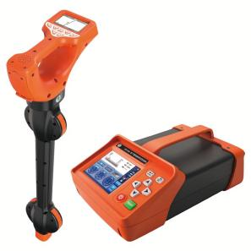 | Standard configuration
2 | toolkit | 1 | 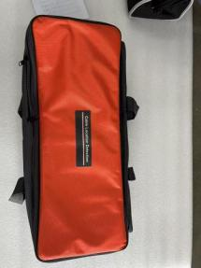 | Standard configuration
3 | Emitting Current Clamp | 1 | 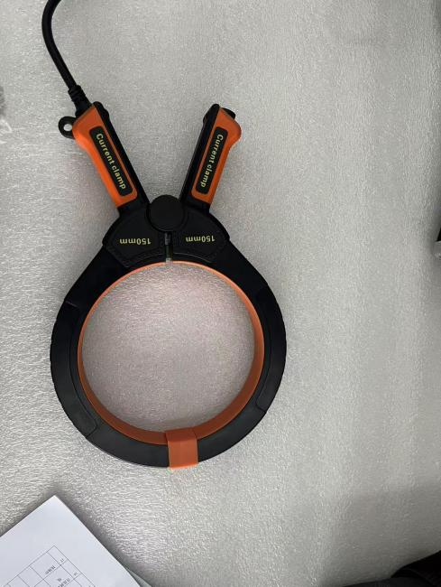 | Standard configuration
4 | Direct connection test cable | 1 | 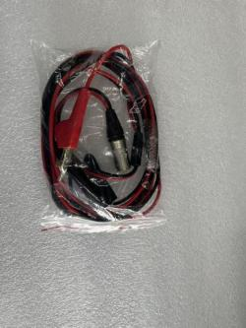 | Standard configuration
5 | grounding pin | 1 | 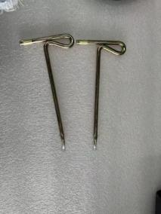 | Standard configuration
6 | Double-headed alligator clip test cable | 1 | 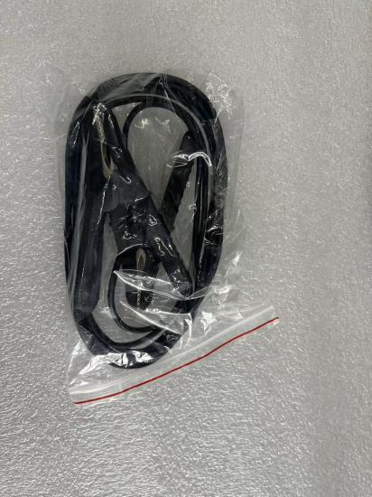 | Standard configuration
7 | 8.4V charger | 1 | 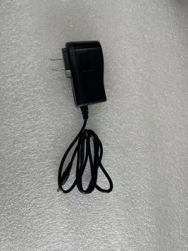 | Standard configuration
8 | 12.6V charger | 1 | 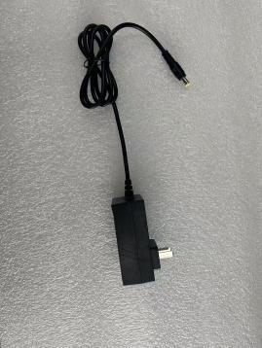 | Standard configuration
9 | Flexible clamps | 1 | 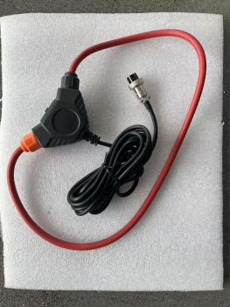 | Standard configuration
10 | A-frame | 1 | 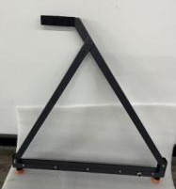 | Optional

