HZ-A52
Handcart-type Cable Fault Tester

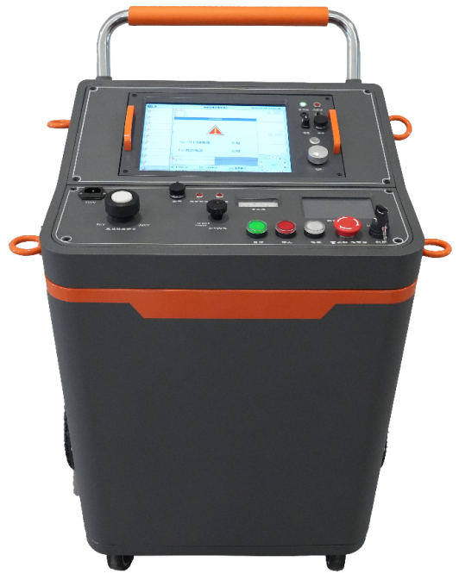

Huazheng Electric Manufacturing (Baoding) Co., Ltd

Dear user:
Thank you for choosing HZ-A52 Handcart-type Cable Fault Tester.
We hope that this instrument can make your work easier and more enjoyable, so that you can get the feeling of office automation in the test and analysis work.
Before using the instrument, please read this manual, and operate and maintain the instrument according to the manual to prolong its service life.
"Just a light press, the test will be completed automatically" is the operating characteristics of this instrument.
If you are satisfied with this instrument, please tell your colleagues; if you are not satisfied with this instrument, please call (0312) 6775656 to tell you to serve you at all times-Baoding Huazheng Electric Manufacturing Co., Ltd., our company will definitely make you satisfied !
Contents

I. Product Introduction 1
II. HZ-A52 Handcart Cable Fault Tester: Advantages and Features 1
III. High-voltage unit 2
IV. Distance measuring unit 2
V. Fixed-point unit 4
VI. Packing List 5

- Product Introduction
HZ - A52 trolley- type cable fault testing system is a product of our company's long-term commitment to power cable fault testing. To meet the rapid development of the power industry, it highly integrates traditional, independent cable fault location measurement, an integrated power frequency high-voltage power supply, a multi-pulse generator, and automatic discharge into a single trolley-type cable fault testing system. The system features a compact and safe high-voltage design with embedded distance measurement units , and strong anti-interference capabilities. This system is used for measuring the distance to various power cable faults . The testing software automatically identifies the fault location and reads the distance, making cable fault testing truly convenient, simple, efficient, and safe, providing ease of rapid testing for power cable faults.
- HZ-A52 Handcart Cable Fault Tester: Advantages and Features
Through continuous development and innovation, the product possesses the following characteristics:
- With built-in three-stage capacitors, it is suitable for testing various main insulation faults in power cables of different voltage levels.
- It boasts rapid voltage boost, high power output, saves time, and reduces labor costs .
- the power frequency high- voltage power supply unit embodies human-machine interaction, making operation convenient and the display simple and intuitive.
- The system is equipped with a 25m test line, which facilitates cable fault testing at long and short distances and in complex environments.
- The entire machine is designed according to European standards and has a key authorized for use by professionals.
- The entire unit has a grounding circuit and a step voltage monitoring and protection system to protect equipment and personal safety in real time.
- It features an emergency stop button and automatic discharge function, automatically reducing voltage and discharging during emergency stop or shutdown, ensuring safety and reliability .
- The high voltage output has single pulse and continuous pulse functions, which can be used in conjunction with a fully intelligent multi-pulse cable fault tester and a precise locator to find fault points .
- High-voltage unit
Technical indicators
- Output voltage: 0-32kV continuously adjustable.
- Start the high-voltage equipment with the authorized key.
- Built-in capacitors: Three capacitor options : 64 μF /8kV , 16 μF /16kV, and 4 μF /32kV.
- Maximum impact energy: 2048J.
- Operating modes: continuous flash and single flash.
- Continuous pulse period: 1 to 10 seconds.
- Display device: 5-inch color LCD with a resolution of 800×480.
- Prompt format: Chinese prompts, with intuitive numerical display.
- The control software operates stably under high voltage.
- Automatic discharge function: After pressing the emergency stop button or powering off, the instrument will automatically discharge all remaining power.
- Input voltage: AC220V±10%/50Hz.
- External dimensions: 750mm×560mm×915mm .
- Weight: 130kg .
- Distance measuring unit
Advantages and features:
◆ Features a large 12.1-inch screen with rotary mouse control, a high-brightness LCD display suitable for outdoor use in sunlight, lithium battery power supply for convenient on-site testing. The engineering plastic chassis is shockproof, moisture-proof, and offers excellent stability.
◆ The flash tester is equipped with a WIFI module and SIM interface, enabling wireless remote transmission of measurement data and technical support from mobile terminals . It adopts integrated communication technology, ensuring stable signal acquisition. The host can automatically select eight sampling frequencies ranging from a minimum of 3.125 MHz to a maximum of 400 MHz , with adaptive pulse width, meeting the testing requirements of cables of different lengths .
◆ The software enables automatic replacement of three types of testers: low-voltage pulse method , lightning current method, and multiple pulse method. Wiring is simple and testing is intuitive. It features fully automatic identification and search of waveform inflection points, automatic positioning of waveform fault inflection points, and automatic reading and display of fault distance .
◆The waveform is displayed in three zones on the same screen, and ten measured waveforms are randomly displayed on the same screen for selection. It can also realize waveform positioning verification in both automatic and manual processing modes, and has the function of test waveform data storage, playback and analysis.
◆ The unique multi-pulse generator design produces ten low-voltage short-circuit pulse waveforms with a single discharge, automatically selecting the optimal standard waveform to significantly reduce interference from large oscillations.
◆ The precision point-finding instrument adopts noise filtering dual-selection technology , which can directly and synchronously display the change in distance between the test point and the fault point, and simultaneously detect the cable path direction at the fixed point .
◆ The precision positioning device supports a mobile app, which connects to a mobile phone and headphones via Bluetooth , enabling two people to quickly and simultaneously locate points with one probe.
◆ The professional cable testing app supports remote assistance to users anytime, anywhere, including waveform analysis, case sharing, teaching and training, and mock exams.
Technical parameters:
- It can test various main insulation faults of power cables with different voltage levels, cross sections, media and materials, including: open circuit, short circuit, low resistance, high resistance leakage, and high resistance flashover fault.
- Display method: 12.1-inch industrial-grade LCD screen ( Linux operating system ).
- Storage space: 32GB electronic disk.
- Language: Switch between Chinese, English, and Russian.
- Test methods: three types: low-voltage pulse method, high-voltage flashover method, and multiple pulse method.
- Operation method: Dual operation via touch screen and photoelectric knob (touch screen function optional)
- Pulse width/pulse amplitude (100ns~10μs, 120V)
- Gain adjustment (-20…+40dB)
- Output impedance matching ( 120 ohms)
- The flash tester is equipped with a WIFI module and a SIM interface, enabling remote transmission of test data.
- Test distance: 5m-100km.
- Minimum test distance (blind zone): 5 meters.
- Precise positioning error: ±0.2m.
- Test error: System error is less than ±1%.
- Multiple pulse generator: impulse voltage ≤40kV.
- Resolution: v / (2f ) meters. ( v: propagation speed m/ μs ; f: sampling frequency MHz)
- Sampling frequencies: 400MHz, 200MHz, 100MHz, 50MHz, 25MHz, 12.5MHz, 6.25MHz, 3.125MHz.
- Power supply and power consumption: AC220V±10%, not more than 15W; DC12V (7AH), not more than 20W.
- Standby time: Approximately 6 hours of continuous use.
- Fixed-point unit
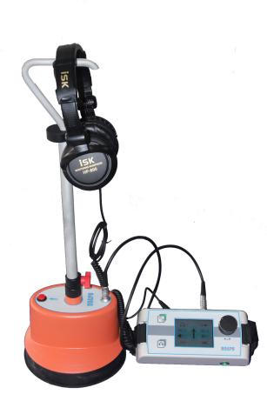
- Sensor dynamic range: Sound channel >104dB, magnetic field channel >110dB; Sensor frequency range: 100 Hz --- 1500 Hz
- The amplification factor of the impulse discharge sound is >90dB, and the upper limit of the impulse discharge volume is 84dB(A). This can be turned on or off.
- Wavelength settings: Unfiltered 100 Hz --- 1500 Hz
- Low-pass filter: 100Hz-400Hz; Band-pass filter: 150Hz-600Hz; High-pass filter: 200Hz-1500Hz
- LCD monitor: High-brightness true-color screen, 320 x 240 pixels, suitable for outdoor use.
- On-site continuous working time: Alkaline replaceable battery for convenient on-site use.
- Packing List
Serial Number | Part Name | quantity | Remark
1 | HZ-A52 Handcart Main Unit | 1 unit | 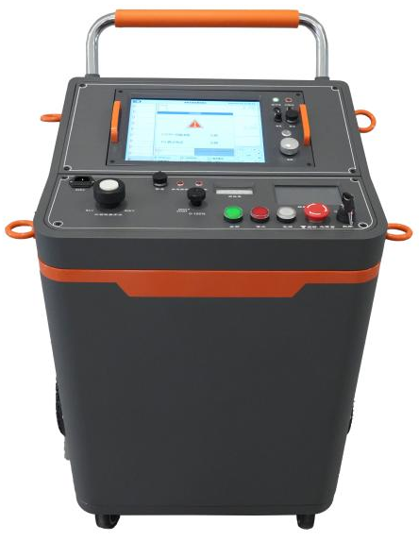
2 | HZ-B+ Positioning Instrument Host Computer | 1 unit | 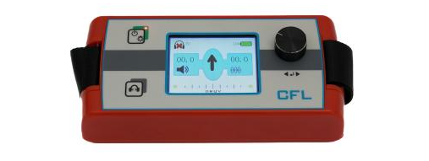
3 | HZ-B+ Positioning Instrument Lower Machine | 1 unit | 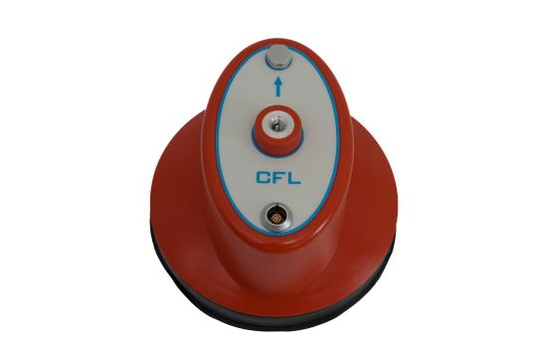
4 | HZ-B+ Positioning Instrument Connection Cable | 1 piece | 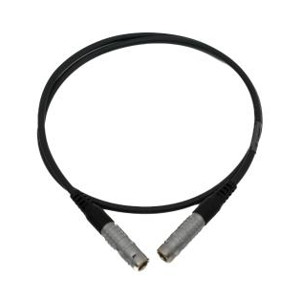
5 | earphone | 1 pair | 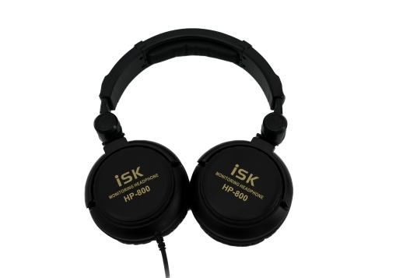
6 | HZ-B+ Positioning Instrument Handle | 1 | 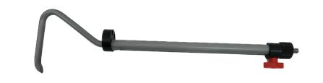
7 | HZ-B+ Positioner Charger | 1 | 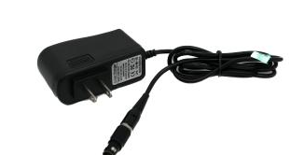
8 | Small needle | 1 | 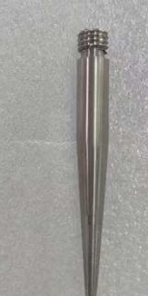
9 | Cable Fault Tester Charger | 1 | 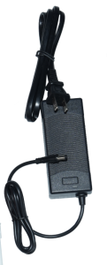
10 | Main control line | 1 piece | 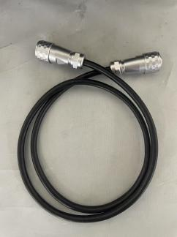
11 | power cord | 1 piece | 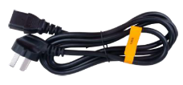
12 | 25-meter test line | 1 piece | 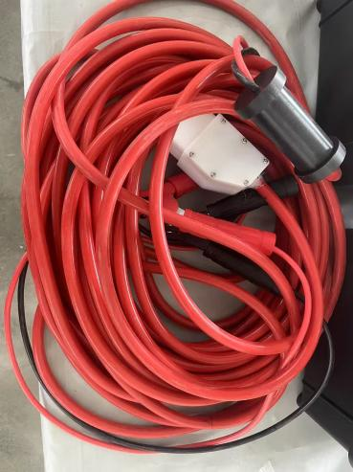
13 | 5-meter step voltage test lead | 1 piece | 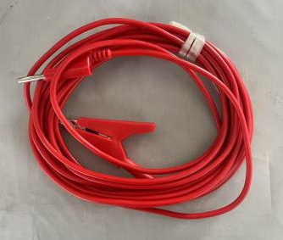
14 | 10- meter grounding wire | 1 piece | 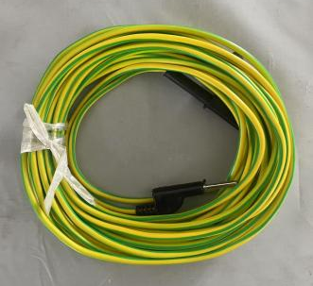
15 | Discharge rod | 1 piece | 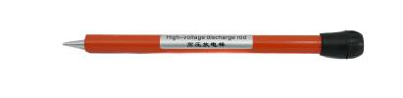
16 | 0.8-meter jumper wire | 3 | 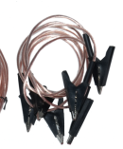
17 | ground wire | 2 sticks | 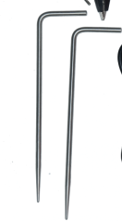
18 | Insurance | 5 | 10A (Spare power outlet)
19 | HZ-R10 path transmitter and related accessories | 1 unit | 