HZ-A40
Vehicle-Mounted Cable Fault Integrated Testing System

USER MANUAL

Huazheng Electric Manufacturing (Baoding) Co., Ltd

Contents

I. Overview 1
1.1 Product Features 1
1.2 Technical Specifications 2
1.3 Usage Conditions 4
II. Introduction To Cable Fault Location 4
III. Instrument Structure 7
3.1 Panel 7
3.2 Control Panel 10
3.3 High-voltage switchgear output terminal 10
3.4 Install external terminal boxes for high-voltage switchgear 11
3.5 Output Cable Reel 12
IV. Cable Fault Testing System Operation Procedures 13
V. Test Instructions 17
5.1 Wiring 17
5.2 Low-voltage pulse method (TDR) 18
5.3 Multiple Pulse Method (MIM) 20
5.4 Pulse Current Method (ICE) 22
5.5 DC Output​ 23
5.6 Precise location 24
5.7 Problems and Solutions 35
VI. Configuration List 36
VII. Transportation And Storage 36
7.1 Transportation Precautions 36
7.2 Storage conditions, storage period and precautions 37
VIII. Unpacking Inspection And Maintenance 37
8.1 Unpacking and Inspection 37
8.2 Maintenance 37

- Overview
Our export-type vehicle-mounted intelligent cable fault location system is a high-performance device developed by our company to keep pace with the development trends of the international power industry and meet the dynamics of rapid power development. Designed to meet the needs of power cable operation and maintenance sites, it integrates a complete set of cable fault testing functions. The entire system is designed with an integrated approach, eliminating the need for vehicle transport during export. This allows for flexible vehicle selection and portable installation in the destination country.
The entire system meets the General Technical Conditions for Special Testing Instruments for Power Equipment as specified in the People's Republic of China power industry standards DL/T849.1-2019 ~ DL/T849.3-2019. It is used for testing various faults in power cables, and its functions cover accurate testing of faults in power cables, railway and airport signal control cables, and street light cables.

1.1 Product Features
Through continuous development and innovation, the product possesses the following characteristics:
- basis for cable installation, maintenance and management .
- Wave velocity verification: By verifying the signal propagation speed in the cable, the accuracy of fault location can be improved.
- Based on the principle of multiple pulses, various power cable main insulation faults can be pre-located.
- Embedded design, Chinese interface, stable operation.
- It adopts distributed control bus technology, which has a high degree of automation, is simple to operate, and is convenient for testing and wiring.
- The output high-voltage pulse frequency is controllable, and the impact energy is large, meeting the requirements for pre-positioning and precise positioning.
- DC high voltage output, continuous high current burn-through, rapid carbonization of high resistance fault points (such as water inlet cables).
- It provides a stable output of 2,048J of high impact energy, making it particularly suitable for internal faults in high-resistance connectors.
- Used for conducting cable withstand voltage tests, efficiently detecting cable insulation performance and potential faults .
- It features a grounding protection safety monitoring system , a test site video monitoring system , and step voltage safety protection and self-testing functions , ensuring the personal safety of operators to the greatest extent possible.
- Optional wireless walkie-talkies can be equipped to enable timely communication between the fault location site and vehicle personnel, and to quickly handle abnormal situations.

1.2 Technical Specifications

1.2.1 Vehicle-mounted test main control system
- It can test various main insulation faults of power cables with different voltage levels, cross sections, media and materials, including: open circuit, short circuit, low resistance, high resistance leakage, and high resistance flashover fault.
- Display method: 15-inch industrial-grade LCD screen (Linux operating system), with a resolution of 1024*768 .
- Storage space: 32GB electronic disk.
- Test methods: low-voltage pulse , high-voltage flashover , multiple pulses , DC/burn-through .
- Burn-through mode: Output voltage 0-40kV, output current 0-100mA.
- Operation method: photoelectric knob operation (touch screen function is optional).
- Pulse width/pulse amplitude (100ns ~ 10 μs , 120V).
- Gain adjustment (-20 ~ +40dB).
- Output impedance matching ( 120 Ω ) .
- Test distance: 5m ~ 100km.
- Minimum test distance (blind zone): 5 meters.
- Precise positioning error: ±0.2m.
- Test error: System error is less than ±1%.
- Multiple pulse generator: impulse voltage ≤40kV.
- Resolution: ( v /2)* f meters ( v /2 : half-wave velocity m/ μs ; f : sampling frequency MHz).
- Sampling frequencies: 200MHz, 100MHz, 50MHz, 25MHz, 12.5MHz, 6.25MHz.
- Positioning accuracy: ±(0.2%·L+1)m .

1.2.2 Vehicle-mounted high-voltage control system
- Output voltage: 0-32kV continuously adjustable .
- Start the high-voltage equipment with the authorized key.
- Built-in capacitors: Three capacitor levels : 4 μF /32kV, 16 μF /16kV, and 64 μF /8kV.
- Maximum impact energy: 2048J.
- Operating modes: continuous flashover, single flashover, DC high voltage.
- Continuous pulse period: 1 to 10 seconds.
- Display device: 5-inch color LCD with a resolution of 800*480.
- Prompt format: English prompts, with numbers displayed intuitively.
- The control software operates stably under high voltage.
- Automatic discharge function: After pressing the emergency stop button or powering off, the instrument will automatically discharge all remaining power.
- Input voltage: AC220V±10%/50Hz.

1.2.3 Vehicle-mounted cable reel and safety monitoring system
- Safety monitoring module: Real-time monitoring of the FOHM loop circuit, FU step voltage (whether it is within acceptable limits), secondary pulse overheating (whether it is normal), and whether the " threshold switch" is closed. If any signal is abnormal, a pop-up window will appear on the host interface displaying information for each signal. When an abnormality occurs, the host will simultaneously cut off the power to the high-voltage section, and the high voltage will automatically discharge. After the abnormal signal is processed, the four monitoring signals will return to normal, the host pop-up window will automatically disappear, and the power to the high-voltage section will return to normal.
- High-voltage cable reel : 50m.
- System grounding wire panel : 50m.
- Power cord reel: 50 m .
- Step voltage line reel : 15m.
- Safety contact switch: As shown in Figure 3.5 ③ “ Threshold switch” socket , it can be expanded into a door safety contact switch .

1.3 Usage Conditions
- Operating temperature: -10℃～+45℃
- Relative humidity: ≤90% (no condensation)
- Introduction To Cable Fault Location

2.1.1 Cable Fault Types
■By the cause of the malfunction:
● Forced failure due to external forces (forced failure)
● Failures caused by non-external forces (non-forced failures)
☆ Connector Failure
☆ Outer sheath failure
☆ Body failure
■According to the nature of the fault:
● High resistance fault (insulation resistance value above 1k ohms)
● Low resistance fault (insulation resistance value below 1k ohms)
● Dead ground fault (insulation resistance value close to zero)

2.1.2 Fault Location Process
The basic requirements for cable fault location are rapid location, safe operation, and accurate location, which places high demands on the technical skills of the operators and the reliability of the equipment.
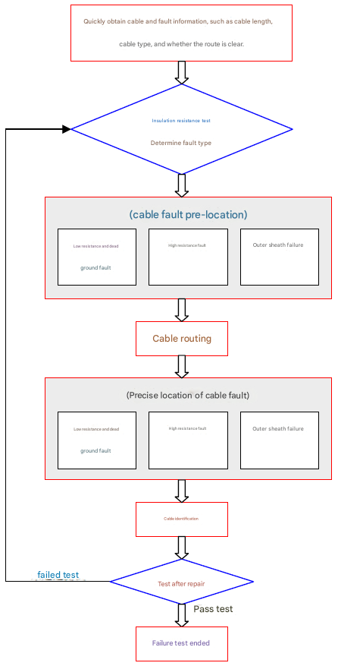
Figure 2.1 Fault location process
Before locating a fault, it is important to understand the basic condition of the cable, such as cable type, length, joint location, and laying method. In addition, the nature of the fault should also be understood before locating it.
Cable fault location, as a specialized technical discipline, is highly dependent on equipment configuration and technical experience. Without specialized testing equipment, fault location becomes significantly more difficult; conversely, with adequate equipment and appropriate methods, location efficiency and accuracy can be greatly improved.
Tips for locating cable faults:
●Many cable faults are caused by external damage, which can be found by inspecting the cable lines;
● When locating a fault, it is best to have detailed cable information. If the information is not detailed, it is best to find it yourself and not to rely on the drawings easily.
● Different cable faults require different testing methods and instruments; accurate prior assessment is crucial for achieving optimal results.

2.1.3 Safe Operation
Always exercise caution when operating high-voltage equipment and strictly adhere to safety regulations and procedures. Before conducting fault tests, strictly follow these five safety rules:
● Ensure the cable under test is de-energized. | ● Ground the non-test cable core.
● Prevent the tested cable from continuing to be energized. | ● Isolate or shield surrounding electrical equipment.
● Ensure that there is no residual voltage in the cable being tested.
During fault testing, prevent other personnel from approaching the site. Ideally, isolate the testing area with warning signs to prevent electric shock. After testing, discharge the cable under test. Safety first, prevent electric shock!
Possible problems | Solution
Self-check error report | Based on the system error message, check the status of various components, such as wiring, FOHM circuit, FU step voltage, secondary pulse overheating, and threshold switch. If the error is caused by a system malfunction, because the system is a high-voltage device with a high degree of integration, do not attempt to open or repair it yourself. Please contact our after-sales service.
Test waveforms cannot be obtained when measuring high-resistance faults. | Check if the system parameter settings are reasonable, the condition of the cable ends, and whether the applied test methods are appropriate (if the multiple pulse method cannot obtain waveforms, use the pulse current method), and whether water has entered the cable joints or fault points, requiring arc burning...
- Instrument Structure

3.1 Panel
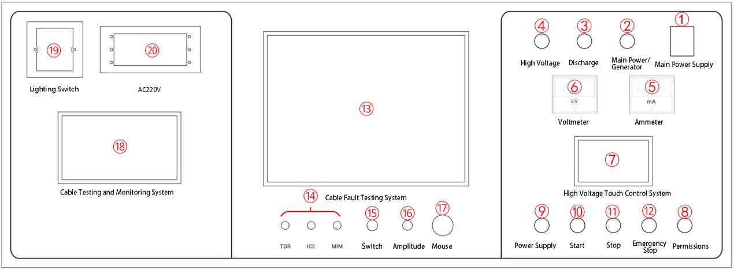
Figure 3.1 Panel
① "Power" switch : This switch controls the power supply of the entire system. Pushing this switch up will power on the system; pulling it down will power off the system.
② "Main Power/Generator" selector switch : Responsible for selecting and switching the system power supply type (mains power/generator). When connected to mains power, please switch to the "Main Power Supply" position; when the generator is running, please switch to the "Generator Power Supply" position.
③ "Discharge" warning light : This warning light indicates the discharge process after the system automatically closes the discharge mechanism when the emergency stop button is pressed. The warning light will turn off when the stored power in the system is depleted (the process is: from bright to dim to off).
④ "High Voltage" warning light : When the warning light is on, it indicates that the instrument is currently performing DC output or fault detection.
⑤ Voltmeter : Indicates the high voltage output voltage value.
⑥ Ammeter : Indicates the DC output current value.
⑦ High-voltage touch control system : A 5-inch LCD screen for software operation and control of the high-voltage section. It can start and stop voltage boosting, set the pulse output discharge time interval, display the operating mode, voltage level, and overvoltage warning, start and stop DC output, and display overcurrent warning.
⑧ “Permission” switch : Insert the special key. The “0” position turns off the power to the high-voltage section, and the “1” position turns on the power to the high-voltage section.
⑨ "Power" button /indicator light : This is the power switch for the high-voltage section. When the access key is turned to "1", the white light on the power switch will illuminate. Pressing the power switch will turn off the white light.
⑩ “Start” button/indicator light : This is the high-voltage start button. When the ⑨ power button is pressed , the ⑨ white light goes out, and the green light on the start button illuminates, indicating to the operator that the voltage boost can be started.
⑪ “Stop” button : This is the high-voltage stop button. When the ⑩ Start button is pressed , the ⑩ green light goes out and the stop button red light comes on, prompting the operator to stop reducing the pressure.
⑫ “Emergency Stop” button : Pressing this button indicates an emergency stop, while rotating it clockwise and allowing it to automatically spring back indicates a start. In any situation, pressing this button will stop the equipment and automatically release the high voltage.
⑬ Cable Fault Testing System : This system includes a waveform interface for cable fault testing and an LCD screen for displaying fault information from the test vehicle system.
⑭ Cable fault test system indicator lights :
"TDR" indicator light : When the cable fault test software selects the low-voltage pulse method as the working mode, the green light will illuminate, indicating the working status.
"ICE" indicator light : When the cable fault testing software selects the pulse current method as its working mode, the red light will illuminate to indicate the working status.
"MIM" indicator light : When the cable fault testing software selects the multiple pulse method as its working mode, the red light will illuminate to indicate the working status.
⑮ "Switch" button : After pressing this switch, wait a few seconds for the cable fault test system to start automatically.
⑯ “Amplitude” knob : Used to adjust the amplitude of the input and output pulses. Adjustment should be made according to the waveform displayed on the screen. If the adjustment is too small, the pulse reflection will be very small, or even impossible to sample, as shown in Figure 3.2 (left). If the adjustment is too large, the reflected pulses will not intersect the baseline, or the baseline may even become a slanted line, as shown in Figure 3.2 (right). Generally, before sampling, rotate the input amplitude knob about 1/3, then adjust it according to the sampled waveform and resample.

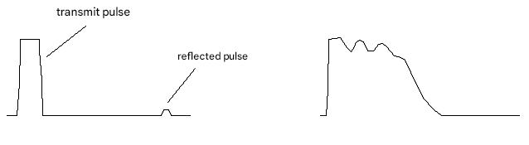
Figure 3.2 Example of amplitude modulation
⑰ Mouse knob : Rotate to select functions and operate the entire system. Press this button to confirm.
18. Cable Testing and Monitoring System : When the system power switch is "on", the monitoring system automatically turns on and starts working. The monitoring interface is divided into two parts: one is a wired monitoring screen, which is connected through the high-voltage cabinet safety camera socket; the other is a monitoring screen of the test site, which is connected to the mobile monitoring probe wirelessly.
⑲ "Lighting" switch : a three-way single-pole switch that can be used as a lighting switch.
⑳ “AC220 V ” output port : provides AC220V mains power.

3.2 Control Panel
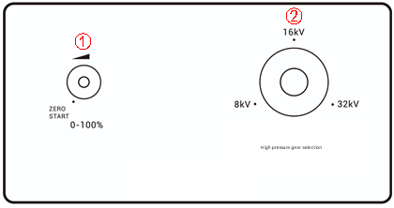
Figure 3.3 Control Panel
① "Voltage Adjustment" knob: Adjusts the output voltage of the high-voltage unit.
② "Voltage Range" Knob: Used to switch the maximum output voltage range. To use, pull the knob up, rotate the knob until the white indicator point on the knob is at the appropriate range, and then press the knob down.

3.3 High-voltage switchgear output terminal
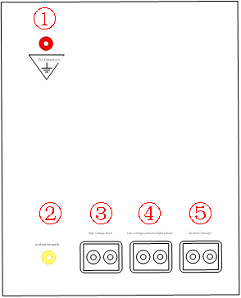
Figure 3.4 High-voltage switchgear output terminal
① "Step voltage detection grounding" socket: Step voltage detection grounding must be reliably grounded near the vehicle.
② "Protective Ground" socket: The grounding of the high-voltage cabinet and the panel housing must be reliably connected to the dedicated grounding busbar.
③ "Pulse Current Method" socket : The impulse flash output port can output a single high voltage pulse or a continuous high voltage pulse. It is the port used for impulse flash current method testing and fault location.
④ “Low-voltage pulse method/multiple pulse method” connector: Low-voltage pulse/multiple pulse output port, outputs single or multiple pulses continuously, used for multiple pulse method test port. Low-voltage pulse waveform can also be tested using the low-voltage pulse method on this connector.
⑤ "DC Output" jack : DC output port, capable of outputting a maximum current of 100mA, used for high-resistance faults or intermittent fault burn-out.

3.4 Install external terminal boxes for high-voltage switchgear
An external terminal box is installed on the right side of the high-voltage switchgear, as shown in the figure below:
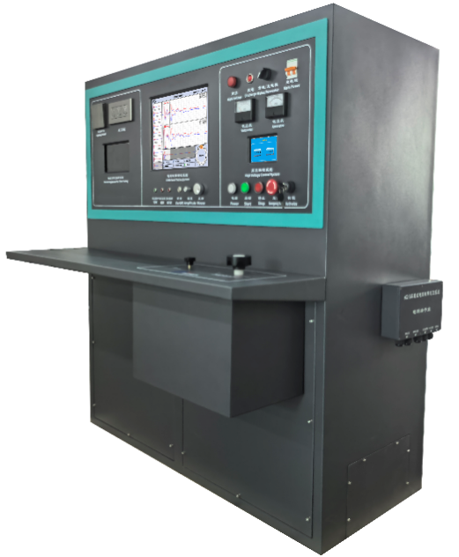 | 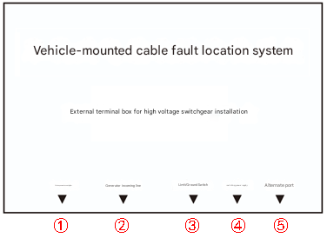
Figure 3.5 High-voltage switchgear power supply
① " Main Power Inlet " socket: When using mains power, the power is connected through this socket.
② "Generator Inlet " socket: When using generator power, the power is connected through this socket.
③ “ Limit/Ground Switch ” socket : The limit switch socket is connected to the door contact switch to ensure that the door is closed before operation ; the ground switch socket is connected to the ground switch in the output panel in Figure 3.6 to monitor the ground wire .
④ " Switch/Power " socket: Power output port, which can supply power to the outside .
⑤ " Spare " port: The "security camera" is connected to this port .

3.5 Output Cable Reel
Figure 3.6 Output coil
① High-voltage cable reel : 50m.
② System grounding wire panel : 50m.
③Step voltage line reel : 15m.
④ Power cord reel: 50 m .
⑤ Grounding switch: Monitors the grounding wire.

- Cable Fault Testing System Operation Procedures

4.1.1 Startup
After pressing the power switch, press and hold the ⑮ "Switch" button until the screen lights up and the buzzer sounds. Release the button to turn on the device.

4.1.2 Fault Detection
Figure 4.1 , rotating the ⑰ "Mouse" knob switches the focus to the " Fault Test Settings " display . Pressing the ⑰ "Mouse" knob button enters the Fault Test Settings interface. Rotating the ⑰ "Mouse" knob places the focus on a specific test mode, sampling frequency, or wave velocity, and pressing the ⑰ "Mouse" knob button allows you to select the desired setting or input a custom wave velocity.
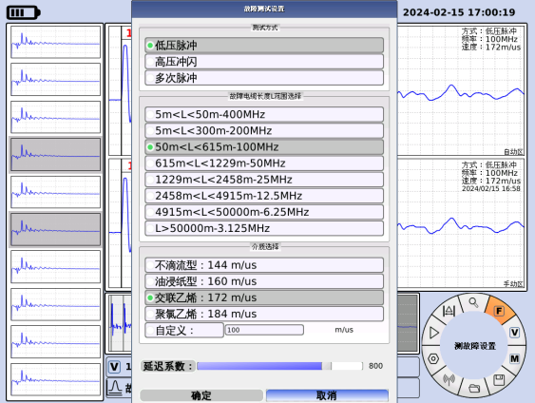 | 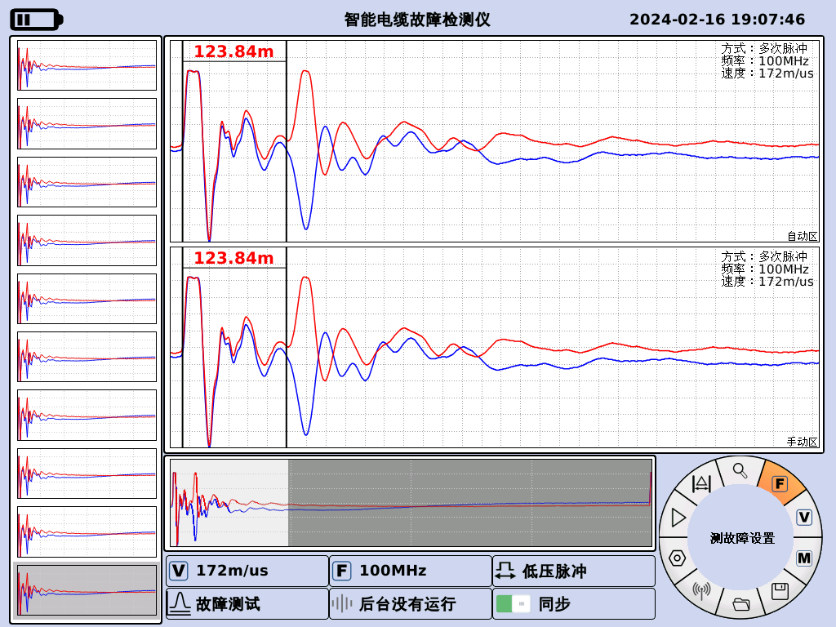
Figure 4.1 Fault setting interface | Figure 4.2 First-level menu after successful parameter setting
Rotate the 17th mouse button to switch the focus to the " OK " button and press the 17th mouse button to successfully set the parameters. At this point, the first-level menu interface is shown in Figure 4.2. The focus should be on the mouse button. Press the 17th mouse button to start sampling. If you need to change the settings, switch to the " Cancel " button and press the 17th mouse button to return to the modification .

4.1.3 Speed Measurement
Figure 4.3 , rotate the 17th "Mouse" knob to switch the focus , and press the 17th "Mouse" knob to enter the speed test interface. Press the 17th "Mouse" knob to switch the focus between selecting the fault cable length L range (the system automatically sets an appropriate sampling frequency), " OK " , and " Cancel " . Alternatively, rotate the 17th "Mouse" knob to place the focus on " Cable Length " , press the 17th "Mouse" knob , and use the pop-up numeric keypad to input the length.
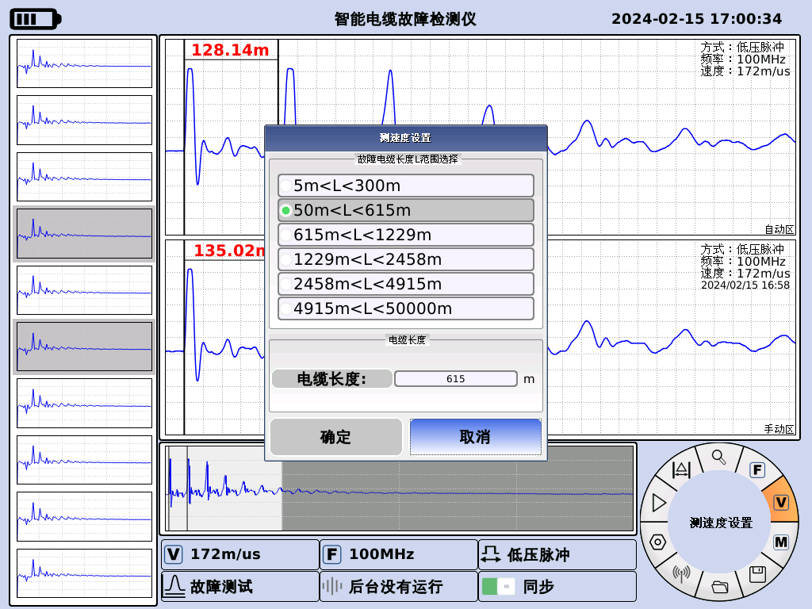 | 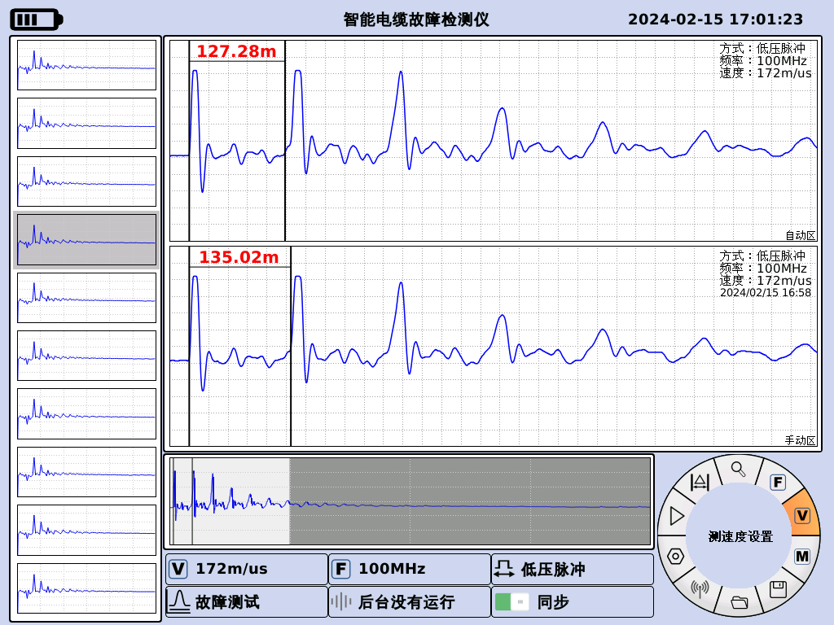
Figure 4.3 Speed Measurement Settings Interface | Figure 4.4 First-level menu after successful parameter setting
After selecting the length and sampling frequency as described above, rotate the 17th "mouse" knob to switch the focus to the " OK " button, and then press the 17th "mouse" knob to successfully set the parameters. Once set, rotate the 17th "mouse" knob to the position shown in Figure 4.2 to begin data acquisition.

4.1.4 Distance measuring caliper
in Figure 4.4 . Rotate the 17th "Mouse" knob to switch the focus . Press the 17th "Mouse" knob , then rotate the knob left and right to adjust the left-side locking line. When adjusting the locking line, the step size increases with the number of rotations. After passing the desired locking position, the knob should rotate from right to left, with the step size increasing with the number of rotations. The main interface displays the current actual locking distance (fault distance), as shown in Figure 4.6.
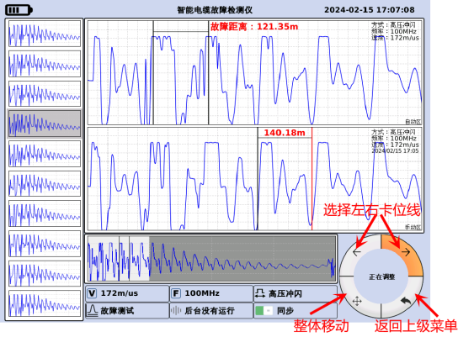 | 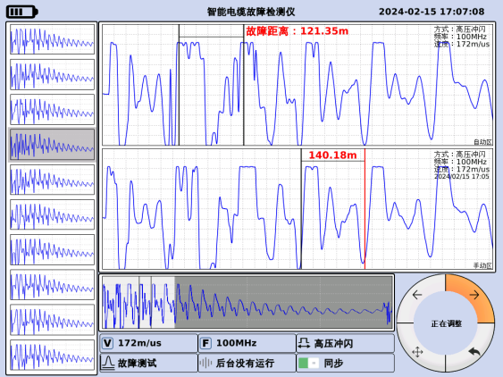
Figure 4.5 Card slot line adjustment secondary menu | Figure 4.6 Fault Distance Display Interface

4.1.5 View Adjustment
Figure 4.7 , rotate the 17th "Mouse" knob to switch the focus , press the 17th "Mouse" knob to enter the view adjustment interface, rotate the knob to compress or stretch the waveform, as shown in Figure 4.8.
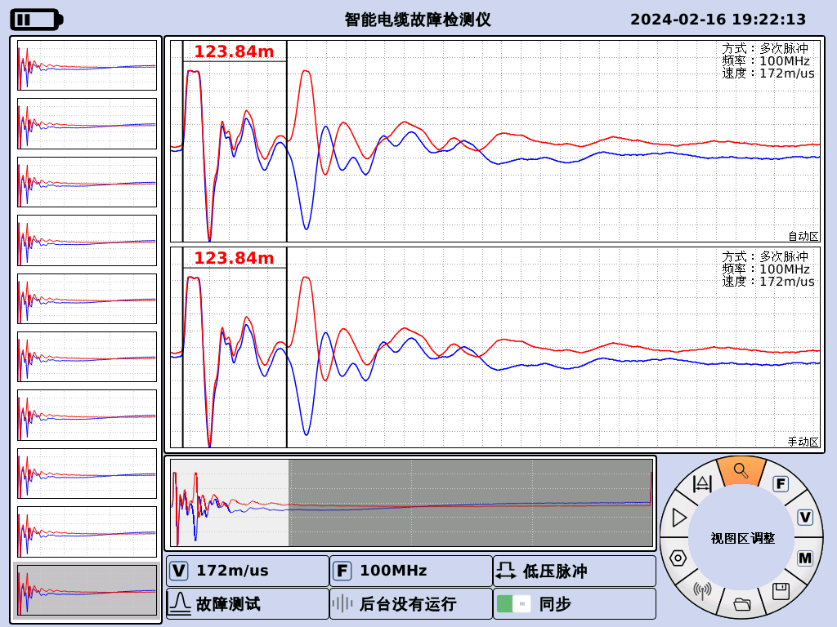 | 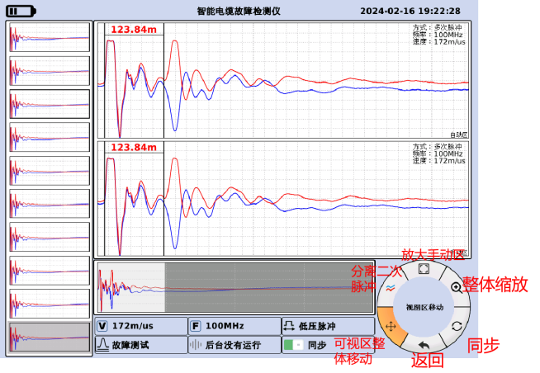
Figure 4.7 View Adjustment First-Level Menu | Figure 4.8 View Adjustment Interface

4.1.6 Open historical data
in Figure 4.9 . Rotate the 17th "Mouse" knob to focus on a specific historical data point, and then press the 17th "Mouse" knob to select that historical data point.
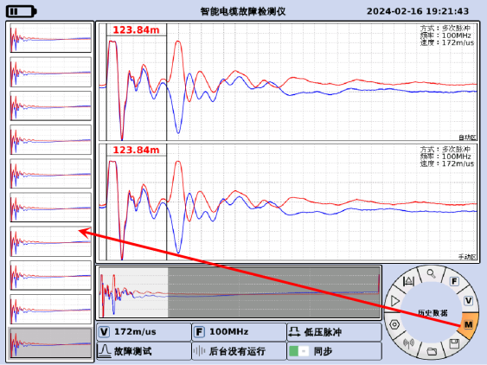 | 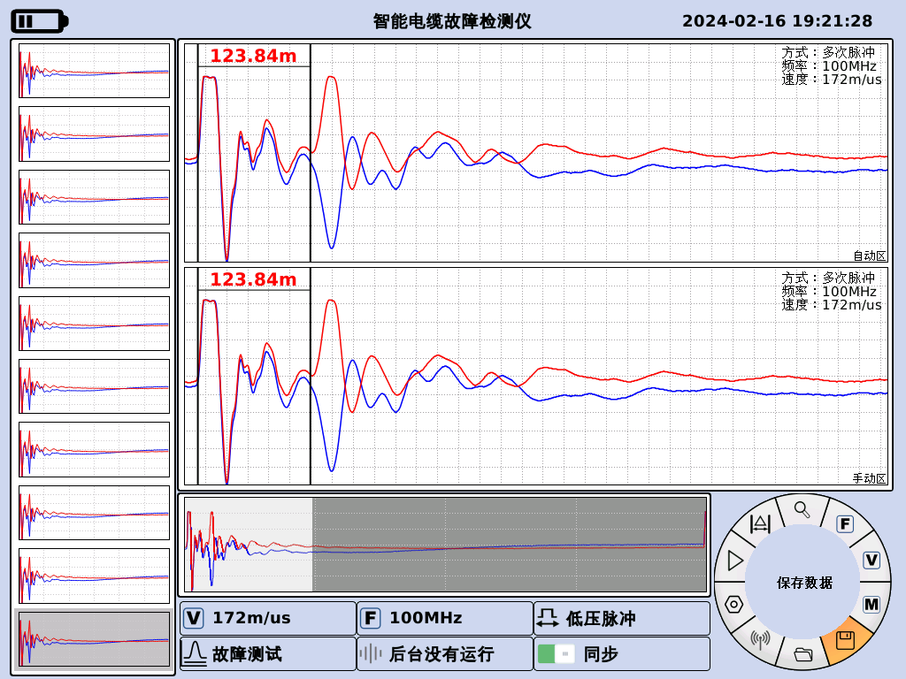
Figure 4.9 Historical Data Selection Interface | Figure 4.10 First-level menu for saving data files

4.1.7 Saving Data
Follow the operation method in 4.1.6 to select a set of data (for example, select the 8th set of data). Then , as shown in Figure 4.10, rotate the 17th "Mouse" knob to switch the focus . Press the 17th "Mouse" knob to save the set of data.

4.1.8 Open Data
Figure 4.11 , rotate the 17th "Mouse" knob to switch the focus , and press the 17th "Mouse" knob to enter the data opening interface. As shown in Figure 4.12, rotate the 17th "Mouse" knob to switch the focus, and press the 17th "Mouse" knob to open the data set and exit the interface.
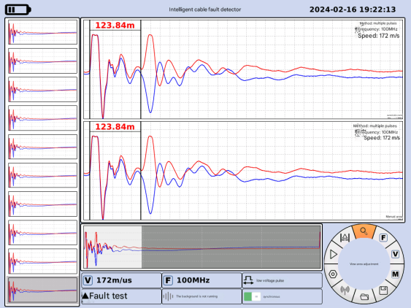 | 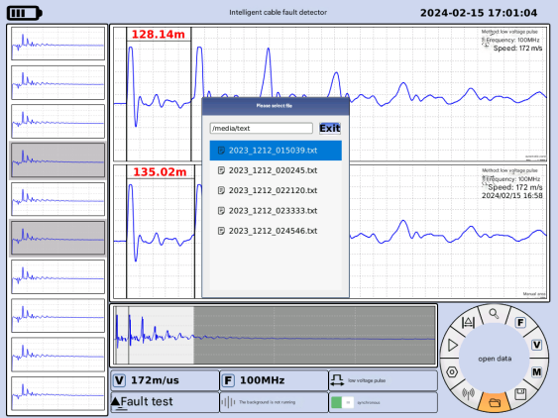
Figure 4.11 Open Data File Top-Level Menu | Figure 4.12 Opening the data interface

4.1.9 Other Settings
Figure 4.13 , rotate the 17th "Mouse" knob to switch the focus to the backlight. Press the 17th "Mouse" knob to enter other settings interfaces. As shown in Figure 4.14, press the 17th "Mouse" knob to switch the focus to the backlight. You can adjust the brightness by rotating the knob.
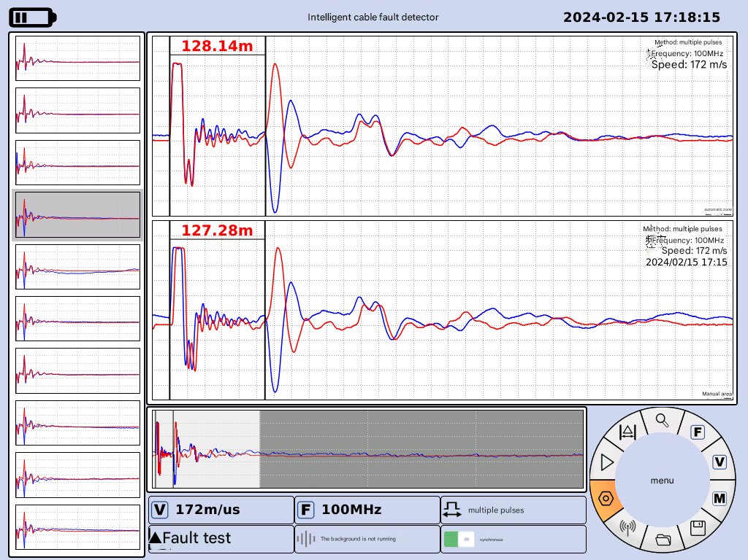 | 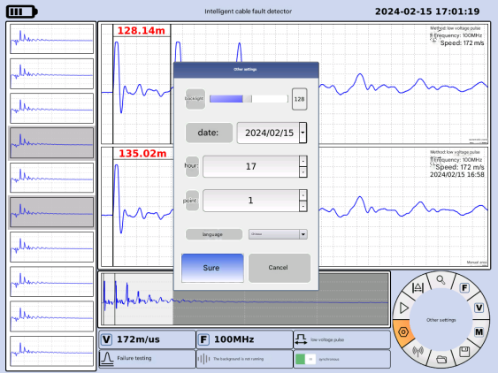
Figure 4.13 Other Settings First-Level Menu | Figure 4.14 Other settings interface
Date adjustment: Select the " Date " with the cursor , press the ⑰ "Mouse" knob to switch between year, month, and day, select the position to be adjusted, and then press the ⑰ "Mouse" knob to select.
Time adjustment: Select " hour " and " minute " with the cursor, then press the ⑰ "mouse" knob and rotate the ⑰ "mouse" knob to adjust the time.
Language adjustment: Select " Language " with the cursor , and rotate the "mouse" knob ⑰ to switch between English, Chinese, Russian, and Turkish.
After all settings are complete, place the focus on the " OK " button and press the "Mouse" knob (⑰) to finish the setup.

4.1.10 Power off
Press and hold button ⑮ "Power" until the screen backlight turns off, then release to power off.
- Test Instructions

5.1 Wiring
The export-type vehicle-mounted intelligent cable fault location system supports pulse current method (ICE), low-voltage pulse method (TDR), multiple pulse method (MIM), and DC output. After determining the operating mode, the high-voltage cable reel plug must be inserted into the corresponding socket . For example, in the case of a phase-B fault, the red clip on the high-voltage cable reel connects to the faulty cable phase B, and the black clip connects to the faulty cable phase C, then grounded via a jumper wire. The grounding busbars on the vehicle body ground and the protective grounding busbar on the high-voltage cabinet are connected to the grounding busbar at the fault location via the grounding reel. The step voltage detection FU is connected to the step voltage cable reel socket, and the step voltage cable reel is grounded near the vehicle. See Figure 5.1 .
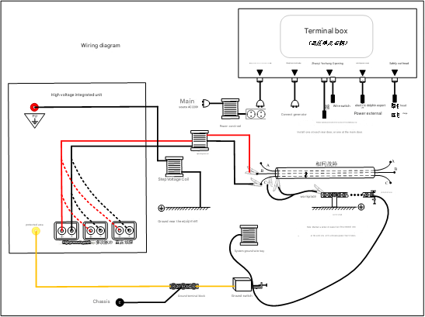
Figure 5.1 Wiring diagram of export-type vehicle-mounted intelligent cable fault location system

5.2 Low-voltage pulse method (TDR)
According to Figure 5.1 , first ground the wires, then connect them, and insert the high-voltage coil plug into the "Low-voltage pulse method/multiple pulse method" socket ④ of the high-voltage cabinet shown in Figure 3.4 .

5.2.1 Fault Detection
Press the ⑮ "Switch" button . As shown in Figure 5.2, rotate the ⑰ "Mouse" knob to switch the focus . The center display will show " Fault Setting " . Press the ⑰ "Mouse" knob button to enter the fault setting interface. Select " Low Voltage Pulse " , choose the required sampling frequency and medium, rotate the ⑰ "Mouse" knob to switch the focus to the " OK " button, and press the ⑰ "Mouse" knob to successfully set the parameters. At this time, the first-level menu interface is shown in Figure 5.3. The mouse knob should be in focus . Press the ⑰ "Mouse" knob to start the test and wait.
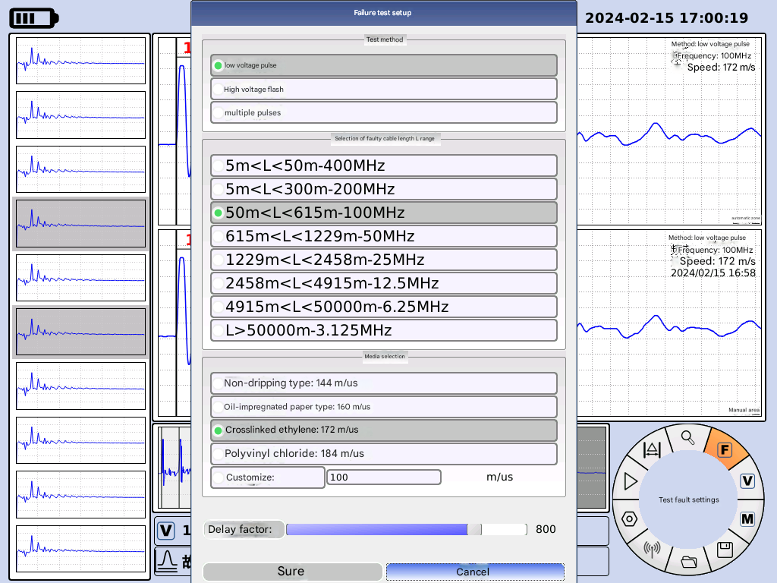 | 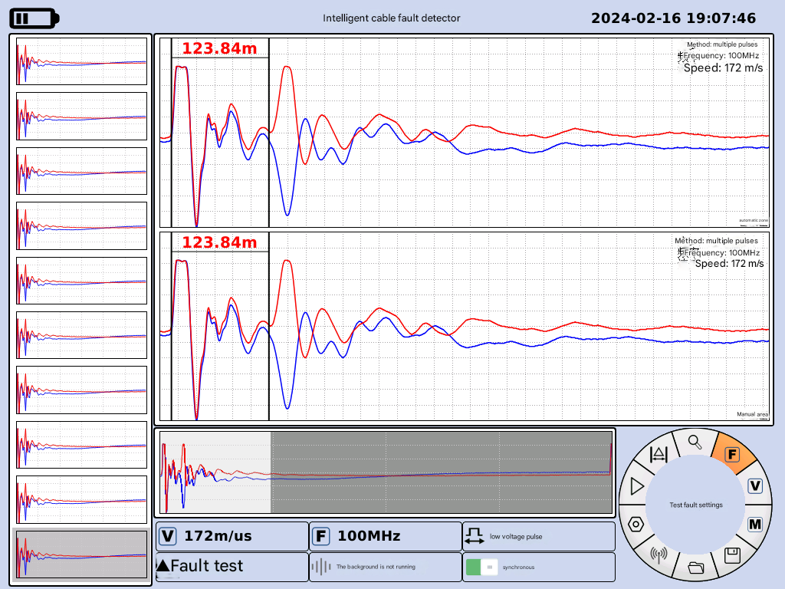
Figure 5.2 Fault setting interface | Figure 5.3 First-level menu after successful parameter setting
Figures 5.4 and 5.5 show the waveforms of open-circuit faults and short-circuit faults measured by the low-voltage pulse method, respectively.
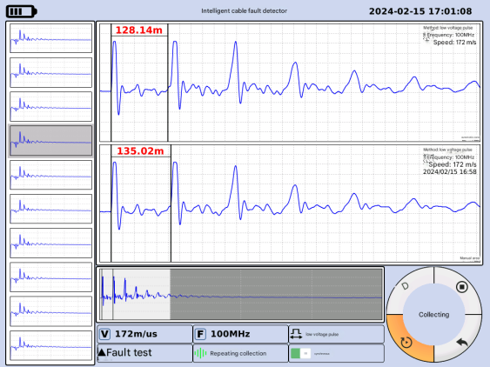 | 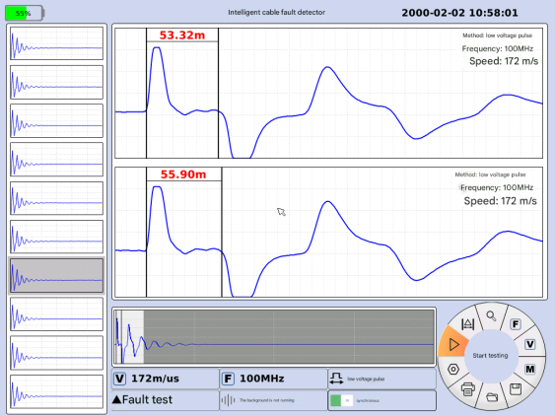
Figure 5.4 Open circuit fault waveform measured by the low-voltage pulse method | Figure 5.5 Short-circuit fault waveform measured by the low-voltage pulse method

5.2.2 Speed Measurement
Figure 5.6 , rotate the 17th "Mouse" knob to switch the focus , press the 17th "Mouse" knob to enter the speed test interface, select the cable length and sampling frequency, rotate the 17th "Mouse" knob to switch the focus to the " OK " button, and press the 17th "Mouse" knob to successfully set the parameters. After setting, rotate the 17th "Mouse" knob to the position shown in Figure 5.3 and press it to collect data . The speed measurement result shown in Figure 5.7 can be obtained.
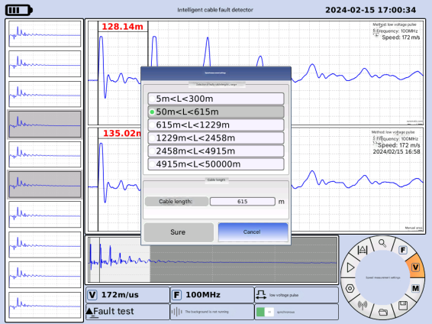 | 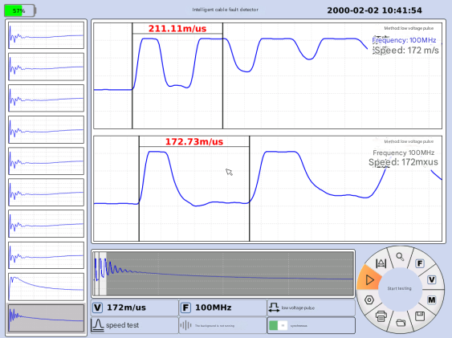
Figure 5.6 Speed Test Settings Interface | Figure 5.7 Interface after speed test completed

5.3 Multiple Pulse Method (MIM)
According to Figure 5.1 , first ground the wires, then connect the wires, and insert the high-voltage coil plug into the "Low-voltage pulse method/multiple pulse method" socket ④ of the high-voltage cabinet shown in Figure 3.4 .
Press the switch for the cable fault testing system . Rotate the "mouse" knob ( Figure 3.1 ) to switch the focus to "Fault Testing Settings," which will be displayed in the center. Press the "mouse" knob (Figure 17) to enter the fault testing settings interface. Select " Multiple Pulses , " and as shown in Figure 5.8, select the desired sampling frequency and medium. Rotate the "mouse" knob (Figure 17) to switch the focus to the "OK" button and press the knob button to successfully set the parameters. The first-level menu interface is now shown in Figure 5.9. The "mouse" knob (Figure 17) should be in focus . Press the "mouse" knob (Figure 17) to start the test and wait.
Figure 5.8 Fault setting interface | Figure 5.9 First-level menu after successful parameter setting
Then, on the high-voltage section on the right side of the control panel, first turn on switch ⑧ "Permission" , then the white indicator light of button ⑨ "Power" will illuminate. Press button ⑨ "Power" / indicator light , then the green indicator light of button ⑩ "Start" will illuminate. Press button ⑩ "Start" / indicator light and release button ⑫ "Emergency Stop" .
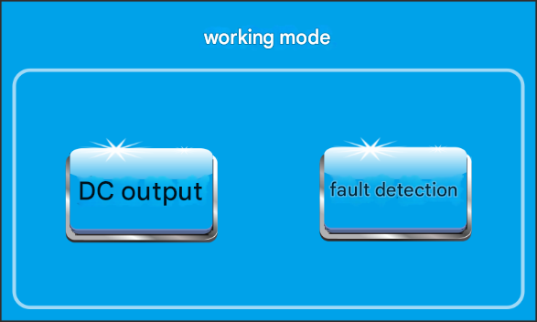
Figure 5.10 High-voltage touch control system operating mode selection interface
high-voltage touch system working mode shown in Figure 5.10 , select " Fault Detection " to enter the fault detection interface shown in Figure 5.11. Select the appropriate voltage level on the operating platform. If the corresponding voltage level on the high-voltage touch system displays a green light, it indicates that the level is in good contact. If a red light is displayed, press down on the "Voltage Level" knob ② in the operating panel shown in Figure 3.3 until the green light is displayed.
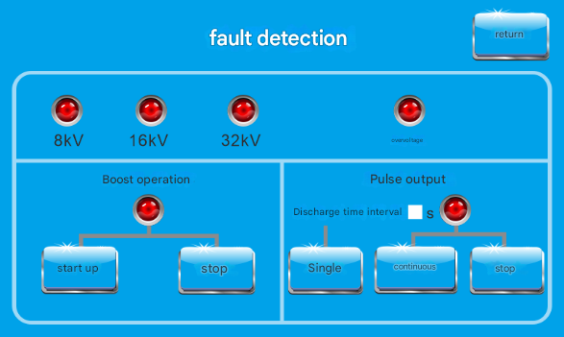 | 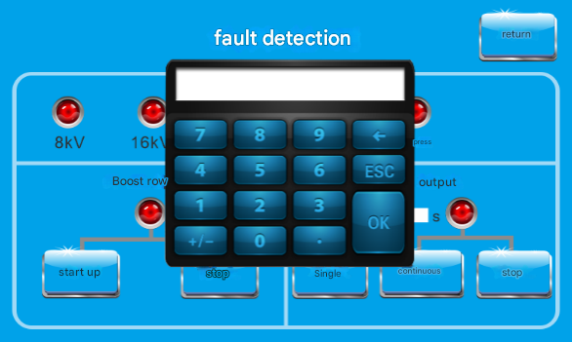
Figure 5.11 Fault Detection Interface | Figure 5.12 Time interval setting interface
exist Click " Start " under the " Boost Operation " menu . The indicator light under the "Boost Operation" menu should turn green , and the red "High Voltage" warning light on the panel should illuminate. If the indicator light and warning light do not change , please check if the "Voltage Adjustment" knob ① on the control panel shown in Figure 3.3 is in the zero position. Then, set the " Discharge Time Interval" in the " Pulse Output " menu , as shown in Figure 5.11. Then, click " Single " or " Continuous " to select single or continuous ignition .
Next, slowly rotate the “Voltage Adjustment” knob ① on the control panel shown in Figure 3.3 until the knob is adjusted to a suitable position, until a standard multi-pulse waveform appears on the main unit screen, as shown in Figure 5.14.
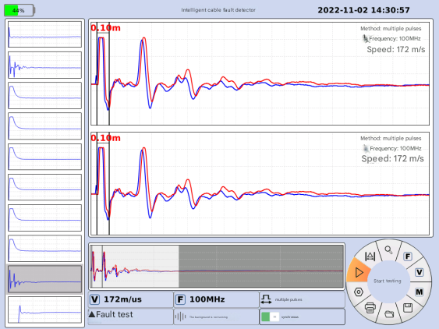
Figure 5.13 Waveforms where the fault point is not broken down by the impact high voltage or where the "delay factor" is too large. | Figure 5.14 Test waveforms of the multiple pulse method
After several consecutive standard multi-pulse waveforms, the ranging operation is complete, and the voltage increase can be stopped. If the voltage increase exceeds the selected voltage level, the " Overvoltage " indicator light in Figure 5.11 will change from green to red as a warning, and the ignition mechanism will activate to discharge for overvoltage protection. After the ranging operation is complete, quickly return the voltage regulator to zero, click the "Stop" button under the "Voltage Increase Operation" menu, then press the "Stop" button on the panel (⑪) , and then press the "Emergency Stop" button (⑫) . The device will automatically discharge. At this time, turn off the "Power" switch (①) and the "Permission" switch (⑧) . After the "Discharge" warning light on panel (③) goes out, the voltmeter pointer (⑤) will also return to zero, indicating that the discharge is complete.
【Caution】To ensure the safety of operators, the cable must be discharged again using a discharge rod! The discharge time should be no less than 5 seconds! It is recommended that the continuous working time not exceed half an hour.

5.4 Pulse Current Method (ICE)
According to Figure 5.1 , ground first, then connect the wires. Insert the high-voltage coil plug into the "Pulse Current Method" socket ③ at the output end of the high-voltage cabinet shown in Figure 3.4 . On the cable fault testing system , select " High Voltage Flashover " , select the required sampling frequency and medium , and start the test. Then, operate the high-voltage section on the right side of the control panel, following the same steps as the Multiple Pulse Method (MIM) operation in 5.3 , to obtain the pulse current method test waveform shown in Figure 5.15.
【Caution】To ensure the safety of operators, the cable must be re-discharged using a discharge rod! The discharge time should be no less than 5 seconds! It is recommended that the continuous working time not exceed half an hour.
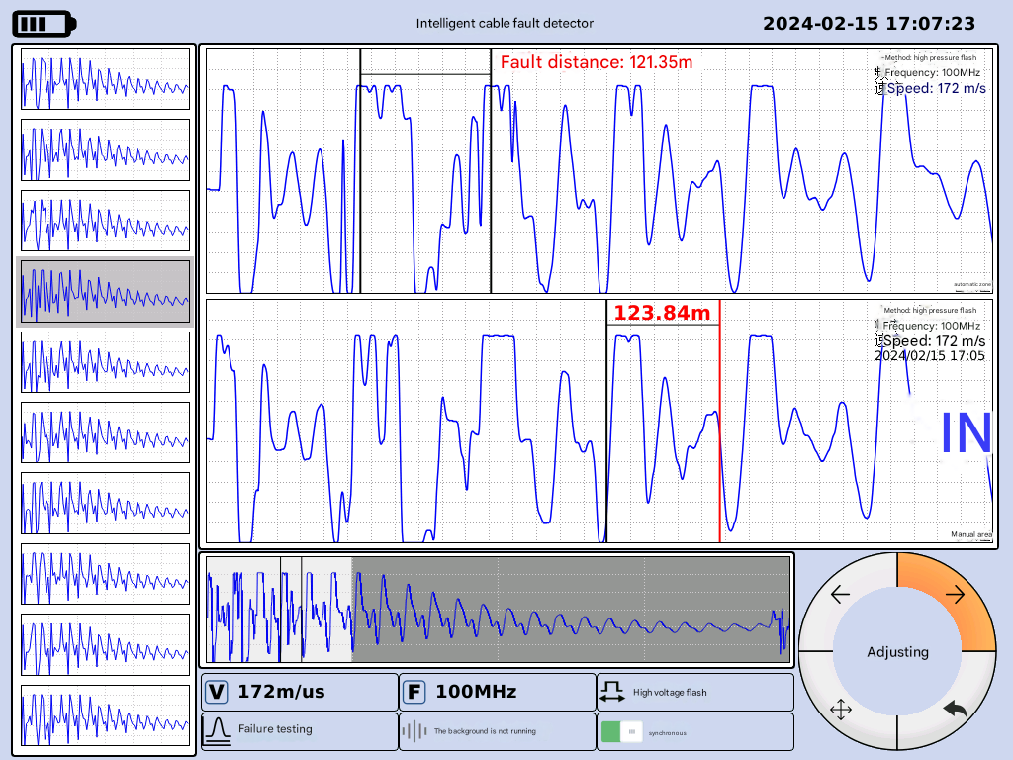
Figure 5.15 Waveforms of the pulse current method test

5.5 DC Output​
According to Figure 5.1 , ground first, then connect the wires. Insert the high-voltage coil plug into the output terminal ⑤ "DC Output" socket of the high-voltage cabinet . First, turn on the ⑧ "Permission" switch . The white indicator light of the ① "Power" switch will light up. Press the ① "Power" switch . The green ⑩ "Start" button/indicator light will light up. Then press the ⑩ "Start" button/indicator light and release the ⑫ "Emergency Stop" button .
In the high-voltage touch control system working mode shown in Figure 5.10, click " DC Output " to enter the DC output interface shown in Figure 5.16 . Click the "1mA" button or "100mA" button as needed to select the ammeter range (e.g., 1 mA range for withstand voltage testing, 100 mA range for DC burn-through). Click " Start " . The high-voltage indicator light on the panel will light up as a warning. The indicator lights on " Start " and " Stop " should turn green . If the indicator lights do not show this phenomenon, please check whether the "Voltage Adjustment" knob shown in Figure 3.3 is in the zero position. Slowly rotate the voltage regulator while observing the ammeter . At this time, pay attention to rotating the "Voltage Adjustment" knob on the control panel ①. Do not exceed the maximum current of 100mA. Be prepared to reduce the voltage and shut down the machine to discharge at any time according to the site conditions. When the current exceeds 100mA, the " Over A" indicator light will change from green to red, and the voltage regulator input will be immediately cut off to provide overcurrent protection . Do not exceed the maximum power of 1500W . When the power is overloaded, the " Over V " indicator light will change from green to red, and the voltage regulator input will be immediately cut off to provide overcurrent protection .
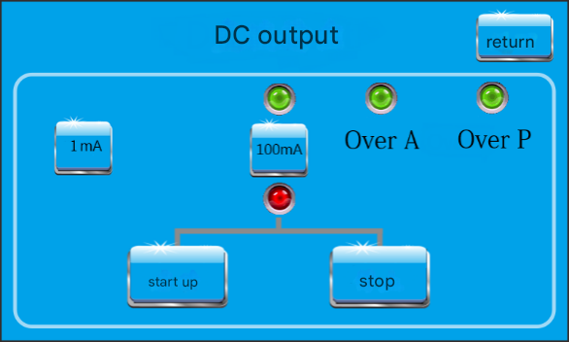
Figure 5.16 DC output interface
After the DC output is complete, return the ① "Voltage Adjustment" knob to zero on the control panel shown in Figure 3.3. The ⑥ ammeter pointer will also return to zero, stopping the DC output. Click the "Stop" button on the DC output interface shown in Figure 5.16 , then press the ⑪ "Stop" button on the panel , then press the ⑫ "Emergency Stop" button , and then turn off the ① "Power" switch and the ⑧ "Permission" switch .
[Note] It is recommended that continuous working time not exceed half an hour.

5.6 Precise location
environment in which power cables are laid makes accurate fault location a crucial step in cable fault testing. Even with accurate coarse distance measurements , rapid and accurate location is difficult due to external environmental influences. This paper describes a solution that combines an ultra- quiet, visual, noise-reducing, and path-indicating precision point locator with a high-voltage impulse generator. This utilizes the time difference between the magnetic field signal and the sound signal generated by the impulse discharge at the cable fault point to pinpoint the exact location . Simultaneously , it employs intelligent background noise reduction and sound tracking technologies to achieve continuous optimization and perfect sound effects. By listening to the discharge sound through headphones , the system combines precise point location with path indication, ensuring rapid location.

5.6.1 Buttons and Ports on the Receiver Main Unit
The diagram below shows the control buttons on the geomembrane receiver. Please connect the components as shown in the table :
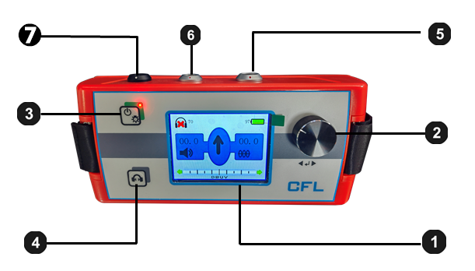
Figure 5.17 Buttons and ports on the receiver main unit
element | Function Description
❶ | LCD monitor
❷ | One-click adjustment key
❸ | Receiver main unit power on / off ( press and hold for 3 seconds ) Backlight on / off ( press briefly )
❹ | Dumb sound on / off
5 | Connect the socket and connect the sensor.
6 | Connect the socket and plug in the headphones.
7 | Charger connector

5.6.2 On-site installation and operation of the positioning instrument

5.6.2.1 Preparation of the Positioning Instrument Sensor
Connect the sensor to the appropriate probe or probe . The positioning sensor can connect to two different probes or probes; the standard configuration includes one 18mm long hard ground probe and one 75mm long grass probe. These probes and probes can be screwed on to suit various ground cover conditions .
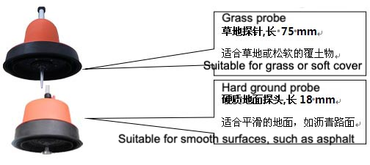
Figure 5.18 Probe and probe
The image below shows how to connect the adjustable handle to the sensor:
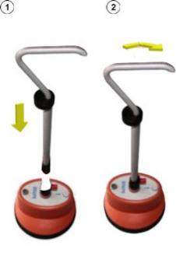
Figure 5.19 Method for connecting the adjustable handle to the sensor
The image below shows how to adjust the handle height:
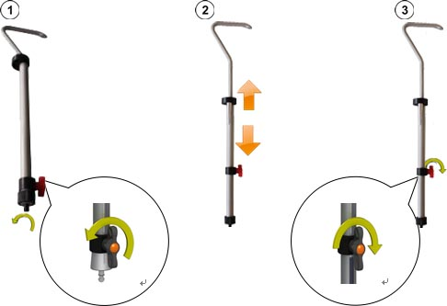
Figure 5.20 Handle height adjustment method

5.6.2.2 Connect the sensor, earphone, and receiver host.
The image below shows how to connect the headphones to the black socket on the receiver unit. Please align the white markings on the plug and socket. This plug is plug-and-play; do not rotate it!
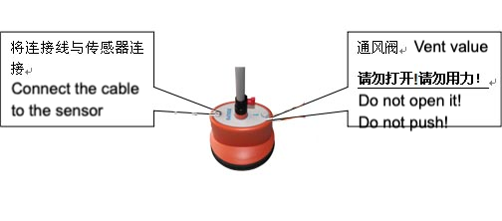
Figure 5.21 shows the black socket for connecting the headphones to the receiver main unit.

5.6.2.3 Powering on the receiver host
Press the power on/off button on the receiver main unit. 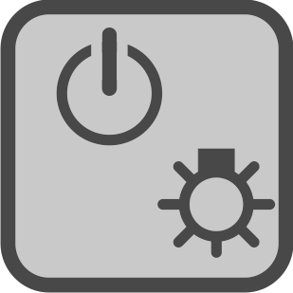 Then, the main unit can be turned on or off. After a few seconds, the receiver main unit will be ready for use, and the measurement interface will be displayed.

5.6.2.4 Battery power self-test
After powering on, please check the upper right corner of the screen to see the remaining power of the lithium-ion rechargeable battery. If you find the battery percentage is close to 25%, please charge it until it is above 50% before using it.

5.6.2.5 Backlight Selection
The backlight function of the positioning instrument is automatically activated upon power-on. The instrument features a TFT ultra-high brightness LCD display. When operating in bright sunlight, briefly press the backlight button to turn off the backlight. This extends the continuous operating time of the receiver in the field. The backlight can be restored at any time by briefly pressing the backlight button again.

5.6.2.6 One-button adjustment knob for the positioning instrument
Aside from a few key functions, the receiver main unit is primarily adjusted using a one-button control . Please refer to the table below for instructions on using the one- button control :
gesture | Measurement interface functions | Menu interface functions
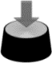 | Open the menu interface | Open the currently selected menu unit
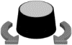 | Adjust the volume (sound amplification factor). | Select menu unit

5.6.3 Interface Introduction

5.6.3.1 Menu Structure
You can set the positioning instrument to the measurement interface at any time. With menu interface Switching between them and changing any setting requires a maximum of two steps:
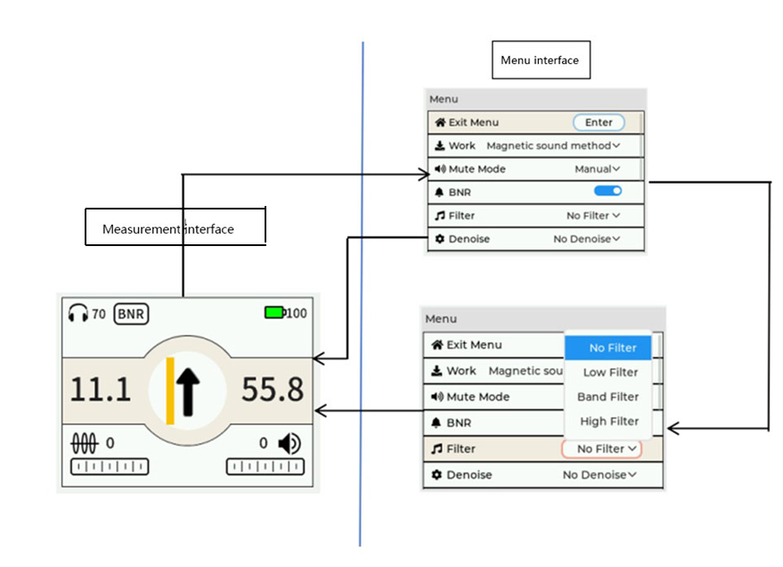
Figure 5.22 Menu Structure

5.6.3.2 Menu interface arrangement
Each Menu interface They are all composed of the following:
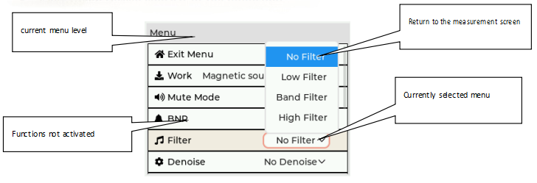
Figure 5.23 Menu Interface

5.6.3.3 Display of the Measurement Interface
displays all potentially useful relevant information through the measurement interface as you approach the fault point during precise locating .

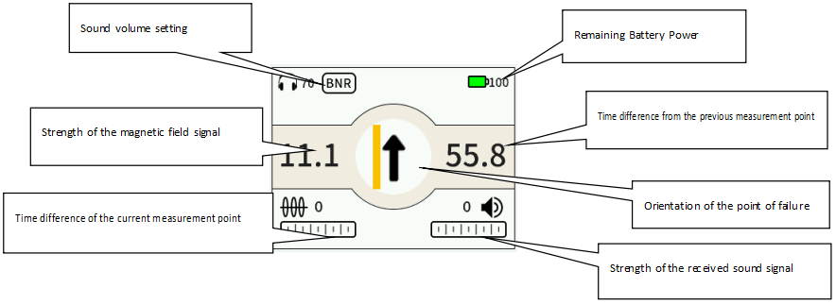
Figure 5.24 Measurement Interface

5.6.4 Applying high-pressure impact
When performing precise location, it is necessary to apply a high-voltage impulse to the faulty cable. When using a cable fault location instrument for precise location, the high-voltage touch control system on the vehicle-mounted panel can be operated to generate a high-voltage impulse.
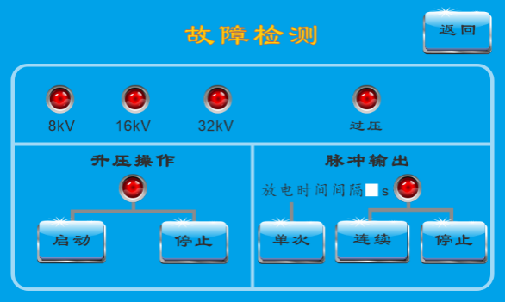
Figure 5.25 Fault Detection Interface
In the high-voltage touch system working mode shown in Figure 5.25 , select "Fault Detection" to enter the fault detection interface shown in Figure 5.17 . Select the appropriate voltage level on the operating platform . If the corresponding voltage level on the high -voltage touch system displays a green light, it indicates that the level is in good contact. If it displays a red light, press down on the "Voltage Level" knob in Figure 3.3 until the green light is displayed.
Under the " Boost Operation " menu , click " Start " . The indicator light under the " Boost Operation " menu should turn green, and the red "High Voltage" warning light on the panel should illuminate. If the indicator light and warning light do not change, check if the "Voltage Adjustment " knob ① on the control panel shown in Figure 3.3 is in the zero position. Then, set the " Discharge Time Interval" in the " Pulse Output " menu , and then click " Single " or " Continuous " to select single or continuous ignition. This will generate a high-voltage surge, which, when used with a cable fault locator, can be used for precise fault location.

5.6.5 Location of the cable path under test
When the area you need to pinpoint is small, you usually need to use a locator to find the centerline of the faulty cable and begin pinpointing the fault. Always keep the arrow on the probe housing pointing towards the far end of the cable being tested. Move the probe left and right, observing the yellow mark on the receiver display. When the yellow mark and the black arrow consistently overlap, it means the probe is directly above the cable's centerline, ensuring accurate pinpointing.

5.6.6 Precise Pointing Timing Adjustment Settings
When you press the single button on the positioning instrument, the operator can remove the positioning instrument from the measurement interface at any time. Switch to menu interface In the menu interface, you can make the following most important measurement settings:
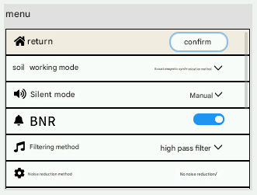
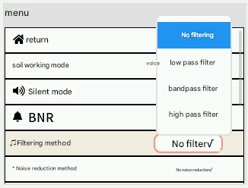 | 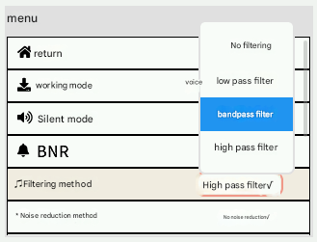
Figure 5.26 Settings Adjustment

Under this menu, you can make the following measurement settings:
Menu unit | Function Description
Turn the fully automatic mute function on/off | the headphones will automatically mute when the operator is about to touch the positioning device handle. This function effectively protects the operator from external noise when moving the probe.
BNR | Enable / disable Background Digital Noise Reduction (BNR) .  Background noise reduction (BNR) technology is used to simplify accurate positioning of the locator when there is a lot of noise in the surrounding environment. Without BNR , it is usually impossible to identify the target sound signal of the impulse discharge in the background noise, such as when a train or car is passing by. Such sound interference makes accurate positioning of impulse discharge very difficult.
Filtering | Filtering settings ( see the next page for details ) .

5.6.7 Precise Timing Filter Settings
The sound of a fault point impact discharge has its own unique, varying timbre. The propagation of the discharge sound signal is greatly affected by the surrounding soil covering the sound wave along its path. The speed of sound propagation and the distance from the sound source will affect the frequency of the sound wave received by the locator sensor. The faster the sound wave propagates and the smaller the distance from the sound source, the less attenuation of the high-frequency sound wave signal.
This means that in actual field conditions, sound waves travel quickly through hard coverings (such as under rocks or slabs of stone), and we can expect to hear a high-pitched impact discharge sound in the headphones. Under these conditions, please use a high-pass filter to reduce low-frequency signals, which will result in a more ideal and effective localization process.
On the other hand, high-frequency discharge sound signals are significantly attenuated on sand or soft soil, especially when the sensor is far from the actual fault point. For such environments, we recommend using a low-pass filter to remove high-frequency signals. Furthermore, the contact between the ground-penetrating microphone and the soil medium through which the sound waves travel affects the characteristics of the discharge sound you hear. This principle of sound wave frequency behavior also applies to the propagation principle of unwanted noise. The noise you hear is also affected by the structure of the sound wave propagation path.
In actual operation, depending on the on-site working environment, you can switch to the menu interface by pressing a single key on the measurement interface .
You can choose one of the following filter settings.
Figure 5.27 Filter settings
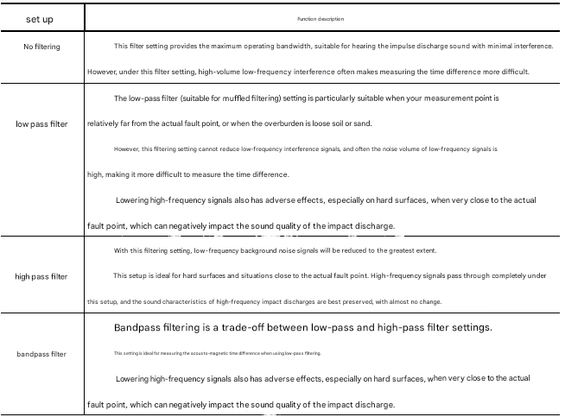

5.6.8 How to accurately locate points in an environment affected by background digital noise reduction (BNR)
When Background Noise Reduction (BNR) is enabled, it automatically collects and analyzes combined information from noise signals and target characteristic signals. Upon receiving the first impulse discharge signal from the fault point, the audio characteristics of this signal are used for automatic background noise filtering. The locator then continues to collect each impulse signal, further improving the effectiveness of BNR. With BNR enabled, the longer the operator stays at the measurement point, the less external interference the locator experiences.
The current status of background noise reduction for the positioning instrument can be viewed on the LCD screen above the main unit. It is recommended that you enable the BNR digital background noise reduction function in the instrument's "Settings".
The following diagram illustrates how the locator indicates the direction of movement ( including the acousto-magnetic time difference / direction arrow ) as the operator gradually approaches and moves away from the actual cable fault point from left to right :
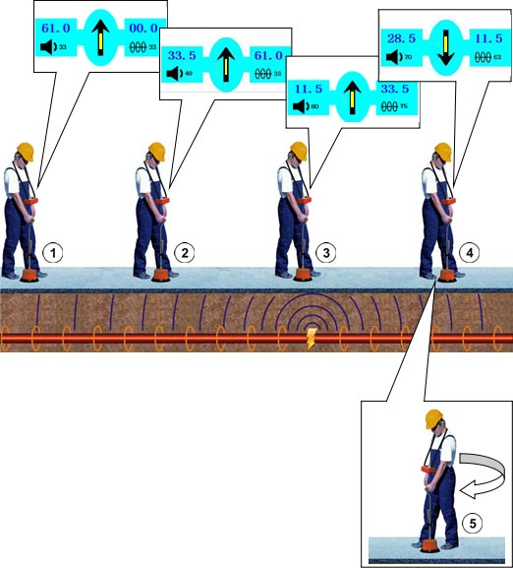
Figure 5.28 Observe the direction of the arrow

5.6.9 Precise Pointing Operation Procedure
When you are near the point of failure, please follow these steps in sequence:
step | action
1 | Please place the ground-penetrating microphone of the geostationary instrument in the starting position.
2 | If the locator cannot pick up any sound signal at the measurement point (the received magnetic field strength is relatively weak), please follow the path of the cable being tested until you see this trigger signal .  Please continuously observe the magnitude of the magnetic field signal pulse. This value and the bar graph indicate the position of the center axis of the faulty cable under test. If necessary, please correct your perception of the center axis position of the cable under test.  When you detect that the locator has received the first useful impulse discharge sound signal, the acoustic-magnetic time difference of that measurement point will be automatically displayed on the left side of the LCD screen of the locator main unit.  If you are in a long area and cannot pick up the impact discharge sound signal using a ground-penetrating microphone or headphones, you should try to pinpoint the location precisely in the opposite direction from the starting point.
3 | Please stay at the measurement point for a period of time ( 1-2 minutes) to receive several impact discharge pulses, which will activate the BNR digital noise reduction function to improve the accuracy of precise positioning.
4 | Continue along the path of the cable under test, moving one step at a time, adjusting your perceived centerline position as necessary. At each measurement point, pause for several impulse discharge pulse signals .  As you approach the cable fault point, the current measurement point time difference (distance from the fault point) value displayed by the locator will continuously decrease, at which point you will see a forward arrow. (That is: , please refer to Figure 5.28 )  and ) ；  Once you have passed the actual fault point, the acousto-magnetic time difference (distance from the fault point) will suddenly increase again. The arrow on the locator main unit will automatically indicate a turnaround (i.e.: Please refer to the location in Figure 5.28. ).
5 | Please rotate the geophone of the geostationary probe 180° ( see the position in Figure 5.28) .  ) , and then approach the fault point again with a smaller step size.
6 | Continue to reduce the step size to find the minimum time difference, pinpointing the location of the fault as accurately as possible. Then, make a precise mark on the ground.

5.6.10 Practical experience, tips and suggestions
If you are unsure whether the received sound signal is the sound of a shock discharge or simply repetitive background noise, it is recommended that you lift the ground-penetrating microphone of the positioning device and then lower it again to "reset" the background digital noise reduction function. If you subsequently find that the positioning device can repeatedly detect a similar sound after the magnetic field triggering process, this is very likely the sound signal of a shock discharge.
"Knocking sound" is the sound produced when a cable impacts a protective conduit or other nearby cables during a faulty discharge. It may occur during precise fault location of a cable running through a conduit. This interference noise propagates from the contact point between the protective conduit wall and the surrounding soil at the fault point to the ground surface, and can be a source of error in precise fault location.
You need to know that the fault point at this time is a "phantom fault point." You can identify it by the magnetic field strength signal indication of the locator: if it is a phantom fault point, the magnetic field strength indication will not change at all when passing the fault point and beyond. However, after the locator passes the real fault point, the magnetic field strength of the locator will drop rapidly.
Sometimes the path of the cable under test crosses other cables, and there may be a fault point advance arrow indicating the crossing cable. This could cause the operator to pinpoint the fault on the wrong cable. Therefore, we recommend that you locate the path of the cable under test before performing precise fault location, and mark the ground at the location measurement point, especially in areas where multiple cables are buried together.

5.6.11 Powering off the positioning instrument
Please press and hold the main unit of the positioning instrument . Power on/off knob.
Note: This instrument is for use only by trained and qualified professional electrical personnel. All other personnel should keep away from this instrument.
This instrument may only be used by authorized electrical professionals. Electrical professionals refer to personnel who hold a high-voltage electrician's license or higher issued by the State Electricity Regulatory Commission, and who have sufficient professional knowledge, work experience, and familiarity with various safety regulations.
Faults or damages caused by user-initiated repairs or disassemblies are not covered under warranty.

5.7 Problems and Solutions
If the wiring and operation are correct, the following may be the reason why the cause of the fault cannot be found and the solution:
■ A large amount of water enters the cable joint—at this time, it is not easy to obtain the pre-positioned test waveform, and it is not easy to dry the water by using the "burning arc" method . You can also try the pulse current method several times.
■ Untreated cable ends – If the cable ends are connected to loads or equipment such as surge arresters, CTs, and PTs, care should be taken to remove any equipment that may affect the measurement results, while also preventing potential damage to other equipment.
■ High-voltage cable fault finding without restored shielding cross-connection — When the test vehicle is used for fault finding of high-voltage cables (66kV and above), the shielding cross-connection of the high-voltage cable must be restored, otherwise the reflected waveform cannot be obtained.
■ Unable to accurately locate the fault point — This may be because the impact discharge energy selected during accurate location is too small. Please pay attention to selecting an appropriate test voltage.
■ Incorrect parameter settings—such as incorrect test voltage, length test range, gain range, etc. Please read the instruction manual carefully or contact our technical staff.
- Configuration List
Serial Number | Instrument Name | quantity | unit | Remark
1 | Vehicle-mounted cable fault  Integrated Testing System | 1 | tower | Built-in fault location, high-voltage power supply, DC burn-through protection, video surveillance, isolation transformer, and safety monitoring modules.
2 | Mobile surveillance video head | 1 | indivual | Used for on- site monitoring of test sites
3 | Roof-mounted surveillance video camera | 1 | indivual | Used for security monitoring behind car doors
4 | Cable reel | 1 | tower | Includes 50 meters of high-voltage cable, 50 meters of grounding cable, 50 meters of power supply cable, and 15 meters of step voltage grounding wire.
5 | grounding rod | 2 | branch | Field grounding
6 | Precision positioning instrument | 1 | set | Precise location of the fault
7 | Instruction Manual | 1 | Book
- Transportation And Storage

7.1 Transportation Precautions
The instrument has undergone the corresponding temperature, humidity, vibration, and shock tests as specified in Group II of GB6587.1. However, please handle it with care during transportation, protect it from sunlight and moisture, and avoid violent impacts.

7.2 Storage conditions, storage period and precautions
To facilitate instrument maintenance and use, please note the following environmental requirements.
- Storage temperature: -40℃～+50℃
- Relative humidity: 40℃ (20～90) %RH
- Atmospheric pressure: (86～106) kPa
When not in use, this instrument should be kept in its original packaging in a well-ventilated and dry environment, free from gases that could cause corrosion. There should be no severe mechanical vibration or impact, and no strong electromagnetic fields around the instrument.
- Unpacking Inspection And Maintenance

8.1 Unpacking and Inspection
Before opening the box for the first time, please follow these steps to perform an unpacking inspection.
  - After unpacking the paper, take out the document bag from the attached bag and look for the instruction manual and packing list.
  - Check against the packing list to ensure all accessories are complete and undamaged.
  - Check if the serial numbers on the packaging box, instrument nameplate, and warranty card match.
  - Upon powering on, check whether the buttons, knobs, and indicator lights on the panel shown in Figure 3.1 are functioning properly. Also check whether the cable fault test system (⑬) and high-voltage touch control system (⑦) shown in Figure 3.1 are working correctly.

8.2 Maintenance
If the instrument malfunction cannot be easily resolved, please do not attempt to repair it yourself, as this may worsen the problem. Please contact the company promptly, and we will be happy to assist you.
Table 8.1 Fault Phenomena and Troubleshooting
Fault phenomenon | Cause Analysis | Elimination methods | Remark
the cable fault test system (⑬) in panel 3.1 is opened , no display is shown on the screen. | The system failed to start normally. | Check if the "Power" switch on panel ① is turned on, then press the "Power" button on panel ⑮ to turn the device back on.
crash | The instrument was subjected to strong interference. | After a system crash, power off and then power on again. During multiple pulse or pulse current ranging operations, do not touch the instrument during the instant of high-voltage discharge to avoid strong electrical interference.

