HZ-4000D
Underground Pipeline Detector

USER MANUAL

Huazheng Electric Manufacturing (Baoding) Co., Ltd
Contents

I.General Safety And Maintenance 1
II.Instrument Features 2
III. Pipeline Detector Components And Structural Functions 4
IV. Technical Parameters 14
V.Check The Instrument Before The Measurement 15
VI. Pipeline Detection Method 17
VII. On-Site Detection Of The General Procedure 38
VIII. Commonly Used Pipeline Detection Techniques 41
IX. Fault Location (Functions Of Optional A-Frame) 45
X. Accessories And Optional Accessories 47
XI. Technical Terms 48

I.General Safety And Maintenance
  - Qualifications for equipment operators
    - Operators must receive professional training on instrument application before use.
  - Safety of on-site operation
    - When using the equipment, the company's safety regulations or other applicable safety regulations shall be strictly followed.
    - Do not connect the transmitter with unknown conductor without authorization.
    - Before connecting the conductor and transmitter, confirm that the grounding rod is firmly grounded.
    - After the transmitter is turned on, it is not allowed to contact any non-insulated part of the connecting lead, grounding rod or clamp.
    - Do not open the enclosure of the transmitter or receiver without authorization.
    - Do not contact corrosive or dangerous chemicals, gases or dust, and do not use in flammable and explosive environment.
  - Battery and charging
    - The instrument is in discharging state, please charge it before use.
    - When charging the battery, it shall not be close to open fire and high temperature source, exposed to the sun, or inverted. The charger and battery should be kept away from the bedroom and inflammables, and the charger should be placed in a place where it is easy to dissipate heat and kept dry.
    - After being fully charged, unplug the charger power supply in time to avoid the high temperature of the battery pack caused by overnight charging, and charge continuously for no more than 8 hours to prevent the diaphragm from being damaged and short-circuited due to overcharging. It is forbidden to charge for a long time without supervision at night, and the violator shall be responsible for the consequences!
    - The battery charger provided by the company shall be used for charging, and other off-label chargers that do not meet the specifications, or unsuitable fast chargers shall not be used, which will affect the service life of the battery itself.
    - Warning: This instrument is prohibited to be used in flammable and explosive environments and is prohibited to be used in rainy environments.
  - Equipment maintenance
    - Use the equipment in strict accordance with the instructions of this manual.
    - Store in a dry place and avoid high temperature.
    - Do not immerse any part of the equipment in water.
  - Precautions for use
    - The equipment uses the electromagnetic signal coupled with the underground pipeline to locate the pipeline, and gives the measured values of depth and current to realize its positioning function. In most cases, the pipeline magnetic field signal is sufficient to enable the equipment to correctly detect the exact location, depth and current of the underground pipeline.
    - Please note that interference factors in some special occasions may cause distortion of the magnetic field emitted by the cable or pipeline to be located, which may lead to deviation or even error of the detected data.
    - During the detection process, please analyze the data displayed by the receiver according to the correct operation method mastered in the training.
    - Please note that the depth detected by the instrument refers to the depth of the center of the electromagnetic field, that is, the buried depth of the center of the pipeline, which is greater than the buried depth of the pipe top.
  - After-sales service
    - When you need product support services, please provide the model and serial number of the transmitter and receiver.
    - Model and serial number of transmitter: located under the transmitter handle.
      - Model and serial number of receiver: located inside the receiver handle.
      - The operation and function of equipment with different models and configurations are different. Some contents in this manual are limited to individual models.

II.Instrument Features
  - Multi-function
    - Transmitter function: it has three signal application modes: induction method, direct method and clamp method, which are suitable for different occasions.
    - Receiver function: it is used to measure the position, direction, buried depth and current in underground pipes and cables.
    - The left and right positioning arrows indicate the position of the target pipeline, and the positioning is fast and accurate; The front and back arrows and dB values indicate the location and size of the damaged point of the anticorrosive coating.
    - Special function of the receiver (optional A-frame): used for fault location (pipeline fault refers to the damage of the outer protective coating, cable fault refers to the damage of the outer protective coating) and detection of the insulation damage of the underground pipeline.
    - Current measurement: measure the current applied by the transmitter to the pipeline under test.
    - Multimeter function: can measure output voltage, line voltage, line current, impedance and power. Test the continuity and insulation quality of the cable before and after the cable fault finding.
    - External inductive clamp: suitable for places where the signal cannot be directly connected when detecting cables.
  - High positioning accuracy
    - A variety of measurement modes for pipeline positioning (valley mode, peak mode, broad peak mode, peak arrow mode), can verify each other to ensure the accuracy of pipeline positioning.
    - Maximum value method: Peak mode, broad peak mode, peak arrow mode
    - can be used to determine the horizontal component ( H X ) or horizontal gradient ( H X )changes, according to its maximum position to locate;
    - Minimal method: the use of the valley model, by measuring the vertical component ( HZ )changes, according to its minimum position to locate.
  - Multi-Measuring depth method
    - With a variety of sounding methods can be arbitrarily optional, and can verify each other.
    - Double - level coil direct reading method;
    - Single - level coil 80% method, 50% method;
    - 45 degree method.
  - Strong anti-interference
    - Observed parameters: both measured horizontal component ( H X ), vertical component ( HZ ) and can measure the level gradient (H X).
    - Transmit power: the transmitter output power of 10W and continuously adjustable, according to the need to choose.
    - Working frequency:
Transmitter frequency:128Hz、512Hz、1KHz、2KHz、8KHz、33KHz、65KHz、83KHz。
Receiver frequency:radio、50Hz、100Hz、128Hz、512Hz、1KHz、2KHz、8KHz、33KHz、65KHz、83KHz。
According to the target pipeline characteristics (material, structure, depth, length, etc.), the environment to select the appropriate operating frequency.
  - Easy to operate
    - Intuitive: the use of graphical display, can continue, real-time display of various parameters and signal strength detection process.
    - Auto: Automatically switches to dual-level antenna mode when measuring depth and automatically adjusts the receiver sensitivity to optimize the measurement signal and automatically recovers to the pre-sounding mode.
  - Continuous working time is long, the use of low cost
    - The transmitter is equipped with a large capacity lithium battery pack, a charge, to meet the field to detect a working day power supply needs, and can be recycled, greatly reducing the detection costs.
  - Transmitter AC and DC
    - Under normal circumstances, if the transmitter battery is sufficient, use the instrument built-in battery pack power supply. If you use the process, the transmitter battery power is low, but the detection task is not completed, you can directly external dedicated power adapter, the instrument can be used normally, without having to wait for the instrument to re-use.

III. Pipeline Detector Components And Structural Functions
  - Receiver
    - It is used for the measurement of underground pipelines, cable positioning, buried depth of underground pipelines, and tube current measurements. A variety of frequency and mode of operation to meet a variety of environments and a variety of pipeline detection needs.
    - Key function
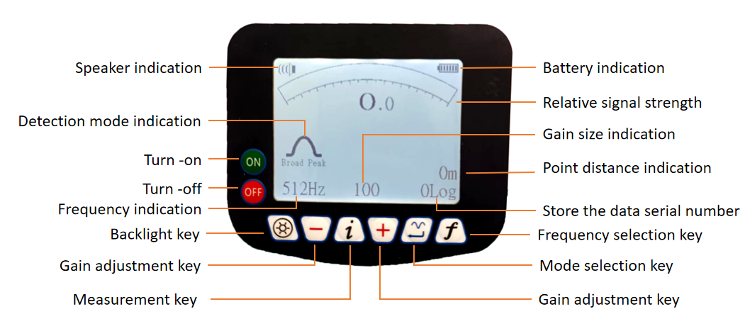
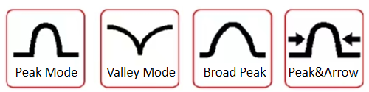
      - Turn-on or off key：When the receiver is turned on, the receiver automatically shuts down if no function key is pressed during the set auto power off time. If any function key is pressed, the receiver will reset the shutdown time.
      - Frequency selection key: Select the corresponding detection frequency according to the frequency of the transmitter. The frequency of choice includes radio、50Hz、100Hz、128Hz、512Hz、1KHz、2KHz、8KHz、33KHz、65KHz、83KHz。Instrument models are different, the frequency configuration is not the same, the specific frequency according to the manufacturer's product specifications to determine.
      - Mode selection key：It is used to select the receiver's operating mode for precise positioning of the pipeline. The positioning process is usually measured by the peak method. Mapping modes include：Valley pattern Peak mode Board mode Peak&Arrow mode.Power mode: 50Hz power cable can be detected When there is an external A-frame, you can also select the external signal mode.
      - Gain adjustment key:often press “+”or“-”3 seconds to start the automatic gain function,At this point the gain number becomes a flashing cursor (as shown on), the instrument automatically adjusts the signal strength to about 70% of full scale. During normal measurement, the signal strength should also be about 70% of the full scale.

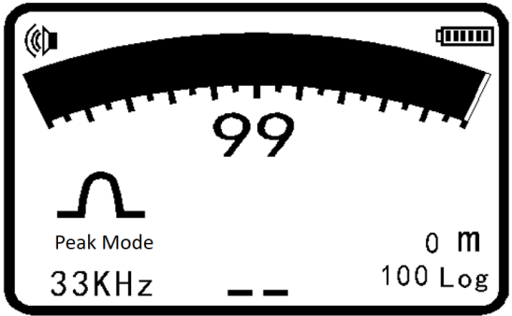

      - Measure depth / current key:It is used to measure the depth of the measured pipeline buried depth, while measuring the depth of the target in the display of the current value of the pipeline。In the current measurement process, regardless of the original use of which positioning mode, the system automatically switch to the peak mode.
        - The depth measurement unit can be selected from the menu by metric or imperial.
        - Metric Units: cm , when the depth of the pipeline is less than 1 mete.
        - When the pipeline buried depth is greater than 1 meter, the depth display unit is m.
        - Inch unit: feet.
        - Current unit: When the current is greater than 1A, the display current unit is A, when the current is less than 1A, the display current unit is mA.
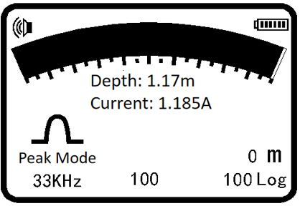

        - Note:
- In order to measure the exact depth of the buried value, the receiver must be kept in a position perpendicular to the pipe.
- In order to improve the accuracy of the depth measurement, it is advisable not to proceed in the valley mode during sounding. It is recommended to switch to the wide-peak mode for pipeline depth measurement.
      - Backlight :The backlight maintains the preset backlight duration, which can be set through the backlight menu.
      - Data storage:
        - Storage method: when the interface displays the buried depth and current value of the pipeline, press the "+" key, the data storage serial number will automatically increase by 1, and the storage is successful. If storage is not required, press the buried depth measurement key again to restore the pipeline positioning status.
        - Store the data browsing:press the “i” key and“+”key for 3 seconds, enter the storage data browsing interface, including: frequency, serial number, dot pitch,depth, current and so on. Data browsing can be done by pressing the“+”or“-”keys.Press the key again to exit the data view mode. If you do not press any key, it will automatically resume the pipeline positioning status after 20 seconds.
        - If the stored measurements can be overwritten,such as the data has been stored at 10 groups, but found or suspected third group of data problems,as long as the return to the third group of data measurement points, re-measurement of the depth of current,press the“+”or“-”key to select the data number 3 to be overwritten, then press the key to store the depth and current and overwrite the original group 3 data.
        - Note: Only 1000 data of the same frequency can be saved. After switching the different detection frequencies, if you need to store the data, you must delete the data of the different frequencies that have been stored before storing the new frequency data.
        - Example: the instrument has been stored 128Hz data 100 groups, and now change the measurement frequency of 512Hz, need to store 512Hz data, the measurement is completed, press the key storage, the prompt "128Hz has been stored 100 data, whether to delete" If you need to delete the key after 5 seconds to delete, re-store 512Hz data.
    - Receiver display window
      - Battery indication：When the battery is worn to the point where it can no longer work, the battery symbol flashes, and it needs to be charged. High-performance lithium battery pack is used in the machine. Generally, it can work normally for more than 10 hours with sufficient power. When charging, one end of the charger is connected to the charging jack, and the other end is connected to the 220V power supply. The indicator light of the charger is red, and the charging indicator light turns green when it is sufficient.
      - Point distance indication(Option)：When the GPS is successfully connected and the satellite signal is received, the detection data saves the distance between the two measuring points and displays it in real time.(GPS module is not selected, and the point distance displays 0m).
      - Speaker indication：The speaker indicator indicates the level of the speaker sound, the sound is divided into high, medium, low, off, when the speaker sound is off, the speaker indicator is not displayed, the speaker volume through the corresponding menu settings.
      - Left / right arrows:When the valley mode or peak arrow mode is used for detection, the left and right arrows indicate that the pipeline position can be quickly tracked. When the instrument deviates from the left side of the pipeline, the right arrow points to the pipeline position (Figure 1). When the instrument deviates from the right side of the pipeline, the left arrow points to the pipeline position (Figure 2). When the instrument is directly above the pipeline, the left and right arrows flash to the pipeline position (Figure 3).
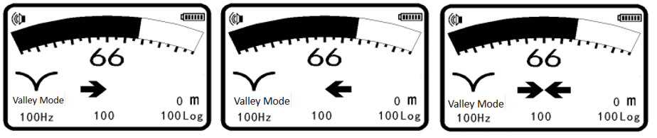Figure 1 Figure 2 Figure 3
      - A-frame (optional accessories): It can be used to detect the damage point of the anticorrosive coating and display the dB value of the damage point.After the receiver is connected to the A-frame, it needs to switch the detection mode to the external signal mode before starting work.
      - Anti-layer damage point indicator arrow:When detecting the anticorrosive coating damage point or cable fault point, use the arrow to indicate the location of the anticorrosive coating. When the A-frame is behind the fault point, the forward arrow indication (Figure 1) indicates that the fault point is in front of the A-frame. When the A-frame is in front of the fault point, the backward arrow indication (Figure 2) indicates that the fault point is behind the A-frame. When the A-frame is directly above the fault point, the front and rear arrows flash to point to the fault point (Figure 3)。
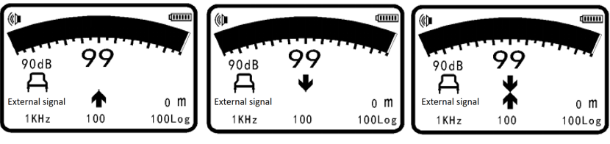
Figure 1 Figure 2 Figure 3
      - Other positioning methods:Detection of power line 50Hz signal, CPS signal (cathodic protection current signal), radio signal detection.
    - Receiver parameter settings
      - Adopt menu mode, fast and convenient.
        - Method of entering the menu: Press and hold the buried depth measurement key for 3 seconds to enter the menu setting interface. The menu is displayed in two pages, with the interface and settable parameters shown in the following figure:
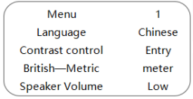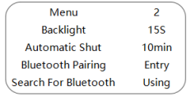
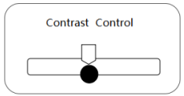

        - Sub menu settings:Before setting, it is necessary to adjust the cursor to the corresponding submenu. Press the”+”or ”-” key to move the cursor or adjust the contrast;The Enter determine key can use to enter the secondary submenu; The measurement key can be used to return to the main menu from the secondary submenu.

NO | Menu | Operation keys | Operation interface | Corresponding parameters
1 | Language |  | Main Menu | Chinese, English
2 | Contrast control |  | Sub menu | Increase，decrease
3 | British—Metric |  | Main Menu | Meter,Feet
4 | Speaker Volume |  | Main Menu | High, Middle, Low, Close
5 | Backlight |  | Main Menu | 5S, 15S, 30S, 1m，On, Off
6 | Automatic Shut |  | Main Menu | 30min, 10min, 5min, Never
7 | Bluetooth Pairing |  | Sub menu
8 | Search For Bluetooth |  | Main Menu | Using，Forbidden
  - Transmitter
    - It is used to apply a signal of the selected specific frequency to the target line, and the signal can be applied by the direct connection method and the induction method. Transmitter has a large power, measuring distance, automatic impedance matching, automatic measurement of pipeline grounding resistance and so on.
    - Keyboard Description
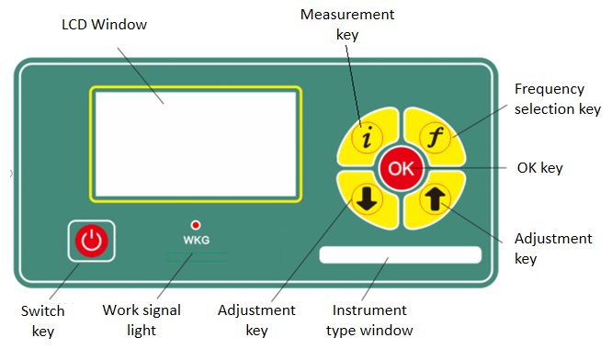
      - Switch key：for opening or closing the transmitter Power.(Requires a delay of 1-2 seconds)
      - Adjustment key: Adjust the transmitter output power (the output power is adjustable in ten gears)。
      - Frequency key：Select the operating frequency of the transmitter：128Hz、512Hz、1KHz、2KHz、8KHz、33KHz、65KHz、83KHz。
      - Measurement key：In the normal working interface，Long press the key three seconds，go to the menu interface.
      - OK key： After setting the frequency at which the signal needs to be applied, pressing the OK key can immediately change the transmitter output frequency. If you do not press the OK key after selecting a frequency, you need to wait for three seconds before the instrument automatically confirms the selected frequency.
    - Operation of Pipeline Instrument Menu：
      - Method of entering the main menu: Press and hold the measurement key for 3 seconds, or press this key to exit the setting.
      - The interface is as follows:
Menu
Language | Chinese English
Backlight | 5S 15S 30S 1m On Off
Contrast | Entry
Direct frequency | Entry
Clamp frequency | Entry

      - Setting submenu: Before setting, it is necessary to adjust the cursor to the corresponding submenu. Press the key to use: the up and down keys can be moved to make the cursor or adjust the contrast strength; The OK key can switch settings or enter the secondary submenu; The measurement key returns to the main menu from the secondary submenu.

NO | Menu | Operation keys | Operation interface | Corresponding parameters
1 | Language |  | Main Menu | Chinese, English
2 | Backlight |  | Main Menu | 5S 15S 30S 1m On Off
3 | Contrast |  | Sub menu | Increase，decrease
4 | Direct frequency |  | Sub menu | 128Hz、512Hz、1KHz、2KHz、8KHz、33KHz、65KHz、83KHz
5 | Clamp frequency |  | Sub menu | 8KHz、33KHz、65KHz、83KHz、131Hz、200Hz

      - Contrast adjustment interface: Click and press the up or down adjustment key to gradually increase or decrease the contrast; Press continuously to continuously change the contrast. Press the measurement key to return and exit the adjustment.
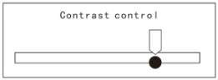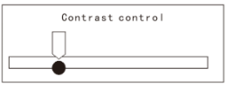
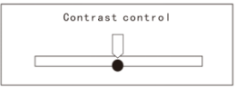
      - Direct connection frequency setting:
        - Open: Enter the frequency selection interface, and a black solid circle will be displayed by default, indicating that a frequency has been opened. Click Move the up and down arrows, switch the cursor to the frequency you want to select, and then press the Enter key. The hollow circle turns into solid black, that is, the selected frequency is turned on, and so on for the rest.
        - Close: Click the up and down arrows, switch the cursor to the frequency you want to select, and then press the Enter key. The black solid circle becomes a hollow circle, that is, the selected frequency is closed, and so on.
- Direct connection frequencies cannot be turned off completely, at least one should be reserved.
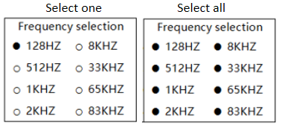
- The clamp frequency setting method refers to the direct connection frequency setting.(Frequencies cannot be turned off completely, at least one should be reserved.)
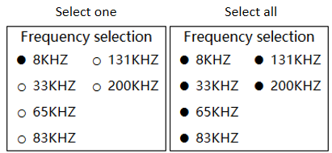
    - Interface display
      - Frequency: Different instrument models have different frequency quantities. Please refer to the manufacturer's product specifications for details.
      - Power supply voltage: When the power supply voltage reaches or exceeds 15 volts, the voltage symbol is all black ,When the power supply voltage is below 11.5 volts, the voltage symbol becomes empty  and flashes，The battery must be charged. During charging, one end of the charger is connected to a charging jack and the other end is connected to a 220V power supply. The indicator light of the charger is red, and when sufficient, the charging indicator light turns green.
      - Gear level: Press the ↑ or ↓ key to adjust the gear level, bar symbol 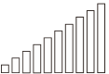 d
display the output gear of the instrument. The gear is divided into 0 ←→ 10 gears, with a level output and a black stripe。
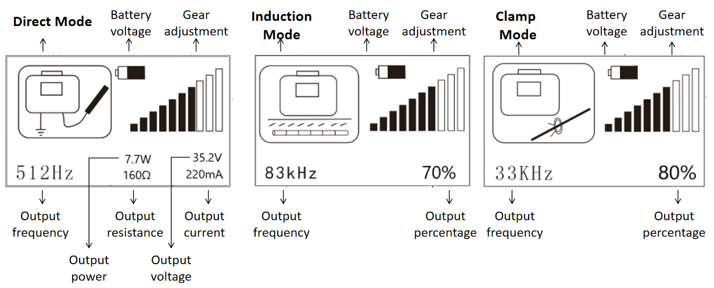

IV. Technical Parameters
  - Receiver
    - Positioning accuracy: ± 5% of depth
    - Depth measurement accuracy: ± 5% of depth (no adjacent line interference) Current measurement accuracy: ± 5% of actual current
    - Depth measurement range: ≤6 m
    - Working mode: valley method, peak method, broad peak method, peak arrow method
    - Operating frequency: radio, 50Hz, 100Hz, 128Hz, 512Hz, 1KHz, 2KHz, 8KHz, 33KHz, 65KHz, 83KHz (operating frequency according to product specifications and different specifications)
    - Working temperature: -20 ℃ ~ +50 ℃
    - Battery: 7.4V lithium battery
    - Dimensions: 595mm × 136mm × 238mm
    - Weight: 1.6Kg (including battery)
  - Transmitter
    - Output power: 10W
    - Operating frequency: 128Hz, 512Hz, 1KHz, 2KHz, 8KHz, 33KHz, 65KHz, 83KHz(The operating frequency according to the product specifications and different specifications slightly different)
    - Working mode: direct connection, induction and clamp three modes of automatic conversion
    - Battery: 14.8V built-in lithium battery pack
    - Working temperature: -20 ℃ ~ +50 ℃
    - Dimensions: 348mm × 228mm × 84mm
    - Weight: 2.5Kg (including battery)

V.Check The Instrument Before The Measurement

Before using the instrument, it is necessary to conduct a routine inspection to ensure that the battery power is sufficient and that all functions of the instrument are normal. If any of the following situations exist, please resolve the problem before using it.
  - Transmitter inspection
    - Battery power check: After startup, the interface displays sufficient power and normal use; Insufficient power, use after sufficient power.
  - Receiver inspection
    - Battery power check: After startup, the interface displays sufficient power and normal use; Insufficient power, use after sufficient power.
    - Power frequency method working mode inspection: Select a 50 Hz working frequency, adjust the sensitivity, and point it at the fluorescent lamp (on) from a distance of 1 meter. The instrument emits a strong signal tone, and the display has a strong display indication.
    - Induction method inspection: Select a place without interference, place the transmitter on the ground in its normal orientation, and turn it on. Adjust the output power percentage and frequency. Then align the wide surface of the receiver (about 5 meters from the transmitter) with the transmitter and maintain the same frequency as the transmitter. When the sensitivity is adjusted to be large enough, the receiver should have a signal response.
    - Clamp method inspection: First insert the external clamp into the transmitter output interface, then open the transmitter, select the clamp frequency, and then clamp the clamp onto the target pipeline to adjust the transmitter output power. Turn on the receiver and select a frequency that is consistent with the transmitter. The receiver should have a signal response along the route of the pipeline.
    - Note: Induction method can only choose 65KHz and 83KHz two frequencies, no direct signal output line or clamp inserted, the instrument automatically select the sensor mode, in the sensor mode, the frequency can only choose 65KHz and 83KHz two; Clamp method can choose 8 Khz, 33 Khz, 65 Khz, 83 Khz, four frequency, when the clamp access to the instrument, through the frequency key, can switch 4 clamp frequency. (In actual use, the frequency of clamps varies slightly depending on the type and specification of the product)
    - When using the induction method or clamp method, the instrument display shows the percentage of output power, Press i button to switch power display.
Corresponding Table of Output Power Percentage at Different Induction Frequencies
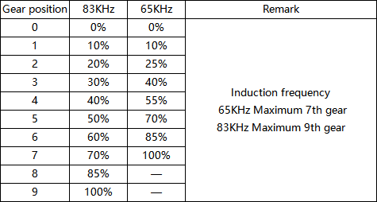
Corresponding Table of Output Power Percentage for Different Clamp Frequencies
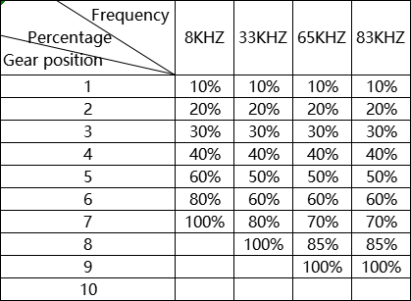
  - Measurement Depth Function Check
    - Select an area without metal structure and other probing lines, place an insulated cable or wire larger than 20 meters on the ground, connect it to the ground bar or connect it directly to the ground, Line of the red line (black line ground), and the output line into the transmitter output jack. Turn on the transmitter, adjust the output signal, and use the receiver to measure the depth at a known height above the long wire. At this point the receiver is placed vertically above the wire, the middle of the long wire, that is, 10 meters from the transmitter. The depth is measured at different heights, and the results are compared to the known heights, and the depth can be calibrated (note that if there is a metal object nearby it will affect its accuracy).

VI. Pipeline Detection Method
  - Transmit signal application operation
    - The detector field source has two working modes: passive source and active source. The passive source mode is used to search for unknown power cables or underground pipelines with cathodic protection signals applied in an area, as well as metal pipelines that can sense radio frequencies. The active source mode is used to track and locate pipeline signals in the area.
    - The working way of Passive source
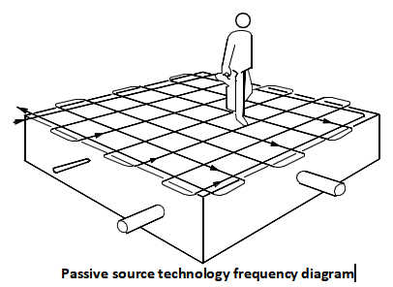
      - Passive frequency method work mode does not require a transmitter.It can search for an unknown area within the power cable. Open the receiver, select the receiver operating frequency of 50Hz, adjust the gain to get a suitable reading and select the maximum or minimum method to grid search in a region back and forth search. Carry the receiver smoothly, so that the fuselage surface and the direction of movement into a straight line and as far as possible through the pipeline at right angles, not arc swing, because it will produce some misleading signals. When the receiver responds with an abnormality,it immediately stops and precisely positions the pipeline and marks it.Traces and marks are also required for a pipeline that pierces the search area.
      - The passive source cathodic protection current (CPS) signal method does not require a transmitter to operate, it can search for an unknown area within the application of the external current cathodic protection of the underground metal pipe. Open the receiver, select the receiver operating frequency CPS, use the same method and the frequency method.
      - Radio frequency detection mode: radio frequency detection mode, mainly used to be able to sense the radio frequency of metal pipeline detection.
  - The working way of Active source
    - Active source way is to send a specific frequency of the signal sent to the pipeline, and then the receiver to locate and track the pipeline. Using the active source method can accurately locate the pipeline, tracking, sounding, but also on the underground pipeline coating damage points to accurately locate and determine the size of the damage point of the coating.
    - Transmitter signal application methods are two: direct method and induction method. Direct method is the ideal way to track the pipeline, the induction method is to find the region the most convenient way to underground pipeline. The specific methods are described below
    - Direct method：The transmitter is connected directly to the pipeline and produces the strongest signal in the pipeline. This method should be preferred in the probing pipeline. It is suitable for continuous tracking and positioning of various underground pipelines, positioning, sounding, high precision.
      - Wiring: Turn off the transmitter and insert the connecting wire into the transmitter output socket. The red wire clip is connected to the target line (if the power cable must be de-energized). If it can not be connected directly, it can be used. Pipe, and then clamp the magnet can be connected, if necessary, to clear the corrosive joints, to ensure a good electrical connection. The other black wire is connected to the ground point, which should be far away from the target line and at right angles to the possible direction of the target pipeline. Be careful not to route the ground wire across other underground pipelines to prevent signals from being sensed on non-target pipelines. If there is no ready-made grounding point, you can use the grounding rod, the grounding rod into the ground, the black fish folder connected to the grounding rod. If the ground is relatively dry can pour water to improve the grounding effect. If possible, the grounding point should not be less than 5 meters from the transmitter.
      - Parameter settings. Open the transmitter, the display shows the selected frequency, transmitter power and output parameters. , According to the frequency required for measurement, by frequency key selection. Press the frequency key, the frequency triangle in the 128Hz, 512Hz, 1KHz, 2KHZ, 8KHz, 33KHz, 65KHz, 83KHz cycle between the light, lit the corresponding frequency of the triangle is the selected frequency. The display window indicates the corresponding parameters (including output power, output voltage, output current and ground resistance) according to the triangle indicator, and the parameter display is selected with the measuring keys.
      - Grounding resistance check.The transmitter has a multimeter function that automatically detects the ground resistance. Select the output parameters to the Ω file, the grounding resistance will be displayed in the display, if the grounding resistance is too large, you must re-select the ground point or add water at the ground to reduce the grounding resistance. Because if the grounding resistance is too large, the power of the instrument can not be increased.
      - Note: Be sure to connect the wires before the transmitter is switched on. If the detection of underground cable using direct method must first cut off the cable power switch.
    - Induction method:
      - When the operator can not directly apply the transmitter signal to the target pipeline, the induction method can be used. There is a transmitter coil in the transmitter, when the transmitter is turned on, the transmitter coil can directly sense the signal to the transmitter below the pipeline, with the receiver can receive the underground pipeline generated by the electromagnetic field. The method is easy to use and does not need to be connected to the target pipeline, but the method signal is also sensed to adjacent non-target pipelines, and a portion of the energy loss of the signal attenuates the induced signal in the surrounding soil.
      - The sensing method can not apply a signal to a pipe under a metal manhole or a reinforced concrete pavement because the signal will be shielded by metal covers or steel bars. The sensing method can not be used to apply signals to well-insulated pipelines unless the terminals are well grounded at both ends of the pipeline.
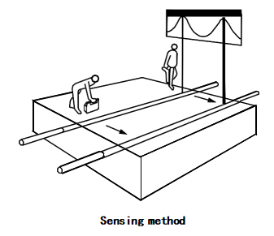
      - Send and receive distance:The transmitter will be fired at the same time to its upper space and the lower part of the pipeline at the same time to send the signal, so the receiver closer to the transmitter from the place to receive the probe, you may receive the transmitter field source signal, in order to distinguish the receiver in the pipeline positioning Whether the transmitter is moving to one side by one or two meters, and if the anomaly detected from the receiver is also moving, it means that the distance between the receiver and the transmitter is too close to receive the detected signal As the source of the launch site. Another method is to direct the receiver directly to the transmitter, then if the receiver is abnormal or increase, then the receiver receives the transmitter field signal, if this happens should increase the transmission and reception distance or Reduce transmitter power, and reduce receiver sensitivity.
      - Place the transmitter:The transmitter placed in the target pipeline "just above", the transmitter placed as far as possible in line with the direction of the pipeline, the only way to make the pipeline to produce a good induction signal.
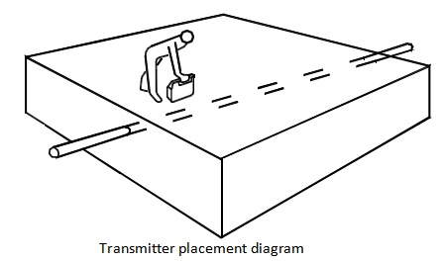
      - Launch frequency selection：High-frequency signals are most susceptible to other pipelines, often using high-frequency when sensing signals. The high frequency signal will sense all the pipelines, so the induction method is the best way to find underground pipelines instead of tracking the pipeline. For the pipeline to track the direct effect of the method is ideal.
        - General principles of frequency selection:
- For high resistance pipelines (eg communication cables, pipes with corrosive pipes and cast iron pipes) use the frequency of 83K, it must also be noted that the higher the frequency, the more easily accessible to other pipelines, and the shorter the signal propagation distance;
- For the general pipeline and cable detection, the use of 65K frequency, the frequency of transmission distance is far, it will not induce too many signals to other pipelines, suitable for long-distance tracking of the pipeline.
      - Transmit power selection: The transmit power selection should be such that the power of the applied signal is kept at a minimum level that meets the operational requirements and that the increased output power should be such that a clear anomaly signal is detected on the pipeline to be probed. If the output power is too high, it will make the adjacent pipeline more signals, so that the identification of the target pipeline more difficult, and will waste the battery energy of the transmitter. So the transmitter power selection should be appropriate.
    - Clamp method：The biggest difference between the clamp method and the induction method is the use of an external clamp to apply the transmitter signal to the target line without the need for an inductive coil inside the transmitter. Use and direct connection method is basically the same.
  - Signal transmission method for cable detection
    - Cable path detection and uniqueness identification play an important role in metal pipeline detection. Compared to a single continuous metal structure of a metal pipeline, a cable is composed of several core wires and metal armor. Differences in structure and usage result in differences in the signal application methods during detection. Different connections will generate different electromagnetic fields, and the detection effect will also vary. Therefore, this chapter describes the signal transmission methods for cable detection separately.
    - Signal transmission method of shutdown cable
      - Basic wiring method: core ground connection method
        - The core to ground connection method is the best wiring method for path detection and identification of offline cables (non energized cables that are out of service), which can fully exert the functions of the instrument and maximize anti-interference, as shown in the following figure:
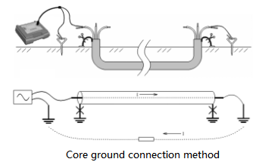

        - Loosen the ground wires at both ends of the metal sheath of the cable, as well as the zero and ground wires of the low-voltage cable. Clamp a good core wire with the red alligator clip of the transmitter, and clamp the black alligator clip onto the ground rod that is driven into the ground. At the opposite end of the cable, the corresponding core wire is connected to a ground rod that is driven into the ground.
        - Note: Try to use a grounding rod instead of directly using a grounding grid! At least a grounding rod must be used at the opposite end of the cable, and the grounding rod must also be away from the grounding grid for a distance, otherwise it may cause ground wire backflow on other cables, affecting the detection effect.
        - The current flows through the core wire from the transmitter, enters the ground at the opposite end of the cable, and returns to the transmitter at the proximal end. This connection method can sense strong signals in the receiver during ground detection, with relatively clear signal characteristics, and can fully utilize the error prevention tracking function of the instrument; The signal flows through a well insulated core wire and does not flow to adjacent pipelines, especially to intersecting metal pipelines. It is most suitable for path finding in complex environments. In addition, due to the grounding of the cable, the signal voltage flowing through the cable is very low, which is not easy to cause capacitive coupling to adjacent lines, reducing interference.
        - Due to the distributed capacitance between the core wire and the ground, the current will gradually decrease as the distance increases. However, if the grounding is good and the capacitive current is small, it may not be considered.
        - The disadvantage of this method is that it requires the grounding wires at both ends of the cable to be completely untied, which is slightly cumbersome.
      - Sheath to earth connection method：
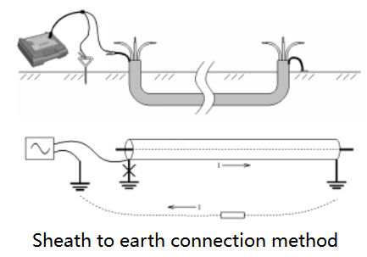
        - As shown in the above figure, disconnect the ground wire of the protective layer at the proximal end of the cable, and the zero line and ground wire of the low-voltage cable should also be disconnected. The protective layer of the opposite end of the cable should remain grounded. The signal should be applied between the protective layer and the grounding rod (grounding grids cannot be used), and the cable phase line should remain suspended. The current flows through the protective layer from the transmitter, enters the ground at the opposite end of the cable, and flows back to the transmitter at the proximal end. This connection method does not have shielding, so the strongest signal is generated on the ground and the signal characteristics are relatively clear. Similarly, due to the presence of shield earth distributed capacitance, the signal will gradually attenuate from near to far.
        - Potential problem: If the insulation layer outside the protective layer is damaged, part of the current will flow into the ground from the damaged point, causing a sudden decrease in the current after the damaged point. The decrease is related to the ground resistance of the damaged point.
      - Phase line sheath connection method：
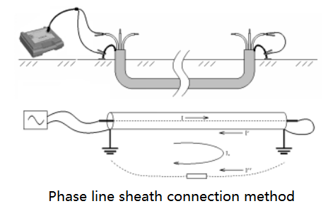
        - As shown in the above figure, the transmitted signal is applied between the first phase of the cable and the sheath, resulting in a short circuit between the opposite phase line and the sheath, and both ends of the sheath remain grounded.
        - If it is laid with a single cable, the signal flows through the core wire from the transmitter, and then returns through two loops, the protective layer and the ground. Because the protective layer (armor and copper shielding layer) consists of continuous metal, the resistance is very small; Due to the existence of ground resistance at both ends of the earth circuit, coupled with soil resistance, the total resistance value is relatively large, so most of the current will return through the protective layer, while a small portion of the current will return through the earth. Due to the reversal of the core current and the sheath current, the effective current that can generate a magnetic field signal at an external distance is the difference, which is equal to the resistance current returned through the ground. In addition, due to the mutual inductance between the core sheath circuit and the sheath earth circuit, induced currents can also be generated in the sheath earth circuit through electromagnetic induction. The comprehensive effect is that the effective current is equal to the vector sum of the resistive current and the induced current of the earth circuit (there is a phase difference between the two). Depending on the on-site situation, the effective current may account for several to ten percent of the total injection current.
        - If there are other cables laid in the same path (with the same positions at both ends), the return current is mainly diverted by the sheath of several cables. For example, if three cables are in the same path, the sheath return current of each of the three cables accounts for 1/3. The effective current is forward, accounting for 2/3 of the injection value, and the adjacent line current is reverse, accounting for 1/3. As shown in the following figure.
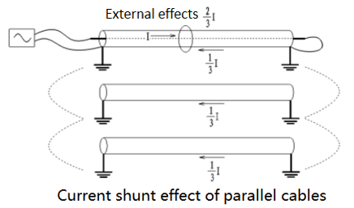
        - The advantage of the phase line sheath method is that the wiring is simple and there is no need to unfasten the ground wire. The disadvantage is that when multiple cables are laid in the same path, the signals of each cable are not significantly different, and it is sometimes difficult to distinguish only by signal amplitude; When a single line is laid, the effective current significantly decreases, and the signal is weak. Moreover, the effective current contains an induced current component. The induced signal phase of the target cable and adjacent pipelines is the same. When using composite frequency detection, it may not be possible to eliminate interference from adjacent lines based on the current direction.
      - Interphase connection method：
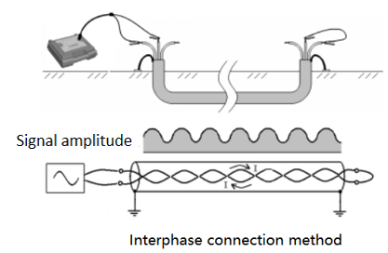
        - As shown in the above figure, the transmitted signal is applied between the two phases of the cable, and the two phase lines at the opposite end of the cable are short-circuited. The two phases are twisted inside the cable, with the same current value and opposite directions. Due to the fact that the two phase lines are very close to each other, but there is still a certain distance between them, there may be a slight difference in the distance between the two phase lines and the receiver coil. The magnetic field generated by the two phase lines here is in the opposite direction, but the intensity will not be exactly the same due to the difference in distance. Although most of them cancel out each other, there is still a small amount of residue, which will be further weakened by the shielding effect of the metal sheath, and the final residual signal can be received. Due to twisting, the signal can vary in amplitude and direction periodically along the cable path.
        - During a twisting cycle, the magnetic flux radiated from the outside cancels out each other due to continuous changes in direction of 360 °, so no induced current will be generated in the sheath earth circuit.
        - Due to the small effective signal, using high-frequency signals will be easier to detect than low-frequency signals. The interphase connection method cannot use the current direction measurement function of the receiver to eliminate adjacent line interference.
      - Selection of transmission frequency:
        - For the detection of general cables, unless the phase to phase connection method is used, it is recommended to use a frequency of 1KHz. Its frequency is low, its propagation distance is long, and it is not easy to sense to other pipelines. It has strong anti-interference ability and is easy to distinguish.
        - For long-distance cables (longer than 2-3km), if a 1KHz signal is used, there will be significant attenuation at a long distance, the signal is not easy to receive, and the phase will also shift. Therefore, it is recommended to use 512Hz transmission signal for detecting long-distance cables.
        - When using the interphase connection method, high frequencies (8kHz, 33kHz,65KHz, or 83kHz) should be preferred。
    - Signal transmission methods for running cables
      - Clamp coupling method
        - This is an ideal method for detecting running cables, which can be tested without any modifications to the cable. The operation is far away from high voltage, and is very safe. There are signals throughout the entire length of the cable, without distance restrictions.
        - Both ends of the cable sheath must be well grounded, otherwise the coupling current will decrease as the grounding resistance increases. The clamp coupling method cannot be used if both ends are not grounded or the cable sheath is disconnected in the middle.
        - Clamp the cable
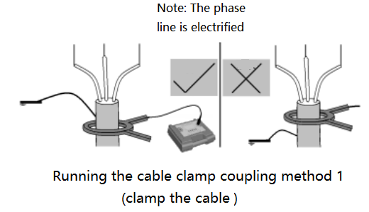
- As shown in the above figure, this method is applicable to the detection of ordinary three-phase turnkey operating cables. The transmitter outputs a clamp to clamp the cable body (be careful not to clamp the part above the ground wire). The clamp is equivalent to the primary of the transformer, and the cable metal sheath earth circuit is equivalent to the secondary (single turn) of the transformer. The magnitude of the secondary coupling current is closely related to the circuit resistance (mainly the ground resistance at both ends). The smaller the resistance, the greater the current.
- The current obtained by coupling the cable through the clamp is small, so a larger output level should be selected to enhance the detection effect.
        - Clamp the cable sheath ground wire
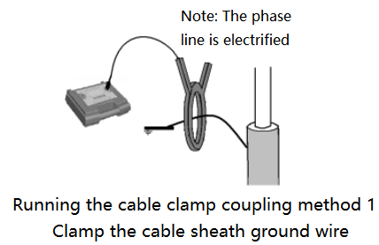
- As shown in the above figure, this method is applicable to the detection of ultra high voltage single core operating cables. Due to the strong power frequency current flowing through the core of a single core cable, and the lack of three-phase cancellation effect of a three core all-in-one cable (externally manifested as relatively small zero sequence current), if the clamp is stuck on the cable body, it is easy to cause magnetic saturation of the clamp and cannot send a signal. Therefore, the clamp should be clamped on its protective layer ground wire.
- Due to the fact that the sheath of long distance ultra high voltage single core cables will be interconnected with ground wires at regular intervals, signals will flow from the sheath of one phase to the sheath of the other phase at the intersection and interconnection point, and attention should be paid to distinguishing during tracking.
- For three-core all-in-one cables, if it is difficult to clamp the cable body due to site conditions, the method of clamping the cable ground wire can also be used, but it should be avoided as much as possible. Under certain special circumstances, unexpected changes in signal characteristics (including amplitude and phase) may occur.。
      - Zero line/ground line/sheath injection method：
        - This is a method of detecting low-voltage cables in operation, because many low-voltage cables do not have a protective layer grounded, or the protective layer is discontinuous, or the grounding is not good enough to use the clamp coupling method. This method does not require any modifications to the cable, and the injected high-frequency signal will not have adverse effects on the operating line.
        - At the user end, connect the red alligator of the transmitter to the neutral line, ground wire, or protective layer, and connect the black alligator to the ground rod that is inserted into the ground, as shown in the following figure:
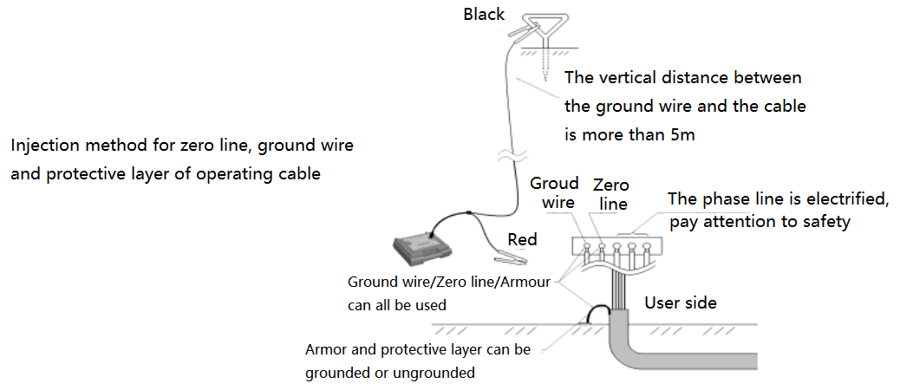
        - Precautions:
- Safety warning: The cable is live, and the wiring must be operated by electrical personnel with relevant qualifications or qualifications!
- Signals must be transmitted at the user end. If signals are transmitted at the substation end, signals will be injected into all outgoing lines, making it impossible to distinguish the target cable.
- Selection of the position of the grounding rod: To ensure the output effect, the grounding rod should be installed 5m away from the cable, and the grounding wire should be perpendicular to the direction of the cable as much as possible.
- If the zero line is not grounded at the user end, the zero line injection signal is preferred.
- The sheath of low-voltage cables is mostly discontinuous. If the sheath injection signal is too weak, or the signal is interrupted at some point in the cable path during the detection process, it can be replaced with a zero line/ground line for injection. Due to the parallel connection of the zero/ground wires or protective layers of all outgoing lines in the substation, some current will be diverted on other cable outgoing lines, and signals can also be detected, but the strength is weak. Attention should be paid to distinguishing in actual testing.
- When detecting high-voltage running cables, if the signal cannot be received or is weak using the caliper coupling method, it indicates that the grounding resistance of the protective layer at both ends of the cable is too large, and injection can be conducted through the protective layer.
- When detecting a single core ultra high voltage operating cable, the caliper coupling method fails, and the sheath injection method can be used.
  - Receive detection
    - It is used to position, deepen and measure the current in the target pipeline.
    - The position, direction, and depth of the target pipeline can be detected by the receiver when the signal of the transmitter is successfully applied to the target line. Location and depth of the underground pipeline is the most important information, so the pipeline positioning and depth is the underground pipeline detection work in the most important part.
    - Pipeline positioning
      - When detecting the position of the target pipeline with the receiver, it is necessary to pay attention to the factors that may interfere with the positioning accuracy at any time, to prevent the transmitter signal from being coupled to the adjacent pipeline, so that the detection result is deviated.
      - Preparations:
        - Check the power supply voltage: turn on the receiver, check the battery voltage, the need for power before the need to fully charge after use.
        - Frequency selection: Press the frequency key to set the receiver frequency at the desired frequency. If the active source mode is used, the receiver should be at the same frequency as the transmitter.
        - Sensitivity setting：Adjust the up or down key to increase or decrease the receiver gain so that the bar reading is at 60-80% of the entire range.
        - Operating mode selection: press the mode key, according to the need to select the appropriate mode of operation. Pipeline detector receiver provides peak mode, wide-peak mode, broad-arrow mode and valley mode four detection modes.
      - Peak (max) method
        - The peak response mode uses a single horizontal antenna (wide) or bi-level antenna to receive the horizontal component of the target pipeline signal, and the receiver responds most directly above the target pipeline. The single-level antenna wide-band mode is used to locate deeper pipelines, with the highest signal sensitivity. When the receiver is directly above the detected pipeline, the signal strength is the largest, the response range is wide, the positioning accuracy is lower than other methods. The double-level antenna peak method has a steeper peak response than the single-level antenna wide-peak mode, the measurement position is relatively accurate and the signal strength is weak. When the receiver is above the positioning pipeline, the signal strength reaches its peak.
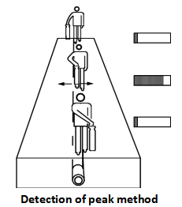

        - First of all, the target pipeline to be positioned to keep the receiver and the ground is generally perpendicular to the receiver body and the width of the transmitter at the transmitter, if the signal is directly connected to the target pipeline, the transmitter as the center, to 5-10 meters Radius (if the induction method, the radius is greater than 20 meters) around the transmitter for circular travel, adjust the sensitivity, so that the receiver to maintain a certain static signal.
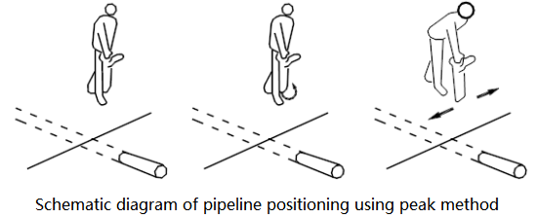
        - Move the receiver back and forth gently on both sides in the presence of a peak response, find the exact location of the peak response and mark it, which is the location of the target pipeline.
        - Use the peak method to locate the pipeline precisely: When the peak response point is found, do not move the receiver, turn the receiver in place, stop when the response is maximum, keep the receiver vertical ground, move the receiver around the pipeline , The largest place to respond is the location of the target pipeline.
        - At the top of the target line, the receiver is connected so that the receiver body width is perpendicular to the pipeline and the sensitivity is adjusted so that the bar reading is between 60-80% of the entire range. Leaving the transmitter, while moving the receiver around the middle of the middle of the peak on both sides of the situation is that the probe detectors walking in the pipeline directly above, so that the pipeline can be long-distance tracking.
      - Valley (minimal) method
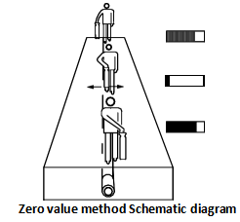
        - The valley (minimum) value response mode uses a vertical antenna to receive the vertical component of the target pipeline, and the receiver receives a minimum response directly above the target pipeline. Valley (very small) value method positioning intuitive, fast, but susceptible to interference, poor accuracy. Mainly used to quickly track the accuracy of the pipeline and verify the response of the peak method. The use of the valley (minimum) method can speed up the tracking of the pipeline speed, can hold the receiver at any angle, because the zero value does not depend on the direction of the pipeline. When walking along the pipeline, the receiver can get the minimum value and the sound is the smallest when the pipeline is above it. When the receiver is moved left and right, the bar reading will increase to a peak and the sound will increase. Therefore, observe the zero value response and the peak response on both sides of the pipeline during the detection process.
        - When using the valley (very small) value response mode to detect the target pipeline, it should periodically switch to the peak response mode in order to verify the exact location of the target pipeline. Using the peak mode for fixed positioning and marking, and then switch to the zero value response mode, in the pipeline valley (minimum) value of the location of the mark, if the peak response tag and the valley (minimum) value of the response mark the same location, then It can be considered that the point positioning is accurate. If the two are not consistent, then the fixed-point positioning can be considered inaccurate, the actual location of the target pipeline should be close to the location of the peak response.。
      - Peak arrow mode
        - The peak arrow mode uses both a vertical antenna and two water antennas, while receiving the vertical and horizontal components of the target line. The receiver gets the maximum value above the target line and has a left and right arrow response. When the maximum value and arrow direction of the same position, you can think that the point of positioning is accurate. If the two are not consistent, then the fixed-point positioning can be considered inaccurate, the actual location of the target pipeline should be close to the location of the peak response. With this method to detect no need to detect the peak and valley during the cycle of the switch, the operation more simple and quick.
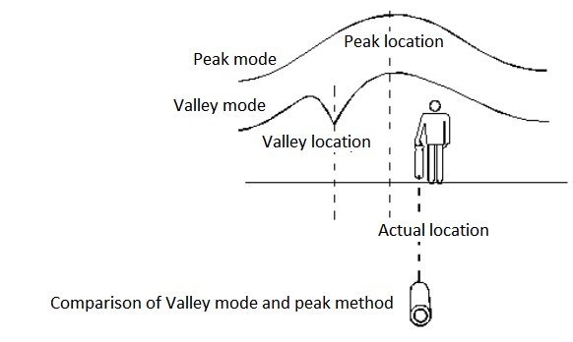
        - During the detection process, the receiver's reading will gradually decrease as the distance between the receiver and the transmitter increases, and it is necessary to hold the rising key to adjust the sensitivity to compensate for the attenuation of the signal. If the receiver reading is suddenly reduced, stop at once and re-detect the position of the pipeline at the drop of the reading, increase the sensitivity, round the radius to 2 m.
          - Possible reasons are as follows:
- Pipeline suddenly deepened, can improve the sensitivity to continue to detect.
- There may be a "T" -shaped branch, and the pipeline may also change direction,check whether more than one tube carries the signal in the circle. If the pipeline is more than one, measure the distance from the intersection of 4-5 meters per place of the response of each pipeline, the strongest response to the main line, weak for the "T" -shaped line, this is because the signal is always selected long or large pipeline For the better earth circuit, which is very useful for detecting the main line and the branch line.
- The signal completely disappeared, may be the end of the pipeline, it may be a metal pipeline into a plastic pipeline, it may be piping from a metal plate or cover through, over the lid, continue to detect.
- When the signal is gradually reduced, and sometimes improve the sensitivity of the pipeline signal or not detected, then you can take the transmitter, the signal added to the last point, the pipeline can continue to detect.
- If the signal becomes blurred, the signal distribution is very wide. Pipes may be in the bar net, the reinforcement network to absorb and radiation signals, this time the receiver can be increased by 0.5m, the sensitivity will be minimized, which will still be able to receive the signal without being affected by concrete in the shallow steel radiation signal and Can continue to detect.(See the various circumstances see Figure a ~ Figure e)
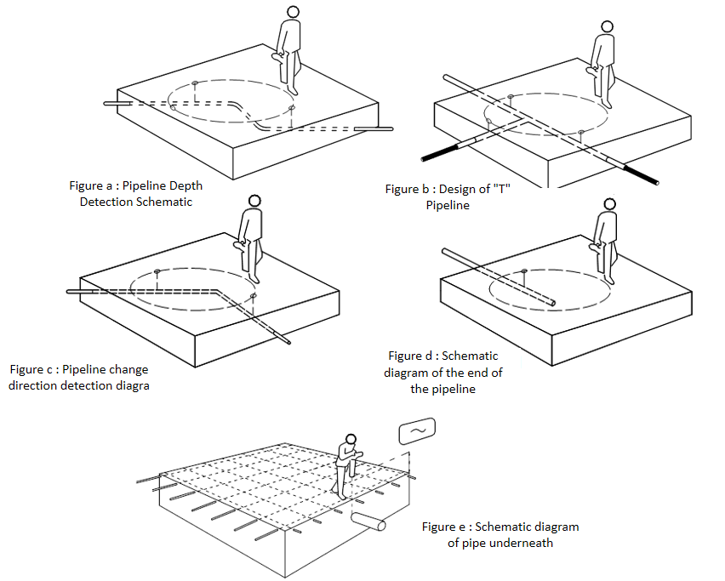
    - Depth measurement
      - Pipeline detector receiver can measure the target pipeline depth, commonly used methods are direct reading method, 80% method and 45 degrees method.
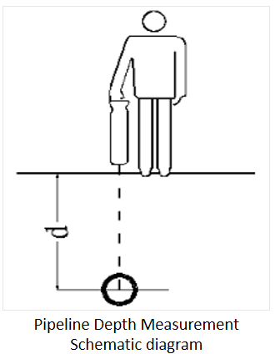
      - Direct reading method:
        - when more than the range or the signal is not normal, the receiver display error message.
        - Before the sounding of the receiver with the peak method and the minimum (zero) value of the target pipeline for precise positioning, if the two positions are not consistent, then there is interference exists, the need to select the peak signal and the minimum (zero) value signal Consistent place for depth measurement.

        - The receiver on the pipeline directly above the body surface and the pipeline at right angles and perpendicular to the ground,It is best not to choose in the vertical antenna mode press the measurement key, the receiver automatically adjust the gain, gain adjustment is completed, the display shows: test, about 5 seconds after the display will show the depth of the target pipeline and tube current , And then press the key to automatically restore the working state before the depth of sounding.
        - Sounding must have a good quality signal applied to the target line, when the button is pressed, the receiver will automatically adjust the sensitivity to the best. If the receiver receives the signal is too weak, the display shows the signal is too weak,press the key to restore the working state before the depth.
        - Direct reading method of sounding method is simple, but the correct results need to read certain conditions, otherwise the measurement accuracy is not high, or even get the wrong results. One of the conditions for applying direct-line sounding is the precise positioning of the pipeline, that is, the peak method and the valley method to determine the target pipeline position to be basically the same, generally should be less than 20 cm, otherwise the error will be great.
        - The depth measurement is the distance from the bottom of the receiver to the center of the target line, not the distance to the top of the pipeline. This is not to be overlooked when the target pipe diameter is large.
        - If there is doubt about the depth measurement results, the receiver can be measured 0.5 meters above the ground again, if the measured value is increased by meters, then the depth of the measurement results are correct.
        - If the condition is appropriate, the depth measurement accuracy can reach 5% of the pipeline depth, but the operator does not know whether the depth condition is always appropriate, so the following techniques should be used to check some readings:
        - Check whether the pipeline is straight, at least in the range of 5 meters on both sides of the measuring point should be straight.
        - Check the signal within 10 meters is relatively stable, if the stability of the original measurement points on both sides and then select a number of points for depth measurement.
        - Check whether there is a jamming line with a coupling signal in the range of 4 meters from the target line 3 to 4, which is the most common cause of the error in the depth measurement. The strong signal in the adjacent pipeline may cause a depth measurement of 50% error.
        - The depth of the point at which the depth is minimized is the most accurate at several points that are slightly offset from the pipeline position, and the position indicated by the location is the most accurate.
      - 80% sounding method
        - Place the receiver on the ground directly above the target line and perpendicular to the ground, select the single horizontal antenna peak mode of operation, adjust the sensitivity, adjust the reading to a suitable value, and then move the receiver in the vertical direction of the pipeline until the monitor The reading drops to 80% of the reading above the pipeline. Mark these two points and measure the distance between them, this distance is equal to the depth of the target pipeline buried.
      - 45° sounding method
        - First, accurately measure the position and direction of the target pipeline, switch the working mode of the receiver to the zero value method, place the bottom of the receiver on the ground above the pipe at the depth measurement point, adjust the receiver body to make it The ground is at an angle of 45 degrees and moves the receiver in a direction perpendicular to the direction of the pipeline. When the received signal is the minimum, the receiver is marked with the ground on the ground, and the distance between the mark and the measuring point For the buried depth of the pipeline.
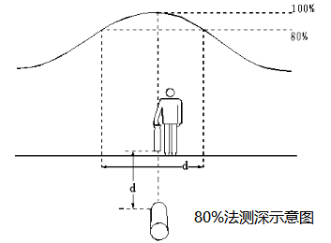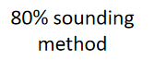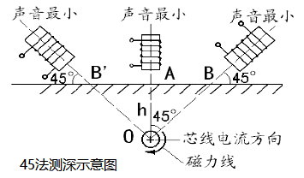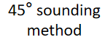
        - Several of the above-mentioned depth measurement methods are often used to verify the accuracy of the depth measurement in the detection process, of which 80% is most commonly used, especially in the complex pipe network measurement depth is more accurate, 45 degrees measurement need to master the receiver body With the ground level. Direct reading depth method in the complex environment, the use of precision error, more suitable for long-distance single-pipe buried soil depth measurement.
    - Current measurement
      - This series of detector also measures the size of the current on the target line compared to conventional pipelines, which helps the operator to better identify the target pipeline. In a pipeline-intensive area, the receiver may detect a stronger signal on the pipeline than on the target line because it is deeper than the target pipeline. At this time it is difficult to accurately distinguish between the target pipeline and the interfering pipeline if it is measured only on the basis of the signal strength. With the current measurement function it is possible to effectively differentiate between the target and non-target pipelines, and the largest (not the strongest signal) of the current measurement data is the target line to which the transmitter signal is applied (see Figure f). The measuring current can also provide useful information about the tee and elbow, which performs the current measurement main line behind the tee as the length of the assembly attracts more current, which can help determine the main line and branch line (see Figure g).
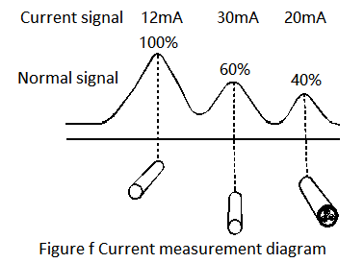
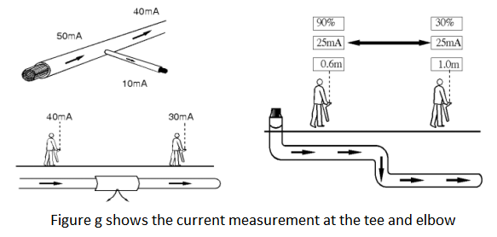
      - The principle of current measurement: the transmitter to the target pipeline to impose a current signal, with the distance from the transmitter increases, the intensity of the current will gradually decrease, the degree of attenuation due to pipeline type and soil may be. But for a certain type of pipeline, the attenuation of the current will remain stable without sudden drop or change. Sudden changes in the current indicate that the pipeline or its condition has changed. (See Figure h)
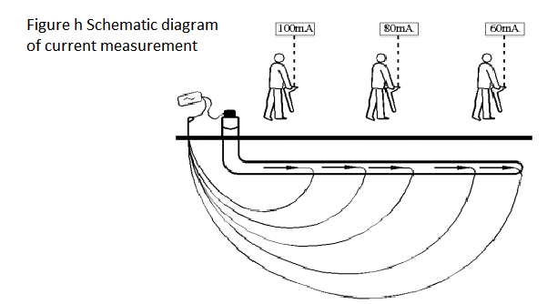
      - Current measurement method: current measurement method and sounding method exactly the same, and the size of the current in the depth of the time will be detected and displayed in the display.
      - Signal sensing to adjacent pipelines will reduce the accuracy of the measurement. If the measured reading is suspicious, search for a nearby area and check for pipelines with other radiation signals nearby. If other signals cause interference, perform depth / current measurements at other points of the pipeline.

VII. On-Site Detection Of The General Procedure

1.1 Pre - exploration data preparation and field study
    - This detector locates all buried metal pipes and cables in a zone. Therefore, the information on the depth and location of the pipeline detected by the detector will help to predict the distribution of the underground pipe network before the construction of the new project. Before using the pipeline analyzer, it should first collect the underground ("Urban underground pipeline project archives management approach" since May 1, 2005 has been implemented, the city underground pipeline related archives information can be to the local urban construction archives consultation), although sometimes this information is not very reliable Or accurate, but it can also provide some of the pipeline within the area of the situation, and look at the scene: covers, lights and all instructions to have a direct pipeline and cable signs should be taken into account.
  - Grid frequency scanning
    - This receiver is capable of testing the frequency of the 50 Hz power cable, which can quickly detect the location and direction of the underground power cable in the area under test and do not require the use of a transmitter.
    - Press the receiver frequency frequency key, select the 50Hz frequency and select an operating mode, the working mode for the peak method to illustrate the detection method: adjust the sensitivity, so that the signal reading in the receiver bar graph full scale of 60-80%. The grid-like route sweeps the area to be detected, and the direction of the receiver is consistent with the direction of the pipeline and is at right angles to the pipeline that may be measured. When the receiver response increases, it indicates that there is a pipeline, where it is stopped, the pipeline is precisely positioned, and the position of the pipeline is marked, traces the pipeline until it leaves the area to be searched, and then returns to continue the network scan in the area.
    - Mark each of the pipeline locations with signal responses and then track the portion of the pipeline outside the area and mark it.
  - Sensing method search
    - Inductive search is the most reliable technique for detecting unknown pipelines. This search method requires a transmitter, a receiver, and two detectors. This search method is called "two-person search method". Before starting the search, determine where you want to search for the area and the direction through which the pipeline passes. Turn on the transmitter, select the working mode for the sensing mode and select the same frequency. One detector operates the transmitter and the other detects the receiver. The signal can be detected by applying a signal to the pipeline when the transmitter passes the pipeline and then the receiver 20 meters upstream or downstream of the transmitter. The direction of the transmitter is consistent with the direction of the estimated pipeline. The second person follows the starting position of the receiver in the area to be searched, and the direction of the antenna of the receiver remains perpendicular to the direction of the possible underground pipeline. The receiver is tuned to the highest sensitivity of the transmitter signal that will not receive directly from the air. When the direction of the transmitter and the receiver remains correct, the two operators move forward in parallel. The operator of the receiver moves the receiver forward and backward while moving forward. The transmitter applies a signal to the pipe directly below and the signal is detected by the receiver. The position of the peak detected at the receiver is marked on the ground. Repeat the search in other directions where there may be pipelines.
    - Search by induction can detect passive pipelines and other pipelines that do not have an inductive 50Hz signal.
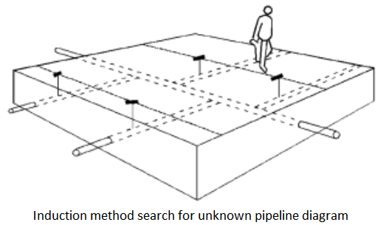
    - Sensing skills:
      - Maintain the distance from the transmitter, in the sensor mode, the transmitter in addition to the target pipeline to send a signal, but also to the air to send a signal, which may give the transmitter near the detection work caused by interference. To check that the receiver is detecting a signal from a pipeline, rather than a signal that is emitted directly from the transmitter, move the transmitter one or two meters, and if the pipeline is moving, this indicates that the receiver is too close to the transmitter. Another way to check whether the receiver has received the transmitter signal is to point the receiver to the transmitter. If the receiver's response size is constant or increased, the receiver receives a transmitter signal that is transmitted directly from the air. In this case, the transmitter output power is reduced and the sensitivity of the receiver is reduced. The receiver may also leave the transmitter 25 to 30 meters. Do not place the transmitter on the cover as this will prevent the signal from being applied to the target line.

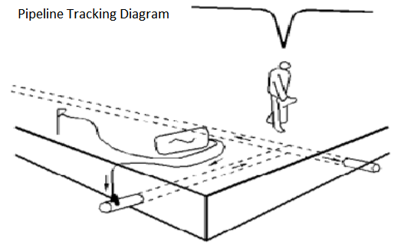
    - Pipeline tracking, fixed positioning and depth measurement
      - The transmitter signal is applied to the location of the buried pipe or cable for

access. Such as: containers, valves, lights, etc., to track the part of the pipeline outside the area and mark.
    - For those pipelines that need to be probed, they can be tracked until they reach the covers, lights and fire hydrants on the ground, then the transmitter signals are applied and then returned from these locations to track the pipelines until they return to the area.
    - The key points and feature points of each pipeline in the area are sent to the location and the depth measurement, and the relevant pipeline data and the detection result are recorded at each detection point, and then the recorded data are sorted and the area is drawn Of the pipeline distribution.

VIII. Commonly Used Pipeline Detection Techniques
  - T-tube detection
    - Once the pipeline has been tracked and marked, the receiver can be traced again along the pipeline, but this time it is about 1 meter away from the side of the pipeline that has been stuck, Pipeline parallel. The signal (or signal is small) from the main line is not detected, but the response to the branch will be noticeable.
    - The most reliable way to locate a branch is to apply the transmitter signal to the end of the branch. This signal will flow from the branch to the main line, and then flow to both sides of the main line. The fuselage surface is at right angles to the main line and the signal is traced along the main line. The receiver will have a zero value response above the T-shaped pipe joint. The position of the zero value is the exact position of the T-shaped pipe joint.
  - Parallel pipeline detection
    - In parallel pipelines, parallel pipelines are a common phenomenon. In pipelines-intensive areas, receivers often receive interfering signals from adjacent pipelines, which can cause difficulties and impacts on the identification and tracking of target pipelines Positioning depth accuracy. So we must use some methods in our work to minimize the impact of adjacent parallel pipeline coupling signals.
    - First of all, in the pipeline-intensive areas as far as possible not to use the induction method, and direct connection method to the target pipeline to apply the transmitter signal. In addition, a lower transmitter frequency can be selected to reduce the coupling capability of the signal. In this case, the peak response mode should be used, using 80% method sounding, which can reduce the deviation.
    - In general, the receiver's response to the target pipeline should be greater than the adjacent pipeline, with the receiver's response to be able to identify and track the target pipeline. However, if the adjacent pipeline is closer to the surface, the receiver's response to the adjacent pipeline may exceed the target line. The target pipeline can not be identified and tracked only from the receiver's response. At this point we need to measure the target pipeline and the signal on the adjacent pipeline and compare the current, with the maximum current value of the pipeline is the application of the transmitter signal target pipeline.
    - If there are several parallel pipelines and can not be directly connected to the transmitter, you can press the pipeline signal method for each pipeline to detect. First, the entire region is searched by means of induction to find the number, general position and direction of the pipeline in the area, and mark on the ground. Then place the transmitter flat on the ground and keep it as much as possible in the direction of the underground pipeline and ensure that the pipeline is just below the transmitter so that the signal below the transmitter is zero, but other lines can be detected, moving along the pipeline The transmitter continues to detect and mark the pipeline position. Finally, the first line is tracked outside the search area until the target pipeline can be precisely positioned.
  - Deepening Pipeline Detection
    - If the signal detected by the receiver suddenly becomes smaller during the probing process, it may be that the target pipeline is branched or the pipeline becomes darker. According to the T-type pipeline to detect the way to determine whether there is a branch pipeline, if there is no branch pipeline may be the pipeline suddenly deepened, then should immediately stop, and then re-track the monitor response to the sharp decline in the location of the pipeline High sensitivity to the signal response drop point for the center, to 2 meters distance for the radius for circular arc detection.
  - Interference signal processing
    - The signal that is sensed from the target pipeline to the adjacent pipeline is the most common problem in pipeline detection, which may cause the location or depth of the target pipeline to be inaccurate or to detect erroneous pipelines. In many cases a certain degree of induction is inevitable, but through field testing experience can be used to reduce the degree of induction, so as to improve the reliability of detection.
    - Try to avoid using the induction method to apply the signal. Because the use of induction signals may be sensed on multiple underground pipelines.
    - To determine the location of the underground pipeline is relatively close to each other, from the pipeline where the simple start to the underground pipeline complex place to detect, rather than from the underground pipeline complex place to start detection. For example, if the building concentrates water pipes, gas pipelines, cables, etc., signals should be applied from valves or other access points other than buildings, and signals should not be signaled from buildings.
    - If possible, use a lower frequency signal to reduce the proximity of the adjacent line.
    - If the signal is returned to the transmitter via another line, a double-ended connection can be used to bypass the ground return.
    - Because of the use of a single-ended connection method, the ground loop signal is returned to the transmitter through other pipelines, which may be stronger than the target pipeline signal because the target pipeline is deeper than the pipeline carrying the signal or the loop line is better than the target pipeline, At this time the target pipeline detection will be a problem. If both ends of the pipeline have access points, the use of a double-ended connection method to connect the transmitter is a pipeline-intensive conditions to identify the target pipeline the most effective way. The specific operation is as follows: connect the transmitter to an access point to the target pipeline where the ground of the transmitter is connected to another access point of the target pipeline via a long wire. This does not require grounding to form a complete loop, the long pipeline should be away from the target pipeline may be.
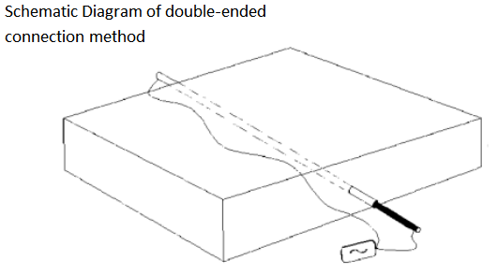

  - Some Problems in Cable Detection
    - Before applying the transmitter signal, it is necessary to disassemble the common connector on the cable so that it can track the target cable. If you want to track all cables from the transfer box, the transmitter can be operated in a sensing mode, placed on one side of the transfer box and aligned with the cable to be tracked.
    - In order for the transmitter signal to transmit a sufficiently far distance, it is necessary to remove the ground connection of the cable.
    - If there is a ring in the ground, the cable will reduce the response on the cable path. In this case, you should return to the response point before the increase in the search range, the receiver will be able to determine the cable in addition to the smallest of all the ring.Most of the cable glands in the receiver will show a peak pulse signal, field detection experience and understanding of the actual situation can determine whether the peak pulse signal indicates a transfer box.
    - The cable is usually buried directly on the road outside the metal fence on the road, the signal will be coupled to the metal fence. Because the metal fence is close to the antenna at the bottom of the receiver, tracking becomes difficult. Then the receiver, so that the lower part of the body antenna and metal fence flat, the problem can be resolved.
    - The transmitter signal is almost as effective as the metal shield of the lighting cable itself, since the metal shield of the lighting cable is generally connected to the metal column.
    - For cables from wooden poles, cement poles or lighting columns, the transmitter can be placed in an induction mode and applied to the pole at right angles to the earth to apply a signal.
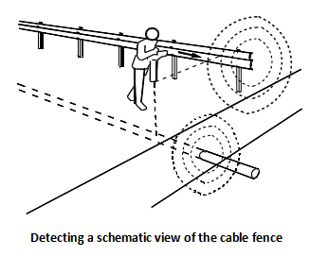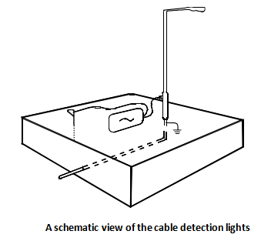
  - Some Problems in the Process of Detecting Cast Iron Pipeline
    - The detector can be used to search for steel pipes and cast iron pipes with spaced-apart interfaces.
    - Some cast iron gas pipes and tap water pipes have insulated connectors that can be used to apply the transmitter signal to the gas meter or water meter. Use a jumper to turn the insulated gasket bypass (use a connecting magnet on both sides of the insulating gasket to ensure that the connecting magnet But also to connect the two connecting magnets with wires), so as to ensure a reliable circuit for the cast iron pipes entering the house.
    - If you want to locate the pipe on the roadside or road pavement, connect the transmitter to the valve with the single-ended connection method and connect the grounding wire to the metal frame of the valve box. Make sure that the connecting magnet is in good contact with the pipe. If necessary, remove paint and rust before connecting.
    - Sometimes there may be some insulation on the pipeline, the transmitter should be in the back of each joint pipeline re-enter and use a higher signal frequency, so that the detection by paragraph, until the detection of the entire pipeline.
    - Combining the above methods is generally successful in tracking cast iron pipes.

IX. Fault Location (Functions Of Optional A-Frame)
  - Fault location is to detect the underground pipeline insulation damage (pipe failure is the outer coating damage, cable failure is the outer sheath damage). When a faulty point is present, a part of the signal will be returned to the receiver via the ground bar via the fault point. The A-frame can be used for fault location of the underground pipeline. Specific steps:
    - Frequency selection: A-frame to find the underground pipeline coating damage point, it is recommended to choose 512Hz or 1KHz two frequencies.
    - Target Pipeline Location: Use the receiver to locate the target pipeline and determine the approximate area of the fault. If there is an abnormal signal loss when the pipeline is tracked, it may be that some of the signal is leaked from the insulation to the earth.
    - Fault detection line connection: Insert the fault detection cable or the A-frame cable into the receiver input jack.
    - Receiver mode setting: adjust the receiver mode key, select the external signal mode.
    - A way to locate the pipeline fault point:
      - Through the detector receiver can detect the value of the flow through the A-frame, through the potential reading changes can be found in the buried pipeline to the ground insulation (steel pipe outside the coating, the cable jacket) failure.
      - When using the A-frame along the pipeline, insert the A-frame every three or four steps. As you get closer to the point of failure, the receiver signal readings will increase, and you need to adjust the gain to reduce the receiver's sensitivity. If the signal starts to increase, the detection speed should be appropriately slowed down and carefully examined every minute on the ground to prevent ignoring the point of failure. The receiver's reading will continue to be increasing until there is a probe across the point of failure. When the fault point is located between the two pins the current will decrease the reading close to zero. Adjust the gain so that the reading remains at a large value while moving the A-frame, moving about 30 cm each time until a minimum reading is made. At this point, the fault point is located between the A-frame two probes.

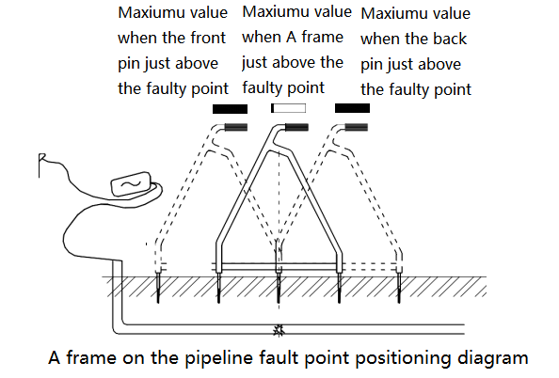

      - If you can not determine the position of the pipeline during the search for a fault, you need to press the mode key to change the working mode to a single horizontal coil, a bi-level coil or a vertical coil mode to precisely target the target line. After positioning is complete, press the mode key again, select the external signal mode, continue to find the fault point.
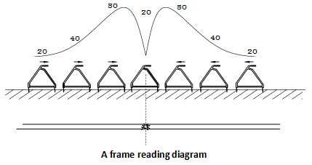
      - As can be seen from the figure above: When the A-frame is close to the point of failure, the horizontal signal of the receiver will gradually increase (the reading in the figure is only a diagram showing the change of the signal size as the detection position is different).
      - When you need to pinpoint the fault point, turn the A frame to the exact location where the fault point is found when you are perpendicular to the cable. At this time the position of the A-frame is the top of the fault point.
      - If the cable in the cement, asphalt pavement below, you can use a special signal pick up the probe, can effectively solve the other instruments can not be in the cement, asphalt pavement detection problems. If necessary, you can use water to wet the road. This will be better.
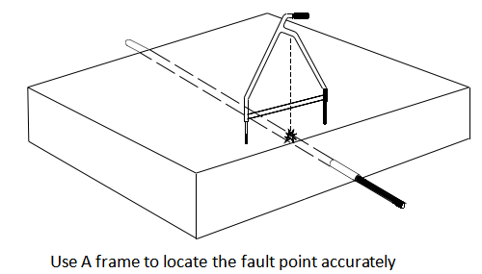

X. Accessories And Optional Accessories
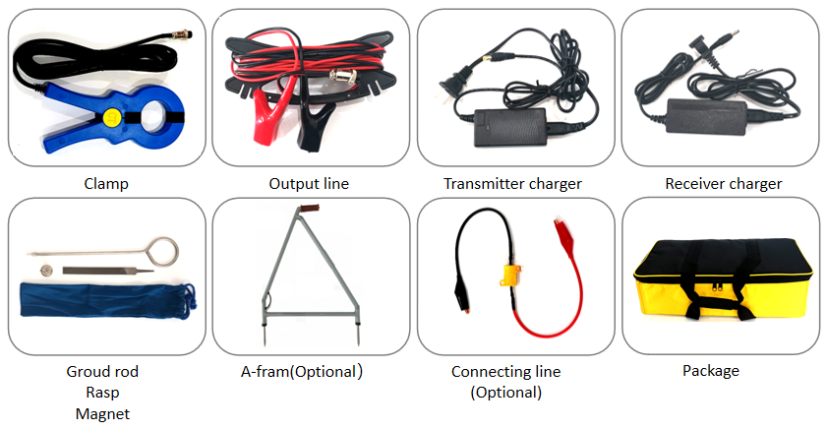

XI. Technical Terms
  - This manual uses a number of terms, which are explained as follows:
    - Active Source Signal: Signed and applied to the pipeline with this Series Pipeline Transmitter.
    - Passive source frequency signal: the power cable naturally generated 50Hz signal. CPS signal: cathodic protection current signal.
    - Pipeline: A continuous underground metal pipe, cable, or other conductor capable of conducting current.
    - Target pipeline: refers to the pipeline exploration project needs to detect the pipeline.
    - Positioning: Determine the position of the target pipeline at the ground level according to the result of the pipeline meter.
    - Response: The receiver detection signal is indicated in its display or speaker. By adjusting the sensitivity of the receiver, you can change the response of a signal.
    - Search: Use the receiver to search for all target pipelines within a region.

Disclaimer: Product and accessory specifications and availability information are subject to change without notice.

