
HZ-B
Cable Fault Precise Determination Point Tester

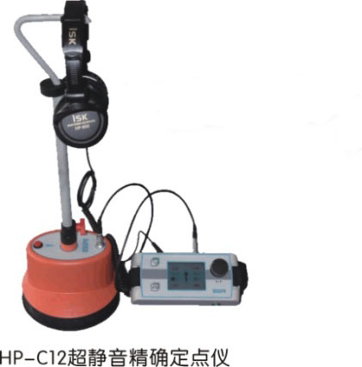

Huazheng Electric Manufacturing (Baoding) Co., Ltd
Contents

I. Overview 1
II. Technical characteristics 1
III. Technical parameter: 1
IV. On-site installation and operation of HZ-B cable fault precise determination point tester 3
V Start to use cable fault HZ-B pinpoint tester 5
VI. Packing List 7

Overview
Because of the extreme complexity of the power cable laying environment, pinpointing points has always been a critical step in cable fault testing. Even with an accurate rough side distance, it is difficult for us to locate quickly and accurately due to the influence of the external environment. The HZ-B cable fault precise locating instrument is a portable, ultra-quiet, visual impact discharge receiving precise locating instrument. It is specially used in conjunction with a high-voltage impact generator. It adopts leading background intelligent noise reduction and sound tracking new technologies to achieve Continuous optimization, perfect sound effect, record the characteristic sound of impact discharge and the signal that will be picked up at the scene to achieve comparison.
When HZ-B uses continuous impulse discharge at the front end, the impulse discharge sound of the fault point within the distance of the thick side propagates on the ground above the cable and is recorded by the ground-penetrating sensor on the ground. The distance between the detection point and the real fault point of the cable can be obtained by the method of impact discharge noise volume.

II. Technical characteristics
◆ Ultra-quiet noise reduction processing, excellent sound quality of discharge sound, the background is quieter, monitor earphones are used to quickly and reliably locate the fault location.
◆ Using ultra-quiet technology and BNR intelligent background noise reduction technology, you can adjust the impact discharge volume.
◆ Molded design of a special self-falling ground sensor, and equipped with a soft pavement, hardened pavement, lawn sensor joint.
◆ Reliable imported connectors are selected to ensure the purity of the sound, and the height-adjustable probe handle is humanized, which is very suitable.

III. Technical parameter:
◆ Sensor dynamic range: sound channel> 104dB.
◆ The impact discharge sound amplification factor > 90dB, and the upper limit of impact discharge volume is 84dB (A).
◆ Liquid crystal display: high-bright true color screen, 320 x 240 pixels, suitable for outdoor.
◆ Continuous working time on site: Alkaline replaceable battery, convenient for on-site use
- Standard configuration：
- One receiver host, model HZ-B, with shoulder strap
- A sensor (ground microphone).
- One height-adjustable handle, height range 450 – 750 mm
- One headphone with sound quality
- One signal line, connecting the main unit of the receiver with the sensor, 1.20 m long
- One hard ground probe, 18 mm long
- One grass probe, 75 mm long
- 6 alkaline batteries of type 5, type IEC R6
- A manual
- Receiver host connection and control
The following figure shows the connection method and control buttons of the HZ-B receiver host：
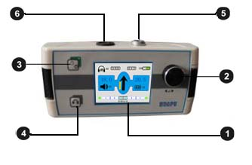
、LCD Monitor 、One-key adjustment key,、The receiver main unit is turned on (the red LED indicator flashes after a long press for 10 seconds) / shutdown (after a long press for 3 seconds) 、Mute on / off、Connect the socket, connect the sensor、Connect the socket, connect the headset

IV. On-site installation and operation of HZ-B cable fault precise determination point tester
HZ-B cable fault precise determination point tester is turned on, sensor preparation
- Connect the sensor to a suitable probe or probe
The HZ-B sensor can be connected to two different probes. The standard configuration includes an 18mm long hard ground probe and a 75mm long grass probe. The above probes and probes can be screwed on to suit various ground cover conditions.
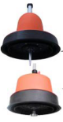
Grass probe: 75mm long, suitable for grass or soft covering

Hard ground probe, 18mm long, suitable for smooth ground, such as asphalt pavement.

- Connect the sensor to the handle
The figure below shows how to connect the adjustable handle to the sensor：
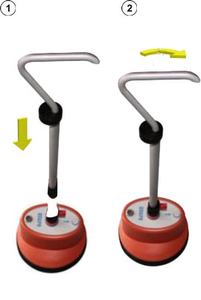
- Adjust the height of the handle
The figure below shows how to adjust the height of the handle：
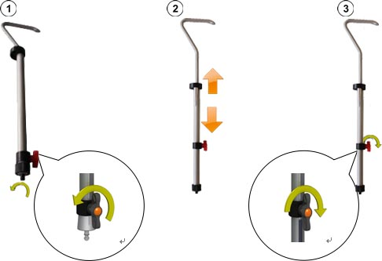
- Connect the sensor and earphone to the receiver host
Connect the headset to the black socket  of the receiver. Be careful to align the white marks on the plug and socket. The plug is plug and play, please do not rotate!
Connect the cable to the sensor

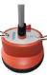
Ventilation valve Do not open it! Do not use force!

- Introduction of HZ-B cable fault precise determination point tester receiver host
5.1 Power on the receiver
The host can be turned on or off after pressing the power on / off key  of the receiver. After more than ten seconds, the host computer of the receiver is ready to use, then the test interface will be displayed。
5.2 Battery self-test
When you turn it on, please look at the upper right corner of the monitor to check the remaining capacity of the alkaline battery. If you find that the percentage of battery power is close to 25%, please charge it first, and then use it after the power is greater than 50%.
5.3 One-touch knob of HZ-B cable fault precise determination point tester
The receiver host is one-touch single-key adjustment. For the use of one-touch adjustment keys, please refer to the figure below：
Gesture | Function of measurement interface
 | Adjust the volume (sound amplification factor)

5.4 Measurement interface display
The HZ-B cable fault precise determination point tester provides the sound signal in the earphone. When you are approaching the fault point during the precise determination point, the tester displays relevant useful information through the measurement interface.
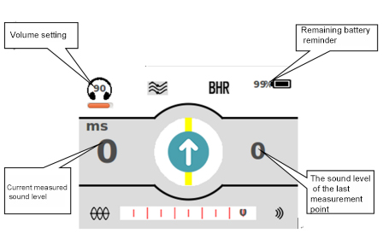

V Start to use cable fault HZ-B pinpoint tester
Please connect the high-voltage integrated impulse generator (high-voltage unit) to the faulty cable, and start to apply the appropriate impulse voltage to cause flashover breakdown discharge at the fault point of the faulty cable. The appropriate impulse voltage refers to the model suitable for the cable under test, and the highest allowable impulse voltage will not cause damage to the cable under test. For more details about the use of high-voltage impact generators (high-voltage units), please read the product's integrated high-voltage power supply operating instructions.
1 Precise point operation procedure
When you are close to the point of failure, please follow the sequence of procedures below：
Steps | Action
1 | Place the HZ-B's ground-penetrating microphone in the starting position.
2 | If HZ-B cannot pick up any sound signal at this measuring point. Please follow the path of the cable under test. When you find that HZ-B receives the first useful impact discharge sound signal, the left side of the LCD of HZ-B host will automatically display the sound level of the measurement point.  If you are unable to pick up the shock discharge sound signal through a ground-penetrating microphone or headphones in a long area, you should try to make a precise point from the starting point in the opposite direction.
3 | Please continue to follow the path of the cable under test and move one step at a time. If necessary, adjust the position of the central axis of the cable under test at any time. At each measurement point, please stay a few impulse discharge pulse signals.  When you are near the cable fault point, you will hear a stronger knocking sound, and the sound level of the current measurement point displayed by HZ-B will suddenly increase.
4 | Please rotate the HZ-B ground-penetrating microphone 180 ° and use a smaller step to approach the fault point again.
5 | Please continue to reduce the step distance, look for the place where the fault is the loudest, and determine the location of the fault point as accurately as possible. Then make an accurate mark on the ground.

2 Shutdown of the HZ-B cable fault pinpoint tester：
3 Please long press the power on / off button on the main unit of the HZ-B cable fault pinpointing tester.
Note: This tester can only be operated by trained and experienced professional electrical workers. Other unrelated persons should stay away from this instrument.
This instrument can only be used by authorized electrical professional staff. The electrical professional staff refers to holding the high-voltage electrician license and above qualification issued by the State Electricity Regulatory Commission, with sufficient professional knowledge, work experience, and familiarity with each. People in this discipline.

VI. Packing List
No. | Item | Qty
1 | Pointer upper computer | 1
2 | Pointer lower computer | 1
3 | Data cable | 1
4 | Headphones | 1
5 | Handle | 1
6 | Ground needle | 1
7 | Charger | 1

