HZKS-3
Open Cup Flash Point Tester

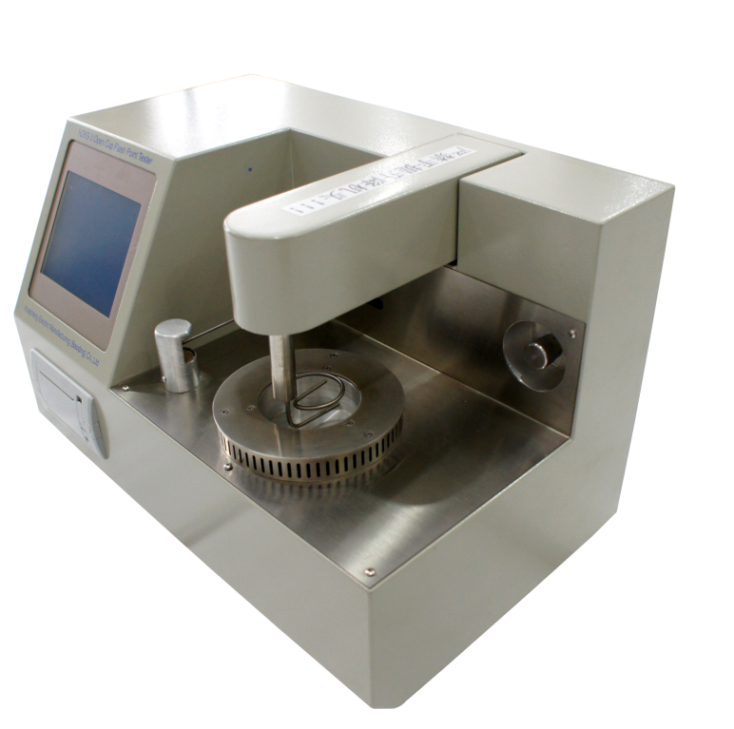

Huazheng Electric Manufacturing (Baoding) Co., Ltd

Contents

I.Safety Instructions 1
II.Function Overview 1
III.Instrument Features 1
IV.Technical Parameters 2
V.Instrument Structure And Installation 2
VI.Use Method And Operation Procedure 3
VII.Precautions And Instrument Maintenance 8
VIII.Failure And Treatment 8
IX.Packing List 9

I.Safety Instructions
1.Be sure to use a grounded outlet for the instrument’s power supply.
2.No touching the Oil Cups and its nearby parts during test, in case of scald.
3.There must be someone on duty during the test. Cover oil cup lid in time if the sample is burning after the test is completed.
4.No touch the oil lid because of high heat.
5.Do not touch the ignition rod by hands; otherwise it will cause permanent damage to the instrument!

II.Function Overview
Flash Point is the lowest temperature at which a liquid can form an ignitable mixture in air near the surface of the liquid. The lower the flash point, the easier it is to ignite the material. Nowadays, Flash point is used to say non-volatile or flammable substances whether exit highly volatile or flammable substances, and has been one of the most important parameters for petroleum products transportation, storage, operations, safety management.
HZKS-3 Automatic open flash point tester is designed and made as per the National Standard of People’s Republic of China GB/T267- 88; GB/T 3536-2008; European standard;ASTM-D92, it is an advanced analytical instrument, mainly used to determine the open flash point of petroleum products.

III.Instrument Features
HZKS-3, with touch screen to replace the keyboard operation, is used to measure the open flash point value of petroleum products. Using advanced technology abroad, LCD screen full English display man-machine dialogue interface, full screen touch keys, convenient and fast, open beam, fuzzy control integrated software, modular structure.
1.Standard modular design, one main engine can control the number of open or closed test furnaces, be freely exchanged between the test furnace, According to user needs, greatly improving the efficiency and economic benefits.
2.High-speed signal processor controlled, high-precision analog / digital converter circuit, the instrument is reliable and high precision.
3.Auto-ignition.
4.Automatic measurement of atmospheric pressure and automatic correction.
5.Adaptive PID control algorithm to automatically adjust the temperature according to standard curve.
6.The whole experiment process is completed automatically, including detection, opening the cover, ignition, alarm, cooling and printing.
7.Automatically stop detection and alarm when the temperature is out of range.
8.Thermal micro-printer, making printing more efficient and more beautiful, with off-line printing.
9.History records with time stamp, up to 256.
10.Large screen with 320x240 graphical LCD display, showing a rich, full character display.
11.touch screen operation, friendly interface; The screen saver function, extend the life of the LCD.
12.Interface, RS232 interface for printer or downloads on PC.

IV.Technical Parameters
- Temperature Measurement
- Temperature measuring range: -59.9°C～399.9°C
- Temperature Control Range: Room temperature～350°C
- Repeatability: ≤150℃ 3℃
＞150℃ 5℃
- Resolution: 0.1°C
- Precision: 0.5%
- Temperature Sensor: Platinum Resistor(PT100)
- Flash Fire Sensor: Ion detection ring
- Ambient Temperature: 0 ~ 40°C
- Relative Humidity: ≤ 85% RH
- Power Supply: AC220V ± 20% ; 50HZ ± 10%
- Power Consumption: approx 400W
- Overall Dimension: 440X280X290(mm)
- Instrument Weight: 14kg

V.Instrument Structure And Installation

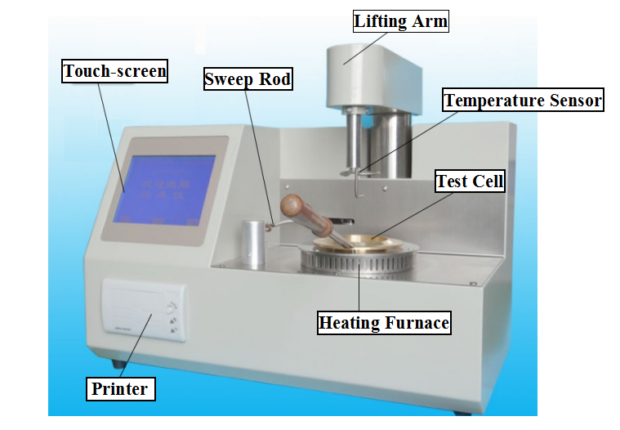
（1）Instrument Installation
- Unpack the instrument and make sure that the equipment is in good condition.
- Check instrument model and all accessories according to the packing list.
- Please debug the instrument after inspection step 1 & 2
（2）Starting-up Preparation
- Insert the furnace plug into AC220V three-wire power socket, and the socket should be based on clear and reliable grounding
- Connect the test furnace and main engine with dedicated instruments dedicated cable
- Clean the oil cup with petroleum ether, pour sample liquid into the oil cup to the scale mark, and put into the heater
- Correctly install the oil lamp and platinum alloy electric ignition wire ignition head

VI.Use Method And Operation Procedure
（1）Test Procedure
- Turn on the power and the Screen displays a welcome screen shown in Figure1.
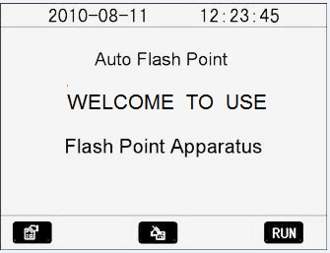
Figure 1
Touch the “” key, enter the parameter setting function screen, as shown in Figure 2.
Touch the “”key, enter the history function screen, as shown in Figure 3.
Touch the “” key, enter the measure function screen, as shown in Figure4.
- Parameter adjustment function screen.
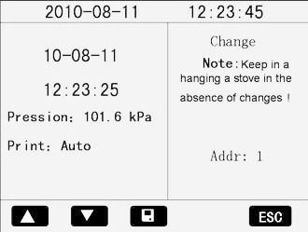

Figure 2
Use your finger or touch pen to select what needs to be modified.
Touch the "▲"and "▼" key to adjust the number selected.

Touch the " " key to store settings
Touch the "ESC" key to back the first screen, as shown in Figure1.
Change Stove Address：
Particular attention：Change it in the case of only one furnace!
The method is as follows：Touch the number behind “Addr”, adjust the digital using“▲”、“▼”key and then press“ ”key after the modification.
- History Function Screen
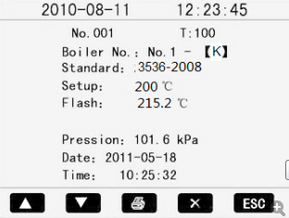
Figure 3
Touch the “▲” and “▼”key to view record sequentially
Touch the “” key to print the history out by the mini-printer of the instrument
Touch the “” key to delete the selected record in the history
- Measure function screen
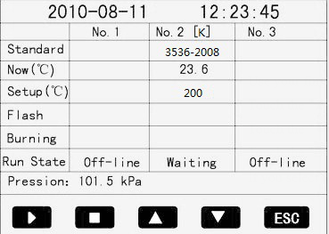
Figure 4
Touch“No.1”、“No.2”、“No.3”to select the stove。
Touch “Standard”、“Setup” below the selected stove, touch“▲”、“▼”key to adjust;
When select “Standard”, press“▲”、“▼”to select, if “user def” is selected，then touch " user def" twice into a custom parameter setting screen, as shown in Figure 5.
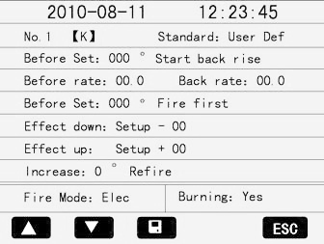
Figure 5
Use your finger to select project needed to be modified.
Touch the "▲"and "▼" key to adjust the number you have selected
Touch the "" key to store settings
Touch the "ESC" key to back the first screen, as shown in Figure4
If you select other standards after double touch, the screen is shown in Figure6.
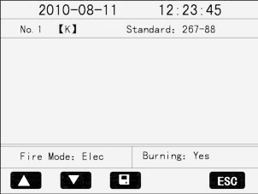
Figure 6
In this picture, you can only change “Fire Mode” or “Burning”.
- In Figure4, touch the“ ”key to start the test, touch the“ ”key to stop the test, and the corresponding testing furnace exits test state, and starts the cooling fan.
- Touch the“▲”key, and the selected stove will rise furnace arm; Touch the“ ”key to stop rising, and stop the cooling fan.
- Touch the“▼”key, and the selected stove will fall furnace arm; Touch the“ ”key to stop falling, and stop the cooling fan.
Pre flash settings should follow the following method: when the flash point value of 200℃, set the pre-flash value should be 10℃ lower than the flash point value, 190℃; If the oil flash point temperature is unknown, the setting value should be set to flash temperature threshold value, then by low temperature to high temperature setting.
- Touch the “ESC” key to exit the test, then all the stoves will stop any action, and return to Figure 1
- The instrument automatically tests the current atmospheric pressure. According to the selection standard, automatically calculate flash point correction value, displayed on the test screen.
- The open and closed type is determined by hanging stove.
- The result of test
The Apparatus tests the flash point in accordance with the testing process required by the selected execution standards and make the pressure correction, record the test results, and start the cooling fan, as shown in Figure7.
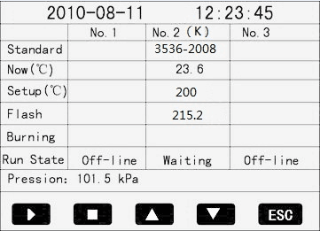
Figure 7
The instrument detects all kinds of faults and prompts the user in the testing process. The users can adopt the corresponding solutions according to the fault tip elements.
The information of run state:
- Cooling: Is cooling
- Testing: Being tested
- Test End: End of test
- Online: The communication is normal
- Off-line: Not online
- Rising: Is on the rise
- Falling: Is falling
- Hot!: Over temperature limits
- Machine!: Mechanical fault
- Sensor!: Sensor fault
- Setup↑!: Pre flash high
- Flash↓!: flash point is low
- Waiting: Waiting for the test
- Burning: Ignition test
- Flash: Flash point test
The cooling fan has two starting method:
1、In test, press the " " key to exit the test, and start cooling fan at the same time.
2、Test process ends or other reasons apparatus consists of testing process into a stop test status, activates the cooling fan.
There are four ways to stop cooling fan:
1. Touch the" ESC" key to exit the test screen, at the same time to stop cooling fan
2. Modification of pre flash value, stop cooling fan.
3. Touch the" ▲" key, then touch the " " key, stop rising at the same time to stop cooling fan.
4. Touch the" ▼" key, then touch the " " key, stop falling at the same time to stop cooling fan.

VII.Precautions And Instrument Maintenance
（1）The instrument should be used in a non-corrosive environment.
（2）The oil cup should be cleaned, when replacing test sample.
（3）Check thermocouple should not have oil contamination, or it will affect the detection sensitivity.
（4）No touch ignition head, oil cup and its surrounding parts to avoid scorching during the test.

VIII.Failure And Treatment
NO. | Failure | Treatment
1 | Turn on the power,  the LCD screen no display | Check power supply is plugged in, open the instrument measured the board examine the plug is not loose.
2 | Large repeatability error for sample testing | Remove the lifting arm top cover, and check  1. whether the mixer shaft is broken  2. Oil may effect on thermocouple sensitivity, plz dry it by filter paper
3 | No heating | Electric wire broken
4 | Lift arm rise or fall failure | Limit opt coupler damage  The screw between main engine and lift arm fell off

IX.Packing List
No. | Item | Qty
1 | Main engine | 1
2 | Test cup | 1
3 | Fuse pipe | 2
4 | Power line | 1
5 | Touch pen | 1
6 | Fire cover | 1
7 | Print paper | 1

