HZBS-3 Closed Cup Flash Point Tester

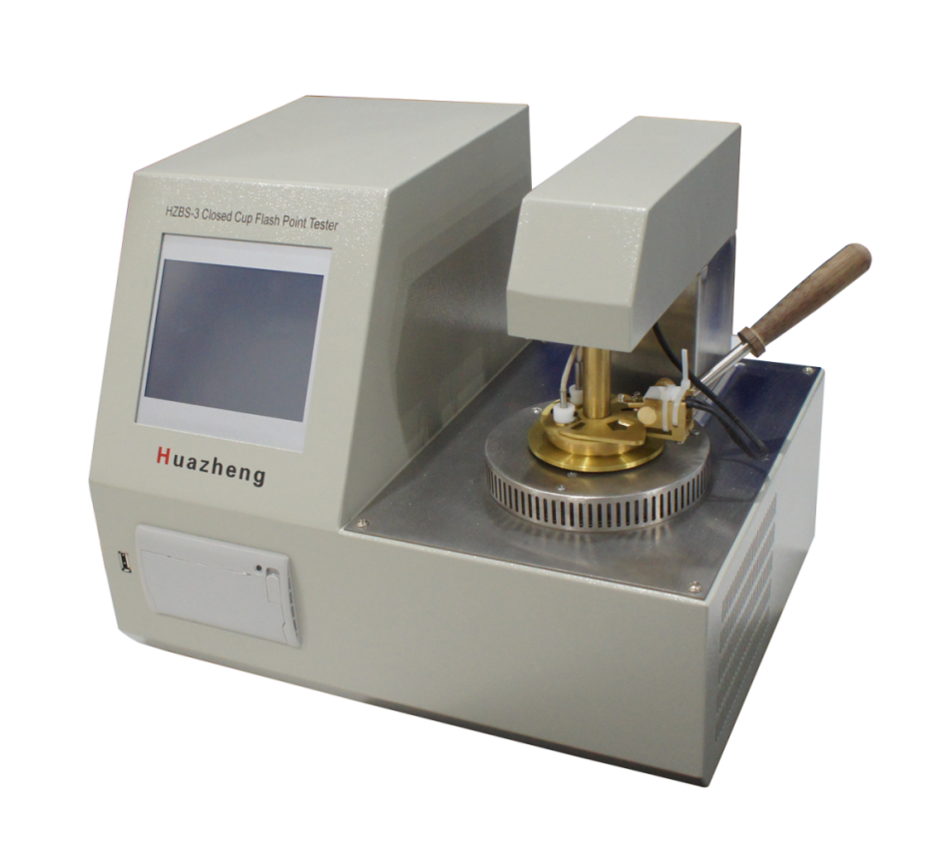

Huazheng Electric Manufacturing (Baoding) Co., Ltd

Safety Instructions

1.Be sure to use a grounded outlet for the instrument’s power supply.
2.No touching the Oil Cups and its nearby parts during test, in case of scald.
3.There must be someone on duty during the test. Cover oil cup lid in time if the sample is burning after the test is completed.
4.No touch the oil lid because of high heat.
5.Do not touch the ignition rod by hands; otherwise it will cause permanent damage to the instrument!

Contents

I. Main Functions And Features 1
II.Working Principle 1
III. Main Technical Index 2
IV. Instrument Structure And Installation 3
V. Usage And Operation Procedures 3
VI. Precautions And Instrument Maintenance 15
VII. Failure And Treatment 15
VIII. Packing List 16

I. Main Functions And Features
HZBS-3 Closed Cup Flash Point Tester, color touch screen instead of keyboard operation. Used to determine the closed flash point value of petroleum products. Adopt advanced foreign technology, convenient and fast, open, fuzzy control integrated software, modular structure. The instrument meets the ISO2719 standard, national standards, the United States and other standards. It is an ideal substitute for imported instruments. It is widely used in railway, aviation, electric power, petroleum industry and scientific research.
Main technical features and functions of HZBS-3 automatic closed flash point tester:
1.The new high speed digital signal processor is adopted to work reliably and accurately.
2.Test, open cover, ignition, alarm, cooling, printing, the whole test process is completed automatically.
3.This instrument uses electric ignition;
4.Automatic measurement of atmospheric pressure and automatic correction of test results.
5.Using the newly developed high power high frequency switching power heating technology, the heating efficiency is high, and the adaptive PID control algorithm is adopted to automatically adjust the heating temperature curve.
6.Temperature overvalue automatically stops detection and alarm.
7.Thermal - sensitive micro-printer, makes printing more beautiful and faster, with offline printing function.
8.Historical test records with time markers are stored up to 50.
9.640x480 color touch screen, easy to operate.
10.Using full-screen touch screen keys, intuitive and convenient operation.
11.Built-in multiple execution standards to choose from.

II.Working Principle
The equipment under the conditions stipulated in the national standard, put the sample into test cup, affect the heating experiment of oil cup, with the oil vapor ambient air and gas with the lowest temperature will ignite a flame as a flash point. The digital signal processor controls the heater according to the temperature change, so that the test oil temperature rises at a certain rate. Automatic control of ignition and flash detection; When the flash is measured, the system stops data collection, displays the flash temperature, prints the recording results, and stops heating.

III. Main Technical Index
- Temperature Measurement
Temperature measuring range: -49.9°C～400.0°C
Temperature control range: room temperature～250℃
Repeatability: 0.029X(x=twice successive test average value)
Resolution: 0.1°C
Precision: 0.5%
Temperature Sensor: Platinum Resistor(PT100)
Flash fire detection: K Thermocouple
- Ambient Temperature: 10 ~ 40°C
Relative Humidity: ﹤ 85% RH
Power Supply: AC230V
Power Consumption: ﹤ 500 W
- Heating rate: in line with national standards, the United States and other standards
- Overall Dimension: 390X300X302(mm)
- Instrument Weight: 15 kg

IV. Instrument Structure And Installation
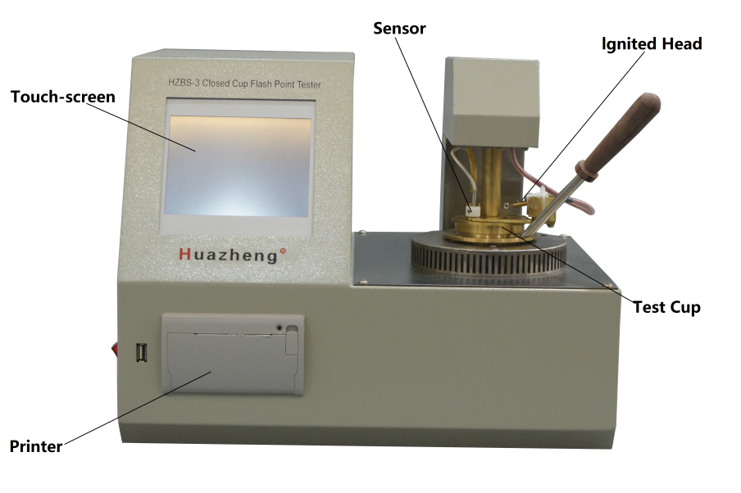
- Instrument Installation
- Unpack the instrument and make sure that the equipment is in good condition.
- Check instrument model and all accessories according to the packing list.
- Please debug the instrument after inspection step 1 & 2.
- Starting-up Preparation
- Connect the instrument to the AC 220V power supply;
Note: Always use a power outlet with a reliable ground to power the instrument;
- Clean the oil cup with petroleum ether, pour sample liquid into the oil cup to the scale mark, and put into the heater.
- Install the platinum alloy electric heating wire ignition head correctly.

V. Usage And Operation Procedures
1、Test Procedure
①、Turn on the power switch, and see figure 5-1 for the screen display device in self-inspection.
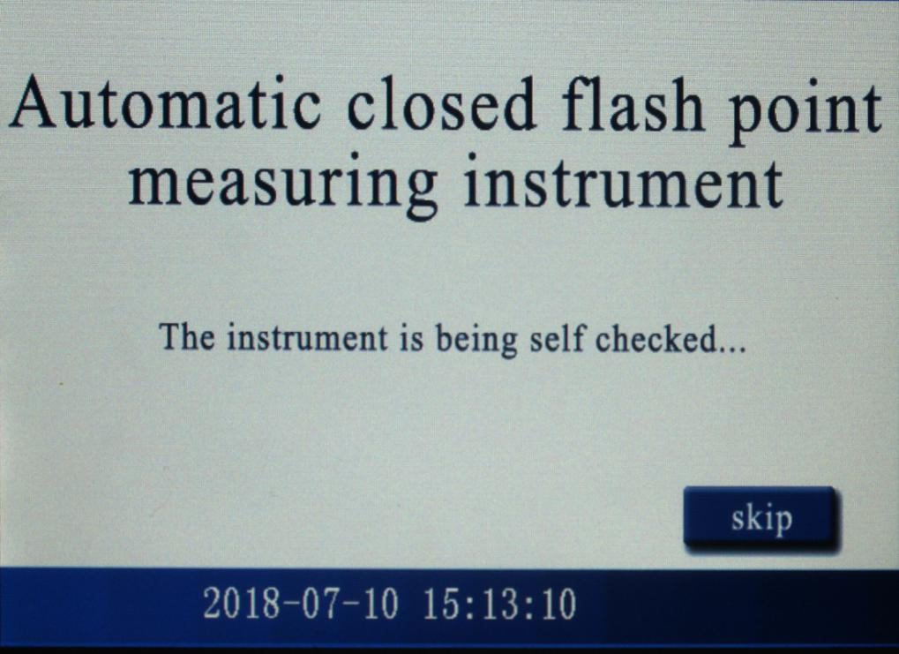
FIG. 5-1 starting interface diagram
Press "skip self-check" to enter the main interface of the instrument, as shown in figure 5-2.
②、Main interface screen of the instrument：
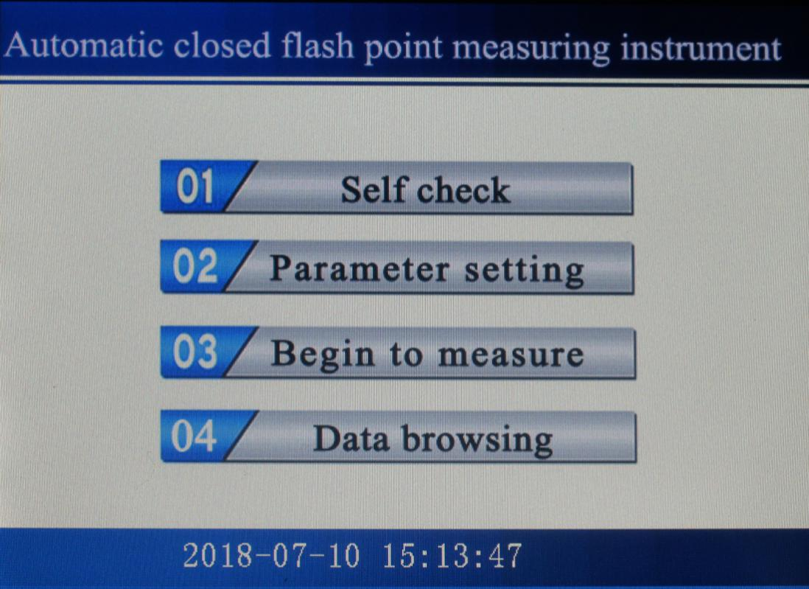
Figure 5-2 Main interface diagram of the instrument
Press the "instrument self-inspection" button to enter the device self-inspection screen, as shown in figure 5-3.
Press the "experimental parameter setting" button to enter the function screen of parameter setting, as shown in figure 5-5.
Press "test flash measurement" button to enter the function screen of flash point measurement, as shown in figure 5-7.
Press“the data browse and query”button to enter the historical data query screen, as shown in figure 5-11.
③、Function screen of instrument self-check：
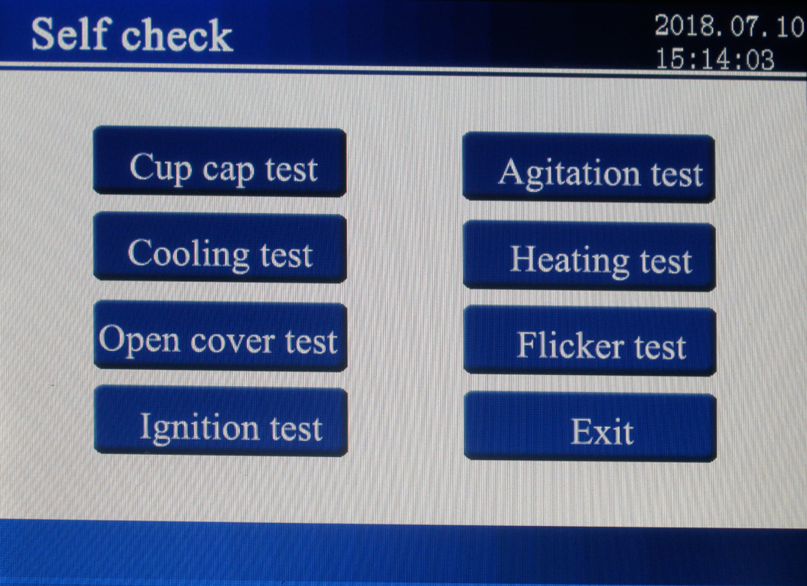
FIG 5-3 Main interface diagram of the instrument
Test the performance of the functional module of the instrument by touching (or touching with a touch pen) the item to be inspected by oneself; For example, press the " Cup cap test" button to enter the functional screen of the cup cap test, as shown in figure 5-4: 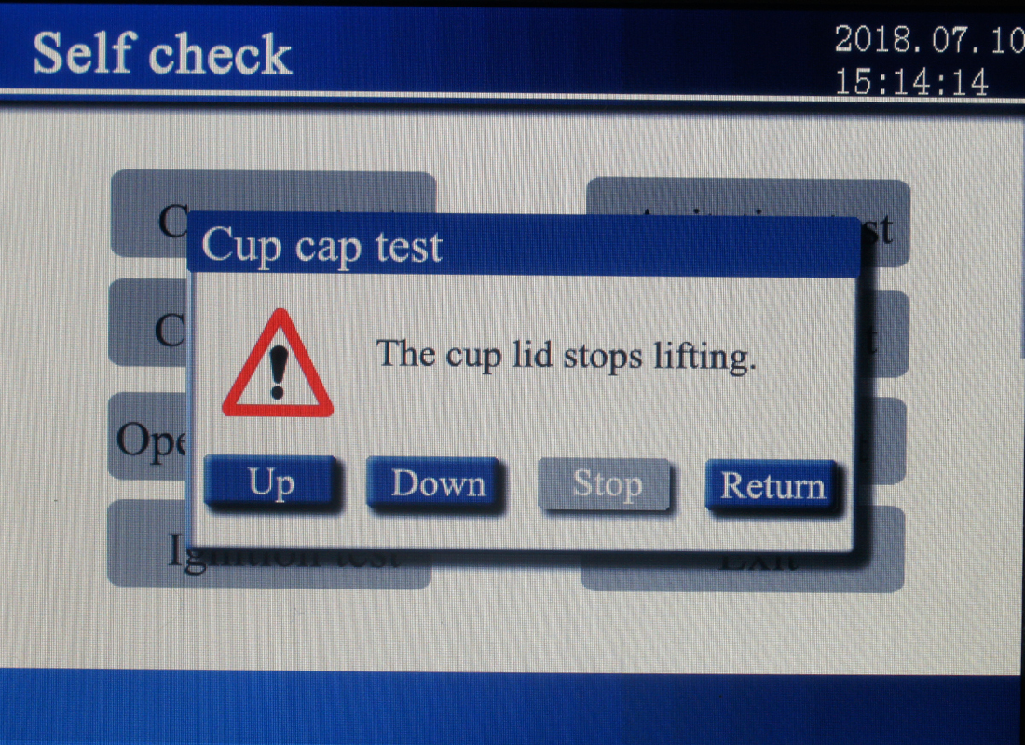
FIG. 5-4 Cup cap test
Press the "up", "down", "stop" and "return" keys, and the instrument will respectively carry out the operations of lifting the cup cap, lowering the cup cap, stopping the lifting and returning. Other self-check items can be operated according to the prompt interface.
④、Function screen of Parameter setting：
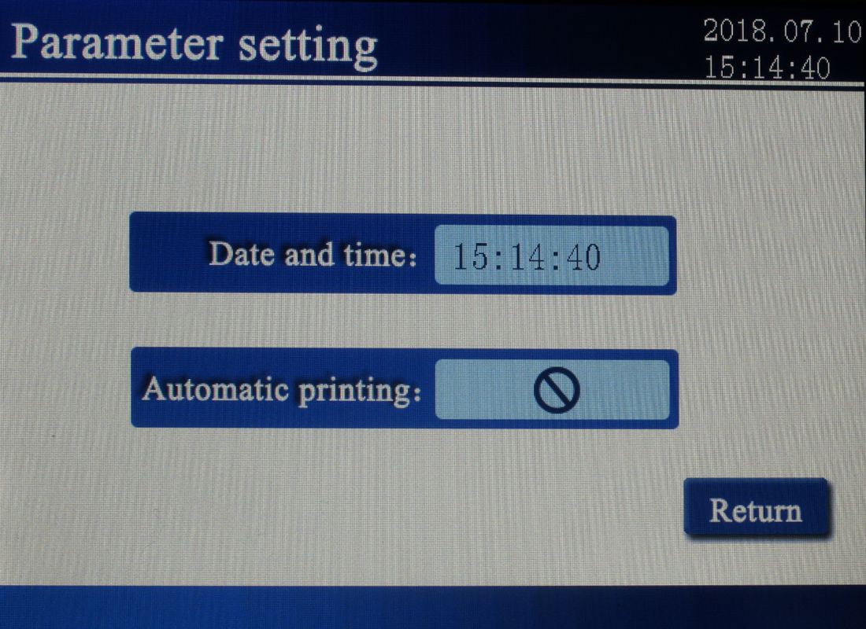
FIG. 5-5 Parameter setting
Touch with your finger (or with a touch pen) the item you want to modify；Click on the time screen to bring up screen 5-6.
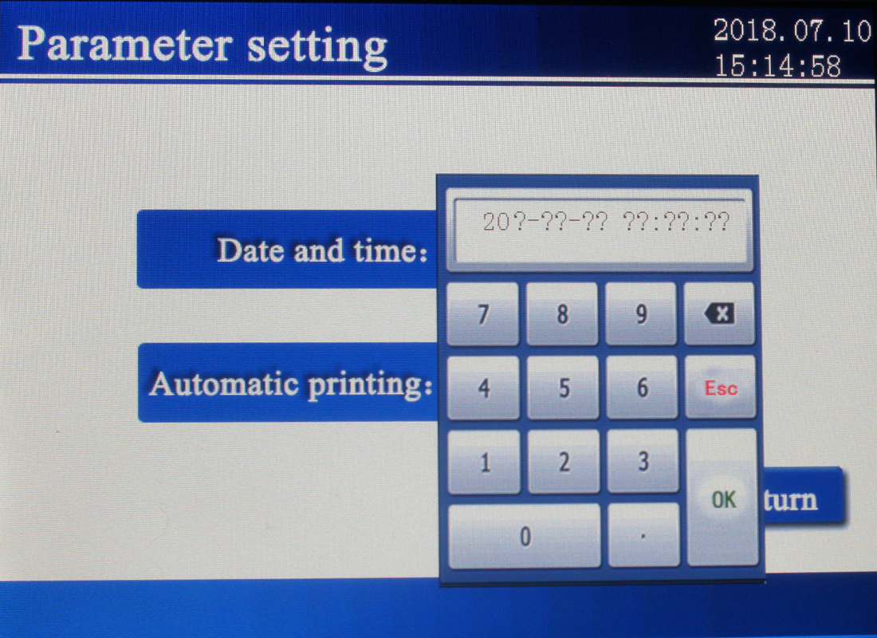
FIG 5-6 modification time
Enter the time of year, month, and day in order. Click "OK" to complete the time change. Otherwise, click "ESC" to return. Click automatic printing directly to change the printing mode, that is, whether to automatically print the experimental results after the end of the experiment.
⑤、Function screen of Test setting：
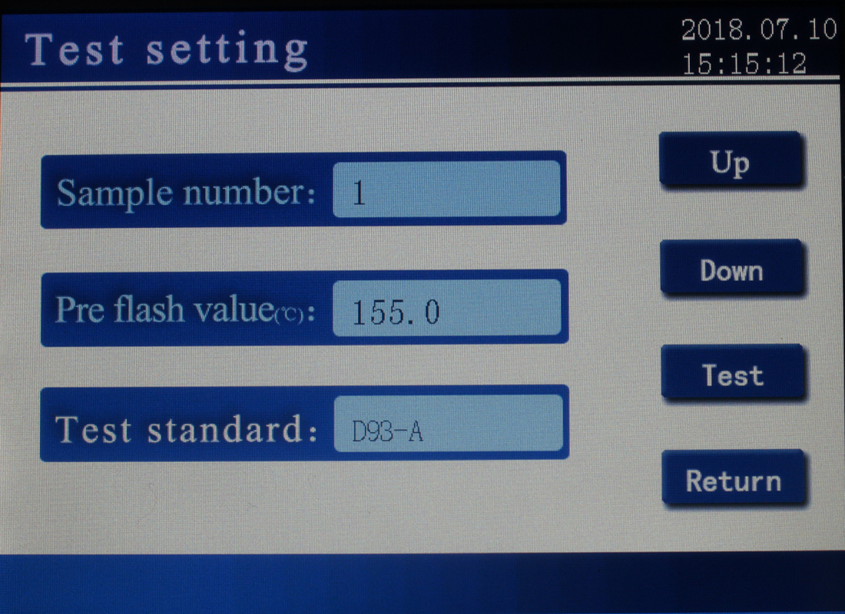
FIG 5-7 Parameter setting of Test setting
◆Touch with the finger (or with the touch pen) the corresponding parameter display box to change the corresponding parameters. When clicking the sample method, enter the test standard selection screen. Figure 5-8.
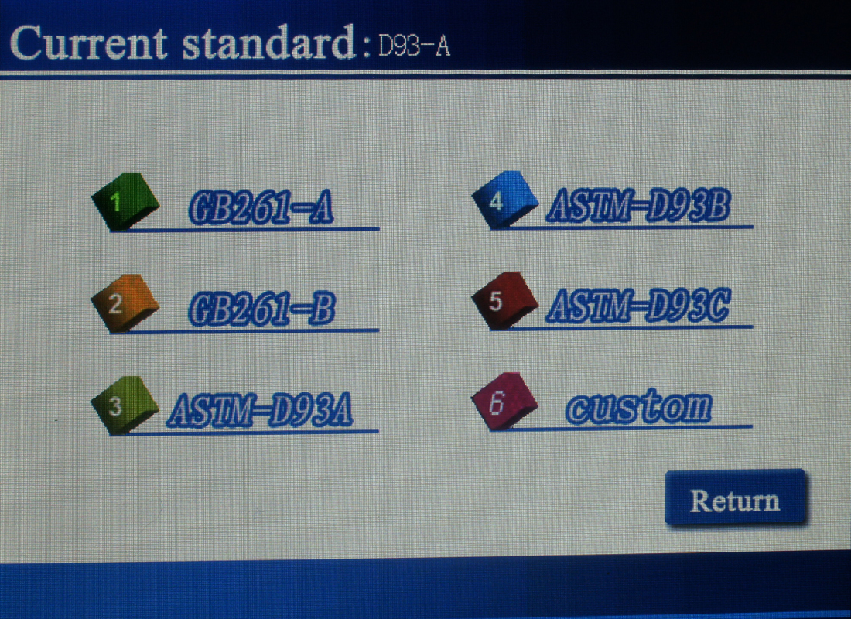
FIG 5-8 Current standard selection
You can choose “custom”, set various parameters according to your own needs, and click “OK” save Settings. Such as picture 5- 9.
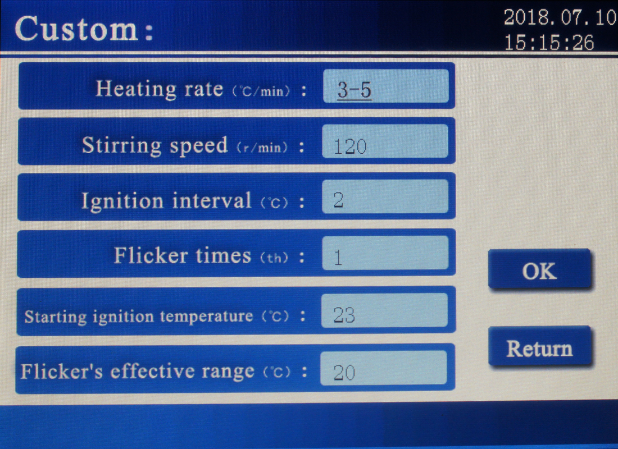
FIG 5-9 Custom parameter setting
◆Parameter setting is completed, and return to screen 5-7 sample test parameter setting interface.
Press the button of "Cup cap rising", take out the sample cup and put in the oil sample, press the button of "Cup cap falling" to drop the lid to prepare the test, press the button of "test", and the instrument starts to determine the flash point of oil sample, as shown in fig.5-10. 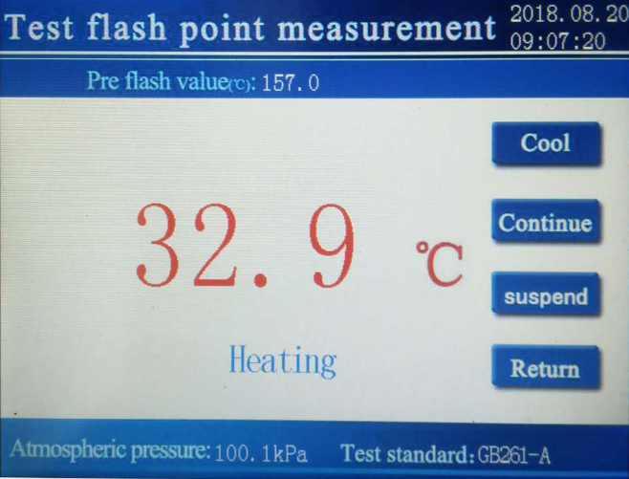
FIG 5-10 Sample testing
In the state of trying to fire, the button is invalid, and in other states the button is valid. After the successful test, the instrument displays the test results as shown in figure 5-11.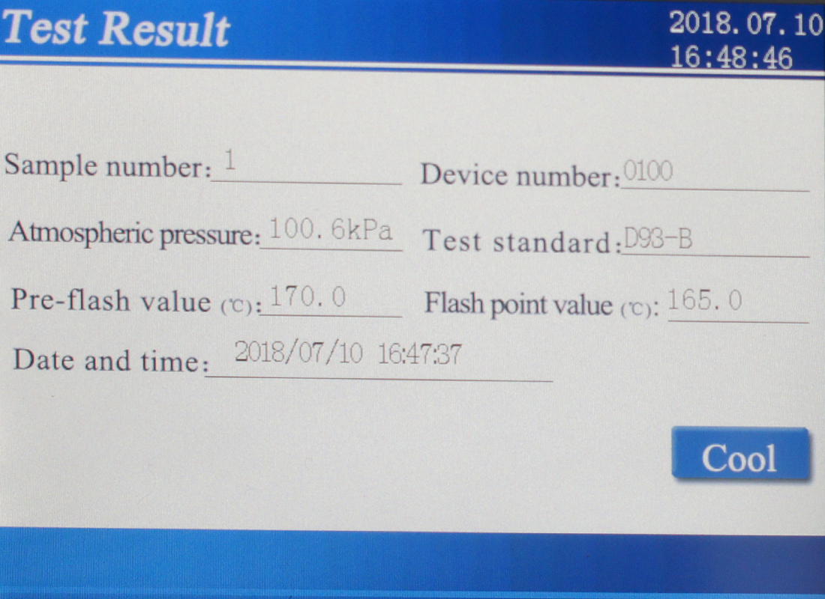
FIG 5-11 Test result
Click the "Cool" button to open the cover of the instrument for heat dissipation. If the test is not successful, the corresponding error prompt window will pop up, and then the interface as shown in figure 5-10 will be displayed. Click to “Cool”, the cooling process needs to be stopped manually. In the process of testing, the instrument detects various faults and prompts the user. The user can take corresponding solutions according to the fault prompts.
Estimated flash value setting method: When the oil sample flash point is known, the flash point value of the oil sample can be set as the estimated flash value. When the oil sample flash point is unknown, the flash point sets the flash point estimated value of the oil sample, and then the test stops. Then reset the estimated flash value according to the instrument prompts.
Press the “Exit” button to exit the test state and the test furnace stops any action and returns to screen 5-7.
The instrument automatically tests the current atmospheric pressure value, automatically calculates the flash correction value according to the selected execution standard, and displays it in the test screen.
⑥、Date Browsing screen：
The instrument keeps 99 groups of test data recently measured, and data records are shown in FIG. 5-12.
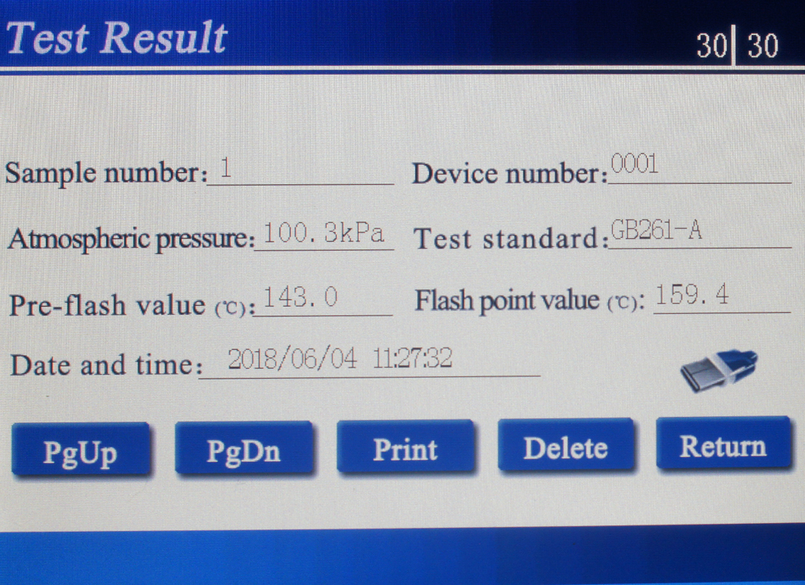
FIG 5-12 Test result screen
Press "page up" and "page down" to view records; Press the "print" button to print the record through the instrument's mini-printer. Press "delete" to delete the record from the history of the instrument; Press "exit" to return to screen 5-2; Click the usb drive icon to export the data usb drive.
If there is no data record, enter screen 5-13. 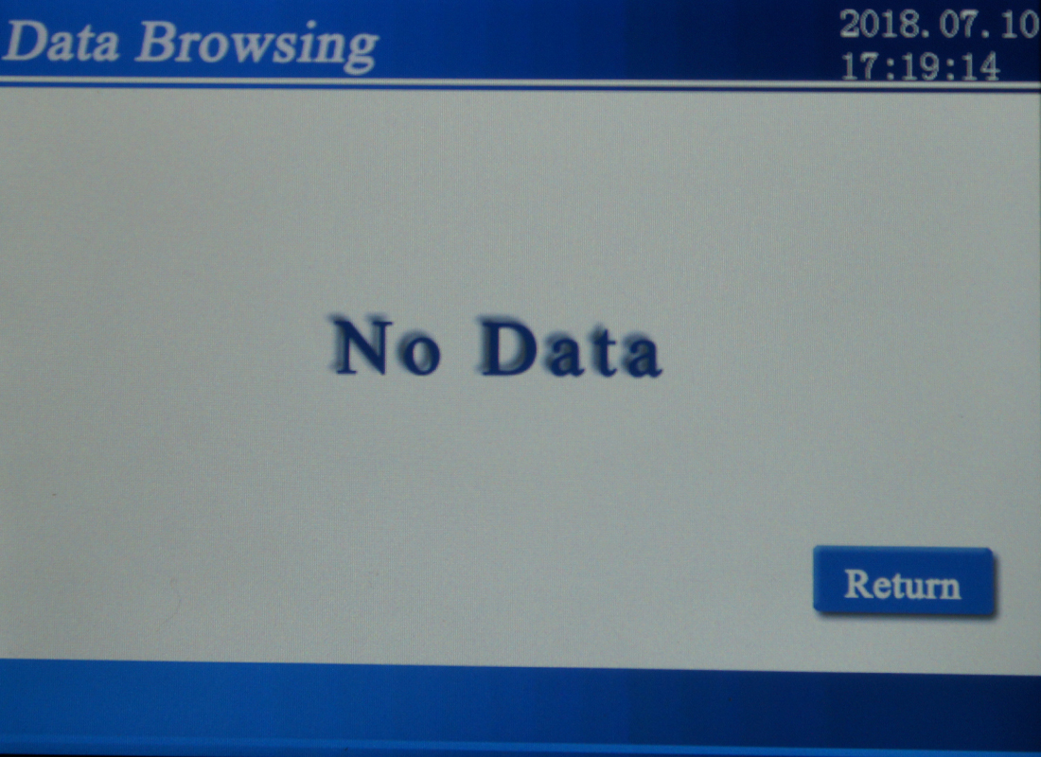
FIG 5-13 No data screen

VI. Precautions And Instrument Maintenance
- The instrument should be used in a non-corrosive environment.
- The oil cup should be cleaned, when replacing test sample.
- Check thermocouple should not have oil contamination, or it will affect the detection sensitivity.
- No touch ignition head, oil cup and its surrounding parts to avoid scorching during the test.
5）For instruments that use electric ignition, the electric ignition head needs to be replaced regularly.Change ignition wire for 1000 times (about 80-100 trials).

VII. Failure And Treatment
NO. | Failure | Treatment
1 | Turn on the power,  the LCD screen no display | Check power supply is plugged in, open the instrument measured the board examine the plug is not loose.
2 | Large repeatability error for sample testing | Remove the lifting arm top cover, and check  1. whether the mixer shaft is broken, replace the mixer shaft  2. Oil may effect on thermocouple sensitivity, plz dry it by filter paper
3 | No heating | Replaced Electric wire
4 | Lift arm rise or fall failure | - To replace Limit optocoupler damage  - The screw between main engine and lift arm fell off, Tighten the screw

VIII. Packing List
No. | Item | Qty
1 | Main engine | 1
2 | Test cup | 1
3 | Fuse pipe | 2
4 | Power line | 1
5 | Print paper | 1

