HZYN-1302
Low-Temperature Kinematic Viscometer

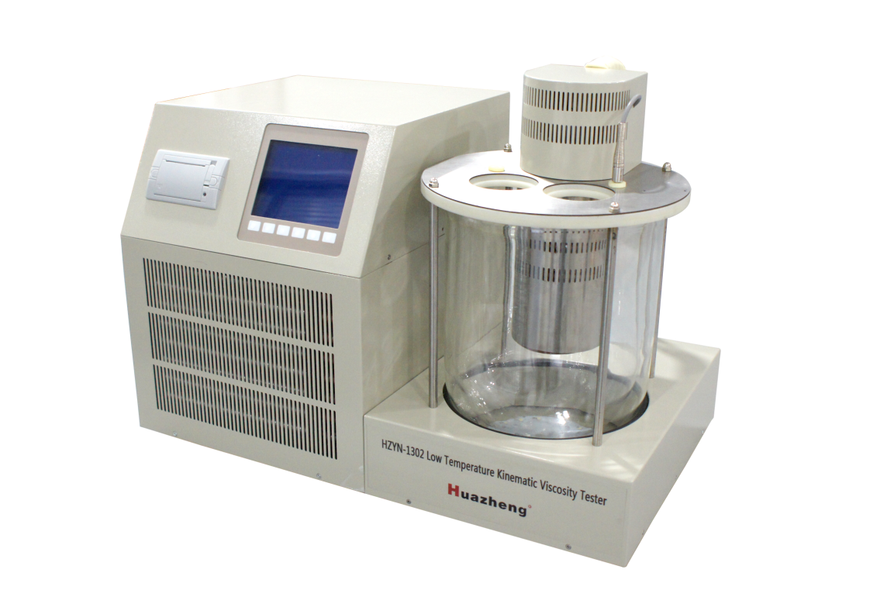

Huazheng Electric Manufacturing (Baoding) Co., Ltd
Contents

I.Summary 1
II.Main Functions and Features. 1
III.Technical Indicators 2
IV.Conditions of Use 2
V.Instrument Structure 2
VI.Control Panel Construction 2
VII.The Operation Process 3
VIII.Install Printer Paper. 10
IX. Packing List 11

I.Summary
This instrument is a special test instrument designed and manufactured according to the national standard gb265-88 petroleum product kinematic viscosity measurement method. It is suitable for measuring the kinematic viscosity of liquid petroleum products.
This instrument has the time of timing sample movement, and calculates the final result of motion viscosity automatically.
This method is applicable to the determination of the kinematic viscosity of liquid petroleum products (i.e., Newtonian liquids). The unit is m2/s, which is usually used as mm2/s in practice.
The kinetic viscosity can be obtained by the measured kinetic viscosity times the density of the liquid.
Under this method is in a constant temperature, the determination of a certain volume of liquid under gravity flow through a calibration good glass capillary viscometer, the product of the capillary viscometer constant with the flow of time, as the temperature determination of kinematic viscosity of liquid.
The kinetic viscosity at the temperature and the density of the liquid at the same temperature are the dynamic viscosity of the temperature.

II.Main Functions and Features.
1、LCD screen, Chinese character display, clear and clear, easy to operate.
2、The keyboard has parameters such as viscometer constant, control temperature value, fine tuning temperature value and test number, etc. The instrument has memory function.
3、Adopt imported sensor, digital PID temperature control technology, temperature control range, temperature control precision.
4、Do not drop the electric calendar clock, the boot automatically displays the current time.
5、Network communication, remote control, transfer table optional function.
6、Button, feel good.
7、The number of experiments is adjustable from 1 to 6 times, which is convenient for your experiment.
8、The experimental records can be saved for later viewing.

III.Technical Indicators
1、Number of bath holes: 2 holes.
2、Temperature control precision: ≤±0.05℃
3、Temperature control: - 20 ℃ ~ 60 ℃
4、Input power: AC220V plus or minus 10V 50/60Hz.
5、Heating power: 800W.
6、Cooling power: 400W.

IV.Conditions of Use
1、Ambient temperature: 0 ℃ to 40 ℃
2、Relative humidity :<80%.

V.Instrument Structure
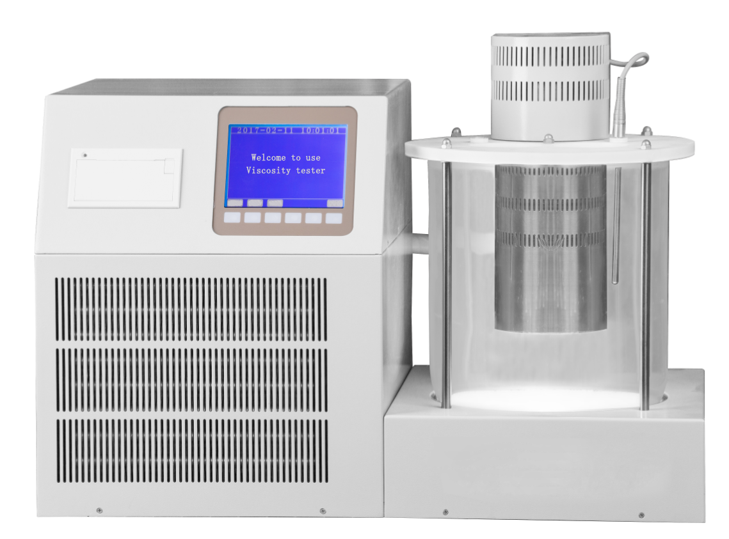
It is composed of heating tube, compressor, condenser, capillary, preheater, stirring motor, thermostatic bathtub, lighting, control part, computer interface, LCD screen, keyboard and so on.

VI.Control Panel Construction
The instrument panel has six white board buttons, different interfaces, and different keys.
The upper liquid crystal of the key corresponds to the function of the key.

Instrument panel structure drawing
Button operation: press the corresponding white board button with the finger, and every time you press, you can hear a key sound.

VII.The Operation Process
1、When unpacking the case, check that the instrument is intact, whether the spare parts is complete, then place the instrument to the well ventilated place without direct sunlight, packed attachments, pay attention to the bath mixture to the amount of the liquid level under the distance covered along the 20 mm.
2、Look at the level of the meter on the instrument, and the four studs at the bottom of the rotating instrument until the level of the level.
3、Plug in the power supply, switch on the power switch, and the liquid crystal display screen is as shown below:
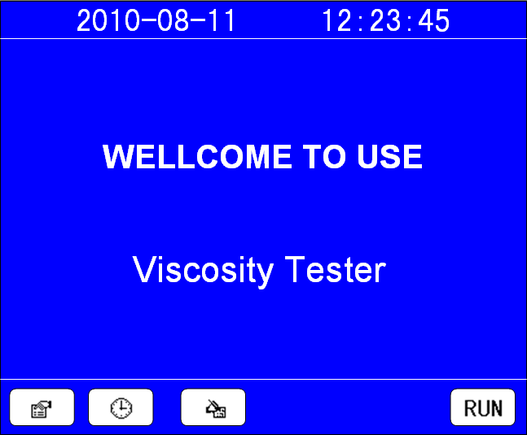
Press the white board button below "parameter" to enter the parameter setting screen;
Press the "clock" under the white board button to enter the system clock Settings screen;
Press "record" the following white board button, can enter the test record query screen;
Press "determine" the following white board button, can enter the motion viscosity measurement screen;
The temperature of the bath liquid is set to 40 when the measuring instrument is out of the factory, and the temperature of the real-time bath liquid is displayed after the starting of the machine. If the temperature of bath liquid is to be modified, the "parameter" key can be used to enter the modification.
4、Parameter setting:
Click the white board button below "parameter" to appear as shown in the picture below. You can change the parameters:
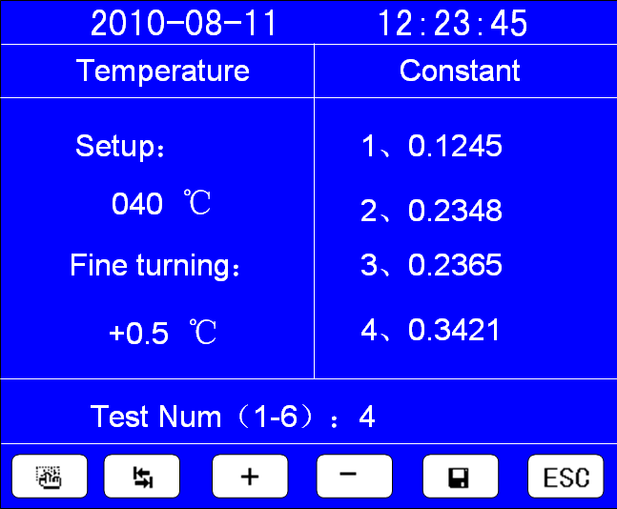
Press "options" button with the cursor to choose parameters, press the "TAB" key to choose one of selected parameters, press "add", "reduce" can modify the selected parameters of a certain value, change after you press "save" button to save, click "cancel" button to return to the first picture.
Where: the fine tuning temperature is -3.0 to +3.0.
The number of experiments is usually 4 times (national standard).
"Setting temperature" : bath temperature during the experiment.
"Fine tuning temperature" : when the temperature is stable, the temperature in the screen is in error with the actual temperature.
Move the cursor to fine-tune the data first, if the actual temperature below the temperature of the screen should be is fine-tuning, fine-tuning temperature display in front of the "+", fine-tuning value increased from zero to start at the same time, but the highest is fine-tuning values are not more than + 3.0 ℃;
If the actual temperature is higher than the temperature of the screen should be negative fine-tuning, fine-tuning temperature display in front of the "-", fine-tuning value increased from zero to start at the same time, but not more than 3.0 ℃ maximum negative fine-tuning, when fine-tuning value reaches the expected value, press the confirmation key, fine-tuning.
5、Clock Settings:
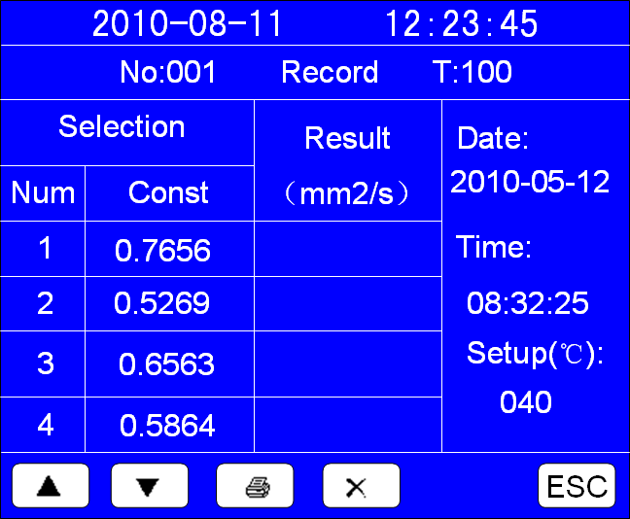
Click the white board button under the "clock" to appear as shown in the picture below. You can change the system clock:
Press the "option" key to select year, month, day, hours, minutes and seconds parameters, press "add", "reduce" can modify the selected year, month, day, hours, minutes, seconds parameter values, change after you press "save" button to save, click "cancel" button to return to the first picture.
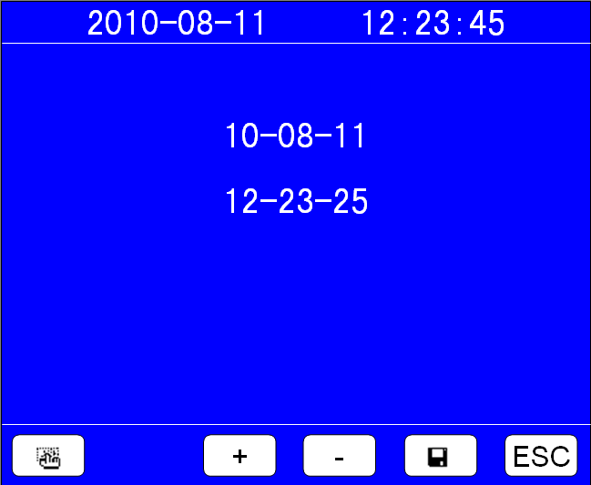
6、Check the experiment record:
According to the "record" of the white board button below, the image shown below can be viewed as follows:
If there is no test record, the "no record" is displayed in the upper right corner of the interface, otherwise the latest record is displayed.
As shown in the figure below:
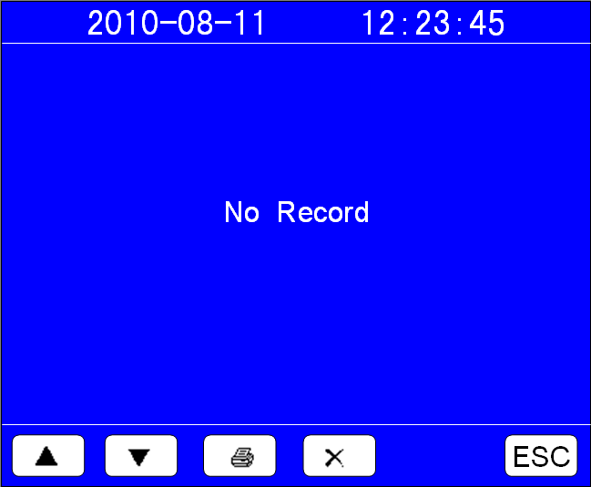
You can press the "upper page" and "next" button to view the test record, press the "print" button to print the current record, and delete the current record according to the "delete" key.
Press cancel to return to the first screen.
7、The determination of:
After the parameters are set, press the white board button below "to determine", and the image as shown in the figure below shows the selection screen and starts heating:
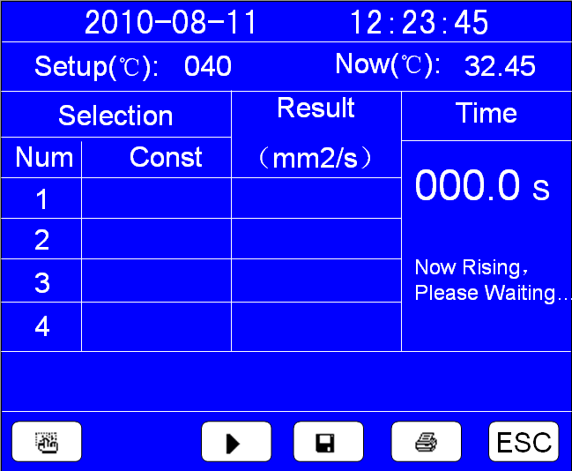
Tip: "warming up, please wait..."
When the temperature rises to the set temperature, the prompt is "ready, press the start button to determine!"
At this time, after you choose the capillary, press the "start" key are measured, you can see, the timing of seconds in the column increases, when the liquid surface flow to the next line, just press the "stop" key again to stop time, then the key prompts the row shows the time of the above, a capillary tube needs to be done to preset test times, each time the experiment time are displayed on the top of the key prompts a line, finish after all test times, the instrument automatically calculate kinematic viscosity value, if the trial is less than 3 times, the average directly, otherwise in accordance with the national standard (gb 4 times test) to calculate,
The unqualified data is automatically drawn on a horizontal line under the experimental data.
The motion viscosity can be calculated according to the requirements of the national standard, otherwise the test results will not be shown.
Here is a brief introduction to the key buttons:

"Options" : this button is used to select the current experiment of capillary number, press the "option" key once the cursor to beat time, from "1" to "2" to "3" to "4", and then to "1" and so on.
"Start" : for the start of the timer, press the "start" button, the label of the key becomes "stop", then press "stop" key, then the "start".
"Stop" : press this button when the level of the liquid reaches the bottom line.
"Retest" : when the number of tests set is done, the test can be redone, that is, the first set of data is thrown away, and the redone experimental data is collected into a new data group for calculation.
"Save" : after all the experiments have been done, if you can calculate the measurement results of the kinematic viscosity, you can press the "save" key to save.
Records are saved as you save them.
"Print" : if your instrument has a printing function, you can press the "print" button to print the current experiment record after the experiment.
"Cancel" : after the experiment, press this button to return to the first screen.
Stop screen:
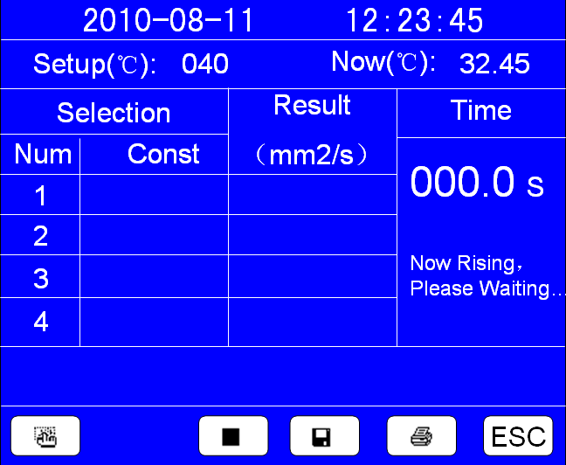
Retest images:
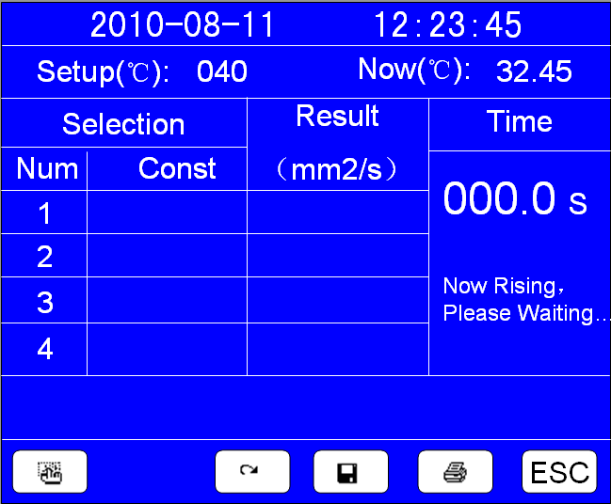
8、Please note in the experiment:
①The capillary is inserted into the four holes, and the capillary is kept perpendicular.
Dip with sample of viscometer constant temperature bath ready in advance, and use the viscometer with fixed bracket, in a fixed position, must immerse the expansion of capillary viscometer part more than half.
When determining the kinematic viscosity of the sample, the appropriate viscosimeter should be selected according to the temperature of the test, so that the flow time of the sample should not be less than 200s, and the flow time of the viscometer with an inner diameter of 0.4mm is not less than 350s.
Before determining the viscosity of the sample, the viscometer must be washed with solvent oil or petroleum ether. If the viscometer is stained with dirt, wash with chromic acid lotion, water, distilled water or 95% ethanol.
They are then dried in the oven, or dried with hot air filtered through cotton.
In the determination of the motion viscosity, the inner diameter of the capillary viscometer that meets the requirements and is clean and dry is loaded into the sample.
Before loading specimen, rubber tube set on the branch pipe, and plug the nozzle, play with his fingers inversion viscometer at the same time, and then insert the pipe shaft of sample container, then use a rubber ball to liquid suction line, at the same time pay attention not to make play, bubble and crack expanding part and the liquid.
When the liquid level reaches line, from the inside of the container mentioned viscometer, and restore its normal state quickly, and will play an outer wall of pipe with the wipe excess samples, and draw on the branch pipe under the rubber tube in tube.
②According to your operation choreography, the constants of the capillaries are determined as the first test frame and the second test frame.
The other two groups are preheated, and the oil that is prepared for the experiment is best placed on the preheating rack for better temperature.
③Capillary in bath crock, must ensure that the temperature e. after arrive 15 minutes before test, recommend that users before not to set temperature capillary to be included in the bathtub, bath temperature and reach the set value, the instrument automatically prompts you to choose capillary experiment.
④By using capillary viscometer pipe shaft mouth part of the sample set of the rubber tube suction expansion, make the sample liquid level slightly higher than the line, and be careful not to let the capillary and expansion of liquid bubble or crack.
Sample flow in the pipe shaft has been observed at this time, the liquid level is just to get on line, press "start" button to start timing, surface flow to the next line, just press the "stop" key again to stop time, the screen shows the movement of the test of time.
When the liquid surface of the sample is flowing in the expansion part, notice that the liquid stirring in the constant temperature bath should be kept constant temperature, and there should be no bubble in the expansion part.
Last time show rear can the next oil absorption, for the last time after the inspection, screen in addition to the show this time, instrument automatic calculation and display the average time and the viscosity of the final results.
If the network function is performed, the instrument will pass the final result to the laboratory computer to generate the summary form automatically.
⑤The oil needs to be sucked up to the middle of the upper sphere and to ensure that the oil absorption test tube is the capillary that you confirm the constant on the previous page.
⑥Do the experiment according to the national standard, if the four times of exercise time, once unqualified, then this group is unqualified, need to redo four samples.

VIII.Install Printer Paper.
Install the paper roll and paper, turn down the front cover of the printer, put the printer paper directly into and set aside a section, and jam the printer cover.
Note: only one side of the printing paper can print out the handwriting, and the printed paper can be printed once. If it can't print out the handwriting, it can be installed on the reverse side of the printing paper.
No. | Item | Qty
1 | Instrument body | 1
2 | Fuse | 2
3 | Power line | 1
4 | Capillary | 1
5 | Capillary | 1
6 | Capillary | 1
7 | Capillary | 1
8 | Capillary | 1
9 | Capillary | 1
10 | Capillary | 1
11 | Thermometer | 1
12 | Heating cable | 1
13 | Sensor line | 1
14 | The preheating shelf | 2
15 | Washing ear ball | 1
16 | Print Paper | 1
17 | Instruction Manual | 1
18 | Certificate | 1
19 | Packing List | 1

IX. Packing List

