HZGC-1212A
Gas Chromatograph

USER MANUAL

Huazheng Electric Manufacturing (Baoding) Co., Ltd

【 Please read this manual carefully and keep it safe for future reference or maintenance 】

Warning words:Note: This information is the manufacturer's special statement on the instrument, which is worth your attention.Note: This information is worth your attention to the important content.
Warning: This information is to remind you to pay special attention to, if not in accordance with the provisions of the operation may cause you (others) personal injury or damage to the instrument.Danger: This information indicates a high level of danger, be alert.

High pressure hazards:
● When the instrument is running, it is strictly prohibited to remove the cover plate of the instrument. When the instrument is running, there is a high voltage inside the instrument that may cause personal injury, and some electrical parts may be exposed when the instrument cover is removed.
● When replacing the fuse and disassembling or maintaining the instrument, unplug the power plug first. Turning off the power switch of the instrument only stops the operation of the instrument, and the high voltage is not completely cut off at this time.
● If the power cord is aged or damaged, it must be replaced immediately.
High temperature risk:
● During instrument operation or for a period of time after shutdown, the instrument's sampler, detector, column box and back outlet and other parts will have a certain high temperature, should avoid contact with them to prevent burns. If you need to replace the parts, be sure to wait until the temperature of the instrument decreases or after using protective measures!
● Pay attention to the hot gas discharged when the instrument is cooled to prevent burns;
● Flammable items are strictly prohibited on the back of the instrument, so as not to ignite flammable items by the schorching gas discharged!
● PVC and other gas pipelines should keep away from the back outlet of the instrument to avoid the hot gas discharged melting the gas source pipeline!Gas source danger:
● For the gas cylinder and gas source used by the instrument, the relevant rules for cylinder transportation, storage, management and safe use should be followed.
● When using hydrogen as carrier gas or FID gas, it should be noted that hydrogen may leak into the column box and cause explosion hazard. Therefore, before the pipeline connection, be sure to close the gas source, install the cromatographic column and correctly connect the connector of the sampler and detector, and check all the pipeline connection points and valves before opening the hydrogen gas source to prevent hydrogen leakage and explosion.
● When conducting special sample analysis (such as toxic), the instrument may discharge toxic substances witch should be discharged to the outdoor safety place to prevent indoor pollution accident.

The information in this instruction document is subject to change without notice. Equipment upgrades (hardware and software) due to technological advances will not be notified in writing.
The text and illustrations in this manual are copyrighted. No reproduction or extract is allowed without written permission.
Contents

I. Introduction Of The Instrument 1
1.1 The Working Principle Of Gas Chromatograph 1
1.2 Characteristics Of HZGC-1212A Gas Chromatograph 2
1.3 Type and technical specifications of HZGC-1212A gas chromatograph 4
1.4 Main configuration description of HZGC-1212A series 6
1.5 Instrument Application Environment 17
II. Installation Of The Instrument 18
2.1 Unbox the instrument 18
2.2 Installation of the instrument 18
III. Operation Of Chromatographic Instrument 20
3.1 Monitor operation 20
3.2 Checking and Setting Temperature Control 21
3.3 Operation to Turn On or Off the Temperature Control System 23
3.4 Checking and Setting of Programmed Temperature Rise 23
3.5 Inspection of the detector: 26
3.6 Viewing of Flow Rate 27
3.7 Viewing of Events 27
3.8 Viewing and Setting of Network Parameters 28
IV. Maintenance And Care Of The Instrument 30
4.1 Cleaning of the sampler 30
4.2 Cleaning of the Hydrogen Flame Ionization Detector 31
4.3 Installation of Chromatographic Column 31
4.4 Maintenance of Gas Purifiers 34
V. Instrument Malfunction And Troubleshooting 34
5.1 Startup Issues 34
5.2 Chromatographic peak problem 35
VI. Maintenance Of The TCD 41
6.1 Precautions for the TCD 41
6.2 Analysis and Troubleshooting of Common Faults of the TCD 41
Appendix A Electrical Condition Details 43
Appendix B Ground grounding 46

- Introduction Of The Instrument

1.1 The Working Principle Of Gas Chromatograph
Gas chromatography analysis is a technique used for the separation and analysis of multicomponent mixtures. It primarily relies on the differences in boiling points, polarity, and adsorption coefficients of the components in the sample within the chromatographic column to achieve their separation. It enables qualitative and quantitative analysis of the separated components.
The gas chromatograph takes the gas as the mobile phase (carrier gas). When the sample is sent into the sampler and vaporized, it will be carried into the filled column or capillary column by the carrier gas, and due to the differences in the boiling point, polarity and adsorption coefficient of the components in the sample, the separated components are sequentially detected by the detector attached to the column, based on their physicochemical properties. Finally, the data is transmitted to the chromatographic workstation through a network, where the gas chromatograms of the components are recorded and analyzed to generate the analysis report. The schematic diagram of its working principle is shown in the following figure
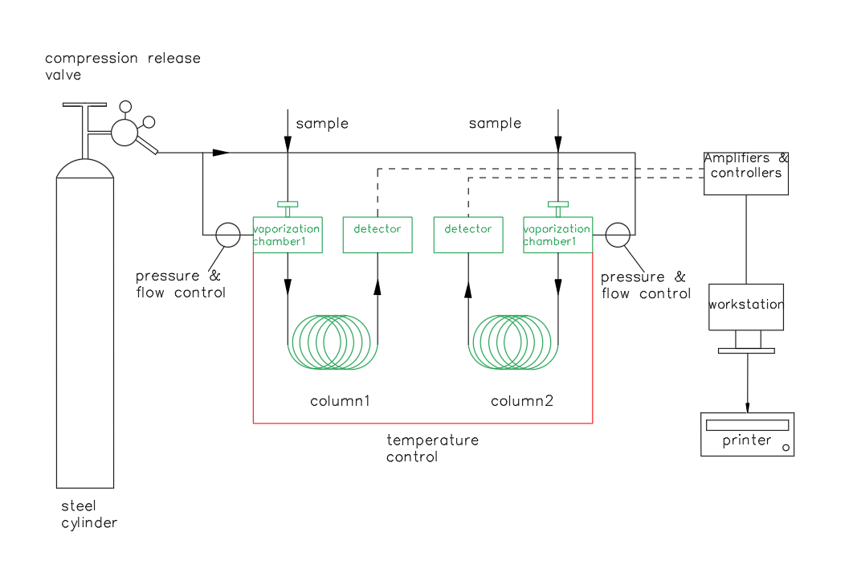
Figure 1.1 Schematic diagram of the working principle of the gas chromatograph
Because the analytical method has the characteristics of high separation efficiency, fast analysis speed and less sample consumption, it has been widely used in petrochemical industry, biochemistry, medicine and health, health quarantine, food inspection, environmental protection, food industry, medical clinical and other fields. Gas chromatography has addressed quality inspection of intermediates and industrial products in industrial production, scientific research, pollution detection, production control, and other related issues in these fields.

1.2 Characteristics Of HZGC-1212A Gas Chromatograph
The traditional gas chromatograph works with 1 chromatograph, 1 workstation, 1 computer and 1 printer. This working arrangement makes it inconvenient for users in chemical plants, laboratories, and educational institutions, as they require multiple devices for operation and management, leading to duplicated investments and significant wastage. Equipped with a large number of computers also bring a lot of inconvenience to users in equipment management and data management. At the same time, this traditional mode often uses a manufacturer's gas chromatograph, and another manufacturer's workstation can be used, making the overall function of the system difficult to play, the performance of the system is difficult to improve, and it is impossible to talk about the increase of functions proposed by the user (such as remote transmission of data, monitoring of multiple instruments, etc.).
In view of the drawbacks of the use of this traditional gas chromatograph, the application of decades of development results, the adoption of a new industrial design, the current mainstream network communication technology applied to the gas chromatograph, the development of a new type of gas chromatograph with international advanced technology. The instrument adopts the latest highly integrated industrial-grade chip, bus technology, Ethernet technology, micro-flow gas control technology and data processing software to optimize the precision of temperature control and gas control, which fundamentally improves the reliability of the instrument.
The HZGC-1212A type gas chromatograph incorporates network communication technology and a built-in high-precision AD conversion circuit, enabling multiple chromatographs to use a single computer to perform data analysis, printing, and storage. It also provides remote control of the instrument and long-distance transmission of chromatographic data, facilitating real-time tracking and management of product quality by business managers.
The following is a schematic diagram of the working mode of HZGC-1212A chromatograph:
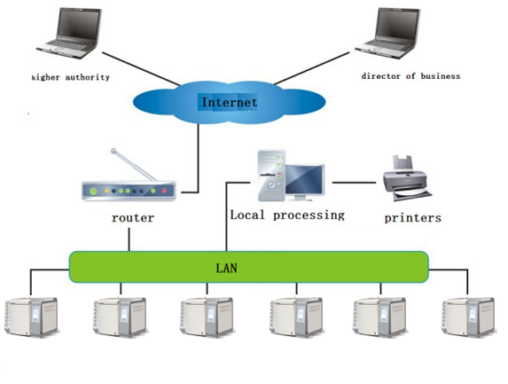
Figure 1.2 Schematic diagram of working mode of HZGC-1212A gas chromatograph
Features of HZGC-1212A Gas chromatograph:
★ It adopts advanced technology of 100Mbps/1000Mbps Ethernet communication interface and built-in IP protocol stack, enabling the instrument to achieve long-distance data transmission through the enterprise's internal LAN and the internet; facilitating laboratory setup, simplifying laboratory configuration, and convenient data management.
★ The instrument is internally designed with three independent IP addresses, which can be connected to the workstation (at the laboratory site), dedicated computers (such as quality inspection department, production department), and executive computers (such as environmental protection bureau, technical supervision bureau). Real-time monitoring of instrument operation and analysis data results is possible.
★ The dedicated workstation equipped with the instrument can simultaneously support multiple chromatographs for data processing and instrument reverse control, simplifying document management.
★ The instrument can be connected to the manufacturer via the internet, enabling remote diagnostics, remote updates, etc. (user configuration required).
★ The instrument is equipped with an 8-inch color LCD touchscreen, supporting hot swapping and can be used as a handheld controller.
★ The instrument operates in parallel with multiple processors, making it more stable and reliable. It can be optionally equipped with a variety of high-performance detectors such as FID, TCD, ECD, FPD, and NPD, with a maximum installation of three detectors simultaneously to meet the analysis requirements of complex samples.
★ The instrument adopts a modular design structure, making it easy and convenient for maintenance.
★ The new microcomputer temperature control system provides high temperature control accuracy, superior reliability, and anti-interference performance. It has eight completely independent temperature control outputs, enabling sixteen-step program heating. It also features an automatic back-opening system for the column oven, improved near-room temperature control capability, and faster temperature ramp rates.
★ The chromatograph has a built-in low-noise, high-resolution 24-bit AD circuit, with baseline storage and subtraction functions.
★ The standard workstation is suitable for operating systems such as WinXP, Win2000, Win7, Win8, Win10.
★ The chromatograph's microcomputer system with fully independent intellectual property rights has the standard MODBUS/TCP protocol and can be integrated with DCS systems.

1.3 Type and technical specifications of HZGC-1212A gas chromatograph
HZGC-1212A gas chromatograph is composed of sample injector, detector, chromatographic column box, gas flow control system, heating control system, signal detection system and network data transmission workstation. 1.3.1 HZGC-1212A Gas Chromatograph
HZGC-1212A gas chromatograph is improved on the basis of GC-6890, so that its degree of automation and overall performance has been a qualitative leap. The instrument has a powerful network remote control function, so that the instrument in unattended, decentralized monitoring, centralized control become a reality.

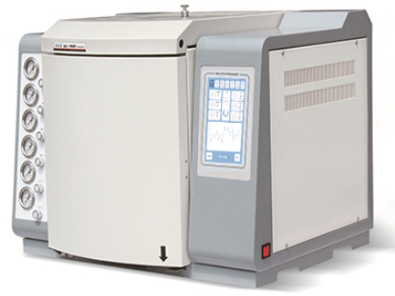

Figure 1.5 Appearance of HZGC-1212A gas chromatograph
Main technical specifications:
● Operation display: 8-inch high-definition color LCD touchscreen, can be used as a handheld controller.
● Temperature control zones: 8.
● Temperature control range: 4℃ to 450℃ above room temperature, increment: 1℃, accuracy: ±0.1℃.
● Program temperature ramp stages: 16 stages (expandable).
● Temperature ramp rate: 0.1 to 60℃/min.
● Gas flow control: Precision mechanical valve flow control.
● External events: 8 channels; auxiliary control outputs: 2 channels.
● Sampler types: Packed column injection, capillary injection, six-port valve gas injection, automatic sampler.
● Number of detectors: 3 (maximum); options include FID, TCD, ECD, FPD, and NPD.
● Injection initiation: Manual or automatic (optional).
● Communication interface: Ethernet: IEEE802.3.1.3.2 Detector technical specifications
1. Hydrogen Flame Ionization Detector (FID)
● Detection limit: ≤5×10⁻¹²g/s(cetane/isooctane)
● Baseline noise: ≤0.05PA
● Baseline drift: ≤0.2PA/30min
● Linear range: ≥10⁶
2. Thermal Conductivity Detector (TCD)
● Sensitivity: S≥10000mV•ml/mg(benzene/toluene) (with amplification 1, 2, 3, 4 times optional)
● Baseline noise: ≤20μV
● Baseline drift: ≤30μV/30min
● Linear range: ≥10⁴
3. Electron Capture Detector (ECD)
● Detection limit: ≤1×10⁻¹³g/ml (propyl BHC-isoctane solution)
● Baseline noise: ≤0.03mV
● Baseline drift: ≤0.2mV/30min
● Linear range: 103
● Radioactive source: 63Ni
4. Flame Photometric Detector (FPD)
● Detection limit: (S)≤5×10⁻¹¹g/s,
(P)≤1×10⁻¹²g/s; (methyl parathion - anhydrous ethanol solution)
● Baseline noise: ≤3×10⁻¹³A
● Baseline drift: ≤2×10⁻¹²A/30min
● Linear range: ≥10² for sulfur, ≥10³ for phosphorus
5, nitrogen and Phosphorus detector (NPD)
● Detection limit: (N)≤5×10⁻¹³g/s,
(P)≤5×10⁻¹³g/s; (methyl parathion - anhydrous ethanol solution)
● Baseline noise: ≤5×10⁻¹³A
● Baseline drift: ≤2×10⁻¹²A/30min
● Linear range: N ≥10², P ≥10²

1.4 Main configuration description of HZGC-1212A series
1.4.1 Column box
The HZGC-1212A gas chromatograph has a large column oven volume, with dimensions of 300*260*270, which allows for easy installation of packed columns or capillary columns. It features a built-in high-power heating filament and a back-opening structure, greatly improving the temperature ramp rate. The column oven temperature control is protected by dual software protection, ensuring the safety of the chromatographic column. The hot stirrer utilizes a low-noise motor and high-quality stainless steel fan blades, providing smooth operation of the instrument.

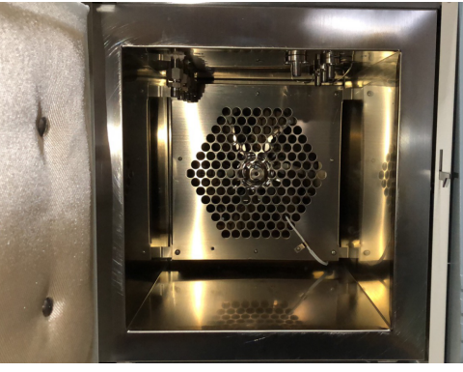
Figure 1-6. Structure diagram of HZGC-1212A inner furnace body
1.4.2 Packed column and capillary vaporization column
The packed column vaporizer of the HF-901 gas chromatograph is installed on the top left front side of the column box, and its structure is shown in Figure 1.7. The capillary vaporization chamber, its structure is shown in Figure 1.8.
The temperature control of the vaporization chamber is set and controlled by a microcomputer control system. At the top of the vaporization chamber is a heat-dissipating cap, and a T-shaped fluororubber sampling pad is embedded in the lower part of the heat-dissipating cap. The carrier gas inlet of the sampler is connected to the output port of the gas path control system.
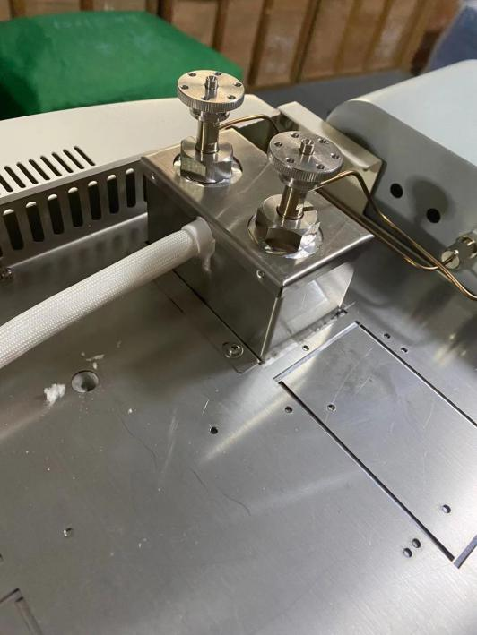

1 Heat dissipation cap 2 sample pad 3 guide piece 4 vaporizing tube 5 platinum resistor 6 heating tube
Figure 1. 7 Schematic diagram of the structure of HZGC-1212A gas chromatograph sampler
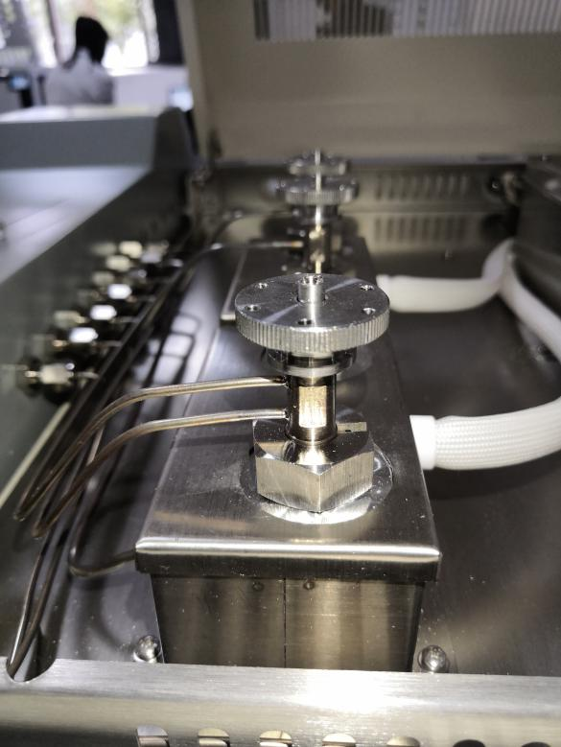
1 Guide (capillary) 2 nuts (capillary) 3 Sampler 4 gaskets 5 hex nuts 6 O-gaskets7 Gasification tube (capillary) 8 slide sleeve 9 conduit 10 Platinum resistor 11 heating wire 12 gasket 13 joints
Figure 1.8 Structure diagram of diaphragm cleaning shunt sampler
Note: 1. The HZGC-1212A gas chromatograph is equipped with multiple samplers, and can simultaneously install up to three packed chromatographic columns and one capillary column;
2. The sampler of the HZGC-1212A gas chromatograph can directly install packed columns with an outer diameter of Φ4mm, and can also install packed columns with an outer diameter of Φ3 by adding a liner;
3. The HZGC-1212A gas chromatograph can install a dedicated capillary diaphragm cleaning and diversion sampler to achieve capillary diversion/non-diversion sampling. Up to two can be installed at the same time.
1.4.3 Thermal Conductivity Detector (TCD)
The HZGC-1212A type gas chromatograph can be equipped with a Thermal Conductivity Detector (TCD). The structure of the TCD detector is shown in Figure 1.9.
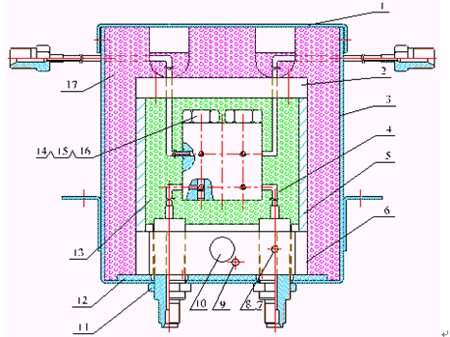
1 Housing cover 2 Upper cover 3 TCD box 4 TCD detector 5 Heat conductor 6 Base 7 Screws 8 Platen 9 Platinum resistor10 Heating wire 11 nut 12 Asbestos heat block pad 13 Air bath 14 nut 15 washer 16 Tungsten wire 17 Thermal insulation foamFigure 1.9 Schematic diagram of TCD detector structure
Its structure and working principle are: four symmetrical chambers are processed in a heat conducting body, and each chamber contains a thermosensitive element. Among them, two chambers are measuring pools, and the other two are reference chambers. The thermosensitive elements in the measurement pool and the reference pool form the four arms of the Wheatstone bridge. The bridge is connected to the thermal conductivity detector signal processing board to control the operation of the bridge and the processing of chromatographic data. The thermal conductivity detector also contains a heating element and a temperature measurement sensor, which are connected to the temperature control system to control its heating temperature.
The TCD reference pool only flows through the carrier gas flow, and the components flowing out of the chromatographic column enter the measurement pool with the carrier gas. When only the carrier gas flows through the reference pool and the measuring pool, the same gas has the same thermal conductivity, at this time the bridge is balanced, and the chromatograph outputs baseline signals. When sampling, the sample is separated and carried into the measurement pool by the carrier gas. Since the thermal conductivity of the carrier gas and the components are different, it causes the balance of the bridge to be destroyed, and the chromatograph outputs peak signals.
Note: The use of the TCD detector must follow the principle of "ventilate first, then heat up, and then current". Never set the bridge current when the TCD detector is not ventilated, otherwise it will damage the rhenium tungsten wire! When turning off the power, be sure to turn off the bridge flow first, then cool down, and wait until the TCD temperature drops to 50℃ at room temperature before turning off the carrier gas!
Note: When operating TCD, please try not to use too high current. High-current operation will accelerate the oxidation of tungsten wire, which will damage the life of the detector. The relationship between the type of carrier gas, the temperature, and the amount of bridge flow is shown in the figure: "
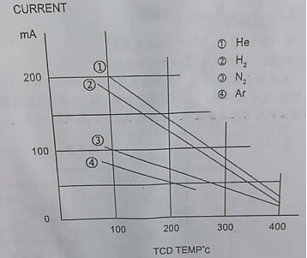
Note: In order to prevent the damage of TCD detector, the bridge current setting value is not saved by shutdown in the design of the machine. That is, when the machine is turned on, the TCD bridge current setting value automatically resetes to 0 mA.

Warning: When the carrier gas contains oxygen, it will shorten the life of TCD tungsten wire. The carrier gas must be thoroughly deoxygenated!

1.4.4 Flame Ionization Detector (FID)
The FID detector is a mass type detector, not only it has high sensitivity and wide linearity range, but also it is relatively insensitive to changes in operating conditions and has good stability. It is particularly suitable for routine analysis of constant or trace amounts. Because of its fast response, it can be used in conjunction with capillary analysis technology to complete trace rapid analysis, making it the most widely used detector in gas chromatography instruments. The HZGC-1212A gas chromatograph can be equipped with two independent hydrogen flame ionization detectors.

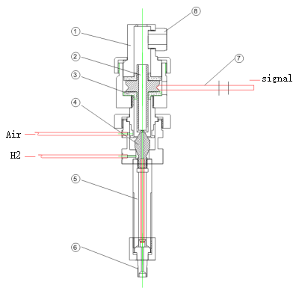
1 Dust cap 2 collector 3 collector pad 4 nozzle 5 Vaporization chamber 6 capillary column connector 7 Signal output cylinder 8 ignition electrodeFigure 1.10 Structure diagram of FID detector
The FID detector is located at the front end of the top of the mainframe. Its base is installed in a heat conducting body, which also has a heating element and temperature measuring sensor, connected to the temperature control system to control its heating temperature. The polarization pole is connected to the output of the polarization voltage of the FID microcurrent amplifier. The signal output of the collecting pole is connected to the FID microcurrent amplifier through a low-noise cable. Hydrogen and air enter from the joint of the gas control system on top of the mainframe.
The principle of the flame ionization detector is: the sample to be tested burns in a hydrogen flame, generates an ion stream, and the positive and negative ions move in a directional manner under the action of the polarized electric field, reaching the collecting pole to generate a weak current signal. After being amplified and processed by a microcurrent amplifier, it is then transmitted to the chromatographic data processing system.
Instructions:
- When no chromatographic column is connected, the hydrogen gas of the FID combustion gas should not be opened to prevent hydrogen gas from entering the column box. When the instrument is turned off, the hydrogen gas and air should be turned off first, the FID is extinguished, and after cooling down, the carrier gas is then turned off.
- The FID is a high-sensitivity detector, and the gas source used must be high-purity carrier gas, hydrogen, and air that have been purified.
- In order to prevent the detector from being contaminated, it is best not to connect the column to the detector when aging the chromatographic column. The detector end can be sealed with a sealing nut, and when using hydrogen for aging, the outlet hydrogen of the chromatographic column needs to be discharged to a safe place.
- Before powering on, check whether the circuit connection is complete and correct, and whether the type of gas is in accordance with the requirements.

Warning: There is a high voltage of 200 volts on the collection pole during the operation of the instrument, please prevent electric shock! 1.4.5 Electron Capture Detector (ECD)
1.4.5 Electron Capture Detector (ECD)
The electron capture detector (ECD) is also an ionization detector. It is a highly sensitive detector with selectivity. It only responds to electronegative substances (such as halogens, sulfur, phosphorus, nitrogen). The stronger the electronegativity of the substance, that is, the larger the electron absorption coefficient, the higher the sensitivity of the detector. For electrically neutral (non-electronegative) substances, such as alkanes, there is no signal.
The radioactive source (63Ni) enclosed in the ECD detection pool generates radiation (β-rays) to ionize the inert gas (N2). A pulsed voltage is applied to the collecting electrode of the detection pool to capture electrons and generate current. When a strong electronegative molecule enters, it absorbs electrons and forms negative ions. Because the molecules carrying negative charges move slower than free electrons, the time to reach the positive electrode is long, and the probability of recombining with positive ions also increases, reducing the electron density in the detector, and the number of electrons captured by a pulse is reduced. According to the degree of reduction in the number of electrons, corresponding multiple pulses are added to keep the current of the number of electrons constant in each unit time, and the change in the number of pulses is proportional to the density of strong electronegative molecules.
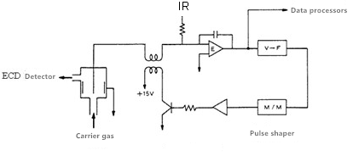
Figure 1.11 Schematic diagram of the ECD device
The ECD device principle diagram is as follows: Through amplifier E, compare the set current IR with the average pulse current formed by the ECD detection pool, and send the voltage when the two are equal into the next voltage-frequency converter (VFC). The pulses emitted by the VFC are adjusted to the appropriate pulse amplitude and pulse height and sent to the ECD detection pool to form a control circuit.

Warning: It is strictly forbidden to disassemble the ECD detector without taking professional protective measures! (Radioactive sources (63Ni) may harm your health)

The radioactive source (63Ni) is a strictly controlled material, and it is strictly forbidden to discard the ECD detector as ordinary waste!
Our company has the final user exemption management for source-containing chromatographs. Customers who purchase our source-containing instruments do not need to go to the local environmental protection department to apply for a "Radiation Safety Permit", but customers need to establish a source-containing instrument use ledger, strictly manage it themselves, and cooperate with our company's tracking investigation of source-containing instruments! The scrapping of source-containing chromatographs must notify our company for filing and recycling, and it is forbidden for units using source-containing instruments to handle the radioactive source (63Ni) without authorization!
1.4.6 Flame Photometric Detector (FPD)
The Flame Photometric Detector (FPD) is a highly selective, highly sensitive detector for phosphorus and sulfur compounds used in gas chromatography. When the sample burns in a hydrogen-rich flame, organic phosphorus compounds emit light at a wavelength of 526nm mainly in the form of HPO fragments, and sulfur compounds emit characteristic light at a wavelength of 394nm in the form of S2 molecules. The photomultiplier tube converts the light signal into an electrical signal, which is recorded after being amplified by a microcurrent. The sensitivity of this type of detector can reach tens to hundreds of Coulombs per gram, and the minimum detectable amount can reach 10-11 grams. At the same time, the response value of this detector to organic phosphorus and sulfur is 10^4 times the response value to hydrocarbon, therefore it can eliminate a large number of solvent peaks and hydrocarbon interferences, which is very beneficial for trace phosphorus and sulfur analysis, and is the main tool for detecting organic phosphorus pesticides and sulfur pollutants.
As shown in Figure 1.12, the FPD mainly consists of two parts: flame emission and optical and electrical signal systems.
The flame emission part is composed of a burner and an emission chamber, the gas flow path and nozzle, etc. constitute the burner, also known as the combustion head. The universal nozzle is composed of an inner hole and an annular outer hole. The outflow of the gas chromatography column and air mix and then enter the center hole, and excess hydrogen flows out from the surrounding annular hole. This forms a larger diffusion hydrogen-rich flame. Hydrocarbons and sulfur and phosphorus compounds decompose in the flame and produce complex chemical reactions, emitting characteristic light. Sulfur and phosphorus emit light in the diffusion hydrogen-rich flame in the upper part of the flame, while hydrocarbons mainly emit light in the oxygen-rich flame at the bottom of the flame. Therefore, adding an opaque light shield at the bottom of the flame to block the hydrocarbon light can improve the selectivity of the FPD. In order to reduce the volume of the emission chamber, a glass or quartz tube can be installed above the nozzle to reduce the response time constant of the detector.
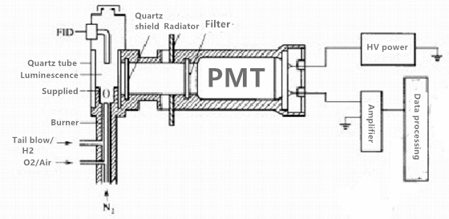
Figure 1.12 Schematic diagram of the FPD system
On the right is the light and electrical signal part. To prevent the large amount of steam generated during the luminescence process, the combustion products, and high temperature from affecting the light and electrical system, a quartz window and heat sink are used to separate the luminous chamber from the photoelectric system. Because the FPD does not convert all light into an electrical signal, it uses a filter to select the characteristic light of sulfur and phosphorus.
Warning: It is strictly forbidden to turn on the high voltage power supply when the detector is leaking light!
1.4.7 Nitrogen and Phosphorus Detector (NPD)
The Nitrogen-Phosphorus Detector (NPD), also known as the Thermal Ionization Detector (TID), is a highly sensitive and selective detector with a wide linear range for the analysis of N and P compounds. The first Flame Ionization Detector (FID) was developed by Cremer and others in 1961, with a heated alkali source above the FID's nozzle. However, due to the volatile alkali metal source used, the detector had a short lifespan and unstable sensitivity, thus lacked value for promotion. In 1974, Kolb used non-volatile cesium carbonate and silicon dioxide to sinter into cesium silicate beads, solving the problem of short bead life, which was electrically heated in a cold hydrogen flame. As a result, the stability of the detector was significantly improved, and its sensitivity significantly increased. The background base flow decreased from 10^-9A to 10^-13A, making NPD one of the most commonly equipped detectors in gas chromatographs, widely used in environmental protection, medicine, clinical, biochemical, food and other fields for the trace analysis of nitrogen and phosphorus compounds.
The structure and operation of the NPD vary according to the product model, with the typical structure shown in Figure 1.13.
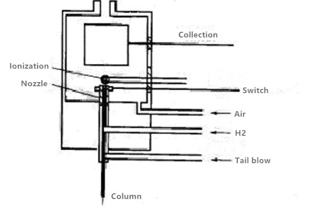
Figure 1.13 Structure diagram of NPD
The operation mode of NPD of HZGC-1212A detector is a nitrogen and phosphorus type operation, and the nozzle is not grounded, as shown in the figure.
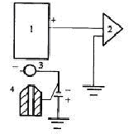
1 - Collector 2 - Amplifier 3 - ion source 4 - Nozzle
Figure 1.14 Schematic diagram of nozzle ungrounded
The air and hydrogen flow rates are relatively small [V_air <150/ml/min, V_H2 <(4~9ml/min)] and are heated to red-hot by the ionization source, forming a cold flame around the ionization source. Organic compounds containing N and P undergo pyrolysis and excitation reactions here, resulting in the selective detection of N and P. The selectivity for hydrocarbons can reach between 102 to 104.
1.4.8 Monitor and Keyboard
The monitor for the HZGC-1212A series is an 8-inch color LCD touch screen, allowing users to easily check the instrument's working status.
The touch screen interface is designed to be simple, clear, fully functional, easy to operate, and user-friendly.
1.4.9 External Event Control and Communication Output
The external event control of the HZGC-1212A type gas chromatograph is located inside the instrument. A column on the right side of the control motherboard is designated for external event control output. From bottom to top, two terminals form a group. These are as follows: Event 1, Event 2, Event 3, Event 4, Event 5, Event 6, Event 7, Event 8, Event 9, Event 10.
The instrument's communication uses a 100-megabit/gigabit adaptive Ethernet interface. It is connected to the computer of the installed workstation via a network cable.
Note: To maintain the instrument's high resolution and stability, a 24-bit AD circuit is integrated inside the instrument. Regular analog signals are no longer output, and it can only be connected to workstations from our company.
1.4.10 Power Switch
The power switch is simply the machine's power switch.
Warning: When opening the machine, there is a risk of coming into contact with electrical parts. The power plug should be disconnected from the power source! Even when the power switch is off, there is still high voltage present in parts of the chromatograph's interior!

1.5 Instrument Application Environment
1.5.1 Installation environment
The HZGC-1212A gas chromatograph should be used within a temperature range of 5 to 35°C and a relative humidity range of 0 to 85%. However, it is best used in an environment where people feel comfortable (appropriate constant temperature and humidity conditions). In this way, the instrument can perform at its best, and its service life will be the longest.
If the instrument is exposed to corrosive substances (be it gas, liquid, or solid), it will endanger the materials and components of the HZGC-1212A gas chromatograph, and this should be avoided.
The test bench on which the HZGC-1212A gas chromatograph is installed must be stable. The vibration of the test bench can affect the stability of the instrument. To allow the hot air from the column furnace to be exhausted, there should be at least 30cm of space left behind the instrument (and no flammable items should be placed behind!), as well as a 30-40cm passage for the installation and maintenance of the chromatograph.
The HZGC-1212A gas chromatograph needs a 10/100M or gigabit Ethernet. Ethernet can be built using a HUB or switch.
1.5.2 Power environment
The power supply for the HZGC-1212A gas chromatograph is 220V±10% (50Hz±0.5 Hz), and the power supplied should not be less than 2500W. To ensure personal safety, the panel and casing of the HZGC-1212A gas chromatograph are grounded with a three-core power cord in accordance with the requirements of the International Electrical Technology Association.
Note: In order to reduce electrical noise from the instrument, it must be well grounded.
Warning: It is strictly forbidden to use water pipes, gas pipes, neutral wires, etc., as a substitute for grounding wires!
1.5.3 Gas environment
In order to achieve the best performance of the HZGC-1212A gas chromatograph, the gas used must reach the appropriate purity level. The following purity values are recommended.

Detector | Gas action | Gas name | Purity
FID | Carrier gas | N₂ or He | Not less than 99.999%
TCD | Carrier gas | He, H₂, or N | Not less than 99.999%
ECD | Carrier gas | N₂(most appropriate) | Not less than 99.999%(Deoxygenated)
NPD | Carrier gas | N₂ or He | Not less than 99.999%
FPD | Carrier gas | N₂ or He | Not less than 99.999%
Tail Blow |  | N₂ | Not less than 99.99%
Gas |  | H₂ | Not less than 99.99%
Auxiliary Gas |  | Air | Clean, dry

We recommend installing a purifier on the gas line! After the gas purifier has been used for a period of time, the molecular sieve and silica gel in the gas purifier should be activated.

- Installation Of The Instrument

2.1 Unbox the instrument
After receiving the instrument, please check the quality of the instrument's outer packaging promptly. If there is any damage, please contact the manufacturer or seller immediately. After unboxing, please check the accessories against the delivery note. If you find that the accessories do not match or there is damage to the appearance of the instrument, please contact the manufacturer or seller immediately to prevent unnecessary financial loss or work delay.

2.2 Installation of the instrument
After the inspection is correct, carefully place the instrument in the appropriate position on the workbench. The workbench must be secure. Do not store flammable materials behind the instrument and leave room for inspection.
2.2.1 Installation of the gas source
Refer to 1.5.3 before using the HZGC-1212A gas chromatograph, and equip the gas source according to the type of detector you want to use.
The gas source should be installed in a safe place. If a gas cylinder is used, it should be secured to prevent it from falling over and causing accidents. Regardless of the type of gas source chosen (such as a gas generator, gas cylinder, air compressor, etc.), the quality of the generated gas should be carefully checked to meet the gas source requirements of the HZGC-1212A Gas Chromatograph, so as not to affect the analysis results or even cause contamination or damage to the chromatograph!
2.2.2 Installation of pressure reducing valve
If a cylinder-style gas source is used, follow these steps to install the pressure reducing valve:
Unscrew the low-pressure outlet heads of two oxygen pressure reducing valves and one hydrogen pressure reducing valve, connect the pressure reducing valve connectors, and screw on the low-pressure output adjustment rods (do not tighten them).
Install the pressure reducing valve on the gas cylinder. After tightening the nut, open the high-pressure valve of the gas cylinder. The high-pressure gauge of the pressure reducing valve should show an indication.
After closing the high-pressure valve of the gas cylinder, the high-pressure gauge of the pressure reducing valve should not decrease. If it does, there is a leak that must be addressed before use.
2.2.3 Installation of external gas path

FIG. 2.1 Schematic diagram of external gas path connection
The HZGC-1212A Gas Chromatograph uses Φ3×0.5 outer diameter polyethylene tube, Teflon tube, stainless steel, or copper tube for the external gas path connection. The connection method is shown in Figure 2.1 above.
Note:
- The exhaust ports for the gas path splitter and detector should use pipes to vent the gases outdoors to avoid indoor air pollution when analyzing toxic and harmful substances.
- In practical operation, be sure to regularly check for leaks! A leak can at best disrupt the normal operation of the instrument and at worst cause an accident (such as a hydrogen leak that could lead to an explosion)!
- The pressure of the carrier gas input to the chromatograph: 0.5MPa;
- The pressure of the air input to the chromatograph: 0.5MPa;
- The pressure of the hydrogen input to the chromatograph: 0.4MPa;
2.2.4 System leak detection
After the installation of the gas path is completed, it is necessary to detect leaks to avoid accidents. The leak detection should be carried out as follows:
(1) Turn off the main power supply
(2) With the low-pressure adjustment rod of the gas cylinder in a relaxed state, open the high-pressure valve of the gas cylinder, then slowly adjust the low-pressure adjustment rod so that the low-pressure gauge reads: carrier gas cylinder 0.5 MPa; hydrogen gas cylinder 0.4 MPa; air cylinder 0.5 MPa (if using a generator, use the pressure indication when the generator stops working).
(3) Close the high-pressure valve of the gas cylinder, close the carrier gas, hydrogen, air, tail blow, split, and purge valves on the chromatograph, put the low-pressure adjustment rod of the gas cylinder in a relaxed state, and check whether the pressure gauge reading drops. If the pressure reading does not drop for 10 minutes, it passes. Otherwise, there is a leak in the gas path, and you should carefully check each section and eliminate the leak.

- Operation Of Chromatographic Instrument

3.1 Monitor operation
The HZGC-1212A gas chromatograph is designed with six temperature control algorithms, which can independently set and control the temperature for eight temperature control zones. Moreover, the chromatographic column box possesses a 16-step (expandable to 99 steps) program temperature increase function. The rear door of the column box will automatically open and close according to the temperature control algorithm of the column box.
The monitor of the HZGC-1212A is a 7-inch Chinese character LCD touch screen, which allows you to easily view the working status of the instrument. The virtual keyboard is designed to be simple and clear, with a full range of functions, easy to operate, and intuitive at first glance.
This button is used to start data collection analysis and, if the program temperature increase is set, to start the program temperature increase;
Note: If is displayed , the data collection buttonor program temperature increase is invalid.

This button is used to end signal analysis or stop program temperature increase in program temperature increase state;

means that the actual temperature of the temperature control unit that is allowed to control temperature has reached the set value. Among them, the column furnace temperature is ±0.5℃ of the set value, and the others are ±5℃ of the set temperature.
After turning on the instrument, press the button in the lower left corner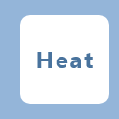to make the instrument enter the temperature control state. If it is an EPC circuit, it will automatically open the gas circuit control.

3.2 Checking and Setting Temperature Control
After turning on the instrument, tap on the screen to enter the main interface of the instrument. Press the button to make the instrument enter the temperature display state. You can view the operating status of each temperature control channel, as shown in the following figure: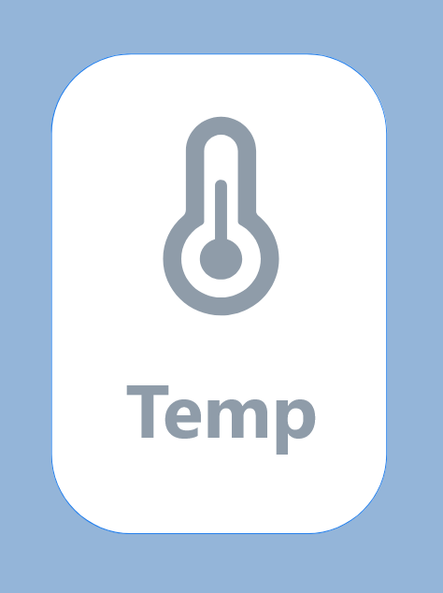
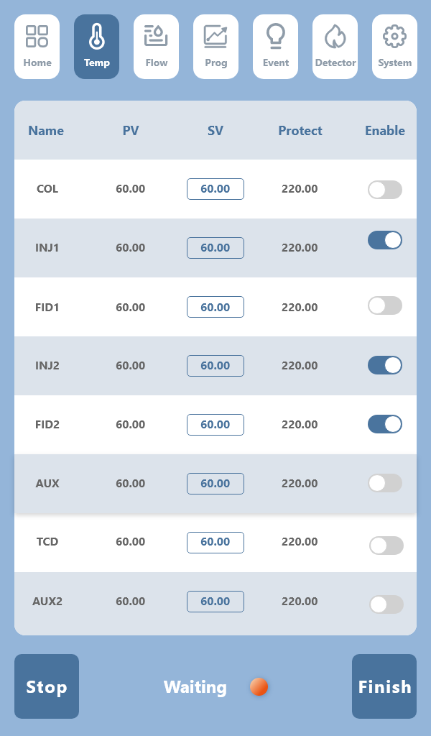
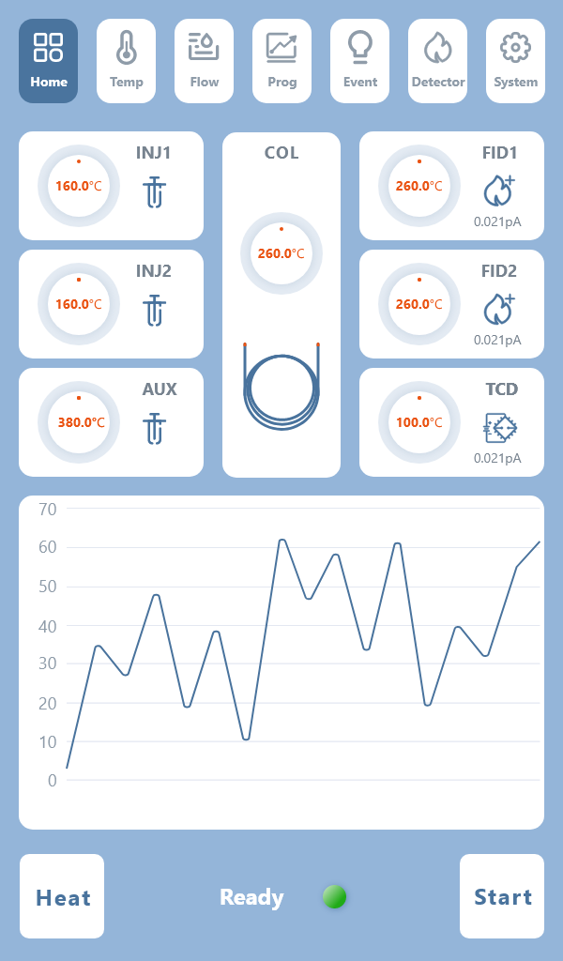
The actual measurement displays the actual temperature of the 8-channel temperature control. The temperature in the setting area can be set  according to different samples, and the enable button is turned on. If the enable button  is virtual, the temperature of this channel will not be heated;
Setting allows you to enter the temperature you need based on your sample. Method of entry: Clicking on the corresponding box of the temperature to be entered will pop up a digital keyboard 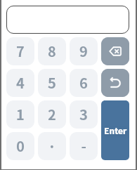. After entering the temperature value, click  to complete the entry.
Protection displays the protective temperature of the 8-channel temperature control. This temperature is automatically calculated by the instrument based on the user's set temperature and does not need to be modified;

3.3 Operation to Turn On or Off the Temperature Control System
In the power-on state of the instrument, press the buttonto heat the instrument. If there is EPC, then H2 shows the flow rate.
When the column oven temperature reaches the set ±0.5℃, and the remaining enabled channels reach the set ±5℃, it will display . After the baseline is stable, you can sample and analyze.
Note: When is displayed, pressing the button after sampling will start the workstation to enter the analysis state; at the same time, if the program temperature rise parameters and external event parameters are valid, it will also make the instrument enter the program temperature rise state and external event control state. After sampling is over, you can manually press to end the analysis, or you can operate on the workstation.
In the temperature control state of the instrument, press the button to turn off the temperature control. At this time, you will hear the sound of the relay in the instrument releasing, and the door will automatically open for cooling.

3.4 Checking and Setting of Programmed Temperature Rise
In the power-on state of the instrument, press the button to make the instrument enter the programmed temperature display state;
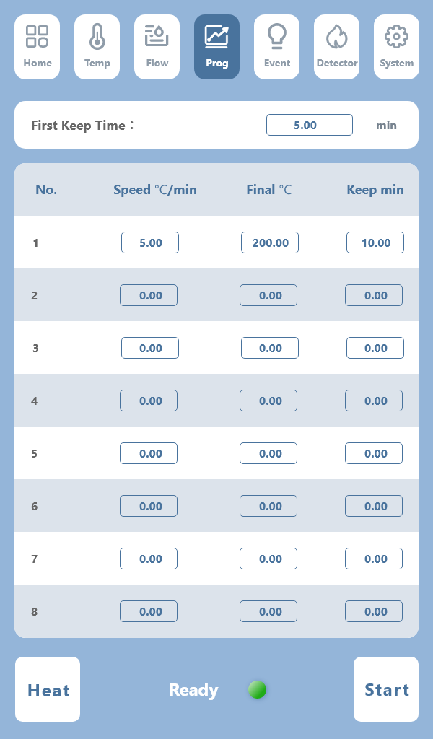
The programmed temperature rise refers to the process in which the column oven temperature needs to rise according to the set value during the sample analysis process, for example: the column oven is at 60℃, hold for 5 minutes, rise to 200℃ at a rate of 5℃, hold for 10 minutes, and can be set as shown in the figure above. The column oven temperature is set in the temperature interface and cannot be set in this interface. The second stage temperature rise is inferred in the same way.
Note: The set terminal temperature of the programmed rise should be higher than the set temperature of the column oven, and the next stage temperature should be higher than the previous stage temperature.
Note: If the heating rate of a certain stage is 0, it will invalidate the programmed temperature rise of this stage and the following stages; if the heating rate of the first stage is 0, the entire programmed temperature rise content will be invalidated.
Program heating operation:
In the power-on state of the instrument, press the button to make the instrument enter the temperature control system. When the instrument is in the state, press the button to start the programmed temperature rise control of the instrument (note: the workstation needs to be connected when starting the temperature rise program).

When the chromatograph executes the temperature rise program, the display area shows "Initial Temperature" when the instrument enters the initial temperature hold state;
When the chromatograph executes the temperature rise program, the display area shows "Heating" when the instrument enters the heating state;
When the chromatograph executes the temperature rise program, the display area shows "Hold" when the instrument enters the temperature holding state;
When the chromatograph executes the temperature rise program, the display area shows "Cooling" when the instrument enters the cooling state;
After the instrument completes a full programmed temperature rise cycle, the stopwatch in the status display area will stop timing and reset to zero; the instrument will automatically open the rear door of the column box to quickly reduce the temperature inside the column box to the initial temperature, shortening the cooling time of the instrument. When the temperature in the column box drops to the initial temperature (±1℃), it will display , waiting for the next programmed temperature rise to begin. This process repeats.
While the instrument is executing the programmed temperature rise, pressing the button under the temperature control system will interrupt the programmed temperature rise state, and the instrument will return to the constant temperature state.
Remark: When there is a TCD in the chromatograph:
Note: The operation of the TCD must adhere to the rule of "ventilation first, then heating, then current". That is, never set the bridge current when the TCD detector is not carrying gas, otherwise, it will damage the tungsten filament! When turning off the machine, be sure to turn off the bridge current first, then cool down, and turn off the carrier gas after the TCD temperature drops near room temperature!
Note: When operating the TCD, please try not to use too high a current. High current operation will accelerate the oxidation of the tungsten filament, which is detrimental to the lifespan of the TCD.
Note: To prevent damage to the TCD detector, the bridge current setting value is not saved when the machine is turned off in the design of this machine. That is, the TCD bridge current setting value is automatically set to 0 milliamperes when the machine is turned on.
Warning: If there is oxygen in the carrier gas, it will shorten the life of the TCD tungsten filament. The carrier gas must be completely deoxygenated!

3.5 Inspection of the detector:
In the powered-on state of the instrument, press the button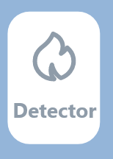. Using dual FID+TCD as an example, the instrument enters the detector interface:
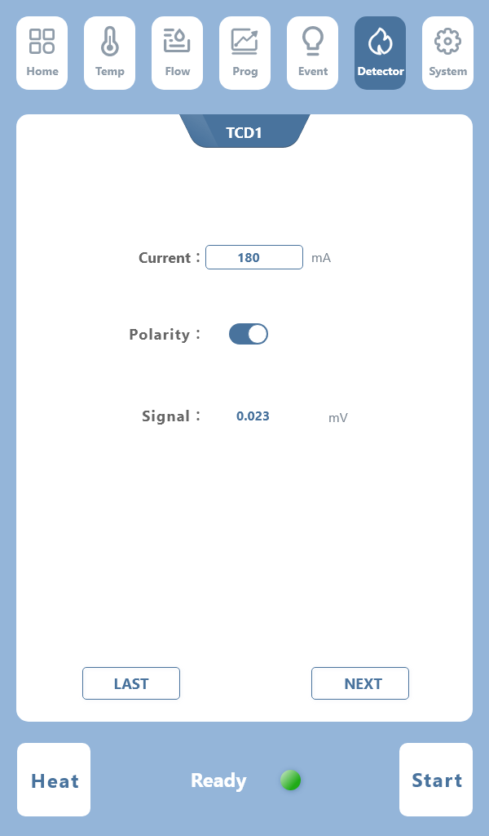
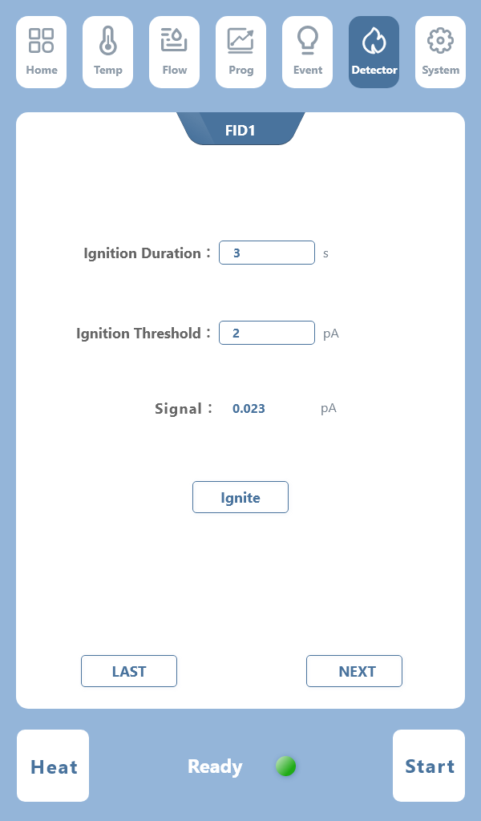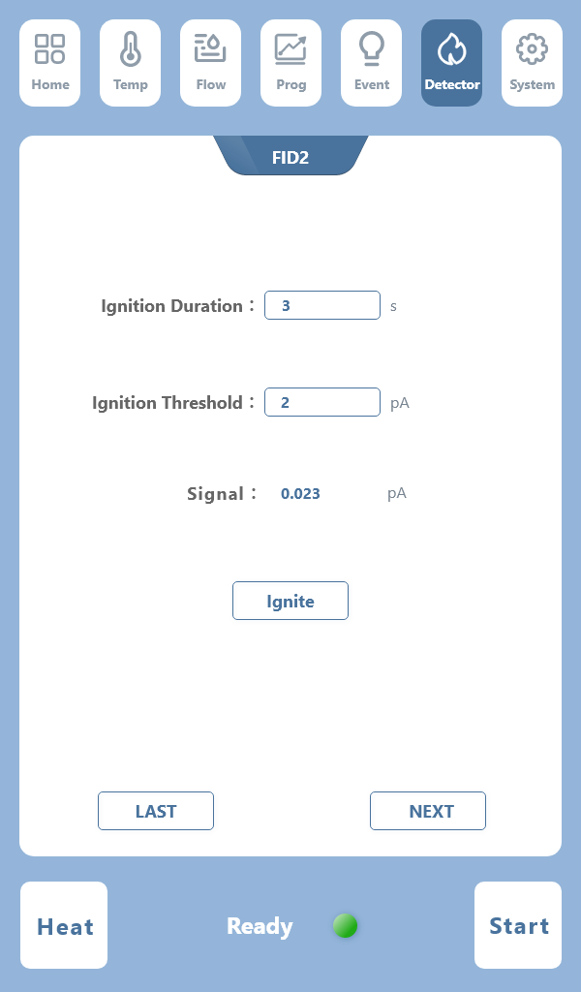
For example, FID I: you can set the ignition duration, ignition threshold, perform ignition operations on the detector, and view the signal value of the corresponding detector. If there are multiple detectors, you can click to find the corresponding detector to set.

3.6 Viewing of Flow Rate
In the powered-on state of the instrument, press the button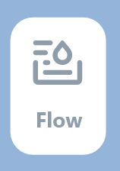 to make the instrument enter the flow rate interface:
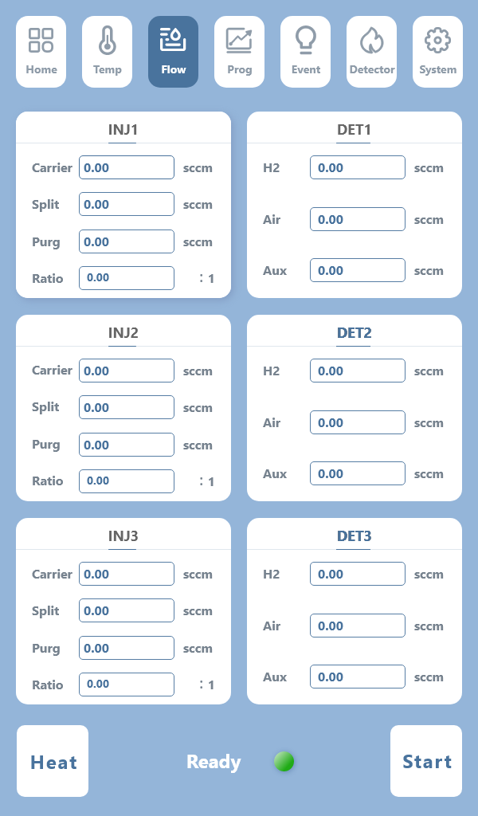
In this interface, you can view the flow rate display of the corresponding injector (INJ), detector (DET), and you can also manually set the flow rate: clicking the corresponding window will pop up a numeric keypad, and the setting can be completed by pressing confirm after setting!
Note: This interface is designed for the EPC module, the flow rate can be input on the display screen and the workstation. If the instrument is a mechanical valve, this interface cannot be inputted!

3.7 Viewing of Events
In the powered-on state of the instrument, press the buttonto make the instrument enter the event interface:
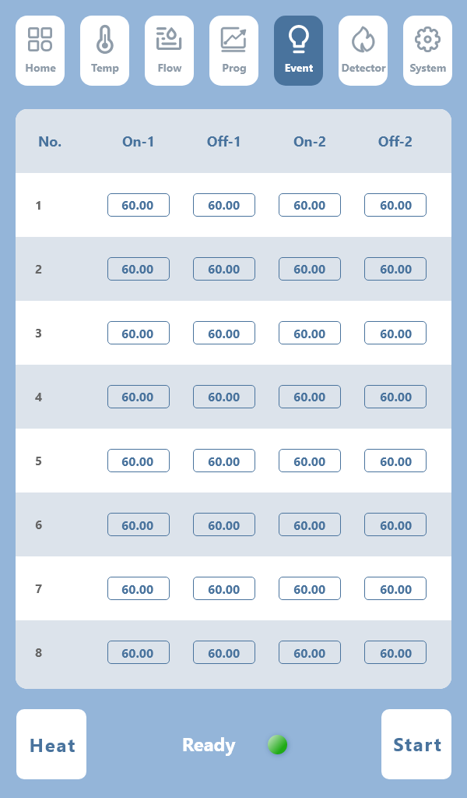
There are a total of 8 event routes in this interface. If you need external events, design them in this interface.

3.8 Viewing and Setting of Network Parameters
In the powered-on state of the instrument, press the button , the instrument enters the state of displaying network parameters:
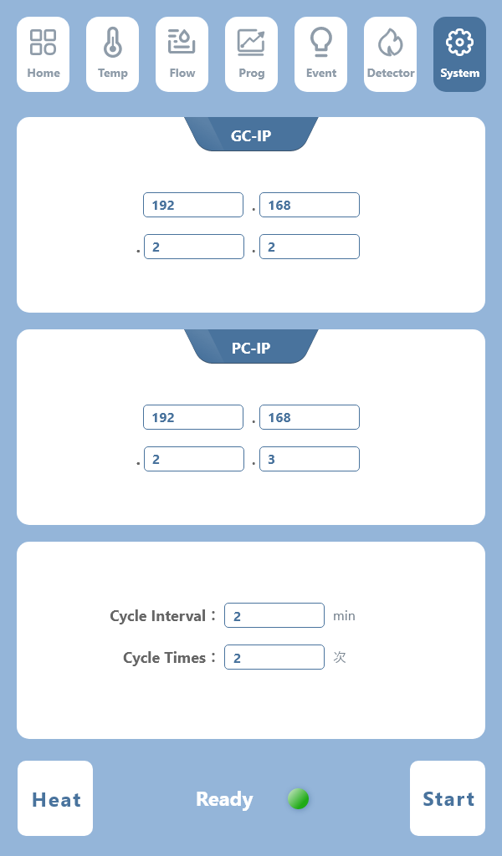
Note: There is no need to set the parameters of this interface. After the instrument is powered on, connect the chromatograph to the computer workstation with a network cable, open the workstation, click on the network configuration in the lower left corner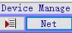, a pop-up window will appear to click search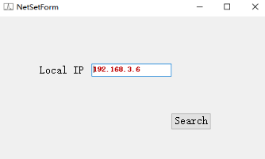, and a green dot will appear in the lower left corner of the workstation. Double-click the dot, and a check mark will appear on the green dot, indicating that the instrument is connected to the workstation. After checking the baseline and the system is normal, sample analysis can proceed.

The "Local IP" in the interface refers to the IP address of this chromatograph. Generally, an IP address that is in the same network segment as the local area network of the company and is not used by other instruments or computers is set.
The "Subnet Mask" sets a subnet mask used by the local area network of the company. It is generally 255.255.255.0.
The "Gateway" sets the same gateway used by the local area network of the company. Generally, it is: 192.168.x.1.
"Working Computer" refers to the IP address of the computer where the workstation software works. That is, it is set to the IP address of the computer where the workstation software works. This parameter must be set correctly, otherwise, the chromatograph will not be able to connect to the workstation software.
The IP address of the computer where the workstation software works can be viewed in the properties of the "Internet Protocol (TCP/IP)" in the properties of the "Local Connection" in the properties of "My Network Places". It can also be viewed in the command status of the operating system with the "IPCONFIG" command. (See later 4.2.2 for details).
The "Manager Computer" refers to the IP address of the computer where the business supervisor (such as chief engineer, quality control supervisor, etc.) works in order to pay attention to the operation status and analysis data of this chromatograph and installs the workstation software. If you want to use this function, this parameter must be set correctly, otherwise, the chromatograph will not be able to connect to the supervisor's workstation. Of course, if the supervisor does not pay attention to the operation status and analysis data of the chromatograph, you do not need to install workstation software, just set this IP address to an unused IP address in this local area network.
The "Leader Computer" refers to the public IP address of the monitoring system set up by the superior administrative supervisory unit (such as: Technical Supervision Bureau, Health Bureau, Environmental Protection Bureau, etc.) in order to monitor the operation status and analysis data of the chromatograph (generally through the Internet). If the superior supervisor does not have such a requirement, just set this IP address to an unused IP address in this local area network. The <——> symbol displayed after the "Superior Supervisor" indicates that the chromatograph and the workstation are successfully connected; if this is not displayed, the chromatograph has not successfully connected to the workstation.
Note: In the case of a local area network, the IP address of the chromatograph and the IP address of the workstation computer must be in the same network segment. That is, the first 3 groups of data of the IP address are consistent!
Note: The IP address of the chromatograph and the IP address of the computer of the workstation software cannot conflict (be the same) with the IP address of other network devices.
Note: The IP address of the chromatograph uses a static IP address working mode. The "Automatically Obtain IP Address" function is not supported.
Note: Because this chromatograph automatically connects to the workstation after power-on. For the stable operation of the system, the IP address of the workstation computer must be fixed. The IP address of the workstation computer should use a static IP address working mode and should not use the "Automatically Obtain IP Address" mode.
Warning: The local computer, manager computer, and leader computer set in the chromatograph are strictly prohibited from being the same! This will make the baseline data of the workstation abnormal! If the business supervisor and the superior supervisor do not use it, these two IP addresses can be set to IP addresses that do not exist in this local area network.

- Maintenance And Care Of The Instrument

4.1 Cleaning of the sampler
The sampler is prone to contamination, especially the vaporizer, hence cleaning the sampler is crucial:
(1) Cleaning the sampler: You can use a solvent-soaked cotton ball to directly wash it, then blow it with an airflow (mainly to blow off cotton fibers and dry the solvent).
(2) Cleaning the inner liner: After removing the inner liner, it can be soaked in acetone for 1-2 hours, then ultrasonicated for more than 30 minutes. If there are still stubborn contaminants, a φ1.6 stainless steel wire with a cotton swab soaked in acetone can be used for removal, followed by ultrasonic treatment.
(3) The new sample pads need to be processed before replacement; then the vaporizer liner and the sealing nut are installed.
The cleaned sampler must be strictly leak-tested before use!

4.2 Cleaning of the Hydrogen Flame Ionization Detector
The FID cover can be removed, the collection cylinder and the insulating gasket taken out, and the cover, collection cylinder, and insulating gasket can be cleaned with acetone or alcohol, then dried.
If the contamination is severe, the parts to be cleaned can be placed in an ultrasonic cleaning solution. After ultrasonication, they should be rinsed clean with water, then cleaned with alcohol and dried.
If the detector is contaminated with chromatographic stationary phase, select a solvent that can dissolve the stationary phase.
If the nozzle is contaminated, use the same cleaning method as above.

4.3 Installation of Chromatographic Column
4.3.1 Installation of Packed Column
The installation of the packed column at both the sampler and detector is similar. The sampler end of the packed column should leave enough empty column (at least 50mm) to prevent the injection needle from touching the glass fiber or packing material at the end of the column; on the detector end, also leave enough empty column (at least 4mm) to prevent the nozzle base from touching the glass fiber or packing material at the end of the column. As shown in Figure 6.1 below:

Leave 50mm empty column at the sampling end
4mm empty column at the test end
Figure 6.1 Schematic of the empty tube portion left at both ends of the packed column
Due to the rigidity of glass, the glass packed column must be installed simultaneously at both the sampler and detector ends. The installation procedure for each end is the same, for the column installation at the detector end, please refer to the relevant section according to the detector used.
Connecting HF-901 gas chromatograph Φ3, Φ4mm packed chromatographic column with the sampler.
Installation steps are as follows:
First, put M10×1 Φ3mm column nuts on both ends of the chromatographic column;
Install Φ3mm graphite rings on both ends of the chromatographic column, then install the liner with the corresponding inner diameter. Push it up to the bottom of the detector (push to the end), then tighten the nut;
The sampler end needs to adjust the height of the chromatographic column according to specific requirements, then tighten the nut;
Check for leaks with neutral soap solution, there should be no gas leaks;
Wipe off the soap solution;
The installation steps for the Φ4mm chromatographic column are the same;
Note: The sample end of the packed column should maintain a length of about 50mm empty tube to avoid difficulties during sampling, and the sample end of the chromatographic column should not be confused with the detector end, markers should be made when packing the packed column. On the detector end, also leave enough empty column (at least 4mm) to prevent the nozzle base from touching the glass fiber or packing material at the end of the column.

4.3.2 Installation of capillary column
Fused silica capillary columns are very regular and do not need to be straightened. However, the column end should be freshly cut, free of burrs, with neat edges, and remove particles from the column, stationary phase, and sealing gaskets. This is very important.
Therefore, the column end should be freshly cut with a suitable special cutting tool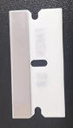, scratching at the point where it is to be cut. Usually, the column nut and gasket are installed before cutting.
Note: Wear protective glasses to prevent potential eye damage from the particles generated when handling cut glass or fused silica capillary columns. Also, be careful to avoid skin punctures when handling capillary columns. Because the column has considerable rigidity, these precautions are essential when handling capillary columns.
As shown in the figure below:
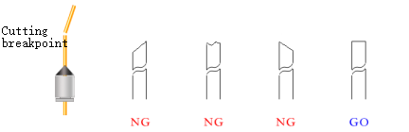

Fused silica capillary column
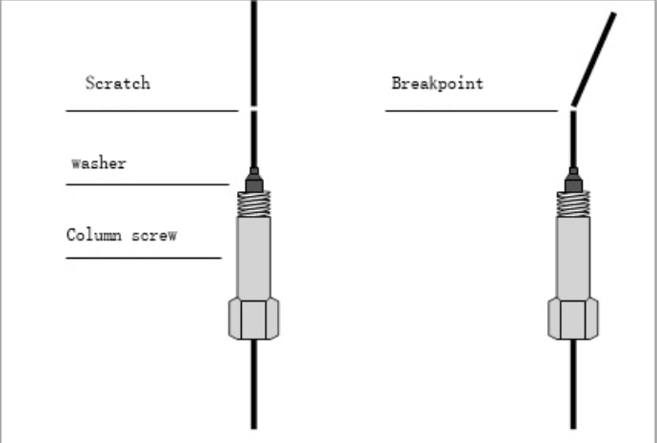
The capillary column is wound on a metal frame, and this frame is hung on the capillary column support in the column box. The ends of the column extend from the bottom of the frame, gently bending towards the sampler interface and detector interface, without allowing any part of the column to touch the inner wall of the column box. Graphite gaskets may contaminate the column during the column threading, which can be avoided by following the "Preparation of Fused Silica Capillary Columns" instructions for cutting column ends.
The following figure shows the lengths to be reserved at the vaporizer end and FID end when installing flexible quartz capillary columns. Leave 40mm for the vaporizer connection and 86mm for the FID connection.
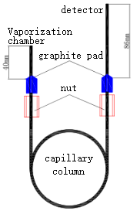

4.4 Maintenance of Gas Purifiers
In the flow control system, there is a filter in which a 5A molecular sieve is placed. The 5A molecular sieve needs to be replaced or activated regularly. The activation temperature is 350℃, for 4 hours.

- Instrument Malfunction And Troubleshooting

5.1 Startup Issues
5.1.1 No startup response
Fault Diagnosis | Inspection methods and repairs
Mains problems | Check the mains
Blown fuse | Check the fuse and replace it
Display does not light up | Check the display

5.1.2 Boot initialization fails
Fault Diagnosis | Inspection method and repair
The power supply to the power board is faulty | Check the +12V, +5V, +15V, -15V of the power board
The RS485 component of the electrical component is faulty | Remove the signal board one by one and troubleshoot the problem one by one
The RS485 component of the display board is faulty | Remove the display board in turn to remove the problem of the signal board

5.1.3 Offline
Fault Diagnosis | Inspection method and repair
Network cable problems | Check the network cable and PING the GC on the PC
The IP address is set incorrectly | Check that the IP address is set correctly
Computer operating system firewall blocking | Unblock the firewall
Computer anti-virus software block | Unblock anti-virus software
The computer or chromatograph network indicator light is not on | Check the network cable, switch, chromatograph, or computer
Online but intermittently on | Check for conflicting networks and IP addresses

5.1.4 Online but not the baseline
Fault diagnosis | Inspection method and repair
Monitor signal board failure 1 | Check on GC to see if the detector is recognized
Monitor signal board failure 2 | Check that this detector signal is normal on GC
Monitor signal board failure 3 | Check if the detector board number of the same type is set repeatedly

5.2 Chromatographic peak problem
5.2.1 No baseline
Fault Diagnosis | Inspection method and repair
The inspection board is not installed | Check that the detection board is installed
Detection board failure | Replace the detection board
The base and background colors are set to the same color | Modify the color
The sampling rate is incorrect | Modify the sampling rate (20 times/second)
The chromatograph is not connected to the computer | Check the network as well as the network parameters

5.2.2 No chromatographic peaks
Fault Diagnosis | Inspection method and repair
The sampler temperature is too low | Increase the sampler temperature
Syringe clogging | Syringe replacement
Disconnect amplifier power | Check the amplifier,
No carrier gas is going through | Check whether the carrier air path is blocked and the gas in the cylinder is used up
The silicone rubber is leaking | Replace the silicone rubber
Flameless | Ignition
FID polarization voltage no | Bad polarization voltage connection is excluded

5.2.3 Sensitivity decrease with normal residence time
Fault Diagnosis | Inspection method and repair
Leak of air in syringe | Syringe replacement
Poor choice of sensitivity | Choose the appropriate sensitivity
Carrier gas leak | Detect leaks and treat them accordingly
Improper selection of hydrogen and air flow (FID) | Correct their flow
Detector No High voltage (FID) | Install high voltage

5.2.4 Trailing peak
Fault Judgment | Inspection method and repair
Contamination of sample tube | Clean the sampler tube
The chromatographic column furnace temperature is too low | Increase the chromatographic column temperature
The injection temperature is too low | Turn up the injector temperature
Improper selection of chromatographic column | Select the appropriate column

5.2.5 Stretch the tongue peak
Fault diagnosis | Inspection method and repair
The sample size is too large | Lower the sample size
Sample agglutinates in the system | First increase the column temperature, and then select the appropriate injector, column, detector temperature

5.2.6 Chromatographic peak separation is not good
Fault judgment | Inspection method and repair
Excessively short columns | Choose a longer column
Fixed fluid loss | Replacement of chromatographic column or aging column
Column temperature is too high | Lower column temperature
Incorrect fixing fluid selection | Select the appropriate column
The carrier gas flow rate is too high or too low | Adjust the carrier gas flow rate

5.2.7 Level the peak
Fault Judgment | Inspection method and treatment
Amplifier input saturation | Lower the sample size and reduce the amp sensitivity
Recorder zero position changes | Check the recorder zero position and act accordingly

5.2.8 Baseline mutation
Fault Judgment | Inspection method and treatment
External electric field interference | Eliminate external electric field interference that affects the normal operation of the instrument
The power plug is in poor contact | Install the electrical outlet securely
Improper selection of hydrogen and air flow | Adjust the flow rate of hydrogen and air

5.2.9 Irregular baseline fluctuations during constant temperature operation
Fault diagnosis | Inspection method and repair
The instrument is installed in a bad position | Install the instrument in a place where there is no strong vibration, it is best to put the instrument on a concrete table without vibration.
The instrument is not well grounded | Check and do good grounding accordingly
Improper fixing fluid | Select appropriate fixing fluid
Improper selection of carrier gas flow rate | Adjust the carrier gas flow properly
Carrier gas leakage | Leak Detection
Detector contamination | Cleaning the detector
Improper selection of hydrogen, air (FID) | Adjust the flow rate of hydrogen and air properly

5.2.10 Low sensitivity for extended retention time
Fault Diagnosis | Inspection method and repair
Carrier gas flow rate is too slow | Increase the carrier gas flow rate
Carrier gas flow changes after injection | Change the sampler silicone rubber
The sampler silicone rubber leaks | Change the sampler silicone rubber

5.2.11 Outgoing peak signal suddenly returns below baseline and extinguish fire
Fault Diagnosis | Inspection method and repair
The sample size is too large | Lower the sample size
The carrier gas flow rate is too high | Choose the right carrier gas flow rate
The hydrogen or air flow rate is too low | Adjust the hydrogen or air flow rate again
Flame nozzle contamination | Clean the flame nozzle
Loss of fixing fluid inside the chromatographic column | Re-age chromatographic column

5.2.12 Baseline does not return to zero
Fault Diagnosis | Inspection method and repair
Detector contamination | Cleaning the detector
Amplifier failure | Checking amplifier

5.2.13 Spikes in irregular distance
Fault Diagnosis | Inspection method and repair
Insulator leakage | Detect the leak and treat it accordingly
Amplifier failure | Elimination of impurities in the flow path
Flame pulsation | Adjust the proper hydrogen and air flow
High frequency signal line failure | Check the high frequency signal cable
The detector has dust. | Wash the ear ball to blow off

5.2.14 Certain burrs in equal intervals
Fault Diagnosis | Inspection method and repair
Water condenses in hydrogen lines | Remove the water from the lines and swap or activate the desiccant
There is blockage in the flow line | Remove impurities from the flow path
Air leakage | Detect the leak and do the sound treatment
Flame pulsation | Adjust the proper hydrogen and air flow

5.2.15 Round peak
Fault Judgment | Inspection method and repair
Exceed detector linear range | Lower the sample size
Poor amplifier selection | Re-select the appropriate amplifier

5.2.16 High Noise at baseline
Fault Diagnosis | Inspection method and repair
Column contamination | Column replacement
Carrier gas contamination | Replace or regenerate the carrier gas filter
The carrier gas flow rate is too high | Adjust the carrier gas flow rate again
Poor grounding | Check and do a good grounding
High resistance contamination | High resistance to cleaning contamination
Sampler contamination | Clean the sample tube in the sampler
Air or hydrogen flow rate too high or too low (FID) | Re-regulate the flow rate of air or hydrogen
Air or hydrogen contamination | Replace the hydrogen or air filter
Water condenses in the FID | Increase the FID temperature to remove water
High frequency signal line failure | Check the high frequency signal cable

5.2.17 Extra Peak
Fault Judgment | Inspection method and repair
High resistance of the previous sample | Wait until the previous sample has all slipped out before injecting
The water condensing in the chromatographic column is at its peak | The operating conditions for installing or regenerating the purifier should be properly selected
Sample decomposition | Lower the sampler temperature
Sample is contaminated | Make sure the sample is clean

5.2.18 Zigzag baseline
Fault Diagnosis | Inspection method and repair
Steady flow valve diaphragm fatigue | Replace the diaphragm or repair the valve
Change the output pressure of the carrier cylinder pressure reducing valve | Adjust the decompression pressure of the carrier gas valve in another position
Improper flow of air | Reset the flow of the air stream

5.2.19 Reverse peak
Fault Judgment | Inspection method and repair
Excessive Hydrogen flow (FID) | Adjusting the hydrogen flow
The positive and negative switches are wrong | Change the plus-minus switch to the correct position
Wrong tungsten leads for reference and measurement tanks (TCD) | Check the tungsten wire leads in the reference and measuring tanks.

5.2.20 Single Direction Change in Baseline without Sample Injection (FID)
Fault Diagnosis | Inspection method and repair
Detector temperature is too low | Raise the detector temperature
Column temperature Stop heating or out of control | Overhaul the temperature control system and the heating wire platinum resistor
Gas leaks | Leak Detection

5.2.21 Single Direction Baseline Drift
Fault Diagnosis | Inspection method and repair
The temperature of the detector varies greatly | Stabilizing the detector temperature
Amplifier zero drift | Overhaul the amplifier components
The column temperature increases or decreases substantially | Stabilize column temperature
Air leakage | Leak Detection

5.2.22 Irregular baseline change during warming
Fault Diagnosis | Inspection method and repair
Excessive column loss | Select the appropriate column, the use of column temperature should be far lower than the fixed liquid maximum use temperature, aging columns
The appropriate operating conditions are not selected | Choose the right operating conditions
The column is contaminated | Change column

5.2.23 Periodic Baseline fluctuations
Fault Diagnosis | Inspection method and repair
Bad temperature control of detector | Check for good contact
Carrier gas flow pressure is too low | Replace the carrier gas cylinder
Improper regulation of column furnace temperature | Check for good platinum resistance contact
Carrier gas flow is not properly regulated | Adjust the carrier gas flow rate again
Improper air and hydrogen regulation (FID) | Re-regulate the hydrogen and air flow

5.2.24 Baseline change after program heating
Fault Diagnosis | Inspection method and repair
Column loss increases when the temperature rises | Select an appropriate column or aged column
Column flow rate is not corrected well | Corrected column flow rate
Contaminated column | Replace column

- Maintenance Of The TCD

6.1 Precautions for the TCD
During the use of the TCD detector, be sure to pay attention to and comply with the following:
● Never set the bridge flow when the carrier gas is not flowing in, so as to avoid accidents of tungsten filament burnout.
● When aging the column for the first time, do not connect the carrier gas at the rear of the column to the thermal conductivity pool; instead, vent it directly in the column box. Do not use hydrogen for aging! Nitrogen is generally used. It is also strictly forbidden to set the bridge flow during the aging period.
● The thermal conductivity pool detector is a precision part. Do not disassemble the tungsten filament in the pool body on your own to avoid unnecessary loss.

6.2 Analysis and Troubleshooting of Common Faults of the TCD
6.2.1 No peak after sample injection
Fault Diagnosis | Inspection method and repair
No set current | First set current
The tungsten wire is broken | Replace the tungsten wire
The internal connector and cable of the TCD thermal conduction power component are not inserted properly | Reinsert the plug socket associated with it
The syringe is deflated or blocked | Replace the syringe
A silicone rubber leak | Replace the silicone rubber
6.2.2 Signal output amplitude is too large (without sampling)
Fault Diagnosis | Inspection method and repair
Internal tungsten wire against pool wall | Contact the factory for repair
Tungsten resistance values are not matched | Contact the factory for repairs
The internal connector and cable of the TCD thermal conductivity power supply component are not inserted properly | Reinsert the plug socket associated with it
6.2.3 The baseline is noisy
Fault Diagnosis | Inspection method and repair
Carrier gas is not pure (carrier gas purity is very important) | The carrier gas is purified before doing such as deoxidation and drying
The heat conduction tank is contaminated | Clean the pool body and sampler
The column is not aged | Re-age column.
Leakage of silicone rubber | Replace the silicone rubber
Air leakage in the gas path system and the connection to the column | Detect the leak and do the appropriate treatment.
The TCD working current is set too high | Lower the working current setting to the appropriate value.
The thermal conduction power supply is unstable | Contact the factory for repairs

Appendix A Electrical Condition Details
A qualified electrical technician should be able to provide the system with an appropriate power supply, whether it involves retrofitting existing electrical equipment or installing new equipment.
* Estimate the total power demand of the area.
* Install a convenient output line.
* Devise a plan for electrical safety.
* Ensure all wiring complies with local regulations.

Determining Power Demand
Calculate the amount of electricity your area requires.
Note: The total amount of electricity should include the originally planned equipment plus any equipment to be added in future expansion plans.

Voltage Limits
At any installation site, when the system is powered, the phase-neutral voltage should remain within the range of +10% to -10% of the rated voltage. The voltage should be measured from the power input side of the system.

Frequency Limits
The allowable line frequency limit depends on the equipment within the system with the narrowest range limit (measured at the power line input of the instrument). The HZGC-1212A network gas chromatograph has a wide range and can operate within a range of 50Hz to 60Hz.

Harmonic Quantity
The maximum total harmonic content of the instrument feeder should not exceed 5% (measured at the power input of the instrument after power is applied).

Power Outages and Surges
In some areas, the power lines used for the instrument system may experience excessive voltage drops, voltage surges, transient voltages, power outages or other unexpected events, making the operation of the instrument system unreliable. Therefore, the quality of the power supply must be checked. If some items are found to not meet system requirements during the inspection, corrections should be made.

Power Noise
The HZGC-1212A network analyzer is designed to withstand reasonable input line noise. However, it cannot control the noise from many other public utilities. This kind of electrical noise primarily originates from other electrical equipment near the instrument, for example, motors, solenoid valves, thyristor rectifiers, and X-ray machines.

Additionally, there may be "neutral-to-ground noise" caused by poor neutral contact and "ground-to-ground noise" caused by poor grounding on the floor. The maximum allowable line noise is 3V (rms) from 30Hz to 50Hz.

You can use an oscilloscope to measure small "ground-to-neutral" voltages. Because if the voltage has a distortion bias, the reading on the analog header will be distorted. Generally, if the voltage is lower than the measurement result, there is a problem.

Noise Elimination
If you want to eliminate the noise from existing electrical equipment or future installations, we suggest installing a qualified feeder between the main distribution panel and the instrument distribution panel. Check whether the neutral contact and grounding are good (please see the "Grounding" section below).

If there are still bad transients after installing a qualified feeder, you should install a device that can reduce input electrical noise.

Power Interference
Input power noise that interferes with the power supply output, or input power noise that interferes with the signal lines in the system, can cause the instrument system to malfunction. These input disturbances can be summarized as impulses, voltage drops, and transients, which are explained below: "Impulses" and "drops" are sudden changes in the positive and negative values of the input voltage, with a duration between 5 milliseconds. Generally, "impulses" and "drops" should not exceed about ±15% of the normal rated line voltage, and should return to a stable state within 17 milliseconds (60Hz) and 20 milliseconds (50Hz).

A "power supply voltage transient" is a sudden change in the positive and negative values of the input voltage, with a duration between 1 millisecond and 5 milliseconds. If this transient time is greater than 20% of the rated voltage (depending on its energy), it will cause the instrument to malfunction.

When monitoring the quality of the input power and evaluating the characteristics of the disturbance, a power input disturbance monitor is very useful. Because power line disturbances may occur every hour, every day, and every week, the monitor should be connected for at least one week. Don't take the results of the measurement as absolute values, because the disturbance value will also be different due to seasonal changes.

The test method is to use a peak signal with a rise time of 0.5 microseconds and a pulse duration of 10 microseconds, which is twice the amplitude of the power supply voltage.

Power Treatment Equipment
If transients still occur after the dedicated feeder and grounding are installed, a device that can reduce input power line interference should be installed. There are basically four types of devices that can complete this task:
1. Isolation Transformer
2. Power Voltage Regulator
3. Motor-generator set
4. Uninterruptible power supply

The power of the line regulation device must meet current and future needs. The minimum rating recommended by our factory is 5KVA, which can meet current requirements and future expansion needs.
Appendix B Ground grounding
To ensure that the instrument operates safely and reliably, it is crucial that the instrument is well grounded. Generally, most countries and regions require the installation of grounding wires for electrical equipment to ensure personal safety.

Safe Grounding:
Various standards typically require the installation of safety conductors for electrical equipment. The standards generally stipulate that each live wire return line (neutral line) should be accompanied by a safety conductor. The size of the safety conductor must be the same as that of the live wire.

Generally, safety standards require that the safety conductor be connected to the conductive surface of electrical equipment that operators may touch, or to conductive surfaces that may be energized due to electrical accidents. Under normal operating conditions, this wire should not carry returning AC current. If the instrument's frame is not grounded, or if the live wire accidentally touches the frame, the voltage on the frame is likely to reach a certain level of harm.

Connecting the safety ground wire to the instrument's chassis can avoid the risk of electric shock, as this forms a very low impedance circuit, causing the circuit breaker to trip or the fuse to burn out. Every instrument product has a safety grounding device. As long as the instrument is connected to a grounded socket or the grounding ring in the instrument is connected to the ground wire as specified by the user, the circuit is considered complete.

As described below, the safety ground wire in the instrument is usually connected to the building's conduit through an insulated grounding device, which in turn grounds the branch circuit distribution. In any case, it must comply with local and national safety regulations.

The safety ground wire must be correctly connected to the terminal of the main distribution grounding bus. It should be understood that the ground wire impedance returning from any load to the main grounding bus must be less than 11 ohms.

Noise-Free Grounding:
To ensure good operation of the HZGC-1212A network instrument, we strongly recommend using a noise-free grounding device. This type of grounding is also called "insulated grounding" because it is separate from other electrical grounding devices in the building. When connecting the HZGC-1212A network instrument with other instruments, using "insulated grounding" will help maintain system reliability.

In most cases, ordinary grounding cannot meet the requirements, because this grounding device is bound to bring in some noise caused by poor grounding. Noise may also come from radio broadcasters, and this ground wire may also carry a generally stable current.

Typical grounding situations that can generate noise include:
1. Conduit
2. Rooftops and building beams
3. Sprinkler pipes (connecting the ground wire to these pipes is generally not allowed by most fire codes).
4. Raised floor support structures.
5. Gas pipes

Connecting the ground wire to these pipes is easily affected by building noise caused by poor grounding, and due to antenna effects, they can also receive radio frequency interference.

The following can be grounded (consult with the local electrical inspection department to choose a locally acceptable grounding method):
1. Connect a suitably sized wire to the building's main pipe or to the ground entrance of the main conduit.
2. Drive a long grounding nail into a damp soil layer and connect it to the ground entrance.
3. It can also be connected to other reliable ground entrances.

The insulated ground wire must be securely connected to the device. Do not clamp the ground wire onto pipes or grounding posts with clamps. Do not use other methods that can loosen the connection. The joint must be copper soldered or tin soldered to minimize the drop in insulation resistance at the grounding joint. If installed improperly, resistance can be measured at the joint, and added to the resistance on the ground wire, can generate undesired potential on the insulated grounding device. When installing the ground wire, prevent it from accidentally coming into contact with other ground wires, which would have an adverse effect on the insulation. The insulation wire must be connected to the insulated bus in the distribution panel, then from the distribution panel, it is connected to each unit of the instrument system via connectors and power ground wires. The insulation bus can be made from the grounding plate on the distribution panel.

The size of the wire used should ensure the lowest ground resistance from the farthest point to the main distribution panel grounding point. Please consult with the local electrical inspection department on the wire specifications.

When network processing devices are installed in multi-story buildings, the outer shell of the network processing device should be connected to the rebar in the building structure, which can reduce grounding noise. One end of the ground wire should be connected to the outer shell of the line processing device, and the other end should be welded to the nearest building vertical beam rebar. Connecting the ground wire to the rebar of the building is better than connecting the ground wire to a separate grounding post in the basement.

Measurement of Neutral-Ground Connection Quality:
Several devices specifically used to measure the quality of grounding systems can be purchased on the market. These devices include grounding detectors, which guide the current in the ground wire, perform tests, and can indicate the quality of grounding (indicator lights or scales in ohms). There is also a ground wire tester for measuring the resistance of the grounding system.

If the grounding impedance is too high, several items need to be checked. If there is no network processing equipment installed, and no designated grounding device, check if the neutral-ground (N-G) connection on the main distribution panel of the building is good. If line processing equipment has been installed, the N-G connection on the line processing device should be checked again. If the N-G joint is not installed in the correct place, it should be moved to an appropriate location, because if it's not properly installed, unwanted current may be generated on the ground wire.

The connection of the grounding wire should be checked to see if it's good. If the size of the ground wire is smaller than the wire in the circuit, or if the ground wire is not insulated, we recommend replacing it with an insulated wire of the same size as the one in the circuit.

Electrical Load Balance:
It's important to balance the electrical load in three-phase and shunt phase systems because:
- It can reduce the adverse effects of external voltage drops and voltage changes on devices driven by individual transformers.
- It can improve the performance of insulation transformers.
- It can extend the service life of transformers.

An unbalanced load can generate a voltage difference between the neutral and ground lines. This voltage can be measured to determine if the load is balanced. A clamp ammeter should be used when balancing the load. First, measure the current of each phase, then remove the power line from the system distribution panel, rearrange the load, and measure again. Repeat this process until the neutral line current drops to the lowest value.

The voltage difference between the neutral and ground lines can also be used to prove whether the load is balanced. After powering the instrument, use an oscilloscope to measure the voltage difference between the neutral and ground lines at the power input terminals of the instrument. The shorter the connection of the ground clamp probe, the better. Remove the power line from the system distribution panel, rearrange the load, and then measure again. Repeat this process until the neutral-ground voltage drops to the lowest value.

When balancing the load of other feed lines, the neutral-ground voltage may drop further, or it may drop when increasing the size of the feed line. If the neutral-ground voltage on the system distribution panel is too high, a dedicated feed line should be hung from the main distribution panel.

