HZSD-29B
Intelligent Petroleum Tester

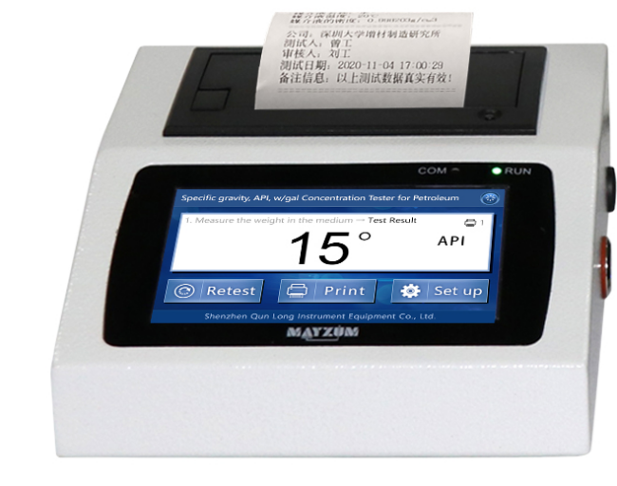
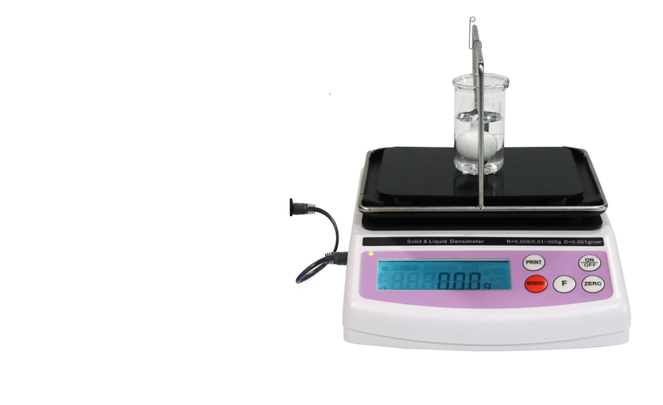

Huazheng Electric Manufacturing (Baoding) Co., Ltd
Contents

I. Installation Of The Instruments 1
II.Function And Technical Parameters： 2
III.Introduction Of The Key Function On The Measuring Host Balance Panel 2
IV.Calibration Of Instruments 3
V.Operating Process 4
VI. Parameter Setting： 6
VII.Packing List 8

I. Installation Of The Instruments
A. Install the accessories of the measuring host first, and the installation schematic diagram and steps are shown as follows：
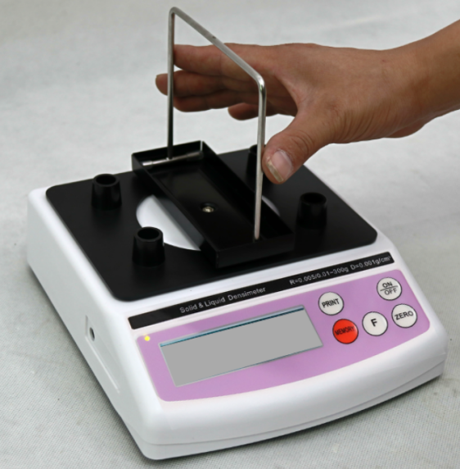 | 1.Gently clamp the stainless steel measuring holder in the black card slot;
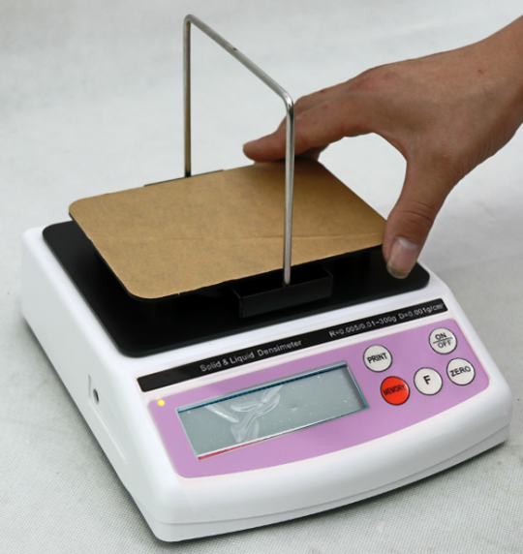 | 2Place the four-legged support plate on the four columns above the host machine to complete the installation.
- After the installation of the accessories, connect the host balance and the processor printing all-in-one machine. The serial port with 1 DB9 pin on the back connects the processor to the host balance, as shown in the figure below：
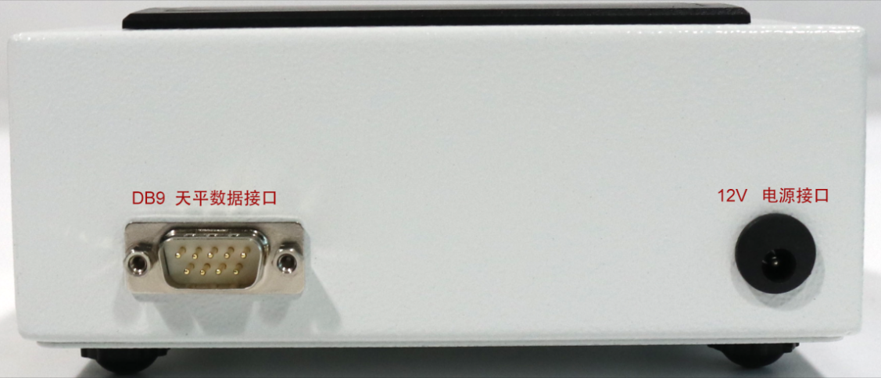
Figure 2: Interface at the back end of the processor (USB interface can connect to the mouse, keyboard, etc., other interfaces are not yet opened)
Note: For the installation diagram of the whole instrument, refer to Figure 1 above.

II.Function And Technical Parameters：
Model： | HZSD-29B
Weighing precision： | 0.001g
Density and specific gravity measurement accuracy： | 0.0001g/cm³
Pomure, concentration resolution： | 0.0~0.000adjustable
function ： | Measure the relative density of oil, API, etc
Choose a piece： | Solid parts

III.Introduction Of The Key Function On The Measuring Host Balance Panel
A. As shown in Figure 4 below, the main function keys are: [ON / OFF] switch, [ZERO] zero, [PRINT] data transmission, [MEMORY] [F] 2 keys are not needed, not specified.
B.key operation technique —— long press: press press, let go when the screen shows changes; short press: press the button to let go

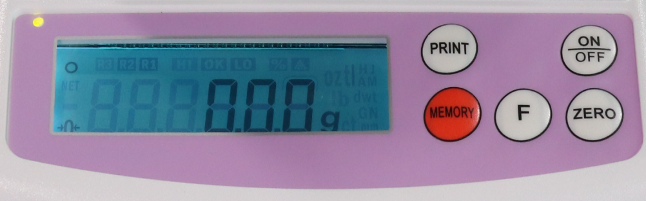
Figure 3: Measure the function button on the host balance panel

IV.Calibration Of Instruments
First used or inaccurate, the user can calibrate the instrument. Calibrate the instrument, please remove the four-foot support plate first, as shown in the figure below：
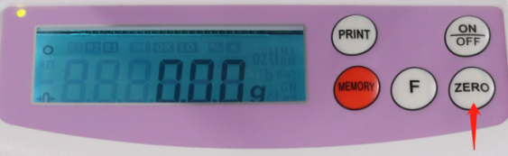 | 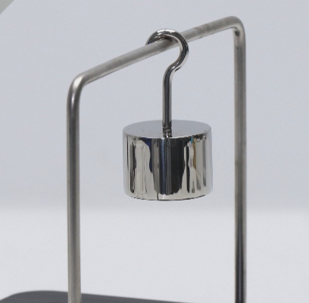
1、When the screen stably displays 0.000g, long press [ZERO] key, and then the screen shows that [CAL 100] is flashing, indicating that the screen has entered the calibration program； | 2、Hang the 100g calibration weight on the central position of the measurement bracket, and the instrument automatically calibrates. When [CAL End] is displayed, the weight can be removed to complete the calibration.
matters need attention:
1. Because the weighing accuracy of the main engine balance is relatively high, please do not calibrate the instrument in places with wind blowing, vibration and strong electromagnetic interference;
2, when calibration, please use sharp tweezers to clamp the weight, and gently put;
3. After the calibration, if the important task is unstable, please do it again once or twice.

V.Operating Process
A. Preparation work before measurement:
After the host balance and the intelligent processor printing all-in-one machine are successfully connected, open the power switch of the industrial computer;
Fill the liquid to be tested with a 50ml glass beaker.
B. Measurement steps (measuring the relative density and concentration of ethanol as an example, other functions are similar)
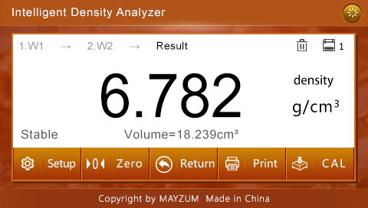
Figure 4: Main interface of measurement
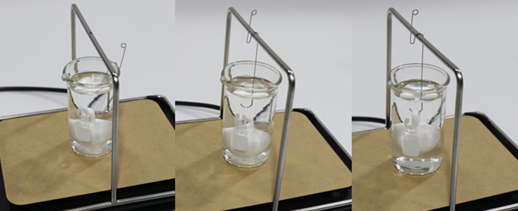

1.Place the measuring block in the liquid and place the liquid sample directly below the measuring frame
3. Hook the measuring block in the liquid and press PRINT to measure the result

2. Hang the hook in the middle of the measuring frame and press the (zero) key to depress the weight of the hook

Figure 5: Measurement steps

1. Soak the measurement block (such as: white spherical Teflon measurement block) in the liquid to be tested, and place the measurement block directly under the stainless steel measuring frame together with the liquid to be tested, as shown in step 1 of Figure 5 above;
2. Hang the hook in the middle of the measurement frame to ensure that the hook part has been immersed in the liquid and touches no measurement block and glass arm. When the data of the measurement host is stable, press the [ZERO] button to deduct the weight of the hook;
3, with hook hook measuring block, and suspended in liquid (note: measuring block surface do not have liquid bubbles, if there are bubbles, can use hook hook measuring block liquid level, then sink into the liquid, so repeated operation several times, bubbles can be eliminated), when the measuring host data show stable, press the [PRINT] data transmission key, in the industrial control display will immediately show the relative density of the liquid, wave beauty, concentration value;
Action tips：If the same liquid requires multiple testing, only press [PRINT] again; if measuring other liquid is needed, repeat steps 1 to 3. In particular, to measure different liquids, please clean and wipe the measurement block before proceeding.
C、Button function and operation instructions on the processor display screen
1. Click the [retest] icon to clear the currently saved measurement data and measure from scratch;
2. Click the [Print] icon to print the measurement results saved in the intelligent data processor. If there are multiple sets of data saved, multiple data will be printed；
3、Click on the circular icon in the upper right corner【】，Switch to other function options, such as: G function to measure the density, specific gravity, concentration of the liquid, switch the function needs to restart the system, and then the system will remember the setting of the user's last time (if it is a single function, to restart the device).

VI. Parameter Setting：
1. Test parameters:
A. Weight of measurement block: refers to the weight of the measurement block (such as white spherical Teflon measurement block). Each measurement block has A similar weight value. When leaving the factory, the weight value of the randomly distributed measurement block has been set to the industrial control screen, and the user does not need to set it again;
B. Measuring block density: refers to the density of the measuring block, the same as its weight, which has been set when leaving the factory, and the user does not need to set it again;
C, Density, wave beauty, concentration error: set the positive or negative value, the density, wave beauty, concentration value calculated by the program will add the corresponding set value, as the final display result value, the default value is 0;
D. Density, wave and concentration display accuracy: refers to the decimal points shown by the calculation results of density, beauty and concentration, which can be modified by users according to the actual needs;
E, temperature taste: at different temperatures, the relative density of the same liquid will show certain differences, especially the volatile liquid (such as ethanol), the temperature has greater influence on its relative density, concentration, so, the user in measuring the relative density or concentration of liquid, must indicate under what temperature measurement, such data is comparable. The temperature range of this instrument is 0-50℃, 20 at the factory;
F. Concentration coefficient: refers to the coefficient of relative density conversion concentration, the relative density and concentration of a liquid can not show an absolute linear relationship, but show a certain curve relationship. This equipment adopts a unique 4-point curve algorithm to convert the relative density and concentration of various liquids. The 4-point curve algorithm has higher accuracy than the 2-point linear algorithm. At different temperatures, the relative density conversion concentration coefficient of the same liquid is different. The equipment has built in the concentration conversion coefficient of some liquids (ethanol, methanol, sodium hydroxide) without temperature,If the liquid tested by the user is built-in, it is no need to set the concentration coefficient, only to set the test temperature and select the corresponding liquid; if testing other liquid, you need to select [Other] under the [measurement liquid] category, and then set the corresponding concentration coefficient E1, E2, E3, E4;
G. Measurement liquid: refers to the name of the liquid whose relative density and concentration conversion coefficient at different temperatures that have been set at different temperatures built in the machine;
H. Display units: the checked units will be displayed in the measurement results, the unchecked units will not be displayed in the results, and only the density units are displayed by default;
I. Weight display: refers to the weighing accuracy of the measuring host. For example, the weighing accuracy of the measuring host is 1 / 10,000, which is set to 0.0000 here.
2. Printing parameters:
A、Report name, unit name, tester, auditor, remarks information, the user can enter the content they want to reflect in the report；
B. Printing mode of test results: After the program calculates the parameter values, if it is [manual printing], the tester need to click the [print result] button on the program interface to print the measurement results through the microprinter; if the selection is [automatic printing], the tester should not click the [print result] button on the program interface. After the data measurement is completed, the program will automatically print the measurement results
C. Empty the history record during the retest: check this item, and the last measurement result will not be retained for each retest, and the last measurement result will not be saved by default;
D.measurement results save: if not check [retest when empty history] option, each measurement after the program will be saved by the user set the measurement data, when all the samples test completed, can click on the second print icon, one-time all the saved historical measurement results printed out.
3. After all the parameters are set, click the [Save] button, the program will save the user's parameter setting, and press the [Return] button not to save the user's parameter setting.

VII.Packing List
No. | Item | Qty
1 | Measure the host machine at 150g | 1
2 | Liquid special frame | 1
3 | Four foot support plate | 1
4 | MAY-D43 smart processor 4.3 inch | 1
5 | Thermal printing paper | 2
6 | 12V-2A power cord (MAY-D43 processor power supply) | 1
7 | CD power cable (power the host from the processor) | 1
8 | Data connection line | 1
9 | 50ml beaker | 2
10 | Stainless steel standard block | 1
11 | Stainless steel hook | 3
12 | A 100g calibration weight | 1
13 | Windproof dust cover | 1

