HZSD-29
Colorimeter

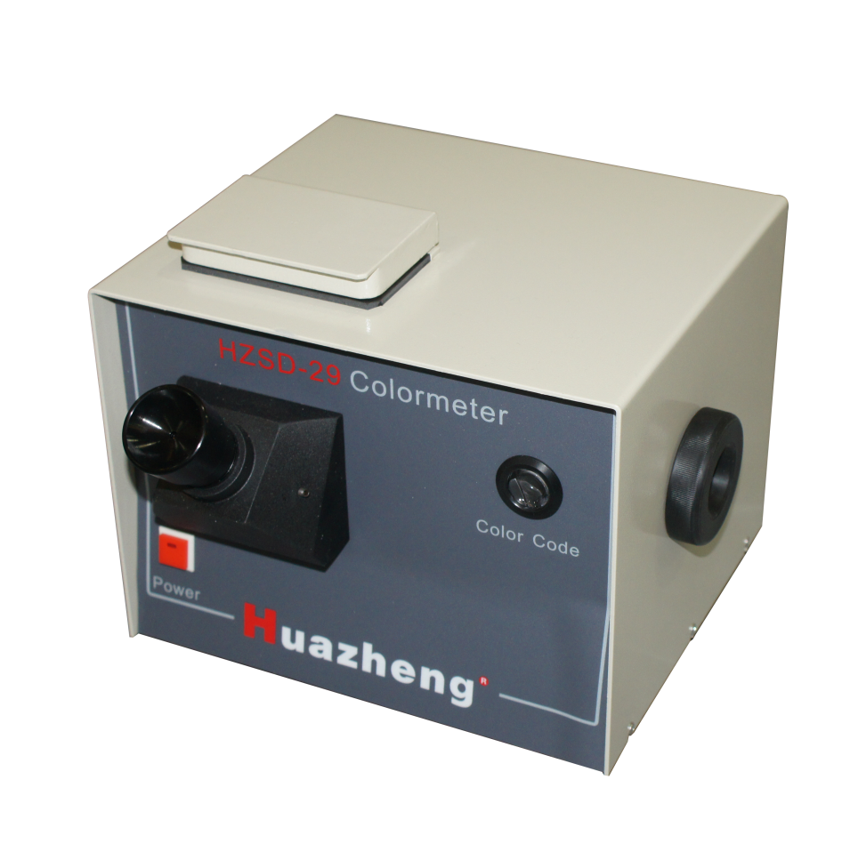

Huazheng Electric Manufacturing (Baoding) Co., Ltd
Contents
I. Introduction 1
II. Main Technical Indicators 1
III. Composition Of The Instrument 1
IV. Performance Features 2
V. Usage Method Of The Instrument 2
VI. Notes 3
VII. Packing List 5

I. Introduction
The instrument applies to the determination of the color of every type of lubricating oil and other petroleum according to ASTM D1500. During the usage of the measuring instrument, the sample of petroleum is injected to the colorimetric tube. Then the chromaticity and the color number are determined after the sample is compared with the standard color sheet.

II. Main Technical Indicators
Power Supply: 240V,100W as well as the milk-shell bulb with dull-polished lining with the temperature as 2750±50K.
Colorimetric Tube: Colorful flat-bottom glass tube with its inner diameter as Φ32.5～Φ33.4mm and its height as 120～130mm.
Standard Color Disk: 26 light holes with the diameter asΦ14, including 25 of them containing glass sheet of which the color number ranges successively and respectively from 1 to 25. The 26th hole is blank.

III. Composition Of The Instrument
The instrument consists of standard light disk, optical lenses for observation, light source and colorimetric tube.
The color is filtered after the source light goes through the milky glass sheet and sunlight-filtering glass sheet. The features of the spectrum of the gotten standard light are similar to that of the north light. Two parallel beams of light are composed after the standard light goes through the plane reflecting mirror and prisma. These two beams of light share the same size and shape, and simultaneously and equally illuminate the colored glass sheet of the standard color disk and the sample in the colorimetric tube.
The standard color disk contains 26 light holes with the diameter asΦ14. Rotate the rotating-hand-wheel of the standard color disk on the right side of the instrument so that the sample fluid can choose the right corresponding color in the experiment of color comparison.
Colorimetric tube is put inside through the position of the small lid at the top of the instrument.
Observation ocular lens consists of convex mirror and concave mirror. Optical ocular lens has the capabilities of adjusting the beam of light and focusing.

IV. Performance Features
Observation ocular lens consists of convex mirror and concave mirror. With its help, both the color of sample and the color of standard color could be observed.
Optical ocular lens has the capabilities of adjusting the beam of light and focusing, and is easy to be put into usage.
Its structure is reasonably designed and is convenient to be handled.
The color number corresponds with the color number of ASTM D1500.

V. Usage Method Of The Instrument
1.Preparation
(1). Use the lens-wiping paper to wipe the colorimetric tube clearly.
(2). Feed distilled water into a colorimetric tube so that the depth of the water is above 50mm. Then put the above-mentioned colorimetric tube as reference liquid on the right side of the lidded container room.
(3). Feed transparent sample into the other colorimetric tube so that the depth of the water is above 50mm. Then put the above-mentioned colorimetric tube on the left side of the lidded container room and remain it lidded.
If the sample is muddy and opaque, then heat it until the muddy color disappears. Then feed it into the colorimetric tube and measure it immediately.
(4). If the color of the sample is darker than the color of the No.25 standard glass sheet, kerosene is used to dilute the sample before the color of the mixture of the kerosene and the sample is measured. The proportion of the volume of sample to kerosene is 15:85.
2. Experimental Procedure
(1) Turn the power switch on and rotate the rotating-hand-wheel of the standard color disk on the right side of the instrument. At the same time observe through the observation ocular lens. You will see two colored semi circles, of which the left one is the color of sample, the other one the standard color. If the color of the sample is as same as that of the standard glass sheet, readings on the figure disk should be recorded as the chromaticity of the sample. If the color of the sample is between the colors of two adjacent standard glass sheets, then the range of the color number should be recorded, such as No.11-12, or No.15-16. The sample measured after being diluted should be noted as “diluted liquid” in the report.
(2) After the measurement is finished, turn the power switch off, take the colorimetric tube out and wash it clearly for its further usage.

VI. Notes
After the focal length and the light have been adjusted properly, the optical lens shouldn’t be moved violently. If the adjustment is necessarily needed, it should be carefully handled.
When the colorimetric tube which contains the sample is put inside the instrument, the external surface and the undersurface should be wiped clearly.
The standard-color glass sheet should be checked with ASM D1500-stipulating standard color-comparing liquid every six months. If the difference between the color of the color sheet and the color of the color-comparing liquid with the corresponding color number is larger than one color number, the color disk should be displaced or sent to its manufacturer to be standardized.
Attachment: comparison diagram of the color number.
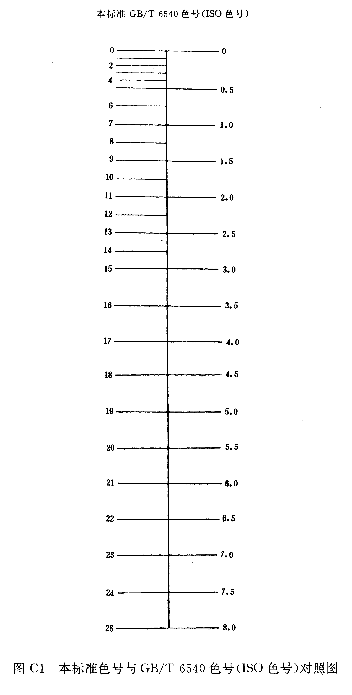
Comparison Diagram of above-mentioned standard color number and the ISO standard color number.

VII. Packing List
No. | Item | Qty
1 | Main engine | 1
2 | Colorimetric Tube | 2

