HZ1200
Karl Fischer Titration Moisture Analyzer

Huazheng Electric Manufacturing (Baoding) Co., Ltd

Advice
- Please read this INSTRUCTION before using the instrument.
- The instrument must be sent to metrological service or other departments that are qualified to check for checking after being used for one year, and only those qualified ones can be used again.
- Must ensure the instrument has a good grounding in order to prevent electric shock.
- Please pay attention to the flow of drains, after a period of time use, the drain pipe might become small because of iodine crystals in KF reagent. Users can repeatedly inlet and outlet anhydrous alcohol to clean pipelines.

Warning:
KF reagents have strong corrosive and smell, should take protection when operation.
If users use traditional K-F reagent that contains pyridine, it is better to prepare solution in a fume cupboard.
K-F reagents must be operated with care since it contains methanol; rinse it with clean water immediately if it gets into eyes accidentally.

Contents

I. Instrument Preparation 1
II. Instrument Operation 10
III. Instrument Maintenance 36
IV. Packing List 40

I. Instrument Preparation
1.1 Unpacking
In the packing box, users can find below parts:
1. HZ1200 Volumetric Karl Fischer Titrator 1 Set
2. External device 1 Set
3. Accessories 1 Set

1.2 Introduction
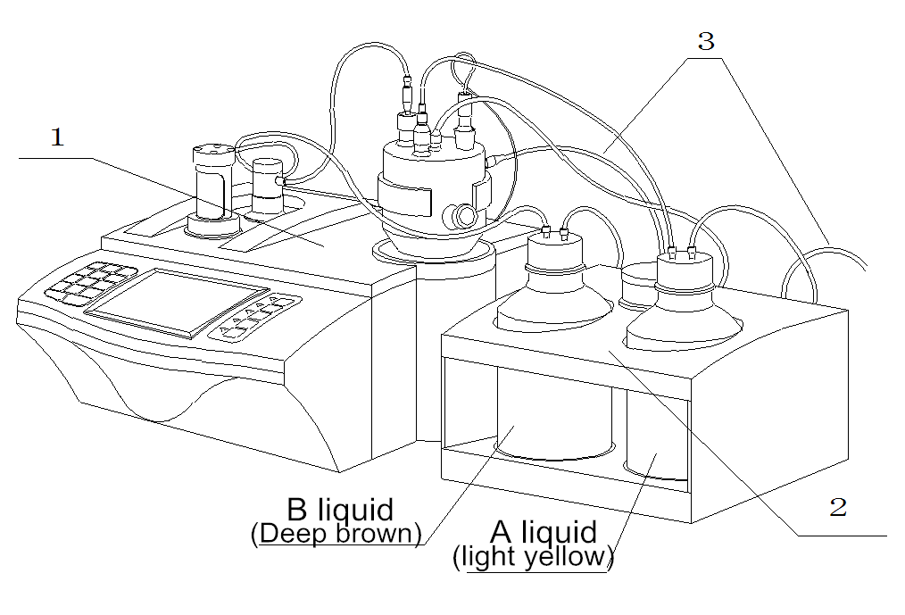

(1) Main unit;
(2) Feeding & drainage device;
(3) Waste outlet

The front view of HZ1200

The instrument is composed of three parts: main unit, titration cup and feeding & drainage device. The Main unit is responsible for handling main functions, such as the exchange display of user interface, data measuring, titrate mode selection, parameter setup, titration control, communication and printing, etc.
The titration cup is the where actually measures water samples, including sampling port, capillary input, electrode interface, inlet of KF reagent A liquid , dryer interface, waste water liquid outlet, etc., adopts full sealed structure.
The Feeding & drainage Device's main function is to prevent users from direct contact with KF reagent, as an auxiliary device designed to simplify user operation, including drainage and feeding function of KF reagents. For example, the initial operation before measurement analysis: Suck out the solution in KF reagent A liquid bottle (solvent), through sealing pipe suck the solution into titration cup, and then start measurement analysis after the sample injection; After sample analysis many times, when the solution in titration cup accumulates to certain degree (or the titration cup solution alarm prompts), users need to operate the instrument to drain the solution inside the titration cup.

(4) The left side of the valve is filling hole;
The right side of the valve is titrant
(5) Titration cup;
(6) Burette device;
(7) Down stirrer
(8) Display;

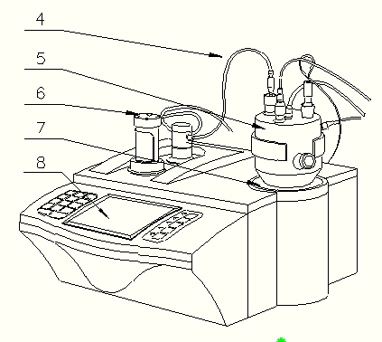

The front view of the Main unit (Diag 1)

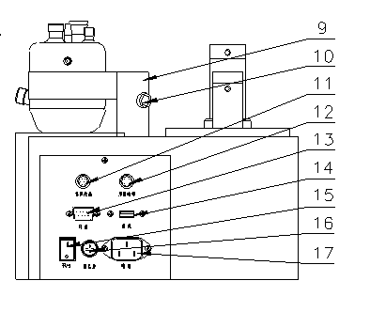
(9) Titration cup holder;
(10) Puller screw;
(11) Feeding & Drainage Device interface;
(12) Electrode socket;
(13) Print output port;
(14) USB interface;
(15) Power switch;
(16) Fuse holder;
(17) Power socket;

The back view of the Main unit (Diag 2)
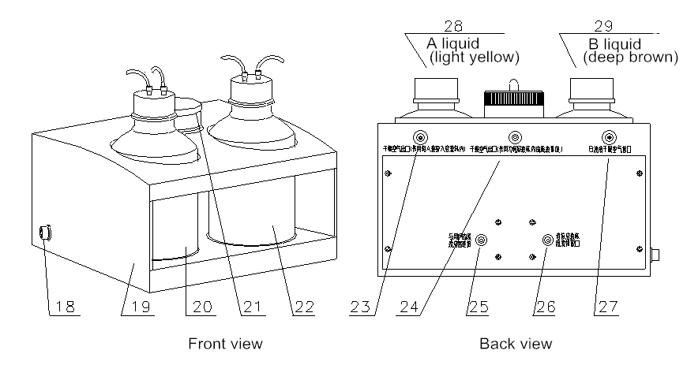
Feeding & Drainage Device

The front view and back view of Feeding & Drainage Device (Diag 3)
(18) The interface with the main unit;
(19) Feeding & Drainage Device (including pump, and bottles that can control and place KF reagent A and B)
(20) KF reagent B liquid (deep brown);
(21) Drying cylinde;
(22) KF reagent A liquid (colorless or slightly yellow);
(23) Dry air outlet (A liquid);
(24) Dry air outlet (titration cup);
(25) Waste outlet (connect with users waste storage container);
(26) Waste liquid inlet (connect with waste outlet of titration cup);
(27) Dry air interface of B bottle;
(28) KF reagent A liquid (colorless or slightly yellow);
(29) KF reagent B liquid (deep brown);

Accessories
(30) Dedicated cable between main unit and feeding & drainage device;
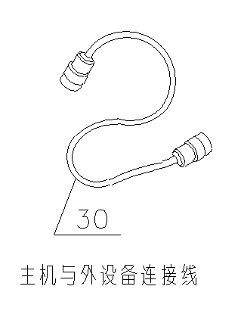
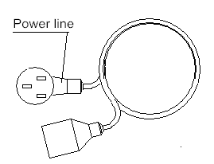

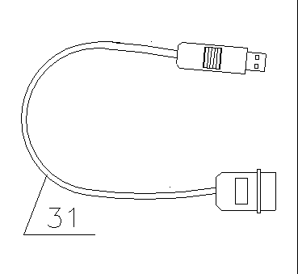
- USB Communication cable;

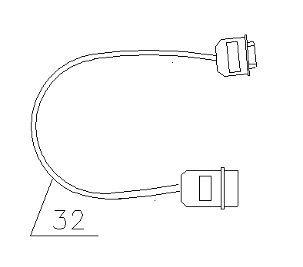
(32) RS-232 Printer cable;

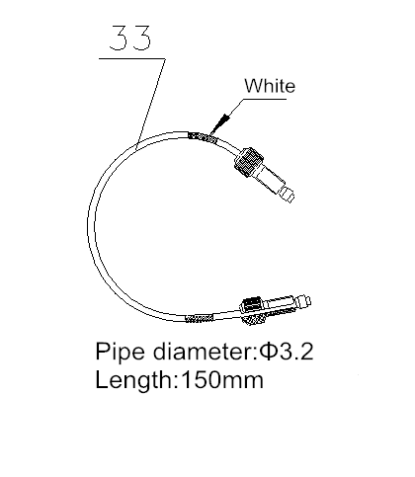
- Filling tube (shorter one, connect magnetic valve to titration apparatus)

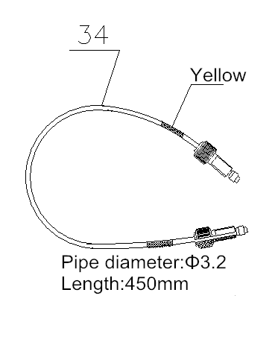
(34) Filling tube (slightly longer one, connect titration apparatus to non-proliferation tube)

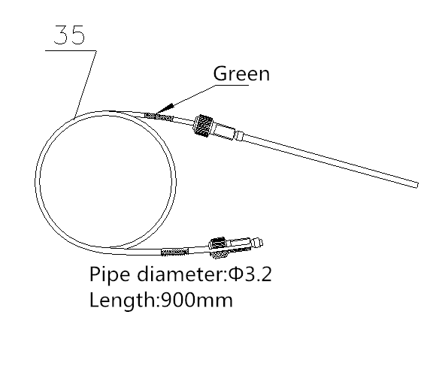
- Filling tube (longer one, connect titration apparatus to B bottle)

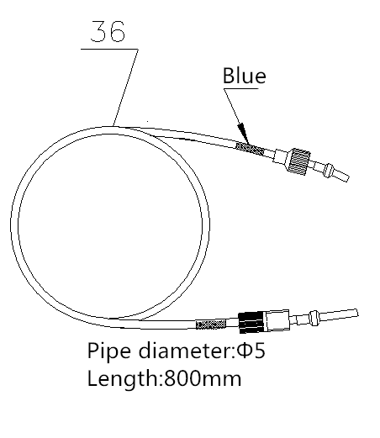
(36) Filling tube φ5 (connect A bottle to tiration cup)

The diagram of accessories (Diag 4)
1.3 Installation
Volumetric Karl Fischer Titrator is a complex device, including the installation of non-proliferation pipe, burette, titration cup and valve; the connection of titration pipe, measuring electrode and feeding & drainage device. Proper installation of all parts can guarantee the normal work of the whole instrument.

1.3.1 Non-Proliferation tube and titration cup （For detailed installation instructions, see below）
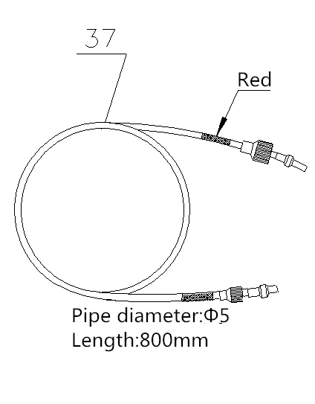
(37) Filling tube φ5 (connect titration cup to feeding & drainage device)

(38) Filling tube φ5 (connect feeding & drainage device to users waste storage container)
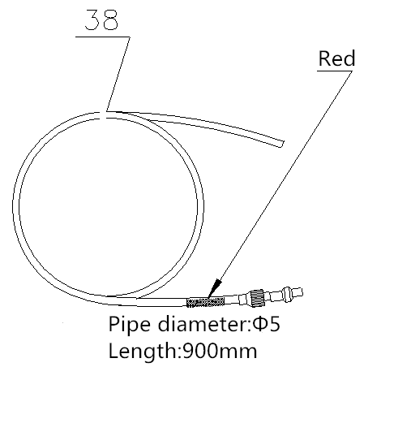

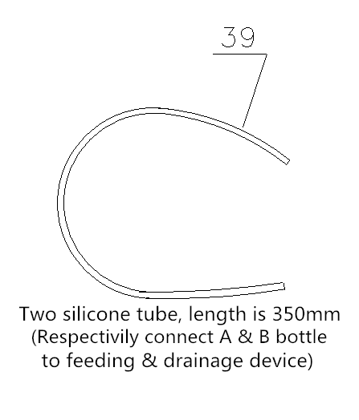
- Silicone tube (connect A & B bottle to feeding & drainage device)

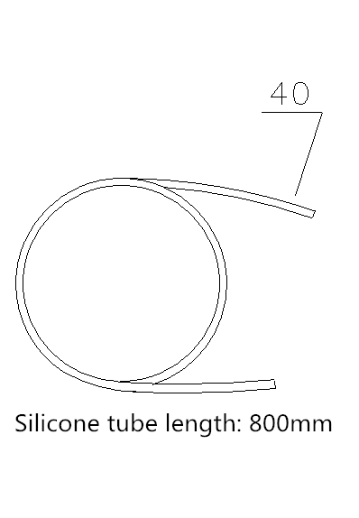
(40) Silicone tube (connect feeding & drainage device to tiration cup)

(41) Measuring electrode (platinum)
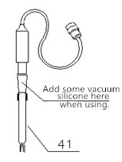

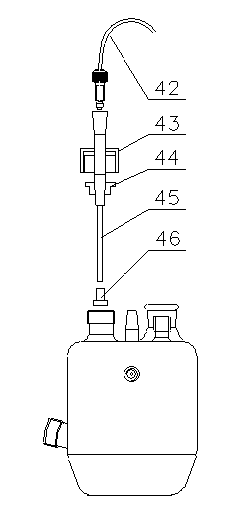
1.3.2 Burette device and valve（For detailed installation instructions, see below）

(42) Filling tube (slightly longer one with black nut)
(43) Nut
(44) Sealing ring (center holes);
(45) Non-proliferation tube
(46) Non-proliferation head

The diagram of non-proliferation pipe and titration cup (Diag 5)

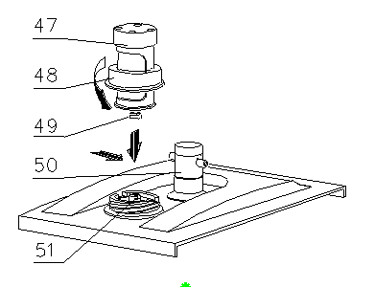
(47) Burette cover
(48) Device fixed nut
(49) Burette piston rod
(50) Anticorrosion three-way valve
(51) Push rod

The diagram of burette device and valve (Diag 6)

1.3.3 Titration cup
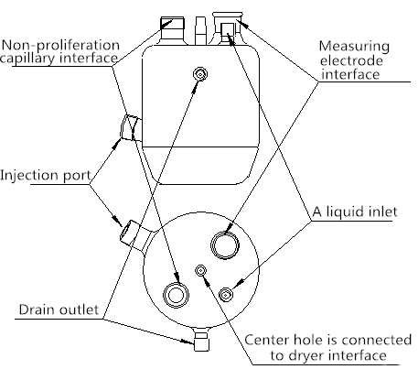
（For detailed installation instructions, see below）

The connections of titration cup (Diag 7)

1.3.4 Install burette device and valve
Place the main unit(3) on test bench, install burette according to diagram 6, during installation the head of piston rod should match the inverted t-slot of the push rod on the main unit, tighten fixed nut(48) of titration device.

1.3.5 Install titration cup holder and titration cup
According to diagram 1 and 2, put the center hole of titration cup holder(9) on the set screw of the main unit, then tighten the puller screw(10), fixed the titration holder; put stirring beads in titration cup(5).

1.3.6 Install measuring electrode
Put some vacuum silicon grease on the conical side of the measuring electrode and insert the electrode into the titration cup’s conical hole (see diagram 2 and 7). After the installation is completed, insert another side of the measuring electrode into the "measuring electrode” socket on main unit.

1.3.7 Install non-proliferation capillary
Pull out the non-proliferation head of the capillary, put the nut and through the rubber ring, then remount non-proliferation head and insert it into the titration cup. After appropriate adjustments to the location of the rubber ring on the capillary, tighten the nut on the titration cup, see diagram 5.

1.3.8 Pipe connection
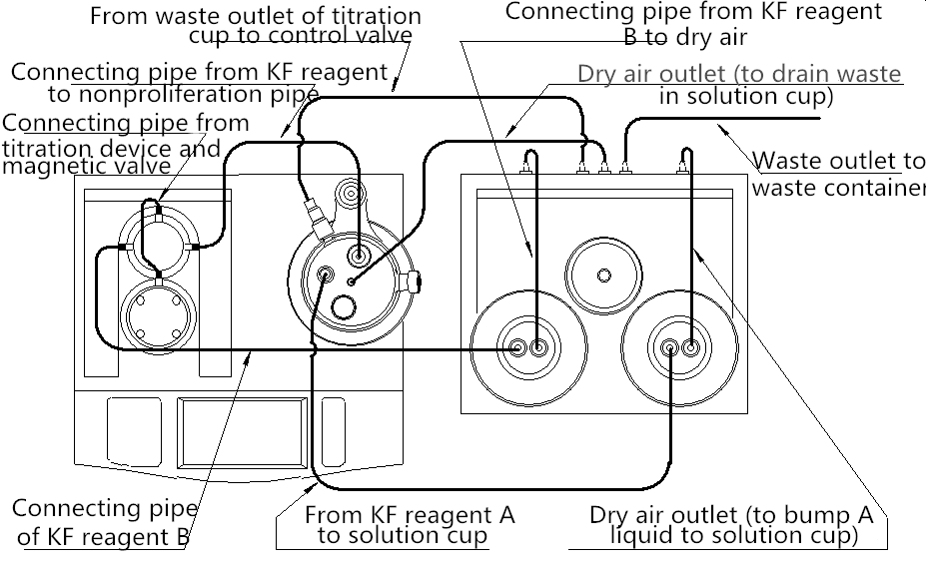

The diagram of pipe connection (Diag 8)

Pipe is the channel that solution correctly flowing, correct connection and sealing of tube is the basic guarantee for the moisture measurement. All pipes need to connect, including valve, titration cup, KF reagent and feeding & drainage device, etc., please see the overall diagram 7 and 8,
- From front view of the instrument, connect one end of the white tube (34) (yellow lable) to the right interface of three-way valve and tighten; connect the other end to the interface of non-proliferation capillary.
- Connect one end of the white tube (35) (green label) to the left interface of three-way valve and tighten the screw; connect the other end to the left interface of KF reagent B bottle (filled with

dark brown solution) and tighten; connect the other interface of B bottle to dry air interface (27) with silicone tube (39).
- Connect one end of the milky tube (36) (hard tube-blue label) to the A liquid injection port above titration cup and tighten the nut; connect the other end to A bottle cap and tighten the nut.
- Connect the center interface of titration cup to dry air outlet (24) with silicone tube(40) (longer one) (see the diagram of titration cup and the back view of feeding & drainage device).
- Connect one end of the milky tube (37) (hard tube-red label) to the waste outlet beside titration cup and tighten the nut; connect the other end to interface (26); Connect one end of the milky tube (38) (hard tube-red label) to interface (25), and insert the other end into the waste container.
- Connect one end of the milky tube (39) dry air outlet (A liquid) (23); connect the other end to A bottle interface.
Note: Each nut joint must be tight, must not have leakage phenomenon.

1.3.9 Connect Feeding & drainage Device
Connect the main unit to feeding & drainage device with dedicated cable (30), connect one end of the cable to interface (11), connect the other end to interface (18) , see figure 3.

1.3.10 Connect power line
Insert the international power wire into power socket (17); unscrew the fuse cover on fuse holder (16); install fuse Φ5x20 (3A) (in accessories), and then tighten the fuse cover, see diagram 2 and 4. (Note: The instrument has been installed with fuse before delivery).

1.3.11 Connect printer
If users need to print the data, please insert one end of the RS-232 printer cable (32) into USB interface(14), and the other end into users serial printer.

II. Instrument Operation
2.1 Introduction
ZDY - 502 Volumetric Karl Fischer Titrator (hereinafter referred to as the instrument) is a highly precise laboratory analyzer, which is mainly used in chemical analysis of college, scientific research institute, petrochemical industry, pharmacy, drug test and metallurgy.

2.1.1 Features of HZ1200
- With new microprocessor technology, the meter can show relevant measuring methods and measuring results. It has friendly operating interface for convenience.
- The meter has several titrate modes including Pre-titrate, Auto titrate, Manual titrate, Constant titrate and KF titer measurement, etc. The instrument has filling and cleaning function.
- For KF reagent, the instrument has feeding, drainage, KF reagent mixing function, prevent users from direct contact with KF reagent, simplify the user operation.
- The instrument supports automatic anti-overflow protection function for solution in titration cup.
- The instrument supports failure detection and prompt functions for KF reagent .
- The transmission system has been improved to reduce the size and noise of the meter during operation. The stirring system adopts PWM technology to adjust the speed of stirring system.
- The meter has USB interface which can be connected to the computer. It is controlled by the professional software.
- It supports GLP norm and can save 200 sets of titration data. Users can view and printout.
- It supports firmware upgrade, allows function extension.

2.1.2 Main Specifications and Performance
- Measuring range: 0.1mg~250 mg;
- Resolution: 0.1mg;
- Accuracy of polarization current: 1µA ±0.2µA; 50µA ±10µA;
- Repeatability of titration analysis: 0.5％;
- Normal working conditions:
Environments temperature:(5.0~35.0)℃;
Relative humidity: ≤80%;
Power supply: (220±22)V，Frequency(50±1)Hz;
There should be no disturbance of electromagnetic field.
- Dimension(mm)：340×400×400 (length×width×height).
- Weight(kg)：about 10.

2.1.3 Function introduction
- The meter has several titrate modes including Pre-titrate, Auto titrate, Manual titrate, Constant titrate and KF titer measurement, etc.
- The instrument supports multiple burette types, and supports recalibration of burette factor.
- The instrument has filling and cleaning function.
- The meter has several titrate modes including Pre-titrate, Auto titrate, Manual titrate, Constant titrate and KF titer measurement, etc. After titration, the meter can generate special titrate modes directly.
- The instrument supports automatic anti-overflow protection function for solution in titration cup.
- The instrument supports failure detection and prompt functions for KF reagent .
- It supports GLP norm and can save 200 sets of titration data; data also supports store, delete, view and printout.
- The meter has USB interface which can be connected to the computer. It is controlled by the professional software.
- The instrument supports RS232 printer to print the titration results.

2.1.4 Titrate mode introduction
- Pre-titrate Mode
To ensure the accuracy of measurement, usually before the formal analysis of samples, the original water inside the titration cup must be exhausted. Keeping the titration cup in a nonaqueous environment, and then start sample measurement, so pre-titrate mode is actually a pretreatment. Usually pre-titrate is performed before each measurement, especially for long time no use or the replacement of KF reagent A, in a word, pre-titrate must be performed if water exists in titration cup.

- Auto Titrate Mode
Select auto titrate mode if the endpoint value of the sample is already known. After users set corresponding control parameters, the instrument will automatically start the titration.

- Manual Titrate Mode
During titration, users need to add solution, determine the potential stability after adding and the next added volume by themselves. This titrate mode will help users find titration endpoint, which is convenient for users to titrate this kind of samples with auto titrate next time.

- Constant Titrate Mode
The titrate mode is suitable for certain special situation, such as continuous titration required anhydrous state all the time.

- KF Titer Measure Mode
Generally, we use KF reagent with known titer to measure water content; in turn, this mode is to determine actual KF reagent titer by adding standard samples..
Note:
After the replacement of KF reagent B (titrant), since the titer of KF reagent varies a lot with actual nominal KF titer, users must measure KF titer again, otherwise will directly affect the measurement result.

2.1.5 KF reagent introduction
KF reagents are usually divided into two parts, one-component reagent and two-component reagent. This instrument adopts two-component reagent. Two-component reagents are usually made of A liquid (solvent) and B liquid (titrant). In general, solvent is called A liquid, titrant is called B.
KF reagent A (solvent) : A consists of substances such as methanol, sulfur dioxide, placed in titration cup and used for titration reaction. Note: Generally, after titrated 50ml~60ml or placed for too long, the reagent will fail and need to be replaced (the instrument has simple tips).
KF reagent B (titrant) : B consists of substances such as methanol, iodine, placed in the burette. Used for moisture titration. The final analysis results is determined by the consumption of KF reagent B. Note: When use new KF reagent B, must mix KF reagents and measure KF titer to determine the titer of KF reagent B.
Note:
- A liquid and B liquid is general description. A liquid is the solvent, B solution is the titrant.

2.1.6 General analytical procedure
- Please strictly in accordance with the installation steps, install the valve body, titration cup; install the measuring electrode, non-proliferation capillary; connect pipelines, external device, power supply. Double-checked prior to installation. Specific installation steps please refer to installation section.
- Feed KF reagent A into titration cup, specific operation please refer to feeding section.
- Mix KF reagent B, specific operation please refer to mixing section.
- Fill KF reagent B into burette, specific operation please refer to filling section.
- Perform pre-titration, exhaust the moisture in the titration cup, be ready for following accurate measurement. Specific operation please refer to pre-titration section.
- After pre-titration, the instrument prompts “wait for sample”, at this time, users should sample manually. Start measurement after sampling.

- Start auto titrate (or other titrate), Specific operation please refer to relevant titration section.
- After the titration, the instrument displays titration results, users can store and output measuring results.
- Drainage.

If users need the second titration, start on the step 5, users don’t have to perform feeding or drainage step before each titration.
After the replacement of KF reagent B (titrant), since the titer of KF reagent varies a lot with actual nominal KF titer, users must measure KF titer again, otherwise will directly affect the measurement result.

2.1.7 Keyboard
The operation keyboard consists of buttons and screen. The screen displays the current working condition of ZDY- 502.
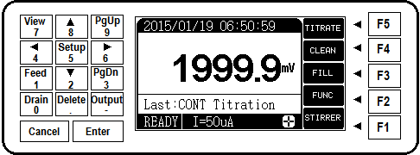
The diagram of keyboard

The meter has 19 buttons, respectively: 1/ Feed、2 /▼、3 / PgDn、4/◄、5/Setup、6/►、7/View、8/▲、9/PgUp、0/ Drain、./Delete、-/Output、Enter、Cancel and function keys F1、F2、F3、F4、F5. The keys are scattered on the both sides of the LCD, the left keys are digital composite keys, confirm key and cancel key. The right keys are function keys (F1~F5), usually users can complete the operation only with function keys F1~F5.
Except ‘Enter’ and ‘Cancel’ keys, ‘-’, ‘.’ and number keys (0~9) are all function composite keys. When users need to input data or set parameters, the composite key is the number key function; In other cases, the number keys function doesn't work, the composite function is valid.
- 1/Feed: Input number 0, excute the function to suck KF reagent A into titration cup;
- 2/▼: Input number 2, move down highlight, minus the parameter value by one when setting parameters;
- 3 / PgDn: Input number 3, page down during menu operation;

- 4/◄:Input number 4, move the cursor left;
- 5/Setup：Input number 5, excute setup function;
- 6/►: Input number 6, move the cursor right;
- 7/View: Input number 7, view titration results, stored data, etc;
- 8/▲: Input number 8, move up highlight, plus the parameter value by one when setting parameters;
- 9/PgUp: Input number 9, page up during menu operation;
- 0/Drain: Input number 1, excute drainage function of reagents in titration cup.
- ./Delete: Input decimal, delete data when viewing stored data;
- -/Output: Input negative number, output corresponding results when viewing stored data, measuring results and condition;
- Enter: Corressponds to most of the functions, press enter key to excute corressponding operations.
- Cancel: Corressponds to most of the functions, press cancel key to give up corressponding operations.
- F1~F5 function keys: They are the most often used keys. The main functions of the meter can be performed by these five keys. The actual functions vary with different modules. The meaning will be determined by the words on the right side of the LCD screen. For example, in the initial state, the LCD will display the following:
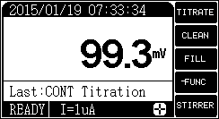
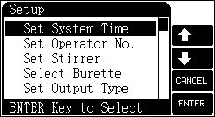

At this time,
‘F5’ key corresponds to titration function;
‘F4’ key corresponds to cleaning function;
‘F3’ key corresponds to filling function;
‘F2’ key corresponds to function selection;
‘F1’ key corresponds to stirring function.

Pressing the corresponding key can perform corresponding functions. If F5 key is pressed, the meter will perform titration. If the function key is corresponded with blank LCD, it means this key is not effective at this moment. In the diagram, the F5 key is ineffective in selecting menu item.
For example: When choosing menu option, ‘F4’ key corresponds to move up highlight; ‘F3’ key corresponds to move down highlight; ‘F2’ key corresponds to cancel function; ‘F1’ key corresponds to confirm function. However, ‘F5’ key is invalid.

2.1.8 Summary
This instrument adopts new microprocessor technology, the meter can show relevant measuring methods and measuring results. The meter has several titrate modes including Pre-titration, Auto titration, Manual titration, Constant titration and KF titer measurement, etc. HZ1200 Volumetric Karl Fischer Titrator is a highly precise laboratory analyzer.
Main steps of HZ1200 Volumetric Karl Fischer Titrator are as follows:
- Parameter setup
- Burette factor calibration
- Reagent treatment
- Titration analysis
- Data processing
During the process, the instrument will display messages from the titrator, and users can change parameters by pressing keyboard. HZ1200 Volumetric Karl Fischer Titrator consists of three parts: main unit, titration cup and external device (feeding & drainage device).Following sections will describe each part of the process.

2.2 Operation
2.2.1 Start-up HZ1200
Successful operation is based on correctly installation and maintenance, check the power supply and grounding before starting.
Open the power switch, the meter will display model, name and software version. After self-inspection, the meter will enter the initial state, as shown in diagram. The middle area displays current potential value and last titration method; the right side displays available function keys; the bottom area displays the state of titrator and stirrer. This state is the initial state, all operations start here.
At this time, press ‘TITRATE’ key to start titration functions; press ‘CLEAN’ key to clean burette; press ‘FILL’ key to fill in the solution; press ‘STIRRER’ key to switch stirrer and set speed; press ‘FUNC’ key the function keys to select functions, such as drain KF liquid, feeding KF and mix KF liquid; press ‘CLEAN’ key to clean titration cup; press ‘Setup’ key to set system time, operator number, burette type, burette factor and output type; press ‘View’ key to view last titration result and stored titration result.

2.2.2 Parameter Setup
Parameter setup contains setup of system time, operator No., burette type, burette factor, stirrer speed, output type and polarization current.
In order to operate the meter correctly, when it is operated for the first time, the user must check whether the set parameter accords with operating conditions. If not, new parameter must be set. In ordinary operation, if users find some wrong operating condition, date, or time, set the relevant parameter again.
In the initial state, press ‘Setup’ key, and the meter will enter parameter setup mode. See the diagram. Then press arrow keys to move the cursor to the targeted parameter and press ‘Enter’ key, the meter will enter corresponding parameter module.
Cautions:
- The burette, burette factor, system time must be set correctly.
- The meter has power-off protection function. If it is power off suddenly, all parameters will not be lost.

2.2.2.1 Set system time
The clock of the meter is supplied with power from button cell, and it has certain timing error. Using it for too long will cause inaccurate timing. Reset it according to the accurate time when necessary. In the initial time, press ‘Setup’ key to select time system item. See the diagram.
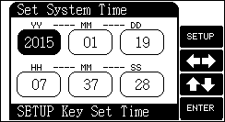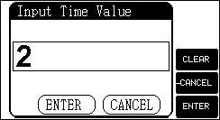
The user can press arrow keys to move the cursor to the targeted time item. Then press ‘SETUP’ key to input actual time.

2.2.2.2 Set operator No.
The meter allows the user to set No. as a part of GLP norm. The range is 0~200.
In the initial state, press ‘Setup’ key and select ‘Set operator No.’ See the diagram. The user can press ‘Setup’ key to input proper operator No.
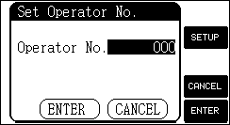
Note: The meter will automatically display the information about the operator No., time, titration result and electrode calibration which meets with GLP norm.

2.2.2.3 Set stirrer
In the initial state, press ‘Setup’ key to select stirrer item. See the diagram. The user can turn on or turn off the stirrer when needed. Pressing ‘++’ or ‘—’ key can adjust stirring speed, or you can input the stirring speed directly. The range of stirrer speed is 0~45.
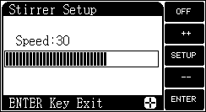

2.2.2.4 Set output type
The instrument supports two interfaces, print interface and USB interface. Print interface supports serial printer, users can connect serial printer to printout measuring results directly; USB interface can be connected to PC, professional software, and output measuring results, etc.
In the initial state, press "Setup" key and select ‘Set output type’, as diagram, user can choose output type according to need.
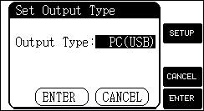
If user has purchased serial printer, it is recommended to choose the printer which can print over 24 words in one line.

2.2.2.5 Set polarization current
The meter supports two polarization current: 1μA and 50μA. For KF reagent with slow response and not obvious jump, can choose 50μA polarization current, and vice versa.

2.2.3 Reagent treatment
2.2.3.1 Cleaning function
This function allows users to clean burette. In the initial state, press ‘Clean’ key, and the meter will display as below diagram.
The number in the diagram means the times of cleaning. The meter supports two cleaning speed and the user can select it when necessary.
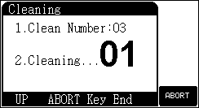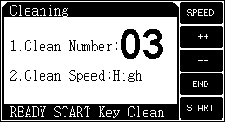
Note: Should not choose DI water or other water phase solution for cleaning. Use anhydrous ethanol to clean.

At this time, Press ‘++’ key can increase the cleaning times; Press ‘--’ key can decrease the cleaning times (Or you can press ‘Setup’ key to input the number of cleaning times); Press ‘Enter’ key to begin cleaning after setup.
After cleaning, the meter returns to the initial state.
During cleaning, Press ‘Cancel’ key to end cleaning and the meter will ask if the user wants to stop cleaning. At this time, Press ‘Enter’ key and the meter will end cleaning and return to the initial state; Press ‘Cancel’ key and the meter will continue cleaning.
Note:
- For new instrument, to check the seal condition of pipe, burette, joint and B liquid with anhydrous ethanol, should guarantee no leakage.
- During daily use, should regularly mix KF reagent B to ensure the consistency of KF titer.
- Cleaning function key is not recommended, it will drain KF reagent B.
- Manual cleaning residual titrant to reduce the waste of titrant; Pay attention to the use of push rod and installation details of mechanical device.

When replace the titrant, if necessary, use anhydrous ethanol to thoroughly clean the residual titrant, auto cleaning at least nine times. Finally, use push rod to clean residual ethanol.

2.2.3.2 Filling function
In the initial state, press ‘FILLl’ key and the meter will prompt a window as the following diagram shows; Press ‘Enter’ key to fill the solution.
After filling solution, the meter will return to the initial state. During filling solution, press ‘CANCEL’ key to stop filling solution.
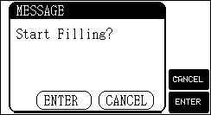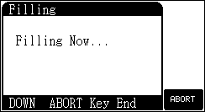

Note: Every time when the titration ends, the meter will automatically fill solution.

2.2.3.3 Drainage、Feeding、KF reagent mixing function
For the convenience of users, this function is mainly directed at the KF reagent A or KF reagent A in titration cup, allows users to direct suck KF reagent A into titration cup; or drain solution in the titration cup; or direct cleaning titration cup. In the initial state, press "FUNC" key to select above functions.
Warning: Please pay attention to the flow of drains, after a period of time use, the drain pipe might become small because of iodine crystals in KF reagent. Users can repeatedly inlet and outlet anhydrous alcohol to clean pipelines.

2.2.3.3.1 Drain function
This function can direct drain reagent in titration cup. Use this function when users find the solution in titration cup need to be replaced; or after repeated titration, there are many solution in titration cup and need to drain some.
In the initial state, press "FUNC" key to select drain function or press the "Drain" key to enter drain function, shown in the diagram.
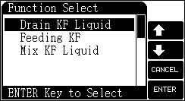
Press "Drain" key to turn on the switch and drain solution in titration cup. After drainage, press "STOP" key to turn off the switch. After the drainage is completed, press "END" key to exit drainage function.

2.2.3.3.2 Feeding function
This function can suck KF reagent A into titration cup. In the initial state, press "FUNC" key to select feeding function or press "FEED" key to enter feeding function, as shown in diagram.
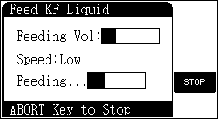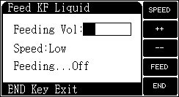
Users can press the "++" or "--" key to adjust feeding volume. After the feeding volume is set, press ‘FEED’ key to turn on the switch suck KF reagent into titration cup. When the feeding volume of KF

reagent reached the set volume, the instrument automatically end feeding. During the process of feeding, users can press ‘STOP’ key at any time to stop feeding. After feeding, press "END" key to exit feeding function.

2.2.3.3.3 Mix KF liquid
There will be precipitation phenomenon if KF reagent B is not used for a long time, , mix well before use for best results; this function can help to achieve this function. In the initial state, press the "FUNC" key to select mix KF liquid function.
This function is similar to the burette cleaning function, users can set mix number and mix speed. After setup is complete, press "START" key to start mixing. During the process of mixing, users can press "CANCEL" key at any time to abort mixing.
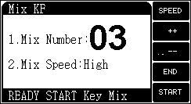

2.2.4 Titration Analysis
Moisture titration, that is Karl Fischer Reagent titrimetry (volumetry), its process and potential changing are as follows: In the beginning, there is moisture in titration cup, so the potential value is high (more than 300 mV); after the feeding of KF reagent, at the beginning the potential changes slowly, when the feeding volume of KF reagent reaches the endpoint, the potential changes strongly, drops from high potential down to the endpoint; after the evenly mixing of KF reagent, the potential fast returns to high potential; repeat this many times, when the potential doesn’t return to high after the feeding of KF reagent, the titration is end. The consumed KF reagent multiplied by titer is the water content of the sample.
This instrument provides the following titration modes: Repeat last titrate, pre-titrate, auto titrate, manual titrate, constant titrate, titer measure, etc.
In the initial state, press "TITRATE" key, show as below. Move highlight to corresponding titrate mode and press "ENTER" key to select corresponding titrate mode.
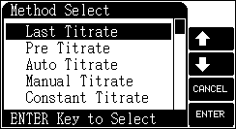
Warning:
- Before titration, please carefully check the connection of pipelines, operate step by step according to moisture analysis. For operators without related experience or knowledge background of the operation and safety precaution of KF reagent, we recommend that you carefully read KF reagent introduction section and operate strictly according to relevant notes, in order to avoid accidents.
- Before each titration, last titration data and titration results will be automatically deleted. If user does not store measuring results, there will be an automatic prompt.
- After the replacement of KF reagent B (titrant), since the titer of KF reagent varies a lot with actual nominal KF titer, users must measure KF titer again, otherwise will directly affect the measurement result.
- Under the same service condition, when using invalid KF reagent A, the titration analysis time will be greatly extended and even unable to reach the endpoint, users can determine to replace KF reagent A.
- When feeding, must ensure that there is no solution in drain pipe, and there is enough solution in A bottle, can’t be empty bottle, or siphon phenomenon could occur, automatically drain A liquid in titration cup through drain outlet, causing the failure of feeding and the waste of A liquid!
- After drainage, please ensure that no residual solution in drain pipe, in particular, siphon phenomenon could occur when the titration cup is not completely empty. The solution in titration cup will automatically drain through the drain outlet, can not meet operating requirement.

2.2.4.1 Repeat Last Titrate
‘Last Titrate’ is set for the convenience of operation. When users have finished one titration, user can directly select ‘Last Titrate’ to repeat last titration. Users can ignore last titration parameter which is convenient for users operation.

2.2.4.2 Pre-titrate Mode
Pre-titrate mode is one of the main titrate mode. To ensure the accuracy of measurement, usually before the formal analysis of samples, the original water inside the titration cup must be exhausted. Keeping the titration cup in a nonaqueous environment, and then start sample measurement, so pre-titrate mode is actually a pretreatment. It can certainly operate as normal titrate mode.
In the initial state, Press ‘TITRATE’ key, select ‘Pre Titrate’ and confirm the selection. The meter will enter the state of pre-titration parameter setup. See the diagram.

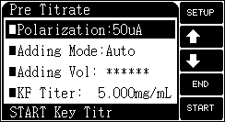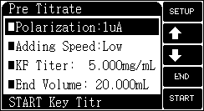

2.2.4.2.1 Parameters
Pre-titration parameter contains: polarization, adding speed, adding mode, KF titer, end volume, result unit, sample quantity, EP delay (Endpoint delay), stirrer speed, etc. Move the cursor onto the corresponding item; Press ‘Setup’ key to modify parameter or value; After modification, press ‘START’ key to begin pre-titration.
- Polarization current
The meter supports two polarization current: 1μA and 50μA. For KF reagent with slow response and not obvious jump, can choose 50μA polarization current, and vice versa.
When users select 1μA, the instrument supports two kinds of adding speed, including high speed and low speed.
When users select 50µA, the instrument has two kinds of adding mode, including auto adding and constant adding.
- Adding mode
When users select 50µA, the instrument has two adding mode, including auto adding and constant adding.
Auto adding, the instrument automatic control the whole titration till end, including sampling, control and calculate next adding volume.
Constant adding, it is different from auto adding in adding volume. That is, the adding volume every time is the same during the control process, adding with the same amount of titrant. Constant adding is suitable for the titration of samples of less moisture. Users must set adding volume before titration. For example, when users select constant adding and set the adding volume as 0.02mL, then the instrument will adding with 0.02mL all the time, can prevent over titrate under the condition of few water content and cause the titration error.
- Adding speed
When users select 1μA, the instrument supports two kinds of adding speed, including high speed and low speed. For 50μA, can not select speed.

This parameter controls the adding speed of titration. When users titrate with high-speed mode and find over adding, can change to low speed mode. When users find the analysis time is too long, can select high-speed mode.
Note:
Under the same service condition, when using invalid KF reagent A, the titration analysis time will be greatly extended, users can determine to replace KF reagent A.

- Titer
If users know the titrate intensity value of added KF reagent B in advance, then can set this parameter. This parameter is involved in the calculation of sample result at the end of the titration.
If the user knows in advance to add KF reagent titration strength value of the liquid B, then you can set this parameter. This parameter at the end of the titration calculating sample results.
After the replacement of KF reagent B (titrant), since the titer of KF reagent varies a lot with actual nominal KF titer, users must measure KF titer again, otherwise will directly affect the measurement result.
- End volume
Although the instrument is designed with automatic anti-overflow detection, it is necessary to set this parameter for security.
This parameter is designed to avoid the damage of meter caused by excessive addition. It is better to set this parameter. During titration, the total added volume will be determined automatically. Once the actual volume exceeds the preset end volume, the meter will stop titration and remind user if it finish titration or not. User can select the needed one when necessary.
- Result unit
This instrument supports various kinds of unit of measurement results, mg、mg/L、%、ppm, users can select according to actual demand.
- Sample quality
This parameter corresponds to measuring result. When users select the result unit as mg/L, users need to input the sample volume (mL); others, users need to set the sample quality (mg).
- EP delay
After reaching the titration endpoint, the potential changes strongly, and rapidly rise again along with the mixing of KF reagent, so it is necessary to set a certain delay time. During this period, if

the potential returns to high, the instrument will continue titration, the titration will end when the potential near endpoint and continue for a certain delay time. Usually the endpoint delay time is 60 s.
Note:
When the endpoint delay time is set 999s, the pre-titrate mode is equal to constant titration.

- Stirrer speed
For some titrations, user needs to adjust chemical reaction speed of titration with different stirring speed. User can set up this parameter when necessary. When the titration begins, the meter will stir the sample in this speed.
Note:
Stirrer speed might be a great factor to the titration results and the whole titration time. Users should use high mixing speed to increase the reaction speed and shorten the titration time.

- Default
This is the function selection. If user has the wrong operation, or the parameter value is abnormal due to other reasons, this function can be used. The meter will recover the default parameter automatically. These parameters can meet with most of the operation.
Default parameters:
- Polarization current: 1μA;
- Adding mode: Auto;
- Titrate speed: Low;
- KF titer: 5.000mg/mL;
- End volume: 20.000mL;
- Result unit: mg;
- Sample quantity: 30.000mg;
- EP delay: 60s;
- Stirrer speed: 30.

2.2.4.2.2 Pre-titrate process
After all specifications have been setup properly, press “START” key to start pre-titrate.
The instrument first begins 10 seconds stirring, then start titration automatically .
The meter displays titration time, titration type, current potential value, adding volume and titration state, etc.

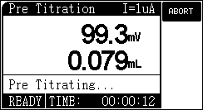
During titration, the meter will automatically start sampling, filling of solution, and distinguish of endpoint. When the meter recognizes an endpoint, there will be three beepers to remind users and end titration. During titration, users can press ‘ABORT’ to end titration at any time. The meter will prompt a window to remind ‘End Titrate?’. Users can continue or stop titration according to actual need.

If the meter recognizes that the added volume is beyond the final volume (maximum volume) setup by the user, it will prompt user to continue or not. User can choose to end or continue the titration based on his case. Press ‘ENTER’ key to end or press ‘CANCEL’ to continue.
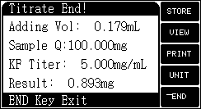
After the titration, the instrument will display the actual titration results, shown in diagram. Users can store and print measuring results or view detailed titration record, press ‘END’ key to return to the initial state.

2.2.4.2.3 Operation after Pre-titrate
Usually, pre-titrate is the pretreatment before titration, is used to exhaust the moisture in titration cup. Pre-titrate process is often included before auto-titrate, manual titrate. After pre-titrate, the instrument prompts "Waiting for sample", users can feed samples. After the feeding is completed, users can start other titrate mode and measure added sample.
Instruments also allows users to use pre-titrate mode alone, after the titration is completed, the instrument will automatically return to the initial state.

2.2.4.3 Auto Titrate Mode
Auto titrate mode includes parameter setup, pre-titrate, sampling and auto titrate. Users perform pre-titrate at first; after pre-titrate is completed, users manual sampling; start auto titrate after sampling.
In the initial state, press "TITRATE" key, select auto titrate and confirm to select auto titrate mode.

2.2.4.3.1 Parameters
The control process and control parameter is same as auto titrate mode. For details please refer to the parameter setup of pre-titrate. mode parameter setting. After corresponding parameter is set, press "START" key to start titration.
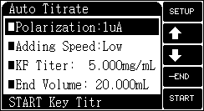

2.2.4.3.2 Pre-titrate process
The instrument will first ask whether to start pre-titrate. If users need pre-titrate, then select pre-titrate operation, otherwise can press "SKIP" key to skip pre-titrate.
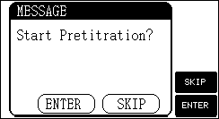

2.2.4.3.3 Sampling process
If perform pre-titrate pretreatment, at the end of pre-titrate, the instrument will prompt ‘Waiting for Sample’; If users skip pre-titrate, the instrument will directly prompt users to sampling. At this moment, users can manually inject sample into titration cup. After injection, press ‘CONT’ key to start formal measurement.
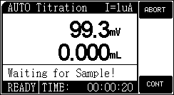

2.2.4.3.4 Auto titration process
The measuring process is same as pre-titrate. Users can abort titration at any time in the process of titration. After the titration, the instrument will display the actual titration results, shown in diagram.
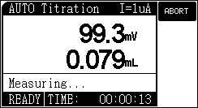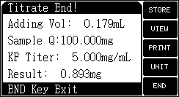
Users can store and print measuring results or view detailed titration record, press ‘END’ key to return to the initial state.

2.2.4.4 Manual Titrate Mode
In the manual titration, user can manually adding and determine if the potential is stable and if it needs addition again.
Manual titrate mode includes parameter setup, pre-titrate, sampling and manual titrate.
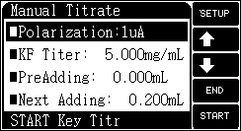
In the initial state, press "TITRATE" key, select manual titrate and confirm to start manual titrate mode.

2.2.4.4.1 Parameters
Manual titration parameter contains: polarization, KF titer, pre adding, next adding, result unit, sample quantity, end volume, stirrer speed, etc. Move the cursor onto the corresponding item; Press ‘Setup’ key to modify parameter or value; After modification, press ‘START’ key to begin titration.
- Polarization current
The meter supports two polarization current: 1μA and 50μA. For KF reagent with slow response and not obvious jump, can choose 50μA polarization current, and vice versa.
- Titer
If users know the titrate value of added KF reagent B in advance, then can set this parameter. This parameter is involved in the calculation of sample result at the end of the titration.
After the replacement of KF reagent B (titrant), since the titer of KF reagent varies a lot with actual nominal KF titer, users must measure KF titer again, otherwise will directly affect the measurement result.
- Pre-adding volume
For certain titration, if users know the consumption volume of titration end point, then can use this parameter to speed up the titrate speed. This parameter controls the first automatic adding volume of at the beginning of titration.
- Next adding volume
This parameter controls the next adding volume of manual titration, users can also modify after the beginning of titration.
- End volume
Although the instrument is designed with automatic anti-overflow detection, it is necessary to set this parameter for security.
This parameter is designed to avoid the damage of meter caused by excessive addition. It is better to set this parameter. During titration, the total added volume will be determined automatically. Once the actual volume exceeds the preset end volume, the meter will stop titration and remind user if it finish titration or not. User can select the needed one when necessary.
- Result unit
This instrument supports various kinds of unit of measurement results, mg、mg/L、%、ppm, users can select according to actual demand.
- Sample quality
This parameter corresponds to measuring result. When users select the result unit as mg/L, users need to input the sample volume (mL); others, users need to set the sample quality (mg).
- Stirrer speed
For some titrations, user needs to adjust chemical reaction speed of titration with different stirring speed. User can set up this parameter when necessary. When the titration begins, the meter will stir the sample in this speed.
- Default
This is the function selection. If user has the wrong operation, or the parameter value is abnormal due to other reasons, this function can be used. The meter will recover the default

parameter automatically. These parameters can meet with most of the operation.
Default parameters:
- Polarization current: 1μA;
- KF titer: 5.000mg/mL;
- Pre-adding volume: 0.000mL;
- Next adding: 0.200mL;
- End volume: 20.000mL;
- Result unit:mg;
- Sample quantity: 30.000mg;
- Stirrer speed: 30.

2.2.4.4.2 Pre-titrate process
After all specifications have been setup properly, press “START” key to start manual titrate. The instrument will first ask whether to start pre-titrate. If users need pre-titrate, then select pre-titrate operation, otherwise can press "SKIP" key to skip pre-titrate.

2.2.4.4.3 Sampling process
At the end of pre-titrate, the instrument will prompt ‘Waiting for sample’; If users skip pre-titrate, the instrument will directly prompt users to sampling.
After injection, press ‘CONT’ key to start formal measurement.
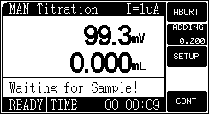

2.2.4.4.4 Manual Titrate process
The display interface is similar to other titrate mode, only add two keys, one is ‘ADDING’, another is ‘SETUP. Press ‘SETUP’ key to set next adding volume, press ‘ADDING’ key to add set volume.
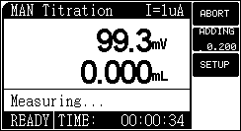

After the adding of set volume, the instrument still wait for users further operation, that cycle repeat until users abort waiting or reach the set end volume. In the process of adding, user should continue next adding until the instrument shows stable potential value, to ensure accuracy of sampling. Manual press ‘ABORT’ key to end titration.
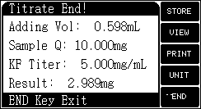

2.2.4.4.5 Operation after Manual titration
After titration, the instrument will display actual titration results. Users can store and print measurement results or view detailed titration record, press ‘END’ key to return to the initial state.

2.2.4.5 Constant Titrate Mode
The titrate mode is suitable for certain special situation, such as continuous titration required anhydrous state all the time.
In the initial state, press "TITRATE" key and select constant titrate, the instrument will directly enter into constant titrate.
All control parameters of constant titrate are same with pre-titrate. Set the delay time of pre-titrate as 999s, then the titration mode will automatically become constant titrate.
During measurement, users can abort titration at any time.

2.2.4.6 KF Titre Measure Mode
Usually, we known the concentration of KF titrant, that is measure unknown sample with KF reagent of known concentration. The converse is, if users know the volume and quantity of sample, then users can also determine the titer of KF reagent.
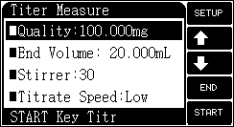
In the initial state, press ‘TITRATE’ key, select KF titer measure and confirm to begin KF titer measurement. Similarly, KF titer measure includes parameter setup, pre-titrate, sampling and KF titer measure.

2.2.4.6.1 Parameters
KF titer measurement mainly includes following parameters: sample quantity, end volume, stirrer speed, etc.
- Quality
We use 100ul sample as standard sample, users can use precision balance to weight the quality value of sample, for specific density of water users can refer to appendix. Set quality value according to the quality value actually weight.
- End volume
Although the instrument is designed with automatic anti-overflow detection, it is necessary to set this parameter for security.
This parameter is designed to avoid the damage of meter caused by excessive addition. It is better to set this parameter. During titration, the total added volume will be determined automatically. Once the actual volume exceeds the preset end volume, the meter will stop titration and remind user if it finish titration or not. User can select the needed one when necessary.
- Stirrer speed
For some titrations, user needs to adjust chemical reaction speed of titration with different stirring speed. User can set up this parameter when necessary. When the titration begins, the meter will stir the sample in this speed.

- Default
Default parameters:
- Quality: 100.000mg;
- End volume: 20.000mL;
- Stirrer speed: 30.

2.2.4.6.2 Pre-titrate process
After all specifications have been setup properly, press “START” key to start titration. The instrument will first ask whether to start pre-titrate. If users need pre-titrate, then select pre-titrate operation, otherwise can press "SKIP" key to skip pre-titrate.

2.2.4.6.3 Sampling process
After pre-titrate, the instrument will prompt ‘Waiting for sample’; If users skip pre-titrate, the instrument will directly prompt users to sampling.
Inject 100uL sample into titration cup, after injection, press ‘CONT’ key to start formal measurement.
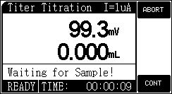

2.2.4.6.4 KF Titre Measure process
The measuring process is same as auto titrate, the instrument will automatically control the measurement and judgment of potential, and control the adding of KF reagent. After titration, the instrument will display the titration results. If users need to store current titer, press ‘STORE’ key to store.
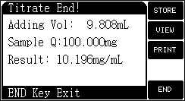

2.2.5 Data Processing
2.2.5.1 View function
In the initial state, Press ‘View’ key to view last titrate data, stored result.
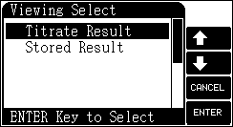

2.2.5.1.1 View titration result
After each titration, the meter automatically record titration process parameter and some basic information, including method, start time, end time, operator, stirrer speed, burette type, burette factor, adding volume, sample quantity, KF titer and result. At this time, users can press "STORE" key to store titration results; Press "PRINT" key to print the titration results.

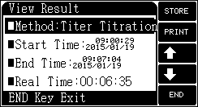

2.2.5.1.2 View stored result
The meter can save 200 sets of titration data which supports GLP norm. In the initial state, press ‘View’ key to view stored data and press ‘Enter’ key to confirm, the saved data can be viewed.
The meter supports viewing detailed saved data. Press ‘DETAIL’ key to view detailed titration result.
The meter supports the printing of the saved data.

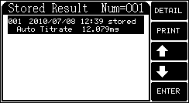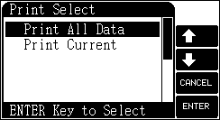

2.2.5.2 Print/Output function
The meter takes USB and RS-232 as output. If user has purchased serial printer, it is recommended to choose the printer which can print over 24 words in one line. If the user connects the printer with computer, install USB driver according to methods in the appendix. The meter adopts standard RS232 communication. The format is 9600,n,8,1. It means: The Baud rate is 9600bps, no odd even check, 8 digits, 1 stop bit.
When viewing titration results or saved data, press ‘Output’ key to print or send the data to PC.
Note: Disconnect the power of the printer and the meter, and the printer can be connected with the meter.

2.2.5.3 Communication function
The meter has USB interface which can be connected to the computer. It is controlled by the professional software. Detailed operation and use please refer to software operation manual.

2.2.6 Shutdown HZ1200
Press "On/Off" button to turn off the instrument. After measurement, if the measuring electrode is polluted or adsorbed impurities, please carefully take out the measuring electrode, gently wipe and rinse it in anhydrous ethanol. For long-term not in use, please note:
- Disconnect the power!
- Keep the sockets of the meter clean and dry. Keep them away from acidity, alkaline and salt solution.

III.Instrument Maintenance

3.1 Maintenance
- When operating the instrument, counterclockwise unscrew the cap of dryer on feeding & drainage device; when not in use, clockwise tighten so that the service time of desiccant is prolonged. In order not to affect test precision, replace desiccant according to the frequency of use.
- Keep the sockets of the meter clean and dry. Keep them away from acidity, alkaline, salt solution and also keep them damp-proof to ensure high performance of the meter.

3.2 Troubleshooting
Phenomenon | Failure cause | Solution
No display after start-up | 1.The power is off.  2.The fuse is damaged. | 1..Check the power  2.Replace the fuse of the same type
Printer does not work or work incorrectly | 1.The printer is not connected with the power  2.The printer line is not connected  3.The printer is set by wrongly  4.The printer is wrongly selected. | 1.Connect the printer power  2.Connect the printer line  3.Set the correct baud rate  4.Replace the printer.
The stirrer doesn't work | 1.The stirring speed is set too low  2.The stirring bar has not been put in the beaker. | 1.Speed up the stirring rate  2.Put the stirring bar
There is bubble in capillary | Leakage occurs in the junction of filling pipe | Install the capillary
Mechanical part does not work normally | Burette is not installed correctly | Install the burette
The titration cup is not fully filled but the instrument prompt alarm | There is residual liquid on the electrode body. | Pull out the electrode, clean and put back to titration cup.
When feeding solution, KF reagent A can not be pumped into titration cup | 1.The dedicated line of external device is not connected or fall off.  2.The pipe isn’t connected well.  3.A bottle is empty.  4.The drying cylinder did not open.  5.The feeding speed is low-speed. | 1. Reconnect.  2. Reconnect dry air outlet (A liquid).  3. Replace new A liquid.  4. Open the drying cylinder.  5.Change to high-speed feeding.
Cannot drainage | 1. The dedicated line of external device is not connected or fall off.  2. The pipe isn’t connected well.  3. The drying cylinder did not open.  4. The magnetic valve of drainage is damaged | 1. Reconnect.  2. Reconnect dry air outlet (titration cup).  3. Open the drying cylinder.  4. Contact our company, replace the magnetic valve
Drainage is not clear | Iodine crystal phenomenon in pipe | Repeat feeding and drainage with anhydrous alcohol to clean pipe
Analysis time is very long (more than 20 minutes) or can not reach endpoint | 1.KF reagent A is invalid.  2.The sealing of titration cup interface is not good or the desiccant is invalid. | 1. Replace KF reagent A.  2. Check the sealing of titration cup or desiccant.
Analysis time is longer (below 20 minutes) | 1.The response speed of KF reagent A liquid is slow.  2.Titer is set too large.  3.The concentration of KF reagent is too small. | 1.Titrate with high-speed.  2.Measure titre or change the original titre smaller.  3.Replace KF reagent with high concentration.
Over titrate | 1.The response speed of KF reagent A liquid is fast.  2.Titer is set too small.  3.The concentration of KF reagent is too large. | 1.Titrate with low-speed.  2.Measure titre or change the original titre bigger.  3.Replace KF reagent with low concentration.
The titration not end | - Delay time is set too long.  - The tightness of the meter is not good. | 1.Set the delay time as 60s.  2.Check the tightness and connect again.
There is turbidity or layering in the solution in titration cup. | The sample isn’t dissolved fully | Replace solvent A liquid or extend mixing time.

3 Appendix
Appendix 1 Water density table
Temp℃ | Density (g/cm³) | Temp ℃ | Density (g/cm³)
0  1  2  3  4  5  6  7  8  9  10  11  12  13  14  15  16  17  18  19  20  21 | 0.99984  0.99990  0.99994  0.99996  0.99997  0.99996  0.99994  0.99990  0.99985  0.99978  0.99970  0.99960  0.99950  0.99938  0.99924  0.99910  0.99894  0.99877  0.99860  0.99940  0.99820  0.99799 | 22  23  24  25  26  27  28  29  30  31  32  33  34  35  36  37  38  39  40  45  50  55 | 0.99777  0.99754  0.99730  0.99704  0.99678  0.99651  0.99623  0.99594  0.99565  0.99534  0.99503  0.99470  0.99437  0.99403  0.99368  0.99333  0.99297  0.99260  0.99222  0.99021  0.98804  0.98570

Appendix 2 USB relevant device and installation instructions
If user needs to use our titration software, operate it according to the manual. If user has not installed the titration software on the computer, operate it according to the following procedures.
- The meter adopts CP2102 as USB interface from Silicon Labs Company. If you need to install CP2102 driver, contact our sales department. Or you can download the driver system from the website of Silicon Labs Company.
- After installing the driver, connect the meter and computer with USB line. Turn the meter on. If this is the first time of connecting the computer, computer will display the prompt of finding hardware and installing the driver system. User checks the serial port of the computer. If there is a sign of 'Silicon Labs CP210x USB to UART Bridge(COMx)', it indicates the driver has been successfully installed. The 'x' of 'COMx' refers to serial port mark, otherwise the driver should be re-installed.
- The meter adopts standard RS232 communication. The format is 9600,n,8,1. It means: The Baud rate is 9600bps, no odd even check, 8 digits, 1 stop bit.
- User uses ordinary serial port for debugging software. When the user views titration data, titration result and calibration data, press 'Output' key to get the result.

Appendix 3 Complete set of the instrument
Model | Name | Description
HZ1200 | Titrator unit | Standard
CDY-3 | Indicating electrode | Standard
KF reagent | Karl Fischer reagent (kit) | Standard
HZ1200 | Feeding & drainage device | Standard
HZ1200 | 500ML solution bottles and connectors  (One set contains two 500ML solution bottles and connectors) | Standard

Accessories:The packing list shall prevail.

IV. Packing List
Parking List
NO. | Name and Specification |  |  | Quantity
1 | HZ1200 moisture titrator |  |  | 1set
2 | Feeding and drainage device |  |  | 1set
3 | 500mL solution cup (with bottle cap and interface) (GL45) |  |  | 2 sets
4 | Measuring electrode (SC8.446.006) |  |  | 1pcs
5 | Non-proliferation capillary DFAQ-6-1543-200 |  |  | 1pcs
6 | Solution cup (SC8.729.023) |  |  | 1pcs
7 | Push rod (SC8.227.126) |  |  | 1pcs
8 | Burette device 10mL (SC5.461.050) |  |  | 1set
9 | Stir bead (middle) |  |  | 3pcs
10 | Solution cup holder (SC5.043.005) |  |  | 1set
11 | 5L polyethylene drum |  |  | 1pcs
12 | Filling tube(fluoroplastics、white sleeve)  Φ3.2×0.5  (L=150mm)  Already installed on the instrument |  | 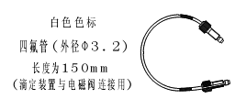 |  |  | 1pcs
13 | Filling tube  (fluoroplastics、green sleeve) Φ3.2×0.5 (L=900mm)  Already installed on the instrument | 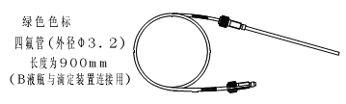 |  | 1pcs
14 | Filling tube (fluoroplastics)  Φ3.2×0.5 (L=450mm)  Already installed on the instrument | 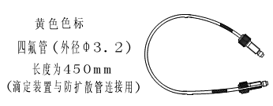 |  | 1pcs
15 | Liquid A filling pipe (fluoroplastics、blue sleeve,  L= 800mm,φ5×φ3) | 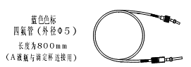 |  | 1pcs
16 | Liquid B filling pipe  (fluoroplastics、red sleeve,  L= 800mm,φ5×φ3) | 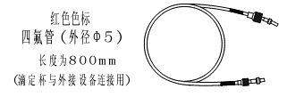 |  | 1pcs
17 | Drain pipe  (fluoroplastics、red sleeve,  L= 900mm,φ5×φ3) | 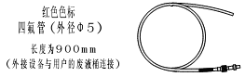 |  | 1pcs
18 | Silicone tubeφ6×φ3 (L=350mm 2pcs，L=800mm 1pcs) |  |  | 3pcs

19 | Silicone tubeφ6×φ3 (spare) |  | 1.5m
20 | Puncture-resistant washer (SC8.370.298)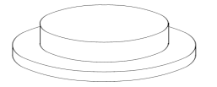 |  | 20pcs
21 | Nut GS-14A,B(white)  Note：Install on valve and titration device | 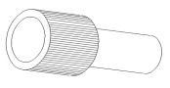 | 3sets
22 | Sleeve 008NF32-YC6B(black)  Note: Install on non-proliferation capillary. | 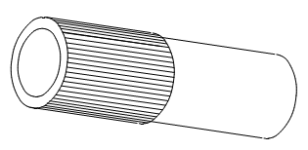 | 1pcs
23 | Inverted cone washer 008CZ32 |  | 1pcs
24 | Micro injector (100μL; 1mL) |  | One for Each
25 | Fuse Φ5×20 (3A) |  | 2pcs
26 | Universal power line |  | 1pcs
28 | Connecting line of main unit and feeding & drainage device |  | 1pcs
29 | USB communication cable |  | 1pcs
30 | Communication software |  | 1pcs
31 | HZ1200 instruction manual |  | 1pcs

