HZKF-2
Trace Moisture Analyzer

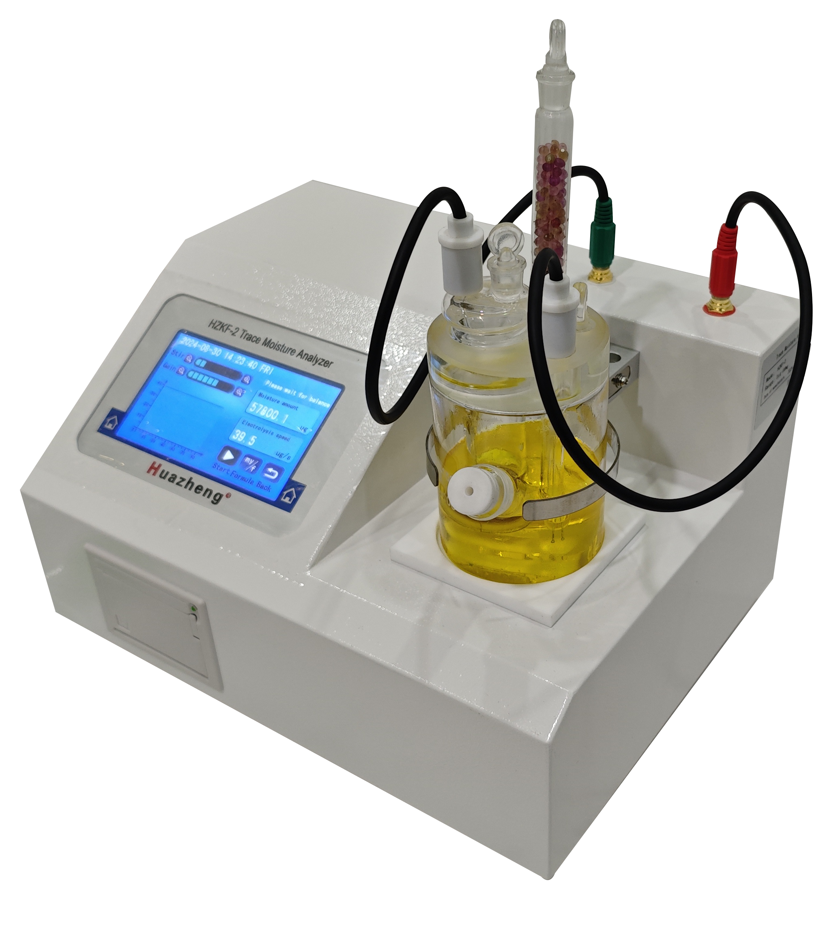

Huazheng Electric Manufacturing (Baoding) Co., Ltd

Contents

I. Overview 1
II. Technical Indicators 2
III. Working Principle 3
IV. Instrument Structure And Installation 4
V. Menu And Key Operation Instructions 7
VI. Sampling Operation 15
VII. Maintenance And Maintenance 17
VIII. Common Troubleshooting 18
IX. Precautions 19
X. RS485 Communication 21
XI. Packing List 22

Overview
The trace moisture analyzer of our company meets the requirements of GB/T 7600, SH/T 0255, GB/T6283, SH/T 0246 and other method standards. The Karl Fischer (Coulomb) method was adopted to determine the content of trace amounts of moisture in liquids of different properties. The trace moisture analyzer has the advantages of high measurement accuracy, fast speed, stable and reliable measurement data, and is widely used in petroleum, chemical, electric power, environmental protection, medicine and other
departments. It can quickly determine the moisture content of alcohols, oils, lipids, ethers, esters, acids, alkanes, benzenes, amines, organic solvents, pesticides, phenols, pharmaceutical raw materials and other chemical, petroleum, pharmaceutical, pesticide and other products.
1.1 Appearance of the Instrument
The appearance of the instrument is as shown in Figure 1.1 below.
Figure 1.1
1.2 Functions and features
The instrument adopts a powerful new generation processor and new peripheral circuits, excellent low power consumption. The measuring electrode signal as the criterion for the end of electrolysis, so its stability, accuracy is the key factor affecting the measurement
accuracy, and the accurate detection of the measuring electrode signal is realized due to the use of advanced devices and methods. Further understanding of the characteristics of the reagent, a new software compensation correction algorithm was proposed, which improved the measurement accuracy. Chinese character graphic LCD display, the display interface is intuitive and friendly. Main functions and features:
●adopting high-resolution color 480×272 dot matrix color touchscreen LCD, Chinese man-machine dialog interface;
●The use of switching constant current source electrolysis circuit (patented technology) to reduce the power consumption of the instrument; ● High-precision measurement electrode signal generation and detection circuits make the judgment of the electrolysis end point fast and accurate, and have strong anti-interference ability;
● Two methods are used to correct the measurement results: reagent blanking current compensation and equilibrium point drift compensation;
● Built-in 9 kinds of calculation formulas, which can meet the calculation of moisture content under different measurement conditions;
● One injection can be converted into mg/L, ppm, mg/kg, %, % to reduce the number of measurements and reagent consumption, and the moisture content conversion unit can also be specified;
● Adjustment of samples volume, mass and density adjustment can be carried out during or after the test;
● 9-speed stirring speed adjustment; 9-speed electrolysis gain adjustment;
● Automatic detection and recording of measuring electrode open-circuit fault and short-circuit fault;
● Automatic storage of historical records with time stamps;
● Reserve RS232 and RS485 ports to communicate with the computer

Technical Indicators
Accuracy: 3μg ～ 1mg±3μg; 0.3% above 1mg
(excluding injection error)
Measuring range: 3 μ g ~ 100mg
Resolution: 0.1ug;
Electrolytic current: 0 ~ 400mA
Maximum electrolytic speed: 40μg;
Power supply voltage: AC220V ± 20%
Standby power consumption: 5W
Ambient temperature: （5～40）℃
Ambient humidity <80%
Overall dimension: (320 × 240 × 200) mm
Weight: 4.5kg

Working Principle
The reagent solution is a mixture of the predominant iodine and sulfur dioxide-filled pyridine and methanol. The reaction of the reagent with water is based on the principle that iodine is reduced by sulfur dioxide in the presence of water to form pyridine hydroiodide and pyridine methyl hydrogen sulfate in the presence of pyridine and
methanol. The reaction formula is:
H20+I2+SO2+3C5H5N → 2C5H5N·HI+C5H5N·SO3
C5H5N·SO3+CH3OH → C5H5N·HSO4CH3
During electrolysis, the electrode reactions are as follows:
Anode: 2I- - 2e → I2
Cathode: I2 + 2e → 2I-
2H+ + 2e → H2↑
The iodine produced by the anode reacts with water to form hydriodic acid until all the water has been reacted, and the end point of the reaction is indicated by a pair of platinum electrodes in a detection unit. According to Faraday's law of electrolysis, the number of molecules of iodine participating in the reaction is equal to the number of molecules
of water, which is proportional to the amount of charge. The equation for water quantity and charge is as follows:
W=Q/10. 722
Which, W -- moisture content in the samples Unit: micrograms
- Electrolytic amount unit: millicoulombs

Instrument Structure And Installation
4.1 Main Instrument Installation
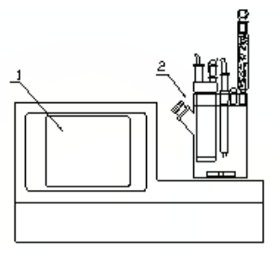
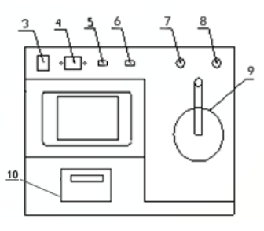
Figure 4.1
(1) Touch screen (2) Electrolytic cell
(3) Power switch (4) Power socket
(5) RS232 port (6) RS485 port
(7) Electrolytic electrode interface
(8) Measuring electrode interface
(9) Electrolytic cell holder (10) Printer

4.2 Electrolytic Cells Installation
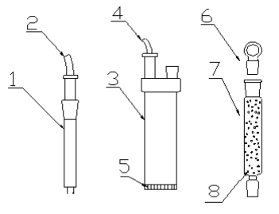
Figure 4.2
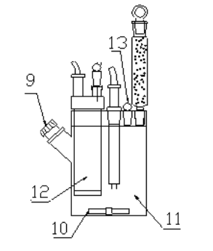
Figure 4.3
(1) Measuring electrode (2) Measuring electrode leads
(3) Electrolytic Electrode (4) Electrolytic Electrode Leads
(5) Ion filtration membrane (6) Drying tube ground glass stopper
(7) Drying tube (8) Color-changing silica gel (desiccant)
(9) Sampling inlet (10) Stirrer (11) Anode chamber
(12) Cathode chamber (13) Electrolyzer ground glass stopper

4.3. Pipeline installation
1. Stuff the bottom of the drying tube with a small amount of degreasing cotton, then fill the drying tube with blue silica gel pellets, then stuff a small amount of degreasing cotton, and finally fill it with ground glass stopper (7 in Fig. 4.2).
Note: The piping of the drying tube must maintain a certain degree of ventilation, not completely closed, otherwise it is easy to be dangerous!
2. Load the milky white silicone pad into the plug and screw it in evenly with the fastening stud (see Fig. 4.4).
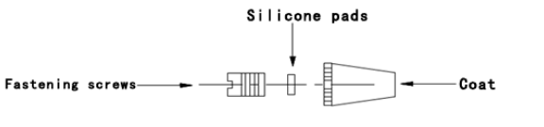
Figure 4.4
3. Put the stirrer into the electrolytic bottle carefully through the sample’s inlet.
4. Evenly coat a layer of vacuum grease at the measuring electrode, electrolytic electrode, drying tube, and the grinding ports of the cock at the sample’s inlet respectively. After installing the above components into the electrolytic bottle, turn it slightly to make it better sealed.
5. Inject about 120-150 ml of reagent into the anode chamber of the electrolytic cell from the seal port of the electrolytic cell with a clean and dry funnel (or use a liquid changer), and also inject the reagent level of the cathode chamber from the electrolytic electrode seal with a funnel (or use a liquid changer) to make the reagent level in the cathode chamber and the anode chamber basically the same. After completion, the electrolytic cell sealing plug and electrolytic electrode sealing plug are evenly coated with a layer of vacuum grease and installed in the corresponding position, and gently rotated to make it better sealed.
Note: The reagent loading operation should be operated in a well-ventilated environment, don’t inhale or touch the reagent with hands, if it is in contact with the skin, rinse it thoroughly with water.
After completing the above steps, place the electrolytic cell into the cell holder (9 in Figure 4.1) and insert the electrolytic electrode connecting cable with lotus plug and the measuring electrode connection cable into the electrolytic electrode interface (7 in Figure 4.1) and the measuring electrode interface (8 in Figure 4.1) respectively.
Note: It is strictly prohibited for the electrode plug and socket to come into contact with reagents causing surface oxidation. The socket protection cap can be installed to prevent oxidization when it is no longer in use.

Menu And Key Operation Instructions
The instrument adopts a large-screen LCD, and the amount of information that can be displayed on each screen interface is richer, reducing the number of switching display interfaces. Combined with touch keys, the key function is clearly defined, so the user learning to use the instrument becomes simple.
The instrument is divided into 7 display interfaces:
1. Boot welcome interface; 2. Main interface;
3. Setting interface; 4. Method interface;
5. Test interface; 6. Measurement result interface;
7.Data recording interface; 8. Fault recording interface;
5.1 Start welcome interface
Connect the instrument power cable, turn on the power switch, the LCD screen displays as Figure 5.1:


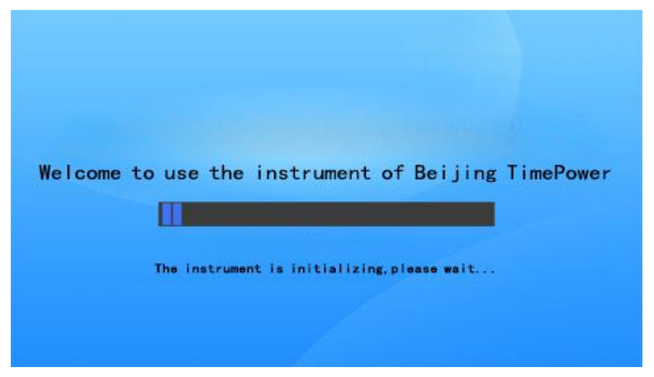
Figure 5.1

5.2 Main interface
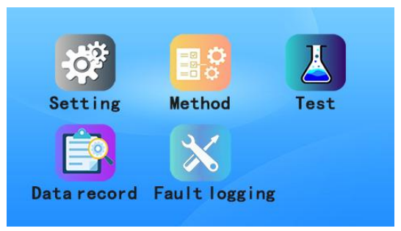
Figure 5.2
After loading the parameters, the instrument enters the main interface, as shown in Figure 5.2; There are the following key operations under the current display interface:
Setting: Click to enter the setting interface.
Method: Click to enter the method setting interface.
Test: Click to enter the samples measurement interface.
Data Record: Click to enter the historical data browsing interface.
Fault Record: Click to enter the fault record browsing interface.
5.3 Setting Interface
Press the "Setup" button in Figure 5.2, the LCD screen will display as Figure 5.3.1:
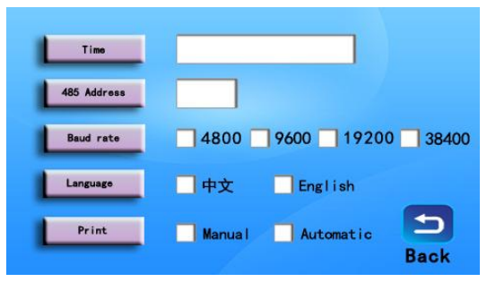
Figure 5.3.1
In the current display interface, there are the following key operations:
Time: Click on the time display area to adjust the time and enter the time adjustment sub-interface 5.3.2.
485 Address: Click to adjust the RS485 address, the adjustment range is from 1 to 253.
Baud Rate: Click to adjust the baud rate, 4800, 9600, 19200, 38400 optional.
Printing method: Click the print box to set the printing mode, manual and automatic printing mode.
Language: Chinese or English
Back: Exit the settings interface and return to the main interface Figure 5.2.
After clicking the time display area, the LCD screen is displayed as shown in Figure 5.3.2.
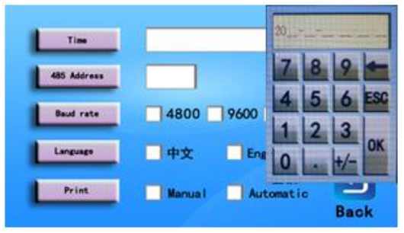
Figure 5.3.2
In the current display interface, there are the following key operations:
Numeric keys: Enter the year, month, day, hour, minute, and second until the end.
ESC: Click Cancel to exit the timing sub-interface, and return to Figure 5.3.1 of the Settings interface.
← ：Click backspace to backward the cursor.
OK: Click Time Alignment to save the current time setting, and return to the settings interface Figure 5.3.1.
5.4 Method Interface
Press the "Method" button in the interface of Figure 5.2, and the LCD screen will be displayed as shown in Figure 5.4:

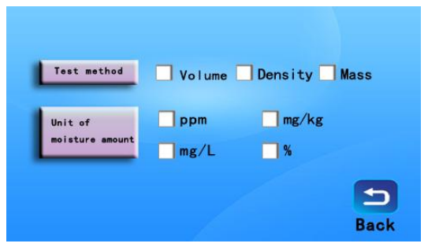
Figure 5.4
In the current display interface, there are the following key operations:
Test method: check "Volume", "Mass", "Volume" and "Density", "Density" and "Mass" according to the test conditions.
Unit of moisture content: The unit of moisture content test result "ppm" can be checked, "mg/kg", "mg/L", "%” according to requirements.
Note: If check "volume" is checked separately, the moisture content test unit can only check "mg/L"; If "Mass" is checked separately, the moisture content test
unit can only check "ppm", "mg/kg", "%".
Back: Exit the setting interface and return to the main interface Figure 5.2.
5.5 Test interface
Press the "Test" key in the interface of Figure 5.2, and the LCD screen will be displayed as shown in Figure 5.5.1：
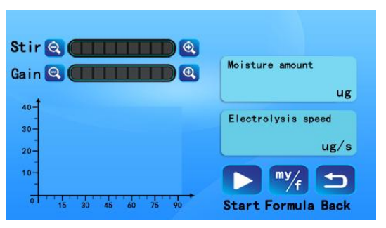
Figure 5.5.1
The samples measurement interface can be adjusted in the following 4 parameters:
1.Stirring：Adjust the stirring speed of the reagent. Make the reagent just enough to create vortex, but cannot create bubbles. The adjustment range is 0 ~ 9 steps.
2.Gain：Adjust electrolytic current. Adjust the electrolysis current slightly, and the adjustment range is 0 ~ 9 steps.
Note: Stirring speed and electrolysis gain should be adjusted before the start of electrolysis process. Adjustment after the start of electrolysis process will affect the measurement results.
3.Formula: Adjust the injection amount of samples test, such as volume, mass and density. Adjustments can be made during or after the test. Built-in 9 calculation formulas can meet the needs of different samples.
4.Stop: During the measurement, the user can terminate the current samples measurement.
5.Formula: Enter the formula interface to input the volume, mass or density of the injected samples.
6.Back: Exit t return to Figure 5.2.
Note：In the current interface, there is a prompt for the current instrument status, please pay attention to check. The measurement process is described as follows:
1. Determine whether the measuring electrode has open circuit or short circuit fault.
2. Determine whether the reagent is in the equilibrium region. If the reagent is in the over-iodine state, please fill in water when it shows that the reagent is over-iodine; If it is in a over-water state, the excess water will be electrolyzed automatically to make the reagent reach an equilibrium state.
Note: For the newly loaded reagent, slowly inject pure water into the anode chamber of the electrolytic cell through the sample’s inlet with a 50 μ l sampler, and observe that the color of the reagent gradually changes from dark brown to light yellow. When the status bar shows "Please wait for balance", it is unnecessary to inject pure water, and the instrument automatically electrolyzes excess water until balance.
3. After the reagent is in equilibrium state, blank current detection and reagent drift detection will be carried out automatically to correct the measurement results.
4. After completing the above steps, the instrument prompts "Press the start key to measure". After preparing the samples, press the start key, and inject the samples into the electrolytic cell within one minute. If the samples is not injected for more than one minute, the instrument will automatically ignore the measurement result and wait for the user to
start again.
5. After the instrument detects the added samples, it will start the electrolysis process, then accumulate the water content and draw the electrolysis curve.

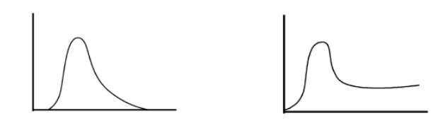
Reagent Good Reagent Expired
Figure 5.5.2
Precautions：
1. The instrument should be calibrated with pure water before testing samples, and 0.1ul of pure water should be injected with 0.5ul sampler (based on 0.5ul imported SGE micro sampler, and the test results of domestic sampler are for reference only). At this time, the
measured result of the instrument should be "100 ± 3ug (excluding sampling error), and the samples can be measured after being calibrated 2-3 times and showing that the result is within the error range.
2. During the normal determination process, each 100 ml reagent can react with no less than 100 mg of water. If the determination time is too long and the sensitivity of the reagent decreases, a new reagent should be replaced. Whether the reagent is expired can be judged according to the following methods: if it is found that the reagent releases a large number of bubbles or the reagent is polluted into light reddish brown in the electrolysis process, the reproducibility of the determination result will be reduced and the time to reach the end point will be prolonged. In this case, the reagent should be replaced as soon as possible; Whether the reagent has expired can be judged according to the electrolysis speed curve depicted by the instrument, as shown in Figure 5.5.2.
5.6 Test Results (Formula) Interface
The instrument detects the stop signal of the measuring electrode during the electrolysis process, ends the measurement, and automatically calculates the moisture content, then generates the result report. The LCD screen is shown in Figure 5.6. 1:

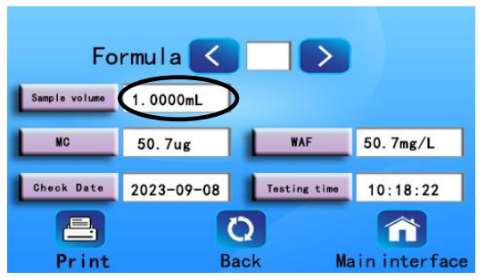
Figure 5.6.1
Note: The formula interface samples volume, samples mass or samples density click on Figure 5.6. 1 ellipse circular position for numerical value input. Under the current screen, the key function is defined as follows:
“<”and“>”: Click this key to select the formula.
"Print": Click this key to print, store and transmit data.
"Back": Click this key to exit the formula interface and return to the test interface Figure 5.5.1.
"Main interface": Click this key to exit the formula interface and return to Figure 5.2 of the main interface.
5.7. Data record interface
Under the interface in Figure 5.2, press "Data record "Key, The LCD screen is shown in Figure 5.7:
"<": Display the previous history record, record number minus 1.
">": Displays the latter history, with the record number plus 1.
Print: print current data record;
Delete: delete the current record.
Back: Exit the data recording interface and return to the main interface Figure 5.2.
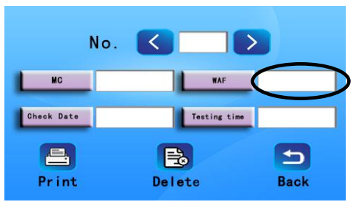
Figure 5.7
Note: Click on the oval area in Figure 5.7 to view other moisture content values.
5.8 Fault Logging Interface
Under the interface in Figure 5.2, press "Failure record "Key, The LCD screen is shown in Figure 5.8:
“<”：Display the previous history record, record number minus 1.
">": Displays the latter history, record number plus 1.
Delete: Delete the current record.
Back: Exit the data recording interface and return to the main interface Figure 5.2.
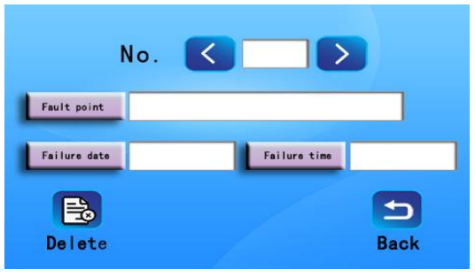
Figure 5.8

Sampling Operation
The typical measuring range of the instrument is 3μ g ~ 100mg. In order to obtain accurate measuring results, the sampling quantity should be properly controlled according to the moisture content of the samples.
6.1. Liquid samples
Measuring liquid samples: samples to be measured is extracted by sampler and injected into anode chamber of electrolytic cell through samples inlet. The needle must be wiped with filter paper before injection. When injecting the samples into the electrolytic cell, the needle tip of the liquid sampler should be inserted into the reagent, and should not contact with the inner wall of the electrolytic cell and electrode.
6.2. Solid samples
Solid samples may be in the shape of powder, particles or lumps (large lumps must be mashed). When the samples are insoluble in the reagent, a suitable water evaporator must be selected and connected to the instrument. The solid sampling is illustrated by taking a solid sample which can be dissolved in reagent as an example.
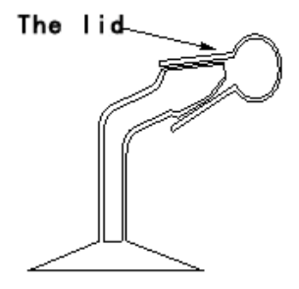
Figure 6.1
① The solid sampler is shown in Figure 6.1, cleaned with water anddried well.
② Remove the lid of solid sampler, load the samples, cover it immediately, and weigh it accurately.
③ Remove the cock of the samples input of the electrolytic cell and insert the sampler into the samples input as shown by the solid line in Figure 6.2. Rotate the solid sampler 180 degrees, as shown by the dotted line in Fig. 6.2, so that the samples falls into the
reagent until the determination is completed. Solid samples should not come into contact with electrolytic electrodes and measuring electrodes when falling into reagents.

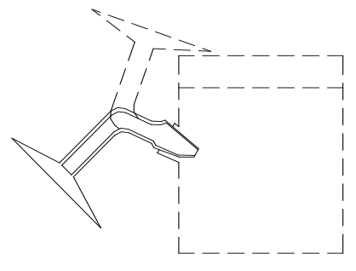
Figure 6.2
The solid sampler and lid are weighed accurately again after sampling, and the mass of the samples is calculated according to the difference between the two weighing times before and after, which is used to calculate the moisture content.
6.3. Gaseous samples
In order for the moisture in the gas to be absorbed by the reagent, a connector must be used to control the samples to be injected into the electrolytic cell at any time (see Figure 6.3). When determining the moisture in the gas samples, about 150 ml of reagent should be injected into the electrolytic cell to ensure that the moisture in the gas is fully absorbed. At the same time, the gas flow rate should be controlled at about 500 ml/min. If the reagent is obviously reduced during the determination process, about 20 ml of ethylene glycol should be injected to supplement (other chemical reagents can also be added according to the actual measured substance).
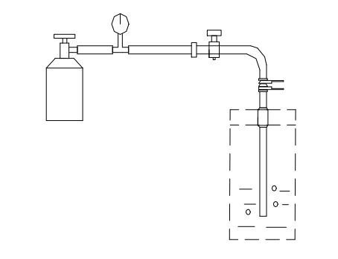
Figure 6.3

Maintenance And Maintenance
7.1. Location of instruments
① Put it in a dark place with the indoor temperature is 5 ℃ ~ 35 ℃.
② Do not install the instrument in the environment with high humidity and large power fluctuation.
③ Do not put the instrument in the environment with corrosive gas.
7.2. Replacement of silicone pad
The silicone pad at the samples input will make the pinhole become non-shrinkage after long-term use, and the moisture in the atmosphere will enter and affect the determination, so it should be replaced in time (see Figure 4.4).
7.3. Color-changing silicone replacement
When the color-changing silicone in the drying tube changes from blue to light blue, new silicone should be replaced, and silicone powder should not be loaded when replacing, otherwise the electrolytic cell cannot exhaust and the electrolysis will be terminated.
7.4. Maintenance of Electrolytic Cell Grinding Port
Rotate the electrolytic cell grinding ports should be rotated every 7 to 8 days. It should be re-coated with a thin layer of vacuum grease and reinstalled if it cannot be rotated easily, otherwise it will not be easy to remove after being used for a long time.
If the electrode cannot be removed, please do not pull it out forcefully. The correct way is to soak the whole electrolytic cell in warm water for 24-48 hours.
7.5. Cleaning of electrolytic cell
Open all the glass openings of the electrolytic cell bottle, clean the electrolytic cell bottle, drying tube, sealing plug, electrolytic electrode and measuring electrode with absolute ethanol, dry them in an oven at about 60 ℃ and then cool them naturally.
Note: It is strictly forbidden to wash with water.
Be careful not to clean the electrode leads when cleaning, as shown in Figure 7.1.

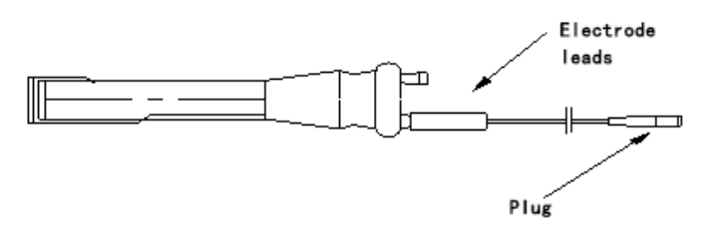
Figure 7.1
7.6 Steps to replace reagents
1. Remove the electrolytic electrode, measuring electrode, drying tube, sampling plug and other accessories from the electrolytic cell bottle.
2. Pour out the reagent to be replaced from the electrolytic cell bottle.
3. Clean the electrolytic cell bottle, electrolytic electrode, measuring electrode and other accessories with absolute ethanol.
4. Put the cleaned electrolytic cell bottle, drying tube, sealing plug, sampling plug, electrolytic electrode, measuring electrode into an oven at about 60 ℃ to dry and then cool naturally. Usually about 30 minutes.
5. Pour the new reagent into the electrolytic cell bottle in an amount of about 130mL (between the two white horizontal lines of the electrolytic cell bottle).
6. Install the electrolytic electrode, measuring electrode, drying tube, sampling plug, etc., and pour the new reagent into the electrolytic electrode, and the pouring amount is as flat as the reagent liquid level in the electrolytic cell bottle.
7. Coat a layer of vacuum grease on all grinding ports of electrolytic cell (electrolytic electrode, measuring electrode, sampling plug and ground glass stopper) and rotate them.
8. Put the changed electrolytic cell bottle into the electrolytic cell bottle clamp of the instrument, and turn the instrument on to the measuring state.
9. The new reagent should be reddish brown and in an over-iodine state. Inject proper amount of water with a 50uL sampler until the reagent turns light yellow.

Common Troubleshooting
1. No display after the instrument is powered on
Check the power connection line and power switch.
2) Measuring electrode open circuit
Check whether the connection between the measuring electrode and the connecting plug of the instrument is in good condition and whether the connecting wire is broken.
3. The electrolysis speed is always zero during electrolysis
Check whether the connection between electrolytic electrode and instrument plug is in good condition and whether the connecting wire is broken.
4. The calibration result of pure water is too small, and the instrument can't detect the samples after injecting the samples
Check whether the reagent is expired.
5. The electrolysis process cannot be completed
Check whether the reagent is expired

Precautions
1. It is necessary to ensure the sealing of the electrolytic cell when changing reagents, and evenly apply a layer of vacuum grease at all grinding ports of the electrolytic cell. Replace silicone pads in time.
2. Check the interface of electrolytic electrode, measuring electrode lead and main machine every time when using, and ensure that there is no sundries and rust that affect the lead resistance at the two interfaces. (If there is resistance at the interface or the sealing performance is not good, it will affect the stability of the instrument, resulting in the reagent cannot reach the electrolytic equilibrium state, and the screen of main machine will display "Press the start key for determination"-"Balancing the reagent, please wait". The above phenomena are common and must be paid attention to.)
3.It is strictly forbidden to use the reagent after deterioration. If the moisture content in the electrolytic cell bottle is too high or too much water is injected at one time, the reagent will expired. Method for determining whether the reagent can be used:
(1) Visual. When the color of the reagent becomes light brown or light red, the reagent has expired;
② Add 0.4 micro-liters of pure water to the electrolytic cell in the electrolytic equilibrium state, reduce the stirring speed to 0, wait for 10 seconds, then increase the stirring speed to the normal level, and carefully observe whether there is a large amount of dark red iodine under the platinum mesh of the electrolytic electrode. If this phenomenon does not occur, the reagent has expired. If the reagent is used continuously after expired, the iodine in the reagent will adhere to the platinum mesh of the electrolytic electrode, and the platinum mesh will change from bright white to black brown (at this time, the iodine is
extremely difficult to remove, resulting in the scrapping of the electrolytic electrode), thus affecting the measurement. This phenomenon is common in normal phenomena.
4. Before entering the liquid samples into the electrolytic cell bottle with the sampler, be sure to wipe the needle of the sampler to keep the needle dry when entering the samples. If the samples is entered without wiping the needle, the instrument will not reach the equilibrium state in the next experiment
5. When replacing the reagent, ensure that the surrounding environment is dry. The disassembled electrolytic cell parts should be placed on filter paper (or other dry paper), and sealed quickly after adding the reagent to minimize the exposure time of each part to the air.
6. It is strictly forbidden to clean electrolytic cell accessories with water or liquid with high water content (0.5 g of water can cause 500 ml of reagent to expire) and clean them with absolute ethanol.
7. The newly replaced reagent should be deep reddish brown. Stop when pure water is slowly added to light yellow with a 50-microliter sampler. At this time, the instrument should display the words "Balancing reagent, please wait". Be careful not to inject too much water at this time. Excessive injection of water will lead to reagent expired.
8. Reagents should be stored in a low temperature and dry environment.

RS485 Communication
1. Instruction format
Byte sequence  number | Byte content | Example
1 | Device address | 0x06
2 | Function code | 0x04
3,4 | The starting address of the  data to be read | 0x0000
5,6 | Number of data to be read | 0x0011 (Register starts at 00)
7,8 | CRC | 0x31B1;
- Register address, data and format
Register address | Data (hexadecimal) | Format/length
0~5 | Time (year, month, day,  hours, seconds) | Integer type
6 | Test Number | Integer type
7~8 | Moisture content | Floating point
9~10 | Moisture content (ppm) | Floating point
11~12 | Moisture content (mg/kg) | Floating point
13~14 | Moisture content (mg/L) | Floating point
15~16 | Moisture content (%) | Floating point
17 | Running status | Integer type (0, open circuit of measuring electrode; 1, short circuit of measuring electrode; 2, reagent over iodine, please add water; 3,balancing, please wait; 4, press the start key to determine; 5, please add the samples to be measured; 6,measuring in progress; 7, no samples is detected; 8, the determination is terminated by the user)
18 | Data record number | Write integer type
19~20 | Moisture content | Floating point
21~22 | Moisture content (ppm) | Floating point
23~24 | Moisture content (mg/kg) | Floating point
25~26 | Moisture content (mg/L) | Floating point
27~28 | Moisture content (%) | Floating point
29~34 | Data detection year  month day hour second | Integer type
35 | Baud rate | Integer type (0:4800, 1:9600,  2:19200, 3:38400)

XI. Packing List
No. | Item | Qty
1 | Trace Moisture Analyzer | 1
2 | Electrolytic cell bottle | 1
3 | Measuring electrode | 1
4 | Electrolytic electrode | 1
5 | Microsampler(0.5μL) | 1
6 | Microsampler(50μL) | 1
7 | Injector(1mL) | 1
8 | Printing paper | 2
9 | Silicone pads(8.8 diameter/2.6 thickness) | 1
10 | Vacuum grease | 1
11 | TPX53-Analytical reagent(150mL) | 1
12 | Color-changing silica gel | 1
13 | Stirrer(8*40mm type B ) | 2
14 | Glass stopper | 2
15 | Glass stopper | 1
16 | Sample plugs | 1
17 | Funnel | 1
18 | Absorbent cotton | 1
19 | Drying tube (small) | 1
20 | Drying tube (large) | 1
21 | Fuse（1A） | 2
22 | Power cord（3×0.5mm×1.5） | 1
23 | Instruction manual | 1
24 | Certificate of Conformity | 1

