HZNQ-1101
Oil Pour Point Tester

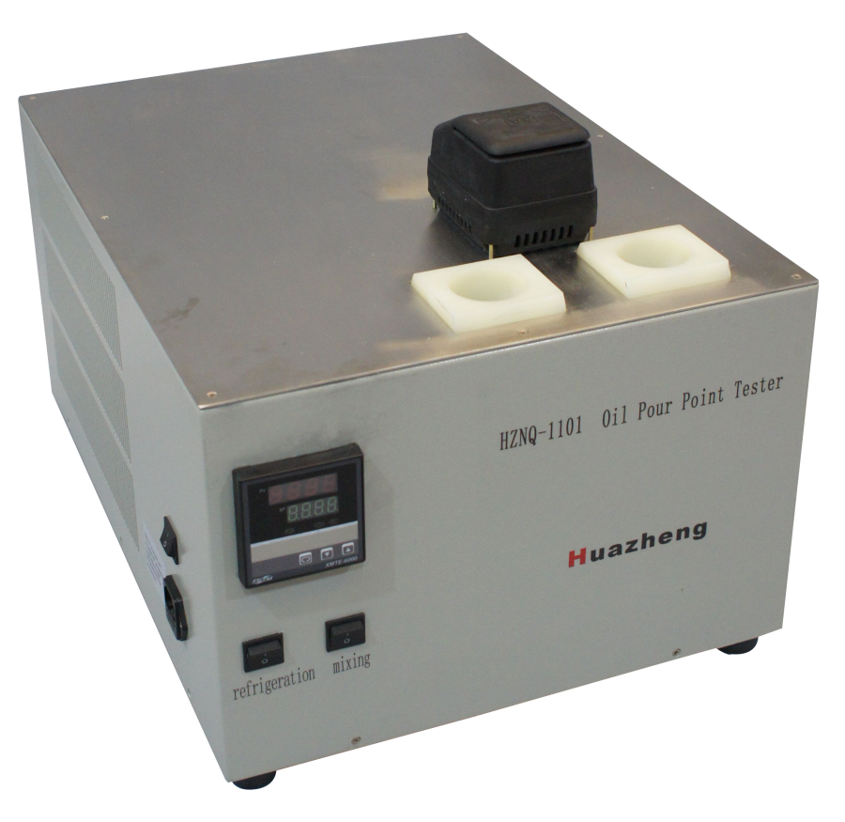

Huazheng Electric Manufacturing (Baoding) Co., Ltd

Contents

I.Overview 1
II.Instrument Introduction 1
III.Technical Parameters 2
IV.Precautions And Equipment Maintenance 2
V.Pour Point Operation Method 3
VI.Solidification Point Operation Method 4
VII.Packing List 5

I.Overview
Freezing point refers to the maximum temperature in which all liquid fluid stops flowing under the specified cooling conditions.
HZNQ-1101 Oil pour point Tester, is used in the determination of transformer oil, lubricating oil and light oil and freezing point values of all kinds of chemical raw materials, the instrument adopts the imported refrigeration compressor, refrigeration rate faster, refrigeration function stronger .Imported high precision sensor, high test precision. It is widely used in electric power, chemical industry, railway, petroleum and other fields.

II.Instrument Introduction
The equipment under the conditions stipulated in the national standard, put the sample into test in vitro, to alcohol bath containing liquid fluid sample tube refrigeration, liquid fluid to stop the flow of the highest temperature is the condensation point of the sample.
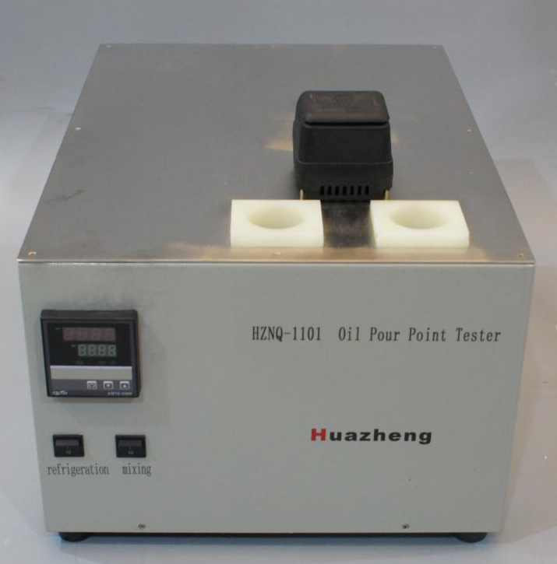
Instrument installation：
1. Open the instrument package to check whether the instrument is damaged or not;
2. Check the equipment model and accessories according to the packing list;
3. The instrument can be debugged after checking the instrument.

Steps for instrument operate：
1. Insert the test furnace power cord into the AC220V three-core socket;
Note: be sure to use a power socket with reliable grounding to power the instrument;
2. Add anhydrous ethanol to the frozen chamber, and the non-aqueous ethanol should be added at least to the evaporator copper pipe in the frozen chamber;
3. The test sample will be added to the test tube to the test tube calibration line, and the test tube will be put into the freezer, and the test tube will be soaked into anhydrous ethanol, and then the thermometer will be inserted into the test sample.
4. Turn on the power switch, stirring switch and refrigeration switch, set the preset temperature on the thermostat, and observe the cooling temperature on the thermostat.When the sample is stopped flowing when the test tube is tilted, it is the point value of the sample.

III.Technical Parameters
Range: room temperature ~ -45 ℃;
Accuracy:±0.1℃
Display: digital tube display;
Test mode: automatic temperature control, manual test;
Temperature sensor: PT100 platinum resistance;
Test hole:Two holes.
Cooling rate: not less than 70 ℃ / h
Refrigeration mode: compressor refrigeration;
Power: 1500W;
Power supply voltage: AC220V 50Hz;
Applicable environment: temperature 40 ℃ or less moisture 80% or less
Instrument weight: about 40KG.

IV.Precautions And Equipment Maintenance
1. The instrument shall be used in a non-corrosive environment.
2. When changing samples, test tube shall be cleaned.
3. The thermometer should not be greasy, so as not to affect the detection sensitivity.
4. During the test, do not put your hands in the freezer to avoid frostbite.

V.Pour Point Operation Method
1. Name: Pour Point
2. Method summary: After the sample is cooled, check the fluidity of the sample every 3°C, and record the lowest temperature at which the sample can flow as the pour point.
3. Operation method
①Pour the sample into the dry and clean test tube to the ring mark, fix the thermometer in the center of the test tube with a stopper, make the bottom of the thermometer bubble 8 mm～10 mm from the bottom of the test tube, and then inject 1 mL～ into the bottom of the sleeve. 2 mL of absolute ethanol.
Then put the test tube into the sleeve to form the test tube assembly.
②Immerse this test tube assembly in the prepared cooling bath. From the first observation of the fluidity of the sample, the fluidity of the sample should be observed every time the temperature drops by 3°C, paying special attention not to disturb the lumps in the sample. The thermometer should not be moved after the sample is cooled enough to form paraffin crystals. When the temperature is low, the condensed water mist will hinder the observation. You can wipe the test tube with a cleaning cloth moistened with a wiper close to the temperature of the cold bath to remove the outer surface Water mist.
③When the test tube is tilted and the sample does not flow, immediately place the test tube in a horizontal position for 5 seconds (measured with a timer), and carefully observe the surface of the sample. If the sample shows any movement, immediately put the test tube back into the bath Or in the casing, when the temperature is lowered by 3°C, re-observe the fluidity of the sample.
④ Operate in this way until the test tube is placed in a horizontal position for 5 seconds and the sample in the test tube does not move. Record the thermometer readings observed at this time, and add 3°C to the recorded result as the pour point or lower Pour point.

VI.Solidification Point Operation Method
1. Name: solidification point
2. Summary of the method: Put the sample in a prescribed test tube and cool it to the expected temperature. Tilt the test tube to 45° from the horizontal and let it stand for 1 minute. Observe whether the liquid level moves. Use the highest temperature when the liquid level does not move. As the freezing point of the sample, it is expressed in °C.
3. Operation method
①Pour the sample into the dry and clean test tube to the ring mark, and fix the thermometer in the center of the test tube with a stopper, so that the bottom of the thermometer bubble is 8 mm to 10 mm from the bottom of the test tube. Then inject 1 mL to 2 mL of absolute ethanol into the bottom of the sleeve.
Then put the test tube into the sleeve to form the test tube assembly.
② Immerse the test tube assembly in the prepared cooling bath. The temperature of the cooling bath should be 7 ℃ ~ 8 ℃ lower than the expected freezing point of the sample.
③When the temperature of the sample cools to the expected freezing point, tilt the sleeve and test tube assembly immersed in the cooling bath to 45° from the horizontal and keep it for 1 minute. At this time, the sample is required to be still immersed in it. Inside the coolant.
④Then carefully remove the test tube assembly from the cooling bath, quickly wipe the outer wall of the sleeve with absolute ethanol, place it vertically, and observe through the sleeve whether the liquid level in the test tube shows signs of movement, until it is determined that a certain test temperature can make the sample When the liquid surface stops moving and rises by 2 ℃ and the sample liquid surface can move again, the temperature at which the sample liquid surface does not move is taken as the freezing point of the sample.

VII.Packing List
No. | Item | Qty
1 | Main engine | 1
2 | Power line | 1
3 | Fuse pipe | 2
4 | Test tube | 4
5 | Thermometer | 3

