HZJQ-X1
Transformer Oil BDV Tester

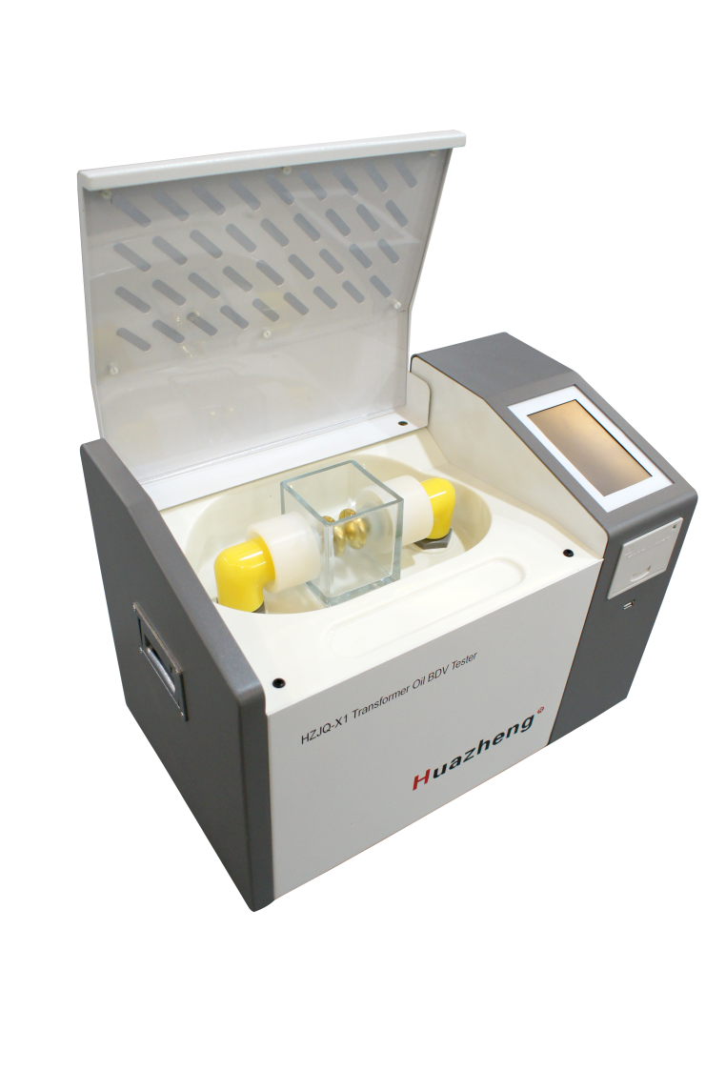

Huazheng Electric Manufacturing(Baoding) Co.,Ltd

Contents

I. Overview 1
II.Key Function And Feature 1
III. Major Technical Indicators 2
IV. Operational Approach 2
V. Precautions 11
VI. Maintenance 12
VII. Oil Cup Cleaning Method And Common Fault Clearances 12
VIII. Packing List 14

I. Overview
Many power systems, railway systems, large-scale petrochemical plants and enterprises have a lot of electrical equipment which internal insulation are mostly oil-filled insulation type, and therefore, test on insulating oil dielectric strength is common and necessary. To meet the needs of the market, we have developed and produced a series of insulating oil dielectric strength testers according to national standard GB/T507-2002, industry standard DL429.9-91 and the latest Electric Power Industry Standard DL/T846.7-2004 by ourselves. This instrument, by using a single-chip microcomputer as the core, can operate in full automation with high accuracy, greatly improving work efficiency and reducing the labor intensity of workers. Moreover, it is small in size and convenient to carry.

II.Key Function And Feature
- With a microprocessor, automatically fulfill the withstand voltage test for oil circulation with a range of 0～80KV (including boosting, maintaining, mixing, standing, calculation, printing and other operations)
- Large screen color LCD display, touchable, Chinese and English interchangeable menu prompts; With beautiful appearance, small size.
- Simple operation. The machine will automatically complete the withstand voltage test on one cup of sample oil after simple setting by the operator. Breakdown voltage value of 1 to 10 times and recurrent times will be automatically saved. After the test, the thermal printer will print each breakdown voltage value and average value.
- Power-down preservation, can save 100 tested results.
- Adopt a single-chip microcomputer to boost the voltage at an even speed. The voltage is accurate at 50HZ, ensuring the whole process easy for control.
- Equipped with over-voltage, over-current and limit protections to ensure the safety of operators.
- With the function of displaying the measured temperature and system clock.
- Communicate with computer with a standard RS232 interface.（Optional）
- USB，can export the test data.

III. Major Technical Indicators
- Output voltage: 0～80KV (optional)
- Voltage distortion rate: ＜3%
- Voltage Booster capacity: 1.5kVA
- Measuring accuracy: ±3％
- Supply voltage: AC230V 50/60Hz
- Power: 200W
- Applicable temperature: 0℃～45℃
- Applicable humidity: ＜75%RH
- Overall dimension: 460×280×320

IV. Operational Approach
1.Preparation Before Test
- Connect the ground terminal (on the right side of the equipment) to the ground wire firmly before starting the equipment.
- Sample the oil according to relevant standard. Adjust the electrode distance inside the oil cup with standard gauge. Clean the cup according to relevant requirements. Pour the sample into the cup and close the cap.
- Switch on AC230V power supply after the above items are confirmed, ready for the test.
2.Testing
①Press the power switch and then enter the following interface:
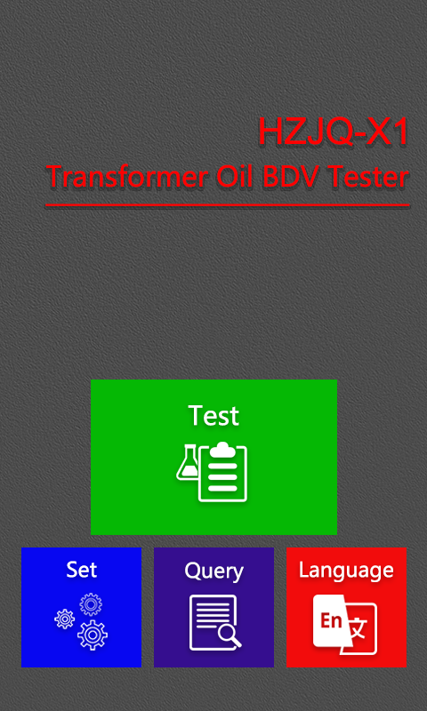

② Setting of system parameters:
Press “Settings” key and enter the following interface:
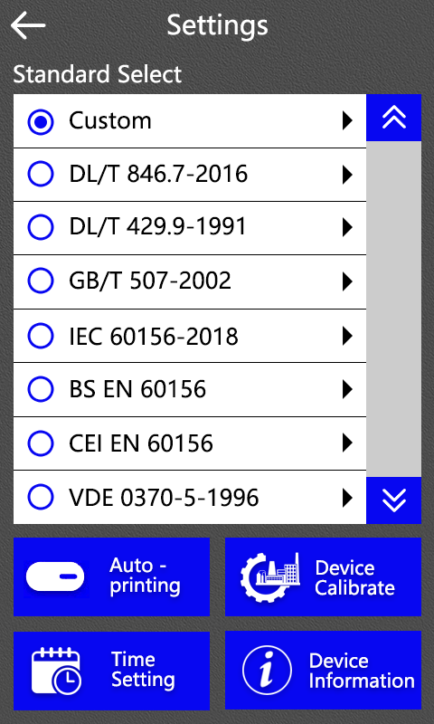
- Standard select
The user can choose the standard of test execution according to the need.
If you choose "Custom", you can choose boost conditions according to actual needs. The user-defined interface is as follows

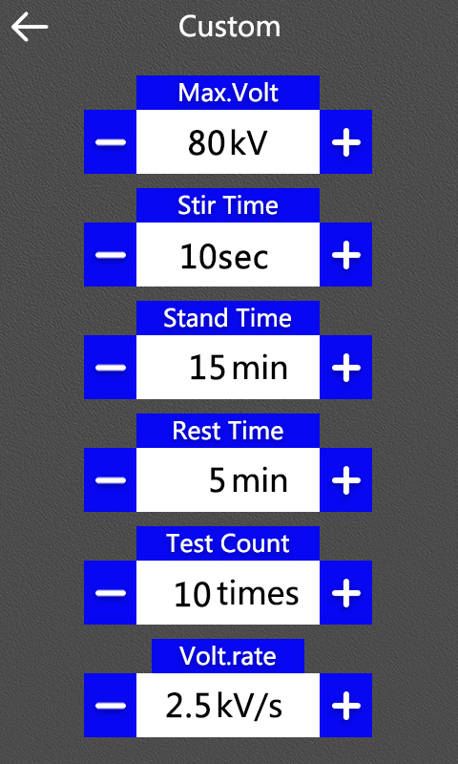
Voltage of boosting stop : 10～80kV(adjustable)
Stir Time : 0～120s(adjustable)/ CONT
Stand time : 0～15min(adjustable)
Interval of boosting : 0～5min(adjustable)
Boosting frequency : 1～10times(adjustable)
Voltage boosting rate : 0.5 kV/s～5.0 kV/s(adjustable)
If other standards are selected, take the power standard DL/T 846.7-2016 as an example, as shown in the figure below, Stir time and Volt.rate are optional, click "" to return to the previous page.
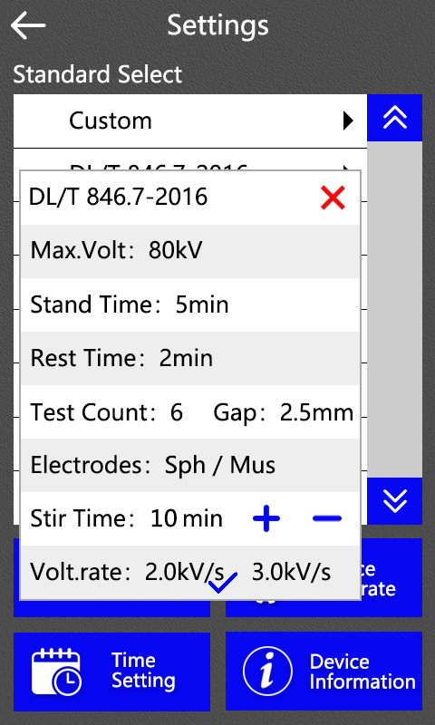
2) System set
(1)Autotype: ON/OFF，select by button.
(2)Time setting：When the instrument time is not accurate, can be adjusted
(3)Generally, users do not need to calibrate the instrument
(4)Device Information. You can view the device version, factory and other information, etc
When setting is complete, click “” to save the settings and return to the main interface.
③ Test:
Press the “Test” key to enter the following interface:
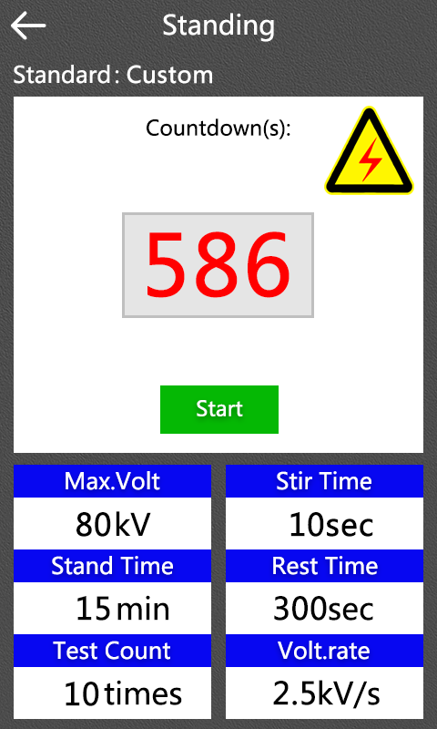
After the static time is over, enter the boost interface automatically. Click "start" button to skip the static entry and enter the boost interface. Click “” to exit the test interface and return to the main interface.
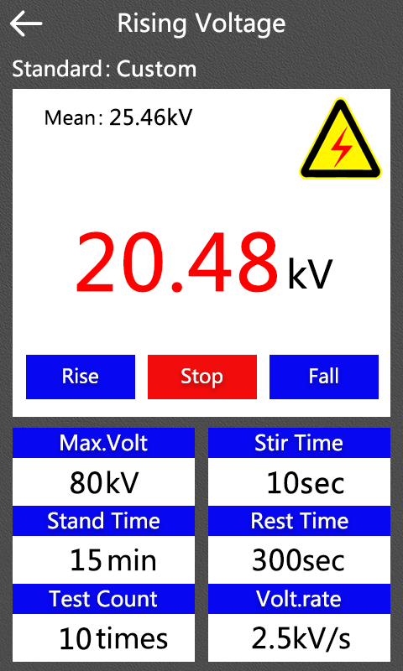
If you click the "Stop" button, then stop the rise voltage
If you click the "Rise" button, then the voltage rises
If you click the “fall” button, then voltage drop
The first test ended, enter the delay interface
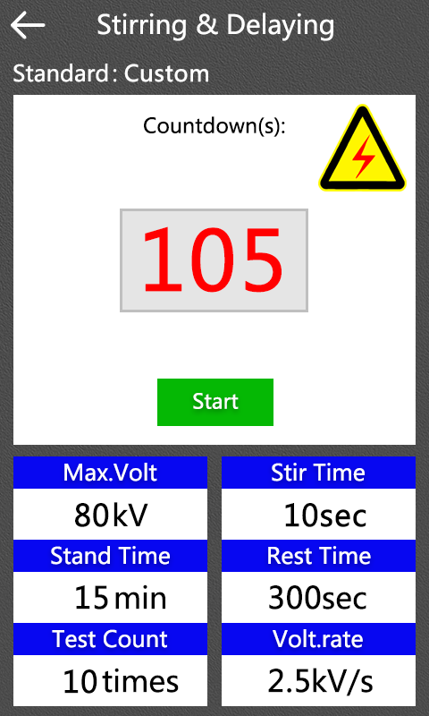
After the delay, the next test start until the boosting frequency is reached. Finally, the result is showed as follows:
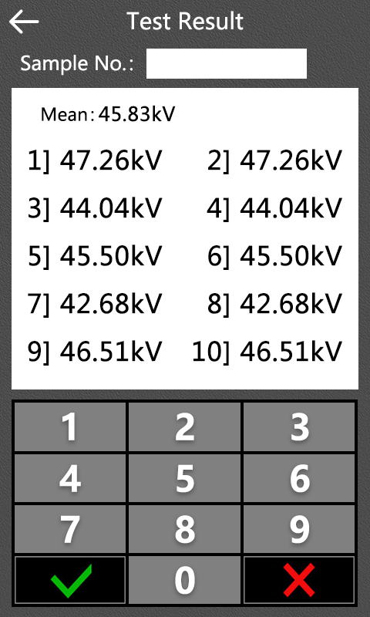
Click“Sample No”to enter the sample number
④ Data Query
Press the “Query” key to enter the following interface:
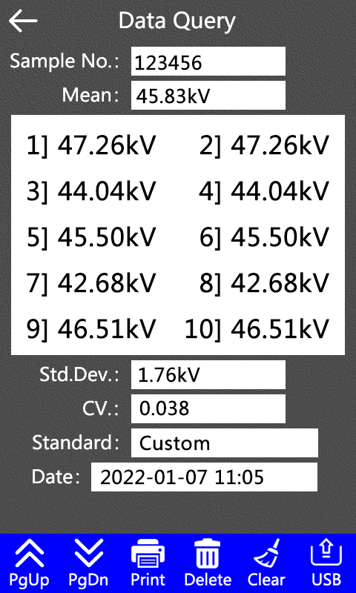
Click the "PgUp" or "PgDn" button to flip pages to display test data at different test times.
Click the "Print" button to print test data displayed on the current interface.
Click on the "Delete" button to delete the test data displayed in the current interface.
Click on the “Clear”, you can delete all test data stored in the instrument. Please operate with caution.
By selecting the "USB" button, all test data stored by the instrument can be imported into the U disk. However, before clicking the button, make sure that the instrument is inserted into the U disk.

V. Precautions
  - The selection, placing and electrode distance of the oil sample before testing shall meet relevant national and industrial standards.
  - The operators or other personnel are strictly forbidden to touch the casing after the power is switched on to avoid accidents.
  - The power shall be cut off immediately if any abnormal event is found during the operation.
  - New oil cup or cleaning the oil cup should be 24 times breakdown after test execution. The oil cup should be soaked with clean oil when not being tested.

VI. Maintenance
  - This equipment shall not be exposed in moist environment.
  - Keep the oil cup and the electrodes clean. Fill the cup with fresh transformer oil for protection during its idle. Check the electrode distance and check the tightness between the electrode tip and electrode bar screw thread before the cup is used again.

VII. Oil Cup Cleaning Method And Common Fault Clearances
1. Oil Cup Cleaning Method
- Wipe the electrode surfaces and bars again and again with clean silk cloth.
- Adjust the electrode distance with standard gauge.
- Use petroleum ether (other organic solvents are forbidden) to clean thrice. Each time shall follow the bellow procedures:
- Pour the petroleum ether into the oil cup till the cup is 1/4～1/3 full.
- Cover the cup mouth with a piece of glass cleaned by petroleum ether. Shake the cup evenly for one minute with certain force.
- Pour away the petroleum ether and dry the cup with a blower for 2~3 minutes.
- Use the oil sample to be tested to clean the cup for 1~3 times.
- Pour the petroleum ether into the oil cup till the cup is 1/4～1/3 full.
- Cover the cup mouth with a piece of glass cleaned by petroleum ether. Shake the cup evenly for one minute with certain force.
- Pour away the left oil sample and then the test starts.
2. Agitating Blade Cleaning Method
- Wipe the agitating blade again and again with clean silk cloth until fine particles are not found on their surfaces. It is forbidden to touch the surfaces with hands.
- Use tweezers to clamp the blade; put them into petroleum ether and wash.
- Use tweezers to clamp the blade and dry them with a blower.
- Use tweezers to clamp the blade; put them into the oil sample to be tested and wash.
3. Oil Cup Storage
Method 1 Fill the cup with good insulating oil after the test is finished and place it stable.
Method 2 Clean and dry the cup under the above procedures and then put it into a vacuum dryer.
Note: The oil cup and agitating blade shall be cleaned under the above procedures after the first test and tests with poor oil.
4. Common Fault Clearances
- Power light off, screen display off
① Check the plugging of power plug.
② Check the condition of the protector tube inside the power plug.
③ Check the socket electricity.
- No punch through oil cup
① Check inserting of connectors on circuit board.
② Check contacting of cap high-voltage switch.
③ Check attracting of high-voltage contacts.
④ Check break of high-voltage line.
- Printer failure
① Check plugging of printer power line.
② Check plugging of printer data line.

VIII. Packing List
No. | Item | Qty
1 | Main engine | 1
2 | Oil Cup | 1
3 | Elbow | 2
4 | Stirrer | 2
5 | Feelergauge | 1
6 | Tweezers | 1
7 | Power line | 1
8 | Fuse pipe | 2
9 | Print paper | 2
10 | Allen wrench | 1

