HZJQ-1B
Transformer Oil BDV Tester

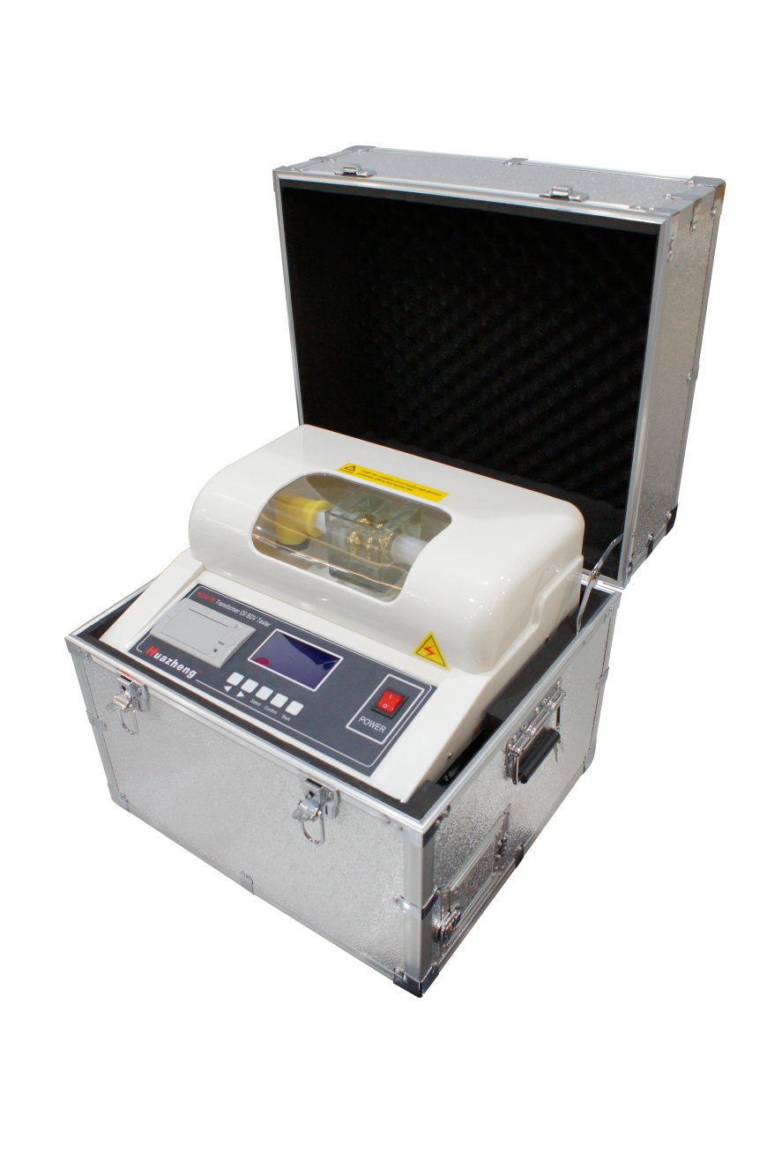

Huazheng Electric Manufacturing (Baoding) Co., Ltd
Dear user:
Thank you for choosing HZJQ-1B Transformer Oil BDV Tester.
We hope that this instrument can make your work easier and more enjoyable, so that you can get the feeling of office automation in the test and analysis work.
Before using the instrument, please read this manual, and operate and maintain the instrument according to the manual to prolong its service life.
"Just a light press, the test will be completed automatically" is the operating characteristics of this instrument.
If you are satisfied with this instrument, please tell your colleagues; if you are not satisfied with this instrument, please call (0312) 6775656 to tell you to serve you at all times-Baoding Huazheng Electric Manufacturing Co., Ltd., our company will definitely make you satisfied !
Contents
I. Overview 1
II. Key Function And Feature 1
III. Major Technical Indicators 2
IV.Panel Description 2
V. Operational Approach 3
VI. Precautions 6
VII. Maintenance 7
VIII. Oil Cup Cleaning Method And Common Fault Clearances 7
IX. Packing List 9

I. Overview
Many power systems, railway systems, large-scale petrochemical plants and enterprises have a lot of electrical equipment whose internal insulation are mostly oil-filled insulation type, and therefore, test on insulating oil dielectric strength is common and necessary. To meet the needs of the market, we have developed and produced a series of insulating oil dielectric strength testers according to national standard GB/T507-2002, industry standard DL429.9-91 and the latest Electric Power Industry Standard DL/T846.7-2004 by ourselves. This instrument, by using a single-chip microcomputer as the core, can operate in full automation with high accuracy, greatly improving work efficiency and reducing the labor intensity of workers. Moreover, it is small in size and convenient to carry.

II. Key Function And Feature
1. With a microprocessor, automatically fulfill the withstand voltage test for oil circulation with a range of 0～100KV (including boosting, maintaining, mixing, standing, calculation, printing and other operations)
2. Display by large-screen LCD and prompt by English menu.
3. Simple operation. The machine will automatically complete the withstand voltage test on one cup of sample oil after simple setting by the operator. Breakdown voltage value of 1 to 9 times and recurrent times will be automatically saved. After the test, the thermal printer will print each breakdown voltage value and average value.
4. Power-down preservation. It can save 100 tested results and displaying current ambient temperature and humidity.
5. Adopt a single-chip microcomputer to boost the voltage at an even speed. The voltage is accurate at 50HZ, ensuring the whole process easy for control.
6. Equipped with over-voltage, over-current and limit protections to ensure the safety of operators.
7. With the function of displaying the measured temperature and system clock.
8. Communicate with computer with a standard RS232 interface.(Optional)

III. Major Technical Indicators
1、Output voltage: 0～100KV (optional)
2、Voltage distortion rate: ＜3%
3、Voltage raising speed: 0.5～5 KV/S (adjustable)
4、Standing time: 15min (adjustable)
5、Boosting interval: 5 min (adjustable)
6、Boosting frequency: 1～9time(s) (optional)
7、Booster capacity: 0.5kVA x 2
8、Measuring accuracy: ±3％
9、Supply voltage: AC220V±10% 50Hz/60Hz
10、Power: 200W
11、Applicable temperature: 0℃～45℃
12、Applicable humidity: ＜75%RH
13、Overall dimension: 465×385×425

IV.Panel Description
④
①
②
confirm
select
back
power

③

① Thermal printer --printing the test results
② LCD --displaying the menu, cues and test results
③ Operating keys:
-- For increasing the setting value after pressing “SELECT”
-- For decreasing the setting value after pressing “SELECT”
SELECT—for choosing functions (the item selected is on reverse display)
CONFIRM—for executing the function
BACK –for exiting the operating interface
④ Power switch and indicator

V. Operational Approach
1 Preparation before Test
① Connect the earth terminal (on the right side of the equipment) to the earth wire firmly before start the equipment.
② Sample the oil according to relevant standard. Adjust the electrode distance inside the oil cup with standard gauge. Clean the cup according to relevant requirements. Pour the sample into the cup and close the cap.
③ Switch on AC220V power supply after the above items are confirmed, ready for the test.
2 Testing
① Press the power switch and then enter the following interface:
Insulation Oil
Dielectric Strength Tester

27℃ | 55%RH | 08/08/14 16:30:44

Parameter Setting
Start Testing
Data Viewing and Printing

27℃ | 55%RH | 08/08/14 16:30:44

② Setting of system parameters:
Press “Enter” key and enter the following interface:
Voltage of boosting stop: 100KV  Standing time: 0～15min  Interval of boosting: 0～5min  Stirring switch: On  Boosting frequency: 1～6  Voltage boosting rate: 0.5～5 KV/S |  |  | Print Automatically:  YES
08/08/14
16:36:21
27℃ | 55%RH | 08/08/14 16:30:44

Setting of voltage boosting: the user may select based on actual demand.

Voltage of boosting stop: 10～100KV Autotype: Yes / No
Standing time: 0～15min
Interval of boosting: 0～5min System time:
Stirring switch: On / Off
Boosting frequency: 1～9
Voltage boosting rate: 0.5KV/S～5 KV/S

Press “Esc” key to exit this interface after the setting is done.
③ Testing:
Press the “Select” key to select the “Start Test” menu and press the “Enter” key to enter the following interface:
Standing, Please wait...... |  |  | Start  Back
863 |  |  | Start  Back
27℃ | 55%RH | 08/08/14 16:30:44

Voltage is boosting...... |  |  | Start  Stop  Voltage Boosting  Voltage reducing  Back
Average:56.0KV  (1)56.0KV |  |  | Start  Stop  Voltage Boosting  Voltage reducing  Back
27℃ | 55%RH | 08/08/14 16:30:44

Stirring, Voltage Reducing and Delaying...... |  |  | Start  Back
288 |  |  | Start  Back
27℃ | 55%RH | 08/08/14 16:30:44

The first test is finished here and the next test starts until the boosting frequency is reached. Finally, the result is showed and printed as follows:
Data of Test |  |  | Print  Empty
Average:53.8KV  (1)56.0KV (2)50.4KV (3)55.1KV (4)54.3KV  (5)54.3KV (6)53.1KV |  |  | Print  Empty
27℃ | 55%RH | 08/08/14 16:30:44

④ Data viewing and printing:
Press the “select” key to select the “Data Viewing and Printing” menu and press the “Enter” key to enter the following interface:
Test Data |  |  | Page Up  Page Down  Print  Empty
Average Value:  (1)56.0KV (2)50.4KV  (3)55.1KV (4)54.3KV  (5)54.3KV (6)53.1KV  16 Articles in total,No.01 article is displaying |  |  | Page Up  Page Down  Print  Empty
27℃ | 55%RH | 08/08/14 16:30:44

Select “Page Up” or “Page Down” and select the records to be printed and select “Print”.

VI. Precautions
1. The selection, placing and electrode distance of the oil sample before testing shall meet relevant national and industrial standards.
2. The operators or other personnel are strictly forbidden to touch the casing after the power is switched on to avoid accidents.
3. The power shall be cut off immediately if any abnormal event is found during the operation.

VII. Maintenance
1. This equipment shall not be exposed in moist environment.
2. Keep the oil cup and the electrodes clean. Fill the cup with fresh transformer oil for protection during its idle. Check the electrode distance and check the tightness between the electrode tip and electrode bar screw thread before the cup is used again.

VIII.Oil Cup Cleaning Method And Common Fault Clearances
1. Oil Cup Cleaning Method
⑴ Wipe the electrode surfaces and bars again and again with clean silk cloth.
⑵ Adjust the electrode distance with standard gauge.
⑶ Use petroleum ether (other organic solvents are forbidden) to clean thrice. Each time shall follow the bellow procedures:
①Pour the petroleum ether into the oil cup till the cup is 1/4～1/3 full.
② Cover the cup mouth with a piece of glass cleaned by petroleum ether. Shake the cup evenly for one minute with certain force.
③Pour away the petroleum ether and dry the cup with a blower for 2~3 minutes.
⑷ Use the oil sample to be tested to clean the cup for 1~3 times.
①Pour the petroleum ether into the oil cup till the cup is 1/4～1/3 full.
②Cover the cup mouth with a piece of glass cleaned by petroleum ether. Shake the cup evenly for one minute with certain force.
③Pour away the left oil sample and then the test starts.
2. Agitating Blade Cleaning Method
⑴ Wipe the agitating blade again and again with clean silk cloth until fine particles are not found on their surfaces. It is forbidden to touch the surfaces with hands.
⑵ Use forceps to clamp the blade; put them into petroleum ether and wash.
⑶ Use forceps to clamp the blade and dry them with a blower.
⑷ Use forceps to clamp the blade; put them into the oil sample to be tested and wash.
3. Oil Cup Storage
Method 1 Fill the cup with good insulating oil after the test is finished and place it stable.
Method 2 Clean and dry the cup under the above procedures and then put it into a vacuum dryer.
Note: The oil cup and agitating blade shall be cleaned under the above procedures after the first test and tests with poor oil.
4、Common Fault Clearances
⑴ Power light off, screen display off
① Check the plugging of power plug.
② Check the condition of the protector tube inside the power plug.
③ Check the socket electricity.
⑵ No punch through oil cup
① Check inserting of connectors on circuit board.
② Check contacting of cap high-voltage switch.
③ Check attracting of high-voltage contacts.
④ Check break of high-voltage line.
⑶ Light display contrast
① Adjust the potentiometer on the circuit board.
⑷ Printer failure
① Check plugging of printer power line.
② Check plugging of printer data line.

IX. Packing List
No. | Item | Qty
1 | Main engine | 1
2 | Oil Cup | 1
3 | Elbow | 2
4 | Stirrer | 2
5 | Tweezers | 1
6 | Feeler gauge | 1
7 | Power line | 1
8 | Fuse pipe | 2
9 | Print paper | 2
10 | Allen wrench | 1

