HZ262B
Automatic Aniline Point Tester

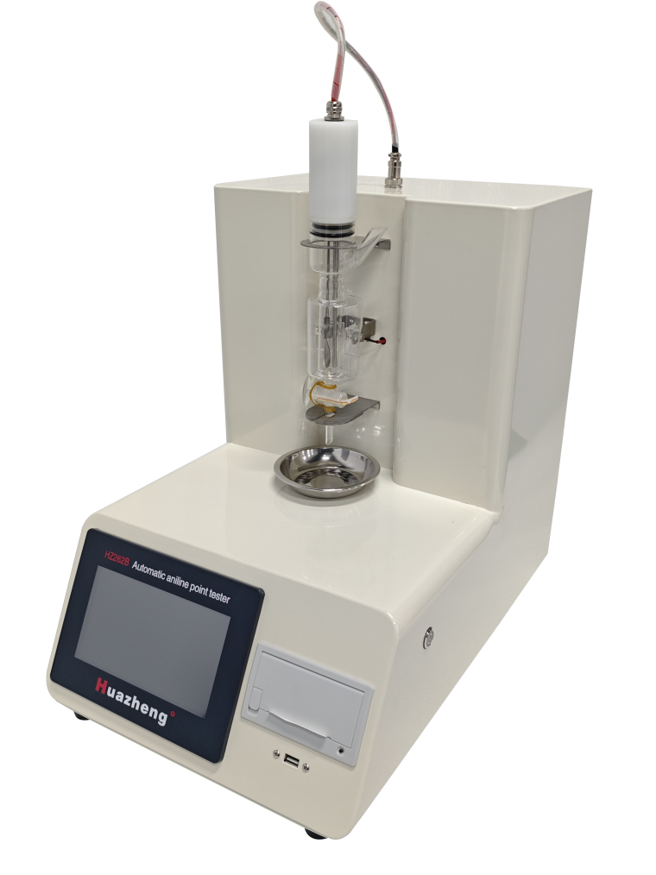

Huazheng Electric Manufacturing (Baoding) Co., Ltd

Dear user:
Thank you for choosing HZ262B Automatic Aniline Point Tester.
We hope that this instrument can make your work easier and more enjoyable, so that you can get the feeling of office automation in the test and analysis work.
Before using the instrument, please read this manual, and operate and maintain the instrument according to the manual to prolong its service life.
"Just a light press, the test will be completed automatically" is the operating characteristics of this instrument.
If you are satisfied with this instrument, please tell your colleagues; if you are not satisfied with this instrument, please call (0312) 6775757 to tell you to serve you at all tie Huazheng Electric Manufacturing(Baoding) Co., Ltd., our company will definitely make you satisfied !
Contents

I. Product Introduction 1
II. Technical Parameters 1
III. Structure And Characteristics 2
IV. Preparation Work 3
V. Touch Screen Usage Instructions 3
VI. Maintenance And Repair 6
VII. Packing List 6

I. Product Introduction
HZ262B fully automatic aniline point analyzer is designed and manufactured according to the requirements of the national standard ASTM D611 and GB/T262-2010 "Determination of Aniline Point and Mixed Aniline Point of Petroleum Products and Hydrocarbon Solvents" . The minimum temperature required for petroleum products and an equal volume of aniline to dissolve into a single liquid phase is called the aniline point.
Place the specified volume of aniline and sample in a test tube and mix them with mechanical stirring. Heat the mixture at a controlled rate until the two phases are completely mixed. Then cool the mixture at a controlled rate, and when the two phases separate, the recorded temperature is the aniline point

II. Characteristics
- 7-inch color LCD touch screen, stylish and beautiful. Chinese human-machine dialogue interface, clear and intuitive.
- Using imported photoelectric sensors from abroad, the test results are accurate and consistent in repeatability.
- Equipped with over temperature alarm function, if the sample temperature exceeds 170 ℃ during the test, the buzzer will automatically sound an alarm and stop the test.
- The host is controlled by a microprocessor program, and the experimental process automatically heats up, stirs, identifies and stores aniline points Working mode: automatic photoelectric detection, microcontroller control
- Automatic printing, automatic shutdown at the end of the experiment.
- The experimental results can be exported through a USB flash drive and stored on a computer for multiple experiments and comparisons
Technical Parameters
● Temperature control range: room temperature~200 ℃
●Temperature control accuracy: ± 0.1 ℃
● Temperature detection: PT100 platinum resistance temperature sensor
●Heating method: electric heating rod
●Heating power: 60W
●Mixing method: Motor driven soft shaft mixing
● Detection method: photoelectric sensor
● Storage records: 200 records
●Printing method: Micro printer
● Working power supply: 110V 60HZ
●Storage method: The experimental results can store 199 sets of historical data for easy retrieval;
● Result output: It can also be equipped with a USB drive output function to output to the PC for long-term storage
●Output format: The output format of the result USB drive is CSV or Excel.
● Standard printing: Standard micro printer with automatic measurement and thermal printing

III. Structure And Characteristics
（1） Structure
The fully automatic aniline point analyzer consists of four parts. This includes a bath temperature heating system, a motor rotation system, a color touch screen human-machine interaction system, and printing. The instrument bath is heated by a heating rod, and the high temperature of the bath can reach 200 ℃.
The instrument comes with a 7-inch color touch screen, which can display the temperature and temperature curve of the sample in real time; Users can set expected turbidity in real-time; After the experiment is completed, the instrument automatically prints the results; At the same time, the experimental results are stored using an embedded system design, allowing users to view historical data.
（2） The system has the following characteristics:
1. Compact structure;
2. Adopting embedded system design, automatic detection throughout the entire testing process;
3 7-inch true color touch screen makes use simple;
4. High measurement accuracy;
5. Good repeatability;

IV. Preparation Work
1. After unpacking the instrument, please count the accessories according to the packing list. If there is any damage, please contact our company.
2. The instrument should be transported vertically, with a tilt angle of no more than 30 degrees along the height of the instrument. It should be placed in a dark place and placed steadily, otherwise there will be vibration after the instrument is started, which will affect its service life.
3. Connect the instrument power supply to a socket with a capacity of 220V/10A or higher, and be sure to have a good grounding wire..
4. When measuring the aniline point, transfer 10ml of aniline point and 10ml of sample into a test tube.
5. Cover the test tube with a rubber stopper containing sensors, heating tubes, and agitation.
6. Turn on the power, click on the touch screen, and enter the main control interface.

V. Touch Screen Usage Instructions
- Turn on the power switch, and the instrument will enter the following main interface: 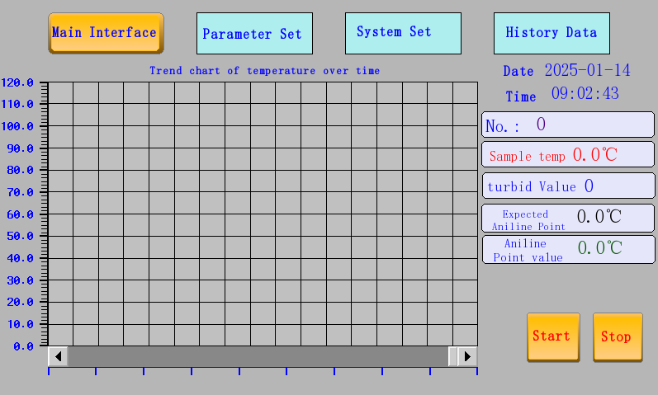
Figure 1

2.The parameter settings are shown in the following figure.
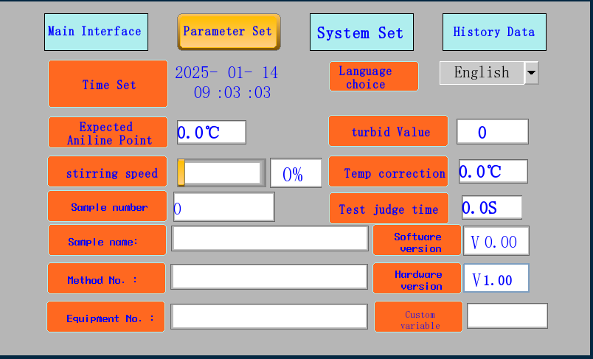
Figure 2
The parameter setting interface can calibrate the sample temperature and bath temperature. And the samples can be numbered. If these parameters are modified, clicking on the time number or clicking on the rectangular box will display a virtual keyboard, completing the modification of the numbers.
3 System set
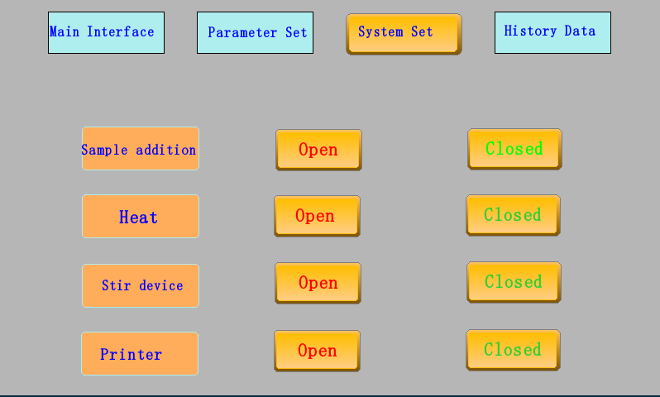
Figure 3
The system settings interface allows for manual open and closed You can first check the condition of each part of the instrument. Turn on the heating device and raise the temperature of the instrument bath; Click on the stirring device to turn it on or off. Click to turn on the printer, and the experiment will be completed with automatic printing,
4.After clicking the start button in Figure 1, the instrument automatically shuts down parameter settings, system settings, and viewing of historical data. Therefore, parameters must be set in advance before starting the experiment.
After all the preparation work is completed, click the start button to start the experiment. During the experiment, the system automatically detects the aniline point. After the experiment is completed, a beep will sound to prompt and the aniline point result will be printed.
- After detecting the aniline point, print the following interface:
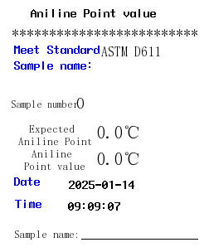
6 History data
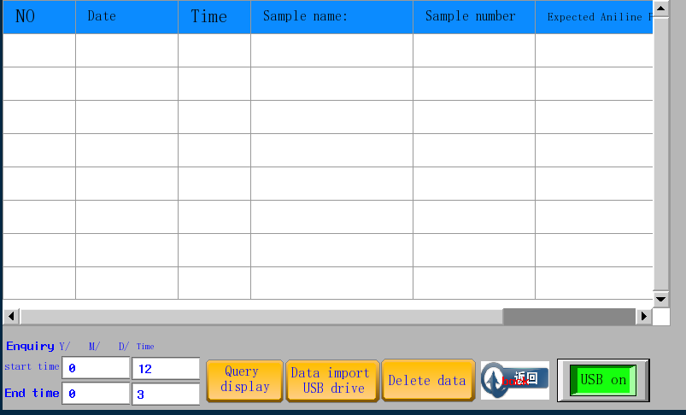
Figure 5
the historical data query interface stores the experimental results in the historical database at the end of each experiment. Including time, date, number, expected aniline point, and experimental aniline point.

VI. Maintenance And Repair
1. Regularly keep the instrument clean to prevent corrosion from acids, alkalis, oil stains, humid gases, etc.
2. Due to the high degree of automation of this instrument, professional personnel should be hired to repair it in case of malfunction, and it should not be disassembled randomly.
3. Please turn off the power and unplug the power plug after the experiment is completed.

VII. Packing List
No. | Item | Qty
1 | Host | 1
2 | Aniline Point Test Tube | 1
3 | Aniline point Sensor | 1
4 | power cord | 1
5 | Cup holder | 1
6 | Printing paper | 1
7 | instruction manual | 1
8 | Certificate warranty card | 1

