HZKM-2
Lubricating Abrasion Tester

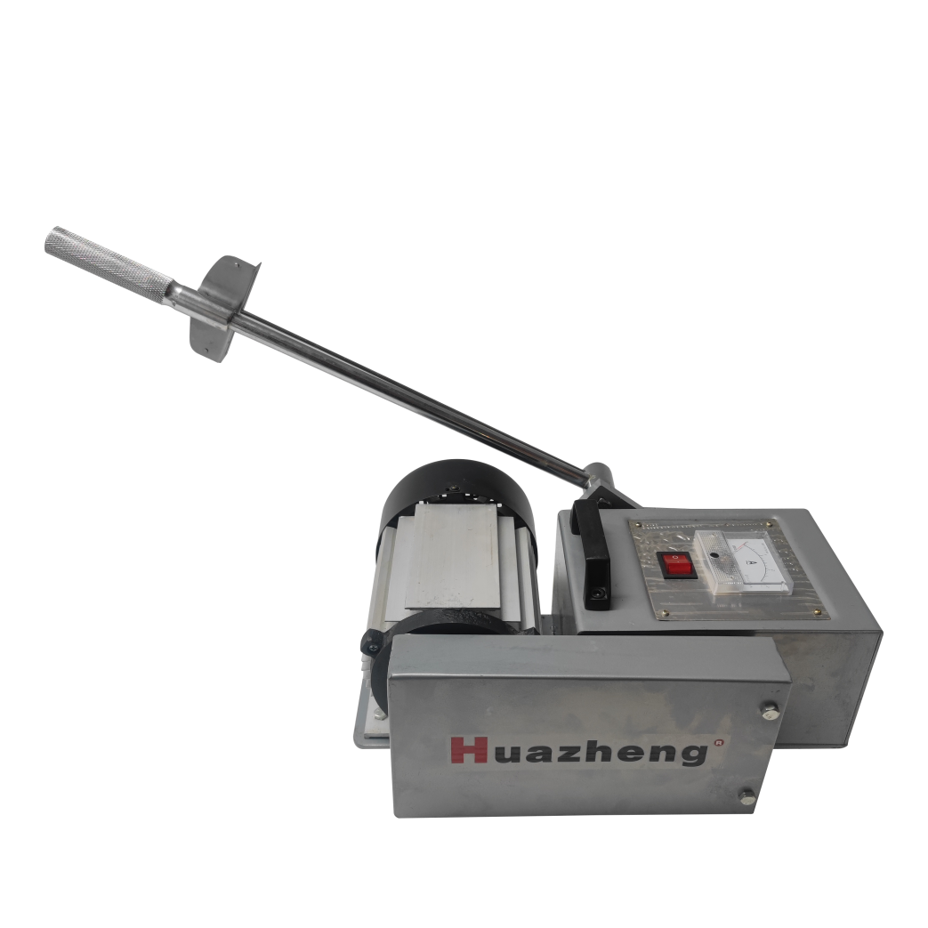

Huazheng Electric Manufacturing (Baoding) Co., Ltd

Machine Use :for testing lubricating oil and lubricating oil mixed with anti-wear additives and oil temperature change
Experimental conditions: under the condition of 220V, the ordinary oil can be held under a certain pressure, and the wear-resistant lubricating oil can not hold.

Operating Steps
1. Connect the power supply and start the motor. Polish the shaft sleeve thoroughly with ordinary lubricating oil, press the shaft sleeve evenly with the thumb, wipe the shaft sleeve clean after grinding, and close the motor. The purpose of grinding is to eliminate the effect of the original oil film or nanomembrane on the experimental results.
2. Fix the steel beads in the short lever tank of the test machine, add ordinary lubricating oil to the oil box, and install the lubricating oil box and the long and short lever.
3. Start the motor, and run it first. Then gradually intensify, add to a certain force, the machine hugs, record the reading of the torque wrench at this time. Look at the change of the ammeter pointer, the pointer increases, prove that power consumption increases, power consumption is oil consumption. As the noise gradually increases, remove the short lever and observe the grinding depth, area and roughness of the cylindrical grinding block.
4. Change the steel ball from an Angle and install the lever. Polish the shaft sleeve again, because the experiment just now on the shaft sleeve wear, to polish flat.
5. Add our wear-resistant lubricating oil to the oil box.
6, in the end of the long lever one by one strengthening, in the process of strengthening, the sound gradually become smaller, the pointer current change is very small, look at the ammeter pointer, only a little move. Current voltage = power consumption, the ammeter pointer changes very little, power saving is fuel saving. The gradual afterburner machine does not cling to death. Antiwear lubricating oil has very good wear resistance.
7.Remove the oil box, and the machine runs as usual. It shows that the nanomembrane does exist and turn off the machine switch.
8. Take off the steel beads and compare them with the grinding marks in front.

Packing List
No. | Item | Qty
1 | Main engine | 1
2 | Balancing weight | 12
3 | Oil cup | 2
4 | Oil stone | 1
5 | Power line | 1
6 | Steel ball | 50

