HZ2351A
Intelligent Touch Control Sulfur Detector

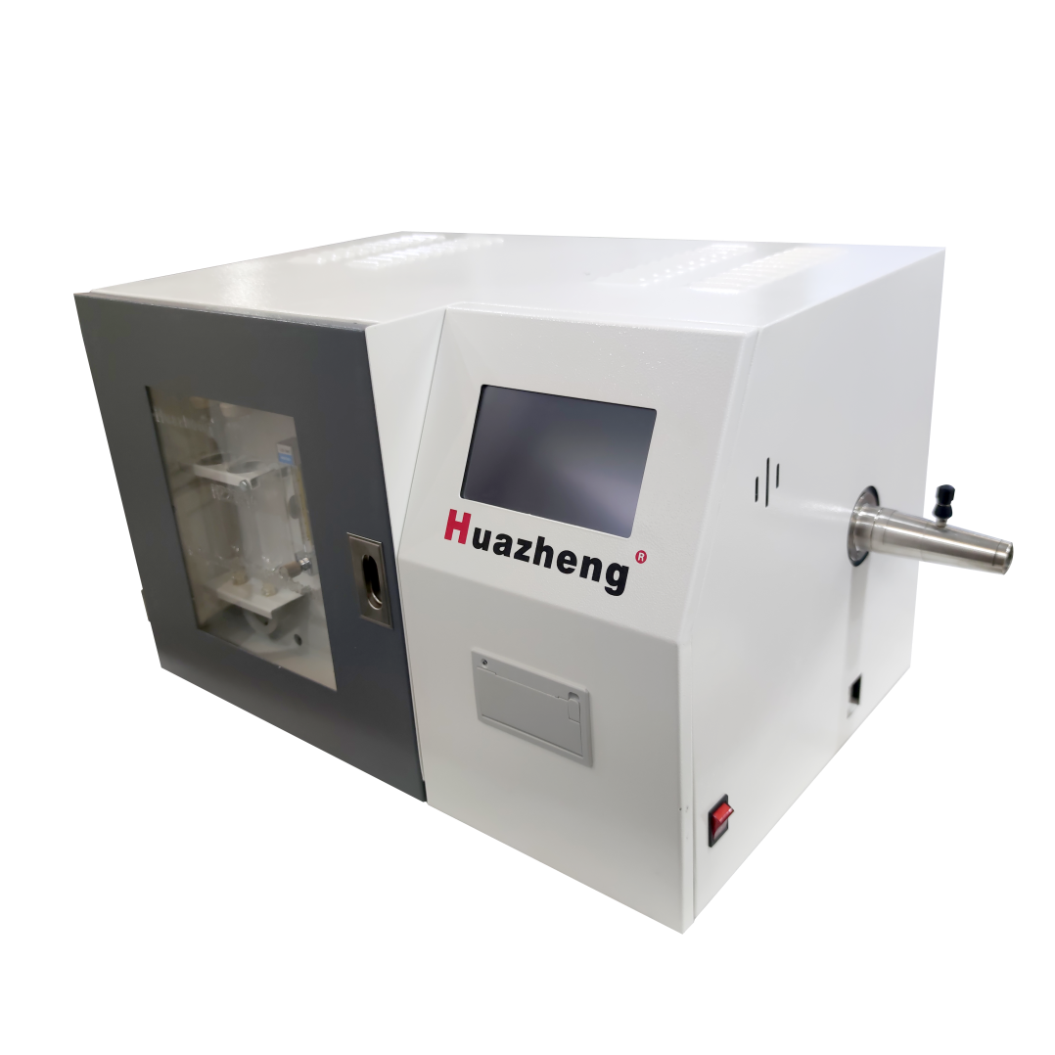

Huazheng Electric Manufacturing (Baoding) Co., Ltd


Safety Caution
1.Please disconnect the power supply when wiring the equipment. No wiring operation is allowed while it is on.
2.Do not press the LCD; Heavy pressure may cause the LCD screen broken or damaged.
3.Do not touch or scratch the LCD touch screen with sharp objects, otherwise the LCD screen may be damaged.
4.The equipment must be grounded reliably to prevent accidental electric shock due to leakage.
5.Before starting the machine, make sure that all connections are correct before starting the machine with electricity.
6.Keep away from inflammable, explosive, corrosive, radioactive and other articles and environment to prevent damage to the equipment or slow down the life of the equipment and prevent accidents.
7.Keep the environment clean and avoid dust, or it may damage the equipment
8.Equipment should be placed in a position conducive to heat dissipation.
9.Please follow the instructions in the product manual to operate.
10.Non-professionals are not allowed to open the equipment shell or replace the internal components.
11.Please take good care of the packaging materials, so as to guarantee the quality and replace the equipment.
12.Please take good care of the instructions for proper use.

Dear user:
Thank you for choosing HZ2351A Intelligent Touch Control Sulfur Detector.
We hope that this instrument can make your work easier and more enjoyable, so that you can get the feeling of office automation in the test and analysis work.
Before using the instrument, please read this manual, and operate and maintain the instrument according to the manual to prolong its service life.
"Just a light press, the test will be completed automatically" is the operating characteristics of this instrument.
If you are satisfied with this instrument, please tell your colleagues; if you are not satisfied with this instrument, please call (0312) 6775656 to tell you to serve you at all times-Baoding Huazheng Electric Manufacturing Co., Ltd., our company will definitely make you satisfied !
Contents

I. Product Introduction 1
II. Product Performance 1
III. Specification 2
IV. Structure And Installation Instructions 2
V. Interface & Amp; Function Description 6
VI. Experiment Operation 10
VIII. Packing List 19

Product Introduction
The product is designed according to the Cullen titration method in GB/T214-2007"determination method of total sulfur in coal", which can automatically complete the determination of total sulfur content in strict accordance with the relevant regulations of GB. Therefore, the product is widely used in coal testing, brick factory, stone heating, electric power, coking, chemical industry, scientific research, food and other industries.

Product Performance
● The Cullen Electrolysis program uses 120mA class Electrolytic current , effectively extend the service life of the electrolytic pool platinum sheet.
● fully automatic electrolytic switch control , the test results caused by electrolyte failure, platinum Pole blackening and so on are not stable or the electrolytic function is destroyed.
● using Dual Independent Hall component Positioning Scheme, the realization of the Continuous Adjustable multi-segment Delivery sample , and is compatible with the determination of high sulfur and fast sulfur samples.
● using self-calibrated heating current method, which effectively improves the service life and compatibility of silicon carbon tubes.
● Reminder: You can choose intelligent Artificial voice broadcast results or buzzer reminders after the end of the experiment.
● data storage: Support for one or two experimental data " continuous scrolling "Storage.
● operation mode: High sensitive touch operation and mask button operation can be used independently.
● Industrial Integration design, high-grade, generous, easy maintenance.
● Horizontal high temperature furnace body design, effectively ensure the stable formation of constant temperature zone.
● Print Mode: Micro-dozen, you can choose to print or cancel printing.
● Experiment Time: The analysis time can be set, automatically judge the end of the experiment.
● temperature display: Ambient temperature -1200℃, resolution 1℃
● Temperature control:℃-1200℃, the target temperature can be set freely.
● Heating time: up to 1150±5℃ in about a minute.

Specification
●Power supply :220V 20V,50Hz.
●power: maximum power 2.5kw.
●Flow measurement range :0.01% 40%, resolution :0.01.
●Accuracy: the allowable error range conforming to the standard sample.
●Print mode: micro typing, you can choose to print or cancel the print .
●Reminder mode: intelligent artificial voice or buzzer reminder.
●Data storage: continuous rolling storage of 2000 pieces of experimental data.
●Experimental time: the single sample general analysis time of 3 and 5 minutes can be set, and the end point of the experiment can be determined automatically.
●Temperature display: ambient temperature 1200, resolution 1 .
●Temperature control :900 1200, target temperature can be set freely.
●Heating time: about 25 minutes to 1150 5
●Operation mode: highly sensitive touch operation and mask button operation.

Structure And Installation Instructions
4.1 Structure
The instrument is composed of four parts: a tube type high-temperature furnace (which provides samples with high-temperature combustion environment) purification agitator (air purification pretreatment and magnetic stirring) and an electrolytic cell.
Sulfur meter controller: this part includes four parts of liquid crystal touch screen printer of the sample sending mechanism of the host system, which work together under the control of the system.
Tubular high-temperature furnace: this instrument adopts tubular high-temperature furnace as combustion furnace, and its heating element is double-threaded silicon carbon pipe, and a reducing pipe is installed inside.
Purification agitator: this part is composed of electromagnetic pump air flow meter dry pipe stirring speed regulating circuit,
electromagnetic pump: by pumping pump and blowing air two pump composition, respectively make the gas in and out.
flowmeter :Glass tube float meter, equipped with needle valve to regulate the gas flow of the electrolytic cell, should be adjusted to about1000ml/min.
Drying tube: remove the moisture rich gas extracted from the electrolysis tank to protect the flow meter. This part of the gas has a high moisture content, so it needs to be baked and replaced frequently.
Mixing speed regulating circuit: The speed of the agitator is approximately 500turn/minute, and continuous adjustable, but not too fast, too fast easy to cause the loss of step.
Electrolytic cell: electrolytic cell with organic glass, volume of about 400 ml, fixed on the upper cover a pair of electrolytic electrode (larger) and a pair of indicator electrode (smaller) in the electrolytic cell with sintering glass plate gas filters, will be released by combustion gas gush into fine bubbles, and under the action of stirrer and stir bar combustion generated SO2 and a small amount of SO3 gas quickly dissolved in the electrolyte.
4.2 Installation environment and user - provided materials
●Avoid direct sunlight, no strong electromagnetic interference, non-corrosive gas, air should be basically free of SO2 gas;
● Ambient temperature 5-40 ℃, relative humidity ≤85%;
●The test bench is 2500mm(length) 700mm(width), and the equipment includes a tubular high-temperature furnace, preferably a temperature-resistant test bench.
●An analytical scale of one part in a million.
●Potassium bromide (analytical pure) potassium iodide (analytical pure) glacial acetic acid (analytical pure).
●Tungsten trioxide (analytical pure) discolored silica gel.
●Distilled water.
●Cotton wool. (medical).
●Standard coal sample.
4.3 Equipment installation steps
▷Installation of main engine accessories
Part 1: remove the protective film on the outer surface of the equipment completely and place it on the inspection table smoothly. Open the left side installation door of the equipment and remove the accessory fixings of the heat shield. Carefully remove the outer protection part of the double-threaded sic tube, load the sic tube into the furnace body, and adjust the position of the clamp of the sic tube so that the sic tube can be placed into the large groove of corundum baffle at the right end of the furnace body, The shape of the clamp of the silicon carbide tube is adjusted so that it can be closely combined with the aluminum conductive belt of the silicon carbide tube to improve the conductivity and avoid the ignition phenomenon caused by bad contact. The heat sink cover and its accessories shall be fixed, and the movable allowance of no less than 1mm shall be ensured in the longitudinal direction in this process, so as to avoid the expansion and lengthening of the silicon carbon tube in the heating process or the extrusion and fracture of the fixing screws. The silicon carbon tube clips shall be fixed on the two terminals at the left end of the furnace body.
Part 2: the positive and negative polarities of the thermocouple connecting wires are distinguished and connected to the tail end of the thermocouple respectively (+ connecting red line; - connect the black wire), then insert the thermocouple connected with the wire into the thermocouple hole at the back of the furnace, insert it to the bottom (the actual insertion depth is about 93mm), and then return to about 1mm for fixing; (due to the 1mm interval, the thermocouple did not directly contact the surface temperature of the silicon carbon tube, so the internal temperature of the furnace was nearly 100 higher than the display temperature under this interval, so when the setting temperature was 1050, the actual temperature of the furnace was 1150).
Part 3: carefully remove the outer protection part of the reducing pipe, insert the reducing pipe into the installed silicon carbon pipe core, adjust the position of the reducing pipe so that the reducing pipe can be placed in the small groove of corundum baffle at the right end of the furnace body, and then tighten the reducing pipe slightly.
Part 4: connect the two terminals of the main power supply with the power line to the two-way air switch supplied by 220V50Hz.
▷Pneumatic connection
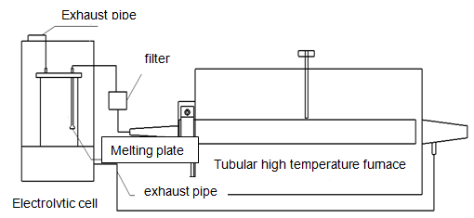
First: a corundum reducing pipe and a carrier gas filter connected to a carrier gas path; (silicone rubber tube must be used for this part due to high temperature).
Second: air inlet connected with carrier gas filter and electrolytic cell; (air inlet with glass melting plate).
Third: connect the air outlet of the electrolysis tank and the suction rubber tube of the stirring purifier.
▷Install sample holder and sample stick:
First: turn on the power switch of the equipment and click to end make the rack exit to the stop position to install the right Angle support and bar. Adjust the height of the right Angle support and nut to keep the bar parallel. When the bar is in the stop position, the hook at the left end of the bar is just overlapped on the vertebral canal of the furnace.
Second: then turn on the controller power. Click start and end repeat the test of sample delivery and stop return to ensure smooth sample delivery.
Third: put the quartz boat in the vertebral canal at the mouth of the furnace, and connect the fixed hole at the right end to the hook at the left end of the sample sending rod.
▷ preparation of electrolytes:
Weighing 6 grams of potassium iodide, 6 grams of potassium bromide, soluble in about 250 ml of distilled water, and then add 10 ml glacial acetic acid can be. The ph value of the electrolyte can be used at 1-3, and when the ph value is less than 1 o'clock, the electrolyte should be discarded.
Note: A few waste samples should be measured before each test, so that the electrode potential of iodine-iodine ion electrical pairs in the electrolyte is corrected to the desired value (the screen indication voltage can be seen generally in 35-39MV).
Offline touch operation mode to microcomputer operation mode (i.e. connected mode):
Click on the settings icon on the touch screen main interface, click on "About this machine", click on the "About this machine" title, enter the factory settings interface, click on "Microcomputer mode", and it will switch to connected mode.
Microcomputer artificial mode to offline touch operation mode (i.e. offline touch screen operation mode):
On the main interface of the microcomputer experiment, click Settings, click Advanced, and then select Offline Mode to switch to Offline Touch Screen Operation Mode

Interface & Amp; Function Description
5.1. Experimental Interface description
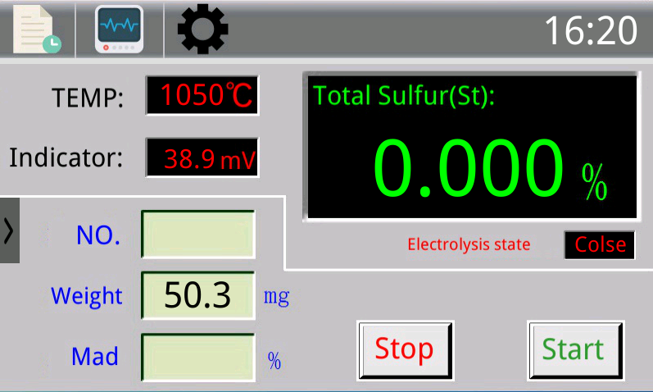
Furnace temperature: displays the measured temperature inside the current tubular high-temperature furnace body.
indicates voltage: displays the measured voltage signal values in the current Cullen integral electrolytic pool.
☆The indicating voltage reflects the changing characteristics of the electrolyte in the electrolytic cell. In the case of static balance (when samples are not made), the indicating voltage is generally between (35, 39)mv and the rate of change is as small as possible, which is generally less than about 2mv.
Total sulfur (st): displays the actual measured total sulfur content of the current sample, which is displayed as a percentage.
Electrolysis status: displays the status of the current coulomb integral electrolysis cell.
☆Click start and it will open automatically; Click stop or the experiment will automatically end, and the electrolysis state will automatically close.
Data icon: click this icon to view the historical experimental data.
Parameter icon: click the icon to view the measured parameter signal of the current state of the equipment (used by engineers for convenient maintenance and overhaul).
Setting icon: click the icon to modify the parameters of the device, such as furnace temperature, experiment speed, result calibration, date and time, etc. See setting for details.
Number: fill in the test number of the current sample.
Sample weight: fill in the test weight of the current sample in mg(mandatory).
Water content: fill in the measured water content of the current sample (if the test result is shown as dry base total sulfur, this must be filled in).
Start: after clicking, the experiment will start and the sample sending device will advance .
Bundling: after clicking, the experiment will end and the sample sending device will exit.
5.2 Data storage interface description
Click on the experiment screen, The data store can store 200 pieces of experimental results. The real-time experimental results will be displayed first. When the storage is full, the continuous rolling storage will continue. Simultaneous switchable the previous or next page query existing history results. Click the print button to print the selected result, Click the clear button to delete all saved data.
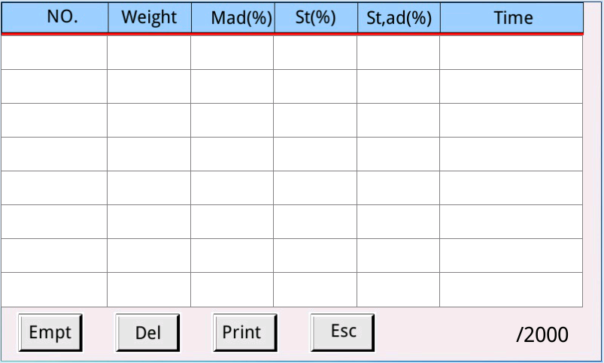
5.3 Description of setting function interface
Click the icon button on the experimental interface to enter the system setting interface and click the corresponding button to enter the corresponding function.
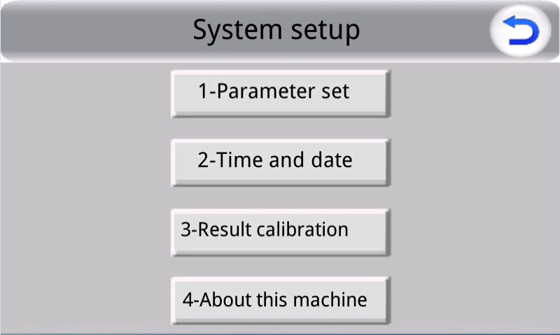
Click the parameter setting button to enter the instrument parameter setting interface.
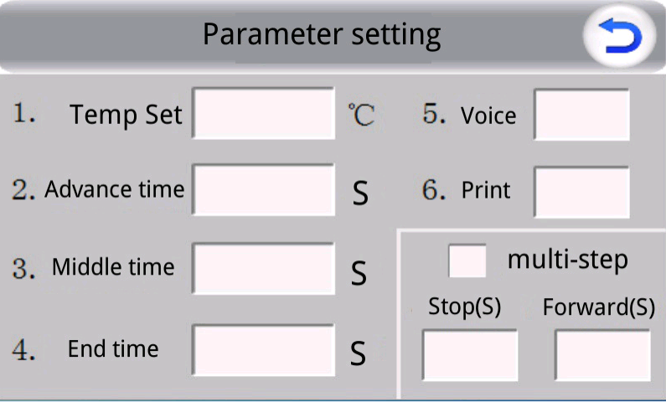
Furnace temperature setting: sets the service temperature of tubular furnace.
Sampling time: sets the advance time of the sampler from the starting position to the pre-decomposition position (low temperature section).
Predecomposition bit: sets the residence decomposition time of the sample in the low temperature section.
Decomposition position: set the residence decomposition time of the sample in the high temperature section.
Voice: fill in 0 after the end of the experiment without voice reminder, fill in 1 after the end of the experiment voice broadcast experimental results.
Print: do not print after the end of experiment 0; print the result after the end of experiment 1.
Multi-stage sample sending: after printing, fill in the value of stay and advance, and control the pre-decomposition bit and corresponding stay time of the sample sending device.
5.4Calibration function description
Click on the experiment screen calibration result button enter the instrument calibration interface. When the experimental results are continuous and stable and the deviation from the standard value is not large, the calibration function can be used to achieve more accurate test value calibration method as follows:
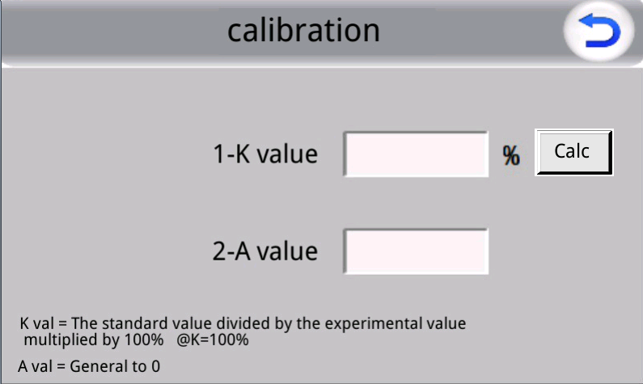
Overall coefficient: this is invalid.
Correction coefficient K: adjust the gain of test results .
correction coefficient A: adjust the deviation of test results.
Select at least two kinds of reference materials, each 3-5 single sample and reasonably calculate the average value as the standard material for samples, by the 100 y = Kx + b list equations, calculate the calibration coefficient K and the calibration coefficient b fill in the corresponding box, click ok calibration completed return experiment interface can do normal sample (on the type of y is the standard values, x is the measured value).
Example: the standard value is 0.5 and the actual measured value is 0.45; The standard value is the standard sample of 2.17, and the actual measured value is 2.25.
100×0.5=k×0.45+b
100×2.17=k×2.25+b
attain understandingk≈93,b≈8

Experiment Operation
6.1 Daily Operation
(1) Heating: turn on the double-channel air switch and power switch powered by the main machine. After the controller enters the experimental interface, it will automatically enter the heating program, rise to the set temperature and keep the temperature constant (about 25 minutes to 1050).
(2) Add electrolyte: add 250mml electrolyte into the electrolyte tank by removing the rubber plug on the top of the electrolyte tank, or directly inhale the electrolyte through the bottom drain (if the suction needs to turn on the mixing purifier beforehand).
(3) Regulated gas flow: Adjust the knob of the flow meter of the mixer purifier to indicate the gas flow rate 800mml/min---1200mml/min between, impact 1000mml/min
(4) Check air tightness: check the air tightness of the gas absorption portion between the corundum reducer and the agitator purifier flowmeter, The method is to fold the silica gel tube between the corundum reducing pipe and the filter so that it cannot be ventilated, At this point the flow indicator should fall to0.2L/min under, It indicates that the air seal is good.
(5) Speed of stirring: Adjust the speed adjustment knob to speed up to 500 RPM/min about, If the electrolyte is not mixed evenly, the test result is not accurate. If it is too fast, the step will be lost, and the test result is not accurate.
(6) Test the sampler: Click on the start button, Start the sampler to test the sampler mechanism to avoid the failure of the sampler card caused by the deformation of the sampler bar or the change of the relative position of the machine, You can click the end button to force the return.
(7) Do waste sample: Add about 50.0 mg of coal sample with sulfur content of about 1.5% to the porcelain boat, cover the evenly laid coal sample with a layer of tungsten trioxide, and place the porcelain boat on the quartz boat.
☆Touch screen operation: click the sample weight box on the experimental interface, and the keyboard will pop up. Enter 500 or 50.0 and click ok, and then click experiment start.
☆Mask operation:click maskor,Select the sample weight bar, enter 500 mask, and then click start.
Note: although the waste sample should be completed automatically by the instrument as the formal sample to avoid human withdrawal, the incomplete combustion of the porcelain boat will have an impact on the subsequent test.
(8) Test sample: evenly spread the weighted sample with tungsten trioxide and put it into the quartz boat.
☆Touch screen
Step 1: click the sample number box on the experimental interface to input the sample number (no input required); Click the sample weight box to enter the sample weight (required); Click the water content box to enter the water content of the sample (no need for dry base sulfur).
Step 2: click the start button on the experimental interface.
☆Panel key operation
Step1:click maskor,, Select the sample number box and enter the sample number (no input required); Click on the mask or press the down key to select the sample weight box and enter the sample weight (required); Click on or press the button on the mask and select the water content box to enter the sample water content (no need for dry base sulfur value).
Step 2: click the start button of the panel
(9)Test interval: the test should be carried out continuously. If the interval is long, the electrolyte indicating voltage will drop due to illumination. If it is less than 35mV, a waste sample should be burned before the test.
(10) After the test, the following operations shall be carried out successively.
▷Shut off the power switch of the controller,
▷Shut down the mixing purifier
▷Release the electrolyte
▷Clean the electrolytic cup
6.2 Routing maintenance
■Clean the electrolytic cell after the completion of the test every day.
■Check the air tightness and air flow of the air circuit after each startup.
■Check the aging of rubber hose in the air circuit regularly.
■Check and replace filters and glass melting plates regularly.
■Clean the yellow crystal at the taper of reducer regularly.
■The 180 rotation of the carbon silicon tube after 3 months can slow down the deformation.
■The electrolytic pole can be swabbed with ethanol or acetone after the top cover of the electrolytic cell is opened because the stirring is out of step or the electrolysis is caused by not stirring.
■The trays for porcelain boat and boat should be kept clean, the new porcelain boat should be treated with high temperature before use, and the sample and standard sample should be mixed thoroughly before use.
■The service time of the electrolyte depends on the number of repeated use and the sulfur content of the sample. However, before each test, the electrolyte should be measured once or twice, so that the electrode potential of the iodide ion pair in the electrolyte can be corrected to the required value of the instrument (general indicating voltage shows 35-40mv).
Offline touch operation mode to microcomputer operation mode (i.e. connected mode):
Click on the settings icon on the touch screen main interface, click on "About this machine", click on the "About this machine" title, enter the factory settings interface, click on "Microcomputer mode", and it will switch to connected mode.
Microcomputer artificial mode to offline touch operation mode (i.e. offline touch screen operation mode):
On the main interface of the microcomputer experiment, click Settings, click Advanced, and then select Offline Mode to switch to Offline Touch Screen Operation Mode
4.1 Startup and Shutdown of Instruments
4.1.1 Startup of the instrument
1. Turn on the power switch of the device
2. Open the microcomputer, find the system software on the microcomputer desktop, double-click to open or right-click to open the system software
3. The bottom left corner of the system main interface displays "Communication status: Connected"; At the same time, the window furnace temperature should display the current actual temperature; The window indicator displays auxiliary sign information such as the actual indication voltage (which should change in the short term).
4.1.2 Instrument exit and shutdown
1. Wait for the inspection sample to be tested and the sample delivery device to return to the stop position.
2. Exit the system software and turn off the microcomputer.
3. Turn off the power switch of the device
4.2 Introduction to menu functions of the instrument
4.2.1 Introduction to System Main Interface Functions
1. Display content of key information on the device itself
Total sulfur (st): displays the measured total sulfur content value of the current sample, which is displayed as a percentage.
Furnace temperature: displays the measured temperature inside the current tubular high-temperature furnace body.
Indication voltage: Display the current measured voltage signal value in the Coulomb integral electrolytic cell. The indicated voltage reflects the changing characteristics of the electrolyte in the electrolytic cell. When in static equilibrium (without sampling), the indicated voltage is generally between (35-39) mv and the rate of change should be as small as possible, generally less than 2mv.
Electrolysis status: Display the current state of the Coulomb integral electrolytic cell. Click on start and it will automatically open; Click to stop or the experiment will automatically end, and the electrolysis state will be automatically turned off
Position x: Relative position of the X-axis origin of the sample retention mechanism.
Position Y: Relative position of the Y-axis origin of the sample retention mechanism.
2. General operation button section
Start button: used to start the experiment. After clicking, the experiment will automatically start.
Stop button: used to stop the experiment. After clicking, the experiment will automatically stop and return to the initial state.
Add button: used to add sample parameters. After clicking, a parameter box for adding samples will pop up.
Modify button: used to modify the selected sample parameters. After clicking, you can modify the sample parameters selected by the current cursor (mainly used for initial input errors and secondary correction)
Delete button: used to delete the first sample parameter.
Clear button: used to clear all sample parameters in the list. After clicking (double confirmation), all sample parameters in the experimental interface can be cleared. Use with caution.
4.2.2 Introduction to System Setting Functions
Click the left mouse button on the system settings on the main interface, and then click on the instrument parameters to enter the instrument parameter settings interface.
Instrument parameter setting items
Furnace temperature setting: used to set the operating temperature of the tubular furnace (generally set at 1050-1150)
Pre decomposition advancement time: Set the advancement time of the sample feeder from the starting position to the pre decomposition position (low temperature range). Note that it is the advancement time.
Pre decomposition time: Set the residence and decomposition time of the sample in the low-temperature range
Decomposition time: Set the residence and decomposition time of the sample in the high temperature range
Volume: Fill in 0. There will be no voice reminder after the experiment ends. Fill in other numbers to represent the volume level, with 100 being the maximum volume.
Printing: Invalid.
Multi segment sample delivery: After selection, fill in the numerical values of the dwell and forward items to control the number of pre splitting bits and corresponding dwell time of the sample delivery device. Applicable usage plan for high sulfur or fast sulfur samples.
Click the left mouse button on the system settings on the main interface, and then click on the serial port settings to enter the instrument serial port settings interface.
Device communication serial port settings
Serial port setting: used to set the interface category for communication between the instrument equipment end and the microcomputer.
Left click on System Settings on the main interface of the system, then click on User Management to enter the Instrument User Management Settings interface.
User Management Settings
User management can pre-set and save multiple pieces of laboratory technician information, laboratory unit information, and commonly used sample numbers, making it easy to directly use and associate information.
4.2.3 Instrument Calibration
Click the left mouse button on the system settings on the main interface, and then click on the result calibration to enter the instrument calibration settings interface. When the experimental results are continuously stable and do not deviate significantly from the standard value, more accurate test values can be achieved through the calibration function. The calibration method is as follows:
Select one standard substance to make 3-5 single samples, and calculate the reasonable average value as the sample value of the standard substance when the single sample results are repeatedly stable.
1. Fill in the nominal value of the standard substance in the "Standard Sample Value Box";
2. Fill in the "sample value box" with the average value calculated when the single sample results are repeatedly stable;
3. Click "Read" and fill in the "Original Whole System Number Box" with the overall coefficient value of the current instrument that has been read.
4. Click on 'Calculate' and overwrite the calculated new coefficient values in the 'Overall Coefficient Box'. Finally, click 'Apply' to complete the calibration.
Segment deviation is incremental fine-tuning, with 0 segments corresponding to the range of 0-1 for total sulfur; Corresponding to Section 1 (within the range of 1-2 for total sulfur); Corresponding to 2 segments (total sulfur range of 2-3) and so on.
Accuracy calibration settings
4.2.4 Introduction to Parameter Detection Function
4.2.5 Introduction to Data Management and Printing Functions
Data management can support conditional query of historical data, printing of historical data, report based printing of data, exporting of historical data formats, etc.
If you need to customize the report format, you can click Export Excel to export a standard Excel document for customizing the report.
Chapter 5 Daily Experimental Operating Procedures for Instruments
1. Preparation before the experiment: Prepare electrolyte reagents, samples for experimental testing, dry and cooled silica gel, clean porcelain boat, spoon, tweezers, brush, and heat-resistant porcelain plate;
2. Install color changing silicone gel; After filling, remember to tightly plug the sealant to prevent air leakage.
3. Check if the gas filter at the inlet of the electrolytic cell is dirty. If it becomes dirty, it is necessary to replace the filter or the filter cotton inside the filter in a timely manner. After inspection, remember to tightly plug the sealant to prevent air leakage.
4. Add electrolyte: Unscrew the electrolytic cell cup cover and add 250mml of electrolyte into the electrolytic cell, then tighten the electrolytic cell cup cover.
5. Turn on the power switch of the device;
6. Open the microcomputer, find the system software on the microcomputer desktop, double-click to open or right-click to open the system software; The bottom left corner of the system main interface displays "Communication status: Connected"; At the same time, the window furnace temperature should display the current actual temperature; The window indicator displays auxiliary sign information such as the actual indication voltage (which should change in the short term).
7. Check air tightness: Click on "debug" in the menu bar of the system main interface, and then click on "purify and stir". At this time, the float of the air flow meter on the equipment should be kept at 0.8-1.2 liters per minute. The silicone tube between the quartz combustion chamber and the filter should be folded to prevent ventilation. At this time, the flow indicator should be able to drop below 0.2L/min, indicating that the air circuit is well sealed and can be used normally. Otherwise, it cannot be used normally, and the entire gas path sealing link should be checked.
Common air leakage links in gas path seals include:
A quartz combustion chamber end and hose connection
The rubber plug of the air filter is not tightly sealed
The rubber plug on the top cover of the electrolytic cell is not tightly sealed
The connecting hose of the bubbling dissolution plate in the electrolytic cell has aged and ruptured
The cover of the electrolytic cell cup is not tightened or the sealing ring of the cup cover is damaged.
The rubber plug in a certain area of the drying tube is not tightly sealed
8. Heating up: Connect the dual air switch and power switch of the equipment power supply, automatically enter heating up, rise to the set temperature and maintain constant temperature (about 25 minutes to heat up to 1050 ℃~1150 ℃).
9. Sulfur content of test sample: Add 50.0 ± 1 milligrams of test sample into the porcelain boat, click "Add", enter the parameters of the sample, click "OK", and place the sample into the first injection slot. If there are multiple consecutive samples, repeat the above steps and place the samples into the injection slot in sequence.
Remember: The order of samples in the list and the order of injection slots must be consistent, otherwise the experimental results will be incorrect in sequence.
Click the start button on the experimental interface, and the instrument will start measuring the sulfur content of the samples in sequence. (If it is necessary to add test samples gradually, repeat this step.)
10. Wait for all samples to be tested and the sample delivery device to retract to the origin stop position.
11. Recycling electrolyte: Click on "Debugging" in the menu bar of the system main interface, click on "Purification and Mixing", then release the water stop hose at the bottom of the electrolytic cell, open the top rubber stopper, and recycle the electrolyte into a sealed ink container for later use. After the electrolyte recovery is completed, restore the original state of the water stop clamp and rubber plug.
12. Clean the electrolytic cell. Add approximately 250ml of purified water into the electrolytic cell (using the same method as adding electrolyte). Click on the purification stirring button, stir and rotate to clean for about 1 minute. Then click on the purification and stirring button to release the cleaned water from the electrolytic cell (using the same method as recycling the electrolyte).
13. Exit the system, turn off the microcomputer, and turn off the device power switch.

VIII. Packing List
No. | Item | Model / parameter | Qty
1 | Liquid crystal intelligent sulfur determination instrument |  | 1
2 | Sample sending rod |  | 2
3 | Sulfur S-type thermocouple |  | 1
4 | Silicon carbon tube (with silicon carbon tube clip and high temperature resistant lead) |  | 1
5 | reducing pipe |  | 2
6 | Electrolytic cell (with electrolytic cell rubber plug) | Special type for Coulomb electrolysis | 1
7 | Electrolytic cell three piece set | (agitator + clamp + electrolytic cell inlet filter) | 1
8 | High quality silicone hose |  | 2
9 | Shi Yingzhou |  | 0.5
10 | Porcelain boat |  | 2
11 | electrolyte | Trial adjustment | 10
12 | Standard coal sample | Trial adjustment | 1
13 | Serial port connection Data cable + software |  | 1
14 | Discolored silica gel |  | 1
15 | Two piece set of experimental tools (spoon + tweezers) |  | 1

