HZ1902
Dual-beam UV-VIS Spectrophotometer

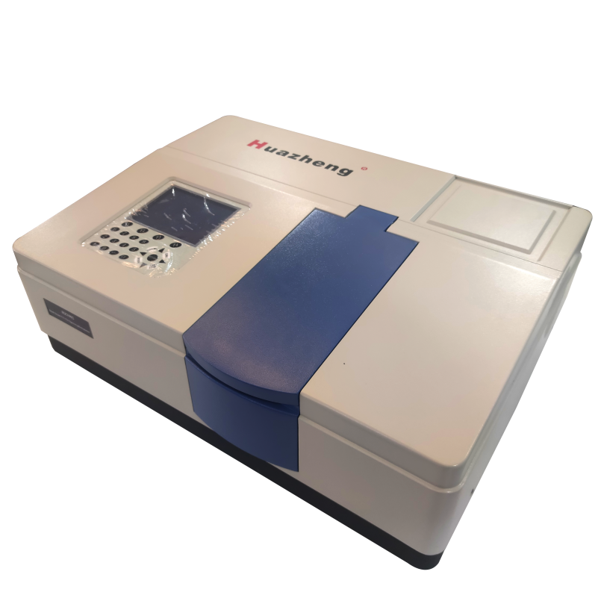

Huazheng Electric Manufacturing (Baoding) Co., Ltd

Contents

I. General Information 1
1.1 Characteristics and Applications 1
1.2 Main Specifications and Technical Parameters 1
1.3 Main Functions 2
1.4 Introduction of Instrument System and Structure 3
1.5 Basic Working Principle 6
II. Installation 8
2.1 Operation Ambient 8
2.2 Connection and Wiring (refer to Fig.3) 11
III. Software Installation 11
IV. Software Operation 12
4.1 Enter the serial number 12
4.2 Work Online 13
4.3 Initialization 13
4.4 Main Menu 14
4.5 Settings 37
V. Failures Analysis And Trouble-Shooting 40
5.1 Instrument Maintenance 40
5.2 Failure Analysis 42
VI. Failures And Change Of Light Source 46
6.1 Failures and Change of Tungsten Lamp 46
6.2 Failures and Change of Deuterium Lamp 47
VII. Packing List 49
Appendix.1 49

- General Information

1.1 Characteristics and Applications
HZ1902is a double-beam UV/VIS Spectrophotometer with a scanning function. It has a wider range of spectrum and is of high quality. Due to its built-in micro-computer system, plus excellent optical and electric circuit system, rational mechanical structure and a large LCD display screen, the instrument will surely be an effective and visual means useful to lab analysis in all kinds of industries.
HZ1902UV/VIS Spectrophotometer adopts a man-machine dialogue operation method. It is easy to learn. Menu at the large LCD screen allows every item to be chosen and accepted corresponding to each operation step. In this way, you can perform function you needed. The change of lamp is simple. By turning several screws, you change the lamp, which will be at the optimal position without being complicated light-adjustment.
Instrument is designed to be protected by software program to restore the instrument to normal work status in a failure.
Being an excellent practical UV/VIS spectrophotometer, HZ1902provides fast and simple analytical methods to be widely used in organic, inorganic, petroleum, pharmacy, environment, bio-chemistry, medicine, food and other national economy departments for QC and QA.

1.2 Main Specifications and Technical Parameters
1.2.1 Technical Indicators
Model | HZ1901 | HZ1902
Photometric | Transmittance,Absorbance,Energy,Reflectivity
Wavelength Rang | 190nm～1100nm
Spectrum Bandwidth | 1nm | 2nm
Stray Light | ≤0.03%T （220nm NaI、360nm NaNO₂）
Wavelength Accuracy | ±0.3nm
Wavelength Repeatability | 0.1nm
Photometric Range | -4A～4A
Photometric Accuracy | ±0.3%T(0～100%T)  ±0.002A(0～0.5A)  ±0.004A(0.5～1A)
Photometric Repeatability | 0.001A(0～0.5A)  0.002A(0.5～1A)
Stability | ≤±0.0004A/h（2 hours after turn-on, at 500nm）
Noise | ≤0.0003A
Baseline Flatness | ≤±0.0008A | ≤±0.001A
Power | AC 100V~240V 50Hz/60Hz
Light source | Deuterium & Tungsten-halogen lamp
Scanning Speed | Fast Middle Slow
1.2.1 Use Conditions
Ambient Temperature ： | 5℃～40℃
Ambient Humidity： | ≤80%
Elevation | ≤2000m
Operation Voltage： | AC 100V~240V 50Hz/60Hz
Rated Power | 200W
Fluctuation range of Voltage | AC 85V~265V 50Hz/60Hz
Fuse Model/Fuse Specification | RF1-20 /F3.15AL250V
 | There shall be no strong electric-magnetic interference and vibration in room.
1.2.3 Specifications
Dimensions： | 650mm (long)×450mm (wide)×220mm (high)
Weight： | 25kg

1.3 Main Functions
There are two main functions: automatic control and analytical test of information processing.
1.3.1 Automatic Control
- Switch on the instrument, the instrument performs self-diagnosis its internal system work status and automatic wavelength calibration.
- Wavelength change and automatic location
- Automatic switching of filter
- Automatic switching of lamp
- Automatic choice of optimal switching point of lamp souce
- Display and print of altas and data
- Display of error information
1.3.2 Analytical Test and Information Processing
- Spectrum scan
- Single wavelength quantitative analysis (including multi-valences regression concentration measurement)
- Two and three wavelength quantitative analysis (including multi-valences regression concentration measurement)
- Multi-valences derivative measurement
- Multi-wavelength measurement
- Chemical-dynamic measurement
- Combination and operation of curves, multi-valences differential smooth of curves, reduction and amplification of alta and storage and call-in of curves.
8. Identification, searching and print of peak values

1.4 Introduction of Instrument System and Structure
Overall structure is shown in Fig.1 which is consisted of three parts: optical system, power system and micro-computer system.
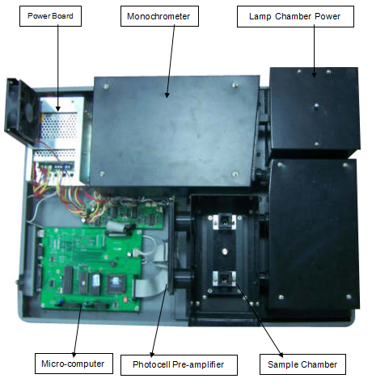
Fig. 1 HZ1902Structure
1.4.1 Optical System
HZ1902optical system is shown in Fig.2.
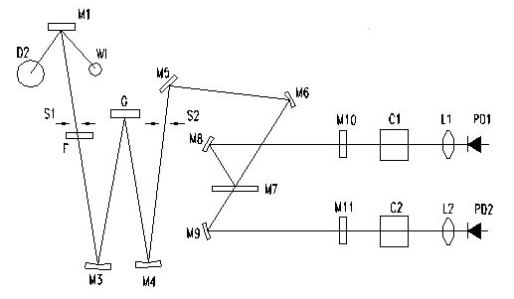
Fig. 2
W1: Tungsten lamp D2: Deuterium lamp
M1: Spherical Mirror S1: Light in Slit
F: Filter M3: Spherical Mirror
G:Grating M4: Spherical Mirror
S2: Light out Slit M5: Plane Reflector
M6: Spherical Mirror M7: Semi-Transparent and Semi-reflect Mirror
M8: Spherical Mirror M9: Spherical Mirror
M10：Protective Piece M11：Protective Piece
C1: Cell Holder C2: Cell Holder
L1: Lens L2: Lens
PD1: Photocell PD2: Photocell
HZ1902optical system consists of Tungsten lamp WI, Deuterium lamp D2 and spherical mirror M1. Energy generated from W1 (VIS source) and D2 (UV source) are concentrated at the light-in slit of monochrometer. Switching of lamp is completed by the movement of M1 driven by a micro-computer controlled step motor.
Monochrometer consists of light in slit (S1), light out slit (S2), alignment mirror M3, M4, grating G and filter set F. Grating G and filter set F are controlled by wavelength step motor and filter step motor respectively, while these two step motors are controlled by a micro computer system.
Two cells can be put into C1 and C2 in the sample chamber at the same time. Lens L1 and L2 will focus the light spot on to the optical cell. Under the standard state, C1 is for placing a reference sample, C2 for a standard sample or sample to be measured.
The optical system adopts C-T arrangement of asymmetrical image difference calibration to ensure a high quality spectrum. Change of wavelength is realized by a sine mechanism: when an external wavelength step motor turns, it brings the turn of the screw inside of monochrometer, making the slide block on the nut of screw to mover forward and backward. Change of wavelength and turn angle of grating is in sine relation. As the turn of grating, spectrum belt being chromatic dispersion will move left to right at the mouth of light out slit where you can get monochromatic light spectrum (monochromatic light beam) with different wavelengths.
If a spectrophotometer wants to realize automatic scan, there must be two conditions: an
independent light beam and an automatic energy compensation system. Double beam instrument has these two conditions. The instrument employs a spectro system consisted of a plane reflector M5 and spherical semi-transparent and semi-reflect mirrors M6, M9 and M7 to split the monochromatic light produced in the monochrometer into two beams. These two beams go through respectively reference sample and sample to be measured. Spectrum scanning altas can be obtained through the receipt, comparison and processing by the electric circuit. Reference light can be fed back to the automatic energy compensation system as an adjuster.
Putting two pieces of protective pieces of M10 and M11 can make the optical path in a more isolated position.
1.4.2 Electric Circuit System
Electric circuit system consists of power transformer, various analogous stabilizer circuits, three-way motor-driven circuit, pre-amplifier and micro-computer control system power units.
Power transformer provides AC power to instrument.Stabilizer circuits include 12V, 20W for Tungsten, 300mA for Deuterium lamp, ±15V for working, +12V DC for fan, -18V for LCD, 15V DC for step motor and 5V of great current for computer.
The pre-amplification system includes current amplifying, program-controlled gain amplifying and (D/F) switching circuits.
Photocell inspector adopts high quality imported silicon photocells, which is featured by long usable life, strong anti-fatigue and anti-moisture, etc.
1.4.3 Micro-computer System
HZ1902UV/VIS spectrophotometer has a micro-computer system which adopts 80C32 as
its CPU and CPLD as its I/O interface devises in MCS-51 system. It is technically reliable. It has RS232 for communication with external micro-computer and has a special printer port. The instrument has a large LCD screen, with the brightness of background violet being adjustable and clear pictures. The system is equipped with a ROM of 256K and RAM of 128 of power-failure protection.

1.5 Basic Working Principle
Along with the development and progress of modern science and technology, the test means and methods of modern spectrophotometry receives consistent improvement. However, the most basic principle is still based on the Brown-Bill law.
A=KLC
where:
A refers to value of light absorption needed by an object to be measured at a given wavelength.
K refers to a factor, called absorption factor of a solution (which is related to the wavelength of light in and the characteristics of an object to be measured).
L refers to thickness of an object to be measured (which is often related to the thickness of a cell chamber).
C refers to the concentration of an object to be measured.
From the above equation, one can see that the absorption of monochromatic light by the object to be measured is proportional to the concentration of the object to be measured.
In practical measurement, monochromatic light reaches photo-electrical receiver through an object to be measured and changed into optical current by photo-electrical amplifier tube or photo-cell. The strong or weak of the light current decides the large or small of the absorption A. Assuming light current going through the reference sample is I₀, while going through sample to be measured is I and the ratio of the two isτ, which is called transmittance rate and expressed in T%.
τ=I/I。×100%

The Brown-Bill Law discovered the change of negative logarithm value of the Transmission ratio (which is absorption A) is in proportional to the change of the concentration of the object to be measured.

A=-lgτor lg（IO/I）=KCL

Different substances have different absorption values to the monochromatic light with different wavelength. This are the characteristics of change that used as the theoretic basis for spectrophotometry to do qualitative and quantitative analysis on substance.
In view of above mentioned principle, you can know any instrument old or modern, the basic requirement is to obtain accurate changing feature of the transmission ration of an substance (or sample) at a given wavelength or absorption within a given spectrum wavelength range (refer to spectrum characteristic altas). Double beam spectrophotometer can measure
reference sample and sample to be measured at the same time, because of which, any influences brought by light source are off-set, so that the accuracy of measurement is ensured from the point of method.

Installation

2.1 Operation Ambient
After you understand the working principle and performances of the instrument, you do the preparation to use. Firstly, a suitable working environment shall be established for the instrument. Because of the limited self anti-interference capacity of the instrument, detailed requirements on the working environment must be taken care of. Try as much as possible not to leave the instrument in an extreme condition.
2.1.1 Temperature and Humidity
The instrument shall be operated in the temperature range of 5℃～40℃ indoor and under the elevation of 2000m. Instrument will remain in stable longer if it is in a very low temperature. If the temperature is too high, care must be given to ventilation. Measurement errors caused by the volatility of samples shall be considered. Optical components contained in the instrument are very sensitive to the ambient humidity. When the Temperature is below 31℃, the instrument is in humidity of 80% or lower, When the Temperature is 40℃, the instrument is in humidity of 50% or lower, users must take drying measures to ensure the life of the components
2.1.2 Operation Power Supply
HZ1902can be operated at the power supply of 100V~240V、50HZ/60Hz and its fluctuation range of voltage is at the power supply of 85V~265V、50Hz/60Hz.
The quality of an external power supply is essential to the stable operation of the instrument. Therefore, it is suggested to use an AC voltage stabilizer with a power of greater than 1000W to prevent the instrument from “ power grid pollution” if the external AC voltage is unstable or there’s a lot of high power electrical equipment in the grid. Power sockets shall be in conformity with the latest national standard with good connection. Otherwise, the instrument will not work properly.
2.1.3 Ground Line
The metal parts of the instrument may be charged with electricity, if the instrument is not grounded properly due to the AC induction of the transformer. Poor grounding will lead to a poor screened potential, resulting in an unstable output signal and jitter digital display. It is suggested to check carefully the ground wire of the power supply of the instrument, which shall be in conformity with the relevant electric-engineering standard.
Note!
The neutral line of the power supply must not be connected with ground line.
 (It is reflected in the box.)
Meaning of crossed –out wheeled dustbin:
Fragile.Handle with care.

Meaning of WARNING:
Confirm the lamp is cool down,when replacing the lamp.

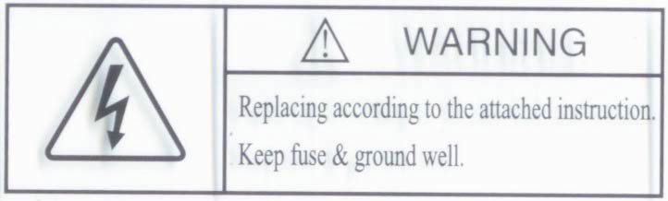
Meaning of WARNING:
Confirm the fuse and ground is well,when replacing according to the attached instruction.
If the equipment is used in a manner not specified by this user manual, the protection provided by the equipment may be impaired.

Meaning of crossed –out wheeled dustbin:
Do not dispose of electrical appliances as unsorted municipal waste, use separate collection facilities.
Contact you local government for information regarding the collection systems available.
If electrical appliances are disposed of in landfills or dumps, hazardous substances can leak into the groundwater and get into the food chain, damaging your health and well-being.
When replacing old appliances with new ones, the retailer is legally obligated to take back your old appliance for disposals at least free of charge.
2.1.4 Placement of the Instrument
The instrument shall be placed on a stable worktable without an obvious vibration source nearby. If the instrument is placed against the wall, there must be a clearance of greater than 15cm to ensure the ventilation and cooling. It must be avoided to place the instrument under intensive and direct sunlight.

2.2 Connection and Wiring (refer to Fig.3)
After the preparation work mentioned above is completed, correctly connect the power line and control line. There are two power lines, one for main instrument and the one for printer. There is one control line, which controls the main instrument and printer. The connectors are of individualized structure. Therefore, in general, miss-matching will not happen.
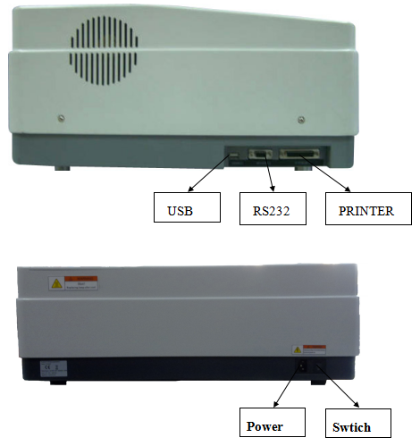
Fig. 3

Software Installation
Step one: Start the comouter,then goto the Windows.（If you have already bought the computer of our company,you may not input serial and install the software.）
Step two: Insert CD, right-click the “My Computer”,then goto “Windows Explorer”.
Step three: In the “Windows Explorer”,choose “CD(X:)”,”X”is NO. of the Drive.
Step four: Double-click the “Setup” in the “CD(X:)”.
Step five: According to the directions of the installation, turn operation until the installation consummation.
Operational environment of the Software:
1. Above “Windows98”
2. Environment of the hardware more than: CPU：PIII 667
RAM:64M
Graphics Memory:8M
Remaining space of hard disk : 10G
3.Resolution:1024 x 768

Software Operation

4.1 Enter the serial number
If you have purchased a computer directly from the manufacturer, you will not be required to enter the serial number and install the software. When you run the program for the first time after installation, you will be required to enter the password. The password is to be provided by the manufacturer. You may contact the manufacturer by email or by phone. When you call the manufacturer or send an email to service@phenixsi.com, please inform the manufacturer of the registration code shown on your screen. For example, the registration code shown in the figure blow is “-1394647803”, the manufacturer will provide you with the serial number which is generated based on the registration code. Enter the serial number and press “OK” to enter the initial state of the instrument. If the serial number which has been entered is incorrect, the program will automatically exit and fail be connected with the instrument. Please note that the serial number is case-sensitive. (See Appendix.1)
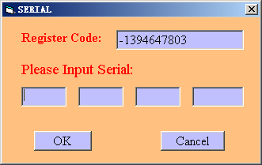

4.2 Work Online
To work online, just press the “Online” button. The program will prompt you to wait for 20 seconds, while the instrument is activating the deuterium lamp. After the deuterium lamp is lit, the instrument enters the initial state. If you press the “Offline” button, the main menu will be displayed, and, in this case, you can only work with certain data and cannot control the instrument. If the instrument has already been initialized and has not been powered off, you may select “Offline” to bypass initialization. See the figure below:
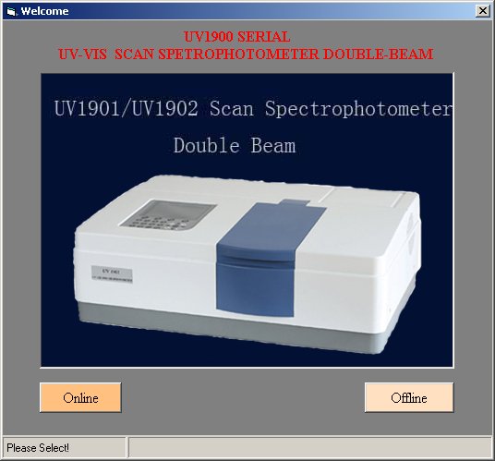

4.3 Initialization
Press “OK” to start initialization. There are seven steps to be completed. If any step fails during the process, the program will stay at the step without starting subsequent steps. If you press the “Exit” button, the program will automatically enter the main menu for offline operations. If the program does not react and initialization is not started after you have pressed “OK”, it indicates that the instrument cannot establish communication with the computer due to something wrong with the com port confirmation. Please change the serial port in the offline state, and restart the program to activate the online state. See 4.5.2 for information on how to change the serial port.
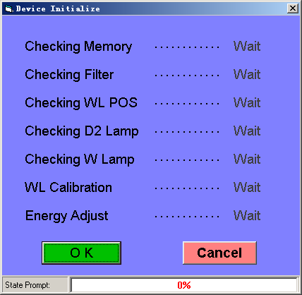

4.4 Main Menu
4.4.1 Work Mode
The work mode can be realized in two ways: 1) clicking on the menu, and 2) clicking on the toolbar.
The program will prompt you functions of the buttons, when you move the cursor to the tool bar, as shown in the figure below:
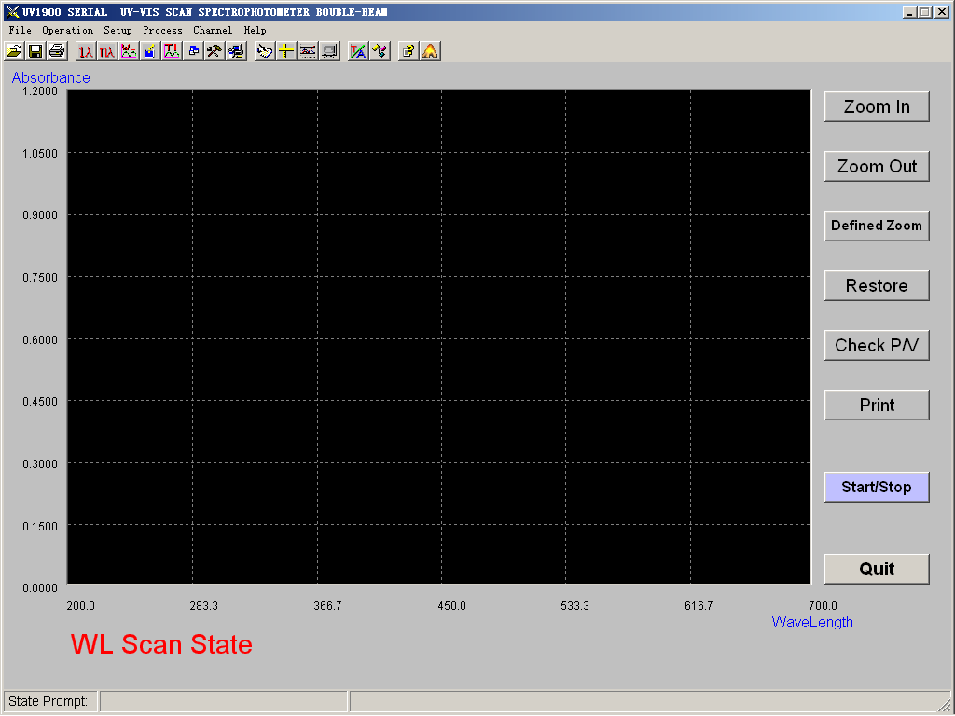
4.4.1.1 Single-point collection
The four modes are: T (transmissivity) / A (absorbance) / C (concentration), and E (energy). [T/A/C/E Switch] is used to switch among modes. In the C (concentration) mode, you can conduct simple concentration tests, i.e. C=K*ABS. To drive a wavelength, enter the value of wavelength in the field behind wavelength and press the “Enter” key for confirmation. The wavelength can be driven to the designated value by pressing the [Drive] button or the “Enter” key. To adjust the full range, just press [Full Range]. However, the full range is not adjustable in the C (concentration) mode. To read the concentration of the sample, set the slop factor in the C (concentration) mode, and press the “Enter” key. To print the data, press [Print]. (See Figure 4.1-1 and 4.1-2)
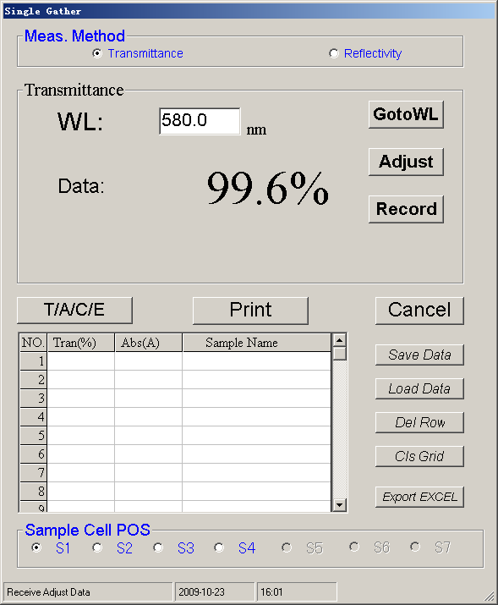
Figure 4.1-1
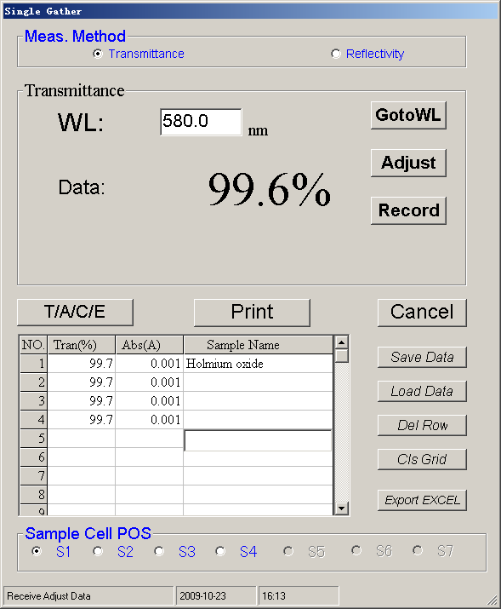
Figure 4.1-2
4.4.1.2 Multi-point collection
Up to 10 wavelengths can be tested, along with concentration testing. Click “Wavelength to Be Entered” in the wavelength area, enter the desired wavelength and press the “Enter” key to modify the wavelength. However, wavelengths must be entered consecutively without any blank in between the wavelengths; otherwise, subsequent wavelengths after any blank will not be tested. Other functions are the same as those of single-point collection. Adjust the full range for each wavelength, and testing samples and printing the data. (See Figure 4.1-3)
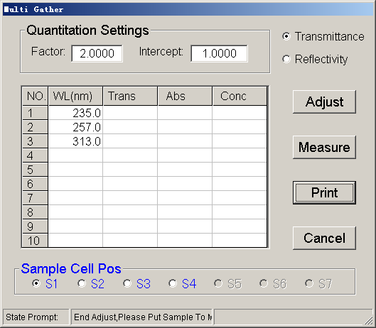
Figure 4.1-3
4.4.1.3 Wavelength scanning
Set related parameters first. Just modify parameters which are different from existing ones. After that, you can start wavelength scanning. (See Figure 4.1-4)
4.4.1.3.1 Set measurement mode
There are three modes available, i.e. absorbance, transmissivity and energy.
An additional sub-menu will appear for the energy mode for setting the multiplying factor from four options.
It is possible to view the energy at the full wavelength for different multiplying factors.
4.4.1.3.2 Set scanning interval
Set the minimum interval of sampling by the instrument. 5 options are available: 0.1nm, 0.5 nm, 1.0 nm, 2.0 nm and 5.0 nm. Full wavelength scanning is possible for each option in the PC program.
4.4.1.3.3 Set scanning speed
Fast, medium and slow. Speeds can be selected according to your needs.
4.4.1.3.4 Set spectrum display mode
Two modes are available, that is, Continuous and Overwrite. In the Continuous mode, the curve from the last scanning will be retained, and scanning continues from the existing screen. In the Overwrite mode: The curve from the last scanning is cleared, and a new curve will be plotted.
4.4.1.3.5 Set scanning wavelength
Click in the field behind “Start wavelength”. Enter the start wavelength there, and press the “Enter” key for confirmation. Then, the cursor automatically moves into the field behind “End wavelength”. Enter the end wavelength there, and press the “Enter” key for confirmation. Then, the cursor automatically moves into the field behind “Upper data limit”.
4.4.1.3.6 Set data range
Click in the field behind “Upper data limit”. Enter the desired value there, and press the “Enter” key for confirmation. Then, the cursor automatically moves into the field behind “Lower data limit”. Enter the desired wale there, and press the “Enter” key for confirmation.
4.4.1.3.7 Select baseline
Click on “Baseline calibration” to check the preceding box. This indicates that the baseline will be calibrated before scanning; otherwise, scanning will immediately start. (Figure 4.1-5)
After above parameters have been set, press the “OK” button to activate scanning. If baseline calibration is selected, baseline calibration will start first. After that, the program will prompt you to insert the sample, and then you can press the [START/STOP] key to start scanning. (See Figure 4.1-6 and 4.1-7)
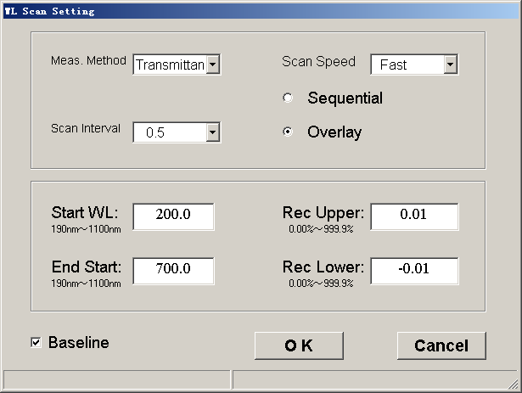
Figure 4.1-4
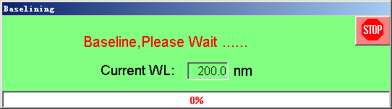
Figure 4.1-5
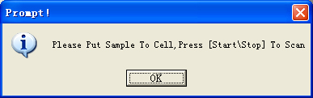
Figure 4.1-6
Figure 4.1-7

4.4.1.4 Quantitative analysis
This screen allows settings for application methods and curves. Application methods include single-, dual- and triple wavelength methods, and have options of measurement times and unit. Curve settings include K factor method, single-point calibration and multiple point calibration as well as measurement methods including input from measurement or keyboard. (See Figure 4.1-8)
4.4.1.4.1 Set wavelength method
Select the desired wavelength method from the pull-down menu. Enter the wavelength(s) corresponding to method λ1, λ2 or λ3 and press the “Enter” key for confirmation. Place the reference sample to set the full range, after the desired wavelength method is selected.
4.4.1.4.2 Set measurement times
Click in the field behind “Measurement times” and enter the desire value (up to 9) there. Press the “Enter” key for confirmation.
4.4.1.4.2 Set measurement unit
Click in the field behind “Measurement unit” and enter the unit of concentration there.
4.4.1.4.4 Set calibration method
Select the desired calibration method from the pull-down menu.
- K factor: Enter the slope factor and intercept in following respective fields. At this time, the measurement method is deactivated. And the standard curve will be established. (CONC=K*ABS+B)
- Single-point calibration: Two methods can be selected from for single-point calibration. One is direct input, and the other is input from measurement. By means of direct input, just click in the following fields for concentration and absorbance, and enter the corresponding values. By means of input from measurement, the absorbance can be obtained by measuring a standard sample, and a standard curve passing the origin can be obtained by entering the concentration of the standard sample. With (CONC=B_{CONC}/B_{ABS}*ABS), B represents the standard sample. Procedure: After the reference sample is inserted, adjust the full range of the wavelength. Click [Sample test] to enter the screen for measuring the absorbance of the standard sample. (See the figure below) Directly click [Test] to obtain the absorbance, after entering the sample test screen. After the absorbance is obtained, press [Exit] to leave the current screen and return to the screen for parameter setting. The field behind “absorbance” is automatically filled with the value obtained just now. Press [OK] to start measure the test sample. (See Figure 4.1-9)
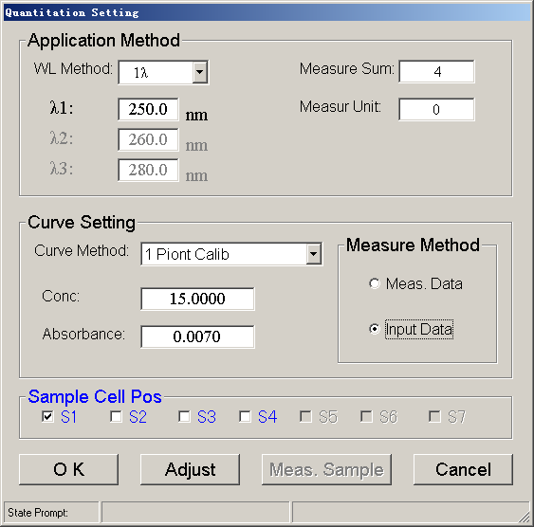
Figure 4.1-8
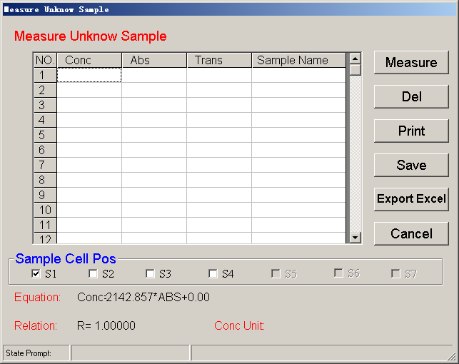
Figure 4.1-9
- Multi-point calibration: Two methods can be selected from for multi-point calibration. One is direct input; and the other is input from measurement. In the following example, the absorbance is obtained from measurement with 5 standard samples and establishment of a linear equation. Procedure: Step 1: set the number of standard samples, and the order of the equation to be established. Enter 5 and 1 respectively in the fields after “Standard samples” and “Equation order”. Step 2: Select “Measurement data” under “Measurement method”. Step 3: Insert the reference sample, and press the Zero key to adjust the full range at the wavelength. Step 4: Press “OK” to enter the process of equation establishment. After entering the screen for equation establishment, enter the concentration of the standard samples. At this time, it is possible to modify the number of standard samples by entering the concentration of the actual samples. After the concentration is entered, insert the standard samples one by one, and click [Read standard sample value]. The absorbance of all standard samples is read. After several rounds of averaging, the absorbance corresponding to the concentration is automatically filled. Press [Establish equation] to establish the equation, and you can view the equation factors, related factors and the equation curve. (See Figures 4.1-10, 4.1-11, 4.1-12 and 4.1-13) Directly click [Test unknown example] to test the unknown samples.
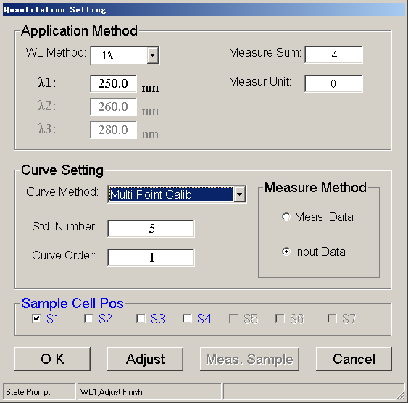
Figure 4.1-10
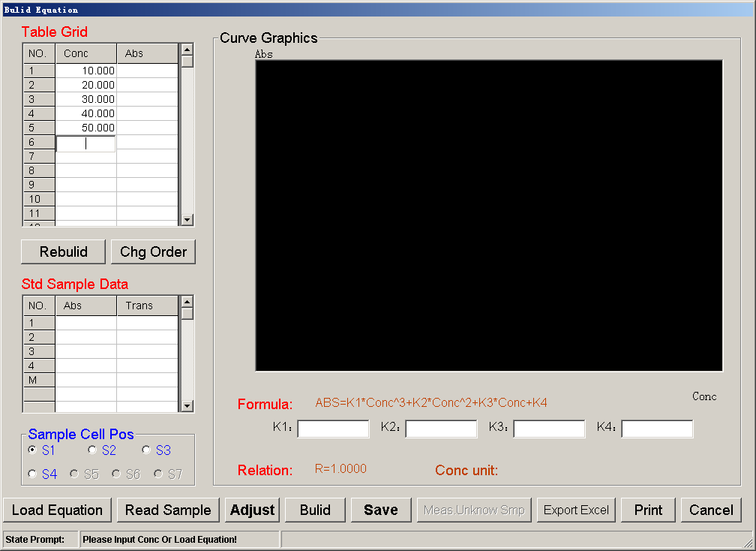
Figure 4.1-11
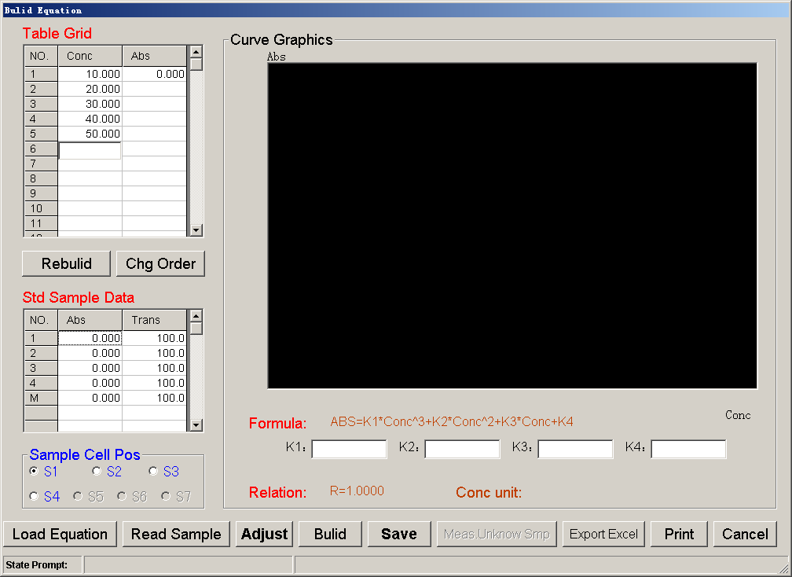
Figure 4.1-12
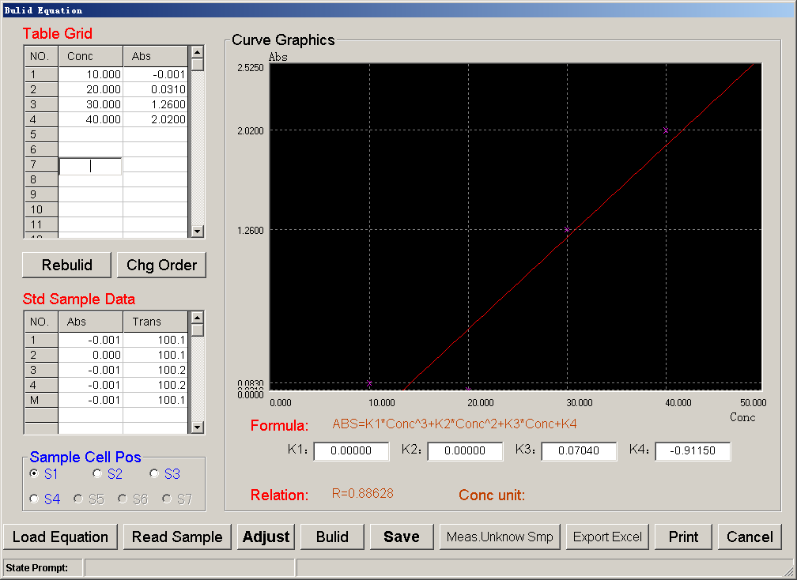
Figure 4.1-13
Step 5: It is possible to modify the standard curve with three options, add, edit and delete. For example, to add a group of samples prior to the third group, right click the mouse on the concentration corresponding to ground under 3. Double right click the mouse to call a pop-up menu which provides the three options. Select “Add” from the options. The program automatically moves down by one line, and the third line now becomes blank and requires input of the concentration and absorbance (You can directly enter the absorbance, if the “Data input” has been selected in parameter setting for qualitative analysis. If “Measurement data” has been selected, the absorbance can be obtained by pressing [Read standard sample value] after having inserted the sample of the current concentration. It is recommended to adjust the full range before standard samples are inserted.) After that, press [Establish equation]. The edition and deletion procedures are similar to that of addition. (See Figures 4.1-14, 4.1-15, 4.1-16, 4.1-17, 4.1-18 and 4.1-19)
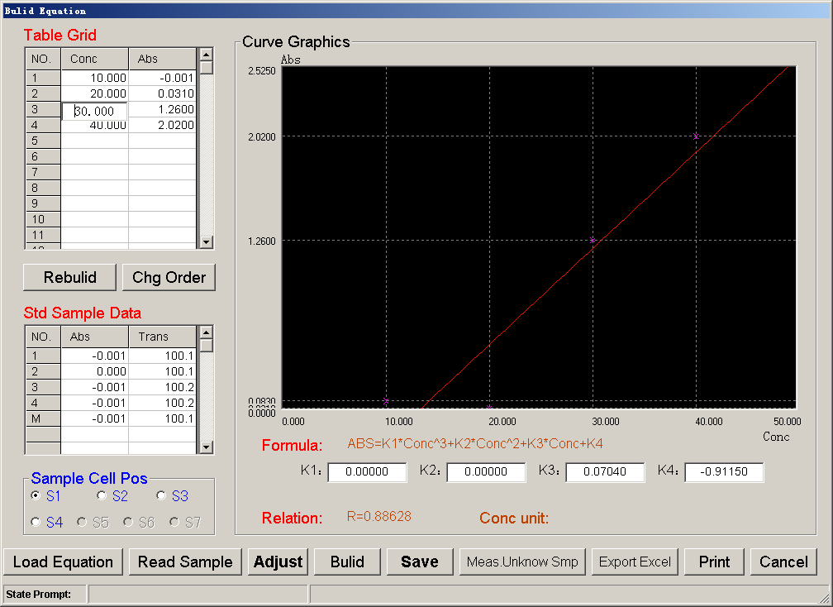
Figure 4.1-14
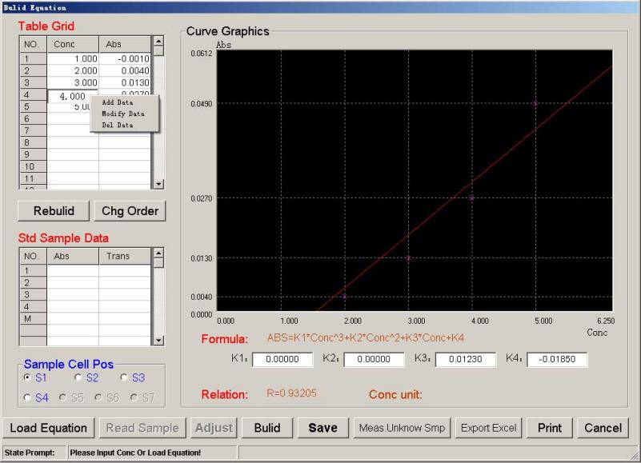
Figure 4.1-15
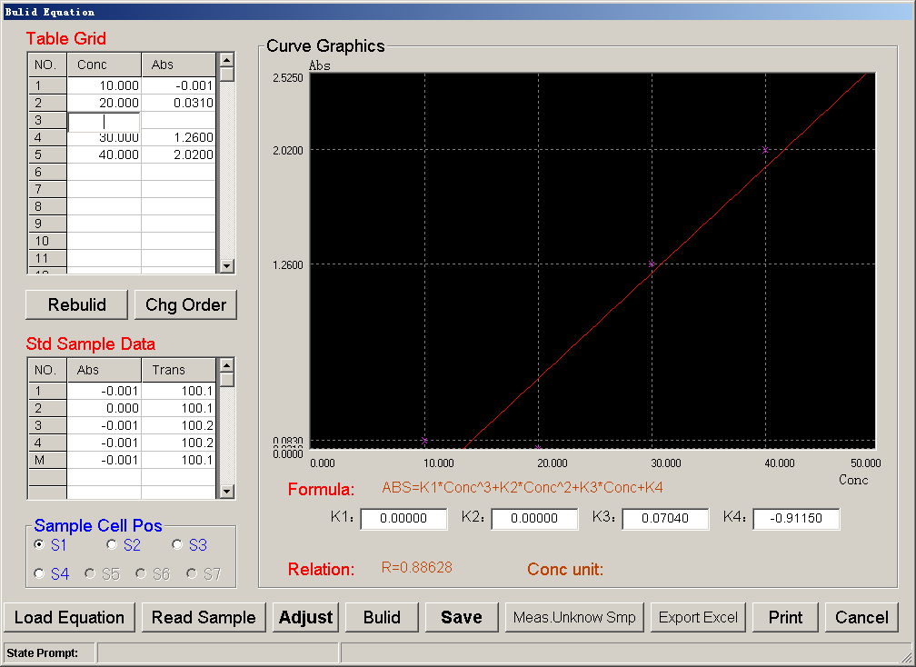
Figure 4.1-16
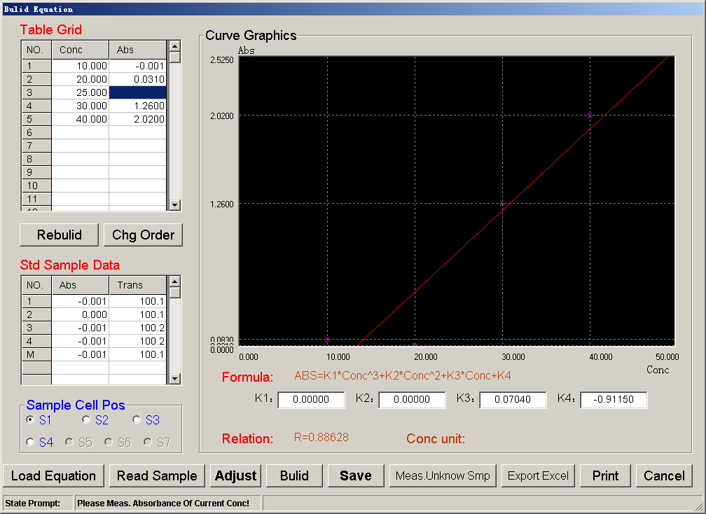
Figure 4.1-17
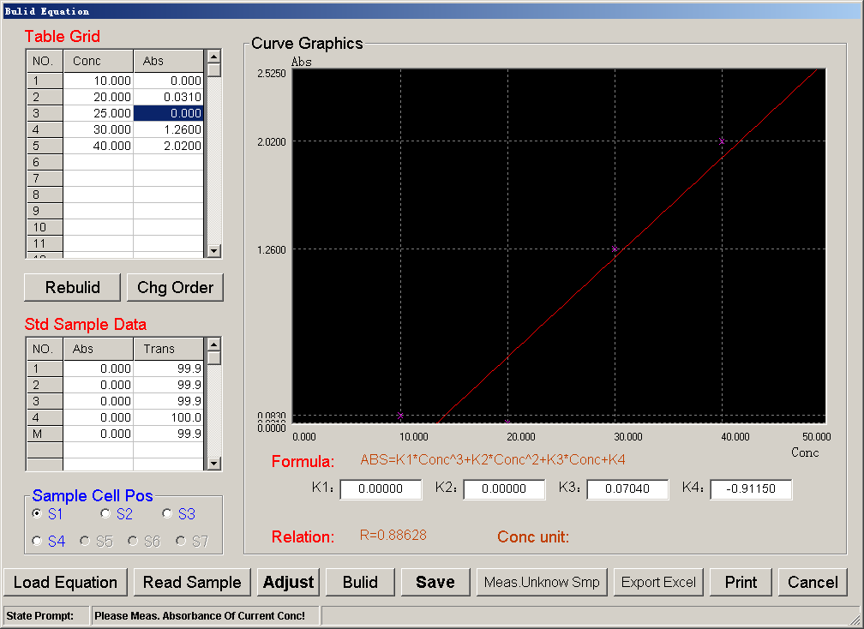
Figure 4.1-18
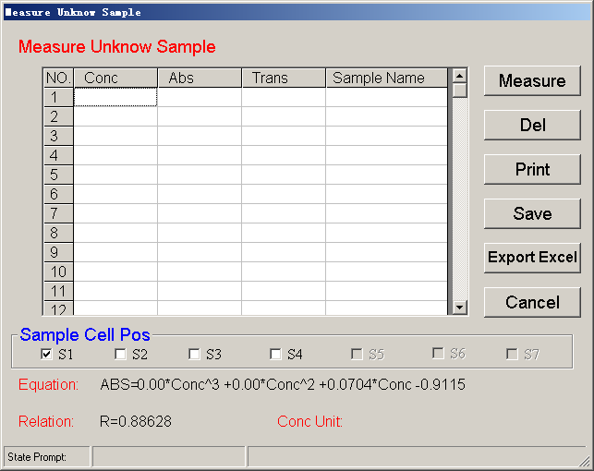
Figure 4.1-19
4.4.1.5 Dynamic analysis
Set related parameters first. Just modify parameters which are different from existing ones. After that, you can start time scanning.
In the following example, air is the sample; the wavelength is 500.0 nm; the recording internal is 0.1 S; the recording time is 3600 S; the upper record limit is 0.0 1ABS; the lower record limit is -0.01 ABS. (See Figure 4.1-20)
4.4.1.5.1 Set measurement modes
Two modes are available, i.e. absorbance, and transmissivity. Click on the pull-down menu and select “Absorbance”.
4.4.1.5.2 Set wavelength
Click in the field behind “Current wavelength” and enter 500.0 there. Press the “Enter” key for confirmation.
4.4.1.5.3 Set recording interval
Click in the field behind “Recording interval” and enter 0.1 there. Press the “Enter” key for confirmation.
4.4.1.5.4 Set recording time
Click in the field behind “Recording time” and enter 3600 there. Press the “Enter” key for confirmation.
4.4.1.5.5 Set upper record limit
Click in the field behind “Upper record limit” and enter 0.01 there. Press the “Enter” key for confirmation.
4.4.1.5.6 Set lower record limit
Click in the field behind “Lower record limit” and enter -0.01 there. Press the “Enter” key for confirmation.
4.4.1.5.7 Select full range
Click on “Full range” to check the preceding box. This indicates that the full range will be adjusted before time scanning; otherwise time scanning will immediately start.
After above parameters have been set, press the “OK” button. The instrument automatically reaches the designated wavelength. After that, the user is prompted to insert samples. Press [OK] key to start time scanning for air. (See Figures 4.1-20, 4.1-21 and 4.1-22)
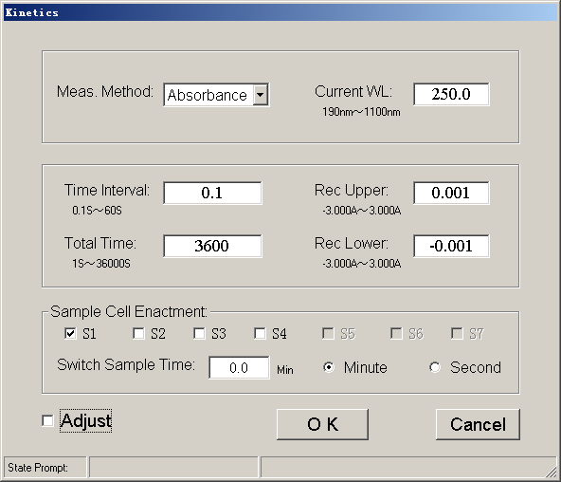
Figure 4.1-20
Figure 4.1-21
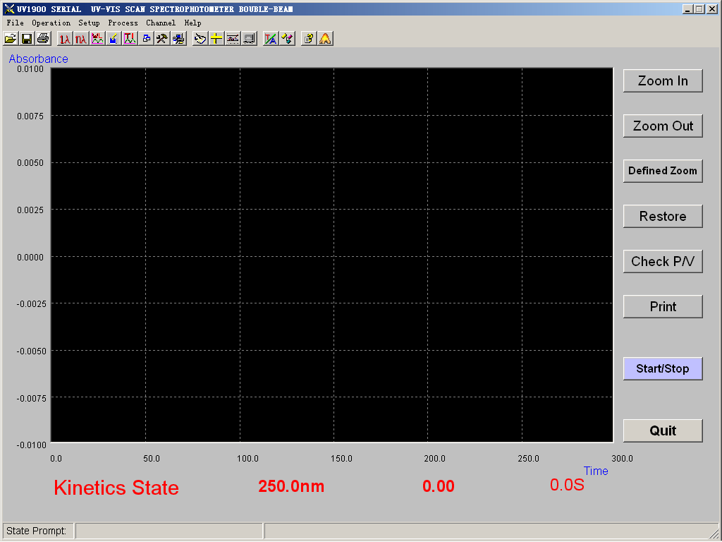
Figure 4.1-22
4.4.1.6 Data analysis
For individual curves, available functions include derivative operation, smoothing operation, peak and valley, multi-point collection, etc. For any two curves, it is possible to execute functions include addition, subtraction, multiplication and division. Details are given below:
4.4.1.6.1 Load curve: Press the [Load curve 1] button and select the desired curve. Click the [Load curve 2] button and select the desired curve. (See Figures 4.1-23, 4.1-24, 4.1-25 and 4.1-26)
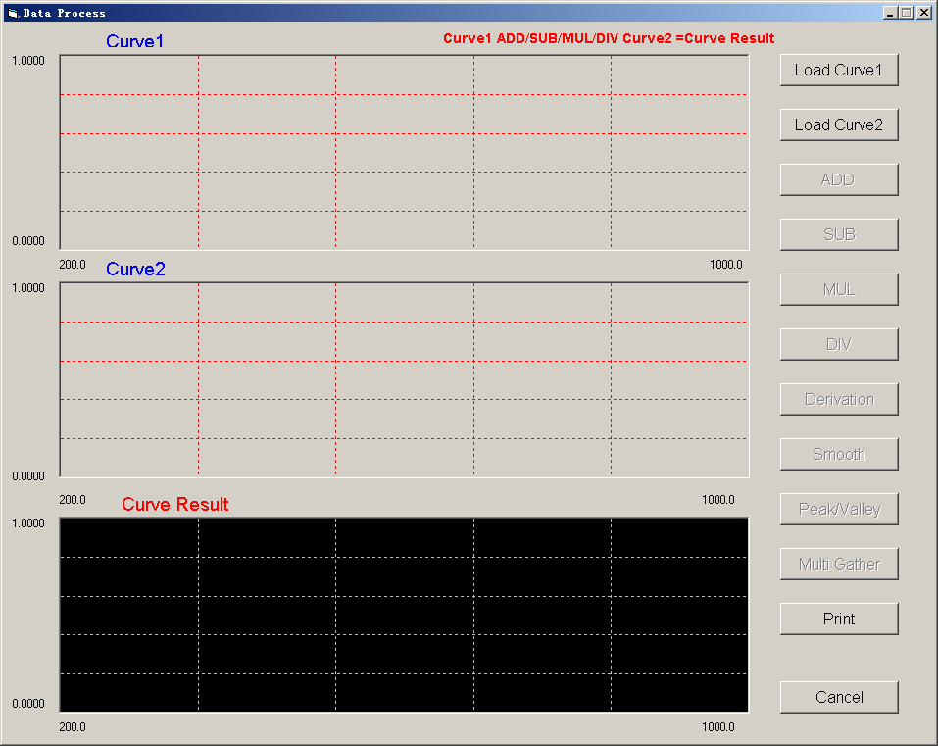
Figure 4.1-23
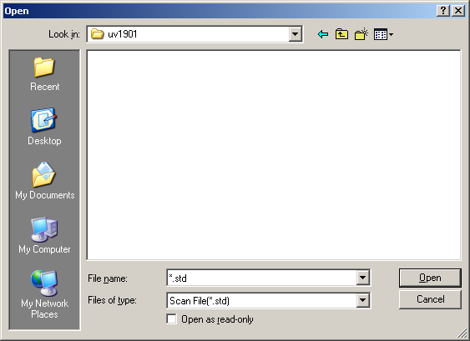
Figure 4.1-24
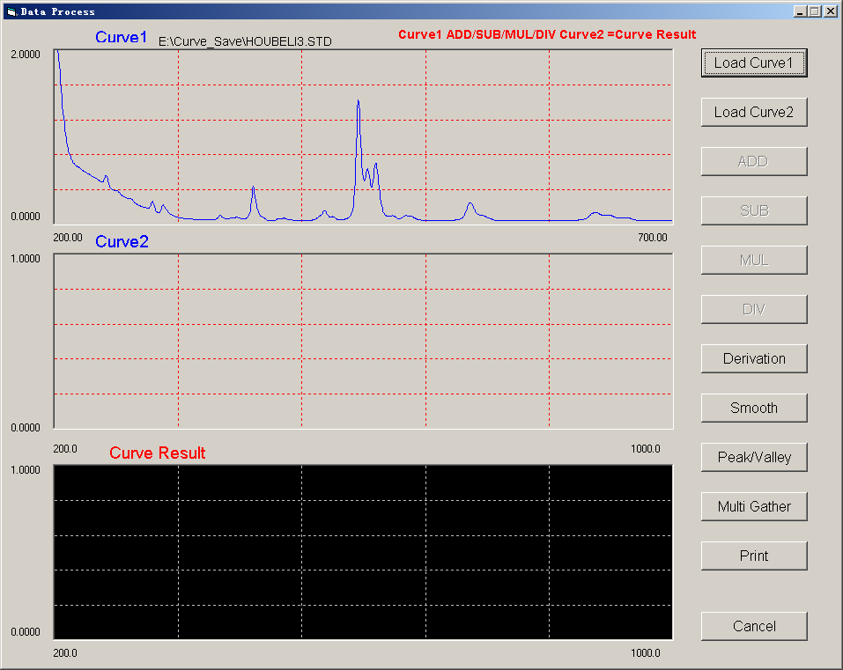
Figure 4.1-25
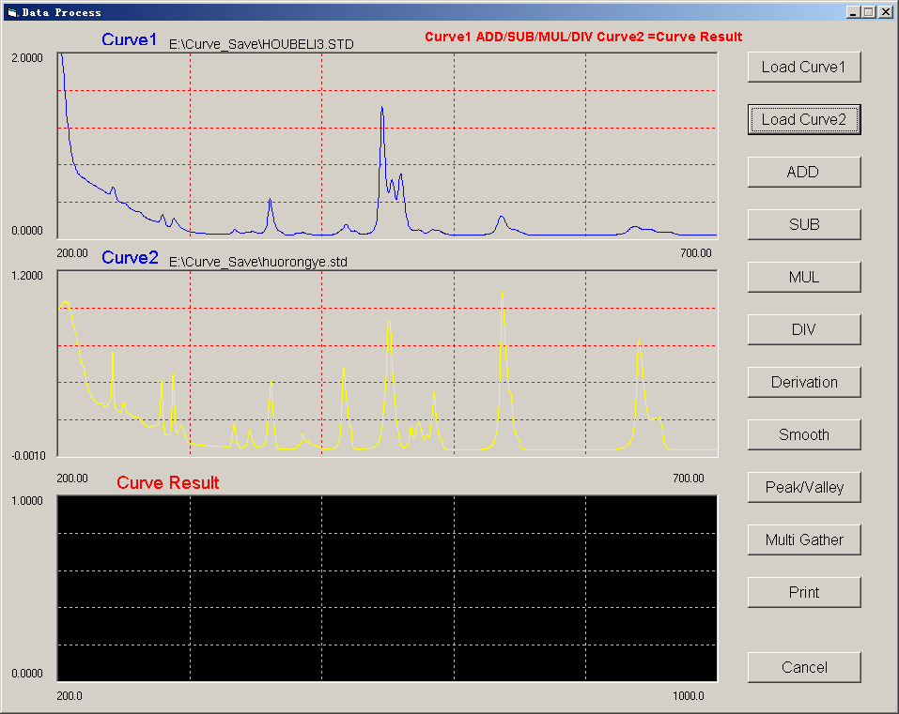
Figure 4.1-26
4.4.1.6.2 Operations with individual curves
- Derivative operation: Press the [Derivative operation] button to enter the screen for setting derivative parameters. Click in the field behind “Current wavelength” and enter 1 there. Press the “Enter” key for confirmation. Now click on “Curve 2”. Press the “OK” button to accept the derivative parameters. Curve operations will inform you which curve is used and which operation is conducted. (See Figure 4.1-27 and 4.1-28)
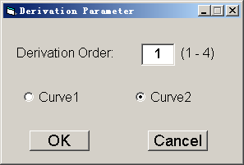
Figure 4.1-27
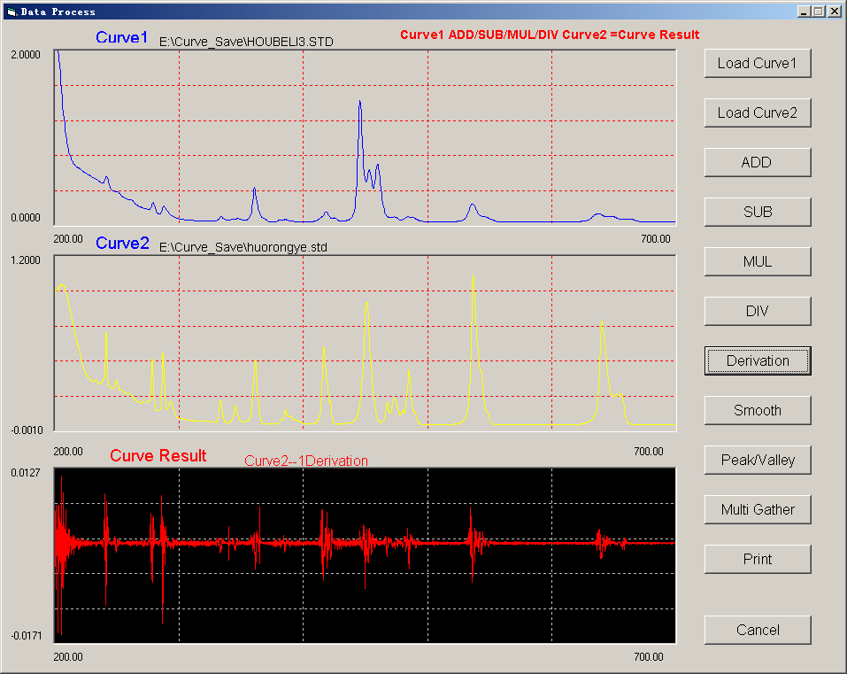
Figure 4.1-28
- Smoothing operation: Press the [Smoothing operation] button to enter the screen for setting smoothing parameters. Enter 10 in the field behind “Smoothing times” and press the “Enter” key for confirmation. Now click on “Curve 2”. (See Figure 4.1-29 and 4.1-30)
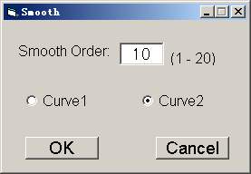
Figure 4.1-29
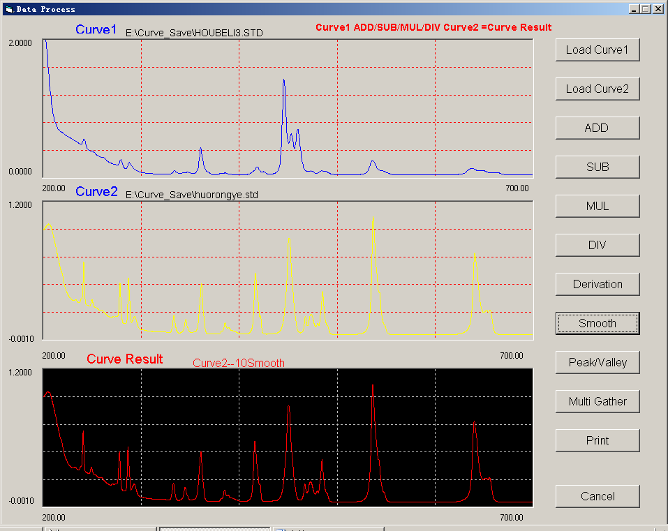
Figure 4.1-30
- Peak and valley: Press the [Peak and valley] button to enter the screen for peak and valley detection of data processing. The functions are largely similar to those of wavelength scanning. However, “Curve 1”, “Curve 2” and “Curve operation result” may be selected at any time, and peaks and valleys are listed here. (See Figure 4.1-31)
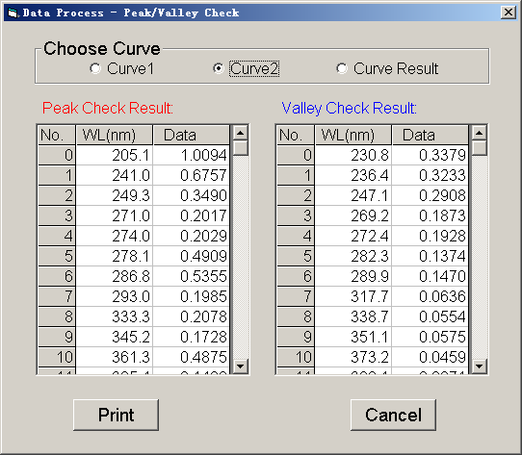
Figure 4.1-31
- Multi-point collection: Press the [Multi-point collection] button to enter the screen for curve data collection. Two options are available for this function: direct wavelength input and wavelength interval input.
- Direct wavelength input: Select “Curve 2” under “Multi-wavelength setting 1”, and select “Wavelength input” under “Multi-wavelength setting 2”. Direct the wavelengths in the fields in the “Wavelength” column. The wavelengths should be within the start wavelength and the end wavelength of the curve. At least 2 wavelengths should be entered. Press the [collect] bottom to obtain data of corresponding wavelengths. (See Figure 4.1-31)
- Wavelength interval input: Select “Curve 2” under “Multi-wavelength setting 1”, and select “Wavelength interval” under “Multi-wavelength setting 2”. Enter values of “Number of wavelengths”, “Start wavelength” and “Wavelength interval” under “Multi-wavelength setting 3”. For example, the number of wavelengths is 200; the start wavelength is 200.0 nm and wavelength interval is 1 nm. (See Figures 4.1-32 and 4.1-32)
4-22
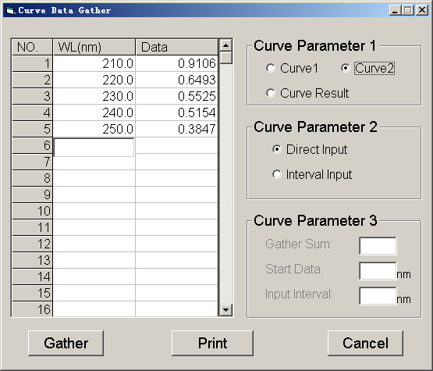
Figure 4.1-32
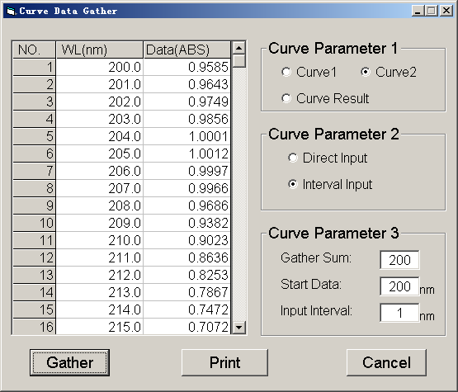
Figure 4.1-33
4.4.1.6.3 Two curve operation
It is possible to execute functions include addition, subtraction, multiplication and division.
  - Addition: Load two curves and click [Addition]. (See Figure 4.1-34)
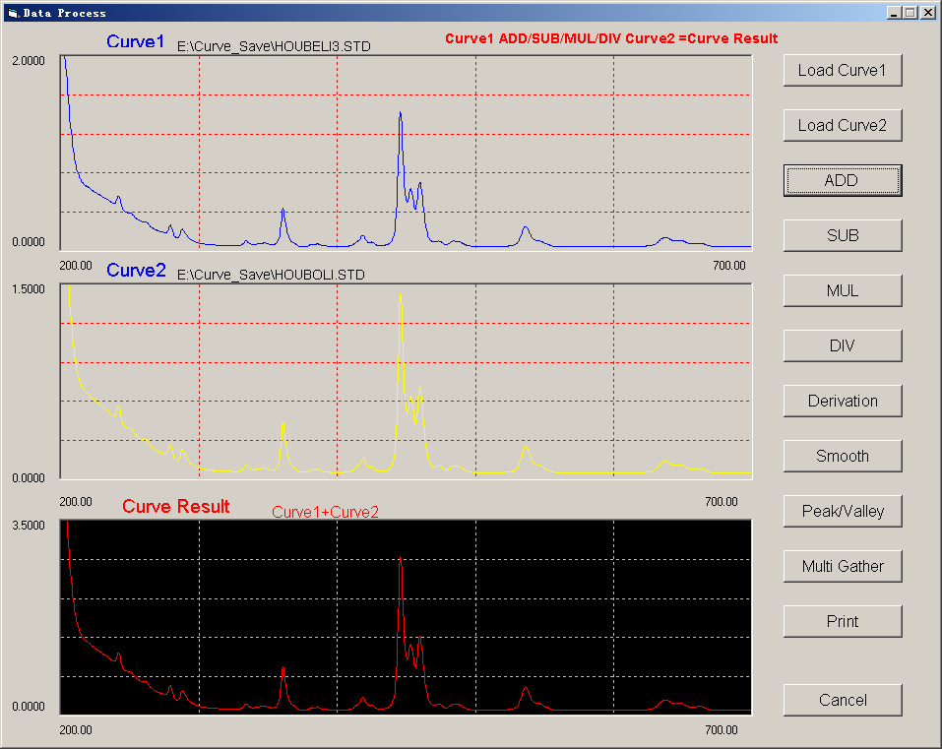
Figure 4.1-34
- Subtraction: Load two curves and click [Subtraction]. (See Figure 4.1-35)
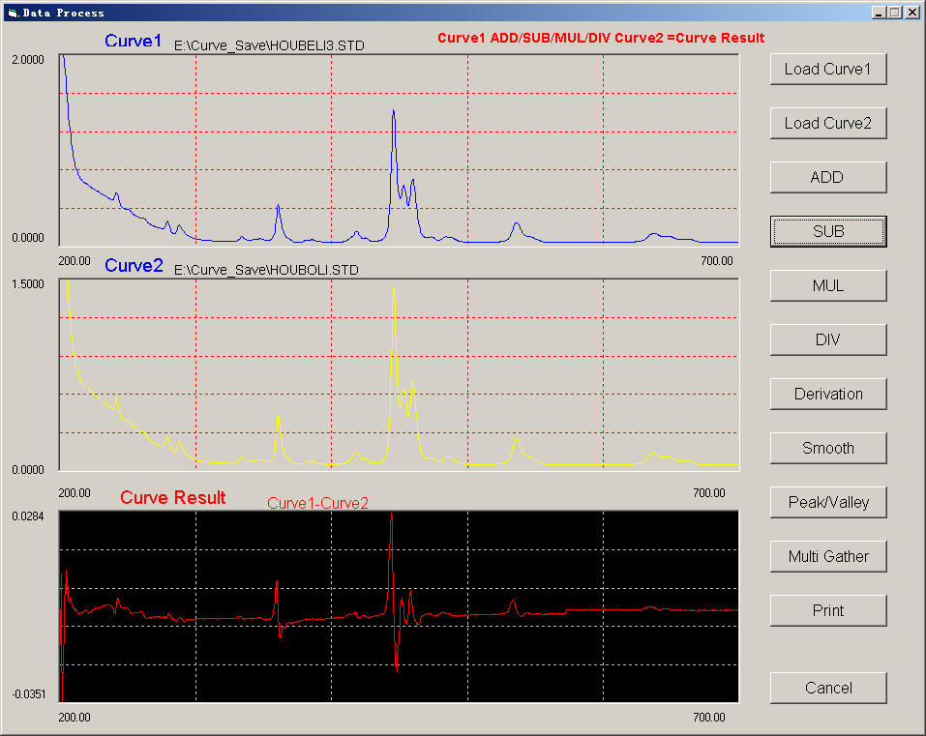
Figure 4.1-35
- Multiplication: Load two curves and click [Multiplication]. (See Figure 4.1-36)
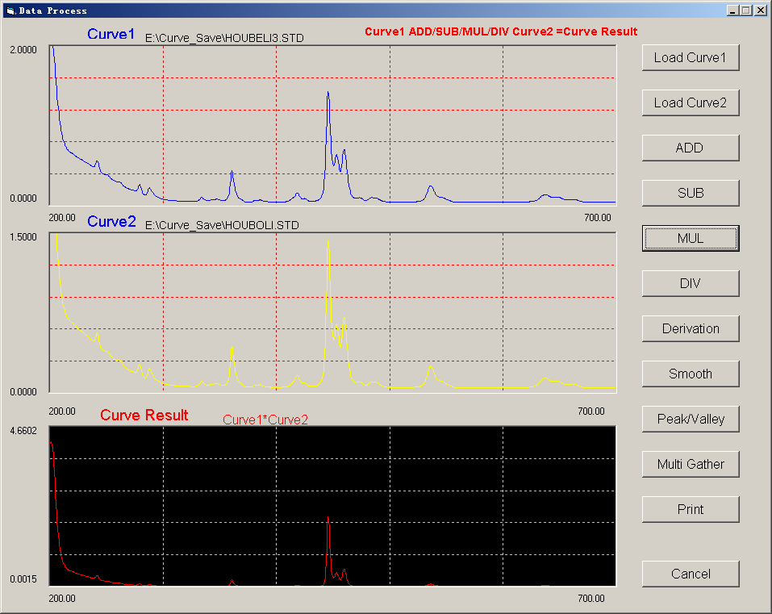
Figure 4.1-36
- Division: Load two curves and click [Division]. (See Figure 4.1-37)
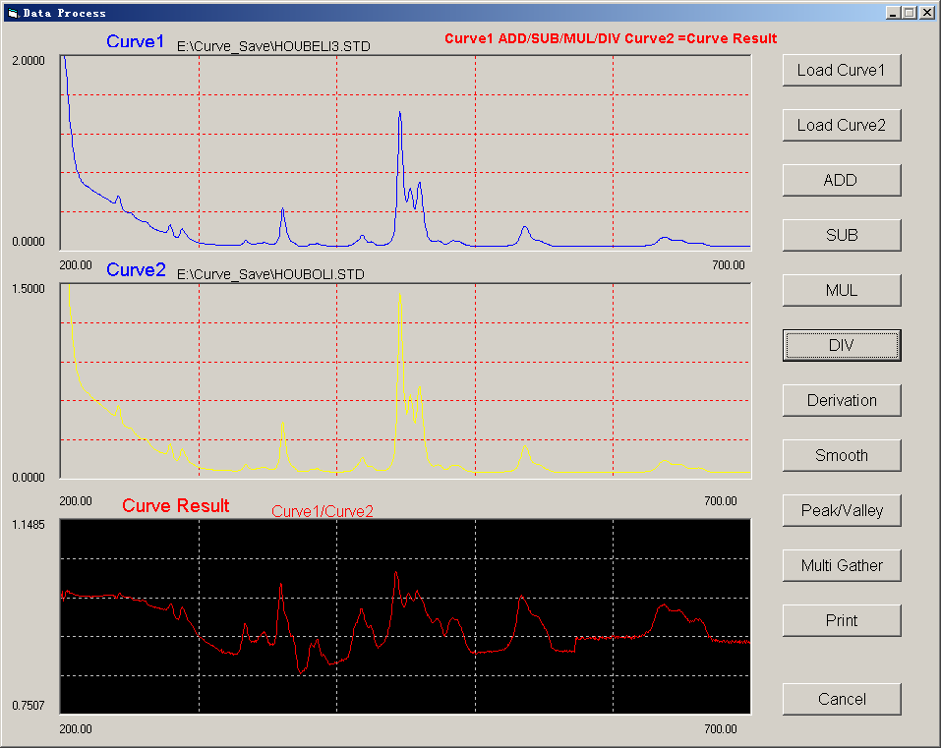
Figure 4.1-37
4.4.1.7 System function setting
Settings are provided for five functions, i.e. deuterium lamp control, tungsten lamp control, sample reference switch, ultraviolet/visible switch wavelength, and wavelength correction. It is recommended to set all necessary parameters before pressing the “OK” button. (See Figure 4.1-38)

4.4.1.7.1 Deuterium lamp control
Click up “On” or “Off”, and “OK” to control the deuterium lamp.
4.4.1.7.2 Tungsten lamp control
Click up “On” or “Off”, and “OK” to control the tungsten lamp.
4.4.1.7.3 Sample reference switch
Click up “Standard” or “Non-standard”, and “OK” to switch between standard or non-standard samples.
4.4.1.7.4 Ultraviolet/visible switch wavelength
Click in the field under “Ultraviolet/visible switch wavelength” and enter 340.0. This means that wavelengths less than 340.0 nm belong to the ultraviolet zone, and those larger than 340.0 nm belongs to the visible zone.
4.4.1.7.5 Wavelength correction control
Click in the field under “Wavelength correction” and enter 0.0.
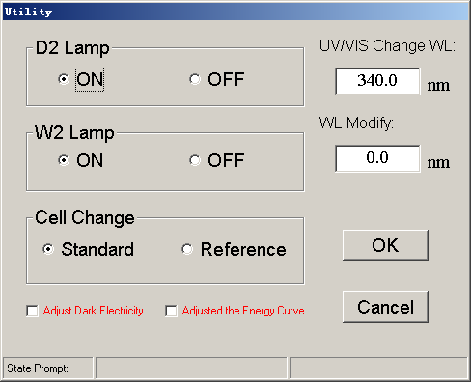
Figure 4.1-38

4.5 Settings
Settings are provided for five functions: spectrum attributes, serial port setting, zoom, peak and valley detection height, and data conversion. (See Figure 4.5-1)
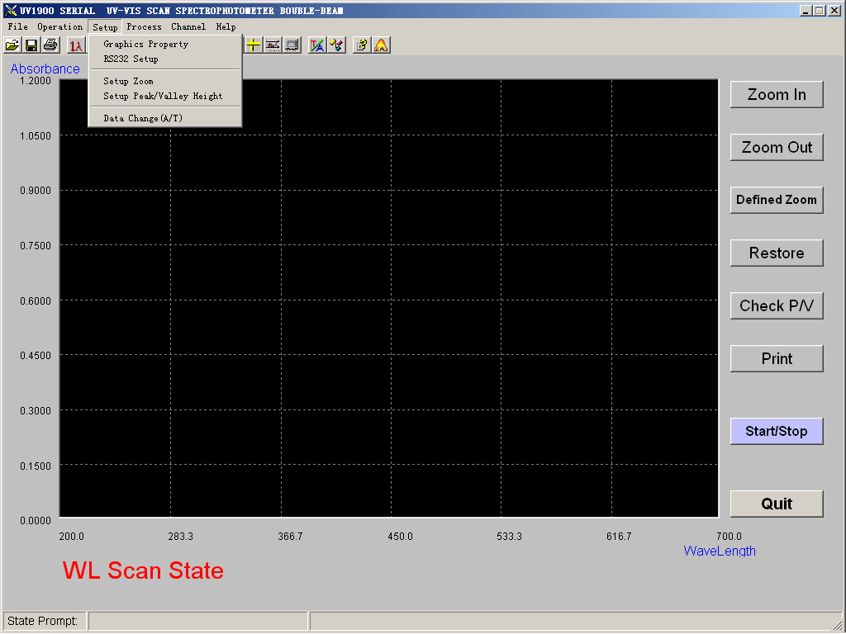
Figure 4.5-1
4.5.1 Spectrum attributes
Click “Settings” on the menu bar and select “Spectrum attributes” from the menu, to enter the screen of spectrum attributes. Designate the number of data entries to be shown in the fields after “Y axis” and “X axis” These values decide how many data entries are given under the Y axis.
Press “OK” after the numbers have been filled. Now you can work with the graph in the main menu. (See Figure 4.5-2)
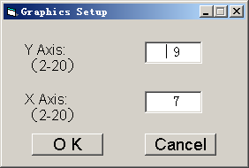
Figure 4.5-2
4.5.2 Serial port setting
The settings decide whether the serial port cable is connected to COM1 or COM2 of the instrument which is working online. Here, you select the COM port based on the actual connection. Select the COM port from the pull-down menu under “Communication port”, and the baud rate from the pull-down menu under “Baud rate” (9600 is recommended). Press “OK” for confirmation. If you have changed the serial port, restart the program for it to establish communication with the instrument; since it lose communication with the instrument in the current state. (See Figure 4.5-3)
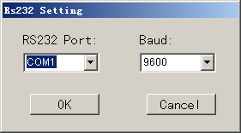
Figure 4.5-4
4.5.3 Zoom percentages
The percentages decide the scale to the current record range when the graph is zoomed in/out. Enter values in the fields for X axis and Y axis, and click “OK”. (See Figure 4.5-5)
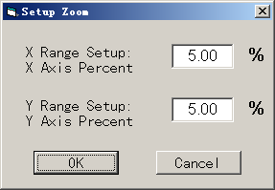
Figure 4.5-5
4.5.4 Peak and valley heights
Set the corresponding data for peak and valley detection to control the peak and valley heights. If large values are set, only high peaks and valleys will be detected. (See Figure 4.5-6)
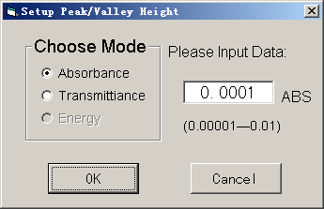
Figure 4.5-6
4.5.5 Data conversion
Wavelength scanning spectrums and time scanning spectrums can be switched between absorbance and transmissivity.

Failures Analysis And Trouble-Shooting

5.1 Instrument Maintenance
For any instrument, the correction use is the best maintenance. To maintain an instrument, emphasis shall be put into the use environment and movement. Cares shall be given to above-mentioned requirements as well as the following issues:
- To keep clean the environment and cover the instrument with a cloth to prevent dust deposit. If the instrument will be put idle for a long time, it shall be placed in a dry room with a constant temperature.
- Be careful when you put the sample in the cell. Do not split the solution in the sample chamber to prevent erosion. As for some volatile samples, it is suggested to use a cover on the cell so as to prevent the volatile gas from interfering the light thus to affect the test accuracy of the instrument.
- When you switch on the instrument, you must turn on both the tungsten and deuterium lamps. After the wavelength is calibrated, turn off the lamp not in use to prolong the life of the lamp.
- Screws and nuts in the optical path must not be loosened except those in the light source chamber to prevent the drift of optical path from affecting normal work of the instrument.
- All mirror surfaces must not be touched by hand or other soft or hard matters. Once a stain is left it will pollute the mirror and cause severe stray light, reduce effective energy and damage the instrument to an extreme end.
- The instrument must be handle with care during movement. No heavy matters shall be placed on the housing of the instrument, otherwise it will bend the optical path to affect the stability and accuracy.
- Instrument can not work under intensive light so as to ensure the accuracy of measurement.
- Instrument shall not be put idle for a long time, for it will affect the usable life of the instrument. If it is the case, switch on the instrument once or twice for half an hour a week.
5.1.1 Inspection of Quartz Lens in the Sample Chamber
Inspect regularly the quartz lens in the center from left of sample chamber (L1 and L2 in the Fig. Of Light Path) to see if there is a fingerprint or other stain. If there is a heavy stain, it will surely affect the accuracy of test value.
Once a stain is found, wipe it with a clean cloth dipped with alcohol.
Inspection Interval: Once a month.
5.1.2 Inspection of Wavelength Accuracy
Use 656.1nm of spectrum line of deuterium lamp to check the wavelength accuracy.
Inspection Methods:
- Chose [System Status Setup] in the main menu. In the [System Status Setup] of the menu, place the lamp source switching wavelength at the 700nm and press Key [MODE] to return to the main menu.
- Chose [Spectrum Measurement] in the main menu. In the measurement modes of Menu of [Spectrum Measurement], chose [E] scan mode with a scan range of 654.1-658.1 to conduct a slow scan, with a sampling interval of 0.1nm The difference between the wavelength corresponding to the maximum energy value and standard wavelength is the accuracy of wavelength.
Inspection Interval: once or twice a year

5.2 Failure Analysis
When it fails, the instrument is able to make a preliminary judgement of the nature of a failure. Normally, there are many kinds of failures, such as internal or external failures, failures due to the usable life or an accident. Failures can or can not be shot by users. The distinction of the above will be very helpful to the use and maintenance of the instrument. Even if user can not solve the problem, the information about the failure provided to the repairman will be useful to the in-time shot of the troubles. Generally speaking, if users are not sure of their maintenance capability, it is better to ask special maintenance persons to fix it up. Examples of common failures are analyzed as follows.
5.2.1 Instrument Does Not Work (No way to switch on)
Phenomenon | Cause | Remedy
1. switch on and screen does not light. | a. No power in the power socket.  b. Power line of the instrument does not connect properly.  c. Fuse at the input end of power supply is broken.  d. Power switch is broken.  e. Poor connection of cable plug.  f. Power printed circuit board is broken.  g. CPU printed circuit board is broken.  h. Screen is broken | - check the external power supply of 110-220V  - re-insert firmly the power of the instrument.  - change a new fuse of 3A  - change the power switch.  e. re-insert firmly cable plug.  f. repair or change  g. repair or change.  h. repair or change.
5.2.1 Deuterium Lamp Works Improperly
Phenomenon | Cause | Remedy
The lamp does not light, with beating sound of relay. | a. poor connection of lamp socket.  b. lamp is broken  c. lamp electric circuit system fails. | a. re-insert firmly.  b. change a new lamp  c. repair
The lamp does not light, without beating sound of relay. | Lamp electric circuit system fails. | Repair
Then lamp lights. | a. matters in sample chamber are blocking the light.  - Lamp reaches its end of usable life.  - The most intensive light energy does not go into the slit. | - remove this matter.  - Change a new lamp  - Step lose of motor for light source switching.
The lamp does not light. | The time of switching off the instrument and switching on the instrument is too short. | The time of switching off the instrument and switching on the instrument must over 2MIN
5.2.3 Tungsten Lamp Works Improperly
Phenomenon | Cause | Remedy
The lamp does not light, with 10.6V DC | a. poor connection of lamp socket.  b. lamp is broken | a. re-insert firmly.  b. change a new lamp
The lamp does not light, without 10.6V DC | Lamp electric circuit system fails. | Repair
Then lamp lights. | a. Lamp reaches its end of usable life.  b. Not all the light energy of the lamp go into the slit.  c. Matters in sample chamber are blocking the light. | a. Change a new lamp/  b. adjust the fixing screw of the mirror of light source.  c. remove this matter.
5.2.4 Wavelength Self-calibration Goes Wrong
Phenomenon | Cause | Remedy
The deuterium lamp does not light. | a. poor connection of lamp socket.  b. lamp is broken  c.lamp electric circuit system fails. | a. re-insert firmly.  b. change a new lamp  c. repair
The deuterium lamp lights. | a. The deuterium light energy does not go into the slit.  b. Matters in sample chamber are blocking the light.  c.Lamp reaches its end of usable life.  - Pre-amplifier is broken. | - Adjust the angle of light source mirror.  b. remove this matter.  c. change a new lamp  d. Repair.
5.2.5 Energy is Low
When the instrument is switched on for the first time, you may find its energy is too low. It is possibly due to the UV absorption by harmful gas produced in the instrument after the instrument being packed or stored for a long time. If it is the case, please open the sample chamber and leave the instrument for one or two days, it will work properly.
Thank you for your cooperation.
Phenomenon | Cause | Remedy
Both light source lamps light | a. Filter loses some steps.  b. Pre-amplifier is broken.  c. Light source switching mirror not in the right position  d. Light is blocked in sample chamber (cell holder not positioned correctly). | a. switch off the instrument, and 10 minutes later, re-switch on  b. repair  c. Adjust mirror fixing screw and make the screw tight.  d. Pick out matter blocking the light or to pull cell holder to make it in the right position.
In the UV Spectrum | Choose the wrong cell. | Use quartz cell
Light source lamp does not light. | Lamp is broken, no energy. | Change new light source lamp.
5.2.6 No Print of Altas or Data
Phenomenon | Cause | Remedy
Screen is OK | a. No connection to power of printer.  - Connection cable of instrument to printer is broken.  c. Instrument print output system fails.  d. Printer fails. | a. switch on the power of printer.  b.Re-make a connection to the cable plug.  - Repair  - Repair
Printer works properly but no prints or very light prints on the paper. | Ink-jet head is broken  (no ink) | change another ink-jet head of the same specification.
5.2.7 Digits on the Instrument Screen Beating and Unstable
Phenomenon | Cause | Remedy
Digits drift toward increase or decrease continually. | a. Instrument warm up not long enough (normally it will take 30min).  b. Instrument internal is wet due to the ambient effect. | - Increase warm up time.  reduce ambient humidity.  b. Increase warm up time.
Digit beats and unstable | a. poor grounded of instrument  b. Instrument is wet.  c. Light source lamp reaches to life end.  d. Working room’s temperature is too high  e. Unstable power  f .Optical path deviation.  g. Pre- amplifier fails. | a. check and keep good grounding.  b. Improve working conditions  c. Change new light source lamp.  d. Improve working condition  e. add an AC stabilizer.  f. Re-adjust light path.  g. Repair or change.
5.2.8 Big Error of Measuring Readings of Test Sample
Phenomenon | Cause | Remedy
Deviate from standard readings | - Big error of test sample matching.  b. poor cell match  c. cell’s pollution  d. Instrument is unstable  e. Fluctuation of solution test sample caused by time or temperature. | a. check test sample matching procedure and related tools.  b. calibrate matched cells or change new cells.  c. after being put in the cleaning solution, inside and outside of light passing surfaces of cells must be cleaned.  d. repair instrument  e. strictly follow test sample measurement procedures.

Failures And Change Of Light Source
Before change a lamp, cover of the instrument must be opened. How to open the cover is shown in the following figs.
- Move the back plate of the lamp chamber backward to access the connector of fan and power board, pull off the connector.
- Open the cover of sample chamber to access a back plate, take out the plate.
- There are two fixing screws at the lower part of both sides of the instrument, respectively. Take off these screws.
At that time, cover of the instrument is opened. The connector of screen, keyboard to main board shall be taken off if necessary.

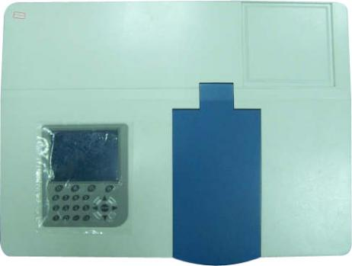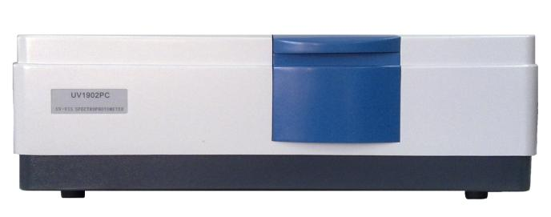

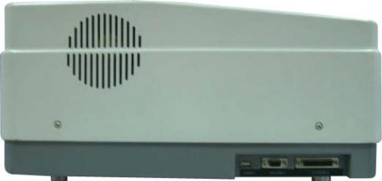

6.1 Failures and Change of Tungsten Lamp
Main tungsten failure is that the lamp does not light because of broken filament, resulting in failure to pass tungsten lamp self-test. User can adopt following method to inspect or change.
1. Use a DC voltmeter to measure two poles on the porcelain lamp socket. Under normal situation, there shall be10.5V or so. If no, check first printed circuit board. If fuse is broken, change it. If fuse is OK, the problem may be in circuit. If voltage is OK, the lamp is broken.
2. If the lamp is broken, please switch off the instrument. Open the cover of lamp chamber, pull out the metal plate to remove the lamp. Change a new tungsten lamp and insert metal plate as shown in the Fig.5. Switch on the instrument to ensure that the lamp lights. The structure is shown in the Fig.5.
Fig. 5

6.2 Failures and Change of Deuterium Lamp
Deuterium lamp is one of the heat-generating components in the instrument. Whether a deuterium lamp does not light or reaches its usable life end can be reflected by failure to pass its energy self test. It may be that the deuterium lamp is broken or lamp power supply circuit is broken. Users shall adopt the following method to inspect or change deuterium lamp.
1. First of all, it shall be sure that when instrument is performing self-diagnosis, there shall be no filter or cells in the sample chamber. Filter related motor does not lose steps.
2. Switch off the power of the instrument. After open the cover of light source lamp chamber, pull of three connectors at the socket, then Loosen the fixing screw with a screwdriver to take off the deuterium lamp.
3. Put on a new deuterium lamp in the socket and put the three connectors back to the socket according to original sequence. Tight the fixing screw with a screwdriver. Refer to Fig. 6 as follows.
Round hole

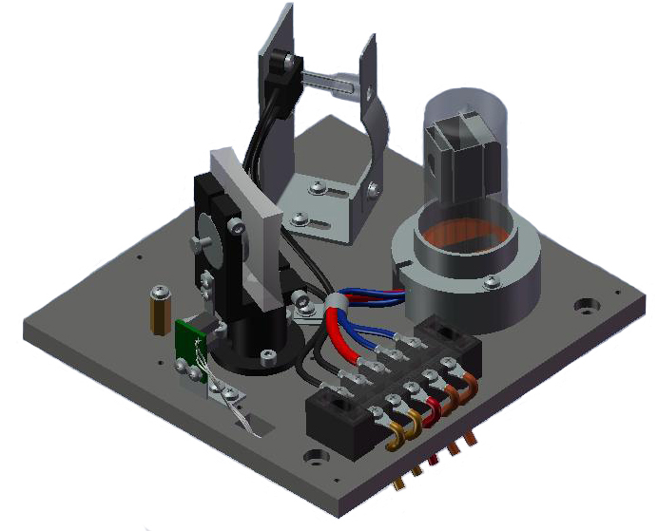
Link out red line

Link in red line
Switching mirror
Gap
Fig.6
Note:
a. The gap and the round hole must be in alignment with the Switching mirror.
b. The link-in red line must be link with the link-out red line.
6.3 Other remarks on the change of light source lamps
1. When you change the light source lamp, you must not touch the light window with hand. In case you touch it, fingerprints must be cleaned with anhydrous ether and dried using a hair dryer before turning on the light. Otherwise, a dirty spot will be left on the light source, which can never be cleaned.
2.Screws on the other parts must not be loosened unless it is in a special case.
Note:
Connector of fan to power board must be put back after the change of lamp.

Packing List
No. | Item | Qty
1 | spectrophotometer | 1
2 | 1cm cuvette (quartz) | 2
3 | 1cm cuvette (glass) | 4
4 | Power cable | 1
5 | User’s manual | 1
7 | Calibration Certificate | 1
9 | Dust cover | 1
10 | USB Flash disk | 1
11 | Cable for RS232C serial interface | 1
12 | USB2.0 Converter | 1

Appendix.1
HZ1902serial Operation Guide
HZ1902SERIAL is the uncode program.
HZ1902Setup is the operation program.
- Uncompress HZ1902SERIAL and HZ1902Setup program
- In HZ1902SERIAL uncompress directory , PRESS INSTALL.EXE program to install program.
- After installation finished, in Windows [Program], search PROJECT1 MENU and run PROJECT1. Eg. picture 1 :
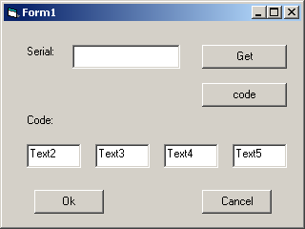
picture 1
- Press [get] to get serial, press [code] to get code.
- Record the four code.
- In HZ1902NEW1 uncompress directory , PRESS INSTALL.EXE program to install program.
- After installation finished, in Windows program, search uvcontrol MENU and run uvcontrol. Eg picture 2
picture 2
- Input the four code of recorded . and press [ok] to enter uvcontrol operation menu.
9. Switch on the machine . press anykey to online pc. [notice]
10. In uvcontrol operation menu,press [online ] key to ready to machine initialize.

