HZ2329
Thermogravimetric Analyzer

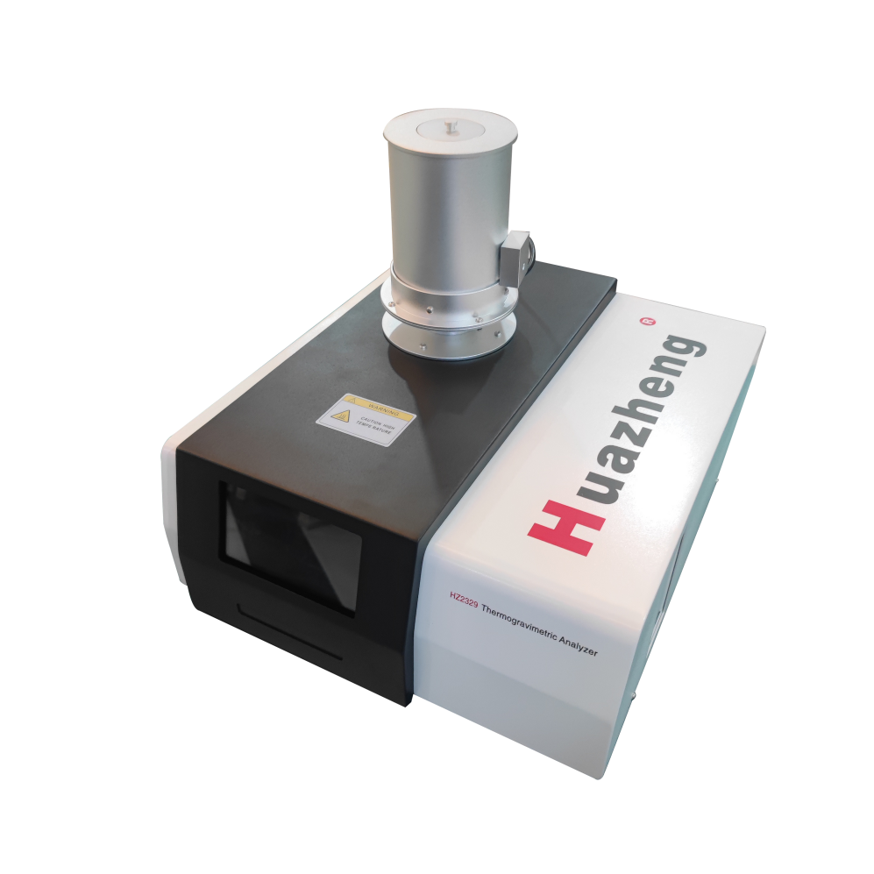

Huazheng Electric Manufacturing (Baoding) Co., Ltd

Dear user:
Thank you for choosingHZ2329 Thermogravimetric Analyzer.
We hope that this instrument can make your work easier and more enjoyable, so that you can get the feeling of office automation in the test and analysis work.
Before using the instrument, please read this manual, and operate and maintain the instrument according to the manual to prolong its service life.
"Just a light press, the test will be completed automatically" is the operating characteristics of this instrument.
If you are satisfied with this instrument, please tell your colleagues; if you are not satisfied with this instrument, please call (0312) 6775656 to tell you to serve you at all times-Baoding Huazheng Electric Manufacturing Co., Ltd., our company will definitely make you satisfied !
Contents

I. Overview 1
II. Instrument Technical Indicators 2
III. The Instrument Working Environment 3
IV. Instrument Installation 3
V. Experimental Principle 3
VI. Equipment Interface And Software Operation 4
VII. Software Map Analysis 8
VIII. Reference Material Selection And Sample Preparation 10
IX. Matters Needing Attention 11
X. Packing List 11

I. Overview
Thermogravimetric method (TGA) is a technique to measure the relationship between mass and temperature at programmed temperature. When a substance is heated, it undergoes physical and chemical changes, and its mass also changes.
Thermogravimetric analyzer is an instrument that comprehensively studies the functional relationship between the above changes.
About TGA:
TGA test can be conducted as required, as shown in the following figure:
The relationship among thermogravimetry, time and temperature of samples
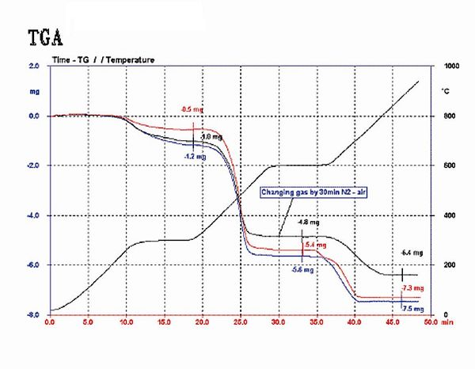
TGA
The following figure reflects:
Relationship among Thermogravimetric Analysis (TGA), Time and Temperature of Samples
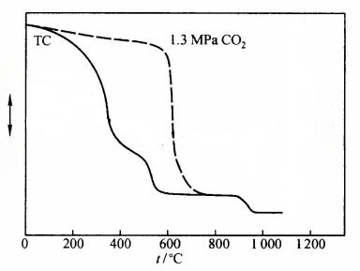
Exothermic
Endothermic
Loss of weight/%

II. Instrument Technical Indicators
model | HZ2329
display mode | 24bit color, 7-inch LCD touch screen display
TG range | 1mg ~ 3g
TG resolution | 0.01mg
temperature range | Room temperature ~1150℃
temperature resolution | 0.01℃
temperature fluctuation | ±0.01℃
Temperature repeatability | ±0.1 ℃
heating rate | 0.1 ~ 100℃/min
Temperature control mode | Heating, constant temperature and cooling (automatic program control)
programing control | Four-stage temperature control can be realized, and special parameters can be customized.
Curve scanning | Heating scanning
Atmosphere control gas | Two-way automatic switching (instrument automatic switching)
gas-flow rate | 0-200mL/min
gas pressure | ≤0.5MPa
Constant temperature time | 0 ~ 300min can be set arbitrarily.
data interface | Standard USB interface
working power supply | AC220V/50Hz

III. The Instrument Working Environment
Power supply AC220V±10V ≤10A
The ambient temperature is 20 ~ 28℃
The table top on which the instrument is placed is flat. There are no large machinery or other vibration sources around.
This instrument is highly precise, and the temperature fluctuation in the laboratory should be less than 2 degrees Celsius during the whole experiment (about one hour).
You can close the doors and windows of the laboratory and control the temperature of the laboratory 1 hour before the experiment.
The instrument should be powered on half an hour before the experiment.
The instrument should be far away from the heater and the air outlet of the air conditioner.

IV. Instrument Installation
Check whether the instrument parts are complete according to the packing list.
The instrument is laid flat on the workbench and connected with the power line and signal line.
The ambient temperature is 20 ~ 28℃
The desktop of the workbench where the instrument is placed is flat.

V. Experimental Principle
After the sample and reference substance are put into the crucible, the temperature is raised at a set rate. During the heating process, the sample will undergo changes such as volatilization and decomposition, and the weight will change in the process. The software records the relationship between weight and time/temperature.

VI. Equipment Interface And Software Operation
Connect the power cord, USB cable and the required gas, and the boot display is as shown in the figure: preheat the boot for 30 minutes. After stabilization, if the TG quality display is not 0, press TG to reset it.
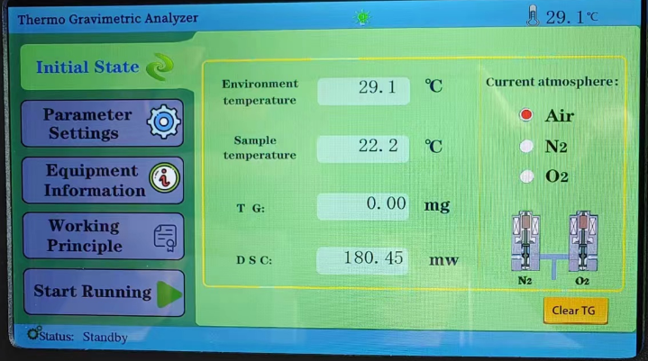
6.1 Instrument interface
A "Initial State" key, which is used to view information such as ambient temperature and sample temperature.
B "parameter setting" key is used to set experimental parameters, which is usually set in software.
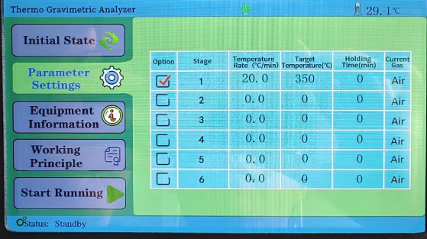
C "Equipment Information" key, which displays the equipment information.
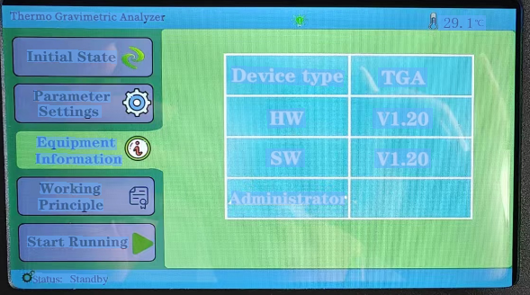
D "Start Running" key, after the operation on the computer software starts, the current data information will be displayed.
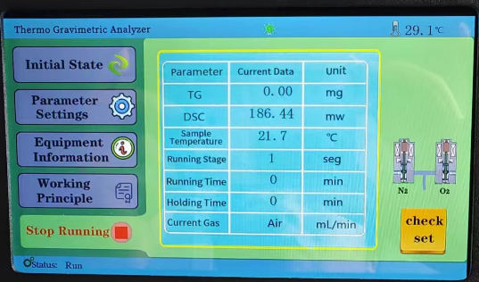
6.2 Software operation
All parameters are set and operated on computer software.
- Open the software, select File, click New, or click New on the taskbar, fill in Sample Name, Empty Crucible Quality, and select Crucible Type and Atmosphere. Don't repeat the name of the experimental sample to prevent the last experimental data from being overwritten. As shown below:
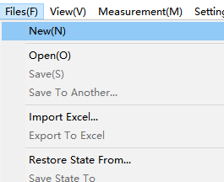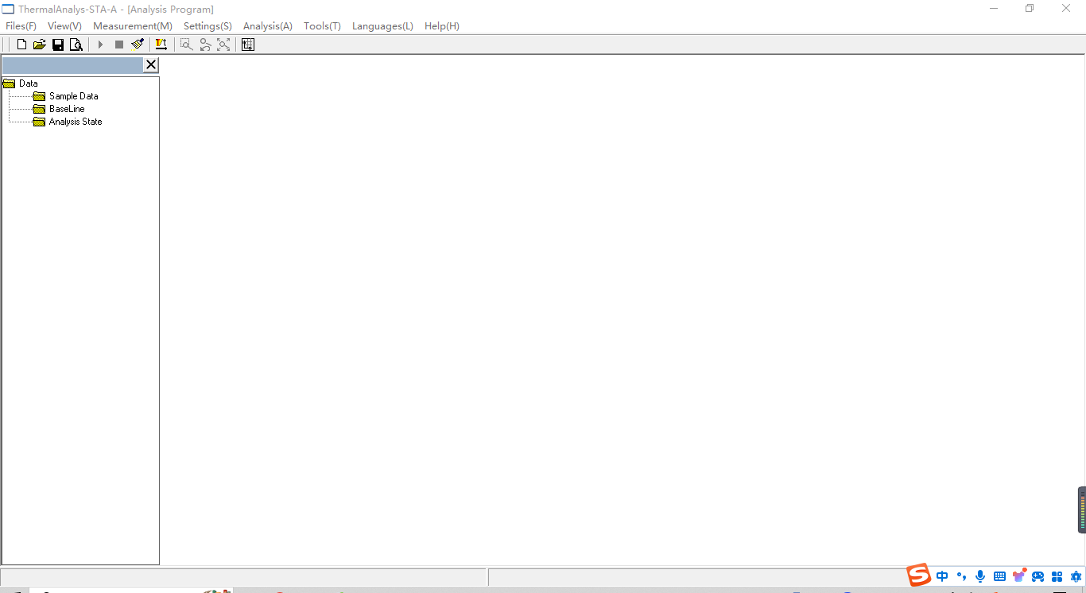
New
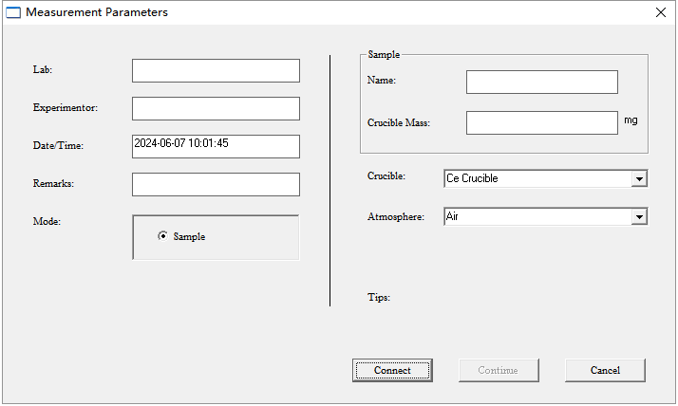
2. Put two empty crucibles on the sample tray respectively;
3. When the quality is stable, fill the quality displayed in the interface into the software "Crucible Quality" and click [Connect Instrument]; As shown above
4. Take out the crucible on the right side of the tray, put the sample in and put it on the tray;
5. Cover the furnace body, first cover the internal ceramic cover and then cover the metal cover;
6. Click [Continue] to enter "Parameter Settings" to set the temperature in stages; The following figure
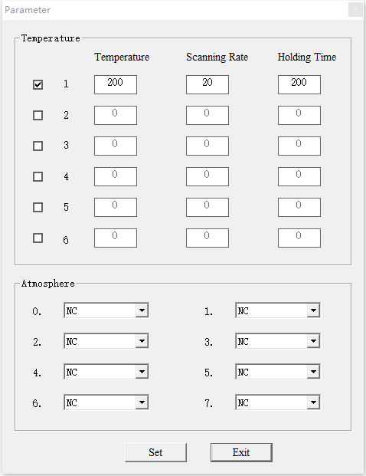
- After setting the required parameters, click the [Setup] button in the above figure, and click the [Run] button on the software after TG quality is stable, as shown in the following figure:
Run

VII. Software Map Analysis
- When the set temperature is reached, the instrument automatically stops, and the following figure appears: green is the TG mass line, the abscissa is the temperature, and the left ordinate is the TG coordinate. Save the atlas first, and then analyze it to prevent the atlas from being lost.
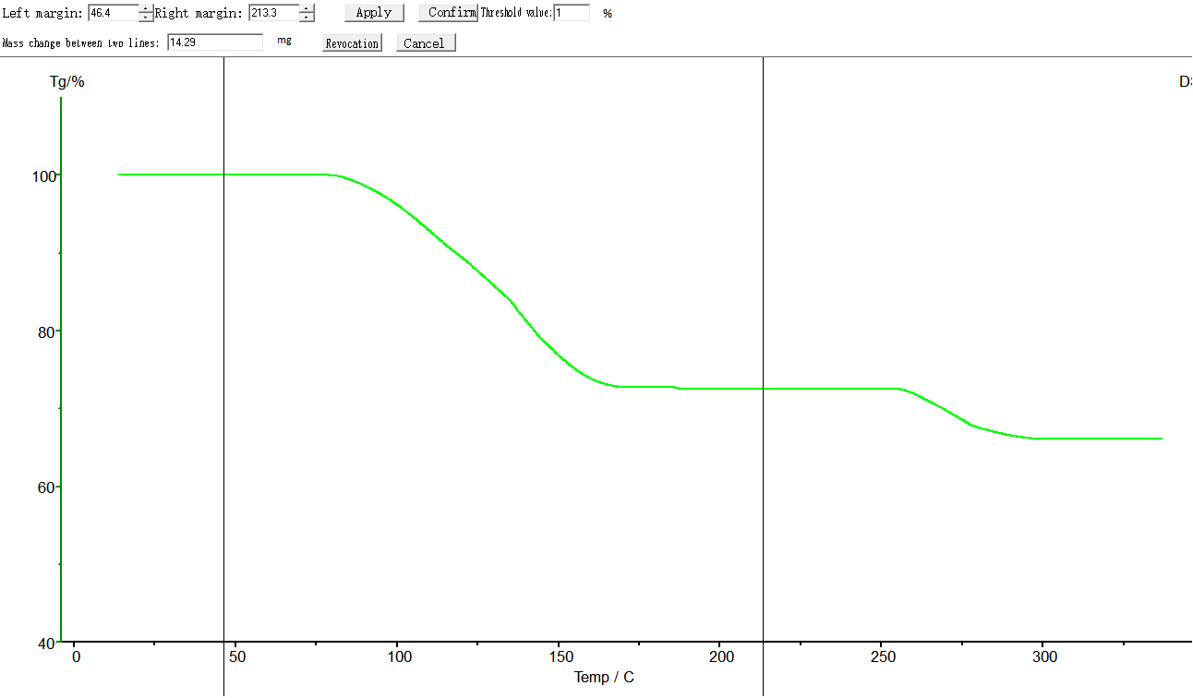
- Click the map, that is, the color of the map changes from dark green to grass green, that is, select the map, click Analysis-Quality Change in the taskbar to drag the left and right black lines to select the temperature range, and then click the map to make it dark green, as shown in the following figure.

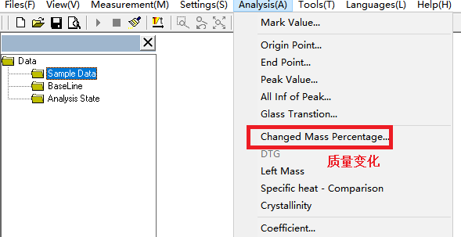
Quality Change
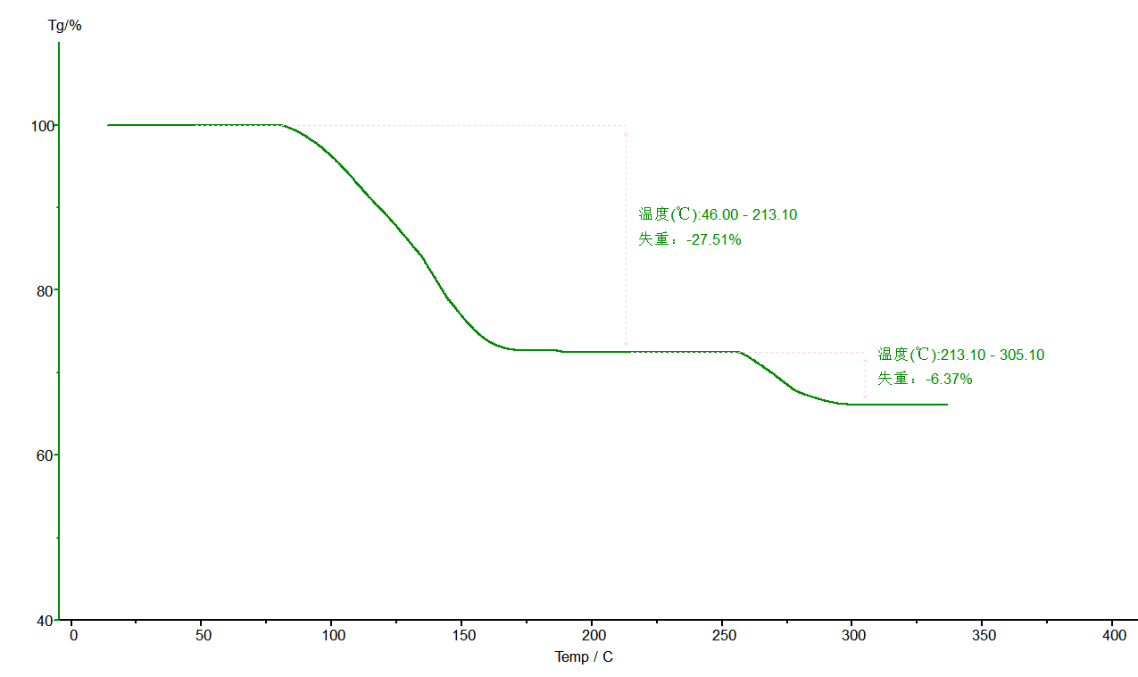
Temperature(℃): 213.10-305.10
Loss of weight : -6.37%
Temperature(℃): 46.00-213.10
Loss of weight : -27.51%
- Click File-Save as Status T to save the analysis data. As shown below:
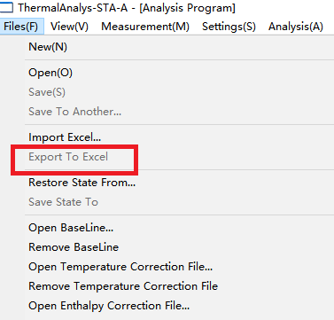

- You can click Print Preview, as shown below:
Preview
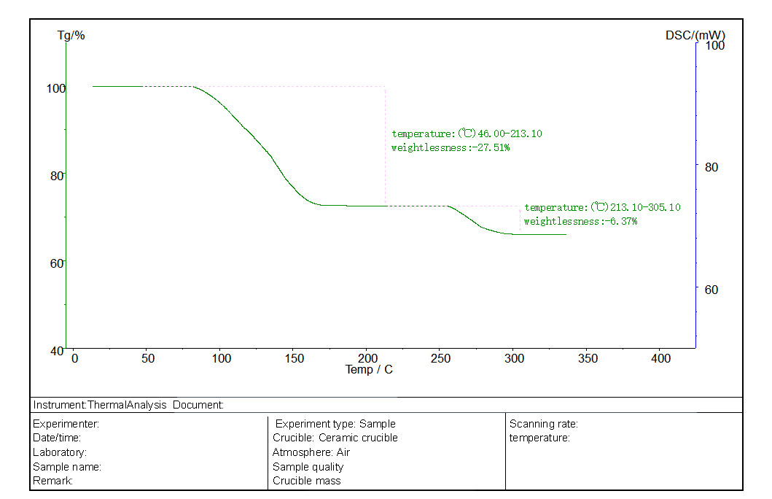

VIII. Reference Material Selection And Sample Preparation
1, polymer materials:
Reference-an empty ceramic crucible.
Samples-samples of cured epoxy resin with high melting point (such products are generally used for electronic devices and transformer potting) can be made into cubes, and the samples can be directly placed in a crucible dedicated for samples. The volume of the sample shall not exceed half of the crucible.

IX. Matters Needing Attention
1. Do not use hard objects to clean the sample holder and experimental pool, so as not to cause permanent damage to the instrument. .
2. Use a rubber ball to blow away the dust in the experimental pool. Do not blow with your mouth to prevent personal injury.
3. When the sample holder is seriously polluted, the cutoff temperature can be set to 580℃, the heating rate can be set to 20℃/min, and no crucible is placed in the instrument, so that the pollutants can be volatilized by burning at high temperature. Then press the [Run] key to start running.
4. When the instrument is not used for a long time or during the low-temperature test, the baseline appears uneven and burr, which is due to the invasion of water into the experimental pool.
You can set the cutoff temperature to 400℃ and the heating rate to 20℃/min, and press the [Run] key, and the baseline will return to normal after running.

X. Packing List
No. | Item | Qty
1 | Host machine | 1 set
2 | USB flash disk | 1
3 | Data wire; data cable | 2 pieces
4 | Power cord | 1 root
5 | Ceramic crucible | 200
6 | Ceramic cap | two
7 | Metal cover | one
8 | Raw tape | Volume 1
9 | Pure tin particles | 1 bottle
10 | 10A fuse | Five
11 | Sample spoon/sample presser bar/tweezers | 1 each
12 | Ear-sucking ball | one
13 | Trachea | 2 pieces
14 | Balancing weight | one
15 | Sensor | one

