HZ-600A+
Sweep Frequency Response Analyzer

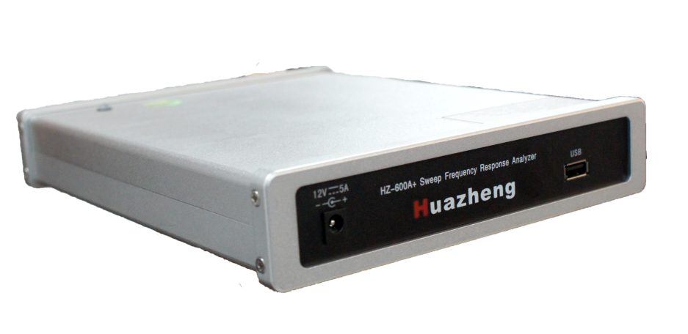

Huazheng Electric Manufacturing(Baoding) Co.,Ltd

Dear user:
Thank you for choosing HZ-600A+ Sweep Frequency Response Analyzer.
We hope that this instrument can make your work easier and more enjoyable, so that you can get the feeling of office automation in the test and analysis work.
Before using the instrument, please read this manual, and operate and maintain the instrument according to the manual to prolong its service life.
"Just a light press, the test will be completed automatically" is the operating characteristics of this instrument.
If you are satisfied with this instrument, please tell your colleagues; if you are not satisfied with this instrument, please call (0312) 6775656 to tell you to serve you at all times-Baoding Huazheng Electric Manufacturing Co., Ltd., our company will definitely make you satisfied !
Contents

Attentions 1
System Introduction 3
I.Simple Operation Flow Of System 6
II.Preparation 6
III.Test Wiring 7
IV.System Test 11
V.Tester Maintenance 18
VI.Packing List 19

Attentions
- Please read carefully the Instructions for the transformer winding deformation tester!
- Operators must read carefully the Instructions before use.
- The tester is applicable to testing of transformer winding deformation with frequency response method.
- Equipment irrelevant to the tester cannot share power supply terminal with the tester.
- Power supply of the system must be provided with reliable grounding to prevent the risk of electric shock.
- Operators cannot leave the test site in the process of equipment operation.
- The transformer core must be reliably grounded with enclosure. Shell of tester and shell of measuring impedance must be reliably grounded with transformer enclosure.
- Please do not start test before “ground” of the tester is correctly connected.
- Please fully discharge terminal of the transformer to be tested before test.
- Before use, please check appearance of the tester and check whether its power switch is at “closed” position and every wiring terminal is normal.
- Winding deformation test must be carried out on the conditions that all leads of the transformer (including overhead line, enclosed busbar and cable) are disconnected and far from the transformer bushing to the extent possible (surrounding grounding body and metal suspended solids must leave the transformer casing by more than 20cm), especially for the transformer connected with enclosed busbar.
- Correctly record positions of tap switches before test and put tap switches of the tested transformer at the first tap as far as possible, especially for the on-load regulating transformer, in order to achieve complete winding information. For no-load regulating transformer, make sure every measurement is made at the same tap position for easy comparison.
- Make sure wiring clamp of the measuring impedance tightly contacts bushing clip. In case of conductive paste or rust on the bushing clip, scrub it clean with abrasive cloth or dry cotton cloth.
- Do not start any software irrelevant to measurement while using the tester.
- The tester with use of general operating system has the risk of system bug and collapse.
- Generally, system abnormalities may be eliminated by restart of system software.
- Please do not use the system in rainy and foggy days as it is not water-proof.
- Put the tester into its packing case when not used and keep the packing case level.
- The scrapped equipment must be handled according to requirements of national laws and regulations or handed to the Company for handling.
- Please directly contact our after-sales service department if you have any doubt after reading the instructions.

System Introduction
The transformer winding deformation tester is used for power transformer with voltage grade of 6kV and above and other transformers with special purpose. The power transformer is inevitably vulnerable to impulse of various fault short-circuit current or physical collision in the process of operation and transportation and the transformer windings may lose stability under the powerful electro-dynamic force exerted by such short-circuit current, which could result in permanent deformations such as local distortion, swell or dislocation and will severely affect safe operation of the transformer. Deformation of transformer windings is measured with frequency response analysis method according to national standard DL/T911-2004 for electric power industry, i.e. detect amplitude-frequency response characteristic of each transformer winding and make vertical or horizontal comparison of the detection result to judge possible deformation of the transformer winding based on change of amplitude-frequency response characteristics.
1、Main Technical Characteristics
- Characteristics of transformer windings are measured with frequency sweep method. Deformations of windings such as distortion, swell or displacement of 6kV and above transformer are measured by detecting amplitude-frequency response characteristics of each winding, not requiring lifting of transformer enclosure or disintegration.
- Quick measuring, measuring of a single winding is within 2 minutes.
- High frequency accuracy, higher than 0.001%.
- Digital frequency synthesis, with higher frequency stability.
- 5000V voltage isolation fully protects safety of the testing computer.
- Able to load 9 curves at the same time and automatically calculate parameters of each curve and diagnose winding deformations to provide the reference diagnosis conclusion.
- Analysis software has powerful functions and software and hardware indicators satisfy national standard DL/T911-2004.
- Software management is humanized with high degree of intelligence. You only need to click a key to complete all measurements after setting of parameters.
- The software interface is concise and vivid, with clear menus of analysis, save, report export, print, etc.
2、Main Technical Indicators
- Measuring speed: 1 min- 2 min for single-phase winding
- Output voltage: Vpp-25V, adjusting automatically in test
- Output impedance: 50Ω
- Input impedance: 1MΩ (the response channel is built with 50Ω matching resistance)
- Frequency scan scope: 100Hz-2MHz (10Hz-2MHz, optional)
- Frequency accuracy: 0.001%
- Frequency scan manner: linear or logarithmic, frequency sacn interval and number of sweep points are freely settable
- Curve display: amplitude-frequency curve (phase-frequency curve, optional)
- Width of measuring dynamic range: -100dB~20dB
- Supply voltage: AC100-240V 50/60Hz (use DC12V Adapater recommend)
3、Main Features of Test Analysis Software
- Use windows platform compatible with Window 2000/Window XP/Windows 7/windows 8.
- Use database to save test data and render concise and easy data management.
- Able to load 9 curves at the same time and automatically calculate parameters of each curve and diagnose winding deformations to provide the reference diagnosis conclusion.
- Software management function is powerful that takes into full account of site use demand. Measuring data is automatically saved and exported to form Word version test report (require installation of relevant Office software) or JPG photo report to facilitate the user to export test report.
- The software has distinctive humanized feature. Measuring conditions are mostly options, which exempt the need of many inputs and bring about easier operation.
- The software has high degree of intelligence. You only need to click a key to complete all measurements after connection of input and output signals.
- The software interface is concise, vivid and practical.

I.Simple Operation Flow Of System
- Ground collector
- Connect collector and transformer winding
- Connect collector and computer
- Start up computer
- Power on collector
- Log in software
- Input information
- Select end-frequency and adjust testing parameter
- Select winding
- Start testing
- Replace test winding
- Select winding
- Start test
- Repeat above process until all winding tests are done
- Analyze data
- Export report
- Turn off software
- Power off collector
- Disconnect collector and computer
- Remove transformer winding
- Test completed.

II.Preparation
Note: basic operations of computer and Windows operating system are not contained in the operation instructions. Please refer to relevant computer books.
Note: basic operations of Windows operating system involved in the operation instructions are based on Windows 7 operating system. The differences in operation between other Windows system and Windows 7 system are not contained in the operation instructions, for which please refer to relevant computer books.

III.Test Wiring
3.1 Panel Introduction
Panel of the transformer winding deformation tester is as shown in Figure 1.
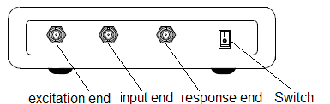
Figure 1a Figure of Transformer Winding Deformation Tester Panel (Front Panel)
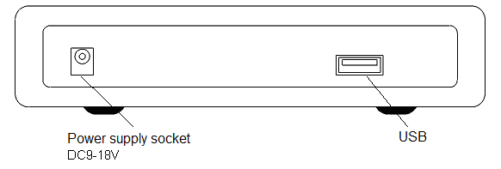
Figure 1b Figure of Transformer Winding Deformation Tester Panel (Rear Panel)
External wiring illustration during transformer winding deformation test is as shown in Figure 2. Frequency sweep voltage signal is input from excitation end of the tester to initial end of the tested transformer winding through input resistance (internal resistance), voltage signal at the initial end to input end of the tester and voltage signal at the tail end of the tested transformer winding to response end of the tester. “Ground” of the transformer winding deformation tester as well as enclosure and core of the “tested transformer” are grounded together.
3.2 Winding Wiring Mode
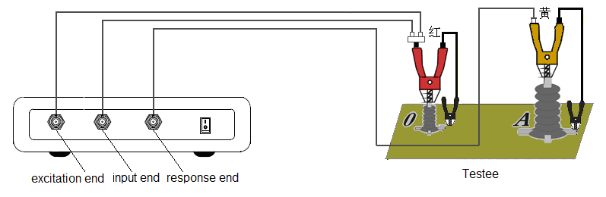
Figure 2 Wiring type
It is recommended to input frequency sweep signal of winding deformation frequency response test from tail end of winding and output from initial end, suspended for non-tested winding. Wiring mode of winding deformation test varies with different wiring group of the transformer.
- YN Wiring
Input impedance of frequency sweep signal is connected to neutral point O and output impedance to A, B and C respectively. For the measuring method, interference signal received by non-measured phase is absorbed by low impedance of the signal generator, as shown in Figure 3.
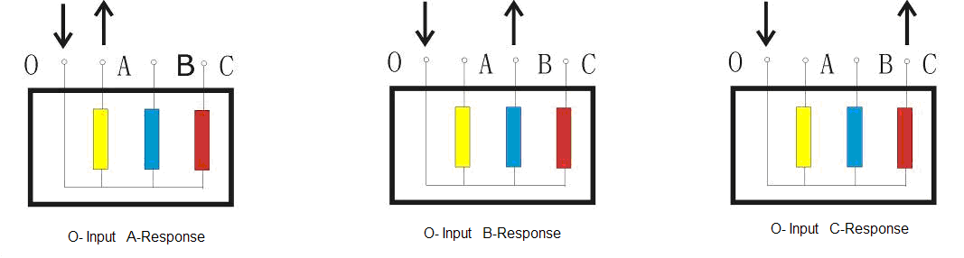
Figure 3 YN Wiring
- Y Wiring
It is required to wire in the following manner as neutral point has no outgoing wire, as shown in Figure 4.
In this test, input impedance is connected to A and output impedance to B.
In this test, input impedance is connected to B and output impedance to C.
In this test, input impedance is connected to C and output impedance to A.

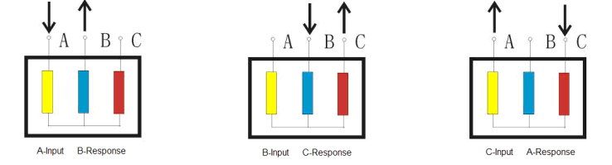
Figure 4 Y Wiring
- Interior Connection △ Wiring
Wiring mode of interior connection △ wired winding is as shown in Figure 5.
In this test, input impedance is connected to c and output impedance to a，on behalf of a phase.
In this test, input impedance is connected to a and output impedance to b，on behalf of b phase.
In this test, input impedance is connected to b and output impedance to c，on behalf of c phase.

Figure 5 Interior Connection Δ Wiring
Theoretically, the two non-measured windings that are connected in series first and then connected with the circuit in parallel in interior connection Δ wiring mode have some effect over the testing process. However, it is believed that their effect over the non-measured coil is negligible when attenuation is more than 10dB.
- Exterior connection Δ wiring
Wiring mode when windings are disengaged in measurement is as shown in Figure 6. It is regarded interior connection Δ wiring if connections are not disengaged, when the wiring mode is as shown in Figure 7.
In this test, input impedance is connected to x and output impedance to a，on behalf of a phase.
In this test, input impedance is connected to y and output impedance to b，on behalf of b phase.
In this test, input impedance is connected to z and output impedance to c，on behalf of c phase.

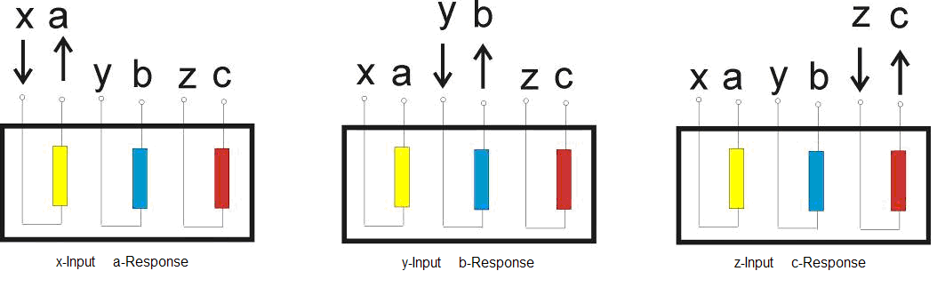
Figure 6 Exterior Connection Δ Wiring
- Transformer with Balance Winding
The transformer with balance winding must be ungrounded in test, as shown in Figure 7.
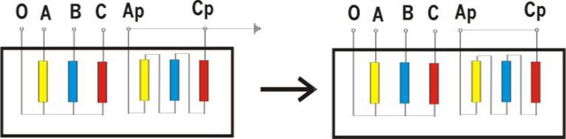
Figure 7 Wiring of Balance Winding

IV.System Test
4.1 Start of “Winding Deformation Test System” Program
- Double click the icon  of “transformer winding deformation tester” to start the program of “transformer winding deformation test system”.
- Enter the main program interface titled “transformer winding deformation tester” after the start process (double click the small icon at the top left corner of the screen to switch to the desktop. Please do not click the icon in the process of test.)
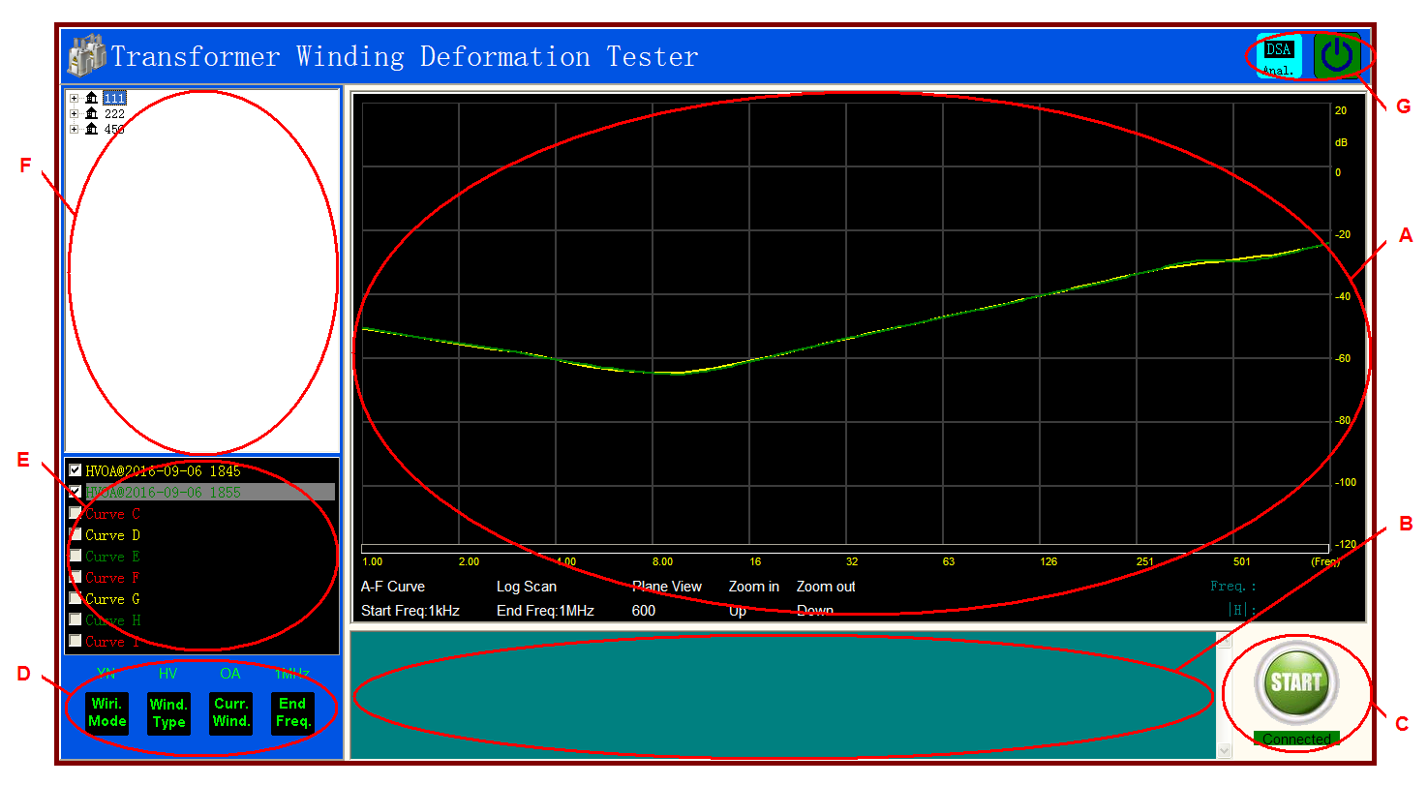
The software main interface consists of 7 parts:
（A）Test Curve Display Area
The area displays test curve with frequency as X-coordinate and dB value with Y-coordinate (amplitude-frequency test) or angle value (phase-frequency test). The label below consists of:
Curve type label: to mark the current display is “amplitude-frequency curve” or “phase-frequency curve”. Click the label to switch between the two types (require hardware support).
Scanning mode label: to display the current scanning mode is linear scanning or logarithmic scanning. Click the label to switch between the two modes.
Start frequency label: to display start frequency of current scanning. Click the label to switch among different start frequencies.
Stop frequency label: to display stop frequency of current scanning.
Scanning point number label: to display total point number of current scanning. Click the label to switch among different point numbers.
（B）Status Display Area
The status display area displays working status of the current equipment.
（C）Operating Zone
There are two keys in the operating area, start  and stop that display in turn according to service status, i.e. “start” displays under stop status and “stop” under start status.
There is a current status display label under the key to display current status of the tester:
“Offline status”: computer is working under off-line status, when only data reading and printing functions are available.
“Equipment connected”: computer is connected with equipment and testing is possible.
“Equipment disconnected”: computer is disconnected with equipment and testing is impossible, generally requiring reconnection and restart of software.
（D）Test Parameter Setting Area
Area D displays parameter setting window that is used for setting of test parameters, including winding wiring method, category and number of the winding to be tested, scan stop frequency, etc.
（E）Curve Description Area
Area E displays description information of the current curve. The label in a color contains description information of its corresponding curve in the same color.
（F）Data Selection Area
What locates at the top right corner (F) is data selection area. Test data applies hierarchical management, where the first grade is name of substation, the second grade name of transformer, the third grade category and number of transformer winding and the last grade existing data. Data name is displayed in the manner of “data type @ test time”. Data displayed in the part matches with content of the label in area (A). When “amplitude-frequency curve” is displayed, the data selection area displays test result of the amplitude-frequency curve and when “phase-frequency curve” is displayed, the data selection area displays test result of the phase-frequency curve.
When “amplitude-frequency curve” or “phase-frequency curve” is displayed, the test result is displayed in area A when relevant data is clicked.
（G）Function Key Area
Keys in the function key area (G) will switch automatically and display dynamically based on the use function.
 “DSA analysis”: used for correlation analysis.
Quit system.

4.2 Frequency Response Method Test
- Environment and Wiring Confirmation
- The system is wired according to requirements of 3.2 winding wiring mode.
- Tap position of the transformer is adjusted to the maximum impedance position (the first tap)
- The surrounding environment is free from strong electromagnetic interference.
- Software Log-in
Double click the icon of “transformer winding deformation tester” on the desktop. The system will flash through the welcome interface and then enter the test interface. The system will have following dialogue box if equipment is not connected:
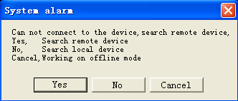
Occurrence of the above dialogue box is generally caused by connection failure of equipment. In this case, first check whether equipment is connected to USB interface of the computer and then check whether equipment power supply is switched on.
- Information Input
Transformer information log-in interface (as shown in the figure below) is entered when equipment is connected, where you may input or select information in relevant textbox and click save key so that the system will enter the test interface.
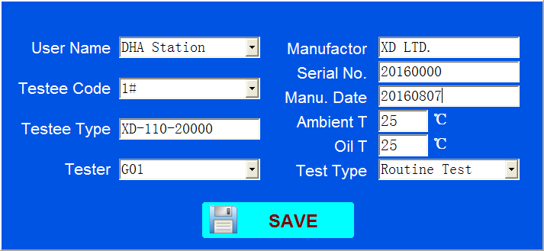
Please input carefully according to the transformer nameplate while inputting information as all information is automatically saved together with the test result and incorrect input may affect the contents of the report.
- Scanning Mode Confirmation and Modification
1、 Selection of Scanning Mode
Click “End Frequency” to select test stop frequency and then the system will automatically set parameters to the set parameters according to the set scanning parameters, including start frequency, scanning mode, and scanning point number. To adjust, click the parameter label in area A to switch automatically (the label automatically turns green when the mouse pointer moves to a changeable label).
2、Change of Default Information
To readjust the default setting information, click“End Frequency” key with right mouse button to let the function menu pop up. The information setting window (as shown in the figure below) will pop up when “setting” is selected, where you may adjust the default scanning information and restart the software after adjustment. Then the system will test with the adjusted default information.
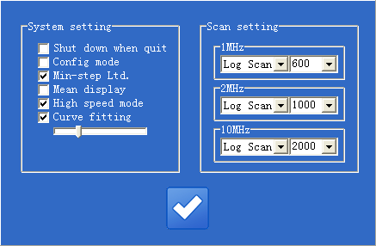
The above adjustment is used for setting of default information that is distinguished by the value of “stop frequency”. Actually, adjustment is generally performed as required during the first time use in practical application and is not performed later unless there is regulation or special requirement.
3、Change of Scanning Parameters
Change of scanning parameters is used for testing of complicated parameter combinations. The system doesn’t have memory function and will recover automatically once quit.
Click parameter label in the curve display area (A) before scanning to change information other than stop frequency in the manner of cyclic adjustment.
Change of scanning parameters is applicable to single test with measuring result requirement or for the sake of research, generally not requiring adjustment.
- Test
You may start data measurement with frequency response method after setting of basic test information. The system will automatically complete frequency sweep after “START” key is clicked. The key will turn to key in the process of test that could stop the current scanning once clicked. The test pauses once the signal curve display area is clicked and proceeds when clicked again.
After completion of a test item, change the wiring mode, change software setting information, click again key, measure the next item and repeat the above operations until all measurement items are completed.
The test waveform display area is unfolded when the test curve display area (A) is double clicked in the test process, which contains waveform display, input voltage peak value (red), response voltage peak value (yellow), amplification factor and X-coordinate time information used for signal research.
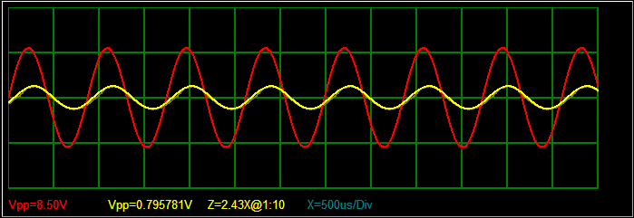
4.3 Correlation Analysis
Curves in area E are automatically divided into three groups, 1-3 as a group, 4-6 as a group and 7-9 as a group and correlation analysis of each group of curves is performed inside the respective group. Once is clicked, report display window will pop up at the left side that displays contents of the current test report. The operator may reconfirm and re-input information and click  on the report display window to let the save dialogue box pop up, where the operator may set file name, file type and save path. The result is saved in “transformer winding deformation test report” of disk D by default with file name of “print report” + “print time”.
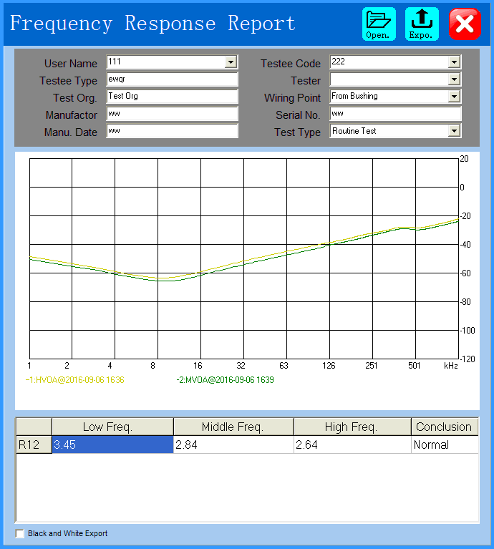
4.4 Data Echo
The system is able to echo saved data. By selecting name of power station, name of transformer, test category and time, as well as winding type and time in turn in area F, the completed test result is called out. By default, the data is displayed at the position of the first curve and displayed downwards with progressive increase of the selection result. When the number of curves comes to the maximum (9 curves), the curve no longer increases and you may select the curve to be replaced for progressive replacement in this case. When a curve is decided not requiring analysis, you may right click “clear curve” on the curve description information (E) so that the curve will be removed out of the analysis list automatically.
Curves in area E are automatically divided into three groups, 1-3 as a group, 4-6 as a group and 7-9 as a group and correlation analysis of each group of curves is performed inside the respective group. Therefore, it is required to ensure the curves to be analyzed are within the same group, or otherwise you cannot get correct analysis result.
When “analysis” is clicked after selection of curve, the report display window will pop up at the left side. All other operations are the same as operations described in 4.3.
4.5 Report Saving Position
Report is saved under folder of disk D with the folder hierarchy of:
D: \transformer winding deformation test result\test report+ print time. doc or test report+ print time. jpg.
The report could be WORD document or JPG photo, subject to the option selected in saving.

V.Tester Maintenance
The section provides basic maintenance data. Please do not try to disintegrate, modify and repair the transformer winding deformation tester.
5.1 Basic Maintenance
Regularly scrub surfaces of the tester and its accessories with a clean cloth.
Put the tester at a clean place with low humidity and protect it against entry of dirt and dust. Put the tester into its packing case when not used and keep the packing case level.
5.2 Senior Maintenance
To be proceeded by professional technicians of the Company.

VI.Packing List
No. | Item | Qty
1 | Main engine | 1
2 | Power line | 1
3 | Excitation cable(red) | 2
4 | Response cable(yellow) | 1
5 | Response pincers(yellow) | 1
6 | Excitation pincers(red) | 1
7 | Ground cable& pincers | 2
8 | Three-way connection | 2
9 | USB data cable | 1

