HZKZ-100A
Transformer On-no Load Loss Tester

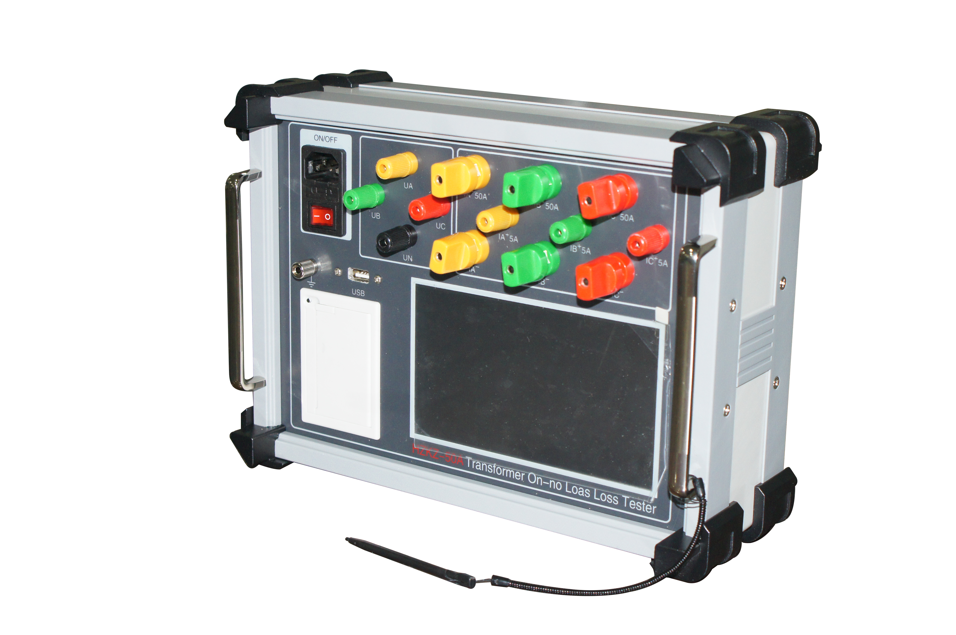

Huazheng Electric Manufacturing (Baoding) Co., Ltd
Dear user:
Thank you for choosing HZKZ-100A Transformer On-no Load Loss Tester.
We hope that this instrument can make your work easier and more enjoyable, so that you can get the feeling of office automation in the test and analysis work.
Before using the instrument, please read this manual, and operate and maintain the instrument according to the manual to prolong its service life.
"Just a light press, the test will be completed automatically" is the operating characteristics of this instrument.
If you are satisfied with this instrument, please tell your colleagues; if you are not satisfied with this instrument, please call (0312) 6775656 to tell you to serve you at all times-Baoding Huazheng Electric Manufacturing Co., Ltd., our company will definitely make you satisfied !

Contents

I. Overview 1
II. Wiring And Attention 1
III. Main Functions And Characteristics 2
IV. Main Technical Specifications 3
V. Key Settings 3
VI. Operation Methods 5
V. Packing List 10

I. Overview
HZKZ-100A Transformer On-No Load Characteristics Analyzer is the latest product of Huazheng Electric Manufacturing (Baoding) Co., Ltd. The instrument adopts the popular ARM processor in this year, with 168M basic frequency and 128m memory, which can be expanded to 4G memory card. Using 7-inch high-definition color touch panel, combined with emwin display interface so as to make the instrument interface being friendly and operated in a simple way, it can be operated through the touchscreen without keyboard. The instrument support database and can be exported through USB disk or transmitted to computer via data wire.
The circuit design of this instrument is exquisite and unique, which makes it superior in performance, powerful in function, small in size and light in weight. It can not only be used to test the on-no load parameters of transformer, but also measure the harmonic content and waveform in the field. The instrument can record the test curve of transformer under on-no load condition, then provide reliable basis for transformer fault analysis.

II. Wiring And Attention
1. When using the instrument, please follow the instructions to wire and operate.
2. The earthing terminal or grounding terminal of power wire should be reliably grounded nearby.
3. Please input the correct setting parameters before testing. Inputting the storage sequence number could save the test results under this record number. Then set the parameters according to the parameters of the tested transformer. After setting up, click the “Save Changes” button to save and enter the test interface. Select the parameters that needed to be tested (impedance or parameter), click the “Start” button, and then slowly raise the test voltage to complete the test. When the test is ended, you can click the “End” button and saved the test record to complete the test.
4. The instrument is operated by full touch screen, please do not bump it.

III. Main Functions And Characteristics
1. The instrument adopts 7-inch true color LED. It can measure voltage, current, angle, power and other electrical parameters, and it also can display the vector diagram of voltage and current, both of the displays are shown clearly and intuitively on the same screen.
2. It can measure the parameters such as no-load loss, load loss and impedance voltage, etc.
3. The instrument has the function of harmonic analysis. It can measure the 1-32 harmonic content of voltage and current applied to transformer and display bar graph as well as voltage and current waveform.
4. The on-no characteristic curve under different voltage and current can be recorded automatically during the test process of on-no load condition of transformer, which can be more convenient to analyze the characteristics of transformer and core.

5.It can be directly measured within the allowable measuring range of the instrument. If it is beyond the measuring range, external voltage and current transformers can be connected. The instrument can set the transformation ratio of external voltage and current transformers to directly display the applied voltage and current values.
6. With the function of data storage and data browsing, the instrument supports DBF database, and it can store test data or browse test records according to user requirements. The instrument also supports the USB disk export function, you can export the test data through USB disk, and the database supports the excel spreadsheet opening mode, which is convenient for editing, printing or archiving.
7. Operate with 7-inch true color touch screen, the GUI interface, with build-in 128M memory (extensible 4G memory card), it supports English and is easy to operate.
8. It is small in size, light in weight, accurate in measurement, no power off calendar and clock function, so it can store test time at any time.
IV. Main Technical Specifications
1. Voltage measurement range: AC 10~500V (phase voltage) 850V (line voltage)
2. Current measurement scope: AC 0.2 ~100 A
3. Capacity measurement range: 30kvA~20000KVA (100% rated current direct measurement) Adding PT and CT can increase the measurement range
4. Measurement accuracy:
Voltage: 0.1% (frequency 40~70Hz)
Current: 0.1% (frequency 40~70Hz)
Power: 0.2% (power factor 1.0-0.2), 1% (power factor 0.2-0.01)
5. Working power supply: AC220V±10%, 50/60 Hz
6. Working temperature: -20℃~40℃
7. Relative humidity: ≤80%RH no dewing

V. Key Settings
This instrument supports full-touch screen operation, with digital keyboard of 16 keys and qwerty full keyboard (similar to computer keyboard). As shown in the figure:
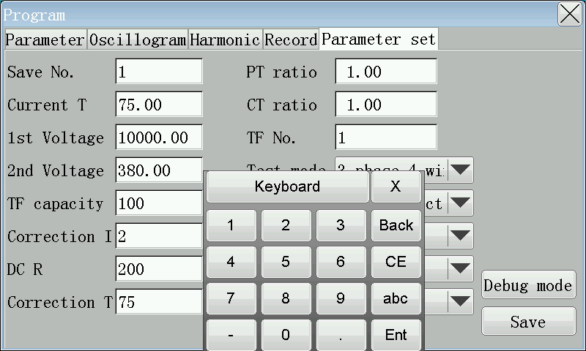

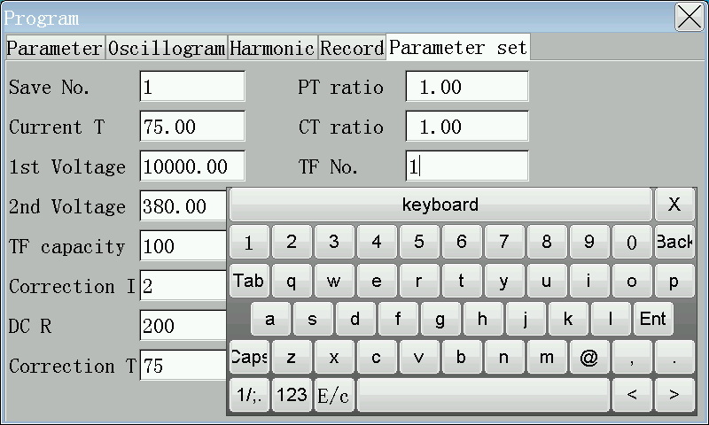
The number keys "0-9": in the parameter input state, they are used for inputting data. The "q-m" keys used for English characters input method to input user name or transformer type and so on, "abc" keys are used to switch the digital keyboard into alphabetical keyboard, "123" for the alphabetical keyboard changes to digital keyboard, "X" is used to turn off the soft keyboard, "keyboard" is used to move the keyboard freely on the screen, you can drag the keyboard to anywhere on the screen by clicking it with your hand, "Back" is the backspace key for clearing the previous character before cursor, the "CE" key clears all characters that are input at present, and "Ent" is the enter confirm key.
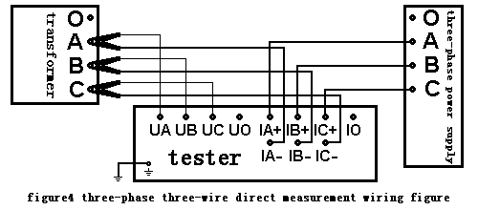

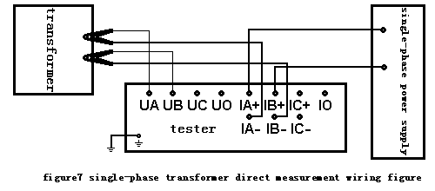

VI. Operation Methods
Connect the power cord, test wire and ground wire according to the wiring and attention in of this instruction, and then enter the main interface of the computer after turning on the power supply.
As shown in the figure：

Click the “operating program” icon on the screen to enter the test program interface
as shown in the following figure:

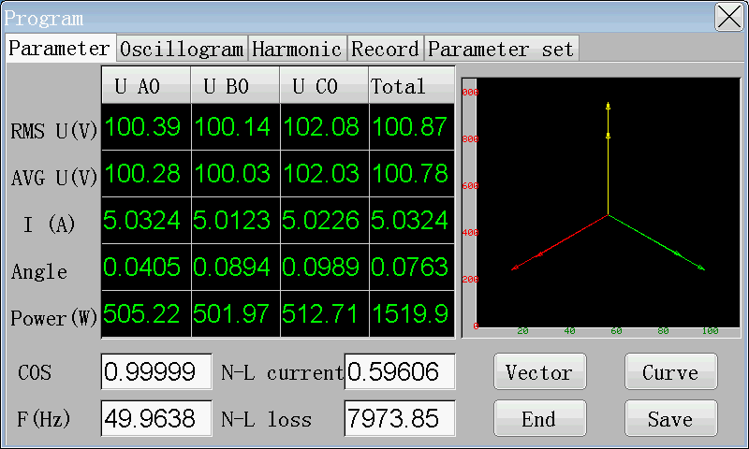
1.1 Parameter Settings
Before testing, firstly setting the parameter, then clicking the “parameter settings” button to enter the parameter setting interface
As shown in the figure:
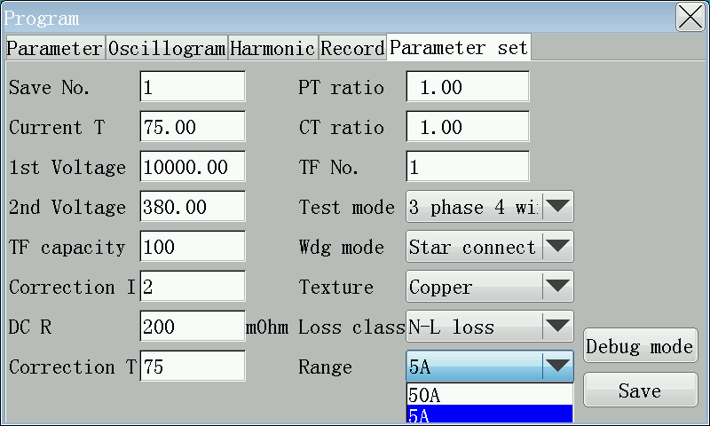
You can click the input box which need testing
Store serial number: used to set which record this test be stored.
Current temperature: the transformer temperature when testing.
First and second voltage: the rated voltage of first and secondary of transformer.
Transformer capacity: rated capacity of tested transformer.
Correction index: testing the correction index at no-load loss under non-rated voltage (generally do not need to test no-load loss at non-rated voltage).
Short circuit resistance: short circuit resistance of second short circuit, if it can be omitted, input 0.
Correction temperature: the temperature that needed to be corrected of transformer test results.
PT, CT transformation ratio: referring to the additional transformation ratio of PT, CT, when beyond the measurement range of the instrument.
Transformer number: used to store the information of transformer to be tested.
Test methods: three-phase three-wire refers to two wattmeter method; three-phase four-wire method is three wattmeter method; three-phase separation is to test three-phase transformer with single-phase power supply; single-phase refers to test single-phase transformer.
Winding type: it is the winding type of the line side of the tested transformer, such as the low-voltage side short-circuit, wiring at the high-voltage side, inputting the high-voltage side winding type.
Winding material: the winding material of tested transformer is copper or aluminum.
Wear type: referring to measurement of no-load loss or load loss.
When the setup is completed, clicking the “Save Modify” button to save the settings to database.
1.2 Loss Measurement
As shown in the figure:

Click the “Start” button to start the test, gradually increase the measurement voltage or current to the required value to complete the test. Click the vector diagram to see the phase relationship of applied voltage and current. Click the curve to see the voltage and no-load current or current and impedance voltage curve. When the test is completed, click the “End” button. Click “Save” button can save it to database (save it to the record number set by the store serial number).
As shown in the figure:
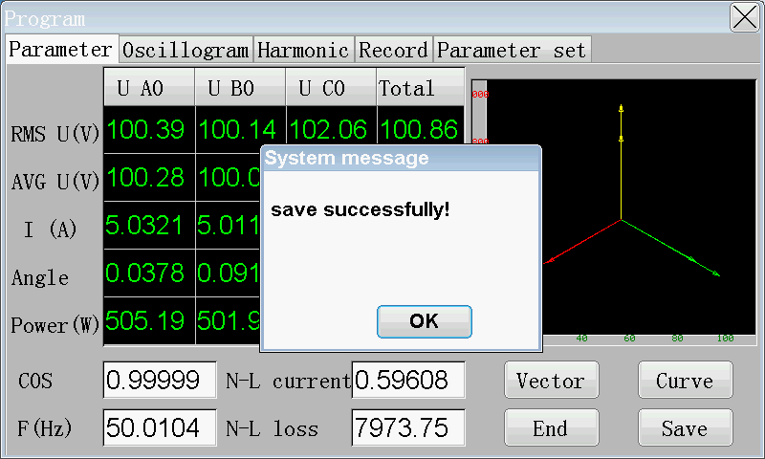
1.3 Waveform Diagrams
After the beginning of test and before it is completed, clicking the wave diagram button to display the current applied voltage waveform of the transformer in first and secondary.
As shown in the figure:
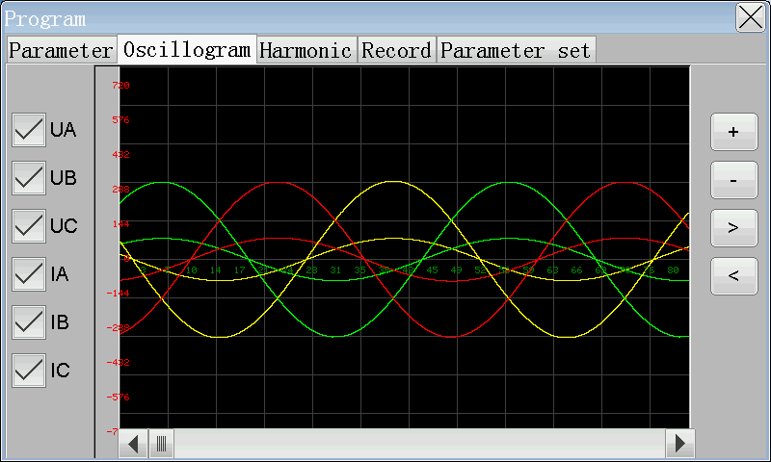

Press the corresponding buttons U1, U2, U3, I1, I2, and I3 to select which waveform to display or close. Click [+], [-] button to enlarge and shrink the waveform, and click [<], [>] to stretch the waveform. Moving the lower slider can move waveform.
1.4 Harmonic Analysis
When starting the test and before it’s finished, click the harmonic analysis button to analyze the harmonic content of the primary and secondary phase voltages.
As shown in the figure:
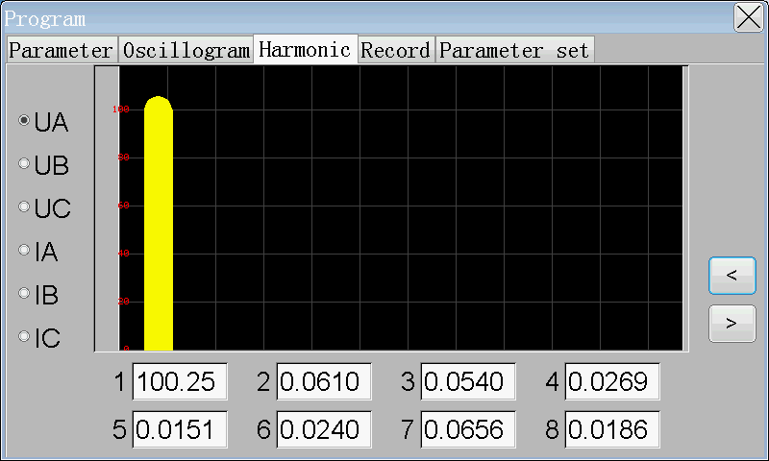
As shown in the figure, set the harmonic of U1, and click [<], [>] to cyclically display 1-32 harmonic contents and percentage
1.5 Record Queries
When the test is completed, the results can be queried and exported to USB disk or uploaded to computer,
As shown in the figure:
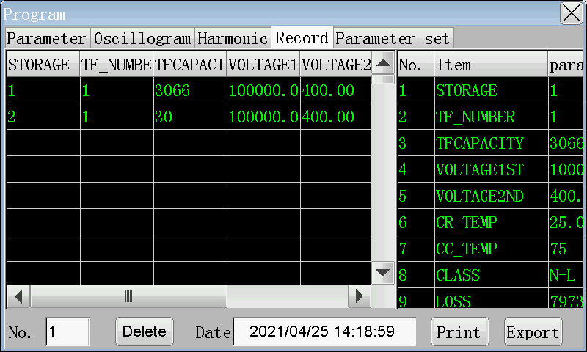
The recorded number in database is displayed on the left and details of a record can be displayed on the right. Clicking the main scroll bar can scroll the screen up and down or left and right to display all the information. Selecting a record and clicking the print button can print the test results on the spot through the printer. Inserting a USB disk and clicking export to export the entire database to the USB disk (inserting USB disk needed to wait for two or three seconds, so the instrument can detect it). The USB disk database adopts Dbase3 database format and can be directly opened, edited and printed by excel spreadsheet. It does not need to install background management software, which makes the management more convenient for users.

V. Packing List
No. | Item | Qty
1 | Main engine | 1
2 | Power line | 1
3 | Ground lead | 1
4 | Touch Pen | 1
5 | Fuse pipe | 2
6 | Print paper | 1
7 | Voltage line | 1
8 | Current line | 1

