HZ2613
Transformer Short-Circuit Impedance And No-load Integrated Machine

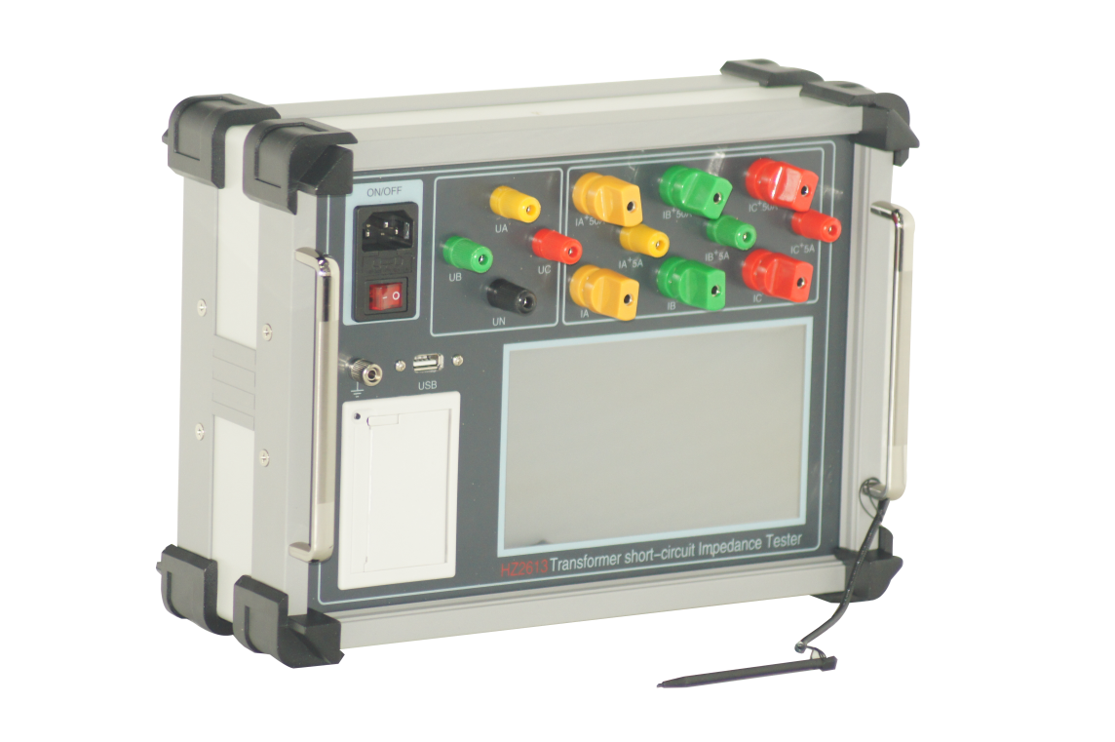

Huazheng Electric Manufacturing (Baoding) Co., Ltd

Foreword
Dear users：
Thank you for choosing HZ2613 transformer short-circuit impedance and no-load integrated machine. In order to ensure that you can operate the instrument as quickly as possible, we are equipped with a detailed operation manual, from which you can learn the product introduction, use methods, instrument performance and safety precautions and many other aspects of knowledge.
Before using the instrument for the first time, please be sure to read this operation manual carefully, and operate and maintain the instrument according to this manual, which will help you better use the product and extend the service life of the instrument.
In the preparation of this manual, we have worked with a scientific and rigorous attitude and believe that the information provided in this manual is correct and reliable. However, there will always be mistakes, and this manual will inevitably contain errors and omissions. If you find an error in the manual, please try to notify us as soon as possible and supervise us to correct the error as soon as possible!
The company reserves the right to improve the function of the instrument. If the function of the instrument is found to be inconsistent with that described in the operation manual during use, the actual function of the instrument shall prevail. We hope that this instrument can make your work easy and pleasant, so that you can experience the relaxed feeling of office automation in the busy work.
When you are satisfied with this instrument, please recommend it to your friends! When you have comments and suggestions on this instrument, please contact us, we will do our best to give you a satisfactory answer. Thank you again for your support to our company!

Contents

I. Overview 1
II. Wiring And Precautions 1
III. Main Functions And Features 1
IV. Main Technical Index 2
V. Key Setting 3
VI. Operation Method 4
1.1Parameter setting 5
1.2 Loss measurement 7
1.3 Impedance measurement 8
1.4 Waveform 9
1.5 Harmonic analysis 10
1.6 Record query 11
VII. Packing List 12

- Overview
HZ2613 transformer short-circuit impedance and on-no load integrated machine, is the latest product launched by our company, the instrument adopts today’s popular ARM processor, 168M main frequency 128M memory expandable 4G memory card. LCD adopts 7 inch HD color touch screen, combined with emwin display interface, making the instrument user-friendly and easy to operate, and can be operated with full touch screen without keyboard. The instrument can support the database and can be exported through the USB disk or transferred to the background computer through the data cable.
The circuit design of the instrument is exquisite and the idea is unique, which makes it have superior performance, powerful function, small size and light weight. It can not only test the empty load parameters of the transformer, but also measure the harmonic content and waveform of the field. The instrument can record transformer no-load test curve to provide a reliable basis for transformer fault analysis.
- Wiring And Precautions
- Please connect and operate the instrument according to this instruction manual.
- The grounding terminal or the grounding terminal of the power cable should be securely grounded nearby.
- Please enter the correct setting parameters before the test, enter the storage serial number to save the test results under this record number, and then set the parameters according to the tested transformer parameters, click the save and modify button to complete the save and enter the test interface, select the parameters to be tested (impedance or parameters), click the Start button, and then slowly raise the test voltage to complete the test. After the test, you can click the end button and save the test record to complete the test.
- The instrument is full touch screen operation, do not knock.
- Main Functions And Features
1.The instrument adopts 7 inch true color liquid crystal, which can measure voltage, current, Angle, power and other electrical parameters, and can display the voltage and current vector diagram, which is clear and intuitive on the same screen.
2. The no-load loss, load loss and other parameters of the transformer can be measured.
3. Can measure single-phase, three-phase transformer impedance, reactance, resistance, impedance voltage percentage and other parameters.
4. The instrument has the function of harmonic analysis, can measure the 1-32 harmonic content of the voltage and current applied on the transformer, and can display the rod diagram and voltage and current waveform diagram.
5. It can automatically record the empty load characteristic curve of different voltage current during the empty load test of transformer, which is convenient for analyzing the characteristics of transformer and iron core.
6. With data storage and data browsing functions, the instrument supports DBF database, which can store test data or browse test records according to user needs. The instrument also supports the USB drive export function, which can export test data through the USB drive, and the database supports the excel spreadsheet open mode, which is convenient for editing, printing or archiving
7. Use 7-inch true color touch screen operation, emwinGUI interface, built-in 128M memory (expandable 4G memory card), support Chinese input, easy to operate.
8. Small size, light weight, accurate measurement, no power failure calendar, clock function, can store the test time at any time.
- Main Technical Index
1.Voltage measuring range： 0－500V phase voltage（line voltage is 800V），
2.Current measuring range： 0.1-50A（Support external CT extended range）.
3.Measurement accuracy：0.2%（Power factor 1.0-0.2），1%（Power factor 0.2-0.01）
4.Working power supply：AC220V±15%
5.Operating temperature：-10℃-40℃
6.Ambient humidity：10%-85%
7.Size ： 320mm×230mm×140mm
8.Weight ： 3.5kg(Test line not included)
- Key Setting
This instrument is a full touch screen operation, with 16 key number keyboard and number pinyin full keyboard (similar to computer keyboard). As shown in the figure:
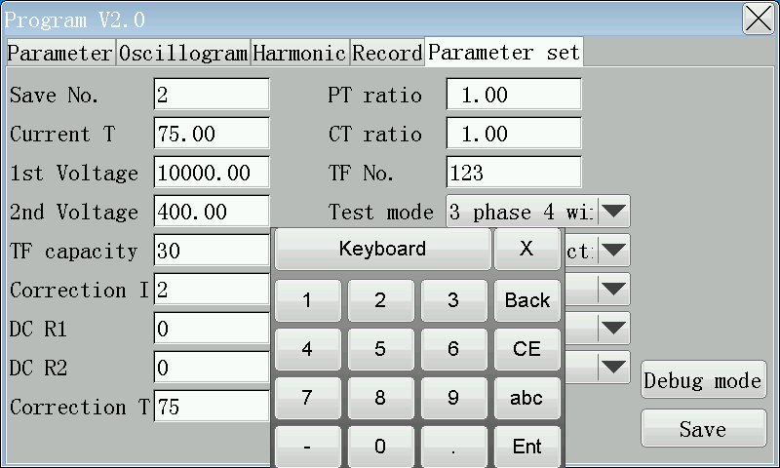
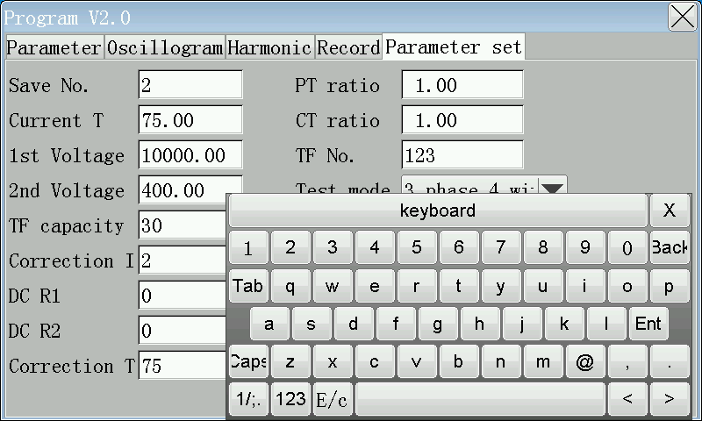
Digit key 0-9: Used to enter data in parameter input state. The “q-m” key is used to enter the user name or transformer model in the alphabetic or full-spell Chinese input method. The “abc” key is used to switch from the numeric keyboard to the alphabetic keyboard, “123” is used to switch from the alphabetic keyboard to the numeric keyboard, and “X” is used to disable the soft keyboard. “keybod” is used to move the keyboard freely on the screen. You can drag the keyboard to any position on the screen by holding this key. “Back” is the backspace key to clear the character before the cursor, “CE” is used to clear all characters of the current input, and “Ent” is the enter confirmation key.
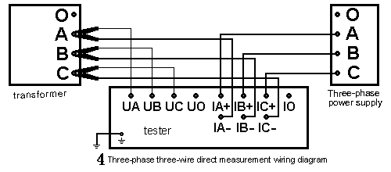
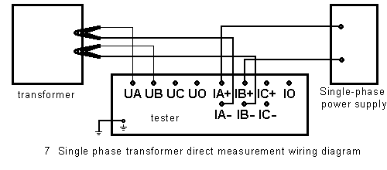
- Operation Method
Connect the power cable, test cable and ground cable according to the requirements of this manual and precautions, turn on the power and enter the main interface of the computer.
As the picture shows:
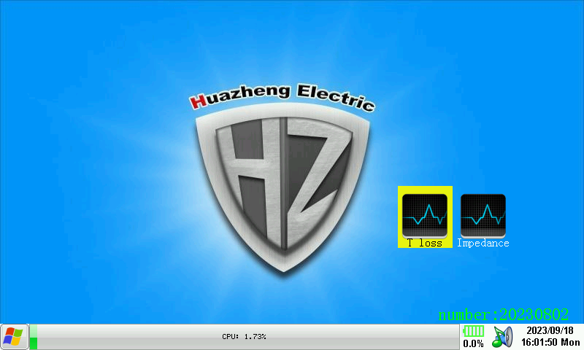
Click the “running program” icon on the screen to enter the test program interface
As shown below:
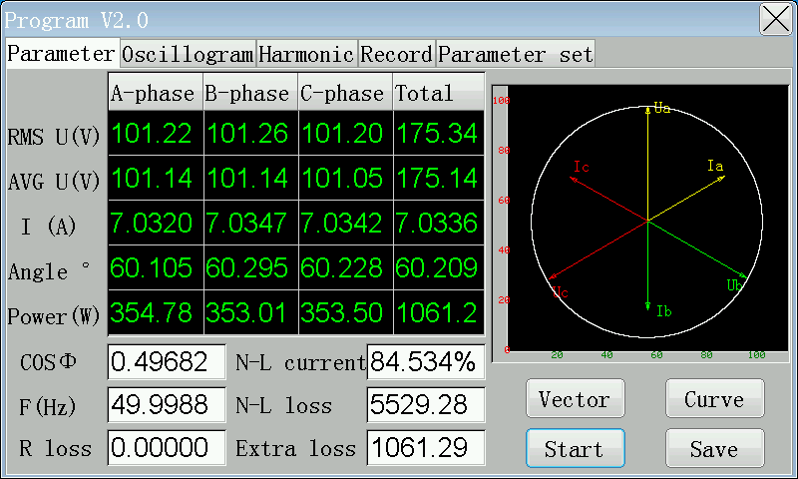

1.1Parameter setting
Before the test, firstly set the parameters, click the “parameter setting” button to enter the parameter setting interface
As the picture shows:
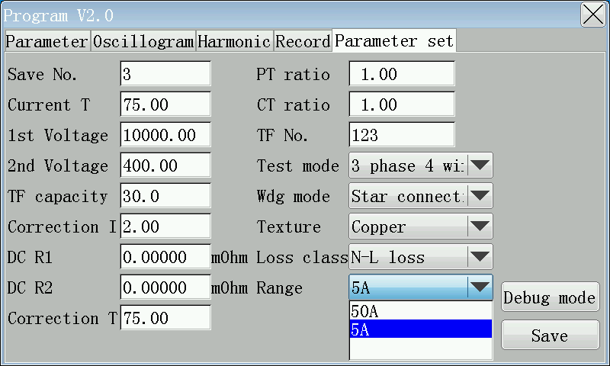
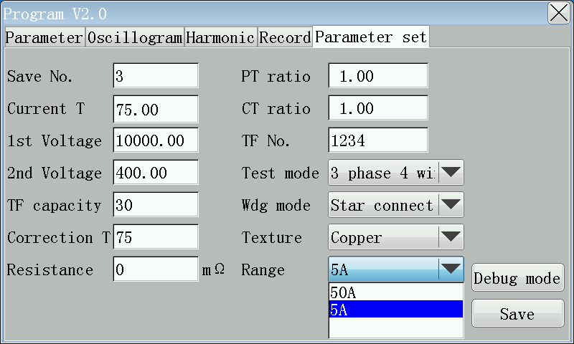
Click on the input box that needs to be set
Memory sequence number：Used to set the record in which the test is stored.
Current temperature: Transformer temperature at the time of test.
Primary and secondary voltage: the primary and secondary rated voltage of the transformer.
Transformer capacity: the rated capacity of the transformer under test.
Correction index: The correction index when testing no-load loss at non-rated voltage (generally do not test no-load loss at non-rated voltage).
Primary resistance: DC resistance between high voltage side lines of the transformer.
Secondary resistance: DC resistance between low voltage side lines of the transformer.
Calibration temperature: The temperature to which the transformer test results need to be calibrated.
Short-circuit resistance: the short-circuit resistance of the second short-circuit. If you ignore it, you can enter 0.
PT, CT ratio: refers to the additional PT, CT ratio when outside the measuring range of the instrument.
Transformer number: Used to store the information of the transformer under test.
Test method: three-phase three-wire refers to the two-watt meter method, three-phase four-wire refers to the three-watt meter method, three-phase phase separation is the test of three-phase transformer with single-phase power supply, single-phase refers to the test of single-phase transformer.
Winding form: It is the winding form of the wiring side of the transformer under test, such as short circuit on the low voltage side, wiring on the high voltage side, and input the high voltage side winding form.
Winding material: The winding of the transformer under test is copper or aluminum.
Loss type: refers to measuring no-load loss or load loss.
After setting, click the “Save and modify” button to save the set information to the database.

1.2 Loss measurement
As shown below：
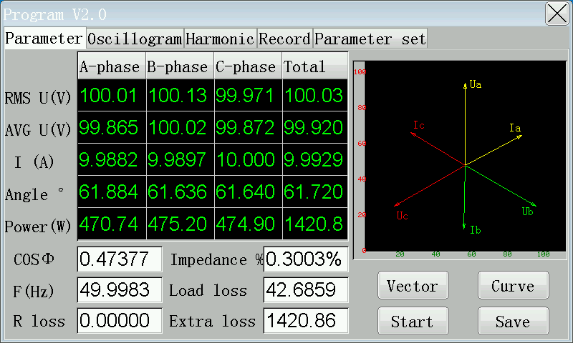
Click the Start button to start the test, and gradually increase the measured voltage or current to the required value to complete the test. Click on the vector diagram to see the phase relationship of the applied voltage and current, click on the curve to see the curve of voltage and no-load current or current and impedance voltage. After the test is completed, click the end button, and click the Save button to save to the database (save to the record number set by the storage serial number).
As shown below：
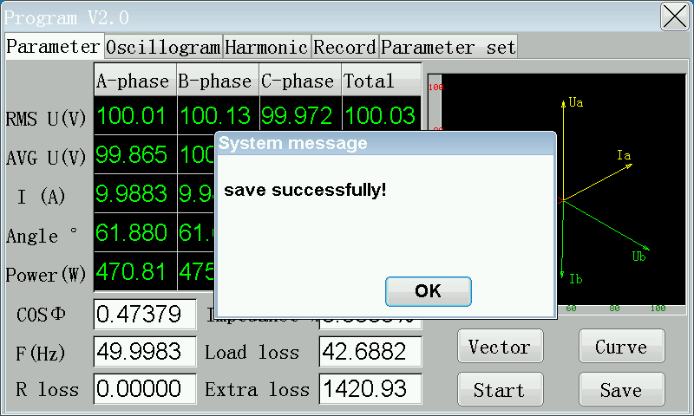

1.3 Impedance measurement
The impedance measurement can be performed by clicking the impedance measurement button，
As shown below：
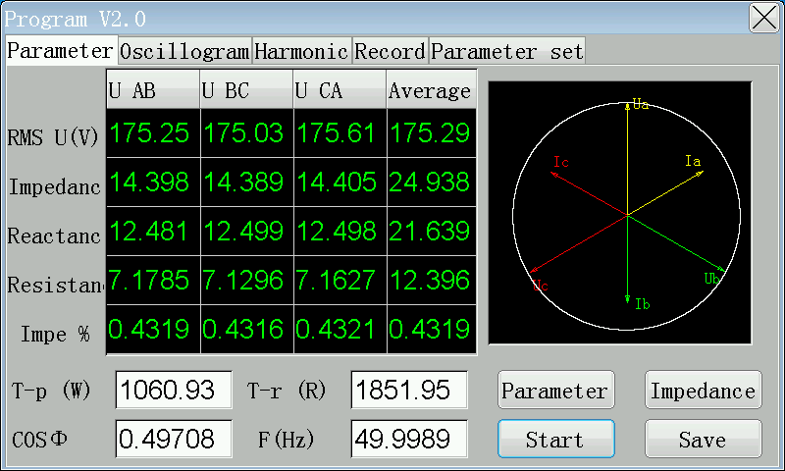

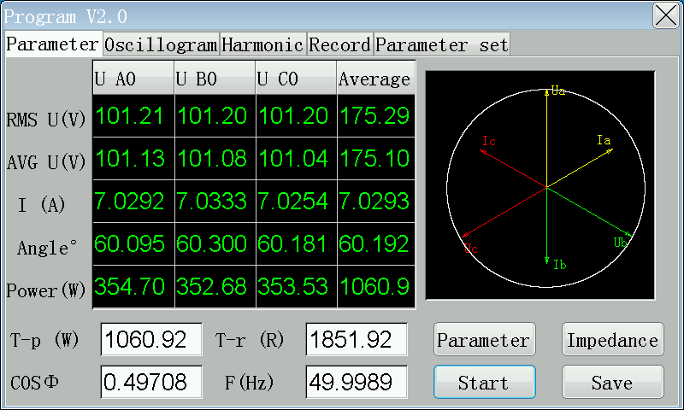
Click the “Start” button to start the test, click the “parameter” or “impedance” button to switch the parameter display content, click the “end” button when the test is completed, click the “save” button to save to the database (save to the record number set by the storage serial number).
As shown below：
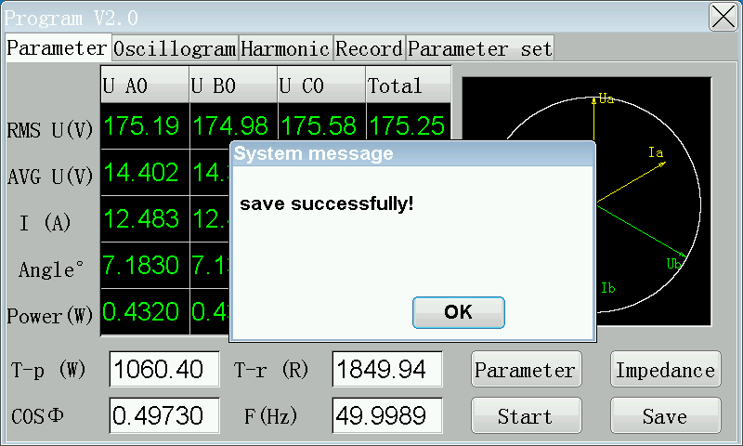

1.4 Waveform
After the start of the test and before the completion of the test, click the waveform diagram button to display the voltage waveform of the transformer applied at the current time.
As shown below:

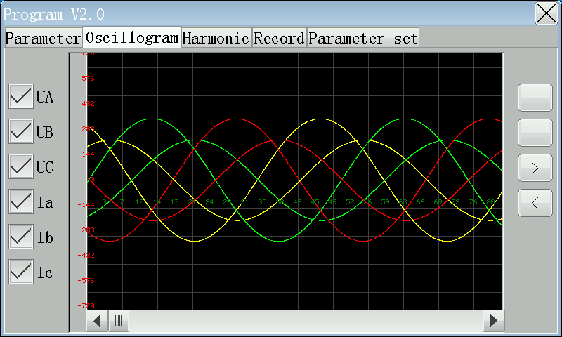
Press UA, UB, UC, Ia, Ib, Ic corresponding buttons to select the waveform to display or close, click 【+】, 【-】 buttons to enlarge or shrink the waveform, 【<】, 【> to stretch the waveform, move the lower slider to move the waveform.

1.5 Harmonic analysis
After the harmonic analysis test starts and before the completion of the test, click the harmonic analysis button to analyze the harmonic content of each phase voltage.
As shown below：
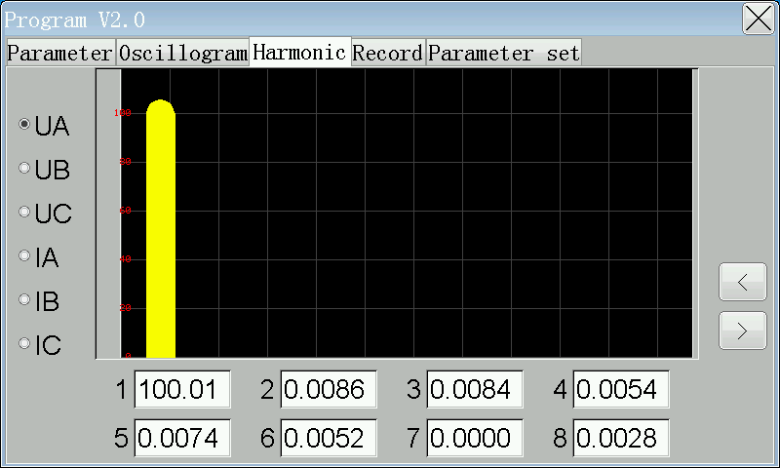

The harmonics of UA are displayed as shown in the figure. Press 【<】, 【>】 to display 1-32 harmonic content and percentage.

1.6 Record query
After the test is completed, the test results can be queried, and can be exported to the USB drive or uploaded to the computer.
As shown below：
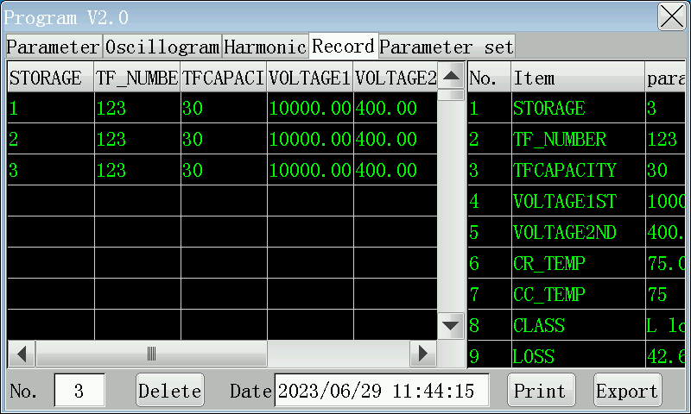
The number of records in the database can be displayed on the left, and the details of a record can be displayed on the right. Click the main scroll bar to scroll the screen up and down or left and right to display all the information. Select a record and click the “print” button to print the test results on site through the printer. Insert flash drive Click Export to export the entire database to the flash drive (wait two or three seconds for the flash drive to be detected by the instrument). The flash disk database adopts the Dbase3 database format, and can be opened directly by excel spreadsheet, editing and printing, etc., without installing background management software, which makes it’s more convenient for users’ management.

- Packing List
No. | Item | Qty
1 | Main engine | 1
2 | Power line | 1
3 | Ground lead | 1
4 | Touch Pen | 1
5 | Fuse pipe | 2
6 | Print paper | 1
7 | Voltage line | 1
8 | Current line | 1

