HZ2612
Transformer Short Circuit Impedance Tester

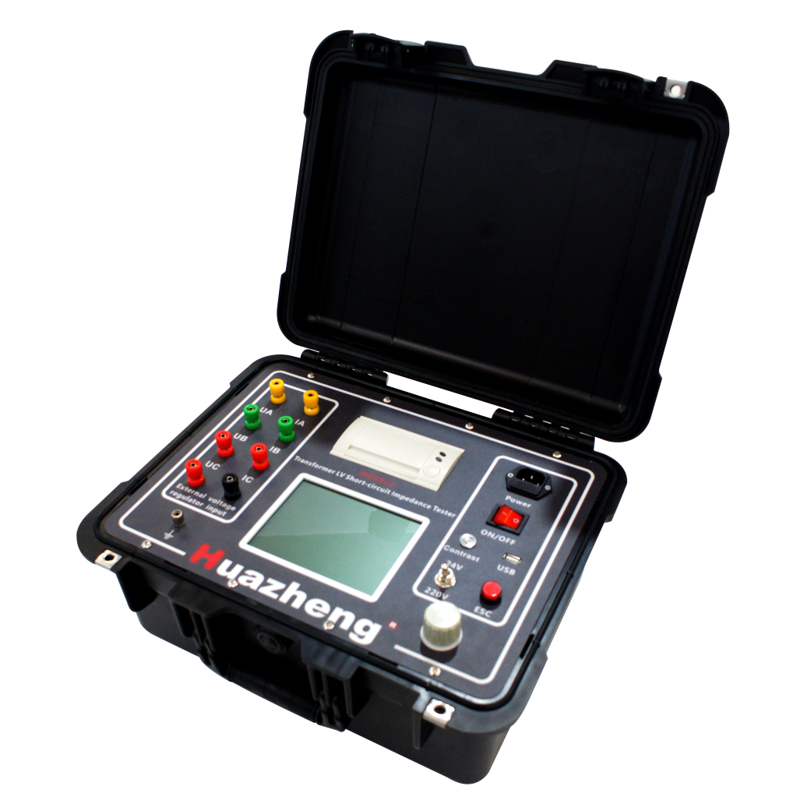

Huazheng Electric Manufacturing (Baoding) Co., Ltd

Legal Disclaimer
Please read this user manual carefully before using the instrument. By using this instrument, we assume that the operator has completed the corresponding reading and training. Our company shall not be liable for any legal responsibility for any safety accidents that occur due to failure to follow the instructions.
Our company’s purpose is to continuously improve and perfect our products. Therefore, the instrument and supporting software you use may have slight differences from the user manual. If there are any changes to the user manual, we will not notify separately.
Safety Requirements
1.The transformer winding deformation test should be carried out before all DC tests or after the winding is fully discharged.
2.Before use, please turn off the power switch of the tester and then connect the wires.
3.The housing of the tester and the transformer should be reliably grounded.
4.The sheathed leads (including overhead lines, enclosed busbars, and cables) should be fully released, and these leads should be kept as far away from the transformer sheath as possible (the surrounding grounding bodies and metal suspensions should be kept more than 20cm away from the transformer sheath), especially for transformers connected to enclosed busbars.
5.In case of an emergency, turn off the power of the tester first and then take further action.

Dear user:
Thank you for choosing HZ2612 Transformer Short Circuit Impedance Tester.
We hope that this instrument can make your work easier and more enjoyable, so that you can get the feeling of office automation in the test and analysis work.
Before using the instrument, please read this manual, and operate and maintain the instrument according to the manual to prolong its service life.
"Just a light press, the test will be completed automatically" is the operating characteristics of this instrument.
If you are satisfied with this instrument, please tell your colleagues; if you are not satisfied with this instrument, please call (0312) 6775656 to tell you to serve you at all times-Baoding Huazheng Electric Manufacturing Co., Ltd., our company will definitely make you satisfied !
Contents

I. Overview And Features Of The Instrument 1
II. Panel Operation And Wiring Instructions 3
III. Operating Instructions 6
IV. Technical Specifications 14
V. Routine Maintenance 15
VI. Packing List 16

Overview And Features Of The Instrument
[Instrument Overview]
During the testing process of power transformers, inter-turn or inter-phase short circuits may occur, or collisions may happen during transportation, causing relative displacement of the coil, and deformation of the coil due to electromagnetic force during operation in short circuit and fault states. This will change the distributed parameters of the transformer windings and consequently affect and alter the original impedance characteristics of the transformer.
The No. [2000] 589 document entitled "25 Key Requirements for Preventing Major Accidents in Power Production" issued by the State Power Corporation specifies in Article 15.2: "Transformers with a voltage level of 110 kV or above should be subjected to low-voltage short-circuit impedance testing or frequency response testing of winding deformation before leaving the factory or being put into operation to preserve the original records". Article 15.6 states: "After experiencing a sudden short-circuit in the near area, the transformer should be tested for low-voltage short-circuit impedance or frequency response of winding deformation, and compared with the original records. Only when it is determined that there is no fault in the transformer can it be put into operation". Low-voltage impedance testing can accurately reflect the changes in impedance values of the transformer before and after winding deformation. The "Guidelines for the Detection and Judgment of Inductive Method for Detecting Deformation of Transformer Windings" (DL/T1093-2008) stipulate that on-site testing power supplies can be used to measure the dynamic stability parameters of transformer windings and iron cores by means of low-voltage testing to determine whether the transformer windings are deformed or displaced. The dynamic stable state of the winding and iron core is determined. The guidelines provide provisions or suggestions for the testing timing, testing parameters, testing methods, testing instruments, judgment principles, and quantitative limits for judgment.
This product uses synchronized sampling of voltage and current, high-speed digital signal processing, and accurate measurement data. The instrument can use an internal output power supply or an external power supply and adopts a step-by-step measurement method. For three-phase transformers, manual or automatic measurement can be performed, and the data can be stored long-term in the internal memory. The instrument comes with data printing function.
Performance Features:
The technical performance fully complies with the technical requirements of the national standard DL/T1093-2008 "Guidelines for the Detection and Judgment of Transformer Winding Deformation by Impedance Method".
Two modes of internal and external power supply are used. The internal power supply provides two levels of 24V and 220V. For the first test, the 24V gear should be selected to prevent excessive short-circuit current. The 220V gear can only be selected when the test current is less than 1A.
High-performance embedded processing chips, digital narrow-band filtering technology, and other technologies are used to effectively suppress power frequency and high-frequency interference.
The three-phase connection method is used for phased measurement. Only the low-voltage side needs to be short-circuited, and the high-voltage side needs to be connected with three phases at one time. The short-circuit impedance of each phase can be calculated automatically after one-time measurement.
Two modes of manual measurement and automatic measurement are optional during the measurement process. For the first test, the manual measurement mode can be used to observe the measured current and voltage as a trial. The automatic measurement mode automatically completes the measurement and calculation.
During the measurement process, synchronously acquire voltage, current, frequency, active power, short-circuit impedance, short-circuit reactance, leakage inductance, etc.
Support test data generation, printing and output.
Short-circuit protection ensures that the instrument will not be damaged in case of accidental short-circuit during wiring.

Panel Operation And Wiring Instructions
2.1 Panel Schematic
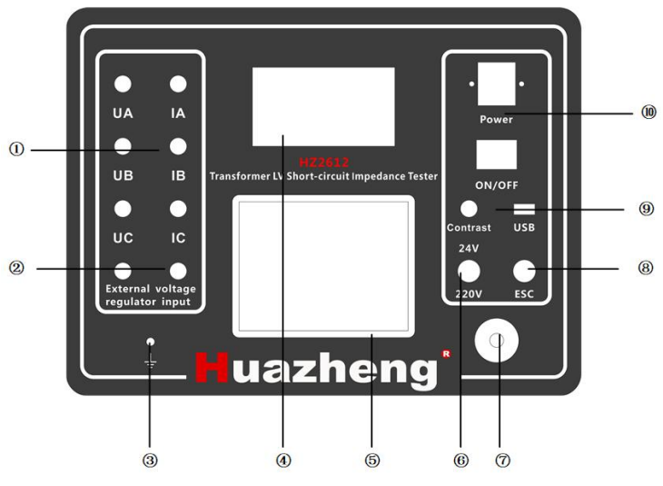
Figure 2.1 Panel Schematic
1) Wiring terminals: The voltage and current measurement poles are connected to the transformer test voltage end. UA, UB, UC are the voltage measurement wiring terminals, and IA, IB, IC are the current measurement terminals.
2) External power supply: Used to input measurement power from an external source, the software interface should also be set to external power supply measurement mode.
3) Grounding terminal: Safety grounding terminal.
4) Printer: Thermal printer, outputs measurement data, paper replacement is as simple as pressing a button to open.
5) Display screen: Large screen, wide temperature band, special white-on-black LCD, clear font visible in sunlight, and all operations displayed in Chinese.
6) Selection of internal power supply voltage: When using the internal power supply mode, the measurement voltage is generated internally by the instrument, providing a choice of 24V and 220V. Flip up for 24V and down for 220V.
7) Rotating mouse: Used for up and down selection by choosing the mouse, press down to confirm.
8) Cancel key: Used to cancel a setting or go back to the previous step.
9) Contrast control: Used to adjust screen display effect.
10) Power input: 220V, 50Hz AC power input.
2.2 Wiring and Measurement
2.2.1 Wiring
1) Clamp one end of the grounding wire to the ground grid and connect the other end securely to the grounding terminal on the panel. Note that the grounding point of the ground grid should have good electrical conductivity, otherwise it will affect the accuracy of the measurement.
2) Strictly follow the wiring diagram below for the high voltage side according to the type of object being measured, and ensure that each contact point is well-connected. Short-circuit the corresponding low-voltage side with a copper strip.
3) During the test process, the specimen should be disconnected from external circuits.
4) Plug in the power plug.
Note: For a single-phase transformer, only connect the A and B test terminals on the high voltage side, and short-circuit the low-voltage winding. The short-circuit wire should be as short as possible, and the connection should be well-connected.
For a three-phase transformer, connect the A, B, and C test terminals on the high voltage side, and short-circuit the low-voltage winding. The short-circuit wire should be as short as possible, and the connection should be well-connected.

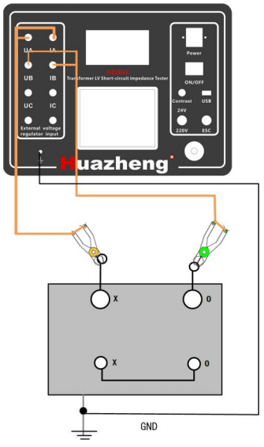
Figure 2.2 Schematic diagram of the wiring for testing a single-phase transformer.
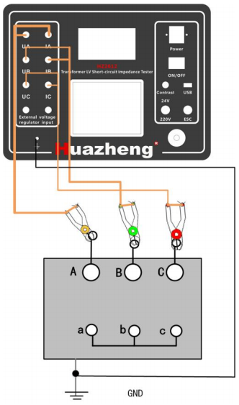
Transformer ground
Figure 2.3 Schematic diagram of the wiring for testing a three-phase transformer.
Translation:
2.2.2 Test Procedure
1) Turn on the power switch and the instrument will display the startup page.
2) Select "single-phase transformer" or "three-phase transformer" according to the actual type of the object being tested, and set other parameters as described in the following section.
3) After setting the parameters, press "Start Measurement" to begin the measurement.
2.2.3 End of Test
1) Turn off the power switch and unplug the power cord.
2) Remove the dedicated test cables and store them properly for future use.
3) Remove the grounding wire and organize it neatly.

Operating Instructions
3.1 Measurement Settings
Figure 3.1 Test Settings
By using the up and down keys, select the corresponding right-hand menu. When the cursor is on the "Measurement Settings" menu, press the knob to enter the right-hand measurement settings. Rotate the knob to select the item that needs to be set. At this time, the selected option will be highlighted. Press the knob to confirm the selection. For options that include numbers, press the knob again to reverse the display of a specific digit. Then, rotate the knob to select the desired data and press the knob to confirm the selected data. Repeat this process to modify each digit. Please make sure that these settings are carefully adjusted, or else the test results may be inaccurate!
Type: Choose either "three-phase transformer" or "single-phase transformer" depending on the device being tested.
Pressurized Winding: When the test type is "three-phase transformer," select "YN type," "Y type," or "delta type" based on the high-voltage terminal of the wiring end and the actual test object. This option is ignored when the test type is "single-phase transformer."
Test Position: Select high-voltage to low-voltage, high-voltage to medium-voltage, or medium-voltage to low-voltage based on the actual testing situation.
Rated Capacity: The rated capacity marked on the transformer nameplate, measured in KVA.
Rated Voltage: The rated voltage value at the current test location, in volts (V). Refer to the information on the transformer nameplate for details.
Nameplate Impedance: The factory impedance value of the transformer or the comparison standard value, measured in percentage (%). According to the specific test location, refer to the information on the transformer nameplate.
Material: The material of the transformer winding, available in copper or aluminum.
Oil Temperature: The working oil temperature of the current transformer, defaulting to 75℃.
Tap Changer: The position of the tap changer during the current test.
Number: The test number used to store the measurement results.
Test Power Supply: The power supply is divided into internal power supply and external power supply. The internal power supply is generated by the instrument itself and has two options, 24V and 220V. The fluctuation switch on the instrument panel is used to select between the two. Select the external power supply and input the appropriate AC power supply through the external power supply terminal on the instrument panel.
Measurement Mode: The measurement mode is divided into manual measurement and automatic measurement. Select automatic measurement, and the system automatically outputs the voltage, judges the output stability, completes the entire measurement process, and obtains the test results. Select manual measurement, and the measurement process needs to be controlled manually.
3.2 Starting the Measurement
Note: When selecting the internal power supply, for the first pressurization, please select the 24V gear (the instrument panel fluctuation switch is pushed upwards), and if the test current is less than 1A, the 220V gear can be selected. Otherwise, the instrument fuse may be blown due to excessive current!
After setting the parameters according to the wiring instructions and actual testing conditions, you can start the measurement. Turn the knob to "Start Measurement". After pressing it, the interface will appear as shown below. Press "OK" to begin the formal measurement.
Figure 3.2 Starting the measurement
During the measurement process, for the three-phase transformer, the instrument will gradually add pressure to AB, BC, CA, and measure the corresponding voltage and current values. After measuring the phase, the interface will display the current measurement of voltage, current, test power (total power), reactance, and impedance values, and then move on to the next phase measurement until the measurement is completed and the measurement results are output.
When measuring in manual mode, please follow the prompts on the interface. After visually confirming the stability of the voltage and current, press the knob to enter the accurate measurement, display the measurement value of the current phase, and then press the knob again to enter the next phase measurement until the measurement is completed and the measurement results are output.
Figure 3.3 Measurement Process One.
Figure 3.4 Measurement Process Two
After the test is completed, the interface is displayed as shown in Figure 3.5, showing the test current, test voltage, active power, and power frequency of each phase. ZA, ZB, ZC are the impedance values of each phase, and ZA%, ZB%, ZC% are the short-circuit impedance values of each phase. ZK% is the short-circuit impedance value of the three-phase transformer, and △ZK% is the error percentage between the measured value and the nameplate short-circuit impedance value.
Figure 3.5 Measurement Results
After the measurement is completed, press the knob button to select "Print", "Quit" or "Store". The instrument comes with a thermal printer that outputs a test report in the following format:
Figure 3.6 Measurement Report Printing.
3.3 Data Viewing
The system can save up to 100 sets of test data, and when it is full, it will cycle to overwrite the first saved data. You can select the desired test data by rotating the knob, then press the knob button to enter the view of the measurement data. You can output the test data by selecting "Print", go back to the main page by selecting "Quit", and save the data to the inserted USB flash drive by selecting "Store".
Figure 3.7 Historical Test Data
3.4 System Settings
Power Beep: Whether to activate the buzzer when the power is on. It is recommended to turn on this setting.
Time Setting: Adjust the time of the instrument.
Measurement Bandwidth: Adjust the measurement bandwidth to increase measurement accuracy.
System Calibration: Calibration of the sampling channel. Normally, testers do not need to use this function, as it is only used by the manufacturer for calibration purposes.
Firmware Version: The firmware version of the instrument.
Figure 3.8 System Settings Interface.

Technical Specifications
1) Technical Parameters:
Voltage Measurement Range: 15V ~ 400V
Voltage Measurement Accuracy: &lt;±(0.2%+2 digits)
Current Measurement Range: 0.1A ~ 20A
Current Measurement Accuracy: &lt;±(0.2%+2 digits)
Frequency Accuracy: 0.1 grade
Dimensions: 407mm(L)×340mm(W)×192mm(H)
Weight: 9.8kg
2) Applicable Environment:
Temperature: -10℃～45℃
Humidity: &lt;90%, non-condensing.

Routine Maintenance
1.Moisture-proof
In areas with humid climate or during humid seasons, if the instrument is not used for long periods, it is recommended to power it on for about two hours once a month to dissipate moisture and protect the components.
2.Storage
When not in use, the instrument should be stored in an indoor environment with a temperature between -20℃ to 60℃, relative humidity not exceeding 85%, well-ventilated, and without corrosive gases.
3.Sun Protection
When using the instrument outdoors, it is recommended to operate it in a shaded area as much as possible to avoid or reduce direct sunlight exposure to the display screen.
4.Fuse Replacement
If the wiring board is powered, but the instrument cannot start properly, check whether the fuse on the power socket is intact. If it is burned out, replace it with a new matching fuse. Refer to the installation position of the original fuse for installation instructions.
5.Printer Paper Replacement
Replacing the paper for the included printer is straightforward. When the print paper runs out, use the panel lever to open the printer cover, identify the front and back of the thermal printing paper, place it facing down (with the sensing surface down) into the printer, pull out the paper, and then close the printer cover.
6.Transportation
This instrument is a precision and valuable device. During transportation, make sure the cabinet is secured to prevent damage to the panel, especially the display screen. Handle with care to prevent dropping or impact.

Packing List
No | Item | Quantity
1 | Transformer short -circuit impedance tester | 1
2 | Dedicated test line | 3
3 | Ground line (including chip head) | 1
4 | Bronze belt | 1
5 | Thermal printing paper | 2
6 | Subtract (20A) | 3
7 | Power cable | 1
8 | User's guide | 1
9 | Factory inspection report | 1
10 | Qualification certificate | 1

