HZ2611
Transformer Short Circuit Impedance Tester

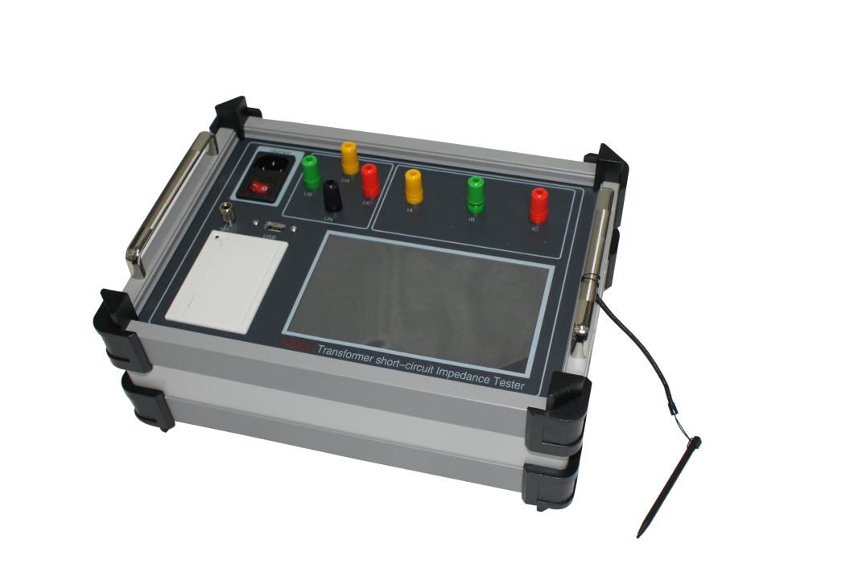

Huazheng Electric Manufacturing (Baoding) Co., Ltd

Dear user:
Thank you for choosing HZ2611 Transformer Short Circuit Impedance Tester.
We hope that this instrument can make your work easier and more enjoyable, so that you can get the feeling of office automation in the test and analysis work.
Before using the instrument, please read this manual, and operate and maintain the instrument according to the manual to prolong its service life.
"Just a light press, the test will be completed automatically" is the operating characteristics of this instrument.
If you are satisfied with this instrument, please tell your colleagues; if you are not satisfied with this instrument, please call (0312) 6775656 to tell you to serve you at all times-Baoding Huazheng Electric Manufacturing Co., Ltd., our company will definitely make you satisfied !
Contents

I. Wiring And Precautions 1
II. Main Functions And Features 1
III. Main Specifications 2
IV. Key Setting 3
V. Wiring Diagram 4
VI. Operation Method 4
VII. Packing List 10

The transformer short-circuit impedance tester adopts the popular ARM processor, 168M main frequency and 128M memory, which can be expanded with 4G memory card. The LCD adopts a 7-inch high-definition color touch screen, combined with the emwin display interface, which makes the instrument interface friendly and easy to operate, and can be operated on a full touch screen without a keyboard. The instrument can support the database and can be exported through a USB flash drive or transmitted to the background computer through a data cable.
The circuit design of the instrument is exquisite and the idea is unique, which makes it superior in performance, powerful in function, small in size and light in weight. It can not only test the impedance load parameters of the transformer, but also measure the harmonic content and waveform on site. The instrument is powerful and easy to operate, providing a reliable basis for transformer parameter analysis.

- Wiring And Precautions
When using the instrument, please follow the wiring and operation of this instruction manual.
  - The grounding terminal or the grounding terminal in the power cord should be reliably grounded nearby.
  - Please enter the correct setting parameters before the test. Enter the storage number to save the test results under this record number, and then set various parameters according to the parameters of the transformer under test. After setting, click the save the modify button to save and enter the test interface . parameter (impedance or parameter), click the start button, and then slowly increase the test voltage to complete the test. At the end of the test, you can click the end button and save the test record to complete the test.
  - The instrument is fully touch-screen operated, please do not bump it.

- Main Functions And Features
1. The instrument adopts 7-inch true-color LCD, which can measure electrical parameters
such as voltage, current, angle, power, etc., and can display the vector diagram of voltage and current, which is clear and intuitive on the same screen.
2. It can measure the impedance, reactance, resistance, impedance voltage percentage and other parameters of single-phase and three-phase transformers.
3. The instrument has a harmonic analysis function, which can measure the 1-24th harmonic content of the voltage and current applied to the transformer, and can display bar graphs and voltage and current waveforms.
4. Built-in three-phase inverter power supply , the impedance of the three-phase transformer can be tested without three-phase power supply and voltage regulator on site , which is convenient for on-site use .
5. With data storage and data browsing functions, the instrument supports DBF database, which can store test data or browse test records according to user needs. The instrument also supports USB export function, which can export test data through USB, and the database supports the opening method of excel spreadsheet, which is convenient for editing, printing or archiving
6. It adopts 7-inch true-color touch screen operation, emwinGUI interface, built-in 128M memory (extensible 4G memory card), supports Chinese character input, and is easy to operate.
7. Small size, light weight, accurate measurement, no power-off calendar, clock function, can store test time at any time.
8. The built-in printer of the instrument is convenient for on-site printing of test records.

- Main Specifications
1. Voltage measurement range: 0-20 phase voltage,
2. Current measurement range: 0-2A.
3. Measurement quantity Refined Accuracy: 0.2% (power factor 1.0-0.2), 1% (power factor 0.2-0.01)
4. Working power supply: AC220V±15%
5. Working temperature: -10℃-40℃
6. Ambient humidity: 10%-85%
7. Volume: 320mm×230mm×140mm
8. Weight: 3kg (excluding test wires)

- Key Setting
The instrument is fully touch-screen operated, equipped with a 16-key numeric keyboard and a full keyboard of digital pinyin (similar to a computer keyboard). As shown in the picture:
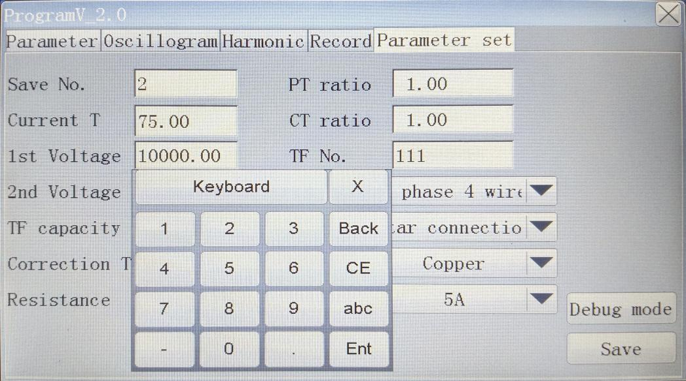

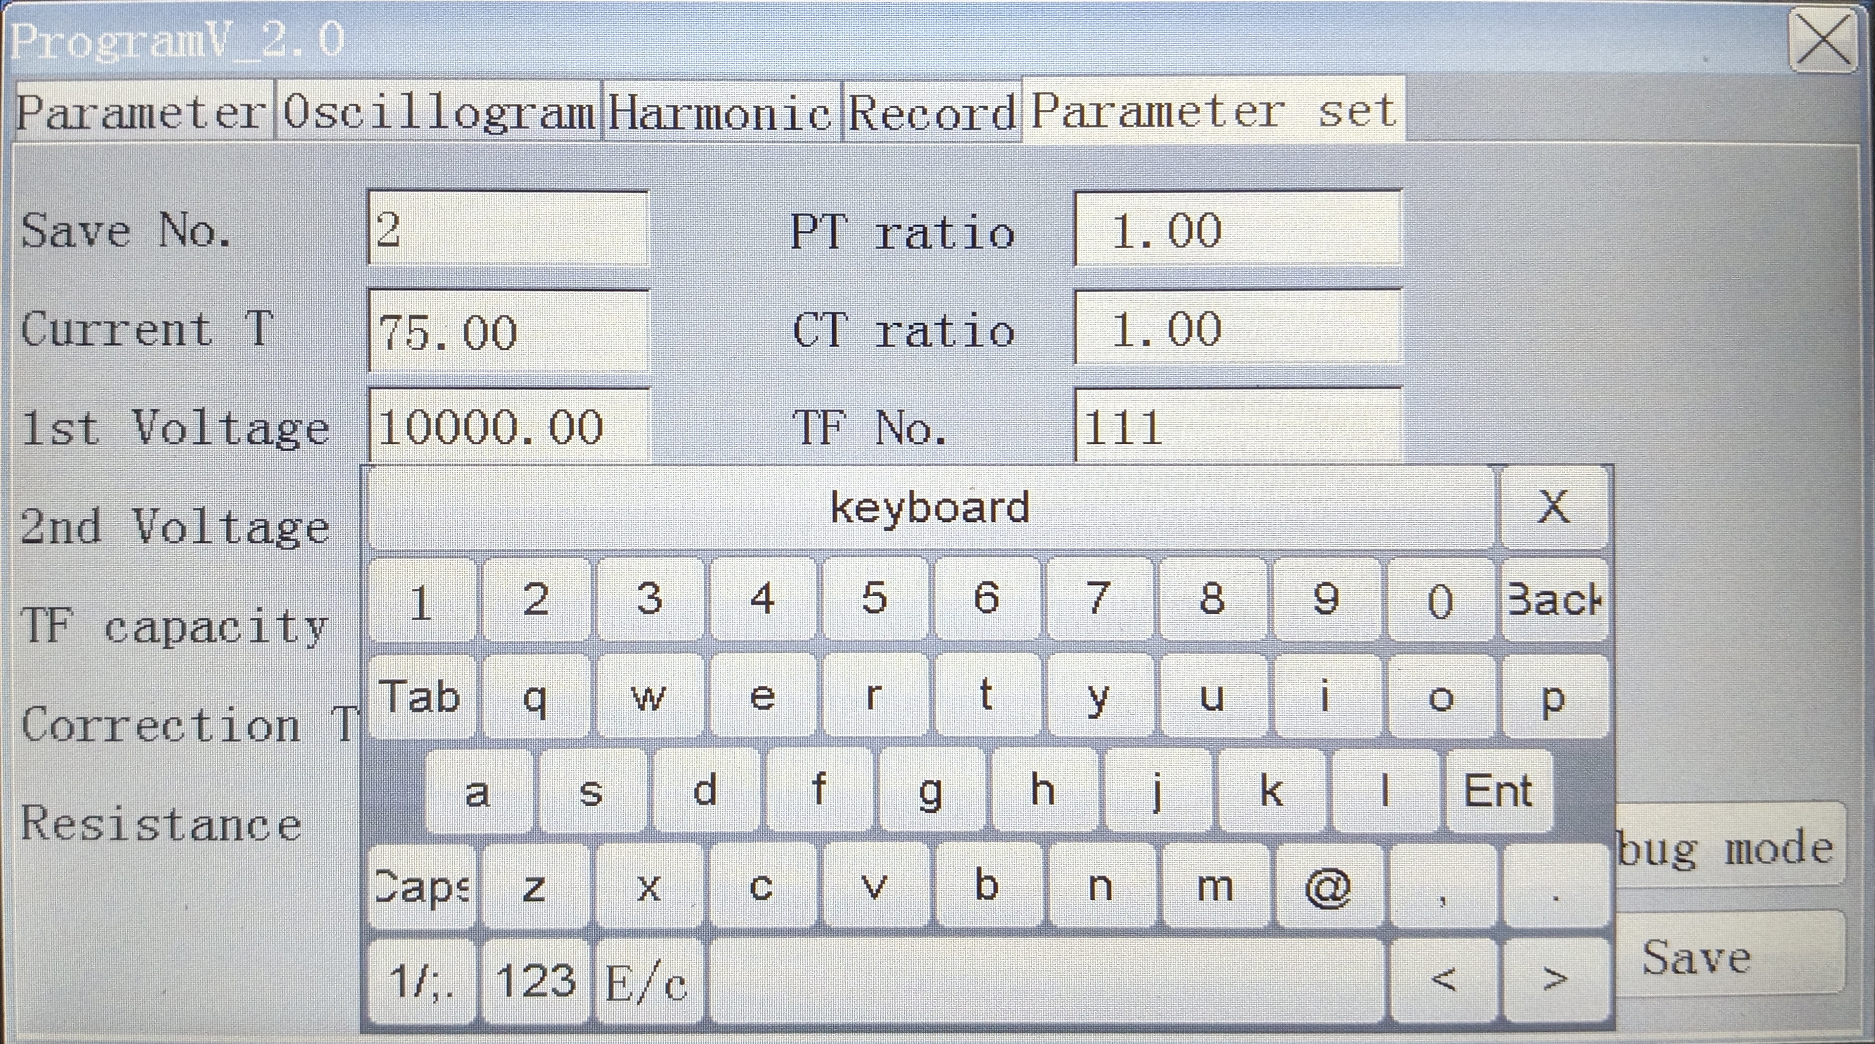

Number keys "0-9": In the parameter input state, used to input data. The "az" key is used to input the user name or transformer model, etc. with the alphabet or full-pin Chinese character input method, the "abc" key is used to switch from the numeric keyboard to the alphabetic keyboard, "123" is used to switch from the alphabetic keyboard to the numeric keyboard, and "C/ e" "c/E" is used to switch from letters to Quanpin input method and from Quanpin input method to letter input. "X" is used to close the soft keyboard. "keybod" is used to move the keyboard freely on the screen, click and hold this key with your hand to drag the keyboard to any position on the screen. "Back" is the backspace key to clear the character before the cursor, "CE" is used to clear all the characters of the current input item, and "Ent" is the carriage return confirmation key.

- Wiring Diagram

C B A
H
V

L
V

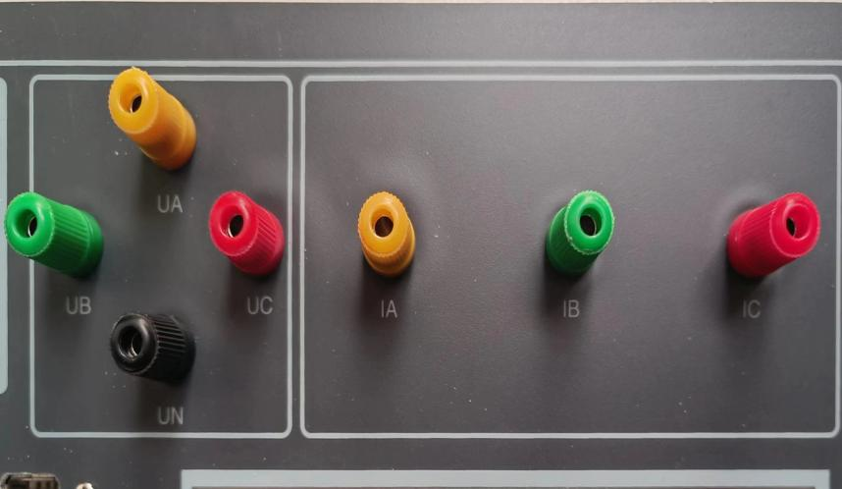

- Operation Method
Connect the power line, test line and grounding line according to the requirements in the wiring and precautions in this manual, and then enter the main interface of the computer after turning on the power.
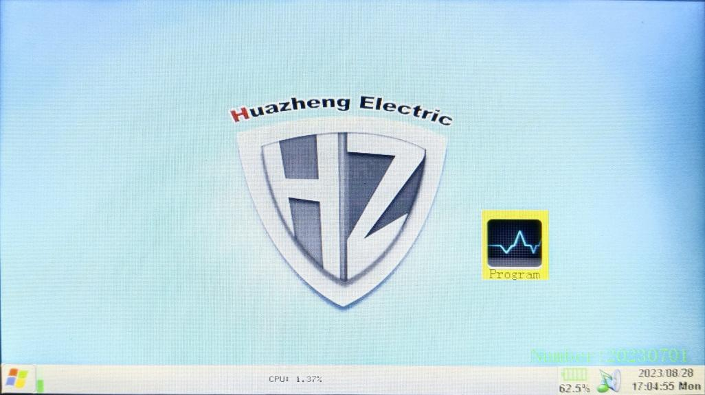
Click program on the screen to enter the test program interface
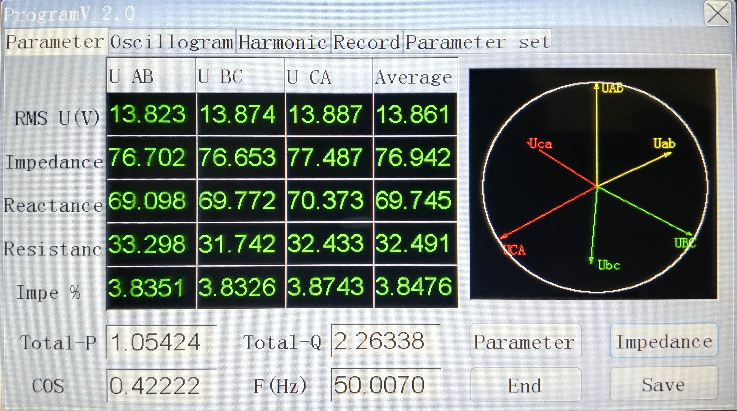
- Parameter setting
Before the test, first set the parameters, click the parameter setting button to enter the parameter setting interface.
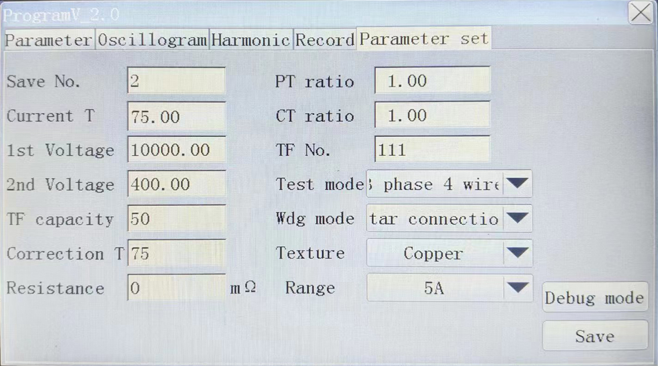
Which input box needs to be set which item can be clicked.
Storage number: used to set which record the test is stored in.
Current temperature: Transformer temperature at the time of test.
Primary and secondary voltage: the primary and secondary rated voltage of the transformer.
Transformer number: used to store the information of the transformer under test.
Transformer capacity: the rated capacity of the transformer under test.
Correction temperature: The temperature to which the transformer test results need to be corrected.
Short-circuit resistance: the short-circuit resistance of the secondary short-circuit, if it is ignored, 0 can be input.
Test method: three-phase three-wire refers to the two-wattmeter method, three-phase four-wire refers to the three-wattmeter method, three-phase phase-splitting refers to testing three-phase transformers with single-phase power supply, single-phase refers to testing single-phase transformers (the instrument is then When using the built-in inverter power supply, the default three-phase four-wire test method ) .
Winding form: It is the winding form of the wiring side of the transformer under test, such as short circuit at the low voltage side, wiring at the high voltage side, input winding form of the high voltage side ( star connection or delta connection ) .
After the setting is completed, click the Save Modification button to save the set information into the database .
- Impedance measurement
Click the impedance measurement button to perform impedance measurement,
As shown below:
Click the start button to start the test, click the parameter or impedance button to switch the parameter display content, click the end button after the test is completed, and click the save button to save to the database (save to the record number set by the storage number).
- Waveform diagram
After the test starts and before the test is completed, click the waveform button to display the primary and secondary voltage waveforms of the transformer currently applied.
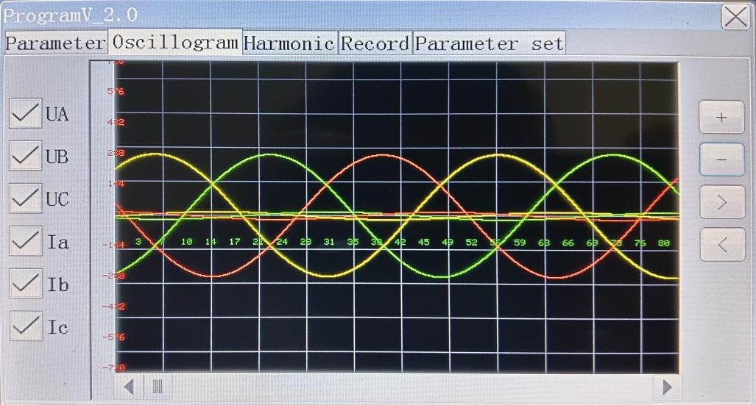
Click the corresponding input phase to choose to display or not display the waveform of a certain phase.
- Harmonic Analysis
After the test starts and before the test is completed, click the harmonic analysis button to analyze the harmonic content of the primary and secondary voltages of each phase.
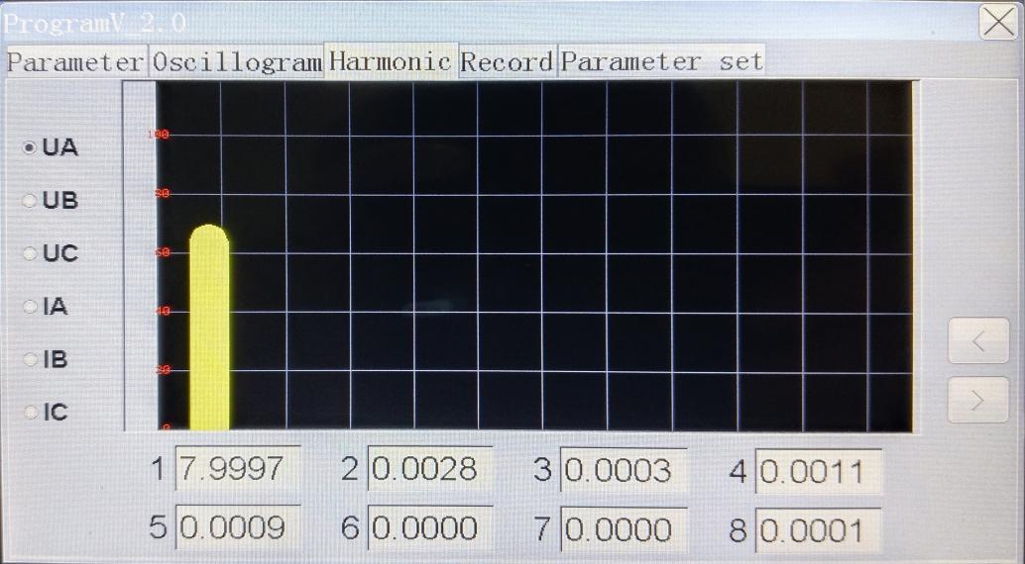
- Record query
After the test is completed, the test results can be queried and exported to a USB flash drive or uploaded to the computer.
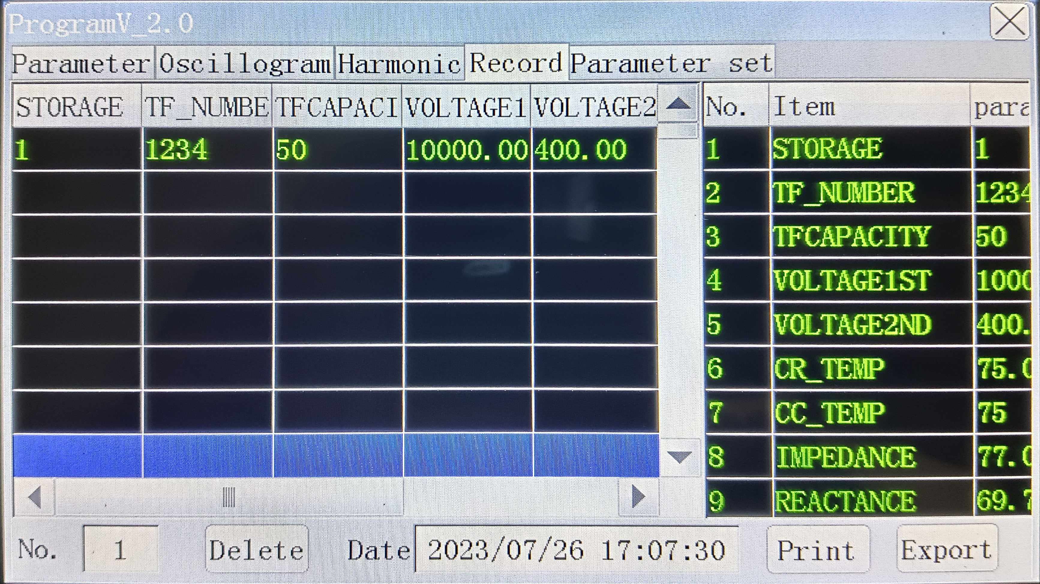
The number of records in the database is displayed on the left, and the detailed information of a record can be displayed on the right. Click the main scroll bar to scroll the screen up and down or left and right to display all information. Select a record and click the print button to print the test results on the spot through the printer. Insert the USB flash drive and click Export to export the entire database to the USB flash drive (wait for two or three seconds to insert the USB flash drive for the instrument to detect the USB flash drive). The USB database adopts the Dbase 3 database format, which can be directly opened, edited and printed by the excel electronic form, without installing background management software, which makes the user's management more convenient.

- Packing List
No. | Item | Qty
1 | Short-circuit Impedance Tester | 1
2 | Test Line | 1
3 | Rough Short Wiring | 1
4 | Power Cable | 1
5 | Stylus | 1
6 | Printer Paper | 1
7 | Testing Report | 1
8 | Manual | 1
9 | Qualification Certificate | 1
10 | Ground Wire | 1
11 | Fuse | 2

