

HZ-3340D
DC Resistance Test Instrument

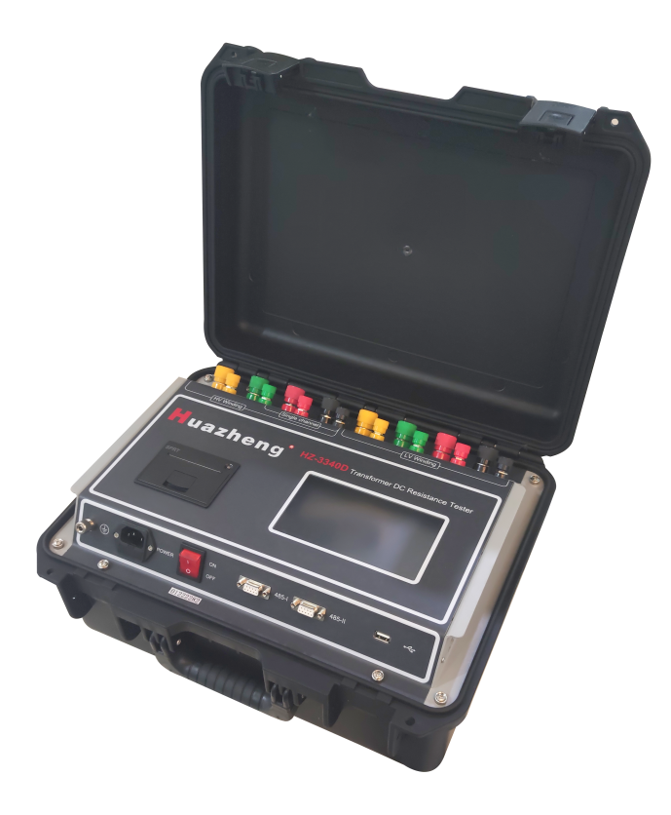

Huazheng Electric Manufacturing(Baoding) Co.,Ltd

Contents

I. Overview 1
II. Safety Measures 1
III. Performance Characteristics 2
IV. Specifications 3
V. System Introduction 3
VI. Test and Operation Method 5
VII. Attentions 18
VIII. Common Problems and Their Solutions 18
IX. After-sales Service 19
X. Communication Protocol 19
XI. The host sends commands: host commands include three types: 20
XII. Data information uploaded by the slave to the host: 22
XIII. Instructions 24
XIV. Packing List 25

Overview
The DC resistance of a transformer is a necessary measuring item in the testing, installation, commissioning testing and electric power department’s preventive testing of semi-finished products and finished products in transformer manufacturing. It can be used to effectively detect the selection of transformer coils, welding, loose connection parts, missing strands, broken wires, etc.In order to meet the needs of Fast measurement of DC resistance of transformers, huazheng has developed a new generation of huazheng series DC resistance test instrument using its own technological advantages. The instrument uses a new power supply technology and has features such as small size, light weight, large output current, etc. It is a test instrument optimized for measuring the three-phase winding DC resistances of large-capacity transformers. The instrument can be used to measure the three-phase winding DC resistances of a transformer at the same time. For an on-load tap changing transformer, there is no need for discharging and tapping is directly adjusted with the instrument; the measuring time is 1/3 of traditional single-phase measuring time, which can greatly shorten working time. The whole instrument is controlled by SCM and automatically achieves functions such as self-check, data processing, display, etc. Moreover, the instrument has functions such as automatic discharging, audible alarming of discharging, etc. The instrument has advantages such as stable test data, high accuracy, quick speed and good repeatability, and is the best choice for measuring the DC resistance of transformer on site.

Safety Measures
1.Be sure to carefully read the operation manual before using the instrument.
2.The instrument operator shall have general knowledge about the use of general electrical equipment or instruments.
3.The instrument can be used both indoors and outdoors. However, be sure to avoid using it at the following places with rain, corrosive gas, too high dust concentration, high temperature, or direct sunlight, etc.
4.The instrument is a high-precision instrument; therefore, it is required to avoid severe vibration of the instrument, and some shock absorption measures shall be taken during transportation.
5.Repair, maintenance and commissioning of the instrument shall be performed by professional personnel.
6.To ensure personal safety, a reliable ground wire shall be connected before turning on the power; in addition, the ground wire shall be removed after removing the power.
7.It is forbidden to dismantle and move test clips and power supply lines during test. The test lines can be removed after discharging alarm sound is ended upon test completion.
8.For no-load voltage regulation winding, it is forbidden to switch the no-load tap changer when test is being conducted or discharging is not completed.
9.When the power supply suddenly fails during the test, the instrument will start to discharge automatically. At this time, it is forbidden to immediately remove the test lines; they can be removed after the discharging alarm sound is ended.

Performance Characteristics
1.Fixed current output (20mA-40A totaling 9 ranges);automatic current output (0.1-40A the optimal current is set automatically based on the resistance of the test product).
2.Wide measuring range (0Ω-20KΩ); able to measure the inductive DC resistance of transformers, mutual inductors, etc.
3.Functions of single channel measurement, YN three-phase simultaneous measurement, YN three-phase compensation simultaneous measurement (including O-phase resistance), automatic YND11 transformer magnetic, YN three-phase selection measurement, D/Y three-phase selection measurement,etc., and can calculate three-phase resistance balance rate automatically.
4.Function of auxiliary judgment of data stabilization. Automatically calculate the percentage of 5′′, 15′′ or 30′′ resistance deviation, accurately judge the readability of data, and prevent misreading of data.
5.Temperature conversion according to test product materials (copper, aluminum), for convenience of comparison with historical data
6.Transformer demagnetizing function; able to effectively reduce transformer remanence
7.Functions such as perpetual calendar, storage of 99 sets of data, Chinese and English interface selection, etc.; no data loss after shutdown. The instrument is provided with micro-printer and “U disk” interfaces.
8.6" color touch LCD
9.Dual RS485 communication interfaces for convenience of inter-device cascading. In cooperation with the control software of the upper computer, the instrument can achieve remote control and measurement. The instrument can be fitted with an optional built-in bluetooth module to achieve bluetooth wireless communication.
10.Audible discharging alarm, and clear discharging indication to reduce misoperation
11.The instrument is protected from wrong connection of AC380V power; after the protection function is activated, an audible alarm is given to reduce the damage caused by misoperation to the instrument. The instrument also has perfect counter emf protection function and strong arc discharge resistance.
12.The instrument has features such as dust prevention, shock prevention, moisture prevention, high measuring accuracy, good stability and repeatability, high portability, etc.

Specifications
1.Output current: automatic, 40A, 20A, 10A, 5A, 2A, 1A, 200mA, 100mA, 20mA
2.Range:
Automatic (0.1-40A) 0 - 200Ω (three-phase simultaneous measurement 0 - 120Ω)
40A 0 – 0.5Ω (three-phase simultaneous measurement 0 – 0.3Ω)
20A 0.0005 – 1.0Ω (three-phase simultaneous measurement0.001–0.6Ω)
10A 0.001 – 2.0Ω (three-phase simultaneous measurement0.002–1.2Ω)
5A 0.002 – 4.0Ω (three-phase simultaneous measurement0.005–2.5Ω)
2A 0.005 – 10Ω (three-phase simultaneous measurement0.01 – 6.0Ω)
1A 0.01 – 20Ω (three-phase simultaneous measurement0.02 - 12Ω)
200m A 0.1 – 100Ω (three-phase simultaneous measurement0.1 - 60Ω)
100m A 0.5 – 200Ω (three-phase simultaneous measurement0.5 - 120Ω)
20m A 10 – 20kΩ only single-phase test)
- Accuracy: 0.2%±0.1μΩ
- Minimum resolution: 0.01μΩ
- Working temperature: -20~ 40℃
- Ambient humidity: ≤80%RH, no dewing
- Working power supply: AC: AC220V±10%, 50Hz±1Hz
- Volume: length 420mm× width 320mm× height 200mm
- Net weight: 14.8kg

System Introduction
See Figure 1 for the instrument panel.
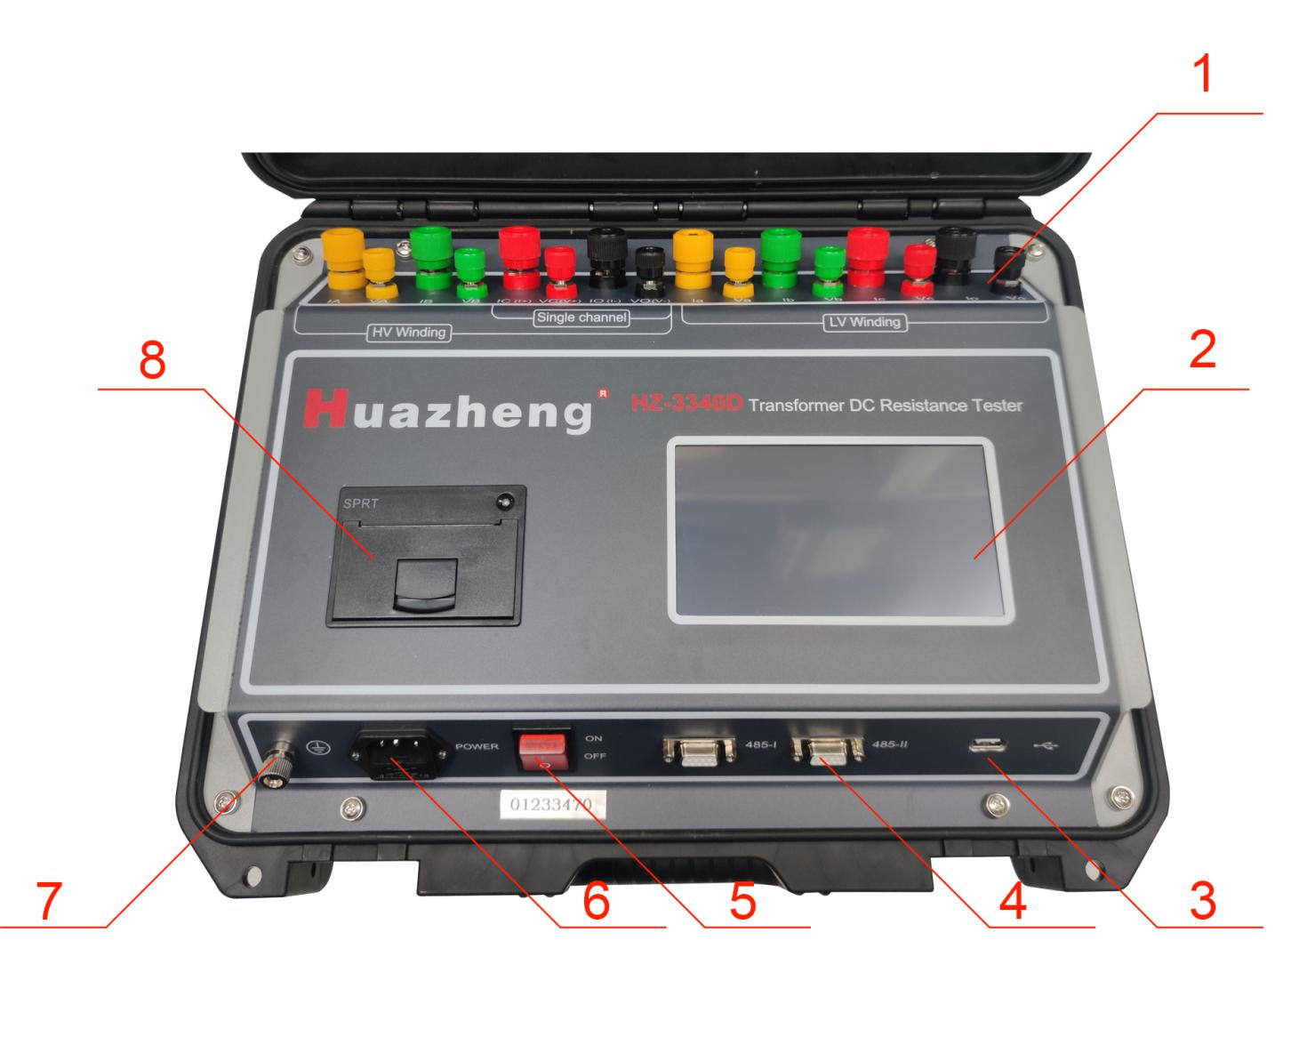
Figure 1
1.Binding post terminal area
IA, IB, IC, and IO terminals: current output terminals for YN winding measurement.
VA, VB, VC, and VO terminals: voltage input terminals for YN winding measurement.
Ia, Ib, and Ic terminals: current output terminals for D or Y winding measurement.
Va, Vb, and Vc terminals: voltage input terminals for D or Y winding measurement.
I+, and I- terminals: current output terminals for single-channel measurement.
V+, and V- terminals: voltage input terminals for single-channel measurement.
2.Display: large-screen true color touch LCD display; touch selection and display of menu; touch operation test and input information; showing test current value, resistance value and relevant information.
3.U-disk interface: to connect a U-disk and export the data from memory.
4.485-I/485-II: two standard 485 communication interfaces.
5.Power switch: control power on and off the whole instrument.
6.Power input port: AC power input port of the whole instrument, rated input voltage AC220V, frequency 50Hz, with fuse box, built-in burnout fuse.
7.Ground pole: used in instrument housing grounding, belonging to protective grounding
8.Printer: to print current value, resistance value and auxiliary information result

Test and Operation Method
1. Measuring wiring: the test product is connected to the test terminal of this machine through a special test cable. The large inserting piece of the test cable is connected to the current terminal, and the small inserting piece is connected to the voltage terminal. They shall be connected securely to prevent loosening. In addition, the ground wire is well connected. The clamp ends are respectively clamped at the two leading-out terminals of the coil resistance of the test product. For the specific wiring method, see the following wiring diagram, taking YND11 transformer as an example. In the following example, measure the minimum wiring; not test the winding’s leading-out column, which needs to be suspended independently.
Three-channel measuring wiring: see Figure 2 for (YN winding three-phase simultaneous measurement) wiring.
Transformer
Instrument terminal
Figure 2
Item-by-item measuring of YN winding: see Figure 2 for (separate measuring of each phase of YN winding) wiring.
Item-by-item measuring of D winding: see Figure 3 for (separate measuring of each phase of D winding) D winding wiring.
Transformer
Instrument terminal
Figure 3
Single-channel direct measuring wiring: see Figure 4 for (YND11 transformer CO phase measurement).
Transformer
Instrument terminal
Transformer
Instrument terminal
Figure 4
Item-by-item measuring of Y winding: see Figure 5 for (separate measuring of each phase of Y winding) Y winding wiring.
Instrument terminal
Figure 5
Iron core five-column YND11 transformer magnetic assist measuring wiring: (optional and item-by-item magnetic assist measurement of low-voltage winding)
See Figure 6(1).
Iron core five-column YND11 transformer
Instrument terminal
Figure 6(1)
Iron core five-column YND11 transformer magnetic assist measuring manual wiring:
Wiring can be in line with the external wiring method shown in Figure 6(2), and measuring is performed using the single-channel method.
(ac phase)
(ab phase)
(bc phase)
Figure 6(2)
- Starting up: Connect the power line supplied with this machine to the AC power input port. Turn on the power switch. Then the LCD will be turned on. (If the input power supply AC220V is connected into AC380V by mistake, the internal protection device of the instrument will function, the internal power supply will be cut off, and the buzzer will always give an alarm.)
The Company's LOGO interface will be displayed on the screen. After it stays for about 3 seconds, it will be automatically skipped. Then enter the main interface for option setting, as shown in Figure 7:
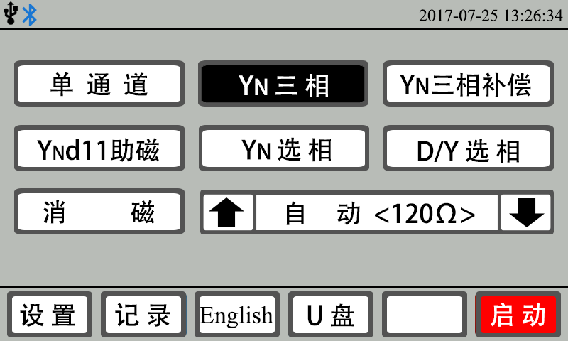
Single-channel
YN three-phase
YN three-phase compensation
Ynd11 magnetic assist
YN phase selection
D/Y phase selection
Demagnetizing
Automatic
Setting
Record
U disk
Starting
Figure 7
3.Measurement mode selection: the interface shown in Figure 7 is displayed on the screen. Here the needed measurement mode can be selected by touching the test mode option.
"Single channel" mode: conventional single-phase winding four-terminal test mode.
"YN three-phase" mode: YN winding three-phase three-channel test mode (excluding O-phase resistance).
"YN three-phase compensation" mode: YN winding three-phase three-channel test mode (including O-phase resistance through compensation mode).
“YNd11 magnetic assist” mode: large three-core and five-column YNd11 connection mode reduces the low-voltage test stabilization time by means of HV-to-LV magnetic assist.
"YN phase selection" mode: YN winding three-phase respective selection test mode (including O-phase resistance).
"D/Y phase selection" mode: D winding or Y winding three-phase respective selection test mode.
"Demagnetizing" mode: Used to eliminate transformer remanence.
Carefully check whether the connected test cable is consistent with the selected mode. The test can be conducted after checking for no error, which will otherwise result in wrong measurement and affect the accuracy of the test result.
- Test current selection: the interface shown in Figure 7 is displayed on the display screen. At this time, you can select the desired measurement current by touching the current selection arrow keys. Each time of touching, the display screen will display the corresponding test current and the maximum test resistance at the corresponding current circularly. (On the premise of satisfying the resistance test range, a large current shall be used as much as possible, but the rated power of the test product shall also be considered. The test at the power exceeding the rated power of the test product can cause damage to the test product. Test product high-temperature also has some influence on test data, so various factors shall be considered comprehensively.)
5. Parameter setting: the interface shown in Figure 7 is displayed on the screen. At this time, you can touch the “Set” button to enter the parameter setting interface, as shown in Figure 8. In this interface, you can set the test product temperature, test product conversion temperature, data stabilization judgment time interval, test product material, communication baud rate, test product number, perpetual calendar time, etc.
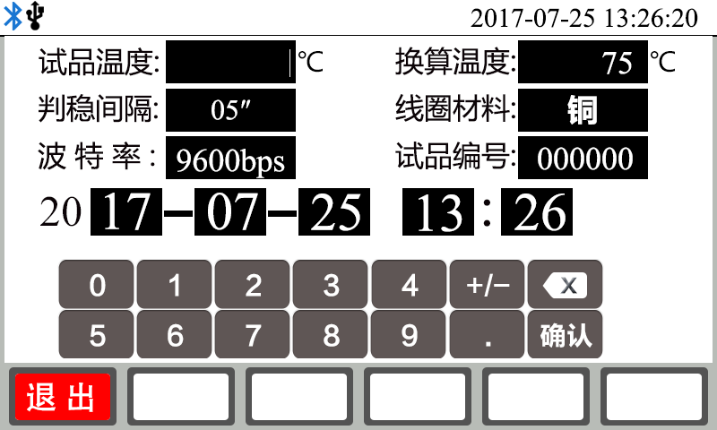
Test product temperature
Converted temperature
Stabilization judgment time interval
Coil material
Copper
Baud rate
Test product No.
Enter
Exit
Figure 8
By touching the display area to be set, the input soft keyboard will pop up automatically; then according to the requirements of the prompt, input the corresponding information and modify the corresponding setting. After setting completion, touch the “Exit” button to return to the optional setting main interface.
6. Test: select the corresponding measurement mode and corresponding test current in the optional setting main interface, and then touch the “Start” button to enter the test process in the corresponding measurement mode.
6.1 "Single-channel" test
After starting the test, the display screen indicates the value of the test charge current while giving the prompt “Recharging...”; in addition, the system clock starts timing and shows the test time from charging. After the test current reaches the preset current and is stable, the prompt “Under Test” is given and then the test resistance value (RX) is displayed. Observe the stability of the test current value and resistance value. The instrument conducts continuous tests (as shown in Figure 9). The instrument will indicate the percentage of the error between the current resistance data and the resistance data before stabilization judgment time interval from the beginning of showing resistance data up to stabilization judgment time interval so as to determine the stability of the channel resistance measurement data. The time interval can be set and switched among 5″, 15″ and 30″ by touching the interval selection button. It can be set according to the historical test experience on test products. The stabilization judgment time interval setting can also be revised in the setting menu. A test report can be generated and printed out by touching the “Print” button. Touch the “Save” button to save the current test data report into the instrument memory. The “Fast” measuring mode is generally selected in instrument test; when the test resistance value fluctuates to a large extent, you can try to switch to the “Slow” mode. At this time, you can switch between “Fast” and “Slow” only by touching the speed selection button. Tapping information input will be activated by touching the “Tapping-” or “Tapping+” button; after re-touching it, change the tapping position value. When the tapping position value is 0, turn off the tapping input function. By touching the “Conversion” button, temperature conversion will be performed according to the set test product temperature, converted temperature and material, and the converted resistance value and the corresponding test product temperature and converted temperature will be displayed. After re-touching the “Conversion” button, cancel the conversion mode and return to the resistance data state without conversion. The test product temperature, converted temperature and material can be set by selecting the setting main interface to enter the setting menu.
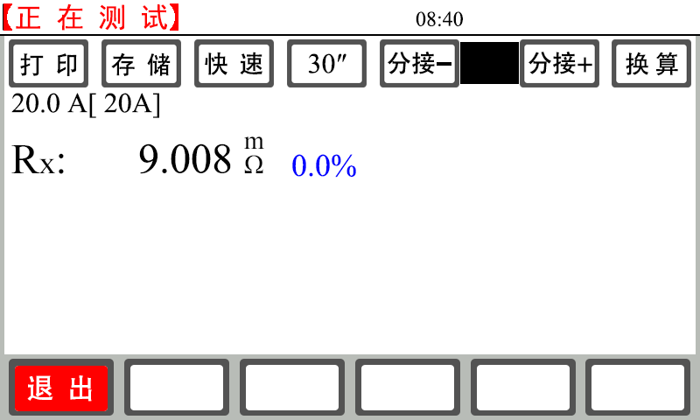
Under Test
Print
Save
Fast
Tapping-
Tapping+
Conversion
Exit
Figure 9
After test completion, touch the “Exit” button. Then the instrument is discharged automatically to end the test and return to the optional setting main interface.
6.2 After starting the test, the display screen indicates the value of the test charge current while giving the prompt “Recharging...”; in addition, the system clock starts timing and shows the test time from charging. After the test current reaches the preset current and is stable, the prompt “Under Test” is given and then the tested AO, BO and CO three-phase resistance values and the three-phase balance ratio δ are simultaneously displayed. Observe the stability of the test current value and resistance value. The instrument conducts continuous tests (as shown in Figure 10). During "YN three-phase" test, BO phase is stabilized quickly, AO and CO phases are stabilized slowly, and their stabilization time is relatively long. This belongs to a normal phenomenon. To adjust the on-load tap-changer, there is no need for stopping test and you can directly switch to tapping test. For the no-load tap changer, you can switch to tapping after stopping test and completing discharging. Other auxiliary function operations are the same as those in single-channel test. For details, see 6.1 “Single-channel” test.
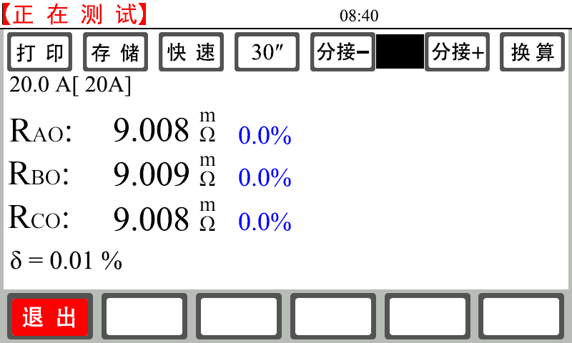
Under Test
Print
Save
Fast
Tapping-
Tapping+
Conversion
Exit
Figure 10
After test completion, touch the “Exit” button. Then the instrument is discharged automatically to end the test and return to the optional setting main interface.
6.3 "YN three-phase compensation" test (applicable to YN three-phase winding multi-tap transformer resistance measurement)
Step 1: measure AO, BO and CO phase selection resistances.
After starting test, the display screen is switched to YN three-phase option test interface (Figure 11).
AO phase test method: touch “A0 phase” button to select; then touch the “Test” button; the display screen indicates the value of the test charge current while giving the prompt “Recharging...”; in addition, the system clock starts timing and shows the test time from charging. After the test current reaches the preset current and is stable, the prompt “Under Test” is given and then the tested AO phase resistance value is displayed. Observe the stability of the test current value and resistance value. The instrument conducts continuous tests. After the resistance data are stable and readable, touch the “Stop” button. Then the instrument will automatically discharge, and the AO phase resistance test will be ended. Moreover, the system will automatically record the AO phase resistance test result.
BO phase and CO phase selection test method: touch the corresponding "B0 phase" and "C0 phase" buttons to select; and then touch the "Test" button. This method is equivalent to the AO phase test method. After the resistance data are stable and readable, touch the “Stop” button. Then the instrument will automatically discharge, and the system will automatically record the corresponding phase selection resistance test result.
Step 2: simultaneous measurement of three phases A, B and C.
Complete the measurement of AO, BO and CO phase selection resistances in step 1 (Figure 12).
Touch the “ABC” button to select; then touch the “Test” button to enter simultaneous measurement of three phases A, B and C. Step 1: the AO, BO and CO phase selection resistance measurement result is recorded on the right side of the screen.
Thee display screen indicates the value of the test charge current while giving the prompt “Recharging...”; in addition, the system clock starts timing and shows the test time from charging. After the test current reaches the preset current and is stable, the prompt “Under Test” is given and then the tested AO, BO and CO phase resistance values are simultaneously displayed. Observe the stability of the test current value and resistance value. The instrument conducts continuous tests (Figure 13).- After the three-phase resistance data all are stable and readable, touch the “Compensation” button. Then the instrument compensates for the YN three-phase simultaneous measurement resistance (compensating for the O column resistance value) according to the AO, BO and CO phase selection resistances in step 1; meanwhile, the system records the compensation quantity of O column of each phase on the right side of the screen (Figure 14). The instrument conducts continuous tests. Note: keep the same tapping position during step 1 and step 2 test processes, which will otherwise affect the compensation value and cause data inaccuracy.
Step 3: simultaneous measurement of the next tap three phases
Adjust the on-load tap-changer to the corresponding tapping position, observe data stability, and read data.
Switch to the next tap, observe data stability, and read data till completing the test on all taps.
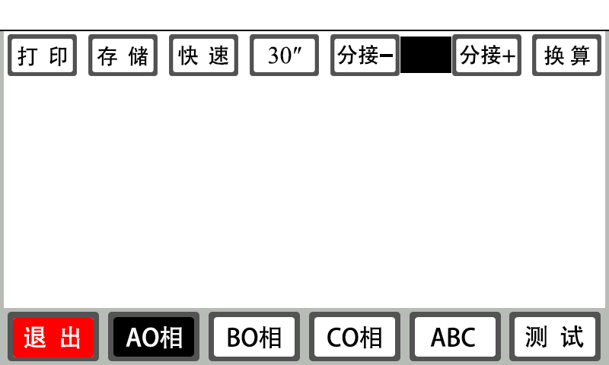
Test
CO phase
BO phase
AO phase
Exit
Conversion
Tapping+
Tapping-
Fast
Save
Print
Figure 11
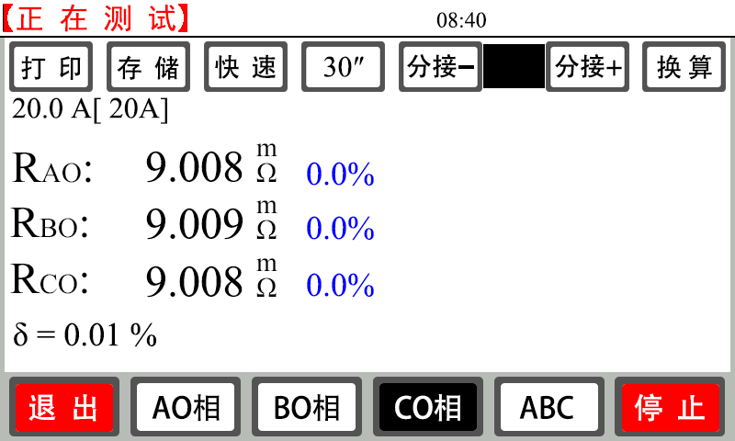
Print
Save
Fast
Tapping-
Tapping+
Conversion
Exit
AO phase
BO phase
CO phase
Stop
Under Test
Figure 12
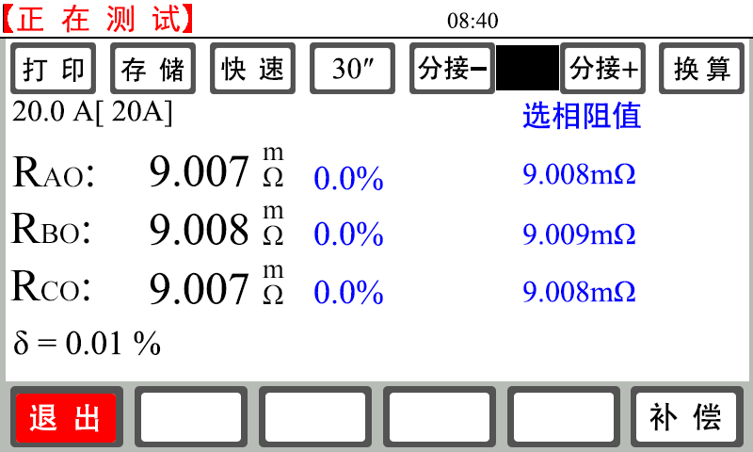
Print
Save
Fast
Tapping-
Tapping+
Conversion
Exit
Under Test
Compensation
Figure 13
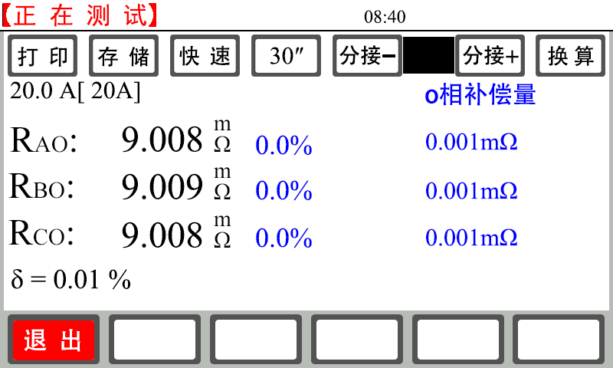
Exit
Print
Save
Fast
Tapping-
Tapping+
Conversion
Under Test
Figure 14
Other auxiliary functions are the same as those in single-channel test. For details, see “Single-channel” test.
After test completion, touch the “Exit” button. Then the instrument is discharged automatically to end the test and return to the optional setting main interface.
6.4 "YNd11 magnetic assist" test
After starting test, the display screen is switched to YNd11 magnetic assist option test interface (Figure 15).
Test Method: Touch any of the three option buttons such as “AO-ca”, “BO-ab” and “CO-bc” (system default: “AO-ca”); taking “AO-ca” as an example, touch the “Test” button; then the display screen indicates the value of the test charge current while giving the prompt “Recharging...”; in addition, the system clock starts timing and shows the test time from charging. After the test current reaches the preset current and is stable, the prompt “Under Test” is given and then the HV AO phase resistance value and the LV ca phase resistance value are displayed. Observe the stability of the test current value and resistance value. The instrument conducts continuous tests. After the resistance data are stable and readable, touch the “Stop” button. Then the instrument will automatically discharge, and the “AO-ca” phase resistance test will be ended. Moreover, the system will automatically record the “AO-ca” phase resistance test result. Select other items again and test the resistance value of other options using the above method. After completing the test on three phases, the system automatically calculates the balance ratio of HV three phases and LV three phases respectively.
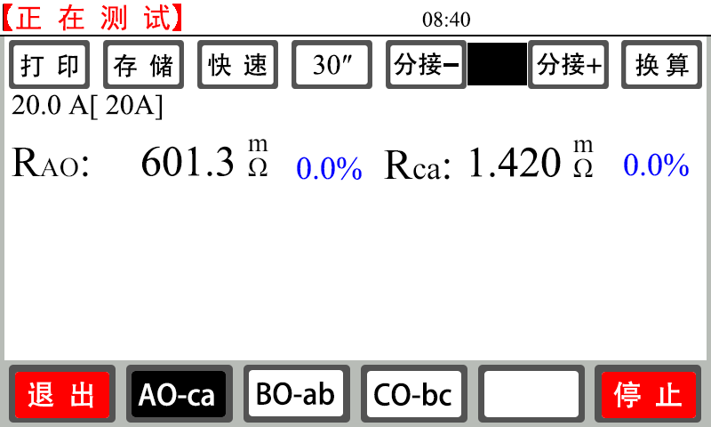
Under Test
Conversion
Tapping+
Tapping-
Fast
Save
Print
Stop
Exit
Figure 15
Other auxiliary functions are the same as those in single-channel test. For details, see “Single-channel” test.
After test completion, touch the “Exit” button. Then the instrument is discharged automatically to end the test and return to the optional setting main interface.
6.5 "YN phase selection" test
After starting test, the display screen is switched to YN phase selection test interface (Figure 16).
Test Method: Touch any of the three option buttons such as “AO phase”, “BO phase” and “CO phase” (system default: “AO phase”); taking “AO phase” as an example, touch the “Test” button; then the display screen indicates the value of the test charge current while giving the prompt “Recharging...”; in addition, the system clock starts timing and shows the test time from charging. After the test current reaches the preset current and is stable, the prompt “Under Test” is given and then the HV AO phase resistance value is displayed. Observe the stability of the test current value and resistance value. The instrument conducts continuous tests. After the resistance data are stable and readable, touch the “Stop” button. Then the instrument will automatically discharge, and the “AO phase” phase resistance test will be ended. Moreover, the system will automatically record the “AO phase” phase resistance test result. Select other items again and test the resistance value of other options using the above method. After completing the test on three phases, the system automatically calculates the balance ratio of HV three phases respectively.
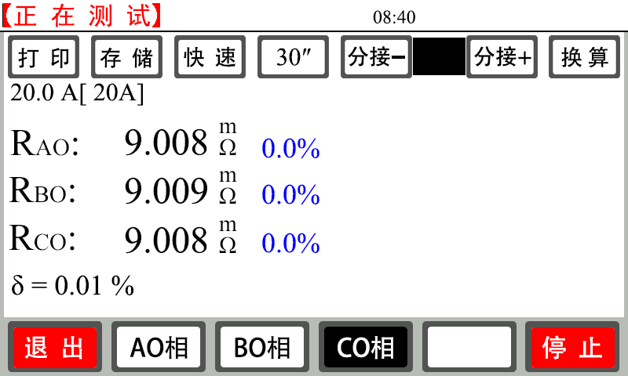
Print
Save
Fast
Tapping-
Tapping+
Conversion
Under Test
AO phase
BO phase
CO phase
Stop
Exit
Figure 16
Other auxiliary functions are the same as those in single-channel test. For details, see “Single-channel” test.
After test completion, touch the “Exit” button. Then the instrument is discharged automatically to end the test and return to the optional setting main interface.
6.6 "D/Y phase selection" test
After starting test, the display screen is switched to D/Y phase selection test interface (Figure 17).
Test Method: Touch any of the three option buttons such as “ca phase”, “ab phase” and “bc phase” (system default: “ca phase”); taking “ca phase” as an example, touch the “Test” button; then the display screen indicates the value of the test charge current while giving the prompt “Recharging...”; in addition, the system clock starts timing and shows the test time from charging. After the test current reaches the preset current and is stable, the prompt “Under Test” is given and then the ca phase resistance value is displayed. Observe the stability of the test current value and resistance value. The instrument conducts continuous tests. After the resistance data are stable and readable, touch the “Stop” button. Then the instrument will automatically discharge, and the “ca phase” phase resistance test will be ended. Moreover, the system will automatically record the “ca phase” phase resistance test result. Select other items again and test the resistance value of other options using the above method. After completing the test on three phases, the system automatically calculates the balance ratio of D/Y three phases respectively.
Other auxiliary functions are the same as those in single-channel test. For details, see “Single-channel” test.
After test completion, touch the “Exit” button. Then the instrument is discharged automatically to end the test and return to the optional setting main interface.
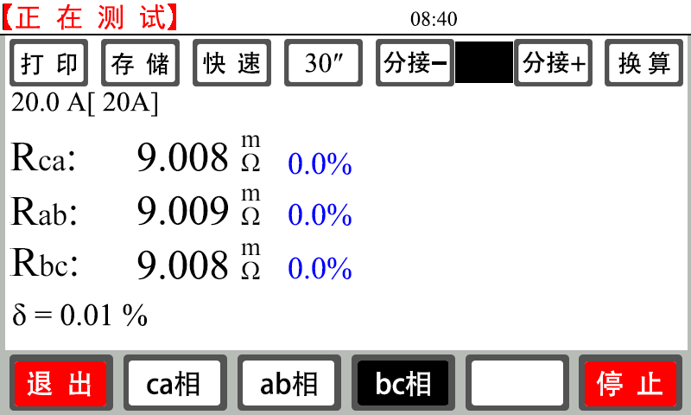
Print
Save
Fast
Tapping-
Tapping+
Conversion
Under Test
ca A
ab phase
bc phase
Stop
Exit
Figure 17
6.7 “Demagnetizing” test
Demagnetizing method: the “single-phase test” wiring method is used in demagnetizing wiring (taking the use of red and black test lines as an example). Firstly connect the current and voltage terminals of the red test line with C phase; then connect the black line with the O phase of the instrument. Clamp the red test clamp and black test clamp onto the demagnetized winding respectively.
After starting demagnetizing, the display screen is switched to the demagnetizing interface (Figure 18).
Then automatic demagnetizing can be performed. This may take a period of time. Please wait patiently.
Note: there will be a repeated charging and discharging process and the buzzer will give an alarm repeatedly during demagnetizing. This is normal. Touch the “Exit” button to end demagnetizing process during demagnetizing.
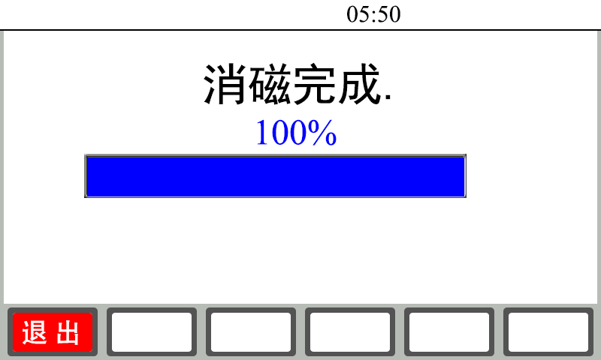
Demagnetizing completed
Exit
Figure 18
- View the data recorded in the memory: touch the “Record” button in the boot screen to enter the record view interface. Data can be viewed circularly. At most 99 sets of data can be stored and viewed. Touch the “Exit” button to return to the optional setting main interface; touch the “Print” button to print the recorded data. If there is no data for view, the interface will show “No Record Temporarily”.
9. Import into U Disk: press the “U Disk” function button in the optional setting main interface to import the instrument memory data into a “U disk”. If there is no data for export, the interface will show “No Record Temporarily”.Please firstly insert a U disk. After inserting the U disk, the icon will be displayed on the upper right corner of the instrument. After unplugging the U disk, the icon will disappear. The prompt “Being Exported” is given during data exporting. After data exporting completion, the prompt “Export Completed” is given. After export completion, the U disk can be unplugged.
Please do not unplug the U disk during “Exporting”.
The name of the file imported into the U-disk is defined as follows:
Firstly create a folder taking day as the unit, e.g. DT170408.
Where "DT" is the fixed format of file beginning; "17" is the latter two digits of 2017; "04 is April; "08" is April 8. Then create a file taking HHMMSS as the unit, e.g. SJ092458.
Where "SJ" is the fixed format of file beginning; "09" is 9 a.m.; "24" is 24min; “58” is 58s.
The export time of the created file is taken as its creation time (system default).
- Language switching: the instrument uses the mode of one keyboard toggle between Chinese and English interfaces.
- “Communication” function: the instrument uses a standard RS485 interface (optional wireless Bluetooth mode). Connect the RS485 interface of the instrument and the USB interface of the computer through a UT850 adapter. In cooperation with the upper computer operation and control software, the functions can be achieved, e.g. instrument communication control, test data editing and printing, etc.

Attentions
1. Before tapping point switching during the test on the transformer with no-load tap-changer, be sure to stop test. Tapping point can be switched after discharging is completed and alarm sound is ended.
2. It is strictly forbidden to dismantle or connect test cables during measuring. The test cables can be removed after discharging alarm sound is ended upon test completion so as to prevent personnel injury and equipment damage.
3. During measuring of the HV side resistance of an on-load tap changing transformer, the test current shall be determined according to the tap position with the maximum resistance value, and then measuring is begun, or the automatic current range is selected for the test.
4.Refer to the range in the technical index column while selecting the measuring mode; do not exceed the range.
5.It had better use the HV magnetic assist method to measure the LV side winding of a large-capacity iron core five-column YND11 transformer so as to save the measuring time.
6.The three-phase simultaneous measuring mode is used to measure YN HV, MV and LW star windings. In order to eliminate the impact of O column resistance on the data, it is proposed to use the YN three-phase compensation” mode in three-phase simultaneous measuring.

Common Problems and Their Solutions
1. The instrument cannot be started and the buzzer keeps tweeting.
In this case, firstly check whether AC380V power supply is connected or whether the supply voltage is too low.
- The LCD screen cannot be turned on and the fan of the instrument fails to work after starting.
In this case, firstly check whether the AC220V power supply is normal; then check whether the fuse is burned out; if yes, replace it with a new one.
- The LCD screen can be turned but doesn’t have normal display or cannot display on after starting.
In this case, firstly start and shut down the instrument once.
- Instable test data or large error
In this case, firstly check the test lines for virtual connection and loosening. If the problem cannot be solved yet, check for rustiness of the test product.
- Always showing “Being Charged. . . .” during test
In this case, firstly check for transformer magnetic circuit problem. If the current doesn’t change and is always near zero for long, check for broken circuit. In case of failure to charge at all, check whether the measurement range is exceeded.
**********If you cannot self-solve the above problems, please timely contact us**************

After-sales Service
Product shall be repaired and replaced free of charge in case of product quality problem in 12 months from purchase date, guarantee and technical service are provided for whole service life of the product.In case any abnormal condition or fault is found in the instrument, please contact the company in time so that we can organize most convenient treatment plan for you.

Communication Protocol
I. Interface form: RS485/232 or Bluetooth
Baud rate: 9600 bps (default), 1 start bit, 8 data bits, non parity, 1 stop bit
II. Functional description:
(1) The host can control the slave station for test.
(2) The host can achieve range setting.
(3) The host can query the slave state at any time.
(4) The host can control slave resetting at any time.
III. Message format: except that the message header and the message trailer use binary codes, all other fields of the message are transmitted in ASCII code mode.
Communication format description:
Message header: 1 byte, 7EH, message trailer: 1 byte, 0DH
Slave address: 2-byte ASCII code value, high byte first, slave address 45H 46H
Data: command parameters to be actually transmitted or measuring result data; the host data are the parameter contents to be transmitted.
1 | 2 | 3 | 4 | 5 | 6 | 7 | 8 | 9
Message header | Slave address high | Slave address low | Data and command length high | Data and command length low | Host command | Data | Data | Data | … | Data | XOR checkout | Message trailer
The slave sends back data:
1 | 2 | 3 | 4 | 5 | 6 | 7 | 8 | 9
Message header | Slave address high | Slave address low | Data and command length high | Data and command length low | Slave state | Data | Data | Data | … | Data | XOR checkout | Message trailer

The host sends commands: host commands include three types:
Exit Command (40H), Print Command (41H), Save Command (42H), Stop Command (43H), Fast/Slow Speed Command (44H), Test Command (45H), Compensation Command (48H), Data Request Command (49H) ), Start Command (4AH), Baud Rate Modification command (4BH), Reset command (4CH).
Note: the start command and the baud rate modification command are used only in reset state, and all other commands can be used after starting test. Please confirm the instrument state before sending a command.
1. The corresponding data sequence is expressed as follows: 7E 45 46 30 31 40 3C 0D
2. Print: the command is 41H.
The corresponding data sequence is expressed as follows: 7E 45 46 30 31 41 3D 0D
- Save: the command is 42H.
The corresponding data sequence is expressed as follows: 7E 45 46 30 31 42 3E 0D
- Stop: the command is 43H.
The corresponding data sequence is expressed as follows: 7E 45 46 30 31 43 3F 0D
- Fast/Slow: the command is 44H <which can be used in the test process>
The corresponding data sequence is expressed as follows: 7E 45 46 30 31 44 38 0D
- Test: the command is 45H.
The corresponding data sequence is expressed as follows: 7E 45 46 30 32 45、The tested phase XOR 0D
The tested phases:
Single-channel, YN three-phase, constant 0x30 during demagnetizing
In other test modes:
Phase A 0x30 phase B 0x31 phase C 0x32 ABC 0x33
7. Compensation: the command is 48H <for YN three-phase compensation only>
The corresponding data sequence is represented as follows：7E 45 46 30 31 48 34 0D
The corresponding data sequence is expressed as follows: 7E 45 46 30 31 48 34 0D
8. Request data: the command is 49H <the only command that is returned>
The corresponding data sequence is expressed as follows: 7E 45 46 30 31 49 35 0D
Each time the host requests data, the slave will upload the current state to the host.
9. Start: The command is 4AH + mode + current
Mode:
single-channel 31H YN three-phase 32H YN three-phase compensation
33H YND11 magnetic assist 34H YN phase selection 35H D/Y phase selection
36H demagnetizing <automatic by current default>
Current:
31H 50A (for 50S only) 32H 40A(for 40S only)
33H 20A 34H 10A 35H 5A 36H 2A 37H 1A
33H 20A 34H 10A 35H 5A 36H 2A 37H 1A
38H 200mA 39H 100mA 3A20mA (for single test only)
30H automatic
For example: the corresponding data sequence for single-phase test+ automatic current is expressed as follows:
7E 45 46 30 33 42 30 3A XOR 0D
10. Modify baud rate: the command is 4BH < baud rate can be modified in main menu state; after modification completion, please use new baud rate to link>
Note: the fixed baud rate in Bluetooth communication mode is 9600bps and cannot be modified.
30H 9600bps 31H 4800bps 32H 19200bps
The data sequence for 9600bps is expressed as follows: 7E 45 46 30 32 4B 30H XOR 0D
11. Reset: the command is 4CH <forcibly reset the instrument>
The corresponding data sequence is expressed as follows: 7E 45 46 30 31 4C 30 0D
Note: it had better not use the command during resistancee test.

Data information uploaded by the slave to the host:
The data information states returned by the slave to the host include 8 types:
Initialization state (40H), Reset state (41H), Instrument setting state (42H), Charging state (43H), Discharging state (44H), Testing state (45H), Test stop state (46H), Current change state (47H), Historical record State (48H), Demagnetizing State (49H)
Initialization state (40H)：7E 45 46 30 31 40 XOR 0D
(State during instrument resetting; operation can be performed after resetting completion.)
⑵ Reset state (41H)：7E 45 46 30 33 41 + mode+ current+ XOR 0D
⑶Instrument setting state (42H): 7E 45 46 30 33 42 + mode+ current+ XOR 0D
(Setting state of the instrument's relevant parameters; please exit to the main menu and then operate.)
⑷Charging state (43H): 7E 45 46 30 39 43 + mode+ current+ current data + XOR 0D
Current data: 6-bit ASCII code.e.g.: 200mA 20 32 30 30 6D 41
⑸Discharging state (44H): 7E 45 46 30 33 44 + mode+ current+ XOR 0D
(6) Testing state (45H): 7E 45 46 3x 3x 45+ mode + current + current data+ specific data<different number in different mode>+XOR 0D
Specific data:
Single-channel: Rx resistance data
YN three-phase: AO resistance data + BO resistance data + CO resistance data + imbalance ratio
YN three-phase simultaneous measuring compensation:
(including three stages such as 0x30, 0x31 and 0x32 stages; 0x30 is the test compensation data stage; 0x31 is the three-phase simultaneous test (non-compensation) stage; 0x32 is the three-phase simultaneous test (compensation) stage).
Data in 0x30 stage: 30 + AO resistance data + BO resistance data + CO resistance data
Data in 0x31 stage: 31 + AO resistance data + BO resistance data + CO resistance data + imbalance ratio
Data in 0x32 stage: 32 + AO resistance data + BO resistance data + CO resistance data + imbalance ratio
YND11 magnetic assist: AO resistance data + BO resistance data + CO resistance data + HV imbalance ratio + ca resistance data + ab resistance data + bc resistance data + LV imbalance ratio
YN phase selection: AO resistance data + BO resistance data + CO resistance data + imbalance ratio
D/Y phase selection: ca resistance data + ab resistance data + bc resistance data + imbalance ratio
Current data: 6-bit ASCII code.e.g.: 200mA 20 32 30 30 6D 41
Resistance data: 1-bit identification <whether data is valid> + 9-bit ASCII code data.
Identification: 30H data invalid, not displayed; 31Hdata valid, can be displayed
9-bit ASCII data, for example: 1.0000mΩ 31 2E 30 30 30 30 6D A6 B8
Imbalance ratio: 1-bit identification <whether data is valid> + 6-bit ASCII code.
Identification: 30H data invalid, not displayed; 31Hdata valid, can be displayed
6-bit, for example: 100.0% 31 30 30 2E 30 25
(7) Stop state (46H): 7E 45 46 30 34 48 +mode + current + identification of completing the test on three phases +XOR 0D
Identification of completing the test on three phases: 0x31 tested for all three phases 0x30 not tested for all three phases
The identification is used mainly in YN compensation.
(8) Replacement with large current (47H): 7E 45 46 3x 3x 47+ mode + current + current data+ specific data<different number in different mode>+XOR 0D identical with “Under Test”
(9) Historical record state (48H): 7E 45 46 30 33 48 + mode+ current+ XOR 0D
(The instrument is in the historial record display interface state; please exit to the main menu and then operate.)
(10) Demagnetizing (49H): 7E 45 46 30 35 49 + demagnetizing progress+ XOR 0D
Demagnetizing progress 4-bit ASCII code for example 50% 20 35 30 25 100% 31 30 30 25

Instructions
Operation  State | Parameter setting | Test | Print | Save | Stop | Exit
Initialization | no | no | no | no | no | no
Reset | yes | no | no | no | no | no
Charging | no | no | no | no | no | no
Under Test | no | no | yes | yes | yes | no
Discharging | no | no | no | no | no | no
Stop state | no | yes | yes | yes | no | yes
The PC is host; if the host doesn’t send a command, the slave doesn’t respond at any time.
The host is powered on, and accesses the slave (looking for the slave) or sends a command once every 400ms; in the event of failure, the host re-sends a command; if there is still a fault after sending a command three times, it is taken as communication error.
VI “Instructions” is the list of limiting upper computer operation. In the listed state, YES means yes, and NO means no.
At this time, it is needed to limit the upper computer.

Packing List
No. | Item | Qty
1 | Main engine | 1
2 | Power Cable | 1
3 | Black test line | 2
4 | Red test line | 2
5 | Green test line | 2
6 | Yellow test line | 2
7 | Grounding wire | 1
8 | Serial port cable | 2
9 | Insurance tube | 2
10 | Standard resistor | 1
11 | USB flash drive | 1
12 | Printing paper | 1

