HZYA-2Z-I
Hand-held On Load Switch Tester

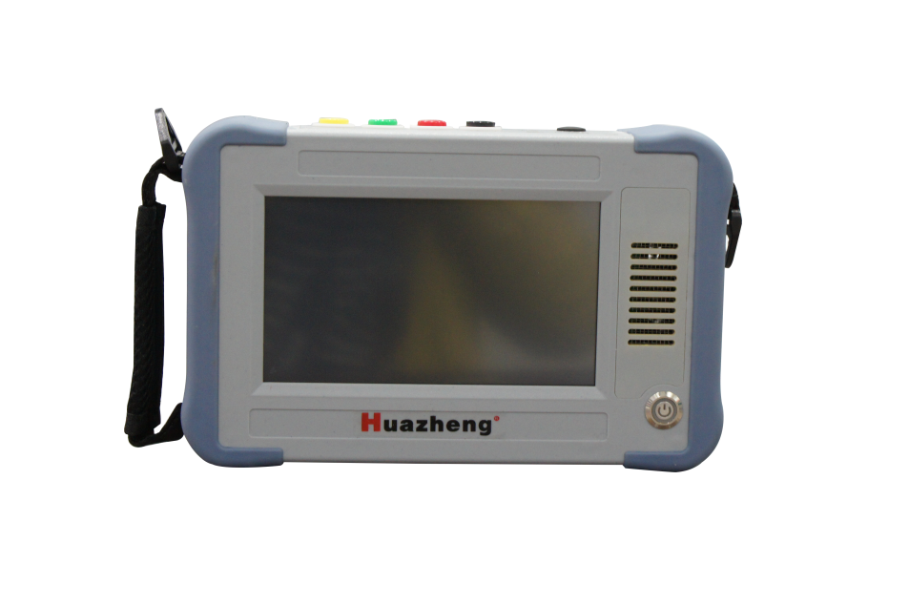

Huazheng Electric Manufacturing (Baoding) Co., Ltd
Contents

I. Product Overview 1
II. Functional Characteristics 1
III. Technical Parameter 1
IV. Conditions Of Use 2
V. Panel Introduction 2
VI. Handling Instruction 3
VII. Principle Of Switch Action And Waveform Analysis 11
VIII. Packing List 13

- Product Overview
On-load tap changer is the only moving part connected with transformer circuit, so the detection of on-load tap changer attracts more and more attention. In the Regulation of Power Equipment Handover and Preventive Test, it is required to check the action sequence of on-load tap changer and measure the switching time. The instrument is mainly used to measure the transient waveform, transient time, transient resistance value at each moment, three-phase synchronization and so on of transformer on-load tap changer.
The instrument has a high degree of intelligence, all Chinese menu prompts and simple operation. The instrument has the advantages of small volume, light weight and strong anti-interference ability, which greatly reduces the labor intensity of field workers. It is an ideal instrument for power generation and supply units and transformer manufacturing industries to ensure safe production and improve product quality.
- Functional Characteristics
- The instrument has large output current and light weight;
- Test Yn, Y and D transformers, and the resistance value is displayed directly without conversion;
- Can be measured with or without winding;
- Waveform display automatically adjusts the amplitude of resistance and time value according to the sampling value.
- With perfect protection circuit and strong reliability;
- Seven-inch high-brightness touch color LCD, clear display under strong light, full touch screen operation, free switching between Chinese and English.
- 500 sets of data can be automatically saved internally.
- Built-in lithium battery power supply, easy to use outdoors.
- The instrument can be connected to an external printer to print measurement data, which is convenient for paperless office. (optional)
- Technical Parameter
Output currents are 1.0A, 0.5A and 0.2A.
Measuring range transition resistance: 0.3 Ω ~ 20 Ω (1.0A) 5 Ω ~ 40 Ω (0.5A) 20Ω～100Ω(0.2A)
Transition time: 0 ~ 320 ms
Open circuit voltage 24V
Measurement accuracy transition resistance: (5% reading 0.1 Ω)
Transition time: (0.1% reading ±0.2ms)
Sampling rate is 20kHz.
Storage mode local storage
Overall dimensions: host 252*160*65 (mm) Outer box 425*335*210 (mm)
Weight: 2KG for the main machine and 8KG for the outer box
The length of the test line is 13 meters as standard and can be customized.
- Conditions Of Use
Ambient temperature-10℃ ~ 50℃
Environmental humidity ≤85%RH
Working power supply battery
Power frequency 50±1Hz
- Panel Introduction
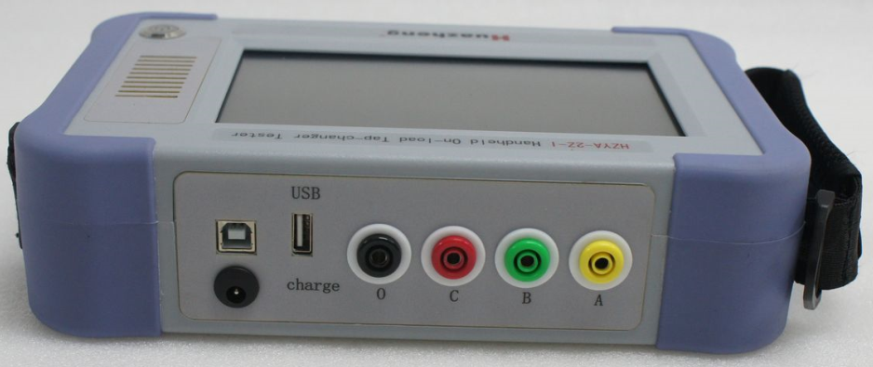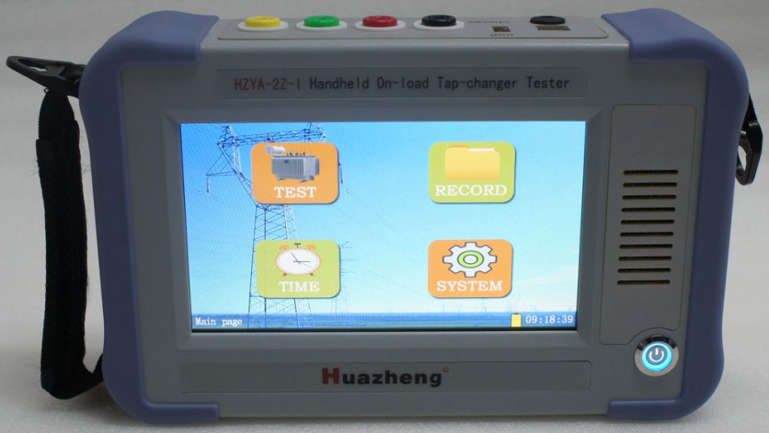
5.1Panel diagram
- Handling Instruction
Matters needing attention in operation:
- Before use, the grounding terminal of the instrument must be connected with the ground wire.
- During the test, it is not allowed to dismantle the test line.
- When testing with winding, the non-test end of the transformer should be grounded by three-phase short circuit.
- For the on-load switch that has not been moved for a long time, the switch should be changed several times before the test to remove the oxide layer and impurities on the contact surface.
（1）Test method of belt winding
1．Remove the three-side leads of the transformer under test, and short-circuit the non-test ends (usually the medium voltage side and the low voltage side) to the ground respectively. Clamp the yellow, green, red and black test pliers to the A, B and C phases and neutral point of the bushing on the voltage regulating side (usually the high voltage side) of the transformer under test, and then connect the yellow, green, red and black wires at the other end of the test line to the A, B, C and 0 terminals of the instrument respectively. The following figure shows the connection modes of different types of transformers:
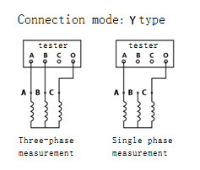
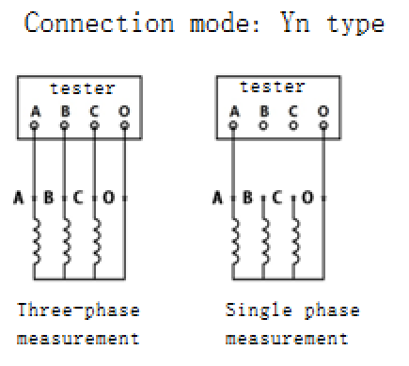

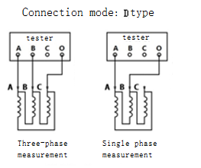
2．After confirming that the above wiring is correct, start the machine and enter the setting interface after the instrument self-check, as shown in the following figure:
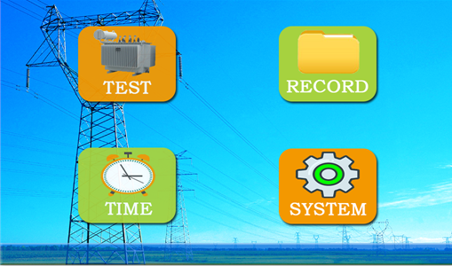
Press Measure to enter the following interface, as shown below
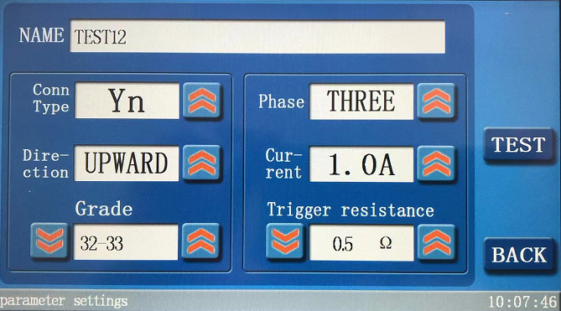
Name: Name of the test article (maximum 16 Chinese characters can be entered)
Shift direction: set whether to shift up or down.
Measure the number of phases: set single-phase and three-phase
Connection type: set Yn, y and d.
Charging current: Select three current gears (0.2A, 0.5A and 1.0A) (choose the test current according to the transition resistance value).
Measuring range: 1.0A (1Ω ~ 20Ω) 0.5A（5Ω～40Ω） 0.2A（20Ω～100Ω）
Gear: 00-99
Trigger resistance: after the test current is selected, there will be a preset trigger resistance, which generally does not need to be modified; (When false triggering occurs, it is necessary to increase the trigger resistance to reduce the trigger sensitivity; When there is no trigger, it is necessary to lower the trigger resistance to improve the trigger sensitivity)
Click on the corresponding input box, modify the corresponding items, and after setting, press "Start Test" to enter the test state. The screen display of test in progress and test completion is as shown below:
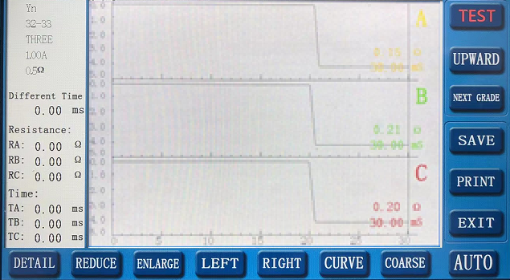
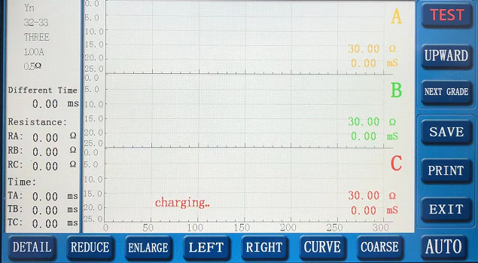

The three curves will change according to the test data. Because the instrument has a process of charging the winding and switch, the curve will change from small to large. When the three-phase curves are stable, press "Start Test", and then the mechanism can be operated manually or electrically (please switch the switch within two minutes after starting the measurement. For the protection of the equipment, the output current lasts for two minutes, and the output will be automatically stopped and switched back to the parameter setting interface).After the action is completed, the LCD screen will automatically display the action waveform. Press the button at the bottom of the screen to adjust the magnification of the curve and move left to right for easy viewing of the waveform.
Press the next gear: automatically switch to the next gear, and press "Start Measurement" to start a new test;
Shift up: press "shift up" to switch to shift down, and vice versa; So you don't have to go back to the parameter setting interface to make settings.
Storage: Store data in memory.
Print: print the test data waveform.
Automatic: When the automatic button shows "Automatic", the instrument automatically discriminates the waveform data. Generally, don't press this button first. When the automatically judged data can't meet the requirements, press this button to manually set the value to be printed. As follows:
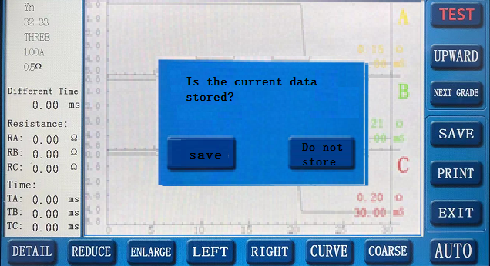
Press "Save" or don't save, and go to the next item. The following interfaces are the same. In the automatic interface, press the "Automatic" button, and in the pop-up menu, press "Save" to enter the time setting of different periods;
Adjust the time of different periods. Because the time of different periods is relatively small, it is necessary to amplify the waveform before adjusting it, so the accuracy is higher. Use ruler 1 and ruler 2 to locate the time of different periods, and the time between the two rulers is the time of different periods, as shown in the following figure:
Adjust the scale, press the "different period time" button to prompt "save" or "don't save", click save, and enter the transition resistance setting.
In the interface of transition resistance setting, adjust the cursor 1 to the place where the line resistance is relatively smooth, and position the cursor 2 to the place where the transition resistance is relatively smooth, as shown in the following figure:
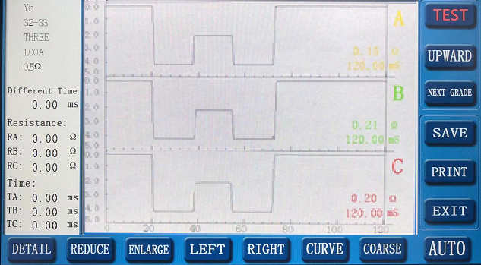
After the setting is completed, press the "transition resistance" button, prompt "save" or "don't save", click save, and enter the A-phase transition time setting. In the A-phase transition time setting interface, adjust the two cursors to be stuck on both sides of the A-phase waveform, as shown in the following figure:
If the waveform is relatively small, the waveform can be scaled appropriately; After setting the cursor, press the "A-phase transition time" button to prompt "Save" or "Don't save", and click Save to enter the B-phase transition time setting. The method for setting the transition time of phase B and phase C is the same, so I won't go into details. After setting the transition time of phase C, enter the printing range setting, and move the ruler forward and backward at the edge of the waveform to make the waveform more complete, as shown in the following figure:
After setting the ruler, press the "Print" button, and the printed data is the data set manually.
Press the "Print Range" button to enter the automatic processing mode; Manual data is only for printing, and has no direct relationship with the data displayed on the left side of the screen; The data in manual mode does not affect the data in automatic interface. Press the key to return to automatic interface and still print the automatically processed data.
Only when the data processed by automatic discrimination method is incorrect, it is recommended to use manual processing method, and it is not recommended to use manual processing method under normal circumstances.
（2）Winding-free test method
Connect the yellow, green and red test tongs of the test line to the voltage-regulating switches X1(A1), Y1(B1) and Z1(C1) respectively, and connect them to the corresponding X2(A2), Y2(B2) and Z2(C2) respectively with short lines, and connect the black test tongs to the neutral point. The other operation steps are the same as those of the winding test. Compared with the test without winding, the action time of the test with winding is longer, about 3-7 ms.
For example, the winding-free test is used to test the connection method of switching action waveform of 4-tap and 5-tap (see Figure 6.5).

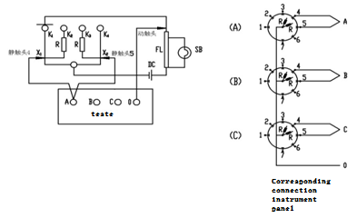
Note: The three-phase moving contacts A, B and C are connected to the neutral terminal of the instrument after short circuit.
（3）Test method of transformer without neutral point of Y-connection of voltage regulating side winding
The neutral point of the sample with this structure can't be led out without hanging the core, so we have to test every two phases, such as A and B. The wiring method is shown in Figure 6.6, and C is equivalent to the neutral point. The operation steps are the same as the winding test method, except that only two groups of waveforms and data are displayed on the LCD screen at a time, and the data analysis method is the same as that of the transformer with neutral point, except that the transition resistance value needs to be converted: let the measured value be R' and the actual value be R, then the two phases will be. After phase A and phase B are measured, phase A can be regarded as neutral point to measure phase B and phase C, or phase B can be regarded as neutral point to measure phase A and phase C.. Its wiring method and data analysis are the same.

ra2 ra1
rb2 rb1

rc2 rc1
黄 绿 红 黑

A B C

rc2 rc1

（4）Test method of transformer with Δ-type connection in voltage regulator side winding:
图6

The trial wiring method is the same as that in Figure 6.6, and the operation steps and data analysis are the same as other transformer testing methods, except that the transition resistance value needs to be converted: let the measured value be R' and the actual value be r, then r = r' for two-phase measurement and R=2/3 R' for single-phase measurement.
（5）、Data query interface
Click Data Query to enter the data query interface, as shown below:
Press "Display Waveform" to display waveform data, which is consistent with the measurement interface. Please refer to the measurement waveform interface.
（6）System setting interface
Set system variables in the system setting interface, as shown below:
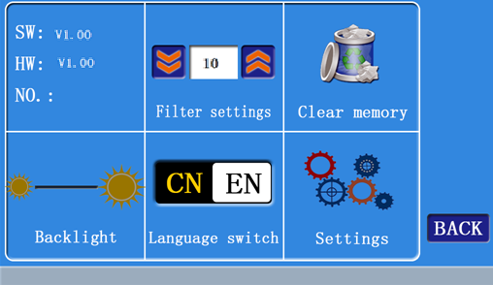
Filter setting: set the filter level of test waveform, 0-60, preset 30; The larger the number, the stronger the filtering ability. When the waveform is not good, it is suggested to increase the filtering value.
Backlight setting: LCD backlight, 10-64;
（7）Time setting interface
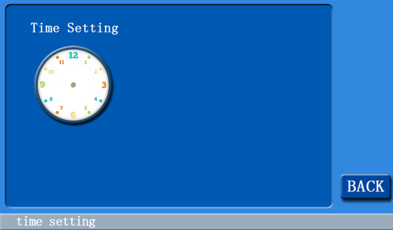
Press the clock icon to pop up the time setting keyboard and set the time.
- Principle Of Switch Action And Waveform Analysis
- Principle of switch action:
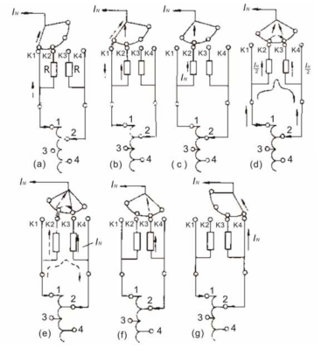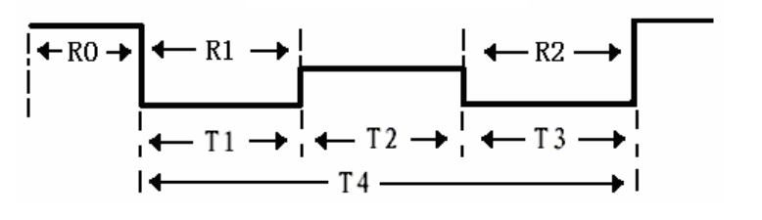
Tap-changer acts in sequence from A to G, and normal action generates standard waveform as shown in the following figure:
R0：Coil resistance and test line resistance
R1：Transition resistance 1
R2：Transition resistance 2
T0：Three-phase synchronization, (based on the earliest detected switching phase)
T1：Running time of transition resistor 1
T2：Bridging time
T3：Running time of transition resistor 2
T4：Transition time
2、Waveform analysis:
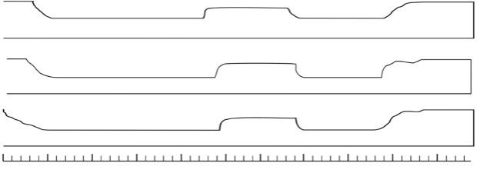
1.

As can be seen from the above figure, the time before bridging is too long, reaching 50ms (three times the normal time), and it is not only one phase, but three phases. This is a typical fast mechanism with aging energy storage spring and slow speed.
Transition waveform (2ms/div)
taps 4 to 3
Transition waveform (2ms/div)
taps 4 to 3
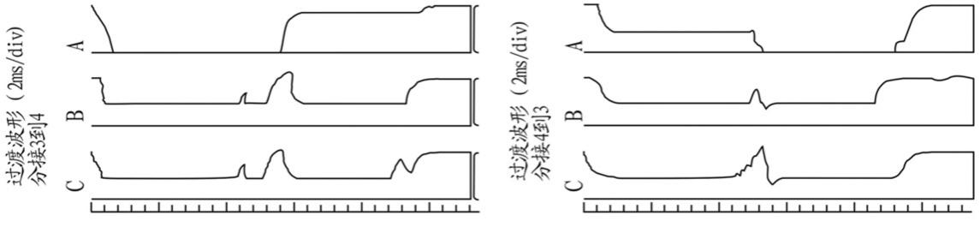
2．

From the above figure, we can see that phase A has symmetrical zero-crossing sections from single to double (3-4) and double to single (4-3), which are on the odd side, and the transition resistance value is much greater than 50Ω from the instrument (more than 50Ω can be regarded as an open circuit). This is a typical transition resistance defect. After hanging inspection, it was found that the transition resistance on the odd side was broken.
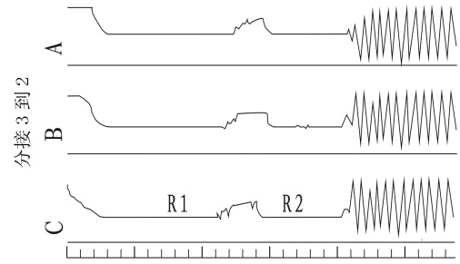
3．
taps 3 to 2

This waveform in the above figure is due to the relatively high sensitivity at the beginning of the test, and the 3-2 direction (increased inductance) is easy to cause oscillation. Reduce the sensitivity appropriately, and the test results from 1-n direction are normal.
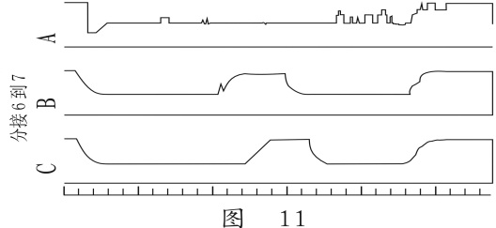
4．
taps 6 to 7

As can be seen from the above figure, the waveform of phase A is chaotic, and the transition resistance value is only 0.3-0.5Ω, and it is the same from 1 to 7. During the hanging inspection, it was found that there was a broken strand in the soft connection of the outgoing line of the A-phase changeover switch, which caused the A-phase transition resistance to be short-circuited (not dead). After field processing, the waveform is normal.
- Packing List
No. | Item | Qty
1 | Host machine | 1
2 | Test line | 1
3 | Recharger | 1
4 | Certificate | 1
5 | Operation manual | 1

