HZ2161
Switch Circuit Comprehensive Tester

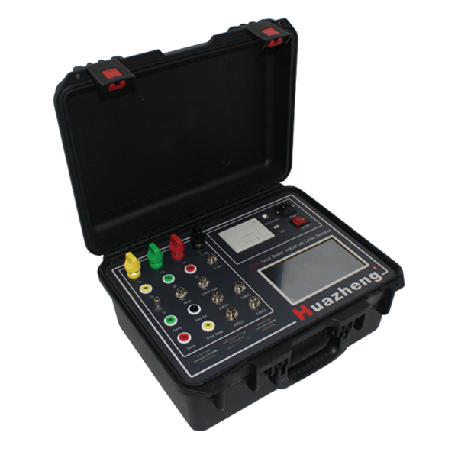

Huazheng Electric Manufacturing (Baoding) Co., Ltd

Contents

I. Product Introduction 1
II. The Function And Operation Description 5
III. The Common Fault Judgment And Treatment Methods 29
IV. Packing List 31

- Product Introduction
  - Product Overview
In the handover test and preventive test of power equipment, the low-voltage test items of circuit breakers usually include mechanical characteristics test and circuit resistance test, and in order to complete the test task, it is usually necessary to carry two sets of equipment for the test. Even if a few devices support two test functions, most of them can only carry out single-phase circuit resistance each time, the wiring and operation is slightly cumbersome, and the work efficiency needs to be improved.
The design team of this machine has many years of field work experience, and has full knowledge and understanding of the above-mentioned actual situation, and through hardware design and software optimization, a set of solutions is proposed in a targeted manner. On the premise of retaining the realization of a single test function, an intelligent test mode is innovatively realized. This mode not only meets the testing needs of the site, but also greatly simplifies the wiring and operation, supplemented by the real voice broadcast and wireless control of intelligent devices, making the testing process more concise, convenient and efficient.
  - Implementation Standards
GB50150-2016 "Electrical installation project electrical equipment handover test standards
DL_T 596-2021 "Preventive Test Procedure for Electric Power Equipment
DL/T 846.3-2017 "General Technical Conditions for High Voltage Test Equipment Part 3: High Voltage Switchgear Integrated Characteristics Tester
DL/T 845.4-2019 "General technical conditions for resistance measuring devices Part 4: Circuit resistance tester
DL/T 845.3-2019 "General technical conditions of resistance measuring device Part 3: DC resistance tester
  - Performance Characteristics
◆It is applicable to the mainstream models of high-voltage circuit breakers at home and abroad, and is equipped with linear travel sensor and incremental rotation sensor. Among them, the incremental rotation sensor installation can be realized without direction, with a special plum connector, which makes the installation more simple and stable.
◆Provide special navigation plug interface for 10kV high-voltage circuit breaker to realize fast, safe and reliable closing and breaking and energy storage coil wiring, and eliminate the safety hazards caused by wiring.
◆With 7-inch resistive color touch screen, full Chinese menu display, real voice broadcast, support for intelligent devices wireless connection control, can generate specific format Word test report, convenient data storage and printing.
◆The test items include circuit breaker mechanical characteristics test, breaking and closing coil resistance test, circuit resistance test, low voltage action voltage test and energy storage motor energy storage. Test items can be freely selected, the instrument intelligent sorting, to eliminate repeated invalid measurement.
◆The instrument supports a maximum of 999 sets of test data storage, test parameters are not lost in power failure, mechanical characteristics test can generate time-displacement diagrams and dynamic current schematic diagrams, speed data can be measured and analyzed again. Provide U disk storage interface, convenient for data storage.
◆Provide USB communication interface, which can realize secondary programming control.
  - Technical parameters
◆Using environment
Input power: 220V±10%, 50Hz±10%
Atmospheric pressure：86～106kpa
Temperature: -10～40℃
Humidity：≦80%RH
◆Safety performance
Insulation resistance: >2MΩ
Dielectric strength: power to the chassis frequency 1.5KV withstand voltage for 1 minute, no flash and flying arc
◆Basic parameters:
Mechanical characteristics of the circuit breaker test parameters table (Table 1)
 |  |  | Measurement range | Resolution | Error
Time |  |  | 0-4000ms | 0.1ms | ±1%±1 word
Itinerary |  | Vacuum Breaker | 50mm | 0.1mm | ±1%±1 word
 |  | SF₆ Circuit Breaker | 300mm | 0.1mm | ±1%±1 word
 |  | Oil less circuit breaker | 1000mm | 0.1mm | ±1%±1 word
Output | Voltage |  | DC5-270V digital adjustable | 1V | ±1%±1 word
Output | Current |  | 20A (instantaneous) | 0.01A | ±1%±1 word
Speed |  |  | 20.000m/s | 0.001m/s | ±1%±1 word
Time measurement channels |  |  | 12-way metal breakout
Data Graphics |  |  | Time-break, Time-displacement, Time-current
Loop resistance test parameters table (Table 2)
Measurement range | Resolution | Error | Power | Working method
0-50mΩ | 0.1μΩ | ±0.5%±2 words | 1000W | Continuous measurement
DC resistance test parameters table (Table 3)
Measurement range | Resolution | Error | Test Current
5mΩ-20kΩ | 0.1μΩ | ±0.2%±2 words | ≤3A
  - Panel Description
Instrument panel layout diagram (Figure 1)
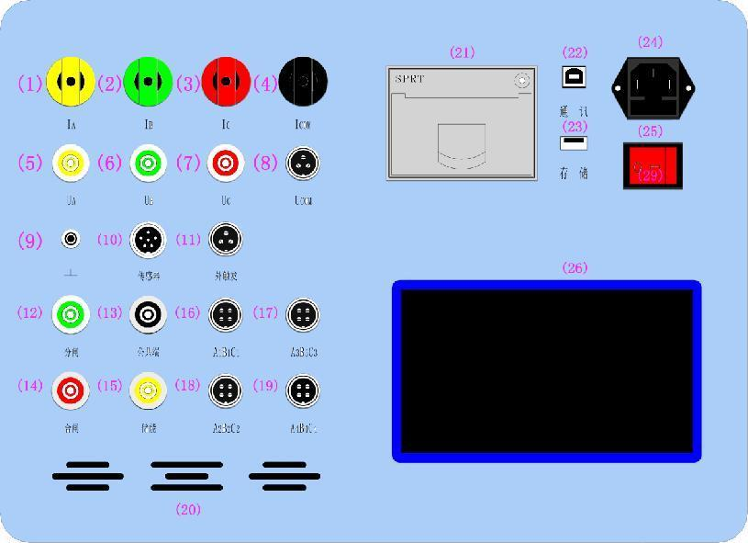
Panel function comparison table (Table 4)
Serial number | Panel Logo | Function Description
(1) | IA | Loop test A-phase current output
(2) | IB | Loop test B-phase current output terminal
(3) | IC | Loop test C-phase current output
(4) | ICOM | Loop test current output common
(5) | UA | Loop test A-phase voltage sampling terminal
(6) | UB | Loop test B-phase voltage sampling terminal
(7) | UC | Loop test C-phase voltage sampling terminal
(8) | UCOM | Loop test voltage sampling common
(9) |  | Grounding post
(10) | Sensors | Digital and analog sensor interfaces
(11) | External Trigger | External trigger signal receiving channel
(12) | Branch gates | Positive output of DC power supply inside the instrument during the breaking operation
(13) | Public side | The negative output of DC power supply inside the instrument during closing and dividing and energy storage operation
(14) | Closing the gate | Positive output of DC power supply inside the instrument during closing operation
(15) | Energy Storage | Positive output of the internal DC power supply of the instrument during energy storage operation
(16) | A2B2C2N2 | 12 channels of break time measurement
(17) | A1B1C1N1 | 12 channels of break time measurement
(18) | A3B3C3N3 | 12 channels of break time measurement
(19) | A4B4C4N4 | 12 channels of break time measurement
(20) | / | Ventilation holes
(21) | / | High thermal printer
(22) | Newsletter | USB communication interface
(23) | Storage | U disk interface
(24) | / | AC220V power outlet
(25) | / | AC220V power switch
(26) | / | Touch Screen

- The Function And Operation Description
The mainframe adopts a 7-inch resistive full-color touch screen, and the menu interface can be switched to a full Chinese display, which is easy to operate and understand. The machine is equipped with a customized Android APP application "Comprehensive test 3", whose operation interface is proportionally designed after the host LCD interface to achieve "zero" learning cost. Therefore, the subsequent function introduction will be mainly based on the host screen operation, except for some special functions, the APP operation will not be repeated.

2.1 Interface Introduction
The menu of this machine is modeled after the UI design of smart phones, the page is divided into three parts: the top status area, the middle content area and the bottom button area (no such area on the home page). The top status area mainly displays the date and time, intelligent voice volume, U disk status, APP Bluetooth connection status and some prompt text; the middle content area is the main display and operation area of the instrument menu content, and the subsequent operation instructions are also the highlighted part; the bottom button area mainly displays the icons and buttons related to screen switching page, data storage printing and test operations. The icons are all schematic icons, matching the functions represented (if in doubt, please refer to the table below). When the buttons in the interface are operated normally, the device will emit a pleasant dripping sound, while when the invalid operation is performed, the device will emit an error sound that is quite different from the dripping sound, so please pay attention to the distinction.
Icon function comparison table (Table 5)
Serial number | Icons | Meaning | Serial number | Icons | Meaning
1 |  | Back to home page | 2 |  | Back to the upper menu
3 |  | Print | 4 |  | Recordable/selectable buttons
5 |  | Previous | 6 |  | Next
7 |  | USB Flash Drive Storage | 8 |  | Delete Data
9 |  | Stop |  |  | Save

2.1.1 Home page
The main menu of the instrument consists of "Data Test", "History Data", "Clock Modification" and "System Setup". There are four first-level menus.
The "data test" includes the mechanical characteristics test, contact resistance test, coil resistance test and energy storage motor storage of the circuit breaker, which includes the "intelligent sequence test" function recommended by the machine.
The "History Data" allows you to view the test data saved during various types of tests conducted by the previous instrument, and print, store, and delete them as needed.
"Clock Modify" is used to display and modify the system clock. When the device is connected with the smart device, click the "Clock Modify" button in the APP to make the host computer quickly synchronize the date and time with the smart device.
Main menu display screen (Figure 2)
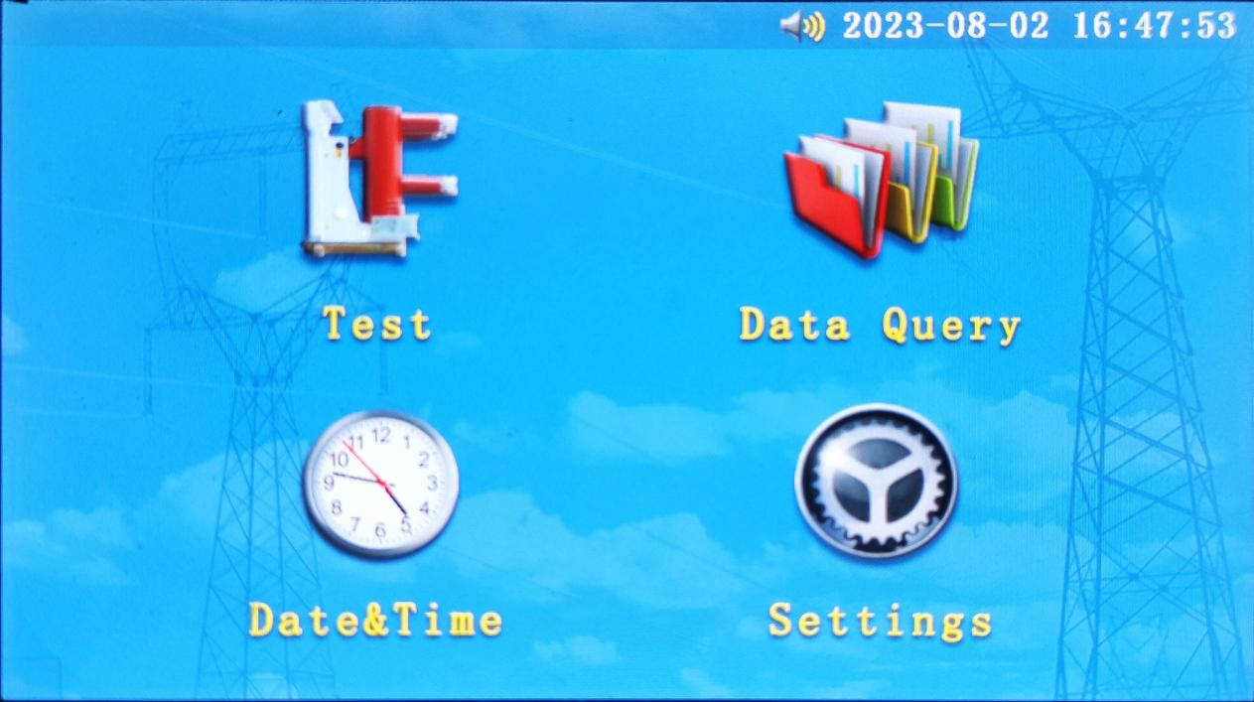
The "system settings" can be set to some of the host state, such as adjusting the brightness of the LCD display, switching the host display language (some versions support), setting the volume of intelligent voice, etc. The "Bluetooth connection" option is a QR code containing the built-in Bluetooth module hardware information. The "Bluetooth connection" option is a QR code containing the hardware information of the built-in Bluetooth module, by clicking the same option in APP and selecting the "Sweep to connect" button, you can realize the communication between APP and the main unit. The APP will record the information after the first connection, and the next time you connect, you can select the "Auto Reconnect" function in the "Bluetooth Connection" option to achieve a quick connection with the host computer (the host computer should be kept in a power-on state).

2.1.2 Data testing
This item is the core area for the instrument to complete the test, which contains the test parameter setting interface and the test process interface. After clicking into it, it is the parameter setting interface. The content display area in the middle of the interface is divided into three areas: test information setting area, circuit breaker fracture state display area and function parameter setting area.
Test information entry interface (Figure 3)
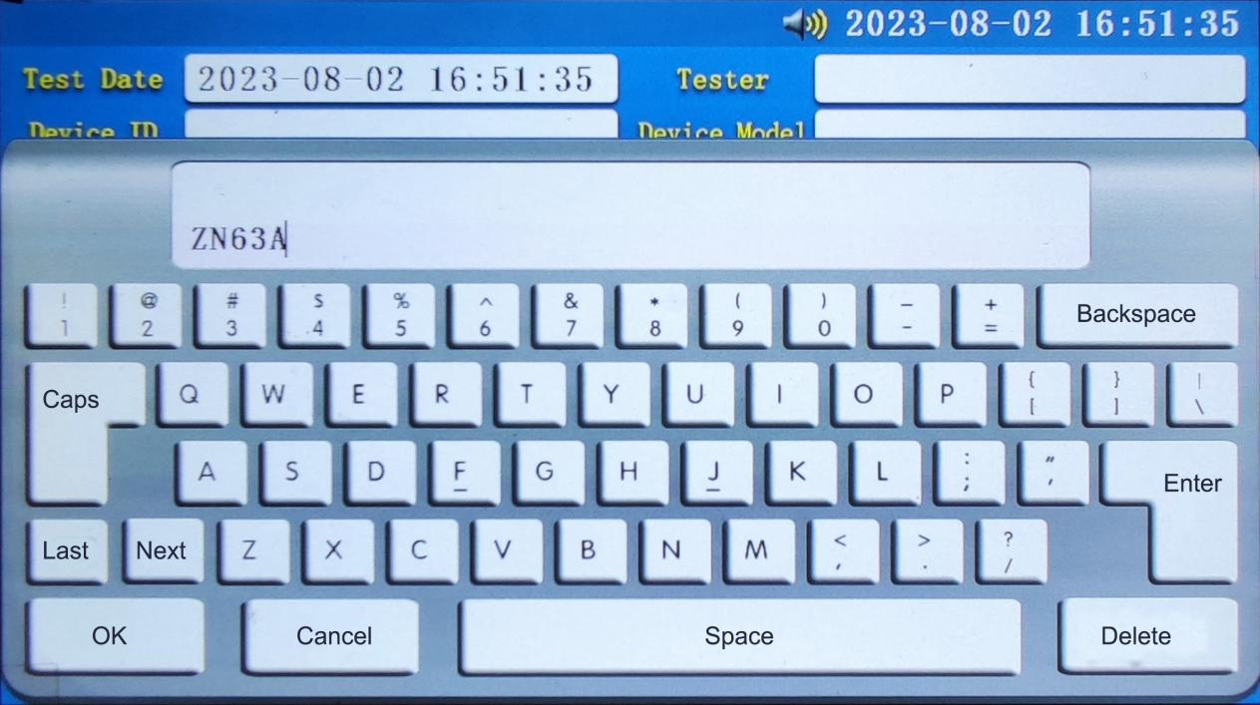
The contents of the test information setting area are general settings, in which the other three parameters are updated and saved simultaneously under different test types and modes, except for the test date which is updated in real time with the system date and time (cannot be changed manually). The way to change them is to click on the parameter display area to change them in the pop-up menu. It should be noted that the pop-up keyboard in Chinese mode is for single-character Chinese Pinyin input (only one Chinese character can be spelled out at a time), press the "up" and "down" keys to select the required Chinese character, press "Finish Press "Finish" to end the entry, and press "Cancel" to exit the entry. Press the number and symbol keys to enter the contents of the corresponding lower row of keys. When you press "Uppercase", press the number and symbol keys to enter the contents of the corresponding upper row of keys, and press the letter to enter the corresponding uppercase letter. When you need to input lowercase letters, please press the corresponding letter button first (you can input more than one), and then press the "line feed" key to complete the entry of lowercase letters. Among them, "equipment number" and "equipment model" can be entered into 20 characters, and the tester can enter 8 characters (a Chinese character is 2 characters).
The breaker break status area shows the closing and breaking status of the breaker break detected by the current device, and its judgment channel will be determined by the "test type" and "by-control test port" mentioned in the subsequent introduction. The machine supports a maximum of 12 channels of metal contact status detection, and is displayed by " " " " two text icons with strong color differences.
The function parameter setting area is divided into three function areas: "General test", "Low voltage action" and "Motor energy storage". When you enter the "Low Voltage Test" menu, you will enter the "General Test" function area by default, and you can switch to the corresponding function area by clicking on the text. The "General Test" function area contains the main low-voltage test items such as intelligent sequence test, mechanical characteristic test, contact resistance test, coil resistance test, etc., while "Low Voltage Action" and "Motor Energy Storage " is to provide its literal meaning in the function of the operation. The former, because of the richer functions realized, has an extra " " set in the bottom button area compared with the latter two, in addition to the common " ". When all parameters are set and the test line is connected, click this button to When all the parameters are set and the test line is connected, click the button to carry out the test item selected in "Test Type", while the latter two have a start button in the functional parameter setting area.

Test parameter setting interface I (Figure 4)
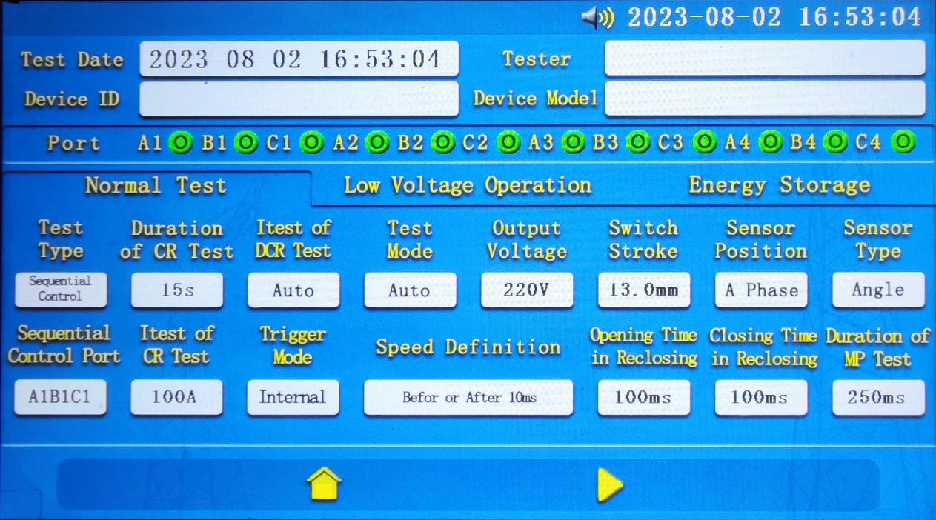
The following are the parameters of the "General Testing" ribbon:
◆Test Type
Click this button, the menu will jump to the test type setting interface (Figure 5). There are 4 single options of test type: "Intelligent Compliance Test", "Mechanical Characteristics", "Contact Resistance" and "Coil Resistance". The last three represent the three kinds of low-voltage test items that can be realized by the device, while "Intelligent compliance test" is a combination of the above three basic functions and the "manual splitting and closing" and "motor energy storage" in "low voltage action". "Intelligent Sequential Test" is a combination of the three basic functions mentioned above and "Manual Closing" and "Motor Energy Storage" in "Low Voltage Action" to automatically generate a set of reasonable action sequence to complete all the test items selected in "Intelligent Sequential Test Item Setting" in one wiring. The content displayed in the black background area above the display area of the circuit breaker fracture status is the order of the test items in the upcoming "intelligent sequential test". The red horizontal line indicates that the item is included, and the white horizontal line indicates that the item is not included. The parameter "low voltage cycle times" is set to the number of cycles for closing low voltage test and breaking low voltage test in "intelligent smooth test", the setting range is 1-5. When the value of this parameter is greater than 1, except for the first time the initial voltage is When the value of this parameter is greater than 1, the initial voltage will default to the last action voltage except for the first time when the initial voltage is "initial voltage" in "low voltage action".
The parameter "Waiting time for the interval of compliance control" is set for the waiting time between two test items in the "intelligent compliance test".
"Test Type" setting interface (Figure 5)
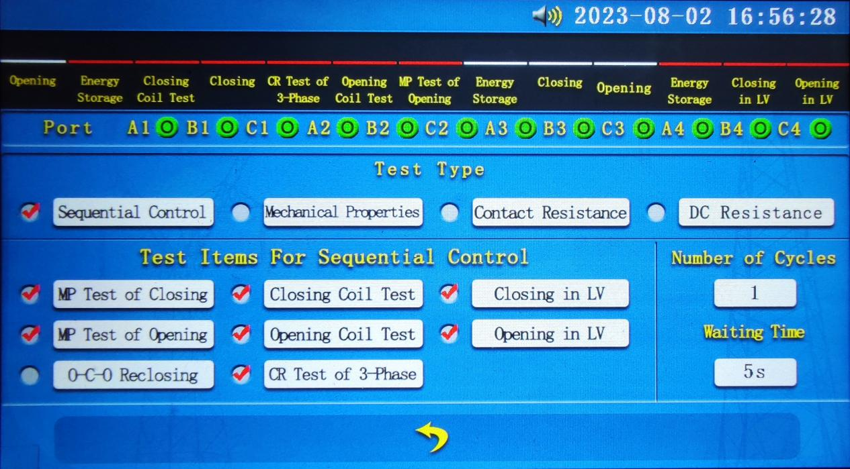
◆Smooth control test port
This parameter provides "A1B1C1" and "A2B2C2" with 2 options, which will be displayed cyclically by clicking the button. When introducing the circuit breaker fracture status area above, we mentioned that the fracture detection channel of the device is determined by the two parameters "test type" and "by-control test port". When the "test type" is set to "intelligent test", the fracture detection channel is set to (5), (6), (7), (8) on the panel as the input, and the "test port with the control " button shows the content of the fracture state channel, switch this button option, will change the channel; when the "test type" is set to other options, the fracture detection channel is (16), (17), (18), (19) on the panel (i.e. " A2B2C2", "A1B1C1", "A3B3C3", "A4B4C4") four data channels, at this time, click The "test port" is an invalid action.
◆Contact resistance test duration
This parameter provides 4 levels of "15s", "30s", "45s" and "60s". Click the button to cycle through the display.
◆Contact resistance test current
This parameter is only available in the "100A" range.
◆Coil resistance test current
This parameter is only available in "Auto" gear and the maximum output current is ≤ 3A.
◆Mechanical characteristic trigger mode
This parameter provides 2 options of "internal trigger" and "external trigger", which will be displayed cyclically by clicking the button. The "internal trigger" mode refers to using the internal DC power output of the instrument to drive the breaking/closing coil of the device under test to realize the breaking/closing action of the device under test during the test; the "external trigger" mode refers to the internal DC source of the instrument not working, but through other power sources The "external trigger" mode means that the internal DC source of the instrument does not work, but through other power sources to drive the measured equipment to split/close the coil work, the instrument only collects external voltage action signal as the starting point of timing. This parameter can only be selected in the "automatic test", "breaking test" and "closing test" modes, and the default setting will be "internal trigger" in other modes. In other modes, the default setting is "internal trigger".
◆Mechanical characteristics test mode
This parameter provides "auto test", "split test", "close test", "split test", "split test", "split test" and "split test", There are 5 options of "Close and Divide Test" and "Divide and Divide", which will be displayed cyclically by clicking the button. Among them, "automatic test" mode is the instrument according to the current state of the port independent judgment to choose to carry out the split or closed test (12-way break has a closed state that is to carry out the split test). Users can choose the corresponding test mode according to the test requirements and the current state of the break.
◆ Mechanical characteristics output voltage
The parameter can be set in the range of 5-270, and the entry interface can be popped up by clicking the parameter display button.
◆Speed definition
Click this display button to enter the speed definition menu. This parameter provides 10 common rules for calculating the rigid division/closing speed and one custom rule to suit the factory rigid division/closing speed requirements of different manufacturers and models of high-voltage switches. If none of the above rules can meet the definition requirements, any of the speed definitions can be selected for testing first. At the end of the test, a specific time or displacement interval is manually selected on the "Time-Travel Characteristics Curve" in the "Curve Graph" for analysis to obtain the corresponding average speed. This method is also suitable for cases where the definition is incorrectly selected before the test.
The "Speed Definition" setting screen (Figure 6)
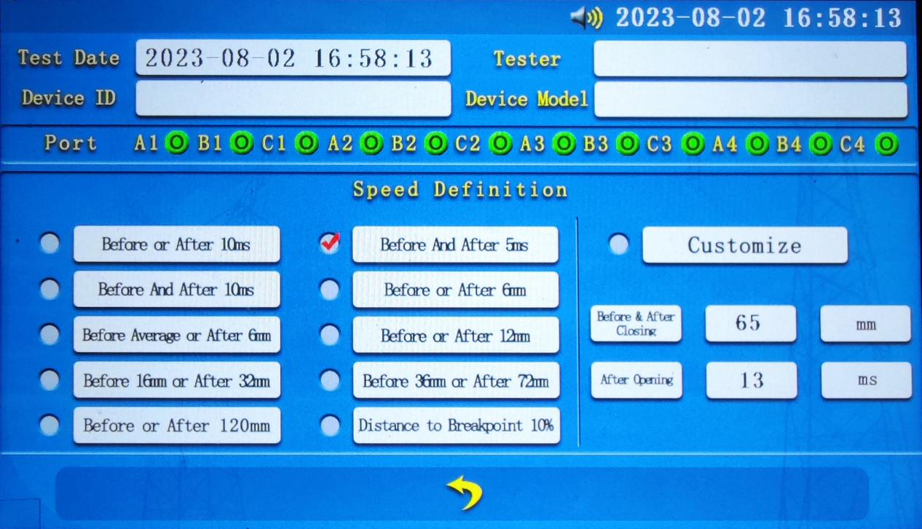
◆Mechanical characteristics switch displacement
The parameter can be set in the range of 0.1-999.9. Click on the parameter display button to bring up the entry interface. It should be noted that the value of this parameter is related to the type of sensor selected. When the angle sensor is selected, the entry value should be the total travel (open distance + overtravel) of the dynamic contact action of the device under test; when the linear sensor is selected, the entry value should be the total distance marked by the linear sensor (the total distance of the standard sensor is 50.0mm).
◆Sensor position
The parameter provides three options of "A phase", "B phase" and "C phase", which are displayed in a cycle by clicking the button. It indicates the installation position of the sensor, and the setting content of the parameter should be consistent with the installation position of the sensor; if the angle sensor is selected and the three phases of ABC are the same rotation axis, it can be set arbitrarily.
◆Sensor type
This parameter provides 2 options of "Displacement Sensor" and "Angle Sensor", which are displayed in a cyclic order by clicking the button.
Reclosing time and closing time of reclosing gate
Both parameters are numerically adjustable from "5ms" to "1000ms" and will be displayed in a cyclic manner at the click of a button. Both of them are valid only when the mechanical characteristics test mode is "split-close", "split-close" and "split-close split". Their meanings are the test duration of split test action and closed test action in reclosing respectively. So both of them should be set with the value of "mechanical characteristic test duration" to meet the following formula:
When the test mode is "split" and "split": T (test duration) ≥ T (split time) + T (closed time)
When the test mode is "split-close split": T (test duration) ≥ 2*T (split time) + T (close time)
When the two parameters do not meet the above requirements at the time of setting, the instrument will automatically change the value of "Mechanical Characteristics Test Duration" to meet the requirements.
◆Mechanical characteristics test duration
This parameter provides "250ms", "500ms", "1000ms", "2000ms ", "4000ms" a total of five gears, click the button will cycle through the display. When the mechanical characteristic test mode is "split-close", "split-close" and "split-close", the instrument will automatically skip the time slot that does not meet the requirements stated in the above reclosing time setting when changing the parameter value. When changing the parameter value, the instrument will automatically skip the time slot that does not meet the requirements of the reclosing time setting.
The following is a description of the parameters of the "Low Voltage Action" function area:
◆Initial voltage
The setting range of this parameter is 5-270, click the parameter display button to pop up the entry interface. It is the starting voltage of low voltage closing/closing action.
◆Stepping voltage
The parameter can be set in the range of 1-10. Click the parameter display button to pop up the entry interface.
◆Action mode
The parameter shows the upcoming action mode, which is set by the automatic judgment of the instrument according to the current state of the collected break, and cannot be changed. Judgment based on the same as the "mechanical characteristics test mode", that is, the 12-way break has a closed state when the break action, otherwise the closed action.
◆Pulse width
The parameter can be set in the range of 1-2000, and the entry interface can be popped up by clicking the parameter display button. The parameter indicates the duration of one low voltage action.
Low voltage action setting interface (Figure 7)
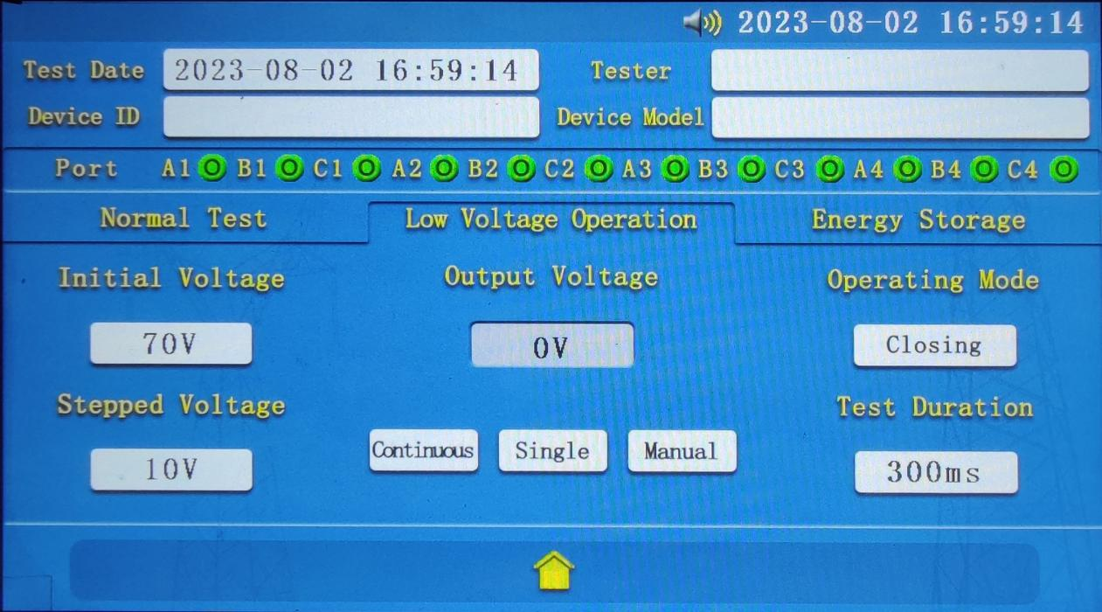
◆Continuous boosting (stop boosting), single boosting, manual splitting and closing
The three are the start buttons for the low voltage action test, which represent the three operating modes.
The "continuous voltage boost" means that the output voltage is output several times in succession, and the output voltage value starts from the "initial voltage" value, after which a "step voltage" value will be added each time until the instrument detects until the instrument detects a change in the state of the break or stops outputting after pressing the "Stop Boost" button. When the output voltage value exceeds the maximum output voltage value (270V), the output will also be stopped and an audio warning will be issued.
The "single boost" means that the voltage is output only once, and the output voltage value is the last output voltage value plus a "step voltage" value. If it is the first time, the output voltage value is the "initial voltage" value; if the last output is "continuous boost" and stopped after pressing the "stop boost" button, the output voltage value will be the last "continuous boost" value. If the last output was "continuous boost" and stopped after pressing the "stop boost" button, the output voltage value will be the last "continuous boost" output value plus a "step voltage" value. The parameters are reset after re-entering the function area.
The "manual splitting" means that the voltage output is performed once according to the "initial voltage" value.
The following are the parameters of the "Motor Energy Storage" function area:
◆Voltage
The parameter can be set in the range of 5-270, and the entry interface can be popped up by clicking the parameter display button.
◆Time, current
These two parameters are the duration of the energy storage output and the instantaneous current of the energy storage output, respectively, which are non-settable parameters.
Motor energy storage setting interface (Figure 8)
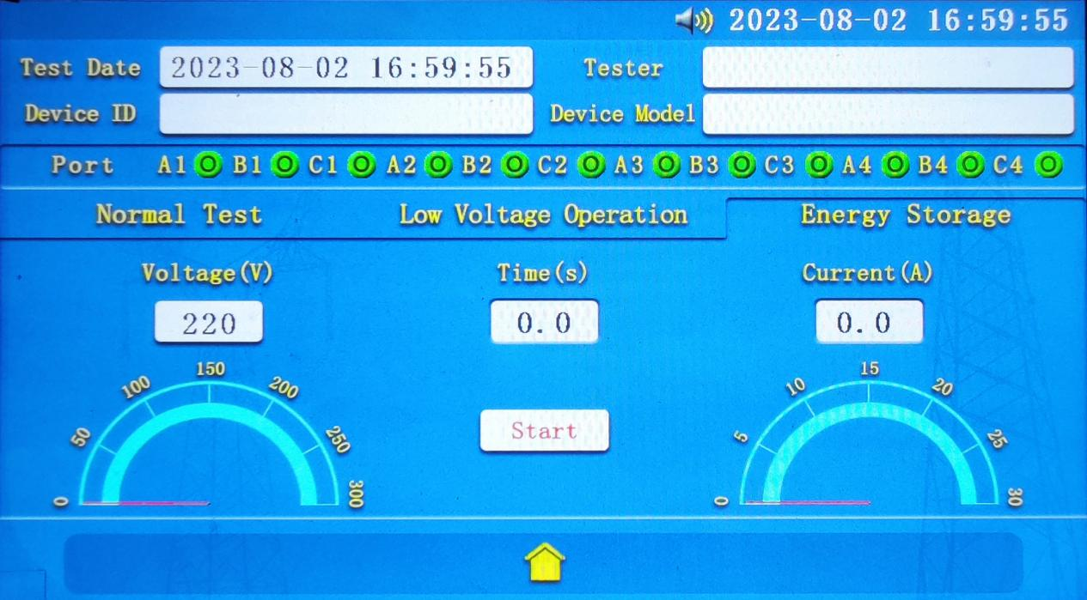
◆Start energy storage (Stop energy storage)
The button is the start button of the energy storage action. After clicking "Start Energy Storage", the button will show "Stop Energy Storage" and the instrument will start to output constant voltage according to the set "Voltage" value, meanwhile "Time" and "Current" start to update in real time. At this time, clicking the button again will stop the output and display "Start Energy Storage". When the output time exceeds 10s and the output current is less than the preset current threshold for a certain length of time, it is decided that the energy storage action is completed or the energy storage circuit is open, the instrument will also stop output and reset the display.

2.1.3 Historical data
When the instrument has stored at least one set of test data, the system will sort the test data according to its storage time and display the last saved data by default. If the instrument has not stored any data, the page will not jump and an error warning sound will be issued. The machine's according to the type of data stored can be divided into intelligent parametric data, mechanical characteristics data, and low-voltage resistance test data (including contact resistance and coil resistance). The first two types of data are automatically saved in the system after the test is completed, and the data display interface of both is basically the same; the latter two types need to be saved manually by clicking the " " button after the test is completed, and the display interface is different, but generally the same. The bottom button areas of all data display interfaces are the same, from left to right, they are " ", " ",
“ ",” ", “ " ,” "and " ", the specific role of each button can be referred to the "icon function comparison table (Table 2)".
When " " is selected, the intelligent parametric and mechanical characteristics data will pop up the print item menu, select one or more items to be printed in the menu and press " " to start printing, and automatically exit the print menu after printing is completed, other types of data will be printed directly.


Users can cycle through the other test data view by pressing the " " and " " buttons, press " " then you can directly enter the data number to directly locate the specified data, enter the number beyond The entry is invalid when the data number exceeds the number of data.
When the U disk interface on the panel is connected to the U disk, you can press " " to store the current view data to the U disk, the data in the U disk can be viewed through the PC data viewer. When the data type is "smart measurement", pressing this button in the APP will bring up an optional menu, prompting you to choose "Store in U disk" or "Generate report". When the latter is selected, the APP will generate a Word type test report in the specified format (see "Appendix "Comprehensive Circuit Breaker Tester Test Report" for report format) and prompt the path to save.
" "A secondary confirmation pop-up window will pop up when pressed to prevent misuse.
◆Intelligent parametric/mechanical characteristics test data
These two types of data usually contain a total of three display screens, namely "Test Parameters", "Test Data" and "Curve Graph".

Historical data test parameters interface (Figure 9)
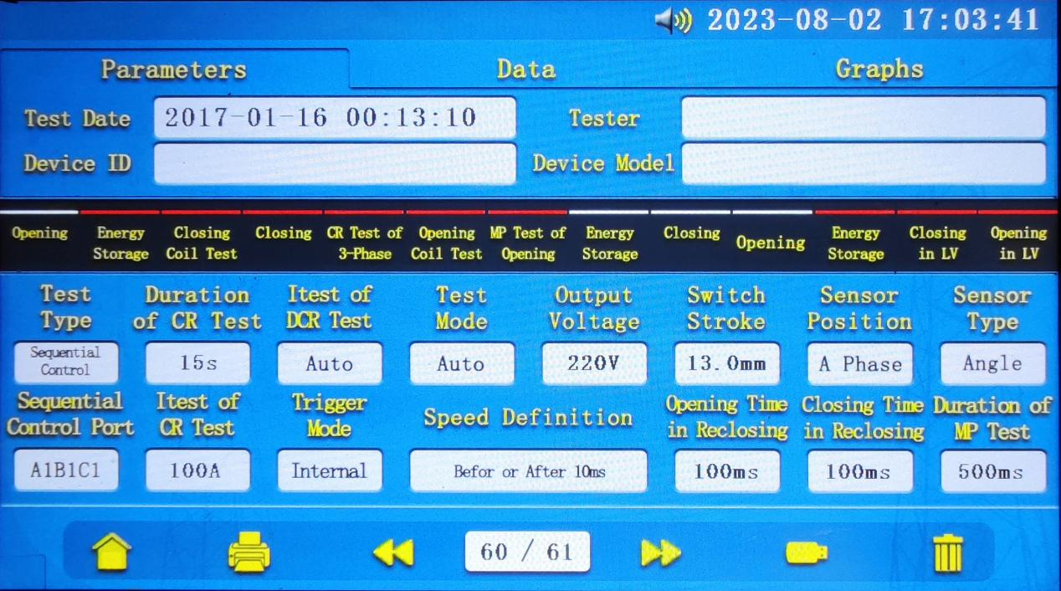
When the data type is "Intelligent Shun Test", if the test item does not contain "Close Mechanical Special Test", "Split Mechanical Characteristic Test" and "Close and Split", the "Curve Graph" page is not available. When it contains two or three of the above three test items, you need to select the type of test item to be viewed in the test item display area of the "test data" page. The graphs displayed on the "Graphical Analysis" page will be updated accordingly. The "Port Group" option in both "Graphical Analysis" and "Test Data" allows you to cycle through the graphs or data for three of the four groups of ports, and the "Magnification" option allows you to view the graphs or data for three of the four groups of ports. Magnification" allows you to enlarge the image by 1, 2 or 3.3 times. By clicking the "T1(ms)" and "T2(ms)" display buttons, you can select any two points in the image and the system will automatically calculate the average speed between the two points, which can be used as "Test Parameters The system automatically calculates the average speed between the two points, which can be used as a supplement to the "Speed Definition" in "Test Parameters". (As shown in Figure 9, 10, 11)

Historical data test data interface (Figure 10)
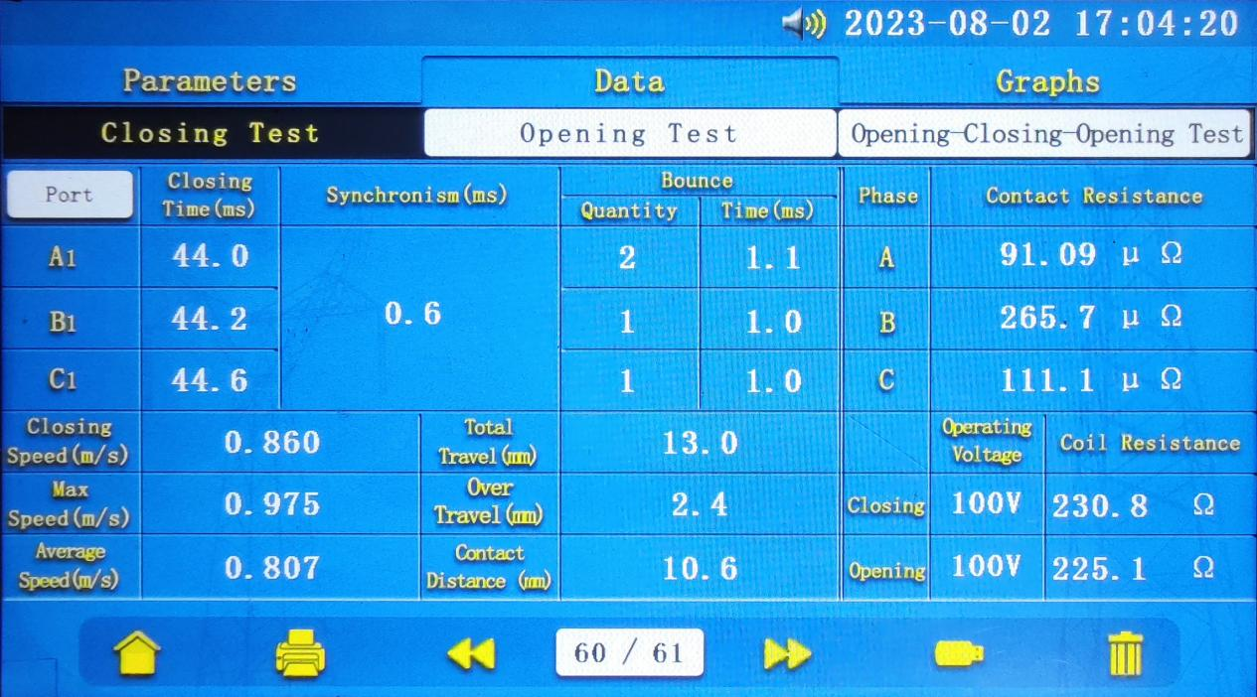
Historical data graphical analysis interface (Figure 11)
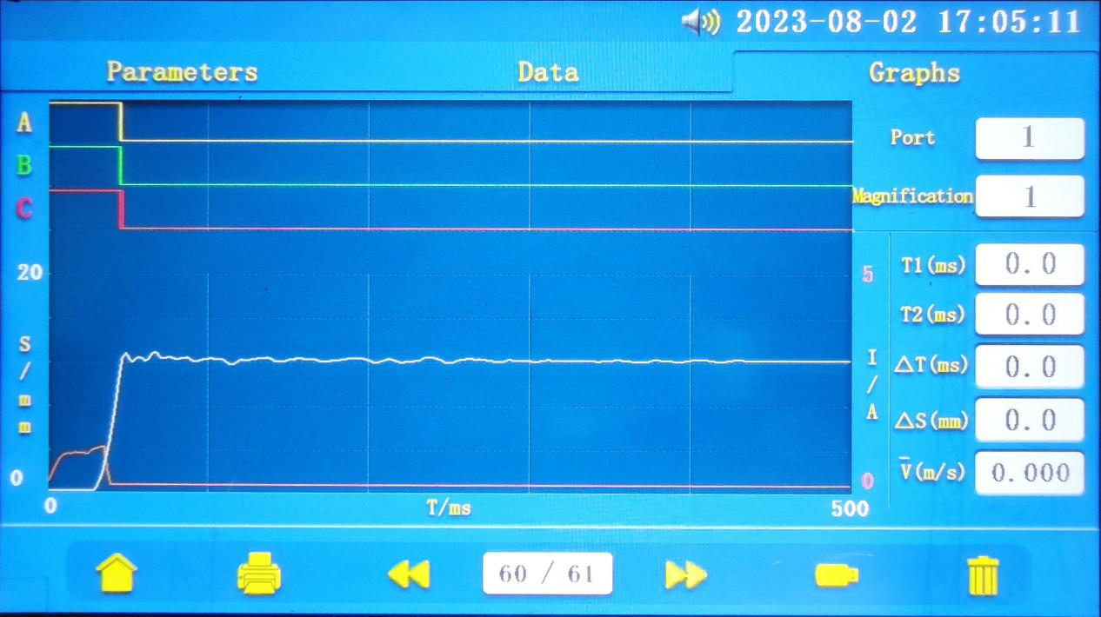
◆Contact resistance/coil resistance test data
The above two data display interfaces are basically the same as their test interfaces, with the only differences being the number and function of the buttons in the bottom button area and the lack of a test timer display in the test parameter display area. (As shown in Figure 12)

Contact resistance test/coil resistance test data interface (Figure 12)
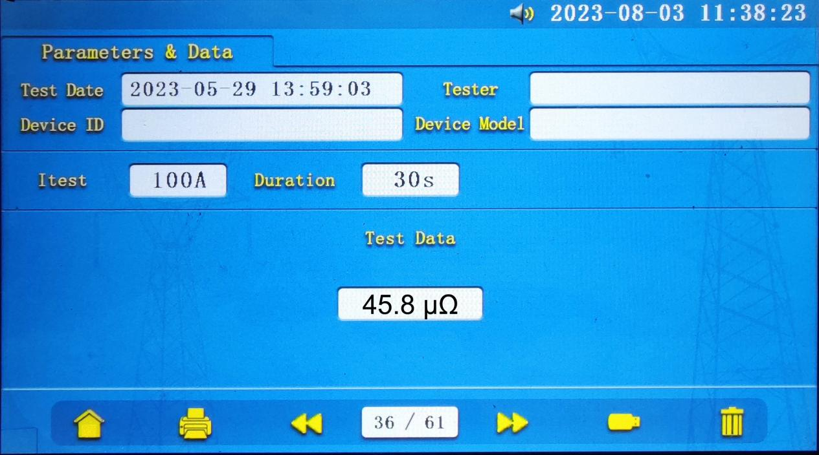

2.1.4 System setup
Click the "System Settings" icon on the home page to enter the menu page. We have already explained in "2.1.1 Home Page", so we will not repeat it here.
System setup interface (Figure 13)
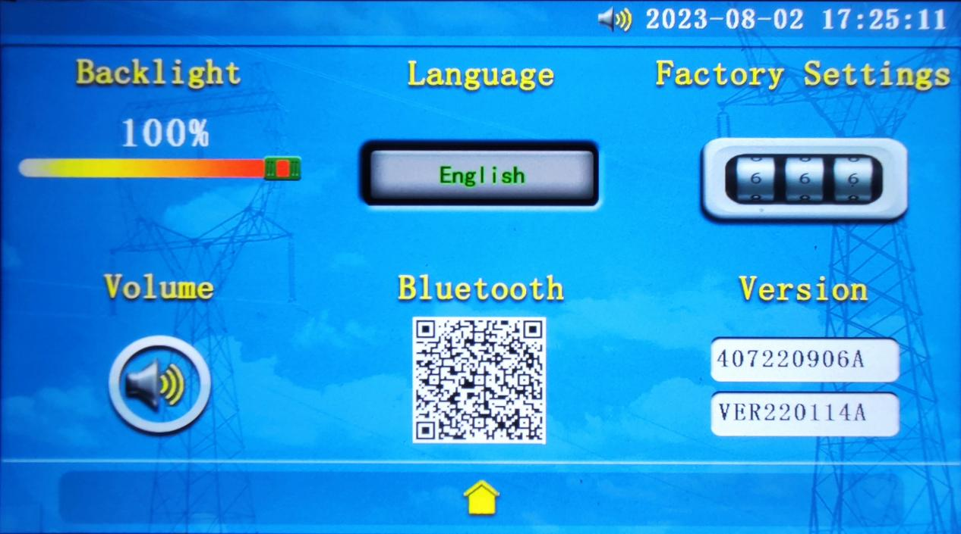

2.2 Test operation and wiring instructions

2.2.1 Mechanical characteristics test
◆Wiring instructions
In "2.1.2 Data Testing", the "Shun Control Test Port" mentions the setting rules of the local machine for the circuit breaker breakout status detection channel, which makes it clear that when conducting other test types except "Intelligent Shun Test "A2B2C2", "A1B1C1", "A3B3C3", "A4B4C4", "A1B1C1", "A3B3C3", "A4B4C4", "A4B4C4", "A4B4C4", "A4B4C4", "A4B4C4", "A4B4C4", "A4B4C4" are status test channels. So you need to use the break state test line (four-core sheathed wire) navigation plug end connected to any one of the above four channels (the default is "A1B1C1", when this channel failure, you can choose other channels, four channels for each other as a backup), the other end with the three-terminal short wiring line through the alligator clips fixed in the circuit breaker three-phase break. It should be noted that the test wire color and phase need to correspond one by one (yellow - phase A, green - phase B, red - phase C, black - common terminal, such as Figure 14).
In addition to the "external trigger" test mode, in the case of confirming the same functional definition of the terminals, you can use the 58-core airline plug with the power test line of the breakout and energy storage coil to connect the action coil of the circuit breaker. If there is a difference in the definition of the function, you can use 10mm fully enclosed alligator clips instead of air plugs on both sides of the action coil on the appropriate terminal row (as shown in Figure 14, 2, 3, 5, 6); when using the "external trigger" test mode, the external trigger test line with 10mm fully enclosed alligator clips are clamped in the same position as above When using the "external trigger" test mode, the external trigger test line with 10mm fully enclosed alligator clips should be disconnected from the test line connected to the "close" and "break" ports.
When the test needs to measure displacement and velocity data, it is necessary to connect the sensor. This machine provides two types of linear sensors and speed sensors, the interface is a six-core navigation plug on the panel. 10kV high-voltage circuit breakers are more suitable for angle sensors because of their structural characteristics. Because of its frequent use, the machine comes with removable plum type sensor fixings that match many domestic circuit breaker rotating inflection arms, making the installation of angle sensors easier and more convenient and secure (Figure 15, 16).

Mechanical characteristics test wiring diagram (Figure 14)
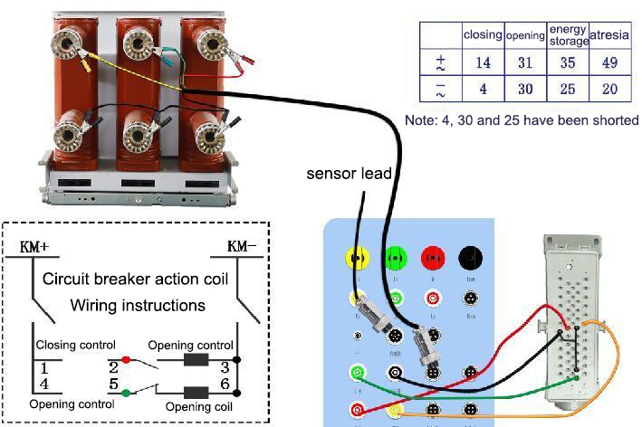
Angle sensor installation schematic (Figure 15)
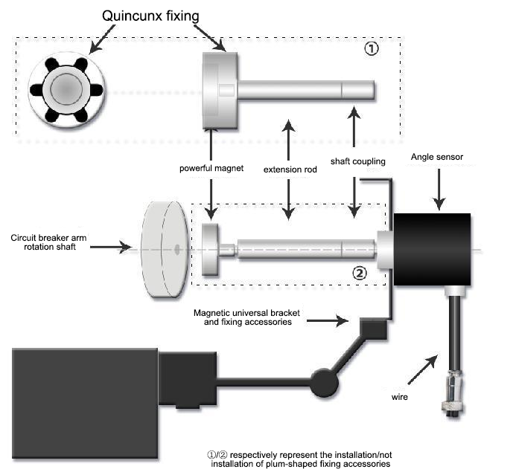

Diagram of linear sensor installation (Figure 16)
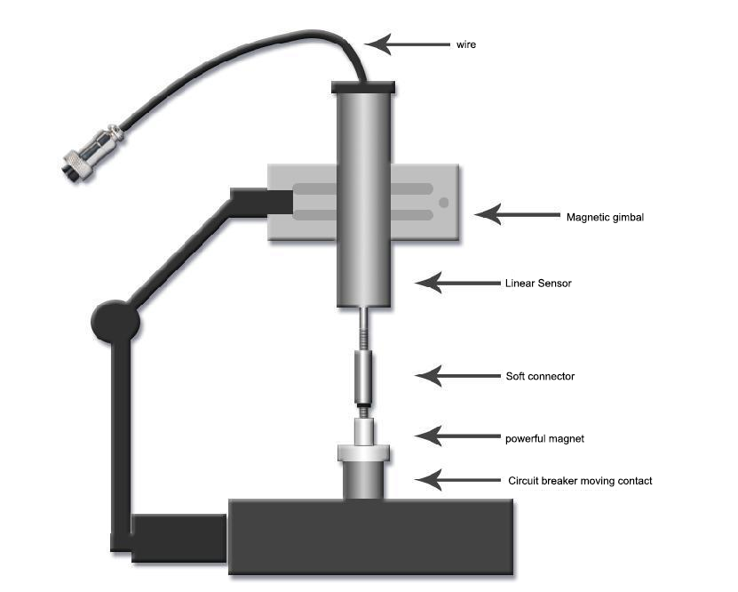
◆Test operation
After the wiring is completed, set the "Test Type" to "Mechanical Characteristics" in the "General Test" interface, set the other test parameters and click " " to start the test, the interface jumps to a test waiting interface. When the selected test mode is "internal trigger", after waiting for a "test duration" to complete the test, the interface will automatically jump to the "test parameters" interface of "historical data". "When "external trigger" is selected, the interface will stay in the test waiting interface until the trigger signal appears, and then the display interface will be the same as that of "internal trigger" after the test is completed. The same. If you need to exit "external trigger" in the middle, click anywhere on the waiting interface. The data viewing operation will be introduced in the subsequent "History Data" operation.

2.2.2 Low voltage action test
This test type is a derivative function of "Mechanical Characteristics", and its wiring method is basically the same as "2.2.1 Mechanical Characteristics Test", except that there is no need to install and use sensors. The specific test operation can be referred to the description of "◆Continuous boost (stop boost), single boost, manual splitting and closing" in "2.1.2 Data test".

2.2.3 Motor energy storage
This test type is also a derivative of "Mechanical Characteristics", which controls the use of the internal DC power supply to continuously regulate the output voltage to achieve the role of energy storage motor storage. The use of this function only needs to ensure that the "common terminal" and "energy storage" of the panel and the energy storage motor to form a circuit, the wiring method can still refer to "2.2.1 Mechanical Characteristics Test" in The wiring method can still refer to "2.2.1 Mechanical Characteristics Test". The specific test operation can refer to the description of "◆Start energy storage (stop energy storage)" in "2.1.2 Data test".

2.2.4 Contact resistance test
◆Wiring instructions
The contact resistance test function adopts the four terminal wiring method, which effectively excludes the influence of test line resistance on the test results. The test line uses yellow and red "100A circuit current and voltage parallel test line" and "circuit voltage adapter wire". The current output channel is "IA-ICOM" and the voltage sampling channel is "UA-UCOM(1)". The "loop voltage adapter wire" is connected to "UCOM" as an adapter wire and connected to the red fork bar, and the other wires are the yellow plug to IA, the red plug to ICOM, and the yellow fork bar to UA.
◆Test operation
After the wiring is completed, set the "Test Type" to "Contact Resistance" in the "General Test" interface, set the "Contact Resistance Test Duration " is set to an appropriate value, after clicking " " to start the test, the menu will jump to the "resistance test" interface. This interface is only the bottom button area buttons can be operated, the rest are display parameters. After the countdown of "Time Remaining" has been running for about 10 seconds, the "Test Data" will appear and continue to update the measured value until the countdown ends and the test is stopped. At this time and can press " " or " " can return to the "regular test" interface or save the test results, press " " for invalid operation; and press " " or " " before the end of the countdown for invalid operation, press " " for can stop the test.
Resistance test wiring diagram (Figure 17)
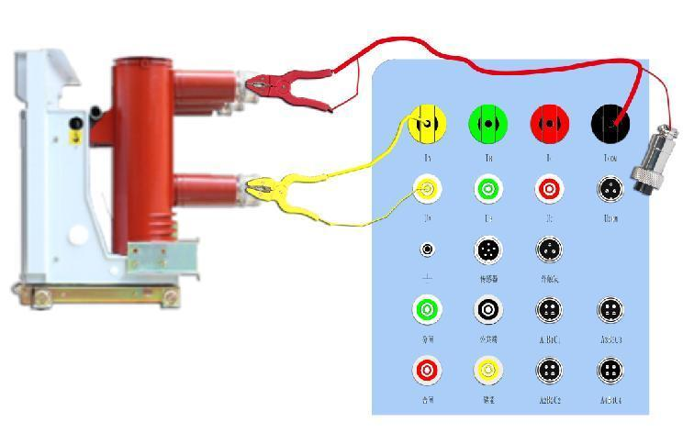
Resistance test interface diagram (Figure 18)
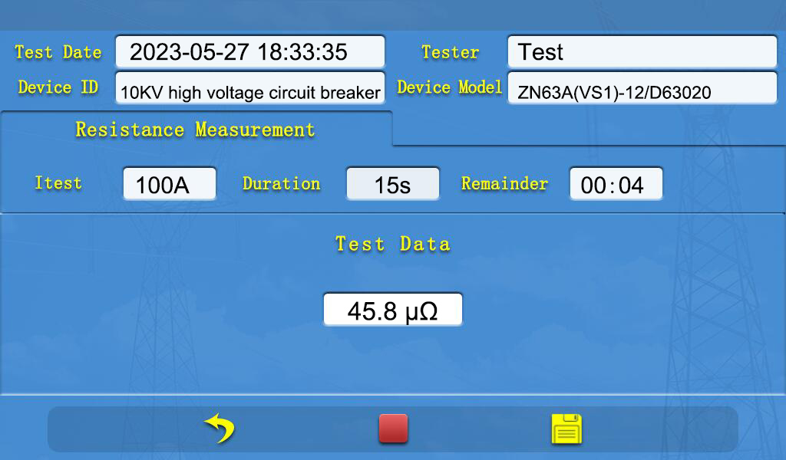

2.2.5 Coil resistance test
This function is compared with "2.2.4 contact resistance test", the main difference between the two is the range, the former output current is ≤ 3A, the range is "5mΩ-20kΩ", the latter output current is 100A, the range is "0-50mΩ". There is a slight difference between the two in the parameter setting, this function needs to select "coil resistance" in the "test type" parameter, as for the wiring method is exactly the same.

2.2.6 Intelligent parametric measurement
This test type is essentially an algorithm that sequences and controls the various sub-functions contained in 2.2.1 to 2.5.5 in a rational manner to achieve the purpose of multiple measurements in one connection.
◆Wiring instructions
This function requires the connection of test lines including three colors 100A circuit current and voltage parallel test line, 100A circuit current test line, circuit voltage test line, the above three test lines are used to detect the state of the circuit breaker fracture, measurement of three-phase contact resistance; breaking and energy storage coil power test line with 10kV circuit breaker special navigation plug or 10mm fully enclosed alligator clips, to achieve the measurement of breaking and closing coil resistance, the output power to achieve the circuit breaker breaking and closing and energy storage action connected to the angle sensor can measure the displacement and speed items, Output power to achieve the circuit breaker breaking and closing and energy storage action connected to the angle sensor can measure the displacement and speed items. For specific wiring, please refer to the intelligent wiring diagram (Figure 19).
Intelligent parametric wiring diagram (Figure 19)
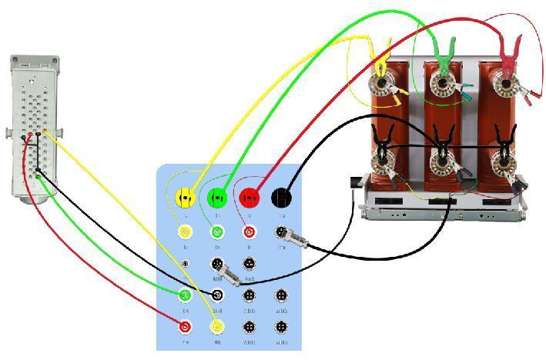

◆Test operation
After the wiring is completed, set the "Test Type" to "Smart Test" in the "General Test" interface, set other test parameters and click " " to start the test. The menu will switch to the corresponding test interface according to the test progress shown on the top of the interface. In order to facilitate the display, the contact resistance test and coil resistance test are combined into the resistance test interface, and at the same time, the operable buttons of each sub-test interface are removed, and only the " " button is set at the bottom button area. Press this button to stop the test during test preparation and partial function test, and press it again to return to the "General Test" interface. When you exit the test manually, the data of the tested items will not be saved. When in the "three-phase contact resistance measurement" test interface, press this button to stop the current phase test and switch to the next phase test when measuring phase A and phase B. When measuring phase C, the test will be stopped directly, and press again to return to the "general test" interface. After each sub-test is completed, it will wait for a "wait time for the control interval", and then go to the next test item after the countdown. After all tests are finished, it will automatically jump to the "Test Parameters" page in "History Data" and save the test data automatically.
Intelligent parametric interface diagram (Figure 20)
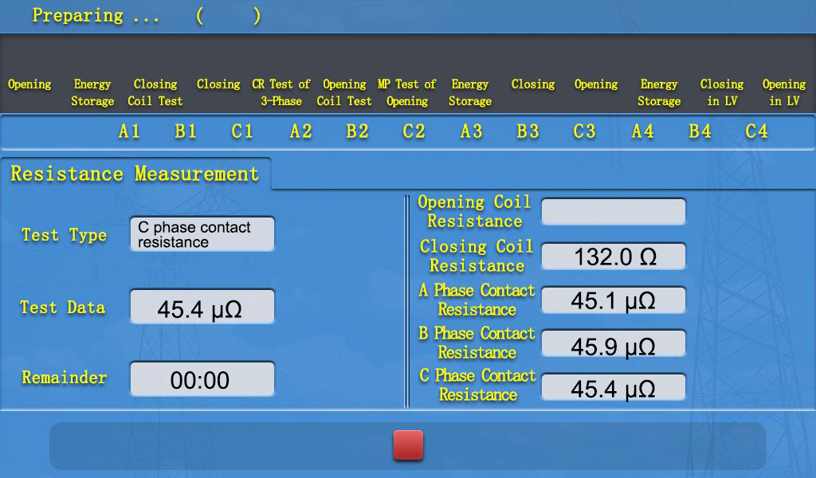

- The Common Fault Judgment And Treatment Methods

3.1 Fault 1: LCD black screen in low voltage test after system restart
Such failure phenomena may occur during routine mechanical characteristics tests, low voltage tests and motor energy storage storage for three possible reasons:
◆ Short circuit in the power output circuit of the closing and dividing coil or energy storage coil. Check the wiring of the three pairs of output terminal groups on the panel, namely "close - public terminal", "break - public terminal" and "energy storage - public terminal "The wiring of the three pairs of output terminal group is not shorted or loose, especially when the "10kV circuit breaker special navigation plug" is not used, but the use of sealing crocodile clips are prone to such problems.
◆The internal power supply is continuously saturated with output for a long time resulting in thermal protection of the power supply. The internal DC power supply of the instrument can be used for the energy storage work of the motor within the rated power, but it is not recommended to use the full power continuously for a long time, and appropriate time should be left to ensure the heat dissipation requirements of the internal power devices of the instrument.
◆ Output failure caused by improper use, device aging or other reasons.
Solution: At this time, you should turn off the instrument power, check and confirm that the above port wiring is normal, and then wait 5-10 minutes after the instrument is re-powered to use. If the problem still exists, the instrument needs to be disconnected, remove all wiring on the panel in addition to the power line, then the instrument power on, select the "feature test" type of "automatic test" mode for testing, if the test can be carried out smoothly and enter the data display If the test can be carried out smoothly and enter the data display interface, it indicates that the instrument has no output fault, need to confirm again whether the wiring is normal; if the fault reappears during the test, it is determined that the instrument output fault, please contact the after-sales service in time for maintenance.

3.2 Fault 2: The state of the circuit breaker break to be tested is not displayed correctly
Fault phenomenon for the "low-voltage test" of the fault state display area can not correctly display the state of the fault to be tested, that is, the circuit breaker fault closure is displayed as " ", and th e breaking is displayed as " ". This fault is common in the fault state wiring channel selection and parameter settings do not match, you can read the "2.1.2 data testing" in the "test type" and "by control test port" of the Related instructions. If you still have questions, you can consult the after-sales service to clarify.
When the break state wiring channel selection matches the test parameters and problems occur, it is generally a wiring location selection error. Yellow, green and red state detection lines need to be with the black common line each constitute a closed circuit with the break as the only on/off switch. When there is a short-circuit connection between the three color status detection line or each with the black common line to form a closed circuit is not complete and unique, there will be a state display failure. Common miswiring such as when using the "mechanical characteristics" test type, not to use the three-terminal short wire with the break status test line or the equipment to be tested in the double-ended ground state.
Of course, the instrument may have a status display failure caused by aging equipment failure, this type of failure can be eliminated by the following steps:
According to the instructions of "2.1.2 Data Test", "Test Type" and "Shun Control Test Port", select the correct test channel for wiring. It is recommended to use the "Mechanical Characteristics" test type and select "A1B1C1" on the panel as the test channel to connect to the "Fracture Status Test Line", when The "Shun Control Test Port" can not be set.
The LCD interface is placed on the "General Test" page of "Low Voltage Test". Manually contact the yellow, green and red banana tips of the break status test line with the black banana tip respectively, and observe whether the break status displayed in the interface is consistent with the contact status. If inconsistent, it can be identified as a hardware failure of the instrument, you need to promptly contact the after-sales service for repair.

3.3 Fault 3: Abnormal displacement or velocity data test data in the characteristic test
This kind of failure is usually caused by the sensor installation and fixed abnormal test data, usually by tightening the sensor fixed parts or adjusting the installation position to eliminate data abnormalities.

3.4 Fault 4: Contact resistance test/coil resistance test data abnormal
This kind of failure is usually due to the existence of dirt or oxide layer on the contact surface of the test clamps and the product under test, the contact surface will be clean or remove the oxide layer can be.
- Packing List
Serial number | Name | Specification | Quantity
1 | 100A circuit current and voltage parallel test line | Yellow parallel line | 1
2 | 100A circuit current and voltage parallel test line | Green Parallel Line | 1
3 | 100A circuit current and voltage parallel test line | Red parallel line | 1
4 | 100A loop current test line | Black single strand | 1
5 | Loop voltage test line | Yellow, green and red three-core sheathed cable with three-core navigation plug | 1
6 | Loop voltage adapter wire | Black single strand with three cores navigation plug | 1
7 | 10kV circuit breaker special navigation plug | 58-pole aviation plug GDZ-58/JZ-58 | 1
8 | Test line for power supply of break-open and energy storage coil | Yellow, green, red and black four-core sheathed wire | 1
9 | Fracture status test line | Yellow, green, red and black four-core sheathed cable with four-core navigation plug | 1
10 | Three-terminal short wiring | Black single strand | 1
11 | External trigger test line | Red, black and green three-core sheathed cable with three-core navigation plug | 1
12 | Sensor extension cable | Six-core shielded cable | 1
13 | Magnetic universal bracket | / | 1
14 | Angle Sensor Kit | Including angle sensor and mounting bracket, coupling, extension rod, plum joint and strong magnet each | 1
15 | Linear Sensor Kit | Includes 1 each of linear sensor and mounting bracket, soft connector and strong magnet | 1
16 | Sensor Installation Tools | Including 3 sensor fixing brackets, 1 small hexagonal wrench for sensor, a set of coupling, extension rod and strong magnet | 1
17 | Print paper | / | 1
18 | 20A insurance | / | 2
19 | Transparent ground wire | / | 1
20 | AC220 three-core power cord | / | 1
21 | 20mm open alligator pliers kit | 1 each of yellow, green and red, 4 of black | 1
22 | 10mm closed alligator pliers kit | 1 each of red, black and green | 1
23 | Instruction manual | / | 1

