HZTTR80A
Transformer Turns Ratio Tester

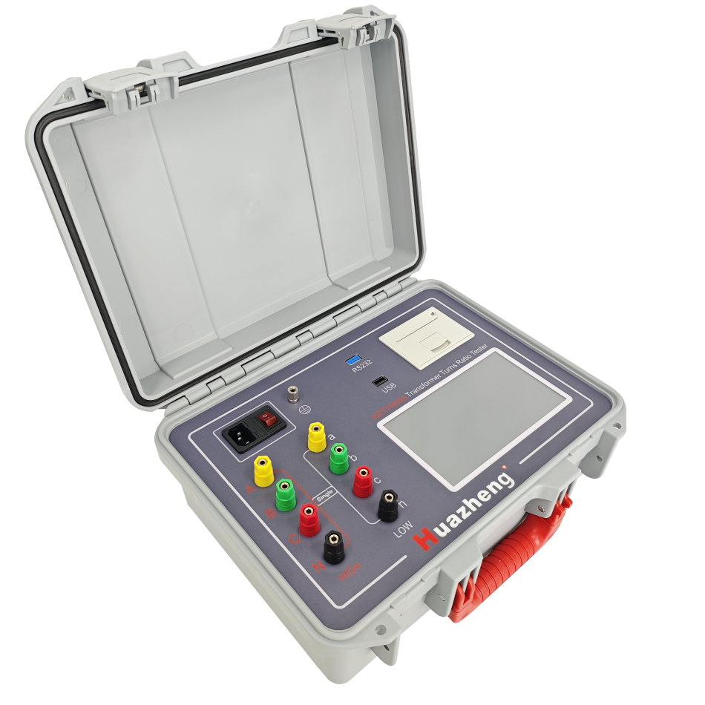

Huazheng Electric Manufacturing (Baoding) Co., Ltd

Dear user:
Thank you for choosing HZTTR80A Transformer Turns Ratio Tester.
We hope that this instrument can make your work easier and more enjoyable, so that you can get the feeling of office automation in the test and analysis work.
Before using the instrument, please read this manual, and operate and maintain the instrument according to the manual to prolong its service life. "Just a light press, the test will be completed automatically" is the operating characteristics of this instrument.
If you are satisfied with this instrument, please tell your colleagues; if you are not satisfied with this instrument, please call (0312 ) 6775656 to tell you to serve you at all times- Baoding Huazheng Electric Manufacturing Co., Ltd., our company will definitely make you satisfied !

Contents

I. Overview 1
II. Precautions 2
III. Technical Parameters 4
IV. Test Preparation 5
V. Operation 7
VI. Troubleshooting and Maintenance 18
VII. Packing list 19

- Overview
1.1 Product Overview
The HZTTR80A transformer ratio test device is a fully automatic tester. It integrates the testing functions of turn ratio, voltage ratio, vector relationship, winding connection, polarity, tap position, and excitation current. This tester is a lightweight and portable instrument, with both the tester and its accessories housed in a multi-functional engineering plastic case that is resistant to cold, heat, sealing, waterproof, and shockproof, making it convenient for field tests. This test device can be used to test single-phase and three-phase transformers, both with and without taps. The instrument can be controlled throughout using a dedicated APP downloaded on an Android phone or tablet, allowing for the storage and upload of test data for easy review.
1.2 Main Functional Features
▪ Capable of PT ratio and polarity testing.
▪ With a blind-testing function, it can accurately measure the turns ratio of a three-phase transformer even when its connection group type is unknown. It can also correctly determine the phase relationship between the primary and secondary sides and accurately calculate the group number.
▪ Capable of testing autotransformers, Z-type transformers, and phase-shifting transformers.
▪ Added tap mode settings to accommodate transformers with high voltage at high tap positions and low voltage at high tap positions.
▪ Added low-voltage side tap settings to accommodate transformers with taps on the low-voltage side.
▪ Graphical display settings for more intuitive readings.
▪ Simultaneous measurement of three-phase ratios during three-phase transformer testing for faster testing speed.

1.3 Panel Description
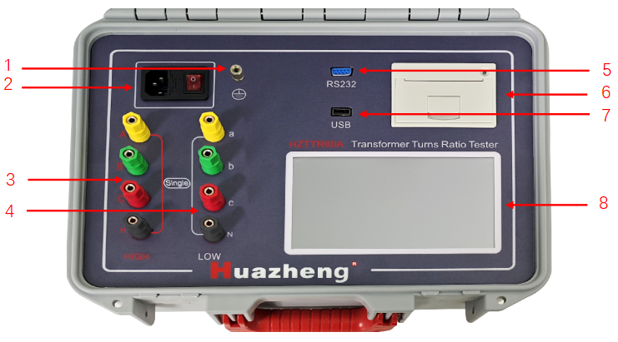
- Grounding Terminal: Before conducting any tests, please safely ground the grounding terminal to avoid the risk of electric shock.
- Power Socket and Switch: The power input port for the entire device, used to connect or disconnect the test power supply.
- High-voltage side connection terminals: There are three-color (yellow, green, red, and black, with the black one being counted as part of the color indication context here for understanding the connection mapping, though technically it's a single additional color column beyond the three primary phase colors) binding posts, corresponding to connection with the A, B, C, N phases of the high-voltage side of the transformer being measured.
- Low-voltage side connection terminals: There are three-color (yellow, green, red, and black, similarly, the black one is included in the context for connection mapping explanation) binding posts, corresponding to connection with the a, b, c, n phases of the low-voltage side of the transformer being measured.
- High-Voltage Side Terminals: Yellow, green, and red terminals for connecting to the A, B, and C phases of the high-voltage side of the transformer under test.
- Low-Voltage Side Terminals: Yellow, green, and red terminals for connecting to the a, b, and c phases of the low-voltage side of the transformer under test.
- RS232 Communication Interface: Interface for computer communication.
- Printer: Prints test results.
- USB: Connects to a USB flash drive for data export.
- Display Screen: 7-inch high-definition color touchscreen LCD with adjustable backlight for displaying the operation menu and test results.
- Precautions
2.1 Usage Instructions
Only qualified and trained operators should operate the tester. Operators must read and understand this manual before operating the tester. Operators must follow the instructions in this manual and adhere to the precautions during the use of the tester. If the device malfunctions, it should be immediately powered off and returned to Huazheng for repair.
2.2 Labeling
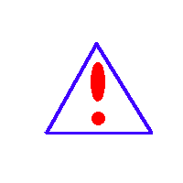
Warning: Please refer to the user manual.

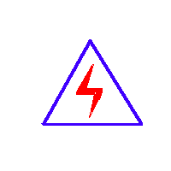
Caution, risk of electric shock.

2.3 Safety Precautions
▪ This equipment is intended solely for the purposes described in this manual. Please strictly adhere to the information provided in the "Precautions" section.
▪ All terminals of the tester and high-voltage electrical power systems pose potential electric shock hazards. Take all practical safety precautions to prevent contact with live parts of the equipment and associated circuits.
• Use appropriate barriers, barricades, or warnings to ensure that personnel not directly involved in the work stay away from testing activities.
• Do not connect the tester to equipment that is in a powered-on state.
• Do not use in rainy or explosive environments.
• Before testing, reliably ground the grounding terminal on the device panel to prevent hazards.
2.4 Operating Precautions
▪ Before conducting any tests, please ensure the grounding post is safely grounded to prevent electric shock hazards.
▪ Before testing, carefully check the wiring to ensure there are no reverse connections, short circuits, or incorrect connections.
▪ For measurements of Y/yn, YN/d, D/yn, D/zn, Y/zn, and autotransformers, there is no need to connect the neutral points. For measurements of single-phase transformers and potential transformers (PT), use the high-voltage side yellow and black test clips, as well as the low-voltage side yellow and black test clips.
▪ Z-type transformers can only be used for voltage ratio measurement.
▪ For transformers with multiple tap points, input the tap level, rated tap, tap type, rated high voltage, and rated low voltage so that the test results can automatically calculate the error values and the position of the tap switch. Once the rated data is input, when testing each tap point, the error value of that point and which tap point it is can be automatically calculated without the need to change the input parameters.
▪ If the number of short-circuited turns is very small, a fault may not be detected solely through a turns ratio test; the problem can be identified by testing the excitation current.
2.5 Precautions for Operating Power Supply
The tester is equipped with a three-wire power cord. It should operate within the following working voltage range:
85-264VAC, 47-63Hz.
Before connecting the power supply, ensure that the operating voltage of the tester matches the input voltage. The control circuit of the tester is protected by a fuse. The fuse is located in the power socket and switch module, installed on the tester panel, and can be replaced by the operator.
------------------------------------------------------------------------------------------------------------------------
Before replacing the fuse,
disconnect the power input plug from the power outlet.
------------------------------------------------------------------------------------------------------------------------
- Technical Parameters
Test Range: Transformation Ratio -- 0.9 to 10000, Current -- 0 to 2000mA, Angle -- 0 to 360°
Ratio Accuracy:
5V Range: ±(0.1% + 2 digits) (0.9-50), ±(0.2% + 2 digits) (51-200), ±(0.5% + 2 digits) (201-600)
80V Range: ±(0.1% + 2 digits) (0.9-500), ±(0.2% + 2 digits) (501-2000), ±(0.5% + 2 digits) (2001-10000)
Current Accuracy: ±(1% of reading + 0.5 mA)
Angle Accuracy: ±0.2°
Output Voltage: Selectable 5V or 80V
Resolution: Ratio -- Minimum 0.0001, Current -- 0.001mA, Angle -- 0.01°
Test Voltage: AC 5V @ 1A, AC 80V @ 80mA
Operating Power Supply: 100V～240V AC, 50/60 Hz
Ambient Temperature: -10°C to 40°C
Relative Humidity: ≤85%, non-condensing
Dimensions: Main Unit: 360290170(mm), Cable Box: 360290170(mm)
- Test Preparation
4.1 Selection of Test Location
• Choose a location that is as dry as possible for testing.
• Keep away from flammable materials.
• Ensure good ventilation in the test area.
• The test area should be a flat surface.
• Set up appropriate safety barriers to protect operators.
------------------------------------------------------------------------------------------------------------------------
For all tests described in this manual, care should be taken to ensure that any and all unused clamps are isolated from each other, the ground, and personnel.
------------------------------------------------------------------------------------------------------------------------

4.2 Wiring
------------------------------------------------------------------------------------------------------------------------
Connections should be made in the following order, and the reverse order should be followed for disconnection after testing. Ensure that the switch is in the "O" (OFF) position, disconnect the power cord first, then the ground wire, and finally the test leads.
------------------------------------------------------------------------------------------------------------------------
- Grounding Cable
Use a grounding cable to directly connect the grounding post of the tester to the earth. Ensure that the transformer case also has a low-impedance connection to the grounding potential.
- Connecting Test Leads
Connect the primary and secondary test leads to the tester. Ensure that all plugs are securely and safely connected to the tester with reliable contact.
The wiring diagram for single-phase transformation ratio testing is shown in the figure below: (Unused test leads can be left hanging)
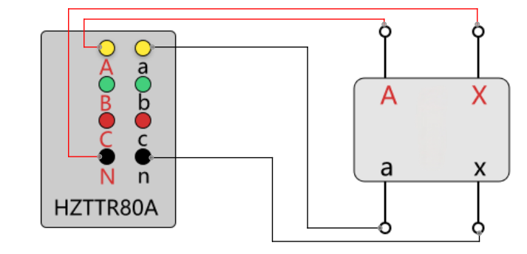
Transformer
The wiring diagram for three-phase transformation ratio testing is shown in the figure below:
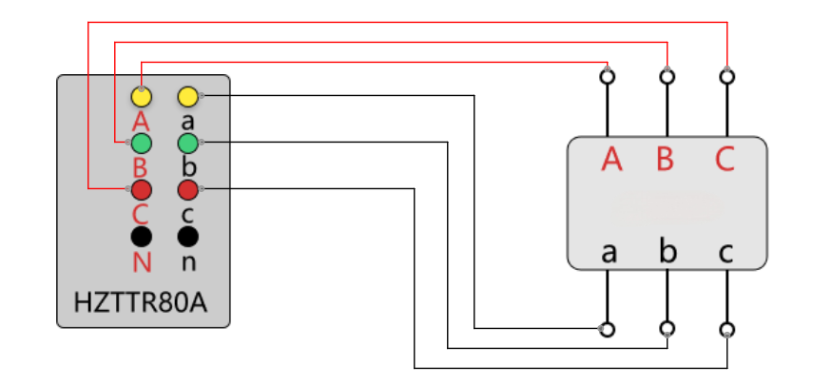
Transformer
- Connecting Power Supply
Ensure that the input power supply meets the requirements, make sure the switch is in the "O" (OFF) position, and connect the power cord to the tester.
4.3 Android APP Software
The testing instrument can be controlled via the touchscreen or operated from an Android mobile phone that has been connected and on which the APP software has been installed.
(1). Installation of APP Software
Install the APP software named hz_device_vX.x.x.apk, where vX.x.x represents the version number.
(2). Connecting to the Device
Click on the APP icon  to enter the main interface, as shown below:
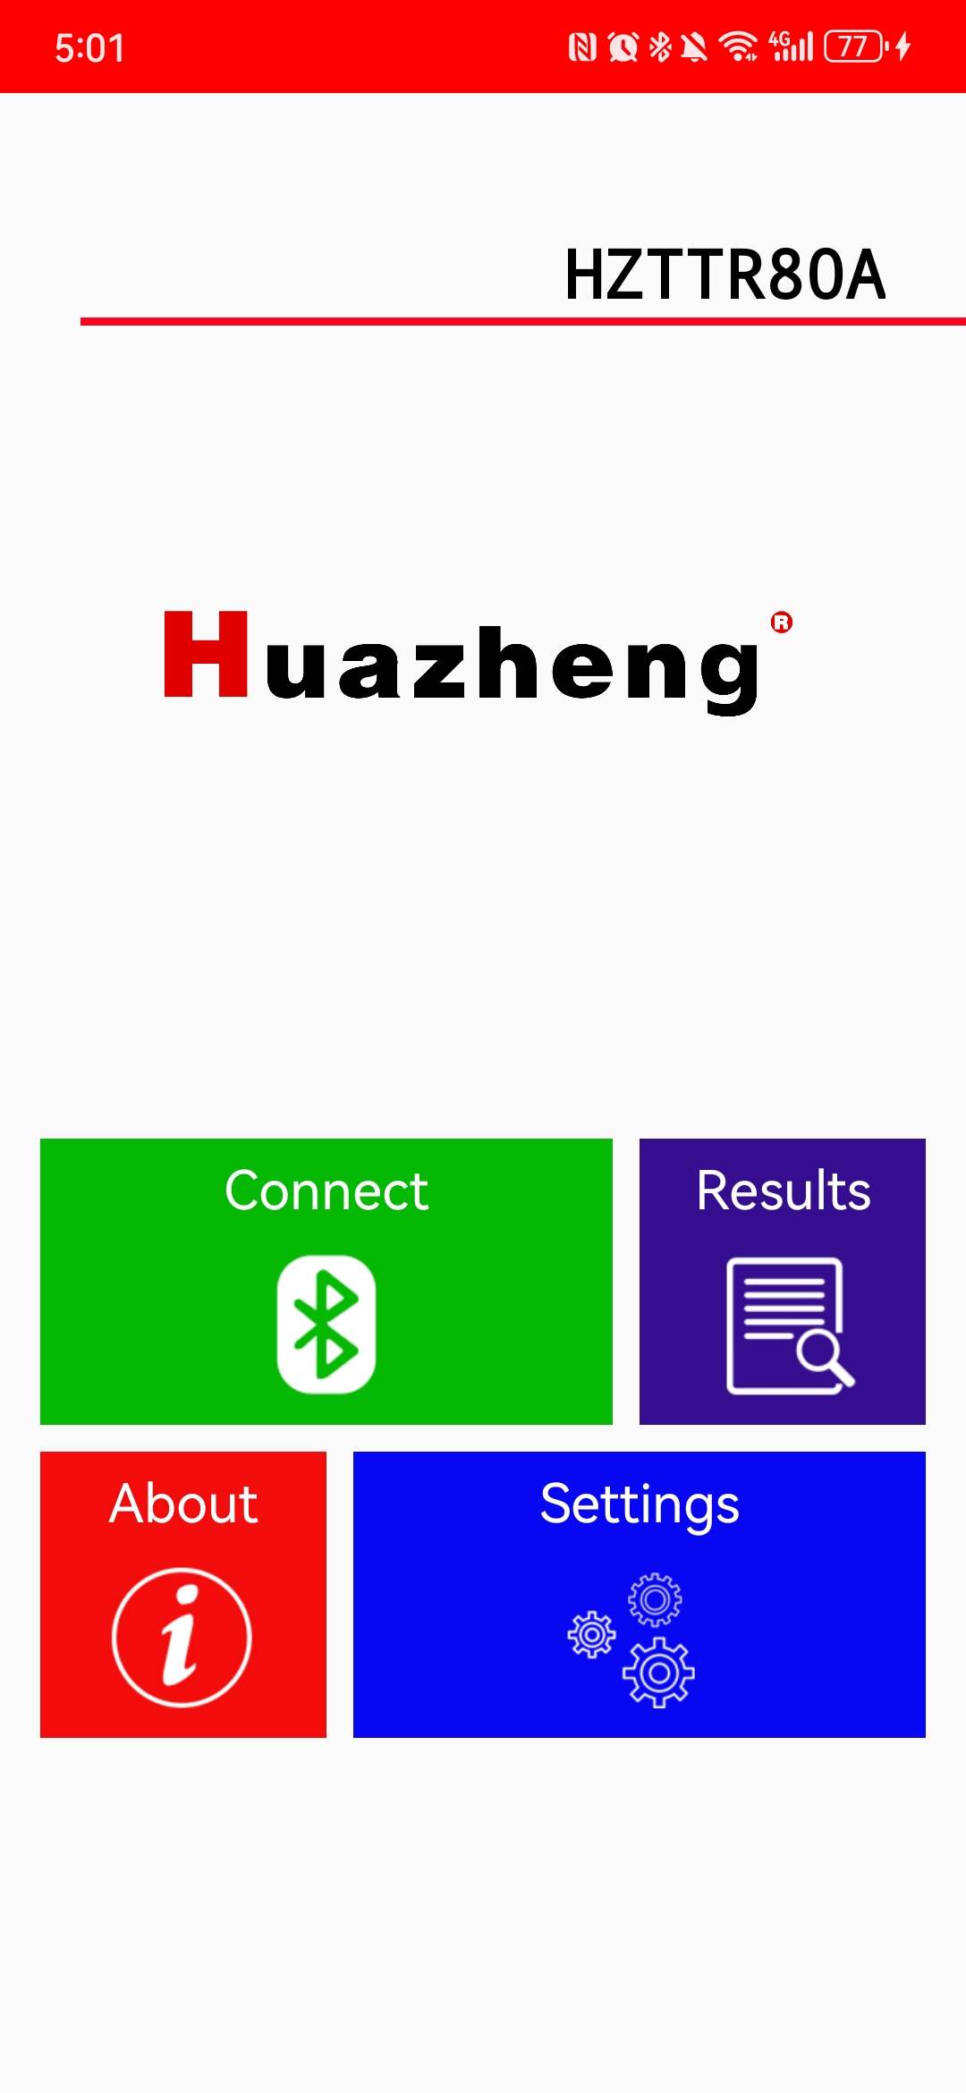
Click on the button to jump to the device scanning interface, as shown below:
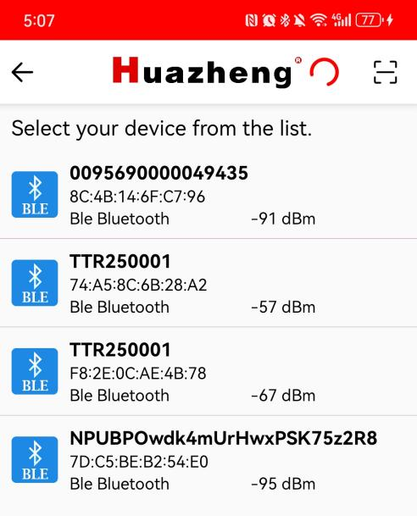
Click on the device name you want to connect to in the list. Alternatively, click on the icon 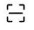 in the top-right corner to jump to the QR code scanning page, and scan the QR code on the testing instrument to establish a connection. After a successful connection, the button will change to 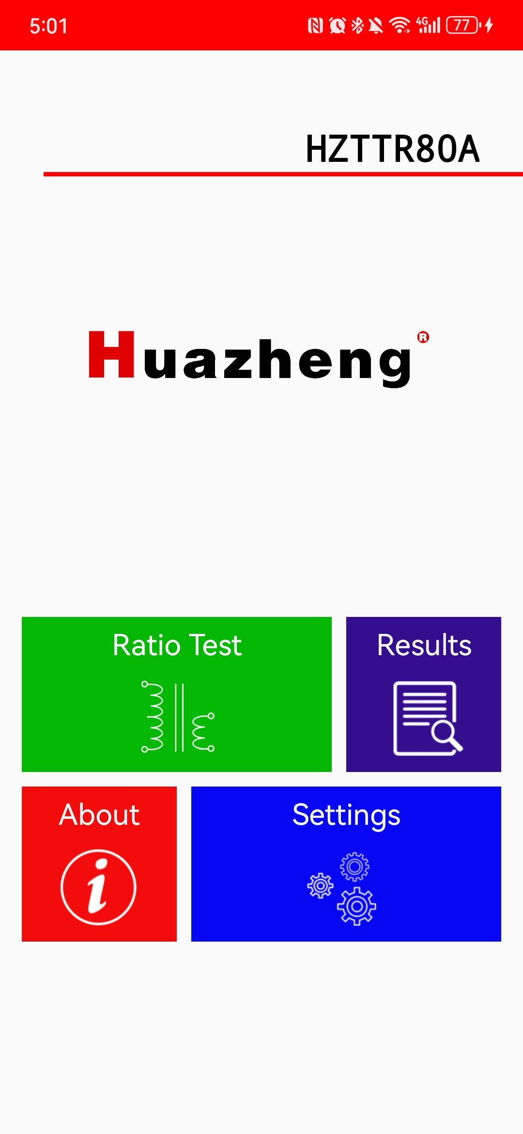 button , as shown below:
V. Operation
5.1 Power-on and Interface Introduction
Input AC power, switch the power switch to the "I" position, and turn on the tester. A startup screen with the company logo will appear, followed by the main interface.
5.2 Introduction to Operation Buttons and Input Keyboard
- Buttons
Button | Description | Button | Description
 | Confirm  Accept changes |  | Home  Return to the main interface
 | Cancel  Discard changes |  | Back  Return to the previous interface
- Input Keyboard
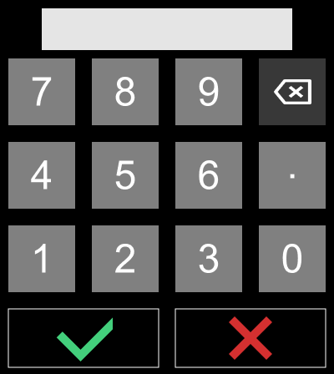
This keyboard can be accessed in the measurement parameter setting interface and the time setting interface for data entry.
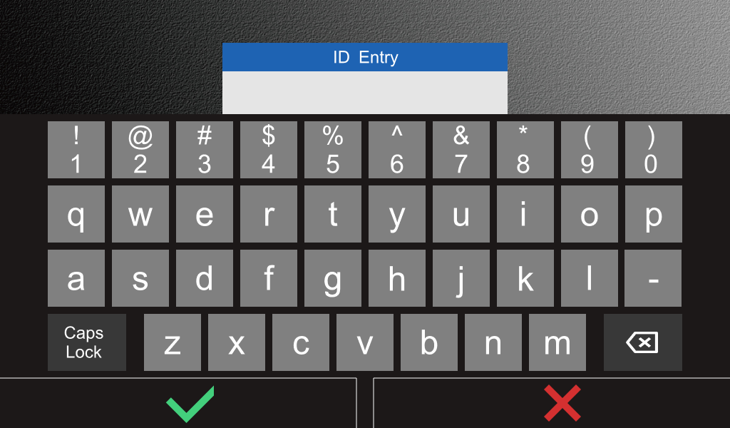
This keyboard can be accessed in the measurement parameter setting interface for entering the ID number of the test specimen.
5.3 Main Interface
The main interface appears after the tester is started. All main functions can be initiated from the main interface.
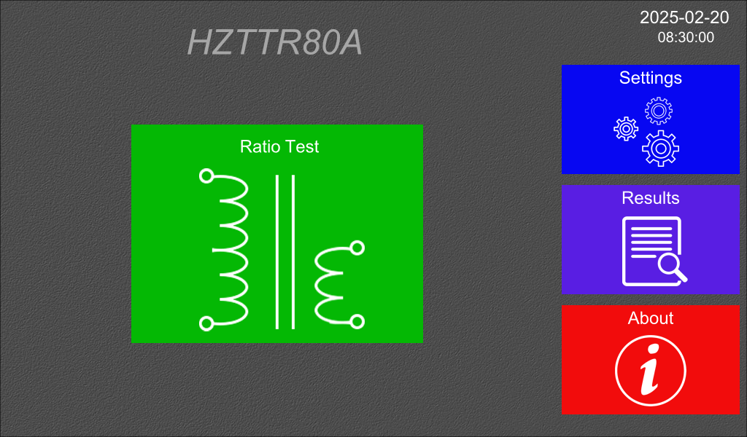
Button functions are as follows:
Button | Description
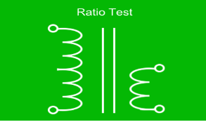 | Transformer Ratio Test  First, enter the measurement parameter setting interface.
 | Settings  Configuration of language, backlight, time, and manufacturer parameters.
 | Result Display  Display of saved measurement results.
 | About  Version information of software and hardware, Bluetooth information, and help.

5.4 System Settings Interface
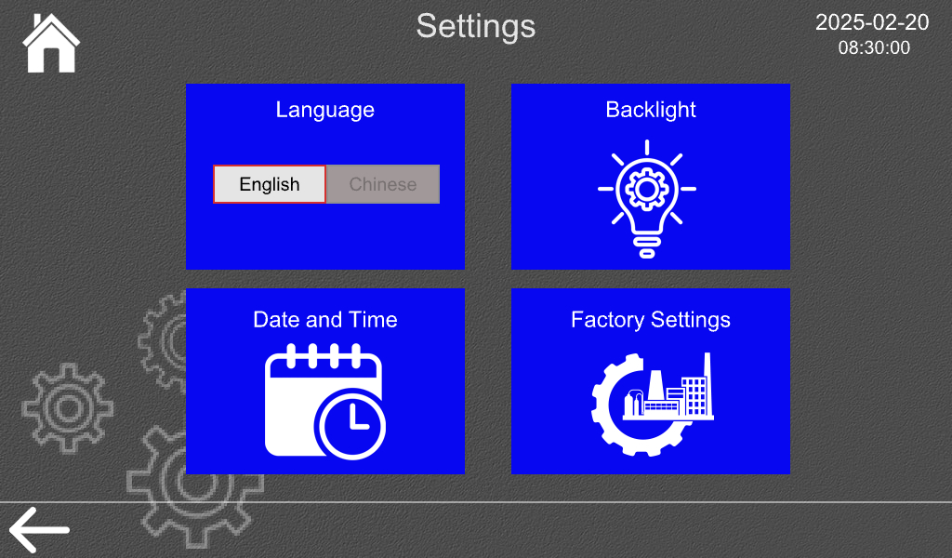
To switch from English to Chinese, simply click the  button; to switch from Chinese to English, click the button. Other button functions are as follows:
Button | Description
 | Backlight settings
 | Time settings
 | Manufacturer settings

5.4.1 Backlight Settings
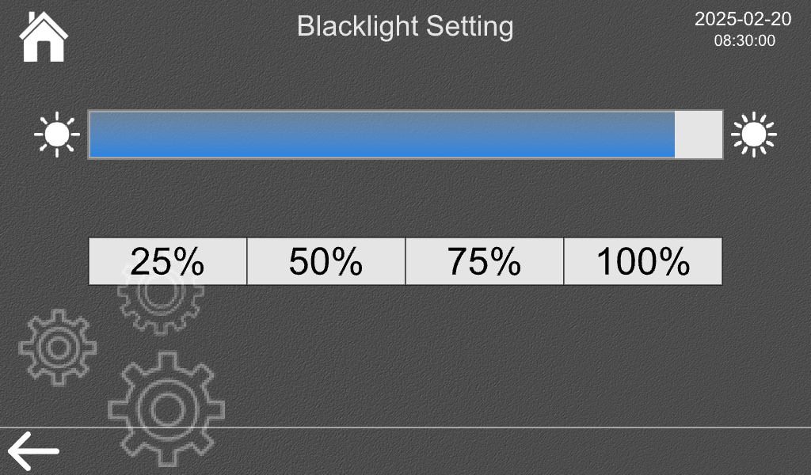
You can slide slider  to set the backlight value, or click 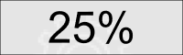, 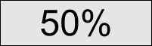, 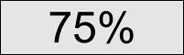, 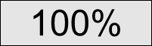 to set fixed backlight values. The backlight value can be adjusted from 25% to 100%.
5.4.2 Time Settings
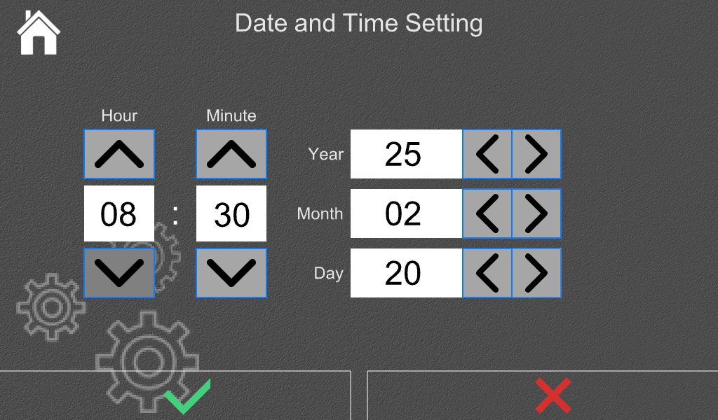
You can click the four buttons  to set the time, or click the edit area to access the input keyboard for setting the time.
Options | Setting Range
Year | 2000 - 2099
Month | 1 - 12
Day | 1 - 31
Hour | 0 - 23
Minute | 0 - 59
5.5 Measurement Parameter Setting Interface
Before measurement, the correct parameters must be set.
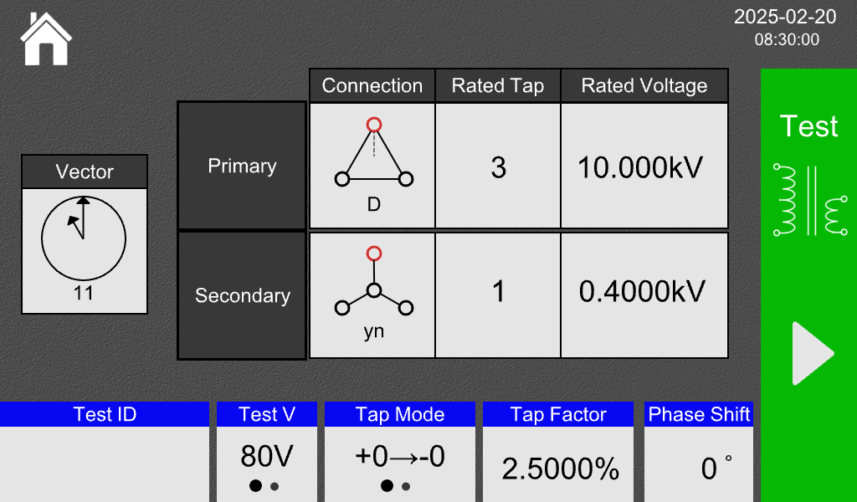
5.5.1 Parameters and Buttons
Options | Description
High-voltage connection | Set the connection mode for the high-voltage side; for detailed selection settings, please refer to section 5.5.2.
Low-voltage connection | Set the connection mode for the low-voltage side; for detailed selection settings, please refer to section 5.5.3.
Connection group number | Set the transformer's group number; for detailed selection settings, please refer to section 5.5.4.
High-voltage rated tap | For transformers with taps on the high-voltage side, please enter the correct position of the rated tap. Incorrect input will affect the judgment of the tap position. If there are no taps or the taps are on the low-voltage side, please enter "1".
Low-voltage rated tap | For transformers with taps on the low-voltage side, please enter the correct position of the rated tap. Incorrect input will affect the judgment of the tap position. If there are no taps or the taps are on the high-voltage side, please ignore this setting.
Rated high-voltage | Please enter the rated high-voltage value from the transformer nameplate correctly. Incorrect input will affect the error calculation. For transformers with taps on the high-voltage side, please enter the rated high-voltage value corresponding to the rated tap on the transformer nameplate.
Rated low-voltage | Please enter the rated low-voltage value from the transformer nameplate correctly. Incorrect input will affect the error calculation. For transformers with taps on the low-voltage side, please enter the rated low-voltage value corresponding to the rated tap on the transformer nameplate.
Test voltage | Options of 80V and 5V are available.
Tap mode | For transformers with high voltage at the high tap position, select 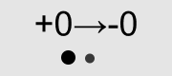.  For transformers with low voltage at the high tap position, select 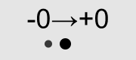.  Ignore this setting for transformers without taps.
Tap spacing | For each tap step, the percentage of transformer ratio adjustment (e.g., 1.25% should be entered as 1.25) must be input correctly. Otherwise, it will affect the judgment of tap positions and the calculation of errors. This setting item can be ignored for transformers without taps.
Test specimen number | Enter the test specimen number, up to 11 characters can be entered.
Non-30° phase vector | For phase-shifting transformers, enter the angle value of the non-30° vector. For other transformers, enter 0°. The input range is 0-360°.
 | Measurement button: click to enter the measurement interface.

5.5.2 High-Voltage Connection Setting
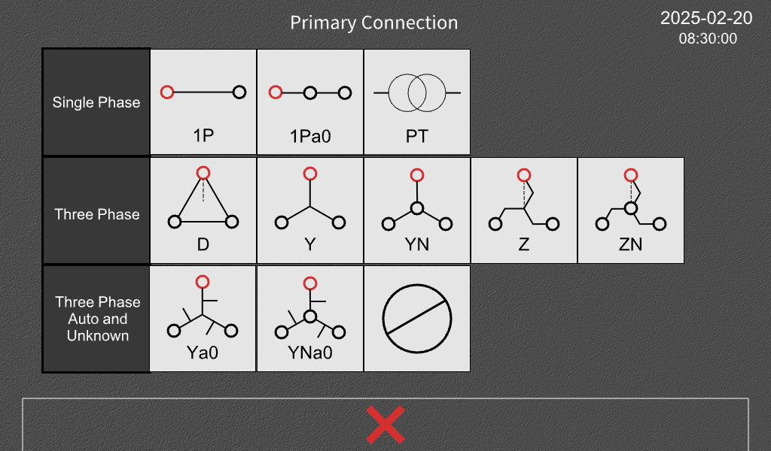
The option is for setting an unknown connection method. Selecting this option allows for three-phase blind measurement functionality.
5.5.3 Low-Voltage Connection Setting
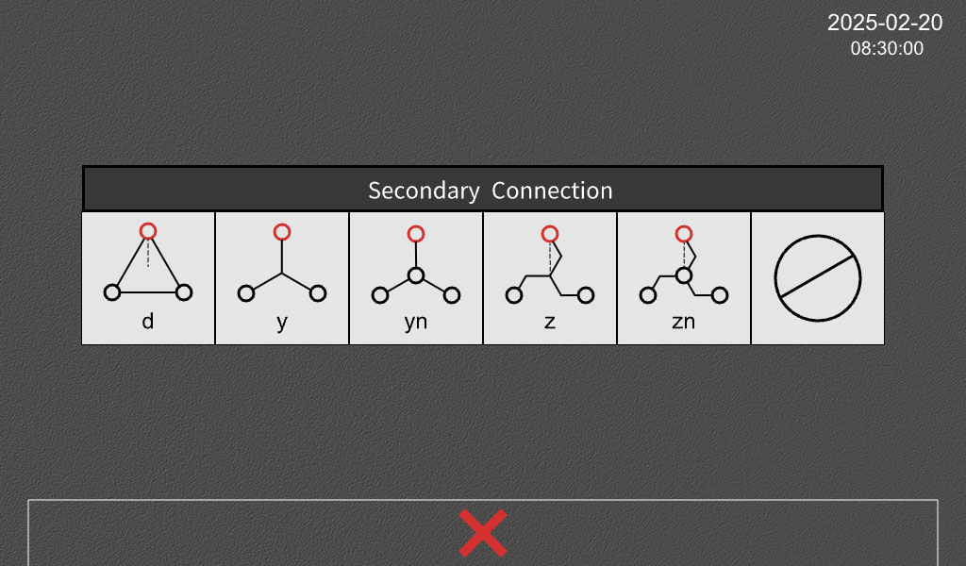
The option is for setting an unknown connection method.

5.5.4 Connection Group Setting
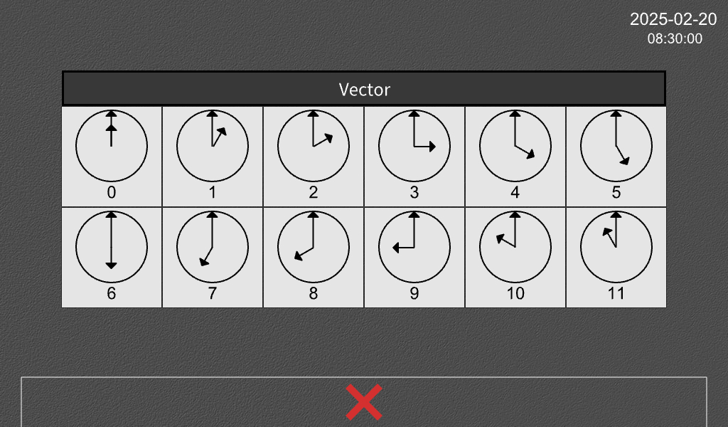
5.6 Measurement Interface
5.6.1 Test Failure
There are many reasons for test failure, including but not limited to:
• Improper test lead connections
• Excessive current consumption
If the test cannot continue due to safety reasons or issues with test lead connections, a "Test Failure" prompt will appear. Read the error message and troubleshoot to determine the cause and solution.
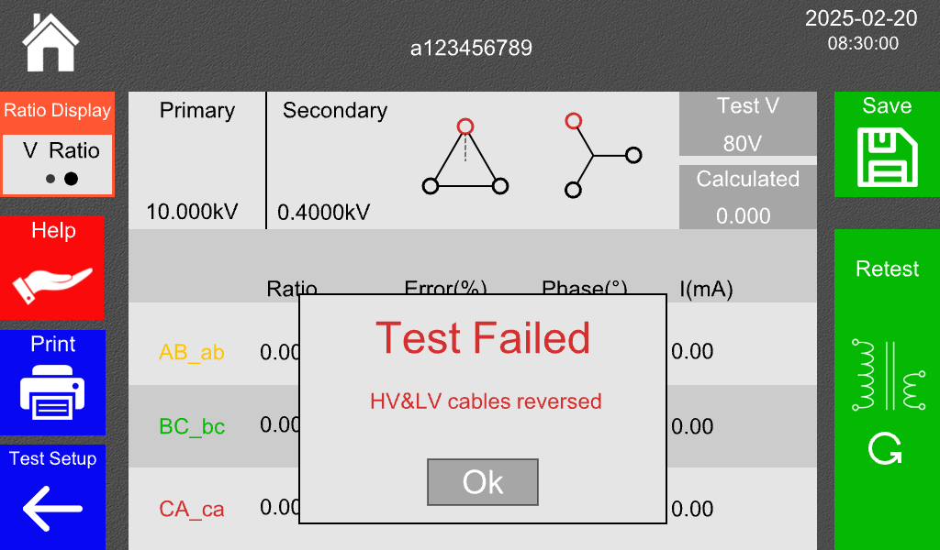

5.6.2 Test Success
When the test is successfully completed, the following interface will be displayed.
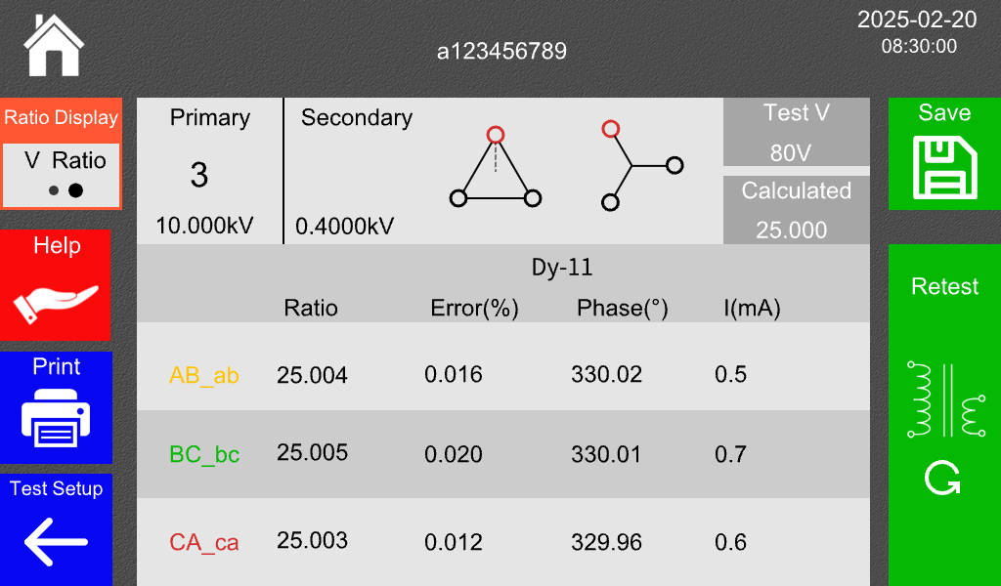
The title contains useful information about the test settings and how the transformation ratio test was performed.
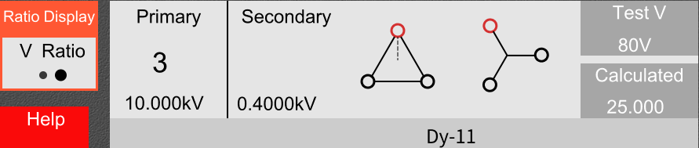

Information | Description
Test Specimen Number | The test specimen number is displayed above the title.
Transformation Ratio Display | Indicates whether the currently displayed transformation ratio data is a voltage ratio or a turn ratio. Operating this button allows switching between voltage ratio display and turn ratio display. Z-type transformers cannot display the turn ratio.
High-voltage Tap Position/Low-voltage Tap Position | Displays the high-voltage or low-voltage tap position determined by the tester's calculations and judgments. Whether the high-voltage tap position or the low-voltage tap position is displayed is related to the settings for rated taps.
Rated High-voltage/Rated Low-voltage | During the measurement process, it displays the rated high-voltage and rated low-voltage values entered in the parameter setting interface. After a successful test, it displays the rated high-voltage and rated low-voltage values at the current tap position calculated by the tester. The display is related to the settings for rated high-voltage, rated low-voltage, and rated tap position.
High-voltage Connection/Low-voltage Connection/Group Number | During the measurement process, it displays the vector relationship entered in the parameter setting interface. After a successful test, it displays the vector relationship and group number determined by the tester's calculations and judgments. The display is related to the settings for group number, high-voltage connection, low-voltage connection, and non-30° phase vector.
Test Voltage | The test voltage selected for this measurement.
Theoretical Transformation Ratio | The theoretical transformation ratio calculated based on the settings for rated high-voltage, rated low-voltage, and rated tap position.
Below the title is the data for the three-phase measurement results. If a single-phase measurement was performed, only one line of results will be available.
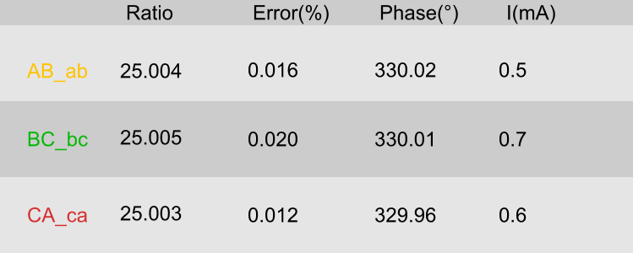
The button functions in this interface are as follows:
Button | Description
 | Save  Save the measurement results, which can be viewed in the data browsing interface.
 | Print  Use the printer installed on the tester panel to print the current measurement result data.
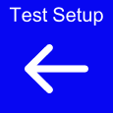 | Back  Return to the parameter setting interface.
 | Remeasure  Adjust to the next tap position and continue the measurement.
 | Blind Test Help Button  Jump to the help page to display commonly used connection groups of three-phase transformers for assistance in analysis. For detailed information, refer to Section 5.6.3.
5.6.3 Blind Test Function
• For tests where both the high-voltage and low-voltage connection methods are unknown, the results are shown in the following figure:
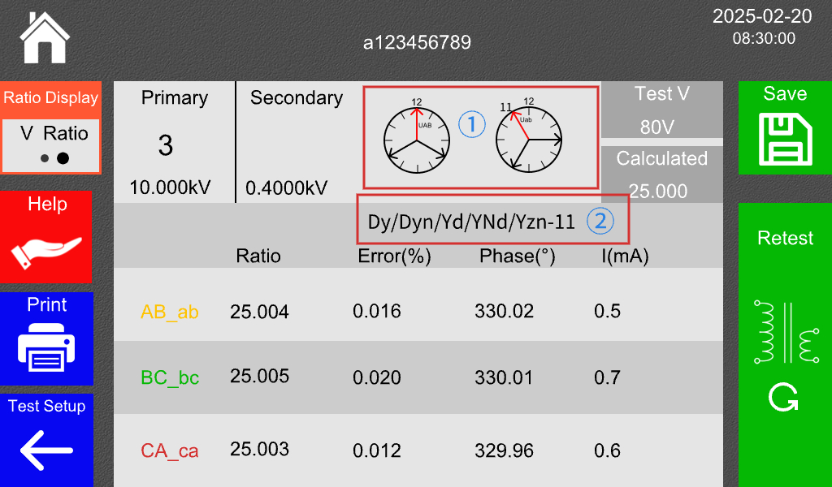
① It displays the vector relationship between the primary and secondary side voltages. ② It shows possible connection groups. Click the "Help" button to navigate to the following interface:
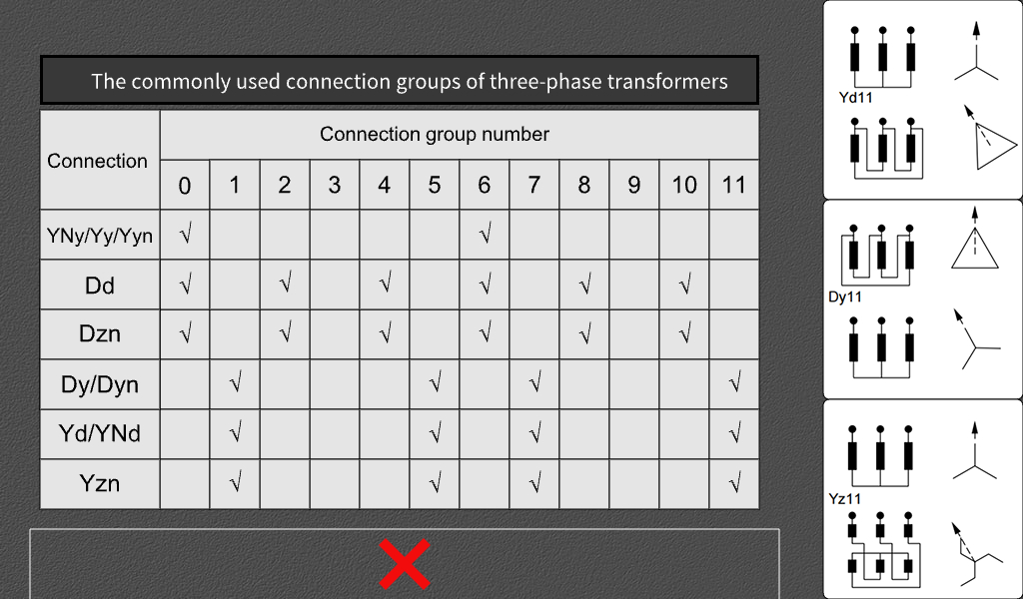
On the left, commonly used connection vector groups for three-phase transformers (in accordance with IEC 60076-1 standard) are displayed, while on the right, the current vector group and a schematic diagram of the transformer's internal connections are shown.
• For measurements where the connection method is known on one side (either high-voltage or low-voltage) and unknown on the other side (taking high-voltage YN and unknown low-voltage as an example), the results are shown in the following figure:
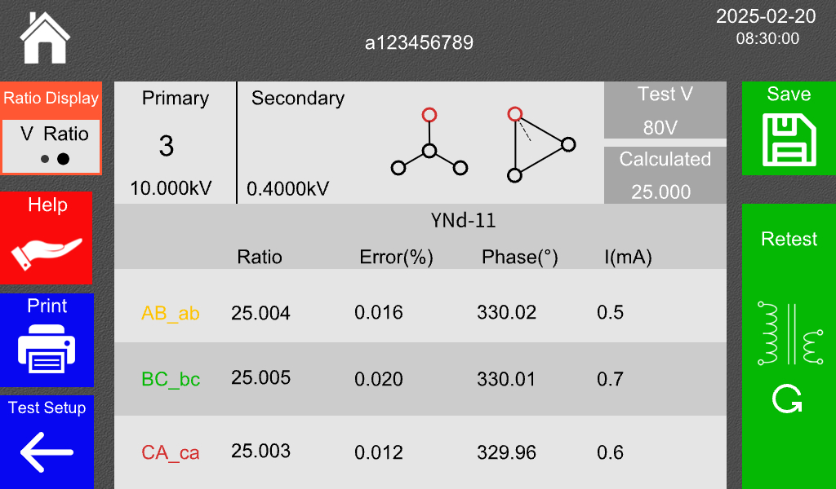
----------------------------------------------------------------------------------------------------------------------
During the measurement process of the tester, the input/output terminals, test posts, etc., may be live. Do not touch exposed contacts and parts to avoid the risk of electric shock. Please follow the instructions carefully!
------------------------------------------------------------------------------------------------------------------------
5.7 Data Browsing Interface
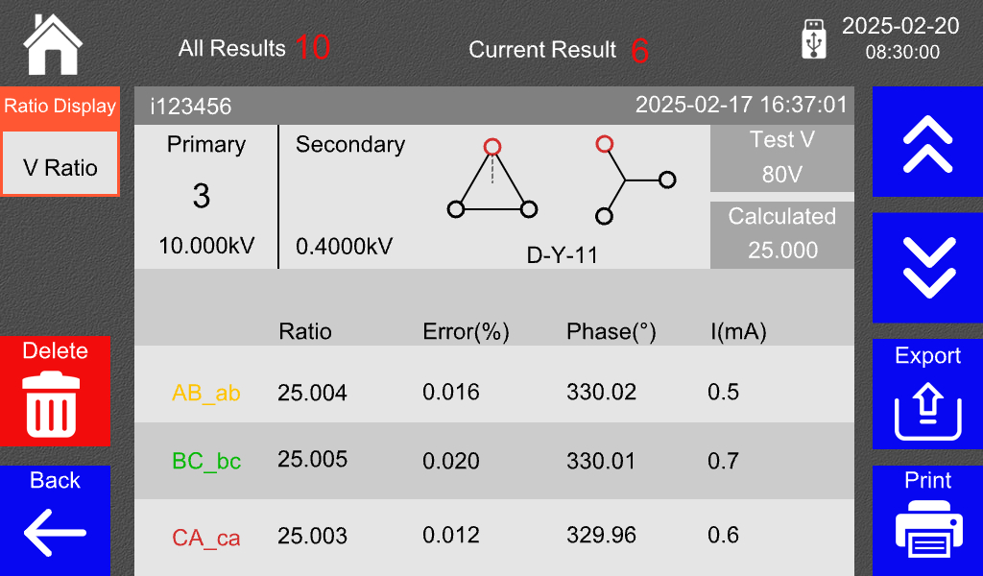
The data browsing interface is almost identical to the measurement interface. At the top of the interface, it displays the total number of stored measurement data results and the current group number being displayed. The tester can store up to 200 groups of measurement data. The button functions are as follows:
Button | Description
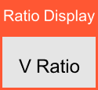 | Transformation Ratio Display: Indicates whether the current transformation ratio data displayed is a voltage ratio or a turn ratio.
 | Previous Set  Switch to the display of the previous set of measurement result data.
 | Next Set  Switch to the display of the next set of measurement result data.
 | Export Measurement Results  Insert a USB flash drive. When the USB drive icon appears next to the time at the top of the interface, you can export the measurement result data to the USB drive in the form of a text file.
 | Print  Use the printer installed on the tester panel to print the measurement result data.
 | Delete  Delete the measurement result data of the current set.
 | Back  Return to the previous interface.
VI. Troubleshooting and Maintenance
If any abnormalities occur during the use of the tester, please follow the steps below for troubleshooting:
- If the measurement data is abnormal, please check if the wiring is correct. If it is still abnormal, you can perform a self-test using the following method. The wiring is shown in the figure below:
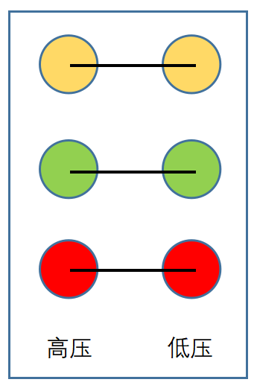
HV LV
After connecting the wires, select any three-phase connection method for testing. If the measured value is approximately 1.0000, the instrument is functioning normally; otherwise, there is an issue with the instrument. If no shorting wire is available, you can also short-circuit the high-voltage side yellow, green, and red wire clamps to the corresponding low-voltage side yellow, green, and red wire clamps.
- If the tester does not respond when turned on and the display screen is not lit, please check if the power fuse inside the panel is blown.
- If it is confirmed to be an internal fault of the tester, please contact our company immediately, and we will resolve it as soon as possible.

VII. Packing list
No. | Item | Qty
1 | Host | 1
2 | Test Cables | 1
3 | Power Cord | 1
4 | Operation Manual | 1
5 | Certificate of Conformity | 1
6 | Fuse | 2
7 | Printing Paper | 1
8 | Packing List | 1
9 | Ground wire | 1

