HZBB-10S
Portable Transformer Turns Ratio Tester

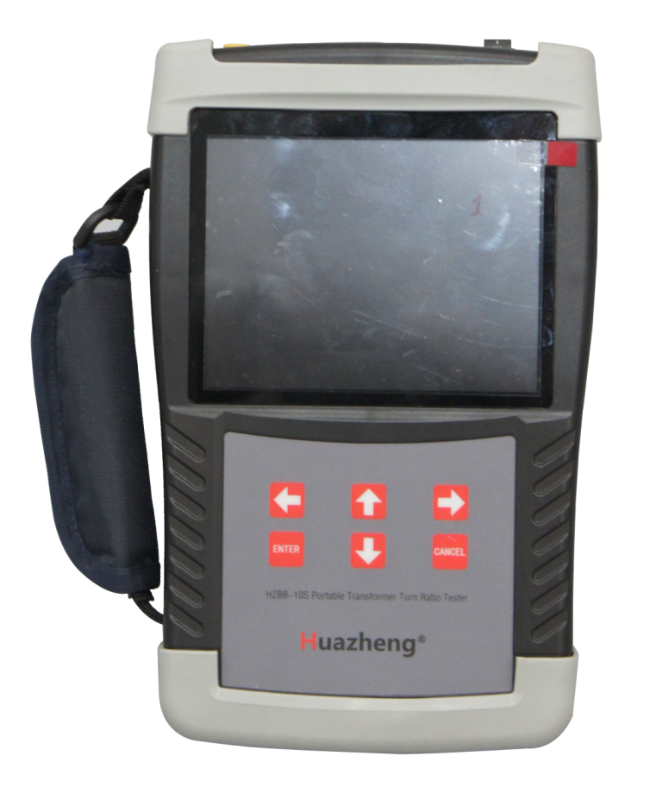

Huazheng Electric Manufacturing (Baoding) Co., Ltd

Dear user:
Thank you for choosing HZBB-10S Portable Transformer Turns Ratio Tester.
We hope that this instrument can make your work easier and more enjoyable, so that you can get the feeling of office automation in the test and analysis work.
Before using the instrument, please read this manual, and operate and maintain the instrument according to the manual to prolong its service life.
"Just a light press, the test will be completed automatically" is the operating characteristics of this instrument.
If you are satisfied with this instrument, please tell your colleagues; if you are not satisfied with this instrument, please call (0312) 6775656 to tell you to serve you at all times-Baoding Huazheng Electric Manufacturing Co., Ltd., our company will definitely make you satisfied !
Contents

I.Important Note 1
II.Introduction 1
III.Packaging Content 1
IV.Functional Characteristics 1
V.Technical Indicators 2
VI.Adjust The Wristband 3
VII.Battery Charging 3
VIII.Tilt Hand-held Tester 3
IX.Product Appearance 4
X.Operation Instructions 5
XI.Matters Needing Attention 10
XII.Packing List 11

I.Important Note
If the instrument is not in use, please turn off the power in time.
If the instrument is not used for a long time, please charge and discharge regularly. Batteries should be charged and discharged at least once a month.
It is strictly forbidden to use power shortage, which will severely shorten the battery life and even make the battery scrap. When the instrument is short of power, the power supply should be switched off and charged immediately. Avoid battery failure due to excessive battery discharge time.
Charging lamp: the charging lamp on the charger is bright red during charging and bright green after charging.
Users must not disassemble the instrument and replace the battery without authorization. When the instrument or battery fails, please return to the factory.
II.Introduction
Hand-held transformer turn ratio tester is an innovative product with compact size, hand-held operation, more portable and easy to carry.
Products are mainly applied to change than group test transformer, PT and CT polarity test, test speed, high accuracy.

III.Packaging Content
After receiving the packing box, open the packing box and check if there is any damage. If the freight packing box is damaged or the liner material is indented, please inform the freight company or our salesman immediately.
Please check if you have received the following items in the product package：
Standard accessories：
√1 Hand-held transformer turn ratio tester
√1 sets of test lines (red and black each)
√1 charger
√1 external printer (with printing cable attached）
√1 wrist band (attached to a hand-held tester)）
√1 print user manual
√1 copy of certificate and factory test report

IV.Functional Characteristics
- Lithium battery power supply or 100-240V AC power supply is self-adaptive. After one charge, more than 100 transformers can be continuously tested in the ratio group. The test process is simple and convenient.
- It has the function of blind measurement, that is, to perform variable ratio and group test when there is no connection between high and low voltage.
- Based on the test of conventional transformer, Z-type transformer and PT sample, the polarity test function of CT variable ratio is added, and the application field is wider
- Wide range and high accuracy, the variable ratio measurement range can reach 10,000, and the test accuracy can be guaranteed 0.3% when the maximum value is 10,000.
- It has perfect protection functions such as reverse connection protection and output short circuit protection.
- 5.6-inch super industrial high-brightness color LCD screen, still visible under strong sunlight.
- equipped with external printer, facilitate data printing
- It can be stored locally and on USB memory.
V.Technical Indicators

Range | 0.9～10000
Accuracy | ±（Reading×0.1%+2 words）（≤500）
Accuracy | ±（Reading×0.2%+2 words）（>500≤3000）
Accuracy | ±（Reading×0.3%+2 words）（>3000）
Resolution ration | 0.9～9.9999（0.0001）
Resolution ration | 10～99.999（0.001）
Resolution ration | 100～999.99（0.01）
Resolution ration | 1000～9999.9（0.1）
Resolution ration | 10000 and above（1）
Working power supply | The built-in battery or external charger, charger conditions of use，Input 100-240 VAC，50/60 HZ
Charging time | About 2 hr
Instrument weight | 1.7 kg
Instrument dimension | 246 mm（L）×156 mm（W）×62 mm（H）
Use of temperature | -10℃～50℃
Relative humidity | ≤90%，No dew

VI.Adjust The Wristband
For better grip, strip the belt and adjust the adhesive tape as shown in the following figure.

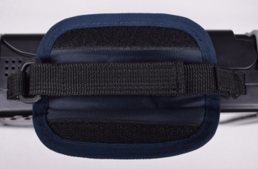

VII.Battery Charging
When the battery is low after long storage or before the first use of the handheld device, please use the charger attached to it to charge the battery for at least 2 hours, and continue to use the hand-held tester when charging. When the battery is fully charged, the charger light changes from red to green.

VIII.Tilt Hand-held Tester
In order to take the instrument or expose the side interface during operation, the hand-held tester can be tilted, as shown in the figure below.
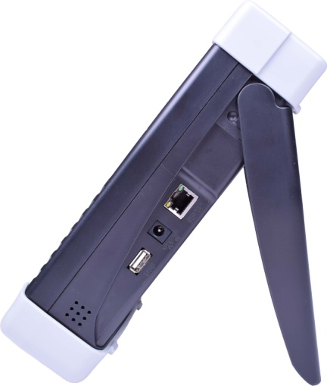

Lift the tilt seat and pull outward

IX.Product Appearance
Top view
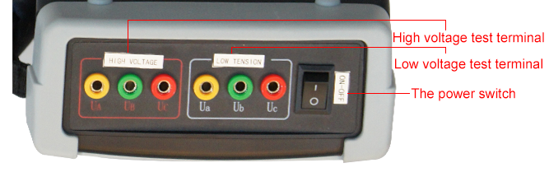

Front View
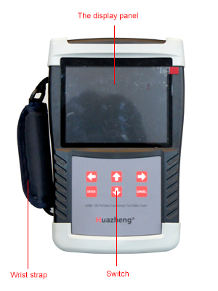
Side View

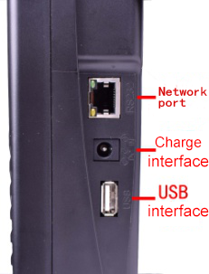

Function module | Instructions
High voltage test terminal | The yellow, green and red three-color junction seats correspond to three-phase A, B and C respectively, and the red test line corresponds to the bullet rod side. The other end of the test line has yellow, green and red three-color test clamps, which correspond to three-phase A, B and C of the high voltage side of the transformer under test; the yellow and green test lines are connected to single-phase test.
Low voltage test terminal | The yellow, green and red three-color junction bases correspond to the three-phase of a, B and C respectively, and the black test line corresponds to the bullet rod side. The other end of the test line has yellow, green and red three-color test clamps, which correspond to the three-phase of a, B and C on the low-voltage side of the transformer under test; the yellow and green test lines are connected to the single-phase test.
Display | 5.6 inch large industrial high brightness color LCD screen, display operation menu and test results.
Button | Operate instruments. “↑↓” is the "up and down" key, select to move or modify data; “←→” is the "left and right" key, select to move or modify data; "Enter" key, confirm the current operation; "Cancel" key, abandon the current operation.
Function module | Instructions
Power switch | The power switch of the whole machine is switched to the open position when it is switched on. Switch to the close position when it is switched off.
RS 232 interface | Connect external printer.
Charging interface | Use instrument charger to recharge.
USB interface | External USB disk is used to store test data, please use FAT or FAT32 format U disk; in the storage process, it is strictly prohibited to dial out the USB disk.

X.Operation Instructions
- Single phase transformer or single phase PT test wiring
The yellow and green test clamps of the red test line at the high-voltage test end are connected to the high-voltage end of the tested product, and the yellow and green test clamps of the black test line at the low-voltage test end are connected to the low-voltage end of the tested product.
- Single phase CT test wiring
The yellow and green test clamps of the red test line at the high voltage test end are connected to the second side of the tested product, and the yellow and green test clamps of the black test line at the low voltage test end are connected to the first side of the tested product.
- Test wiring for three phase transformer
The yellow, green and red test clamps of the red test line at the high-voltage test end connect the A, B and C phases at the high-voltage end of the tested product; the yellow, green and red test clamps of the black test line at the low-voltage test end connect the a, B and C phases at the low-voltage end of the tested product.
- Intelligent power management
When the instrument is not operated for a long time, the LCD backlight is automatically dimmed to save power; the instrument has the function of charging prompt with low power and over-discharge protection; when the instrument is low power, the charger can be plugged in to charge, and the instrument can be used normally in the charging process.
- Instructions for use of printer
The key of the printer and the indicator of the printer are integrated. When the printer is powered on, the indicator light is normally on, and it flashes when the paper is missing. Press the button once and the printer passes the paper.
Printer change paper: take out the rotating spanner and open the paper cover; Load the printer paper and pull out a piece of printer paper (tear the teeth out a little bit). Close the cover and press the print head to the print head. Press the print head back to the print head with a bit of force.
- Operation instruction
After all the test wires are connected, turn on the power switch and enter the "main menu" screen after the instrument is initialized, as shown in the figure below.
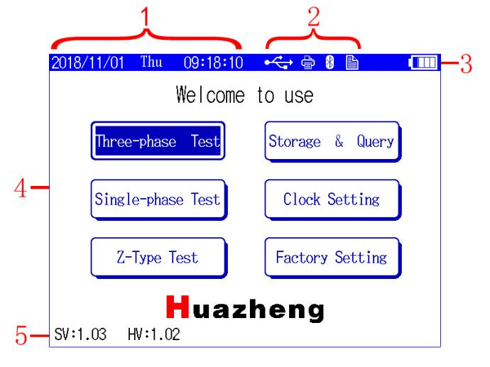

NO. | Instructions
1 | Display date and time.
2 | Displays the peripheral and current operation status.
 | This icon is displayed when you insert a USB drive.
 | This icon is displayed when the printer is inserted.
 | This icon is displayed when storing information queries.
NO. | Instructions
3 | The power of the instrument shows that the icon flickers when the power is low.
4 | In the main menu operation area of the instrument, the corresponding function is selected by the direction key, and the corresponding function menu is entered by pressing the "Enter" key.
 | To carry out variable ratio and group test for three phase transformers.
 | Variable ratio and polarity test for single phase PT, single-phase transformer and single-phase CT.
 | Specifically for Z type transformer with variable ratio, group testing.
 | Query saved in the process of testing data; In the interface can detect data printing and archived usb flash drive operation.
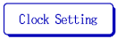 | Set date and time of the instrument.
 | Need a password operation, it is not open to the user.
5 | SV：Display software current version number.  HV：Display hardware current version number.

The function and operation of "  " are described in detail. Other functions and operations can be referred to in this part.
- Normal test: When the connection mode of high and low voltage is known, the test is carried out after the correct input of the connection mode of high and low voltage
- Blind measurement function: The ratio and group can be accurately measured without knowing the connection mode and group of high and low voltage.

Take the " " as an example to illustrate, enter the screen of "Blind test function parameter setting", as shown below.
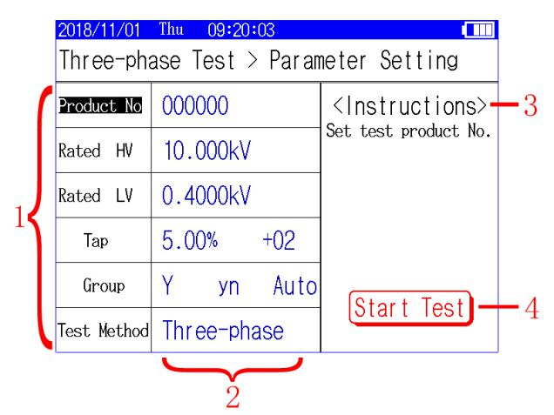

NO. | Instructions
1 | First-level operation directory, through the “←”→” key to select these functions, when these functions are selected, press the “↑”↓”" key to select the parameters of the corresponding functions.    Tip: The cursor can quickly jump to the 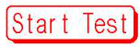 button by pressing the "Enter" button under the first-level operating directory, which can quickly start the measurement.
Product No. | Set the test number for this testing
Rated HV  Rated LV | Set the rated high and low voltage values of the tested products. The high and low voltage values can be input according to the actual voltage value, or according to the actual situation, according to the actual proportional relationship.  Only when the rated high, low voltage, tap spacing and rated tap input are correct, can the test results correctly calculate the current tap gear value and error value.  Notee
Tap | Set the tap spacing and rated tap of the tested product. For the test product without tap, the rated tap input is 00 or 01.
Group | Set up the connection mode and connection group of the tested products
Group | When the user chooses the known connection mode, the measurement and  Notee  display of the instrument are based on the user's input. When the user chooses the "unknown" connection mode, the instrument automatically determines the connection mode. If both the high and low voltage sides choose the "unknown" connection mode, the measurement results do not show the connection mode. For the connection group, the user can choose according to the actual situation. If the connection group is unknown, the user can choose "automatic", which can be judged automatically by the instrument. In the menu of "blind measurement function", the connection group is fixed as "automatic" and can not be changed.
Test method | Choose different ways of measurement..  Three phase ratio: according to the set of high and low voltage connection mode and connection group, three phase simultaneous measurement of conversion ratio.  Group test: only measure the join group.  Three-phase AB, three-phase BC, three-phase CA: According to the set high and low voltage connection mode and connection group, only for the selected phase ratio measurement.  Tip: this function is convenient for measuring and detecting only one phase, saving time.
2 | Two level operation directory, corresponding to the first level operation directory.
NO. | Instructions
2 | Set parameters and modify the parameters through “↑↓”keys.  Tip: the cursor in the second level of operation directory, you can press the "Enter" or "Cancel" key to jump the cursor to the first level of operation directory.
3 | Explanation of selected functions.
4 | When the cursor is here, press the "Enter" button to start the measurement.
In the process of testing, if the instrument detects short circuit, high and low voltage reverse connection fault, the display screen will pop up the fault alarm box, and stop measuring.
“The three phase ratio test results" screen is shown below.
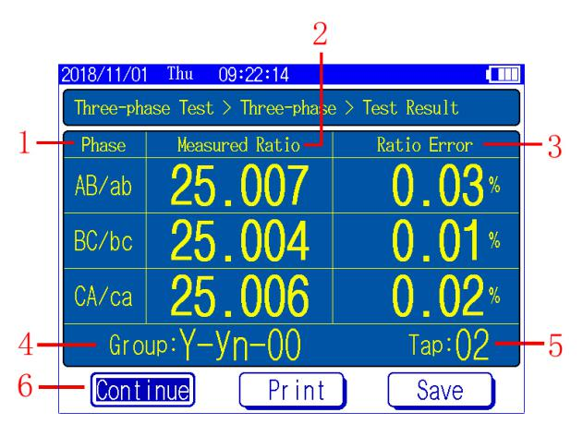
NO. | Instructions
1 | Corresponding test phases.
2 | The corresponding measured variation ratio.
3 | Error value of instrument automatic calculation.
4 | Measured high and low voltage connection modes and groups.
5 | Measured current tap.
6 | Menu selection area.  Press the "left and right" button to move the cursor and select the corresponding function. Press the "Enter" button to perform the current selected function. Press the "Cancel" button to return to the previous screen.
 | Continue the measurement.
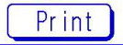 | Print the current test results by connecting the external printer.
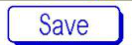 | Save the current test results to the local computer or save it to the external USB disk.  Tip: the data saved to the USB is in WORD format, and can be directly edited or printed with OFFICE.

XI.Matters Needing Attention
- For transformers with multiple taps, the input of rated high and low voltage voltage, tap spacing and rated gear is to enable the test results to automatically calculate the error value and tap switch location.
- 19 archives of transformer on-load tap-changer is, if the 9, 10 and 11 are the same values, instrument input rated tap should be input when 9, at this time 12 points to a later, instrument display tapping position is smaller than actual position 2.
- The instrument tapping position setting according to the high side pressure regulating design, is to assume that one point as the highest voltage range, if the voltage reverse design or tap-changer in low voltage side of transformer, display tapping position and the actual tap position of the horse
- Three-phase transformer variable than the plate of refers to the ratio of the different voltage winding of line voltage, therefore, the transformer in different connection mode, its strain ratio and the number of turns than to have the following relations: the primary and secondary side of the connection of the same voltage of three-phase transformer ratio is equal to the number of turns ratio; Primary side and secondary side of the connection is not at the same time, Y - d wiring of turns ratio is equal to the variable ratio, divided by the square root of - Y connection of turns ratio is equal to the ratio is multiplied by the square root of .

XII.Packing List
No. | Item | Qty
1 | Main engine | 1
2 | Red test line | 1
3 | Black test line | 1
4 | Print paper | 2
5 | Power line | 1

