HZ2162
DC Ratio Integrated Tester

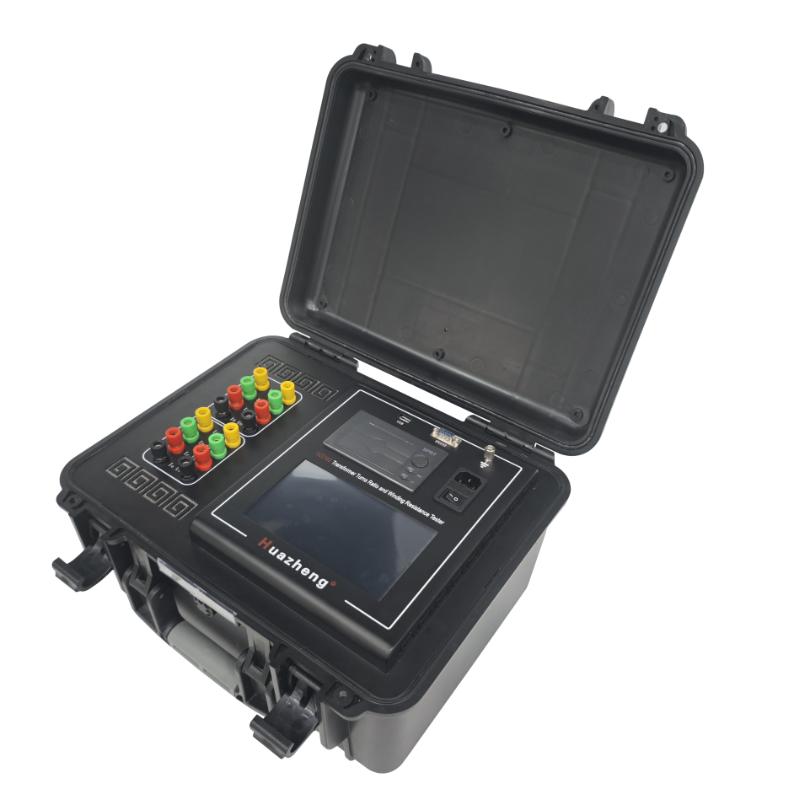

Huazheng Electric Manufacturing (Baoding) Co., Ltd

Dear user:
Thank you for choosing HZ2162 DC Ratio Integrated Tester.
We hope that this instrument can make your work easier and more enjoyable, so that you can get the feeling of office automation in the test and analysis work.
Before using the instrument, please read this manual, and operate and maintain the instrument according to the manual to prolong its service life.
"Just a light press, the test will be completed automatically" is the operating characteristics of this instrument.
If you are satisfied with this instrument, please tell your colleagues; if you are not satisfied with this instrument, please call (0312) 6775656 to tell you to serve you at all times-Baoding Huazheng Electric Manufacturing Co., Ltd., our company will definitely make you satisfied !

Attention
Because the input and output terminals, test columns and so on may have voltage, electric sparks will be generated, be careful of electric shock, avoid the danger of electric shock, pay attention to personal safety!

Safety Instructions
Please read the following safety precautions to avoid personal injury. To prevent possible hazards, only use the product within the specified range.
▼Only qualified technicians should perform maintenance.
▼Prevent fire or personal injury.
▼Use the appropriate power cord. Only use the dedicated and specified power cord. Do not randomly connect or disconnect test leads when they are connected to live terminals.
▼Pay attention to the ratings of all terminals. To prevent fire or electric shock hazards, note all ratings and markings. Before making connections, read the user manual for further information on ratings.
▼Use the appropriate fuse. Only use fuses that comply with the specified type and rating. Avoid contact with exposed circuits and live metal. Do not touch exposed contacts and parts when powered.
▼Do not operate in a humid environment.
▼Do not operate in an explosive environment.

Contents

I. Product Introduction 1
II. Product Features 1
III. Measurement Parameters 2
IV. Instrument Panel Introduction 3
V. Main Technical Specifications 3
VI. Operation Procedure 4
VII. Pre-Test Precautions 8
VIII. Test Procedure 9
IX. Data Management And Storage 13
X. Precautions 15
XI. Packing List 16

- Product Introduction
The HZ2162 Transformer Comprehensive Tester integrates a DC resistance tester and transformer ratio tester into one device for testing large power transformers.
- Product Features
- Product Design
- One-time wiring completes all test items, reducing the workload of on-site testers.
- Equipped with a 7-inch color touch LCD screen for control and display, providing a user-friendly interface.
- Built-in micro printer for on-site printing of test results.
- USB storage function for external storage of test results.
- One isolated RS232 communication interface with standard protocol communication.
- Bluetooth communication module with standard protocol wireless communication.
- High-reliability RS485 bus for internal communication.
- Isolated circuit design to eliminate interference between test functions; hardware and software filtering to improve anti-interference capability; good grounding and shielding measures to enhance overall anti-interference capability.
- DC Resistance Test
1. Three-phase simultaneous testing and automatic magnetization.
2. High and low voltage current and potential test leads can be connected to the transformer at once, eliminating the need to switch test leads during the test.
3. For star-connected windings with a neutral point, the A0, B0, and C0 phase resistances can be tested simultaneously, significantly saving test time.
4. For an internally delta-connected three-phase five-limb transformer, the automatic excitation method can be used during low-voltage side testing, which offers fast testing speed.
5. Displays and prints all test data of high, medium, and low voltage windings, automatically calculates three-phase unbalance, and prints resistance values converted to rated temperature.
6. Comprehensive back EMF protection.
- Transformer Ratio Test
- Chinese/English menu prompts, simple and convenient operation.
- Three-phase testing only requires inputting the high-voltage side connection method to automatically measure the group.
- Capable of both single-phase measurement and automatic testing of three-phase windings. The connection group can be arbitrarily selected, completing the measurement of parameters such as the ratio, error, and connection group of AB, BC, and CA phases in one go.
- Protection function for high and low voltage reverse connection.
- Fast testing speed, completing single-phase testing in 15 seconds.
- Protection functions for transformer short-circuit and inter-turn short-circuit.
- Measurement Parameters
DC Resistance: DC resistance is the resistance presented when a DC voltage is applied across the component, i.e., the inherent, static resistance of the component. When AC and DC are applied to a coil, the resistance presented is different. When AC is applied, the coil has reactance in addition to DC resistance. Since the DC resistance of transformers, mutual inductors, generators, and motors is small, appropriate methods must be used to measure it to reduce errors. Kelvin four-terminal sensing (4T sensing) is a resistance measurement technique that uses separate pairs of current-carrying and voltage-sensing electrodes, allowing for more accurate measurements compared to traditional two-terminal (2T) sensing. The key advantage of four-terminal sensing is the separation of current and voltage electrodes, eliminating the impedance of wiring and contact resistance.
Transformer Ratio: Transformer Turns Ratio refers to the voltage ratio between the primary winding and the secondary winding of a transformer. According to relevant national standards, the transformer turns ratio test is a mandatory item during the production, user handover, and maintenance testing of power transformers. This test effectively monitors the quality of transformer products during manufacturing and usage, preventing issues such as inter-turn short circuits, open circuits, incorrect connections, and internal or contact faults in the tap changer.
- Instrument Panel Introduction
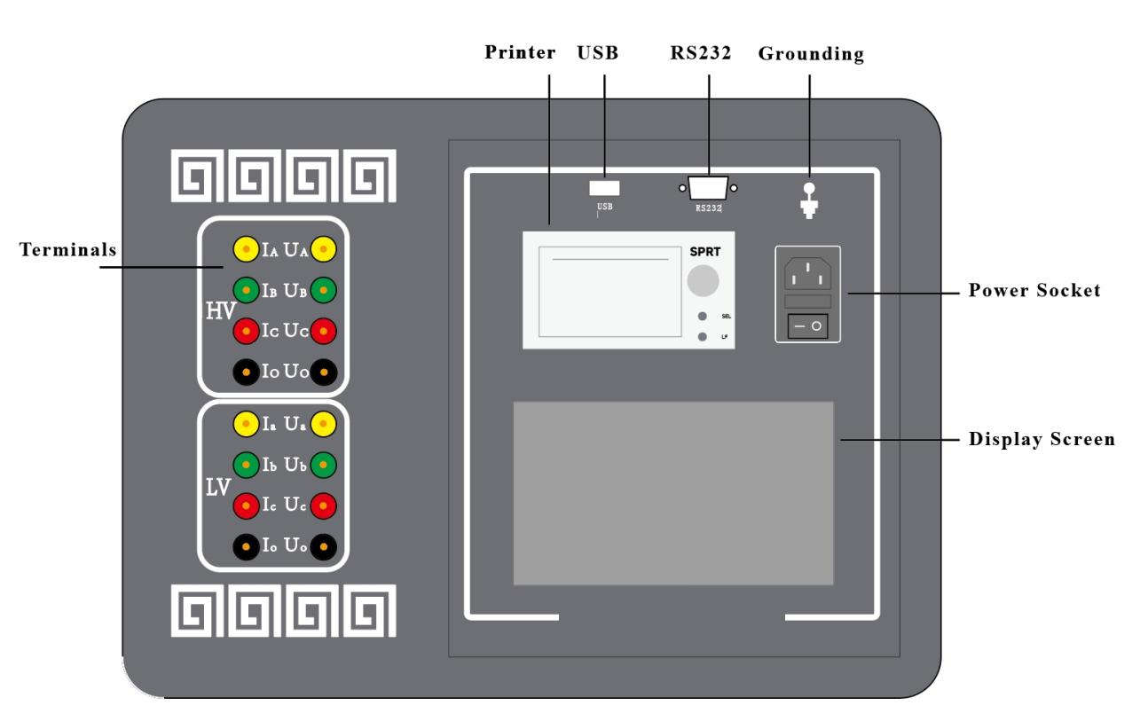
1. Power Socket: With a built-in switch and fuse compartment, fuse: 10A.
2. Grounding: Connect to the ground during use.
3. USB Port: Can connect to a mouse, USB flash drive, and other USB devices.
4. RS232 Port: Connect to an external printer.
5. Display Screen: Touch screen, controls the instrument status and displays various parameters.
6. Printer: Used to print various test parameters.
7. Terminals:Used to connect test leads for different functions.
- Main Technical Specifications
1.DC Resistance Test
Three-Phase Test | 10A, 5A, 1A three ranges.
Test Range | 10A：500.0μΩ～2Ω
Test Range | 5A： 10mΩ～4Ω
Test Range | 1A： 1Ω～20Ω
Phase-Separated Test | 20A, 10A, 5A, 1A four ranges.
Test Range | 20A：100.0μΩ～1Ω
Test Range | 10A：500.0μΩ～2Ω
Test Range | 5A： 10mΩ～4Ω
Test Range | 1A： 1Ω～20Ω
Resolution | 0.1μΩ
Measurement Accuracy | class 0.2
2.Transformer Ratio
Range of Ratio | 1-5000
Measurement Accuracy | 0.1%（0.8—1000）  0.2% (1000—2000)  0.5% (2000—5000)
Transformer Connection Group | YY0，YY6，YD1，YD5，YD7，YD11，DD0，DD2，DD4，DD6，DD8，DD10，DY1，DY5，DY7，DY11
Testing Voltage | 10V/160V
3.Operating Conditions
Instrument Dimensions: 398mm × 262mm × 358mm | Weight: 19kg
Operating Power Supply: AC 220V | Power Frequency: 50/60Hz
Ambient Temperature: -10℃ to 50℃ | Ambient Humidity: ≤85%RH
- Operation Procedure
1. Preparation and Wiring
Before using the instrument, check the current working environment to ensure safety before proceeding with wiring.
To ensure your safety and the safety of the equipment, please check the reliability of the grounding wire.

- DC Resistance Test Wiring Diagram
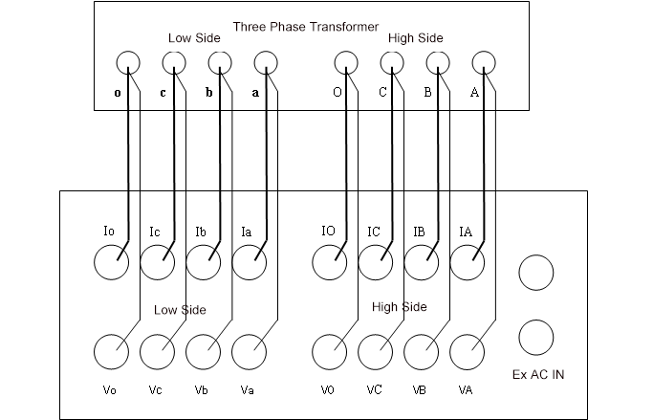
1. Connect the instrument to an external AC 220V power supply using the power cord, and connect the grounding terminal to the ground using the grounding wire.
2. For two-winding transformers, connect the four test clips on the high-voltage terminal (yellow, green, red, black) to the high-voltage side A, B, C, O bushings. If there are only A, B, C bushings, leave the black clip unconnected. Connect the four test clips on the low-voltage terminal (yellow, green, red, black) to the low-voltage side a, b, c, o bushings. If there are only a, b, c bushings, leave the black clip unconnected.
3. For three-winding transformers, after testing the high and low voltage windings, connect the four test clips on the high-voltage terminal to the medium-voltage side for testing.
4. For single-phase transformers, connect the yellow and black test clips on the high-voltage terminal to the high-voltage side of the single-phase transformer, and connect the yellow and black test clips on the low-voltage terminal to the low-voltage side of the single-phase transformer.
5. The dedicated test leads provided with the instrument have the current and potential leads designed into the same clip, so just connect them.
Note: The instrument uses three-channel DC resistance testing, so the leads can be connected at once. When testing the medium-voltage winding, connect the medium-voltage test leads to the high-voltage terminal of the instrument to test the medium-voltage DC resistance.

- Transformer Ratio Test Wiring Diagram
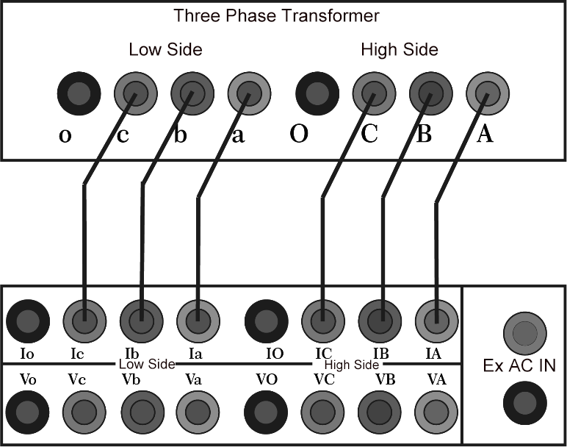
Figure 1

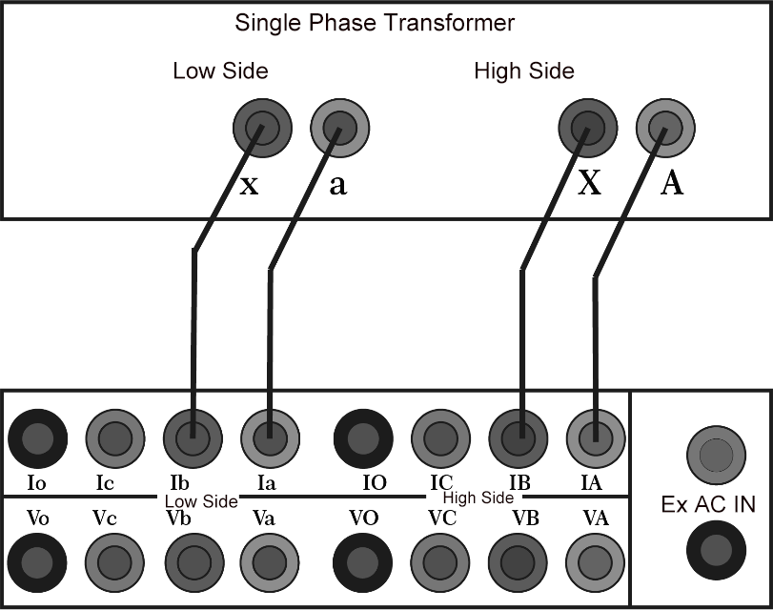
Figure 2
Note: Figure 1 shows the wiring method for the three-phase transformer in the turns ratio test function. The high-voltage side A, B, and C are connected to IA, IB, and IC respectively, while the low-voltage side a, b, and c are connected to Ia, Ib, and Ic respectively. Figure 2 shows the wiring method for the single-phase transformer. The high-voltage side A and B are connected to IA and IB respectively, while the low-voltage side a and x are connected to Ia and Ib respectively.
2. Operating Instructions
Boot - up：Connect the AC220V power supply to the instrument, connect the transformer bushing and the instrument with test leads, and connect the grounding terminal of the instrument to the ground with the grounding wire. After connecting the power cord and turning on the switch, enter the menu interface.
System Settings：On the instrument test interface, touch "System Settings" lightly to enter the system settings interface. Enter the relevant parameters according to the prompts, and then touch "Confirm" lightly to return to the instrument option interface.
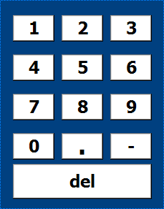
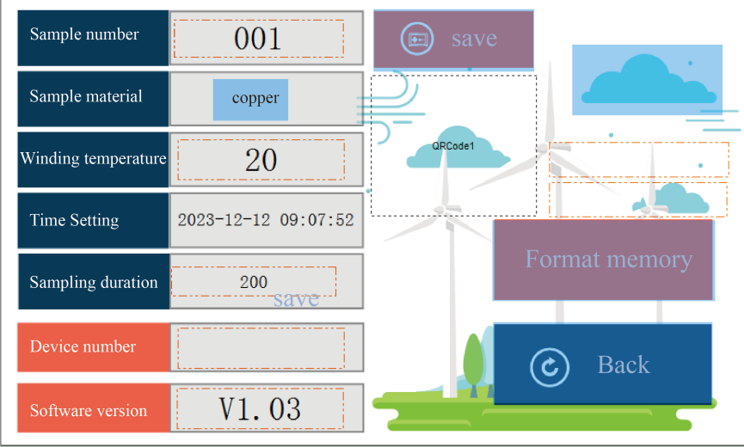
Set the Test Sample Number: Touch the white rectangular area after the test sample number lightly, and a numeric keypad will pop up to set the name for data storage. Touch the [0 - 9], [ - ], [.] buttons to set the test sample name freely. If you want to modify the name, touch the [del] button, and the current number will be erased. Touch any area other than the numeric keypad to exit the setting.
Set the Winding Material: Touch the white rectangular area after the winding material lightly, and you can switch the winding material between copper and aluminum. Touch other areas to exit the current setting.
Set the Test Temperature: Touch the white rectangular area after the test temperature lightly, and a numeric keypad will pop up (refer to the picture for setting the test sample number). Enter the temperature value of the test sample by touching the [0 - 9], [ - ], [.] buttons. If you want to modify the number, touch the [Del] button, and the current number will be erased. Touch any area other than the numeric keypad to exit the current setting.
Set the Time: Touch the white rectangular area after the test temperature lightly, and a numeric keypad will pop up (refer to the picture for setting the test sample number). Set the instrument clock by touching the [0 - 9] buttons. If you want to modify the number, touch the [Del] button, and the current number will be erased. Touch any area other than the numeric keypad to exit the current setting.
Set the Acquisition Duration: Touch the white rectangular area after the recording duration lightly, select the required test duration, and touch the option to be set. Touch any area other than the numeric keypad to exit the current setting.
- Pre-Test Precautions
1. Please follow the instructions in this manual for wiring and operation.
2. The grounding terminal or the grounding end of the power cord should be reliably grounded nearby.
3. For DC resistance testing, select the appropriate test current according to the resistance range of the test object.
4. Although the instrument has a discharge protection circuit, try to avoid abnormal situations such as test clip dropped down or power failure during the test.
5. In case of special circumstances, please turn off the power directly and wait for a while before removing the test leads.
6. Ensure that the instrument is reliably grounded before testing.
7. When wiring, please ensure that the high-voltage and low-voltage leads are not reversed.
8. Before testing, please enter the correct parameter settings. The group number and the tested transformer must be consistent.
9. If the rated ratio is not entered, the test result will only display the measured ratio value, not the error.
10. Note: Do not reverse the high and low voltage connections of the transformer!
- Test Procedure
1. DC Resistance Test
On the instrument test interface, touch "DC Resistance" to enter the DC resistance interface.
Set the correct parameters for winding temperature, conversion temperature, and winding material.
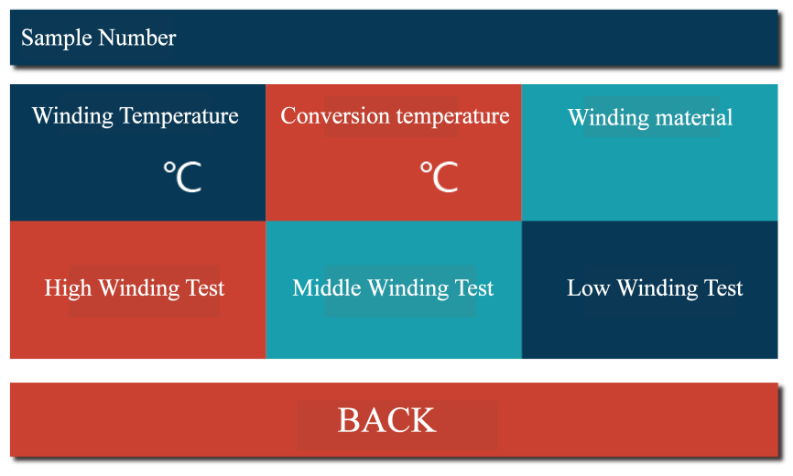
Select "High winding Test", "Middle winding Test", or "Low winding Test" as needed.
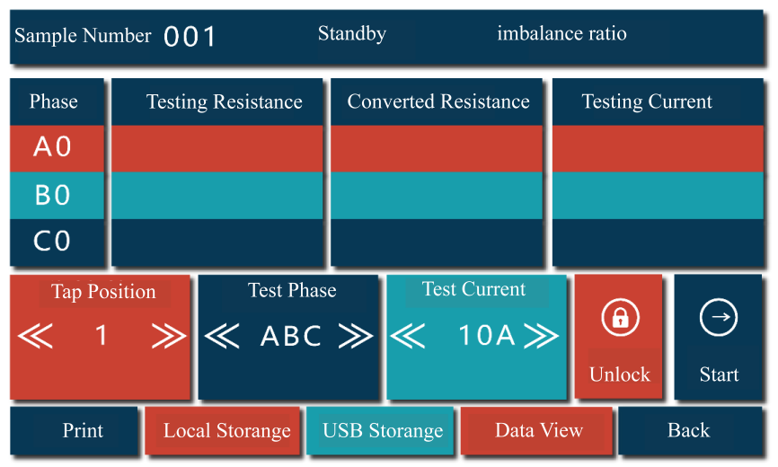
After pressing the high (medium/low) winding test button, the instrument enters the test interface.The status bar will display the current test progress in real-time.
When you enter the test interface but haven't started the test yet, the title bar will show the standby status.
After starting the test, during the process of stabilizing the test current, the status bar will show the charging status.
After the current stabilizes, the current and the measured resistance value will be displayed in real - time, and the status bar will show the testing status.
When you click the stop button, the status bar will show the discharging status.
After the discharging is completed, the status bar will show that the discharging is completed, and then it will enter the standby status.
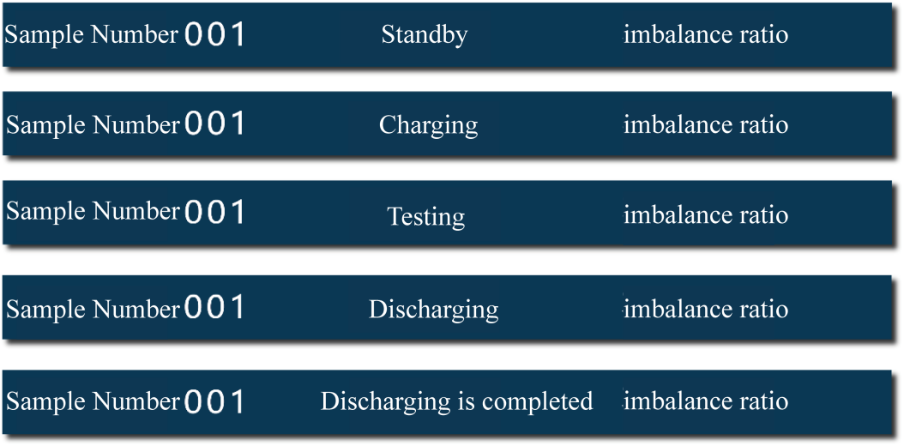
After the data stabilizes, you can perform the following operations:
- For the test phase, the selectable options are A0, B0, C0, AB, BC, CA, and ABC.For the single - phase test, you can select A0, B0, C0, AB, BC, and CA phases.For the three - phase test, select the ABC phase. At this time, the maximum test current is 10A.For the magnetic - assisted test, select AB, BC, and CA phases. In the low - voltage test, the magnetic - assistance button will be automatically displayed. Click the box after the magnetic - assistance button, and a checkmark appears, indicating that the magnetic - assistance function is successfully selected.
- For the test current, the selectable options are 1A, 5A, 10A, and 20A.
After selecting the required test phase and current, touch "Start" to enter the test state. After the data stabilizes, you can perform the following operations:
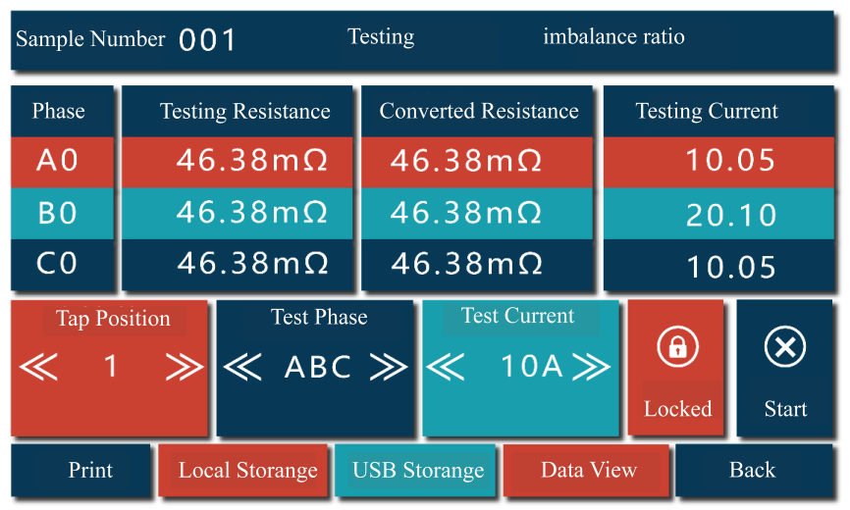
Local Storage: Click the local storage button to save the current test value. The status bar will show that the storage is successful. When you need to test the DC resistance of other taps, you don't need to stop the discharging. Just adjust the tap position of the transformer directly. The instrument will automatically measure the resistance value of the current tap. After the data stabilizes, touch local storage to save the data of the current tap position.
USB Storage: Click the USB storage button to save the current test value to the USB flash drive.
Lock: Click the lock button to fix and display the current test data.
Print: Click the print button to print the test data of the current tap.
After the test is completed, click the stop button to stop the test. After the discharging is completed, click the return button to return to the previous interface.
Data View: Click the data view button to view the test data of all taps. In this interface, you can perform printing and USB storage. Click the return button to return to the test interface.
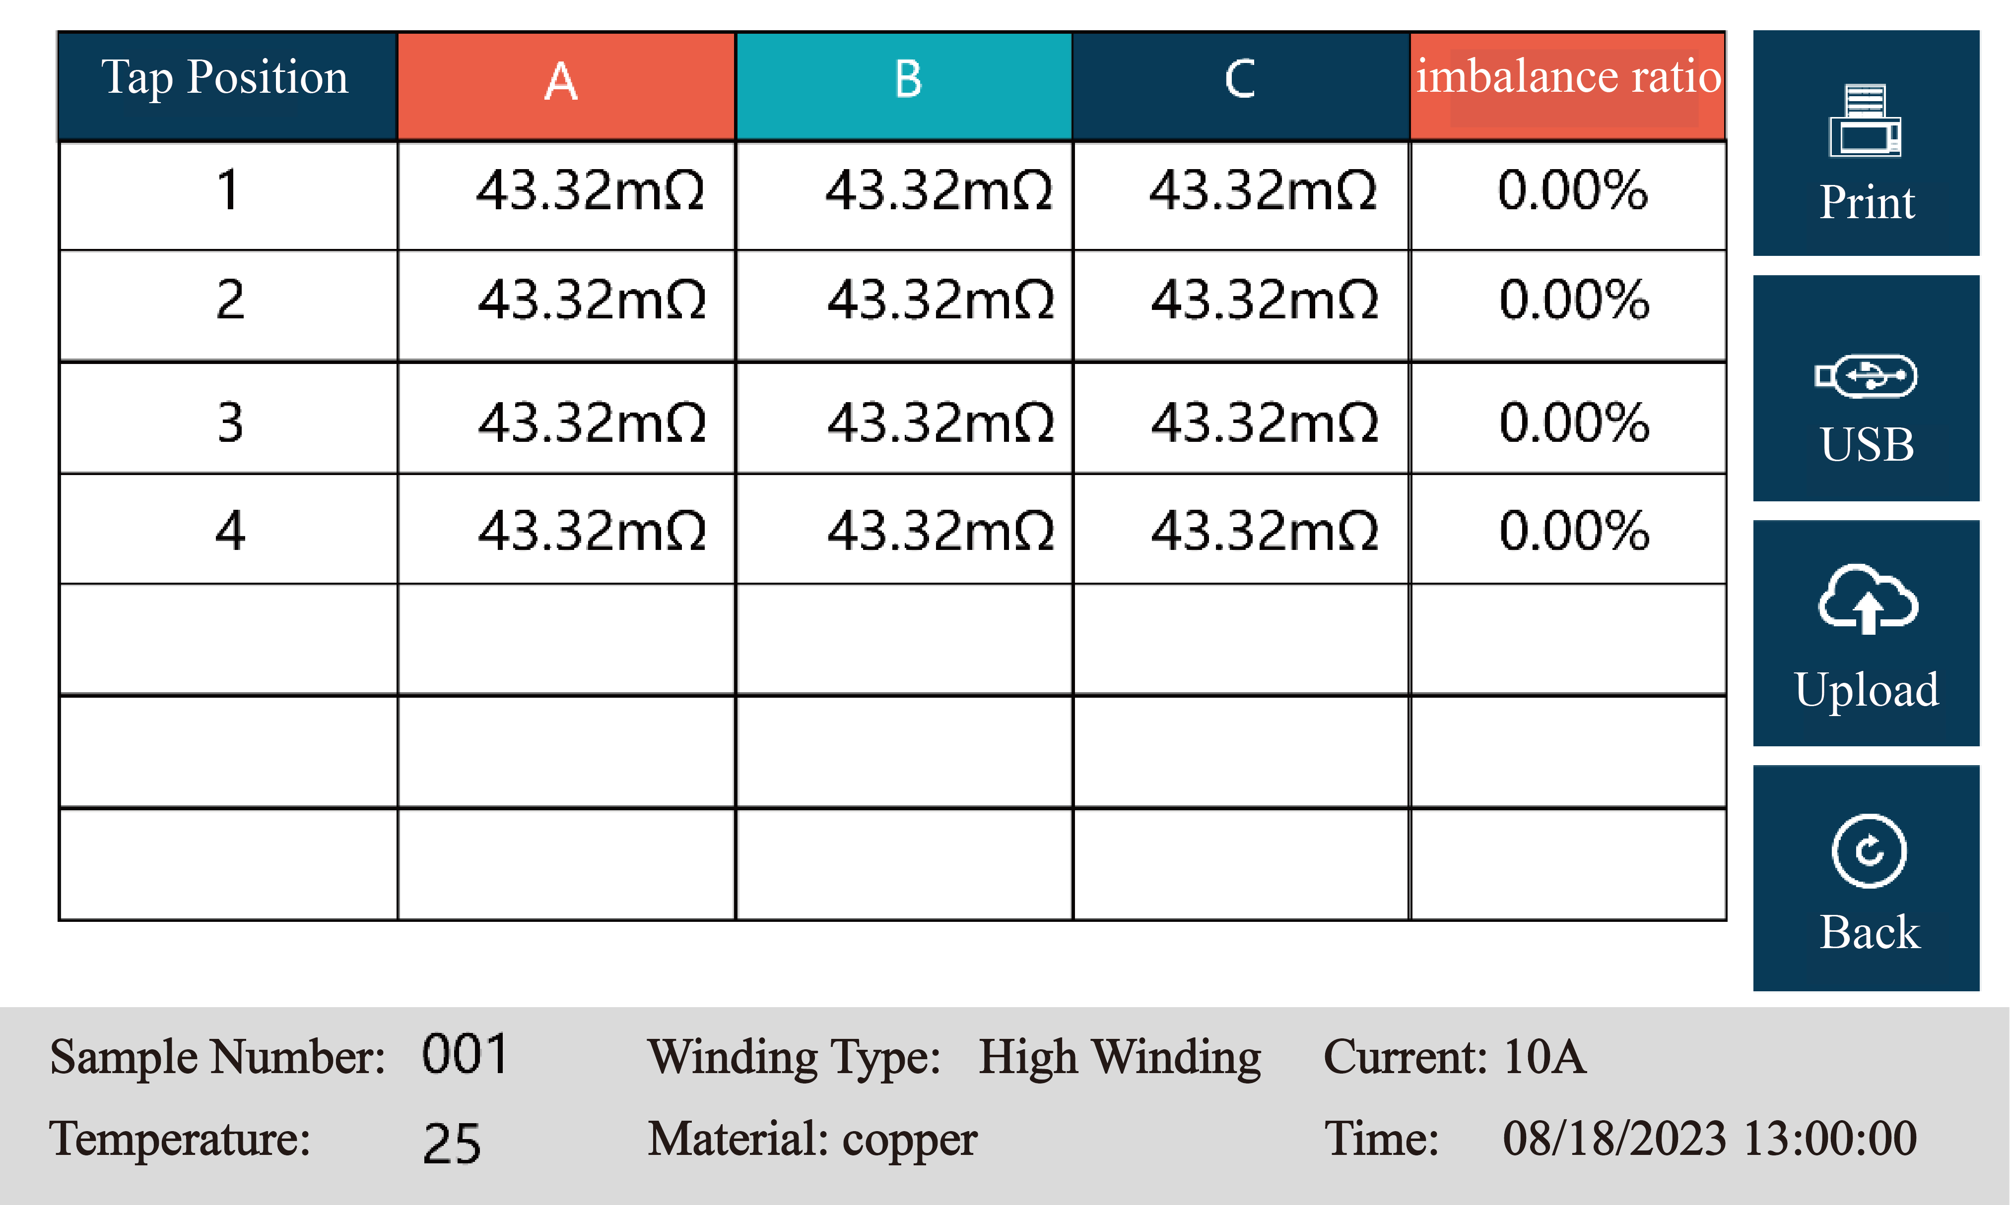
2. Transformer Ratio Test
On the instrument testing interface, touch the "Transformer Ratio Test" to enter the diagram interface.
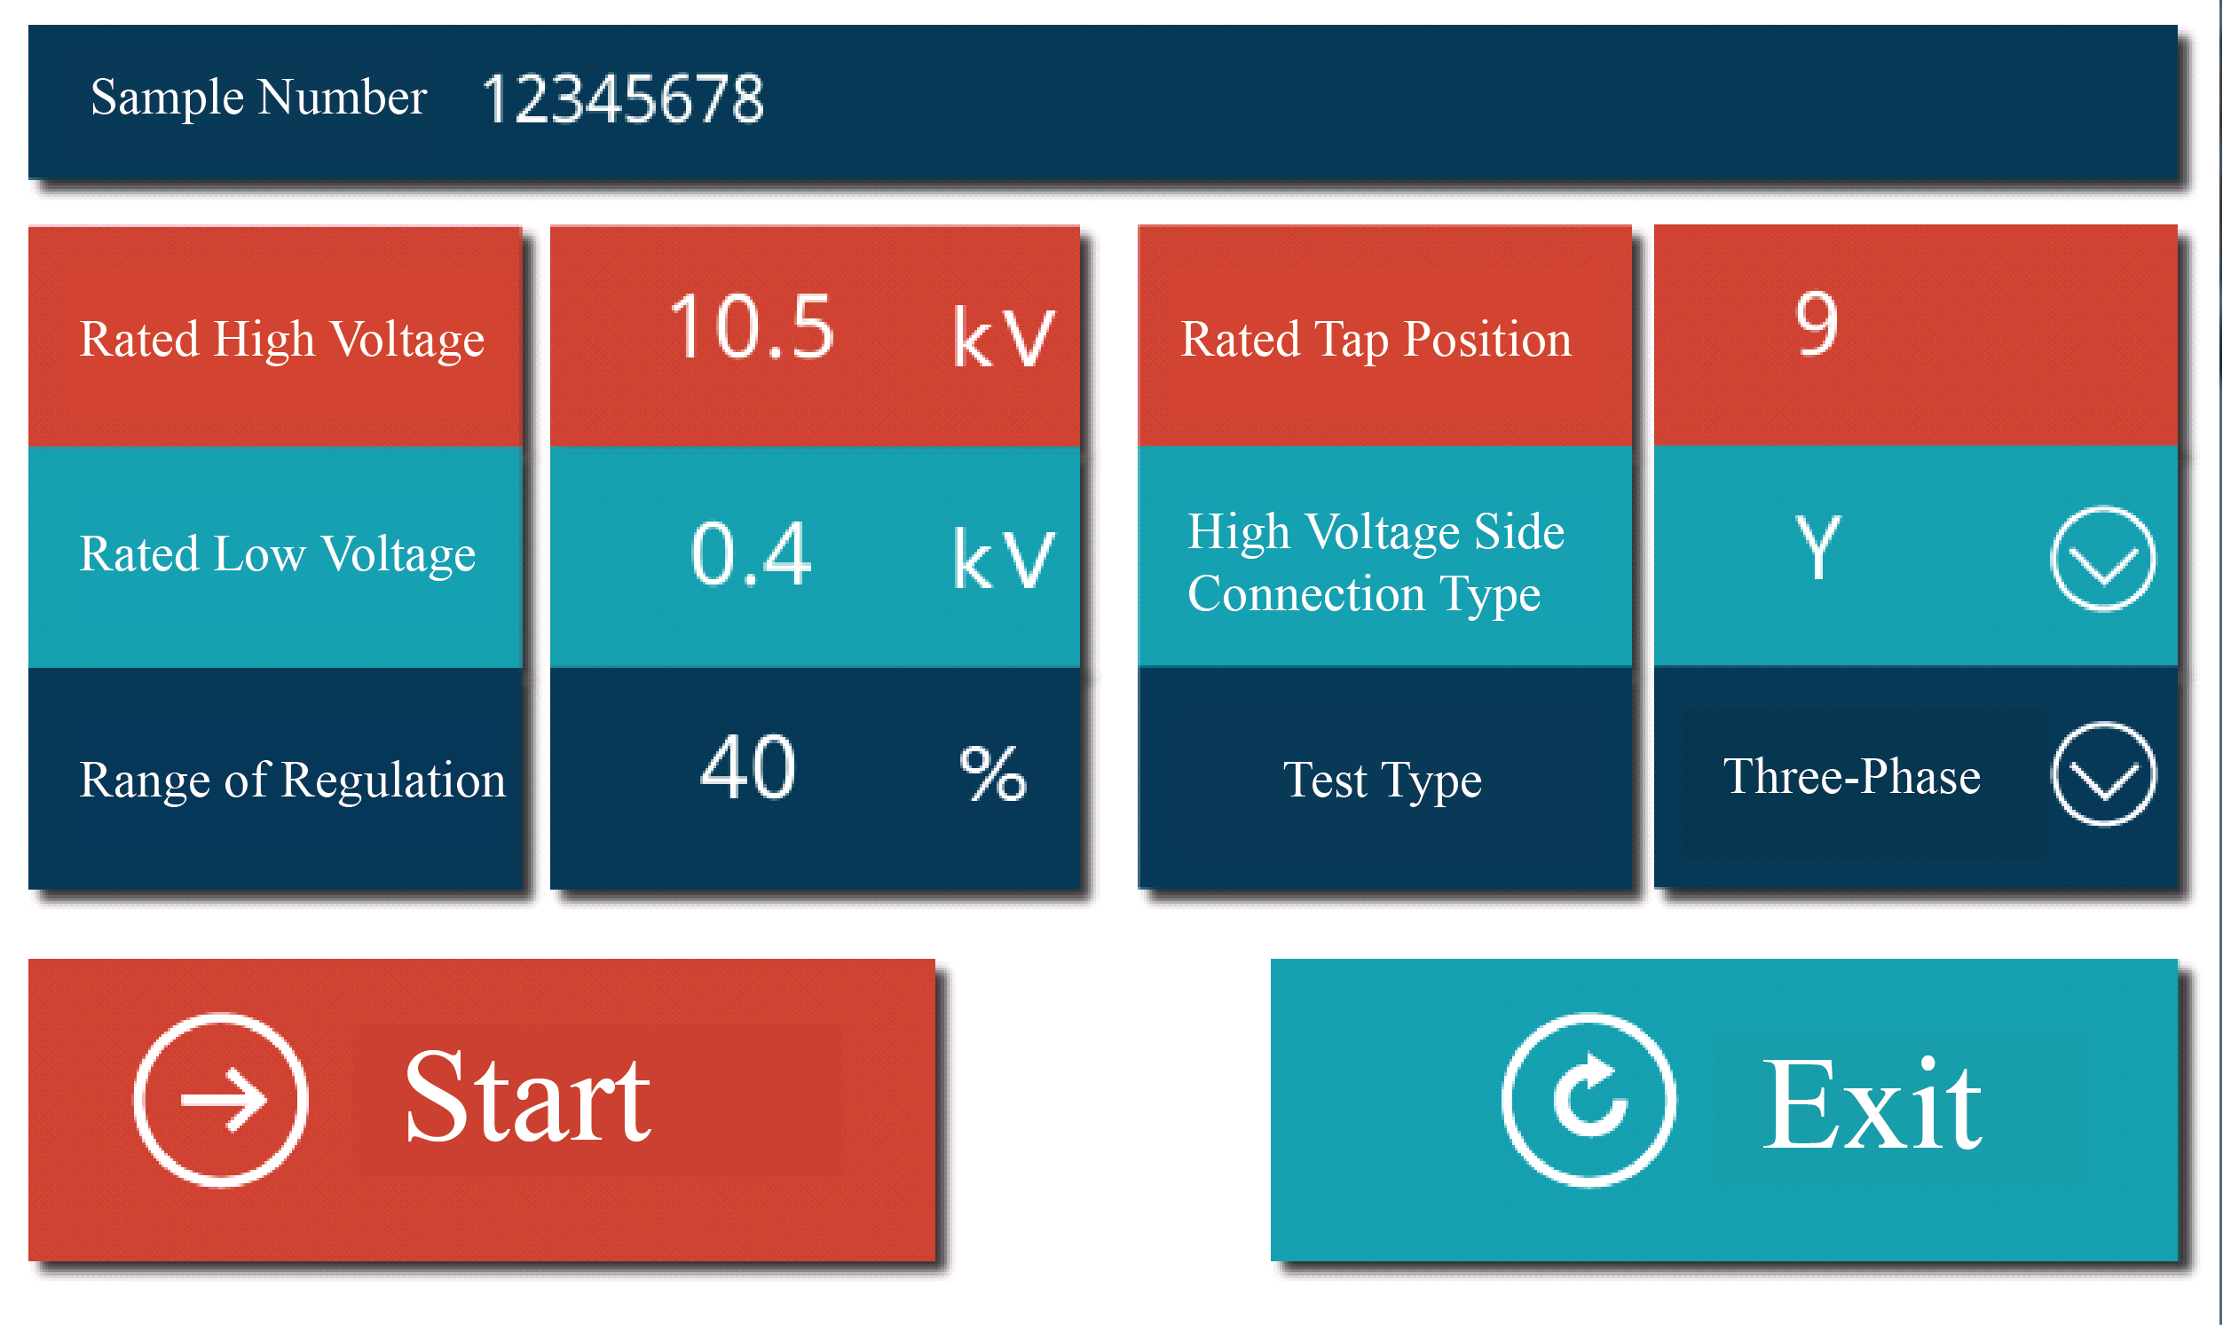
- Single-Phase Test
After connecting the test leads, select Single-Phase from the three wiring methods below the connection diagram. Input the rated turns ratio. If an incorrect ratio is entered, the ratio error and the current tap position will not be displayed correctly. Click the Start button and wait for the test results to appear. If you need to pause during the test, click the Stop button. Click Exit to leave the turns ratio test interface.
2. Three-Phase Test
After connecting the test leads, select Three-Phase Y (if the high-voltage side is star-connected) or Three-Phase D (if the high-voltage side is delta-connected) from the three wiring methods below the connection diagram, based on the high-voltage side connection method of the three-phase transformer. Input the rated turns ratio as indicated on the nameplate. If an incorrect ratio is entered, the ratio error and the current tap position will not be displayed correctly. Click the Start button. The current vector group will be displayed first, followed by the current three-phase turns ratio values. Wait for the test results to appear. If you need to pause during the test, click the Stop button. Click Exit to leave the turns ratio test interface. The completed test interface is shown in the figure below:
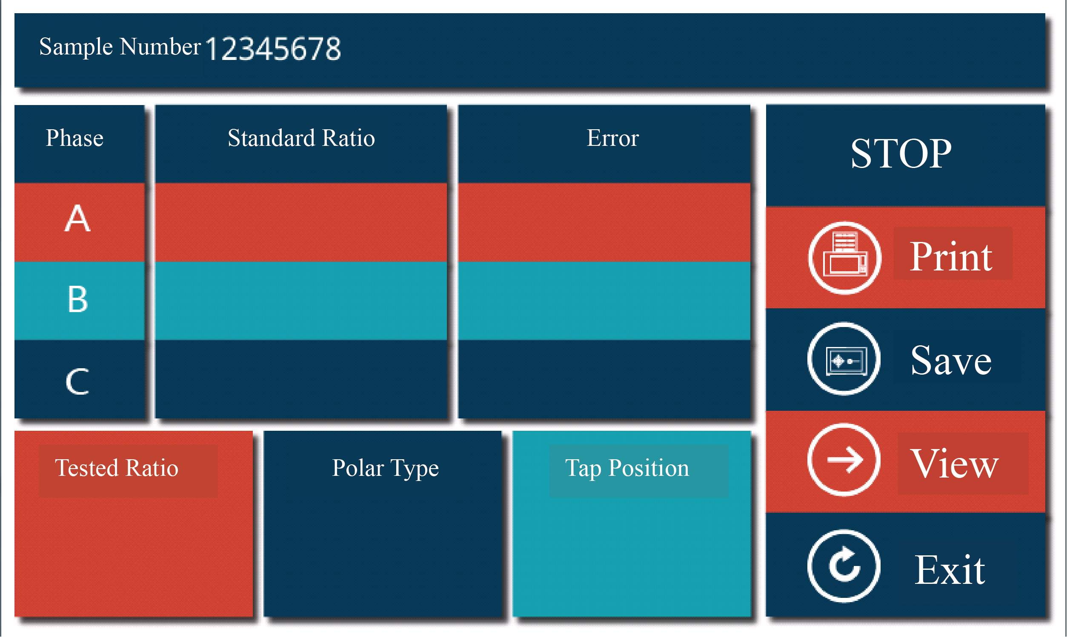
Note: If a wiring error occurs, such as reversing the high and low voltage connections or short-circuiting the primary or secondary side, the instrument will pop up a warning box. In this case, please check the wiring and ensure it is correct before proceeding with the above operations.
- Data Management And Storage
The instrument records test data in the format of "time - transformer number". All the test data collected on the same day are stored in a file directory named after the date, which is convenient for searching.
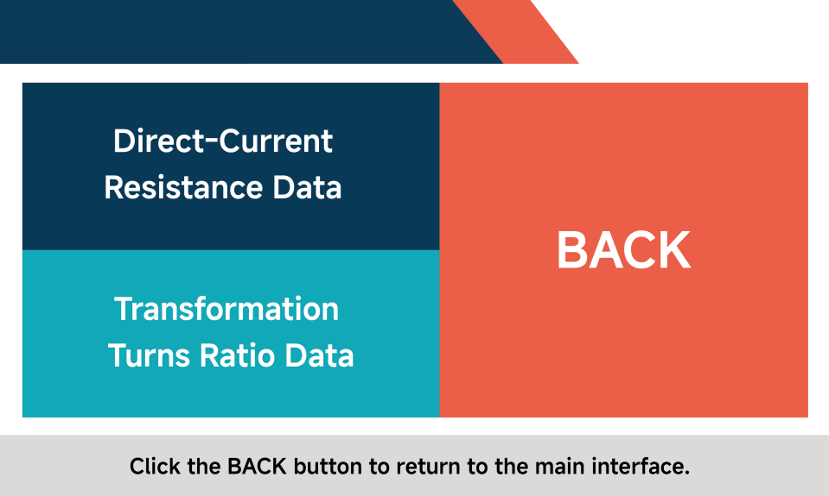
1: Touch "DATA VIEW" to enter the test item interface, and select the test item you want to view.
2: Touch the corresponding item to enter the storage directory, and select the file you want to view or delete for operation.
3: Touch "DC Resistance DATA", and you can enter the DC resistance data management interface. Here, you can view all the saved data or print all the saved data at once.
4. Touch "Turns Ratio Data" to enter the demagnetization data directory. Select the data you need to view, and you can check the corresponding test results.
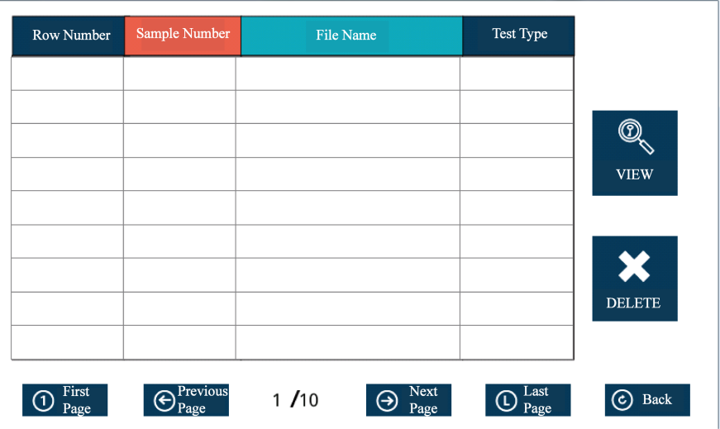
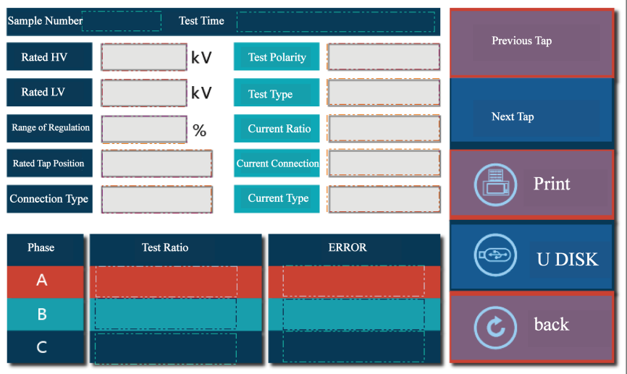
5. Insert a USB flash drive. Touch "Saved Test Data" (it can store all the data of one day named after the time, such as June 4, 2013; or it can store the data of a specific transformer named after the test sample number). After it turns into a blue - bordered box, touch "Save to USB" and a "Storage Successful" prompt will appear, indicating that the selected data has been successfully saved to the USB flash drive.
- Precautions
1. To ensure the safety of personnel and equipment, we repeatedly remind users to pay attention to the grounding of the instrument and the discharging after the test.
2. Before connecting the test wires, make sure that the instrument is not in the working state. The device under test should be disconnected from the power supply and discharged manually. Only after ensuring safety can the wiring operation be carried out.
3. The instrument should be stored in a place where the room temperature is -10°C to 50°C, the relative humidity is 20% - 90%RH, and there are no corrosive gases and harmful substances in the air.
4. Before using this instrument, be sure to read this manual carefully. The instrument operator should have some common sense of electrical equipment or instrument operation. This instrument can be used indoors and outdoors, but it should be protected from rain and strong vibration.

- Packing List
No. | Item | Qty
1 | Main Unit | 1
2 | AC220V Power Cord | 1
3 | 10A Fuse Tube | 2
4 | Test Leads | 2
5 | Grounding Wire | 1
6 | USB Flash Drive | 1
7 | Printer Paper | 2
8 | Wire Box | 1

