HZ-2000D
Transformer Tan Delta Tester

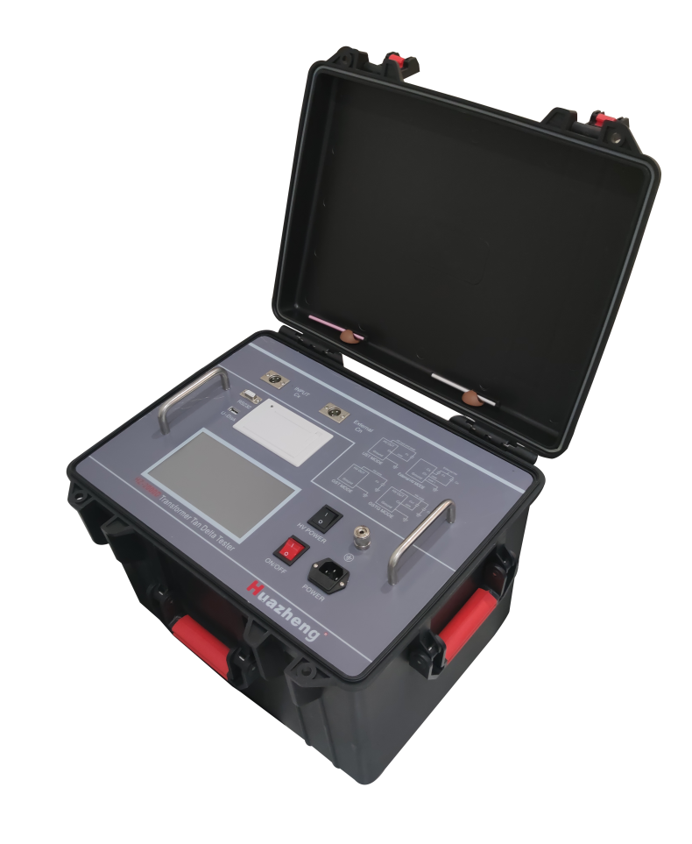

Huazheng Electric Manufacturing (Baoding) Co., Ltd

Contents

I. Overview Of Instrument 1
II. Safety Measures 1
III. Performance Characteristics 2
IV. Technical Indicators 3
V. Measurement Mode And Principle 4
VI. The Wiring Methods Of The Common Equipment 5
VII. Introduction Of Instrument Function 9
VIII. Instrument Operation Steps 11
IX. Notes For The Field Test 18
X. Frequency Conversion Measurement And Discussion 20
XI. Container List Of Instruments 22

- Overview Of Instrument

Interelectric damage measurement is a very basic method in the insulation test, which can effectively find the overall damp deterioration of the electrical equipment insulation, and the local defects. It is widely used in electrical manufacturing, electrical equipment installation, handover and preventive test. The dielectric damage measurement of transformer, transformer, reactor, capacitor and casing and lightning arrester is the most basic method to measure its insulation performance. breaks through the traditional bridge measurement method, using frequency conversion power supply technology, using single chip computer, and modern electronic technology for automatic frequency conversion, analog / digital conversion and data operation, fast test speed, high accuracy, automatic digital, easy operation; power using high power switch, output 45Hz 5 H z and 55Hz pure sine wave, automatic pressure, can provide up to 500 V voltage; automatic filter 50Hz interference, suitable for substation electromagnetic interference field test. Widely used in the transformer, transformer, casing, capacitor, lightning arrester and other equipment in the power industr

II. Safety Measures
1. Be sure to read this manual carefully before using this instrument。
2. The operator of the instrument shall have the general knowledge of the use of electrical equipment or instrument.
3. The instrument can be used both inside and outside the households, but it should avoid the rain, corrosive gas, excessive dust, high temperature, direct sunlight and other places.
4. The instrument shall avoid severe vibration。
5. Maintenance, care and adjustment of instruments shall be performed by professionals.
6. The instrument ground terminal must be reliably connected to the earth by a grounding cable before any wiring。
7. Due to the high voltage generated by the test equipment, the test personnel must fully and strictly follow the safety operation procedures to prevent others from contacting the high-voltage components and circuits. Personnel directly engaged in the test must fully understand the high voltage test line and the key points of instrument operation. Non-testing personnel must be away from the high pressure test area, which must be clearly indicated by fences or ropes, signs,
8. Adjustment, repair and maintenance of the instrument must be conducted without the power supply. If the power supply must be added, the operator must be very familiar with the high-pressure dangerous components of the instrument.
9. When the insurance pipe is damaged, it must ensure that the same insurance is replaced. It is forbidden to replace different types of insurance or short circuit the insurance directly.
10. When the instrument fails, turn off the power switch and wait for one minute before checking。

III. Performance Characteristics
- The instrument adopts Fourier transform digital filtering technology to measure capacitance, dielectric loss and other parameters. The test results have high accuracy and are easy to achieve automated measurement.
- The instrument adopts frequency conversion technology to eliminate 50Hz power frequency interference on site, and reliable data can be measured even in the environment of strong electromagnetic interference.
- Use a full-touch large LCD display, easy to operate. Full touch LCD screen, super large full graphics operation interface, each process is very clear, operators do not need additional professional training to use. The whole process can be measured with a little touch。
- Storage data: internally equipped with a calendar chip and large-capacity memory, which can save the detection results at any time, can view the history record at any time, and can print and output. Current times and storage times can be displayed and printed at any time.
- Scientific and advanced data management: the instrument data can be exported through the U disk, and the data can be viewed and managed on any PC machine through special software.
- The instrument is easy to operate, and the measurement process is controlled by the microprocessor. As long as the appropriate measurement method is selected, the data measurement can be completed automatically under the control of the microprocessor
- Integrated model, equipped with standard capacitance and high-voltage power supply, to facilitate field testing and reduce field wiring
8. The instrument measurement accuracy is high and can meet the requirements of oil intermediate loss measurement, so only the oil intermediate loss measurement can be realized with standard oil cup and special test line.
9. Has the low-voltage shielding function of reverse wiring.
10. Be able to do AC pressure resistance test. Convenient for PT, CT secondary AC voltage test, 400V low voltage system to do voltage test.
11. Can identify the frequency of external high voltage power supply of 40Hz~70Hz, and allow the use of power frequency power supply or serial resonance power supply for large capacity and high voltage resonant loss test.
12、With a thermal printer can print output, with a calendar clock, convenient for users to test report, with U disk output.
13、With a computer interface. One computer can control 32 instruments, which can be integrated into the integrated high-voltage test vehicle, realizing measurement, data processing and report output.
14、Ground protection function. When the instrument is not grounded wire or bad grounding, the instrument does not enter the normal procedure and does not output high voltage. Overcurrent protection function, the instrument is not damaged during the test product short circuit or breakdown.
15、Electric shock protection function, when the instrument operator accidentally electric shock, the instrument will immediately cut off the high pressure, to ensure the safety of the test personnel.

IV. Technical Indicators
Accuracy： Cx: ±（reading×1%+1pF）
tgδ: ±（reading×1%+0.00040）
Anti-interference index： Frequency conversion is anti-interference, with 200% interference
Electrical capacity range： Apply high pressure inside：
3pF～60000pF/10kV 60pF～1μF/0.5kV
Extra high pressure： 3pF～1.5μF/10kV 60pF～30μF/0.5kV
Resolution: up to 0.001pF, 4 valid digitstgδ
Scope: unlimited, resolution 0.001%, capacitor, inductor, resistance of the three test products automatic identification.
Test current range：5μA～5A
Internal high voltage: set the voltage range：0.5～10V
Maximum output current: 200 m A
Lift mode: the voltage is set at will. Like 5123V。
Test frequency: 40-70Hz single frequency is set at will. Like the 48.7Hz.50±0.1Hz—50±10Hz
Automatic double frequency conversion is set at will.60±0.1Hz—60±10Hz
Automatic double frequency conversion is set at will.
Frequency accuracy: ± 0.01Hz
External high voltage: the maximum test current 5A is 5 A, power frequency or frequency conversion 40-70Hz
The maximum test current during reverse wiring is 10kV / 5A, and the power frequency or frequency conversion is 40-70Hz
Input power supply: 180V~270VAC, 50Hz ± 1%, mains power or generator power supply
Computer interface: standard RS232 interface, U disk socket (automatic U disk storage data).
Printer: Micro thermal printer ambient temperature: -10℃ ~50℃ relative humidity: <90%

Overall Dimensions: 500 * 377 * 330mm Instrument weight: 26kg

V. Measurement Mode And Principle
According to whether the tested product is grounded, there are two measurement methods, namely positive wiring measurement and reverse wiring measurement method. The principle of the two measurement methods is shown in Figure
1:
High voltage output Icx R High voltage output
Icx

0.5KV o 0.5KV o

C_{N} I_{CN} ～ Cx C_{N} I_{CN} ～ C_{X}

o
R_{N} R R_{N}
Cx

（a）Positive wiring measurement （b) Rewiring measurement
Picture 1
On the 0.5kV side of the high voltage power supply, the high voltage is divided into two ways, one way to the standard capacitance CN in the machine, this capacitive medium loss is very small, can be considered zero, that is, the pure capacitive current, this current ICN can be used as the capacitive current reference. On the side of the test Cx, the test current Icx is collected into the machine through the sampling resistance R. This Icx can be decomposed into horizontal and vertical components as shown in Figure 2. The tg value can be obtained by calculating the ratio of the horizontal component to the vertical component.
In Figure 1 (a), Cx is the non-grounded test product, and the test product current Icx enters the sampling resistance R from the end of the test product to obtain the full current value. In Figure 1 (b), Cx is the grounding test product, the machine Cx end is directly grounded, and the current Icx obtains the full current value from the test product high voltage end to the sampling resistance in the machine.

I

I_{C} I I

u Ic I_{R}
δ
Φ
O
I_{R} u
(a) Current vector method (b) Test product equivalent circuit
picture 2

VI. The Wiring Methods Of The Common Equipment
1. Description of instrument lead terminal:HV —— Measure the lead high voltage end (with dangerous voltage) of the instrument.CX —— Test product when connectingCurrent input.
——The grounding end of the instrument is reliably connected with the earth when used
2.Refer to wiring2
2.1 Positive wiring, internal standard capacitance, internal high voltage (regular positive wiring):
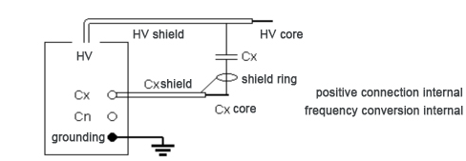

2.2Counterwiring, internal standard capacitance, internal high voltage (conventional rever
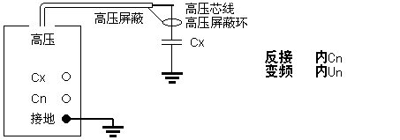
HV core
HV shield ring
HV shield
reverse connection internal
frequency conversion internal
HV

grounding

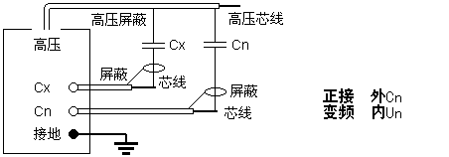2.3Positive wiring, external standard capacitor, internal high voltage:
HV core
HV shield

HV
Core

shield

positive connection extenal
frequency conversion internal
Core

grounding

2.4 Counterwiring, external standard capacitor, internal high voltage：
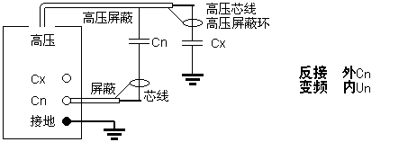
HV core
HV shield ring
HV shield

shield
reverse connection extenal
frequency conversion internal
HV
grounding

Core

2.5 Standard capacitance external high voltage in the positive wiring：
HV core
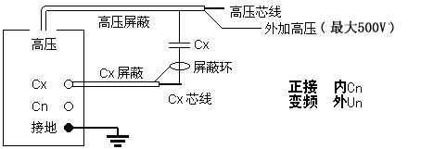
Core

grounding
positive connection internal
frequency conversion extenal
shield ring
shield
HV shield

External HV(Max 500W)
HV

2.6 Standard capacitance external high voltage in reverse wiring:
Core
shield ring
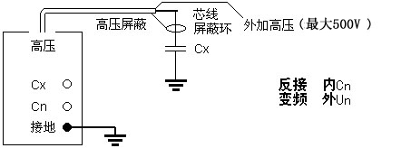
External HV(Max 500W)
reverse connection internal
frequency conversion extenal

HV core
grounding

HV

2.7 Positive wiring, external standard capacitance, external high voltage (high voltage loss loss):

Applied voltage according to Cx/Cn voltage level
HV
core
core

shield
shield

positive connection extenal
frequency conversion extenal

grounding

2.8 Counterwiring, external standard capacitance, external high voltage:

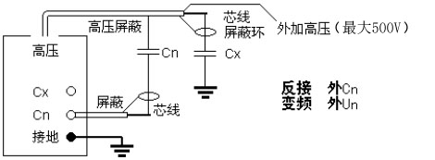
HV shield

External HV(Max 500W)
Core
shield ring

reverse connection extenal
frequency conversion extenal
HV
core
grounding
shield

2.9 Counterwiring low-voltage shielding test
Backwiring low voltage shielding function, primary wiring can simultaneously measure the capacity and electric loss of C1 and C2
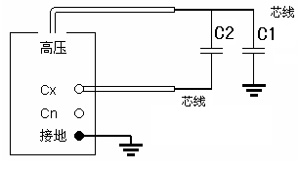
core

HV
core

grounding

Select the reverse wiring low-voltage shield to measure the 2.25kV reverse wiring damage of the upper end capacitor C1 without removing the busbar. As shown in the following figure: the bus line is hung to the ground wire, the upper end of C1 is not disassembled, C1 lower end is connected to the high voltage line core wire, and C2 lower end is connected to the Cx core wire. The instrument adopts the reverse wiring / 2.25kV / M measurement method to measure both the electric capacity and interdamage value of the C11 and the lower end shield part.
busbar grounding

reverse connection

HV

grounding

VII. Introduction Of Instrument Function
1.CN socket- -is the measurement input of the external standard capacitance signal, which is empty when the internal standard is used.
2.CX socket- -is the measurement input end of test product signal, which is connected by a special low-voltage cable, a single-layer shield with a special crocodile clip, 8m long and low end of test product. This end is empty during the reverse wiring.
3.RS232 interface- -It is used to connect the computer, control the instrument, and upload the data.
4.U disk socket- -used to export the data stored by the instrument.
5. Printer- -Print the measurement data.
6. Color touch screen display- -640 * 480 resolution, control and display the menu and various prompts and measurement results.
7. Ground terminal- -is the grounding wire terminal.
8. High voltage switch- -Responsible for starting and closing the high voltage power supply inside the instrument. Close only with external high pressure, and remain open for the rest of the time.
9. Power outlet- -AC 220V ± 10%, 50 ± 1Hz power input with 5A pipe.10.Power switch- -Turn on and off of the whole machine power supply.
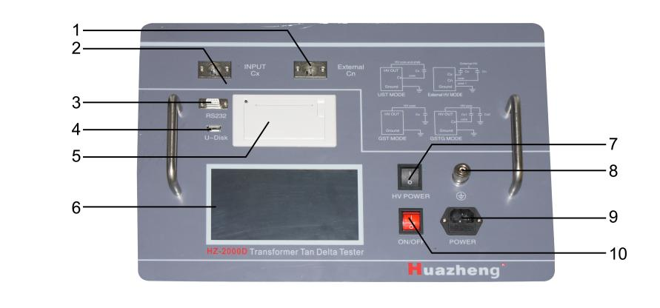
Instrument panel: Figure 3
- High voltage wiring diagram of the instrument

High-voltage line HV socket High-voltage line grounding shield socket (internal internally, just plug in)

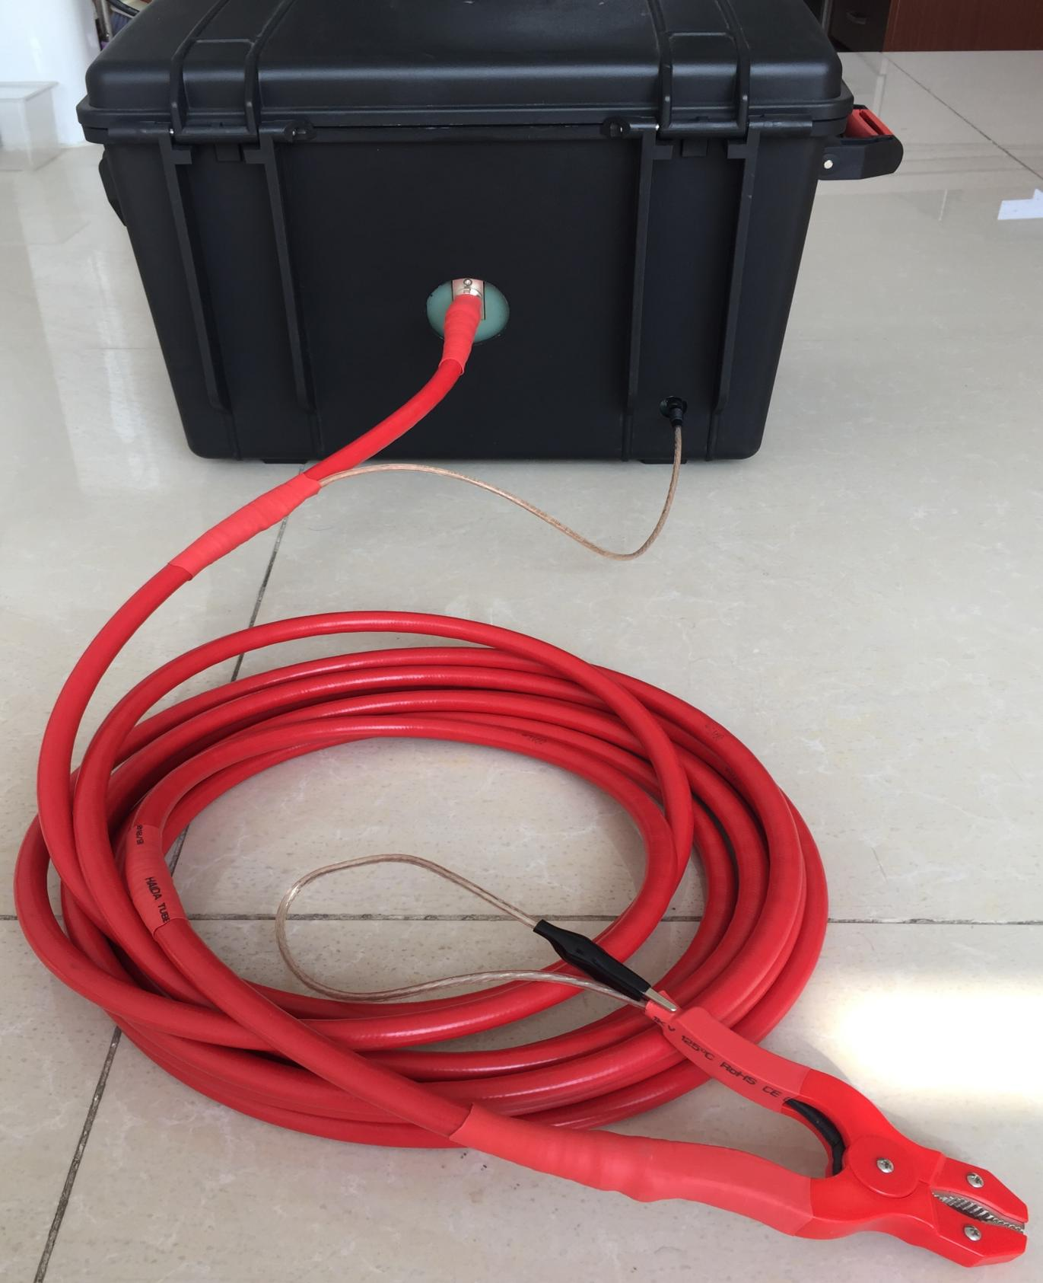
Small black clip is high pressure shielding (with high pressure) The bright red clip is connected to the tested high-pressure part

VIII. Instrument Operation Steps
1. Turn on the power switch and the instrument conducts self-inspection. If the self-inspection is good, the LCD screen .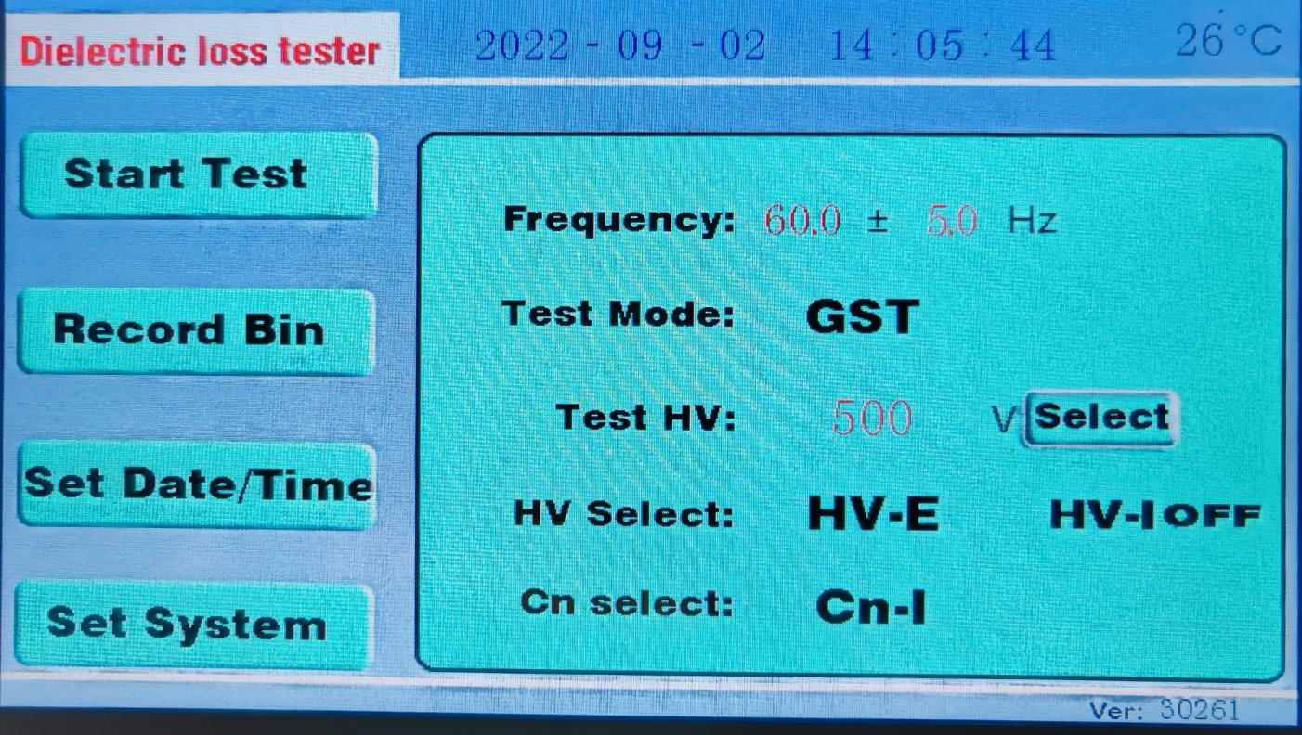
Figure 4 open interface
- Interpretation of test parameter selection
1) Test frequency: 50.0±5.0Hz represents the 45 / 55Hz double frequency conversion test. Field testing is generally selected as
50 ± 5Hz or 60 ± 5Hz. Of course, you can also choose another one. If you want a single frequency such as 50Hz test, you can choose 50.0±0.0Hz. The frequency value is arbitrarily set in the range of 40-70.
2) Test mode: reverse wiring represents the test product using reverse wiring mode. Here is the drop-down menu, which you can select
Positive wiring, reverse wiring, reverse wiring, low-voltage shielding.Test voltage: 500V represents the test voltage value. Minimum 100V, maximum 500V. The voltage value can be set arbitrarily here, such as 436V.
4) High voltage selection: internal high voltage represents the use of internal high voltage power supply. General testing time must be set to the internal high pressure.
External high voltage is only used when the external high voltage power supply is connected。
- 5) Standard selection: the internal standard represents the use of the internal standard capacitance. General testing time must be set to the internal standard.
- External standards are only used when external standard capacitors are used.
- Note: External standards, external high voltage are used in large capacity or high voltage damage. The usual equipment of the substation can be completed with the internal standard and internal high pressure.
Modification and selection of the test parameters:
For test frequency modification, click the red word 45.0 of "45.0±0.0Hz" with a stylus or finger. Figure 5 appears
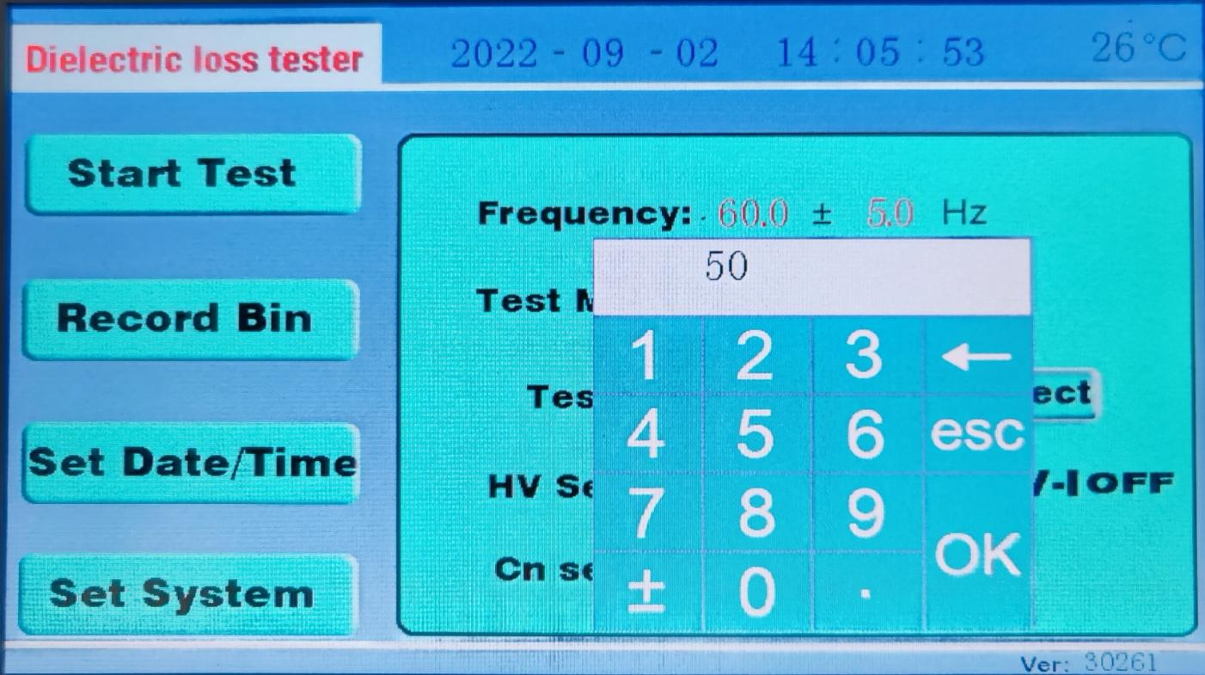

Enter the number of frequency 50 directly from the small keyboard, and then press OK. As the frequency in the figure above is originally 45.0±0.0Hz, and after pressing OK, it will become 50.0±0.0Hz.
If you modify ± 0.0 for 45.0±0.0Hz, click the red word 0.0. A small keypad appears，Then enter 5.0 on the small keyboard, and then press OK.
2) The test voltage modification is the same as the modification frequency. Click the red letter section of the "500 V Test voltage" with a stylus or finger. The screen jumps out of the small keyboard. Enter the test voltage value of 1000 directly from the small keyboard, then press OK, and the keypad disappears. The value of the test voltage becomes the value you just entered from the small keyboard.

To modify the test mode, click on "reverse wiring" with a stylus or finger. Figure 6 appears
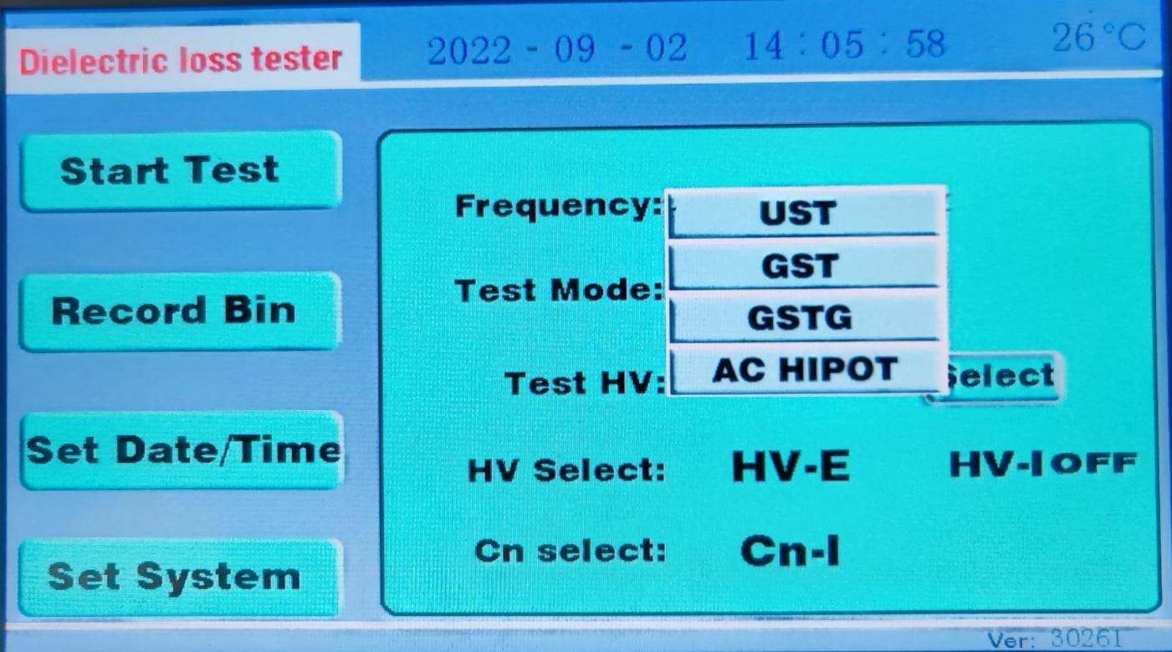
Figure 6 Mode Selection Modify Fig

All test modes are on the drop-down menu, click on the mode you want to select.
Positive wiring, reverse wiring, reverse wiring, low-voltage shielding.
High pressure selected modification, as with the modified test mode. Click "Internal high pressure" with the stylus or finger, and the internal high pressure and external high pressure in the drop-down menu will appear. Click the high pressure you want to choose.
5) The modification of the standard selection is the same as the modified test mode. Click the "internal standard" with the stylus or finger, appear in the drop-down menu internal standard, external standard, click the standard you want to choose.
4. Preparation before measurement:
1) The grounding wire is connected to the grounding column of the instrument, and the other end is reliably connected to the earth to ensure that the instrument shell is on the ground potential.
2) Positive wiring: insert the high-voltage cable plug into the back door HV socket, and clamp the big red pliers on the other end to the high-end lead of the tested product, and the small black pliers are suspended or clamped on the big red pliers. Insert the CX low voltage cable into the CX socket, the red clip on the low end of the specimen, the black clip suspended or connected to the shielding device.
3) Backwiring: insert the high voltage cable plug into the back door HV socket, clip the large red pliers at the other end to the high-end lead of the tested product, and the red small red pliers are suspended or connected to the shielding device. Cx socket not.
5. Test process:
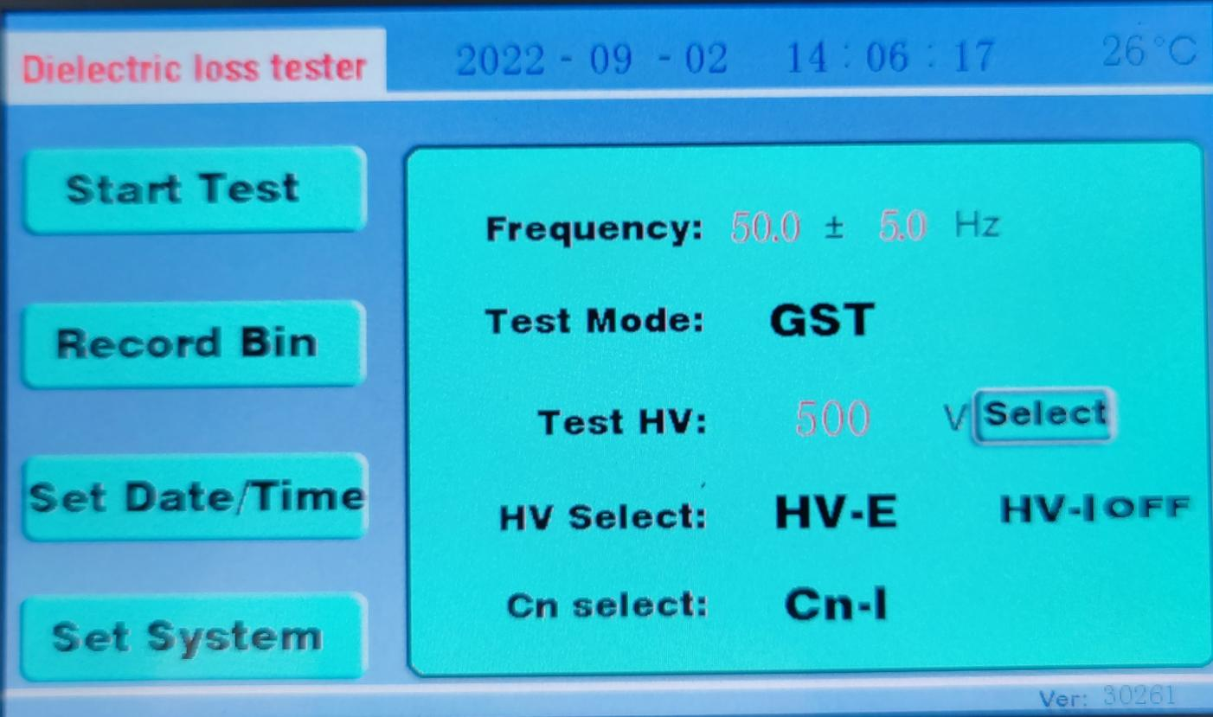Figure 7. Instrument start-up pretest interface
Select the test items, test frequency, test voltage, etc., as shown in Figure 7.
After making sure the wiring is correct, click on Start Instrument Test with a stylus or finger. The instrument begins to boost, measure,
As shown in Figure 8 and Figure 9.
The instrument adopts double frequency conversion test, Figure 8 is 55Hz test, and is 45Hz test 45Hz test.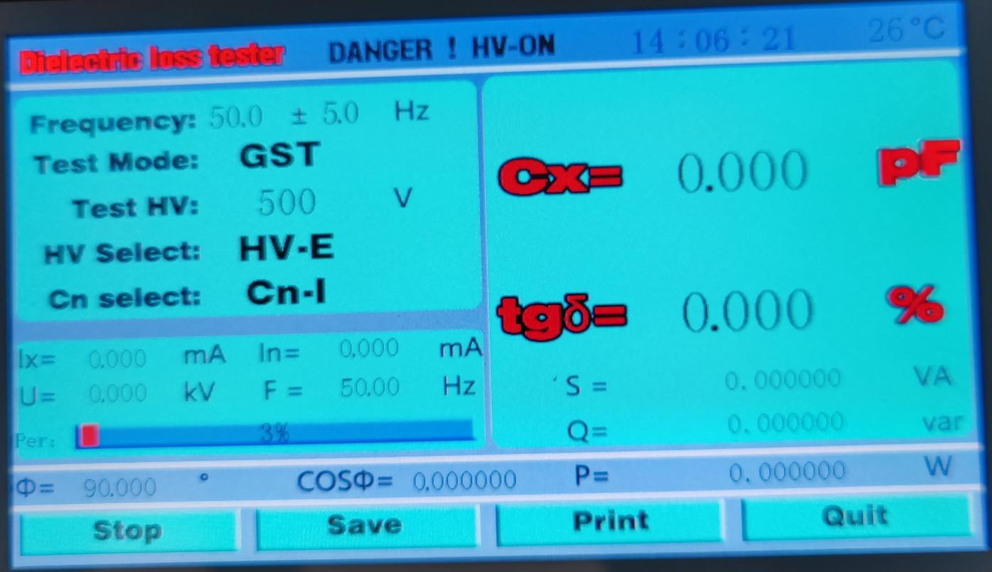
Figure 8. Instrument 55Hz test
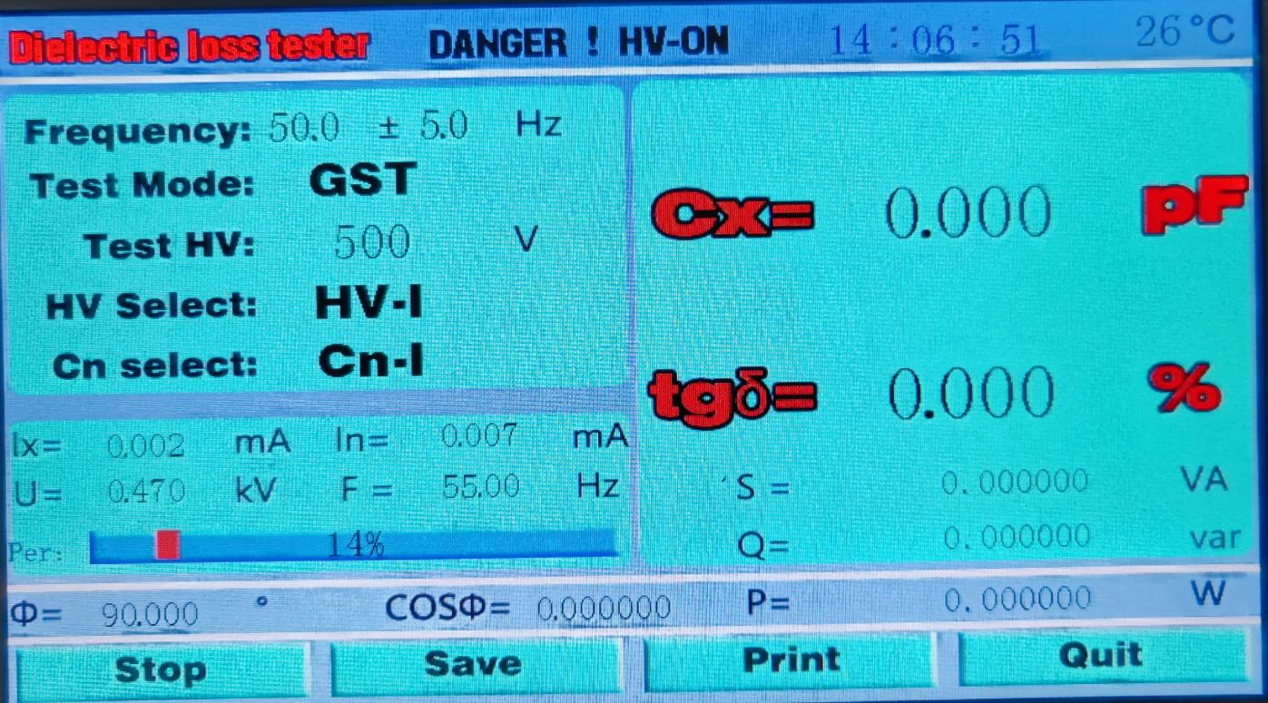
Figure 9. Instrument 45Hz test

6. Test results:
results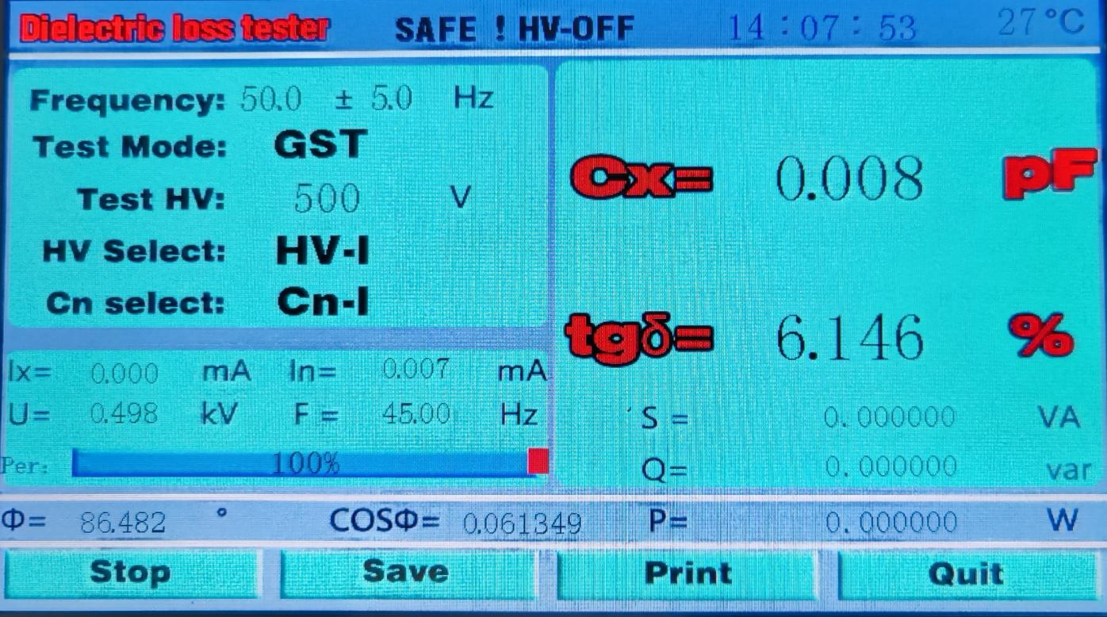Figure 10 reverse wiring test
- Test is completed, event handling
- After the test, you can store the test data. Click the "Store" button with a stylus or finger to see Figure 11
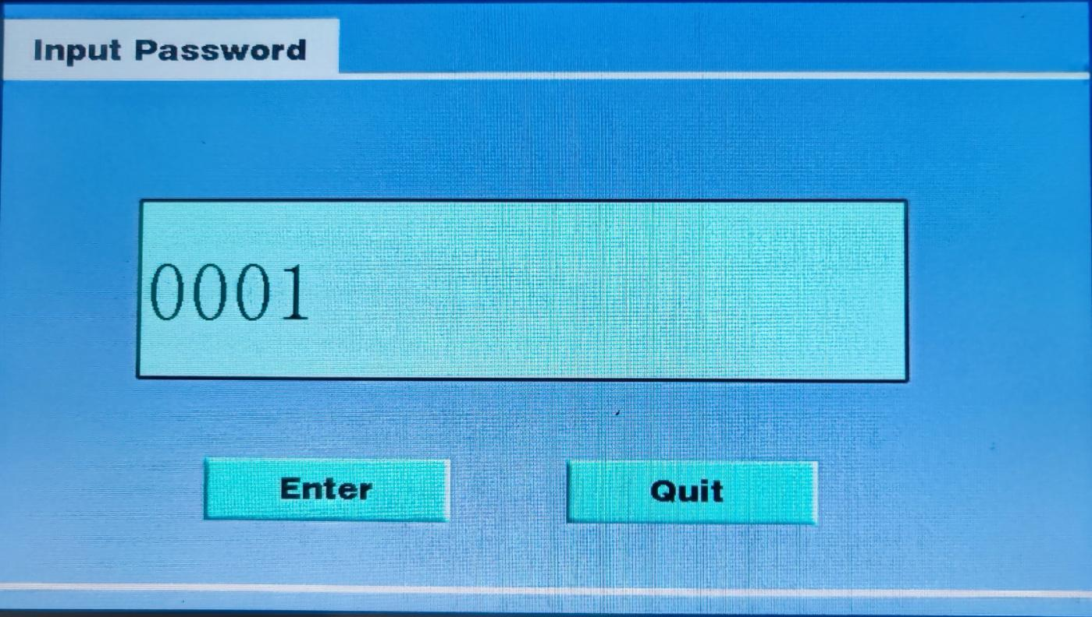
Figure 11. Data storage interface
Click the keypad on the value "1" in the data number box with a stylus or finger. Figure 12
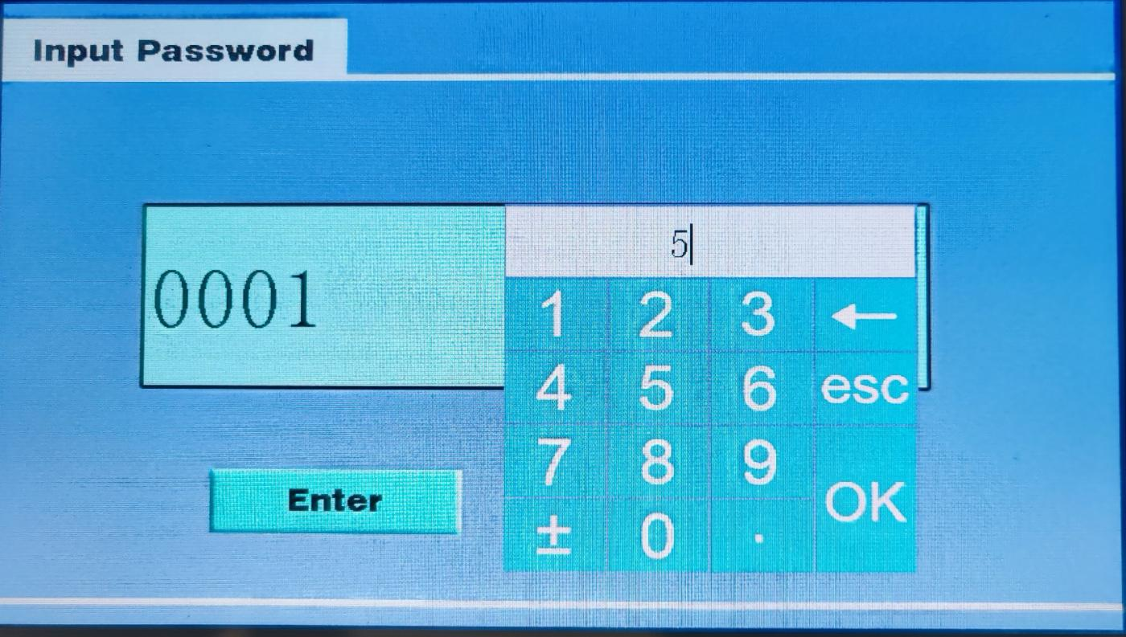
Figure 12 No. No. Data Input Interface
Enter the store number, and then press OK. Data number 5 will appear in the data number box. Press storage, the instrument will "beep" and return to the test results interface. Indicates the finished storage.
Test data printing. After the test, under the test results interface, click the "print" button with the stylus or finger to print out the test data. Figure 13 Data Print drawing
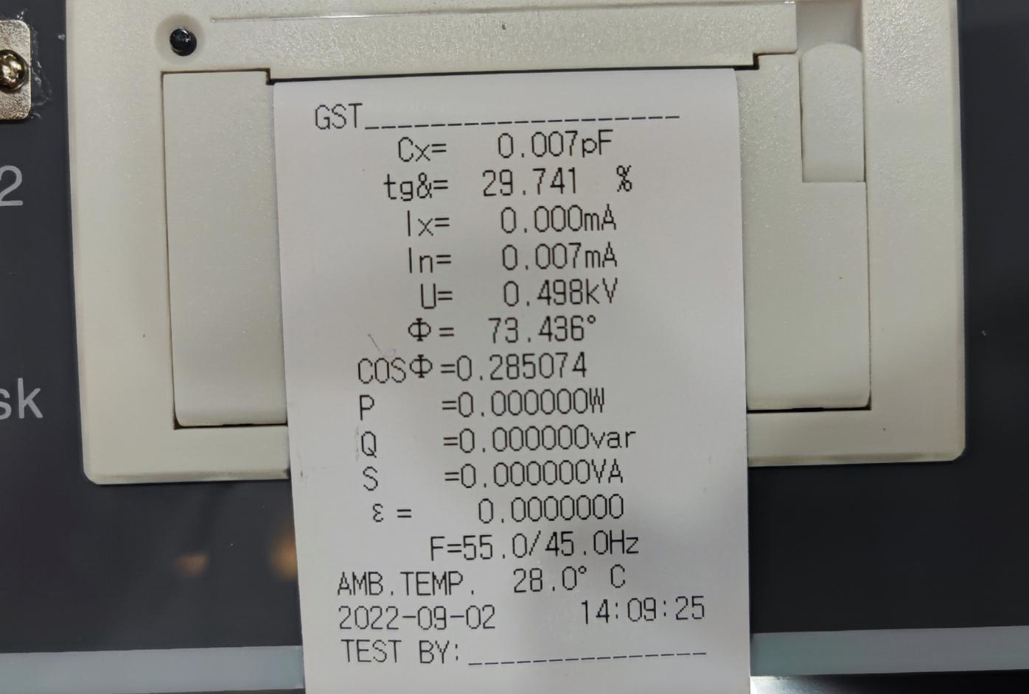

Figure 13 Data Print Drawing
3) Test. After printing data or storing data, click the "Exit" button with the stylus or finger, and the instrument will return to the beginningStart the opening interface.

IX. Notes For The Field Test
If the test data is obviously unreasonable in use, find the following reasons:
- Poor contact with the high-voltage line and the bright red clip
When using the red clip to connect the test product, the red clip must have good contact with the test product, otherwise the contact point will dischargeCan cause serious data fluctuations! Especially the drainage line oxidation layer is too thick, please scrape the skin so as to avoid bad contact。
- Poor grounding contact
Poor grounding can cause instrument protection or severe data fluctuations. Paint and rust shall be scraped to ensure 0 resistance grounding!
- Air humidity is too high
- The air humidity ambassador interdamage measurement value is abnormally increased (or reduced or even negative) and is unstable, and the shielding ring can be added if necessary.
Changing the electric field distribution of the test product, this method is controversial, so you can refer to the relevant regulations.
5Power supply by the generator
6 The output voltage of the generator is unstable and there is high pressure burr, which may cause mis380V protection startup. Several power filters can be connected in series at the output of the generator to solve this problem.
- Test line
Due to the long-term use, it is easy to cause the hidden circuit break of the test line, or the core line and the shielding short circuit, or the bad plug contact, the user should often maintain the test line;
When testing the standard capacitor test products, the fully shielded plug connection should be used to eliminate the additional miscellaneous capacitance impact, otherwise it can not reflect the accuracy of the instrument;
6. Work mode selection
After connecting the line, please choose the correct measurement working mode (positive and negative), but not the wrong one. Especially in the interference environment, the frequency conversion and anti-interference mode should be selected.

7. Impact of the test method

Because damage measurement is greatly affected by test method, it should be distinguished between test method error or instrument error. When a problem occurs, first check the wiring, and then check for the instrument failure.

8.. Instrument failure

Use the multimeter whether the test wire is open circuit, or whether the core wire and shield are short circuit; the input power 220V is too high or too low; whether the grounding is good.

Use positive and reverse wiring to test the standard capacitor or known capacity and damage capacitor test product. If the result is correct, you can judge that the instrument is no problem;

Pull off all test wires and conduct air test boost. If not working properly, the instrument may fail.

X. Frequency Conversion Measurement And Discussion
1. Frequency conversion measurement
When the interference is very serious, the frequency conversion measurement can get accurate and reliable results. For example, when measuring with 55Hz, the measurement system only allows the 55Hz signal to pass through, and the 50Hz interference signal is effectively suppressed, because the measurement system can easily distinguish between different frequencies. The effect of frequency selection measurement can be explained by the following simple calculation:
Two sine waves are superimposed together, and the high frequency is interference, 10 times the low frequency：
Y=1.234sin(x+5.678°)+12.34sin(2x+87.65°)
Four measurements were obtained at x=0 / 90 / 180 / 270 Y0=12.4517，Y1= -11.1017，Y2=12.2075，Y3= -13.5576，
Count A=Y1-Y3=2.4559，B=Y0-Y2=0.2442，or：
φ=tg-1(B/A)=5.678° V= A2+B2/2=1.234
This is just the phase and amplitude of the low-frequency part, and the interference is suppressed. The actual measurement point of the waveform is tens of thousands, and the computational amount is very large. The results reflect the overall characteristics of the waveform.
2、The relationship between frequency and impairment
There are two ideal models of RC series and parallel: series model tg =2 fRC, parallel model tg =1 / (2 fRC), and tg is proportional and inversely proportional with frequency f, respectively. As shown in Fig, f affects both models fully proportional and fully inverse. However, the actual capacitor is a mixed model of multiple models interwoven, and the influence of f is small.

tgδ Tandem model tgδ
The loss is constant
The actual test
Parallel model
f f

Low frequency loss curve (<1kHz) High frequency loss curve or low frequency circuit resonance
3. Automatic frequency conversion is equivalent to 50Hz
The instrument uses automatic frequency conversion to measure one point on each side of the interference frequency of 50Hz (45Hz and 55Hz), and then calculate the data at 50Hz frequency. Except for the low-frequency resonance of multiple component circuits, the medium in a single sample cannot cause the energy absorption peak in the low frequency, and the intermediate loss near the power frequency always changes monotonically with the frequency. Therefore, this measurement method does not bring about significant error. Actually, to average the first two
The intermediate loss value is very close, even if not average, it is completely reference value. At present, the variable frequency damage detector has become a conventional instrument of the the damage measurement, its excellent anti-interference ability and accuracy have been recognized.

XI. Container List Of Instruments
No. | Item | Qty
1 | main engine | 1
2 | High voltage cable | 1
3 | low tension cable | 2
4 | power line | 1
5 | Ground wire | 1
6 | 5A Insurance Pipe (Built in) | 2
7 | Print paper | 1
8 | Instructions | 1
9 | Factory test report | 1
10 | Certificate of qualification | 1

