HZJZ-200V
Transformer Ratio Standard
Tester

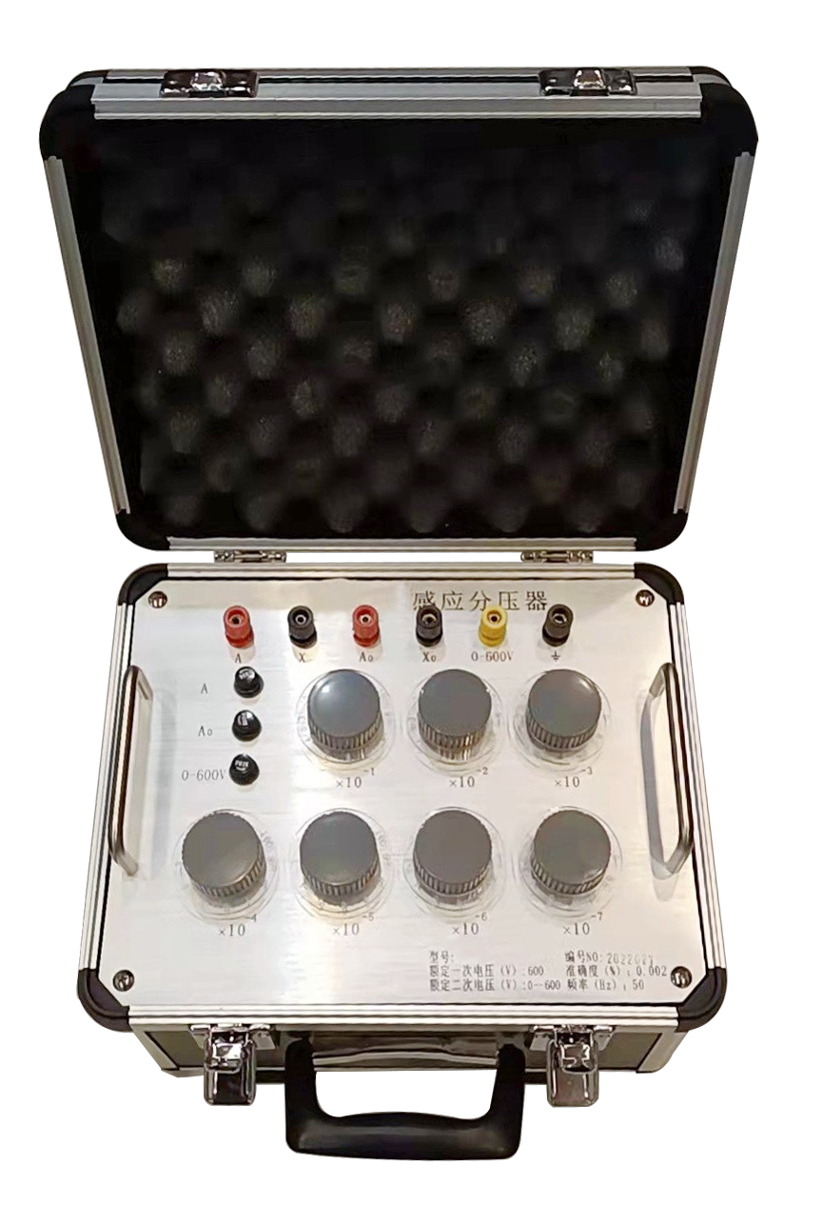

Huazheng Electric Manufacturing (Baoding) Co., Ltd

Dear user:
Thank you for choosing HZJZ-200V Transformer Ratio Standard Tester.
We hope that this instrument can make your work easier and more enjoyable, so that you can get the feeling of office automation in the test and analysis work.
Before using the instrument, please read this manual, and operate and maintain the instrument according to the manual to prolong its service life.
"Just a light press, the test will be completed automatically" is the operating characteristics of this instrument.
If you are satisfied with this instrument, please tell your colleagues; if you are not satisfied with this instrument, please call (0312) 6775656 to tell you to serve you at all times-Baoding Huazheng Electric Manufacturing Co., Ltd., our company will definitely make you satisfied !
Contents

I. Overview 1

II.Technical parameters...................................................................................................1
III. Working principle 1
IV. Operating instructions 2
V. Precautions for use 4
VI. Packing List 4

I. Overview
- HZJZ-200V transformer ratio standard tester, also known as power frequency induction voltage divider, is a ratio conversion device composed of three interconnected transformers. Through switch switching, the output voltage of the device is equal to a proportional value of the input voltage.It has the advantages of accurate voltage ratio, stability and universal ratio.In addition, the equipment also has the characteristics of high input impedance and low output impedance, which provides important performance for accurate electrical measurement. It is widely used in various measurement lines and devices such as electric power, detection, oil field, railway, school, mine energy and so on.

II.Technical Parameters
1. Environmental conditions
Temperature: 20 ± 5 ℃
Relative humidity: < 80%
Altitude: < 1000M
Interfere: No strong electromagnetic field interference source and vibration
2. Power conditions
Frequency: 50 ± 0.5Hz
Input voltage distortion coefficient is less than: 5%
3. Performance index
Primary voltage: 200V
Secondary voltage: 0 ~ 200V
Rated load: 0VA
Accuracy class: 0.002
Proportional uncertainty: 3×10-6
Weight: 10kg

III. Working Principle
The equipment is designed by using the two-stage transformer with the highest accuracy, which overcomes the disadvantage that the rear plate of parallel multi plate induction voltage divider has a great impact on the load of the front plate and the disadvantage that the series type increases an isolation error and the input impedance is not high.The schematic diagram of two-stage transformer type multi disk induction voltage divider is shown on the following pageIt can be seen from the figure that the multi disk inductive voltage divider is composed of multiple two-stage inductive voltage dividers in parallel. The 1 / 10 section of the previous stage proportional winding connects a section of voltage to both ends of the next stage proportional winding through the double pole switch, forcing the next disk to be 1 / 10 of the voltage of the previous disk.Due to the excitation winding, the next disk is divided into the front disk
- The circuit has little influence and eliminates the isolation error, so it can obtain high accuracy.
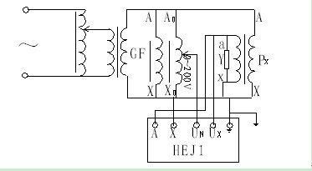
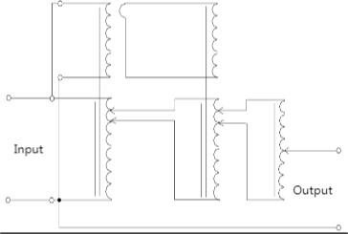.

IV. Operating Instructions
The inductive voltage divider is mainly used in two states: as a voltage divider and as a voltage proportionerThe two usage states are described below.
1.Use inductive voltage divider to calibrate voltage transformer (used as voltage divider)

When using the inductive voltage divider to calibrate the voltage transformer, connect the line according to the above figure. Generally, the standard error of the inductive voltage divider relative to the accuracy of the tested voltage transformer can be ignored. The indication value of the tested voltage transformer can be directly read out from the voltage transformer calibrator, and the error of the tested transformer can be calculated after conversion to one time.If the primary voltage of the tested voltage transformer exceeds 200V, the transformer with two accuracy levels higher than the tested voltage transformer can be used for transformation, and then the induced voltage divider can be used for voltage division to measure the error of the tested induced voltage divider.
2. Measuring circuit for voltage proportional standard
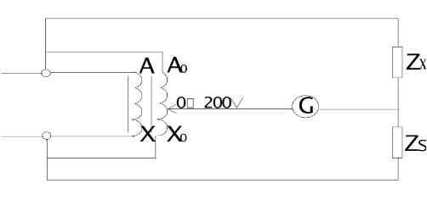
This is the line often used by the transformer ratio bridge. At this time, the voltage ratio has nothing to do with the load, so it has high accuracy.When calibrating the voltage transformer calibrator, this line can be used to obtain the in-phase component value with high accuracy, and the residual orthogonal component will be very small.

V.Precautions For Use
1.The grounding of the instrument and the cabinet shall be reliable.
2.When in use, do not switch the range under full voltage, at least lower than 100V, and then switch.
3. If the output voltage error is found to be too large, check whether the wiring is correct, whether the fuse tube has been burned out, whether the position of the indicator panel is accurate, find out the cause and take necessary measures before retesting.
4. In order to ensure the measurement accuracy, the inductive voltage divider shall not be loaded when in use.
5. The induction voltage divider is a high-precision equipment. When verifying the induction voltage divider, pay attention to the change of the environment and do not exceed the allowable range.
6. The instrument shall be protected against shock, moisture, corrosion and cleaning.

VI. Packing List
No. | Item | Qty
1 | Main engine | 1
2 | User manual | 1
3 | Calibration Certificate | 1
4 | Product certificate | 1

