HZYH93B
Automatic Lubricating Oil Oxidation Stability Tester

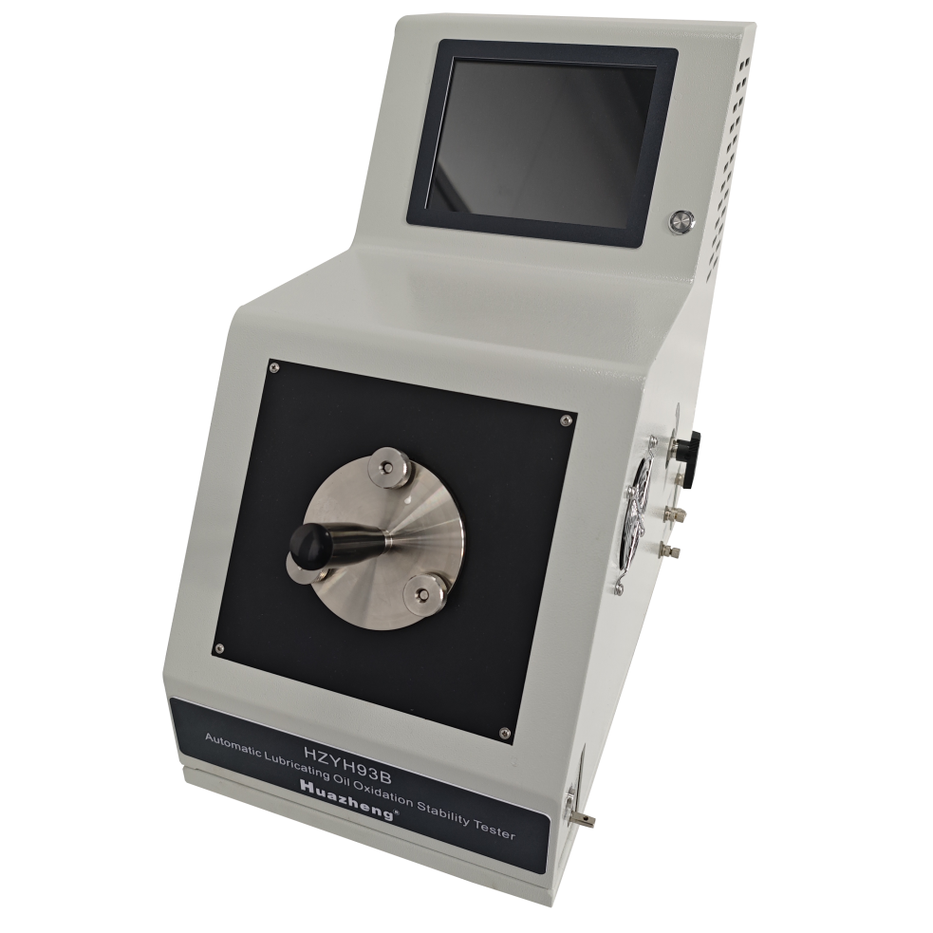

Huazheng Electric Manufacturing (Baoding) Co., Ltd

Dear user:
Thank you for choosing HZYH93B Automatic Lubricating Oil Oxidation Stability Tester.
We hope that this instrument can make your work easier and more enjoyable, so that you can get the feeling of office automation in the test and analysis work.
Before using the instrument, please read this manual, and operate and maintain the instrument according to the manual to prolong its service life.
"Just a light press, the test will be completed automatically" is the operating characteristics of this instrument.
If you are satisfied with this instrument, please tell your colleagues; if you are not satisfied with this instrument, please serve you at all time- Huazheng Electric Manufacturing Co., Ltd., our company will definitely make you satisfied !
Contents

I. Purpose And Scope 1
II. Main Technical Specification And Parameters 1
III. Instrument Structure And Characteristics 1
(I) Main characteristics 1
(II) Instrument structure 2
IV. Operation Methods 2
(I) Preparation before test 2
(II) Precautions 3
(III) Operation of the instrument 3
(IV) Operation of software 5
V. Maintenance 11
VI. Common Faults And Solutions 12
VII. Packing List 13

I. Purpose And Scope
This instrument is designed and manufactured in accordance with Method B of the American Society for Testing and Materials (ASTM) D2272-2009 "Determination of Oxidation Stability of Lubricating Oils" standard and the "NBSHT 0193-2022 Rotary Oxygen Bomb Method" standard. It is suitable for measuring the oxidation stability of oil products specified in the standard at two temperatures of 150 ℃ or 140 ℃. This instrument can be used to determine the oxidation stability of new and in-use turbine oils with the same composition (base oil and additives). (In the case of inaccurate requirements for experimental data, it can also be used to evaluate the oxidation stability of new mineral insulating oils containing 2,6-di-tert-butyl-p-cresol as a rapid evaluation method.)

II. Main Technical Specification And Parameters
- Power supply：AC(220±10%)V； 60Hz
- Total power consumption: ≤1000W
- Temperature control point of test bath: 140℃, 150℃
- Temperature control accuracy: ±0.1℃
- Pressure measurement range: (0～1.6) MPa
- Pressure measurement accuracy: ± 0.5%
- Working mode: metal bath
- Rotating speed of slewing mechanism: (100±5)r/min
- Inclined angle of oxygen bomb and water level: 30°
- Applicable environment: temperature: 15 ℃～ 28 ℃, relative humidity: ≤ 85%
- Overall dimension: 280mm×500mm×510mm（L×W×H）
- GW: about 30kg

III. Instrument Structure And Characteristics

(I) Main characteristics

1. The instrument is integrated designed, desktop structure, high integration, using a touch screen industrial computer. The instrument is equipped with an electric winding machine for making catalyst coils.

2. The metal bath design eliminates the harm of lampblack to operators and environmental pollution, and also simplifies the operation.

3. During the experiment, the glass sample bottle rotates smoothly with low noise.

4. It adopts air cooling system to shorten the time interval of continuous test.

5. It can automatically or manually adjust the pressure, facilitating the operation of oxygen charging and discharging.

6. Adopting high-precision pressure sensors and temperature sensors, the test data is stable and reliable, with temperature overheating protection function.

(II) Instrument structure

Main structure of the instrument(as shown in Fig.1)

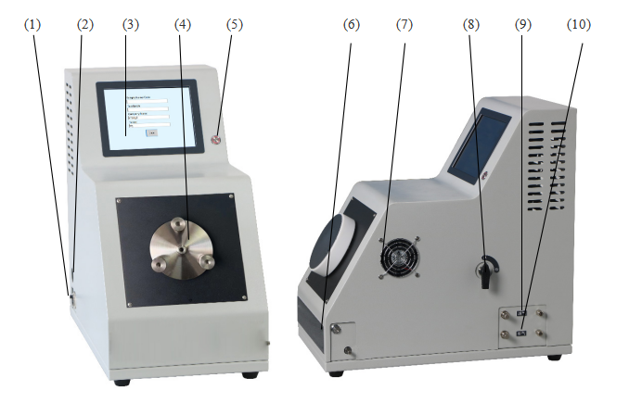
- USB interface (2) Air switch (3) Industrial controlled computer
- Heat insulation sleeve (5) Power switch (6) Winding machine working switch
(7) Cooling exhaust fan (8) Cut-off valve (9) Air inlet (10) Air outlet
Fig.1

IV. Operation Methods

(I) Preparation before test
1.This instrument is an automatic instrument, please carefully read the operation manual before using it.
2. Carefully read the corresponding test procedures, understand and be familiar with the test methods, steps, and requirements outlined in the standards.
3. Prepare various testing instruments, materials, etc. according to the requirements specified in the corresponding testing procedures.
4. Check the working status of the instrument to ensure that it meets the working environment and conditions specified in the manual.
5. The instrument may emit toxic and harmful gases, please place it in a ventilated area for use.

(II) Precautions
1. Before oxygen filling, be sure to confirm proper pressure input. If the pressure exceeds 1.6MPa or it is negative pressure, which will lead to a drift of the pressure sensor, thus will affect the test results. When the pressure exceeds 1.5MPa, the system will start the protection program.
2. In order to control the amount of micro discharge, please connect the standard oxygen discharge pipe to the instrument.
3. Do not tighten one of the three nuts on the spring cap at a time. It is better to screw each nut in by turns until all nuts are tightened, so as to avoid air leakage caused by the deflection of the spring cap. You don't need tools.
4. The magnetic holder must be gently put into the bomb hole with special pliers.

(III) Operation of the instrument
1. Pipeline connection
(1) After checking, turn on the power switch, connect the instrument to the working power, and the screen display is on and normal.
(2) Open the shut-off valve on the right side of the instrument, point it towards "open", connect the oxygen source, use the standard pipeline connector to connect the oxygen source to the intake connector on the right side of the instrument, open the oxygen source valve, adjust the pressure reducing valve to make the pressure gauge reading 800-1000KPa.
(2) Sample preparation
Pour distilled water in the barrel of the oxygen bomb. Put the prepared copper wire, sample and distilled water into the glass sample container, place the glass sample container on the spring fixing plate and clamp it tightly, gently slide the glass sample holder, along with the magnetic base and spring fixing plate, into the bullet hole. Put the Teflon cover on the mouth of the glass sample container, then cover the bomb hole cover, tighten the nuts, and finally cover the heat insulation sleeve.
(3) Test start
Click "Start Test" on the main interface, and then click on " Start" on the test interface. The instrument enters the purging stage and is oxygenated to 620kPa ± 1.4kPa, and then starts the test.
(4) Test ends
The test will end automatically, and then there will be corresponding operation prompts on the interface. Please follow the prompts. The test can also be ended manually by simply pressing the "Stop" button.
(5)Cleaning
(1) Cleaning of oxygen bomb
Clean the oxygen bomb body, cover and inside of the bomb handle with hot liquid detergent, and rinse with water. Flush the inside of the handle with isopropyl alcohol and blow it dry with clean compressed air. If the inside of the oxygen bomb body, cover and handle can still smell sour after simple cleaning, clean them with 1% potassium hydroxide alcohol solution and repeat the above steps.
(2) Cleaning of glass containers
Clean and rinse with a suitable solution (solvent oil or acetone), and then soak or brush in a water containing washing solution. Fully scrub and wash with tap water, then wash with isopropyl alcohol and distilled water, and finally dry with air. If there is insoluble matter, soak it in acid solution for one night, and repeat the steps of washing with tap water.
(3) Cleaning of Teflon cover
Remove the residual oil with a suitable solvent and rinse with a washing solution. Rinse thoroughly with tap water, then rinse with distilled water, and finally dry with air.

(IV) Operation of software
1. Press the power switch, and the instrument will display the software startup interface and main interface as shown in Fig. 2 and Fig. 3.
Note: The upper computer software needs to be installed in a space outside of the drive C. (If reinstalling, it is necessary to back up 0193B.accdb and csjd.txt in the folder and replace them after reinstallation to avoid loss of test data)
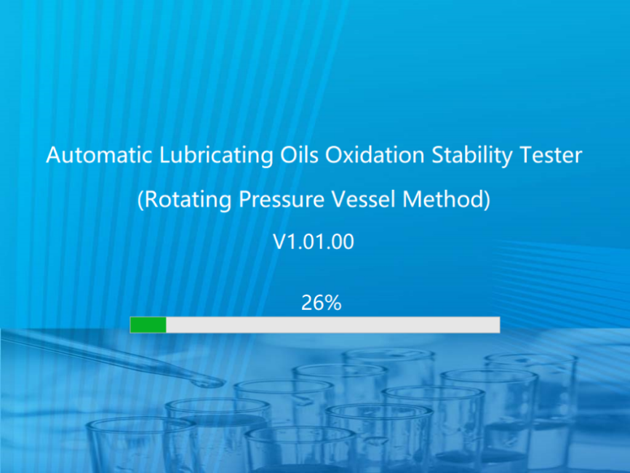
Fig.2
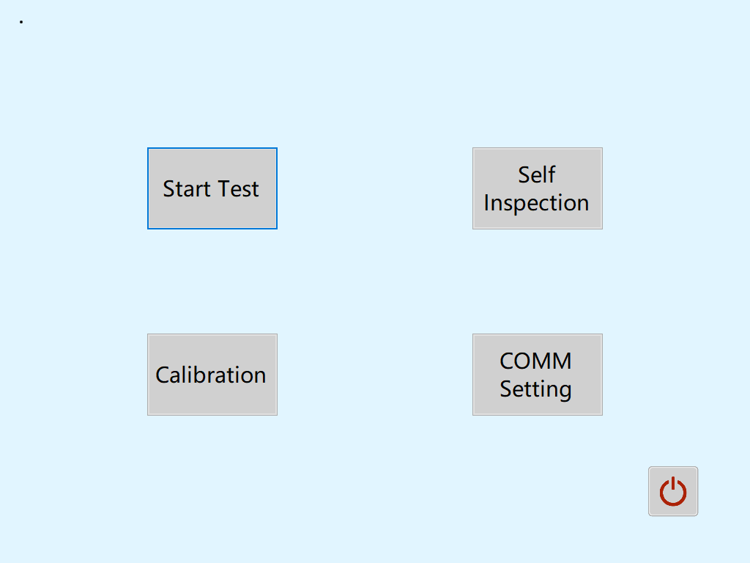
Fig.3
2. Click "COMM Settings", as shown in Fig. 4. After setting the required parameters, press "Enter" to save the parameters, and then press "Cancel" to return to the main interface. The default port is COM1, with a rate of 115200.
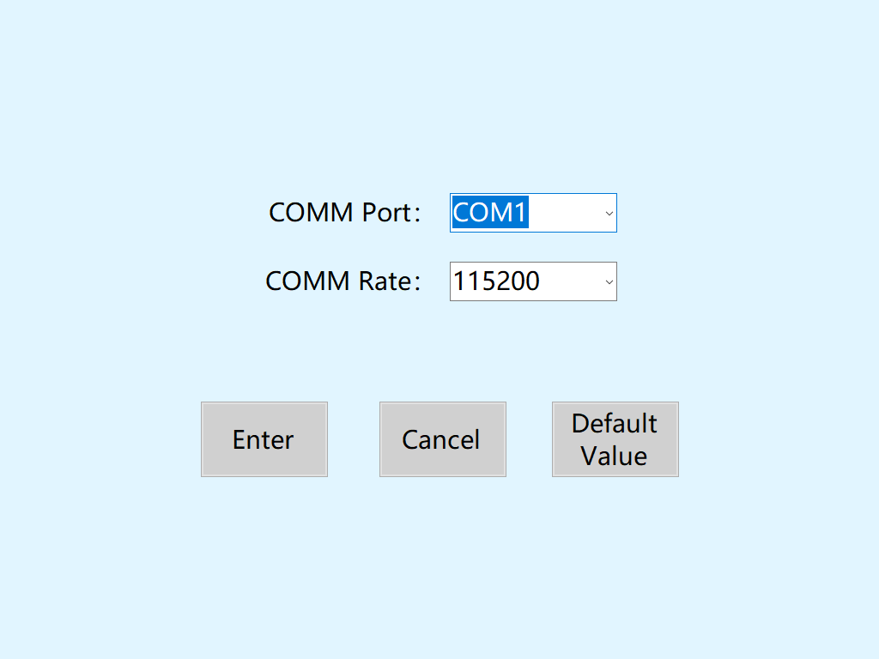
Fig.4
3. Click "Calibration" to come into the interface as shown in Fig. 5. The pressure calibration is displayed on the left side, and three values are taken for pressure calibration. By clicking on "Filling" and "Release", the reading of the pressure gauge is within the specified range. Then, fill the corresponding text box with the reading and save it. (The pressure calibration will be marked before leaving the factory, and there is no need to re mark unless it is a must.) The temperature and pressure readings are located above the right side, and the temperature correction is located below. When correcting the temperature, first click "Temp. Ctrl." and the temperature will be automatically controlled to 150 ℃. After the reading stabilizes, the correction can be made. If the reading is 150 ℃ but the thermometer shows 149.9 ℃, fill in the text box of “Temp. Correction Value” with -0.1, and then click "Save". After the correction is completed, click "Temp. Ctrl." and the instrument will automatically perform a series of operations such as cooling and oxygen release (do not exit this interface under this operation).
Note: Both pressure calibration and temperature correction should be saved after the readings, pressure gauge, and thermometer have stabilized, otherwise it may result in inaccurate readings.
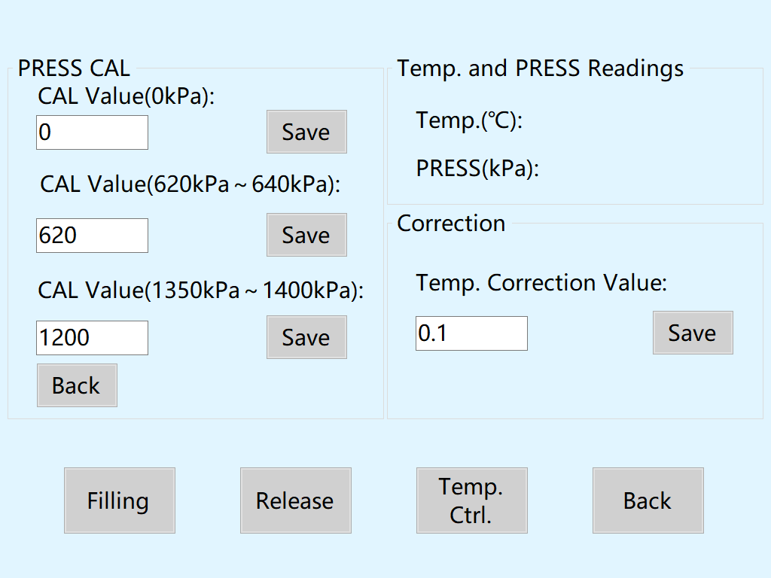
Fig.5
4. Click on "Self Inspection" to come into the interface as shown in Fig. 6. On the left side of this interface is the self calibration of the instrument functions. Click "Filling", open the oxygen filling valve for a period of time, then close the valve, and proceed with a slight filling operation. (Slight filling refers to quickly opening and closing the oxygen filling valve) Click "Release" and perform the same operation on the oxygen release valve. Click "Temp.
Ctrl.", "Stir", and "Cool" to verify the corresponding functions, and then click again to turn off the function. On the right side of this interface is the function of instrument leak test. High temperature leak test automatically pressurizes to above 620kPa and begins to control the temperature to 150 ℃. After the temperature reaches 150 ℃, timing starts. If the pressure drop exceeds 2kPa after 2 hours, it is unqualified. If the pressure drop is ≤ 2kPa within the specified time, it is qualified. After the leak test is completed, the instrument automatically cools down and deflates.
Note: Do not operate during leak testing process. Wait for the instrument to automatically perform subsequent operations and exit this interface after cooling down

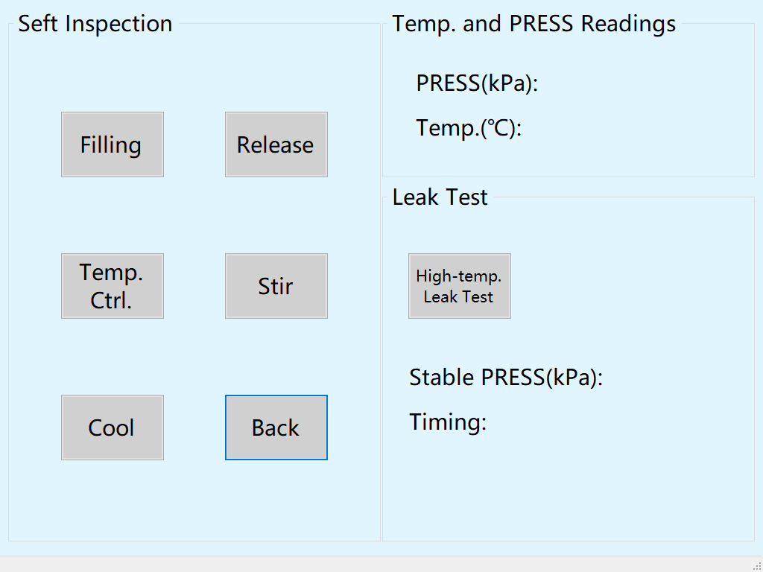
Fig.6
5. Click "Start Test" to come into the interface as shown in Fig. 7. This interface is where the test begins. Click "Setting" at the top of the interface and select "Test Temp." from the drop-down menu to choose whether the test temperature should be controlled to 150 ℃ or 140 ℃. Click on "Test Company" in the menu to come into the interface as shown in Fig. 8. Fill in the corresponding "Sample Name/Code", "Test Batch", "Company Name", and "Tester" for the test in this interface. Click "Enter" to return to the test interface in Fig. 7.
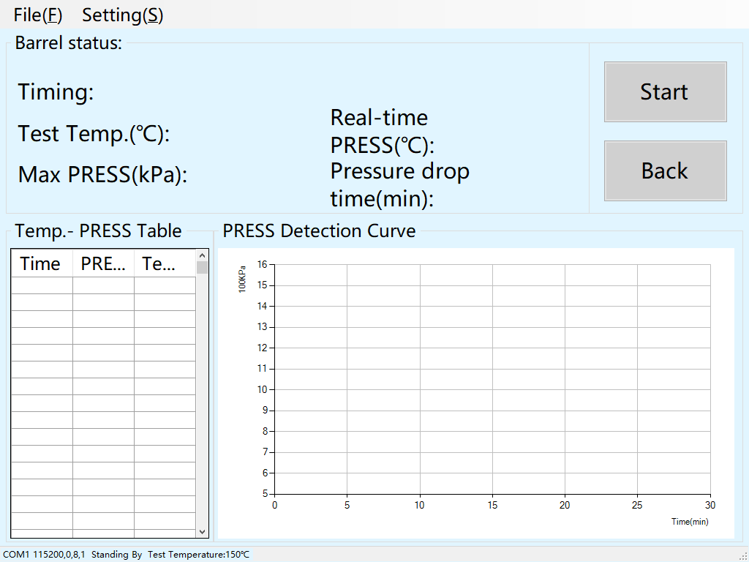
Fig.7
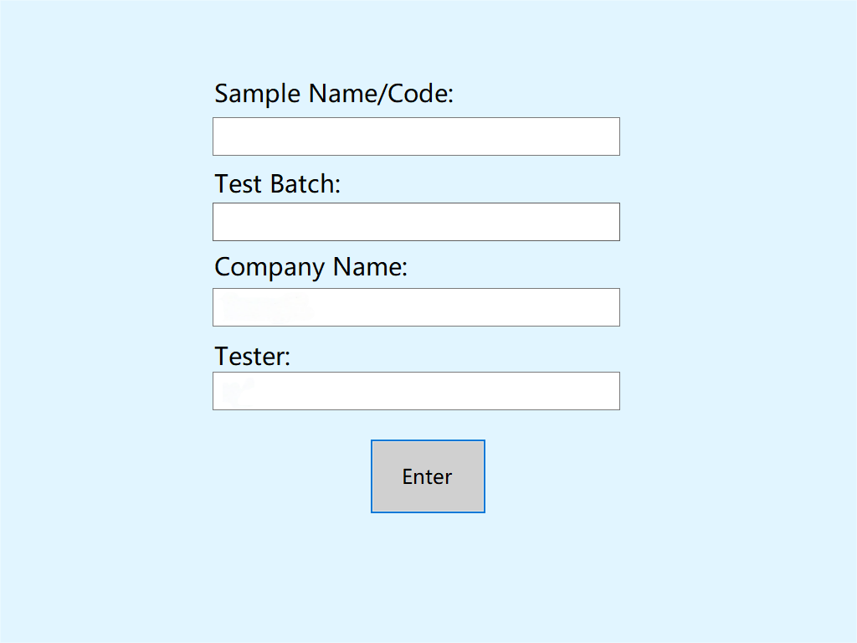
Fig.8
6. Click "Start Test" on the test interface to come into the interface as shown in Fig. 9. The instrument starts to enter the purging stage, and after the purging is completed, it automatically fills with oxygen to 620kPa ± 1.4kPa. After stabilizing, it returns to Fig. 7 and officially begins the test.
If it is found that it cannot reach 620kPa ± 1.4kPa, turn off "Automatic mode" and adjust to manual mode, as shown in Fig. 10. Manually control the pressure to above mentioned range through filling and release button. After stabilizing, click "Manual Start" to officially start the test.
The data during the test will be presented in the form of tables and curves. When the pressure drops by 175kPa from the maximum pressure, the test automatically ends and data is stored, followed by automatic cooling and oxygen release operations.
Note: Do not exit this interface during the test. Wait until the test is completed and the cooling and oxygen release operations are completed before turning off the instrument, otherwise the test may fail.
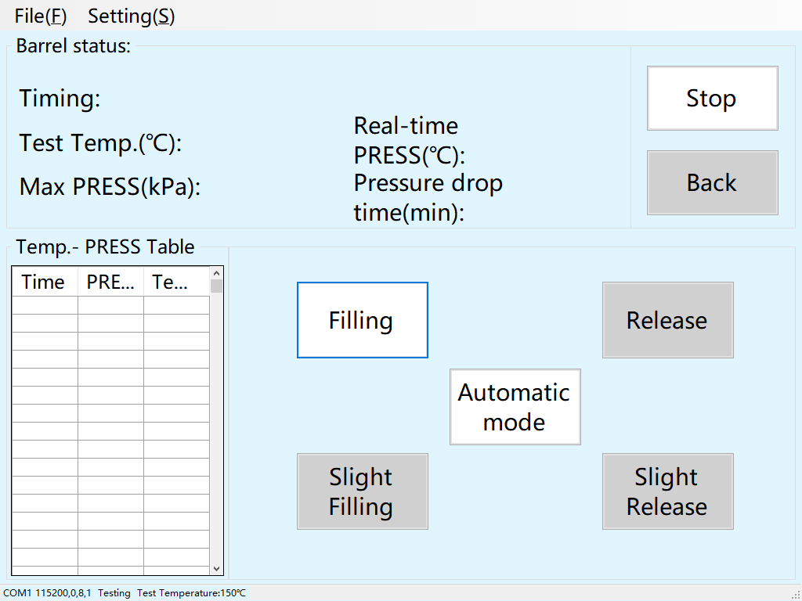
Fig.9
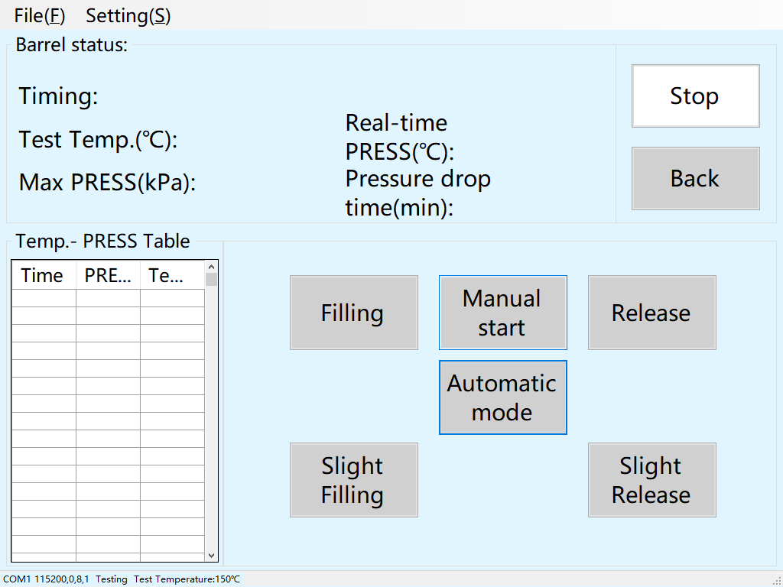
Fig.10
7. Click "File" at the top of the test interface, and click "Data Query" in the drop-down menu, as shown in Fig. 11. This interface allows you to view the data of all previous tests and screen the corresponding test data within the corresponding date based on the date above. For example, if you need to view data between August 6th, 2023 and August 10th, 2023, please fill in "20230806" and "20230810" in the text boxes above, and then click "Screen" to display the required data.
If you need to print and preview a certain file information, select the corresponding file information in the table, and then click "Print" below to print after checking. (Note: If the instrument is not connected to a printer, the "Print" button is equivalent to "Save as File". You can directly store the file in a USB flash drive and transfer it to a computer that can connect to the printer for self printing. If you have a printer, you can directly connect it to the industrial computer using USB to print.)
To delete a certain file data, select the corresponding file data in the table, and then click "Delete" below. (Note: Delete data with caution!)
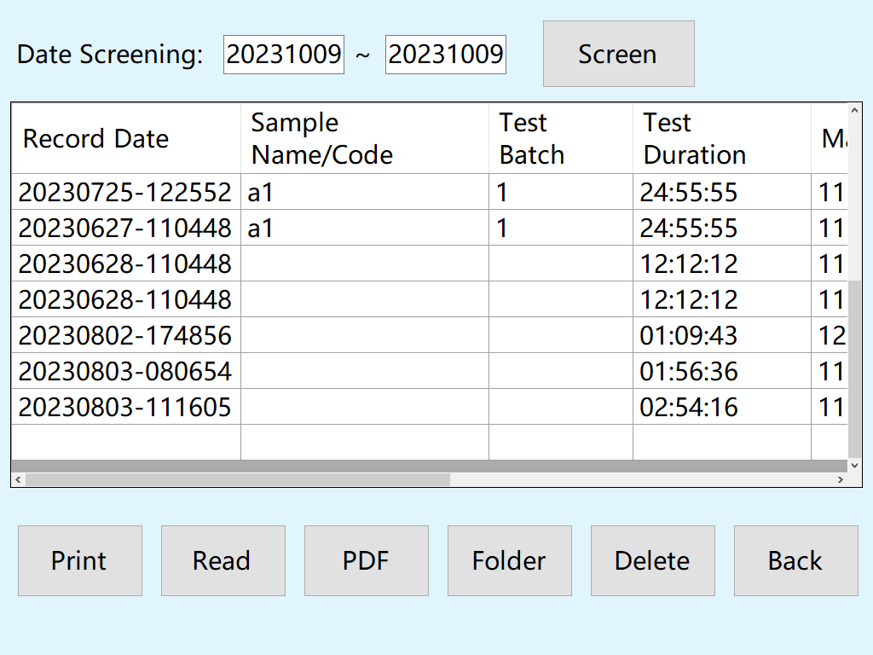
Fig.11
To visually view a certain file information, select the corresponding file information in the table, and then click "Read" below. The corresponding data can be restored in the form of tables and curves in the interface shown in Fig. 7.
Click on "Experimental Documents" to open the folder where the data is saved, where you can back up the data files to a USB drive.

V. Maintenance
1. After the test, clean the glass sample container, Teflon cover and bomb hole.
2. Clean the magnetic holder: gently take it out of the bomb hole with the special pliers for the magnetic holder, and clean it according to the cleaning steps of the Teflon cover.
3. Cleaning bomb hole: suck out the residual liquid in the bomb hole with a washing bottle. Refer to the cleaning method of the oxygen bomb, and use the special pliers for the magnetic support to clean.
4. Put the bomb hole cover back, screw on the fixing nut (there is no need to screw it to the fully closed position here, and a small amount of air leakage can be allowed), connect the clean air to the air inlet, conduct several times of oxygen filling and releasing, purge the residual oil gas and water vapor in the pipeline, and repeat the above steps to clean it. Remove the air pipe and the bomb hole cover according to the oxygen filling procedure.

VI. Common Faults And Solutions
Common faults | Causes | Solutions
The display screen does not light up | 1. The power supply circuit of the instrument's internal display screen is not connected  2. The communication line socket of the internal display screen of the instrument is not plugged properly | 1. Check and connect the power supply line of the internal display screen of the instrument  2. Check and plug the socket of the internal display screen communication line of the instrument
The test bath doesn’t heat. | 1. The solid-state relay controlling the operation of the heating tube is open circuit  2. Heater is broken | 1. Check and replace the solid-state relay  2. Check and replace the heater
Control temperature display deviation | 1. Inaccurate temperature control or temperature drift  2.Temperature sensor failure | 1. Correction through parameter calibration interface  2. Check and replace the temperature sensor
The inflation pressure of the cartridge can not meet the requirements. | 1. Cartridge leakage  2. There are air leakage points in the cartridge inflation pipeline | 1. After inflation, the cartridge is immersed in water to check whether there is air leakage. If there is, replace the seal ring  2. Check and solve the air leakage point of cartridge inflation pipeline
 | Warning | When the instrument fails, the power supply should be cut off immediately. The instrument can only be used after professional personnel repair and eliminate the failure to prevent accidents!

VII. Packing List
Item | Name | Qty
1 | Host machine | 1
2 | Flat cover | 1
3 | Hand-tightening nut | 3
4 | Thermal insulation sleeve | 1
5 | Bakelite handle | 1
6 | Spring-loaded cap seal ring(Two of them are already installed on the lid) | 10
7 | Test copper wire | 3
8 | Glass sample container | 2
9 | Polytetrafluoroethylene (PTFE) lid | 1
10 | Magnetic cup holder | 1
11 | Retrieval tongs | 1
12 | Rod-type mercury thermometer (144℃～156℃, resolution 0.2℃) | 1
13 | Rod-type mercury thermometer (120℃～150℃, resolution 0.1℃) | 1
14 | Intake tube (outer diameter φ6 PU tube, 3 meters long, with quick-connect fitting) | 1
15 | Exhaust tube (outer diameter φ6 PU tube, 3 meters long) | 1
16 | 10mL measuring cylinder | 1
17 | Winding reel | 1
18 | Wash bottle | 1
19 | Flat cover for temperature calibration (including silicone plug) | 1
20 | Flat cover for pressure calibration (equipped with quick-tightening fitting and sealing O-ring) | 1
21 | Power adapter transformer 2000W | 1

