HZWD3081-650
Dry Block Temperature Calibrator

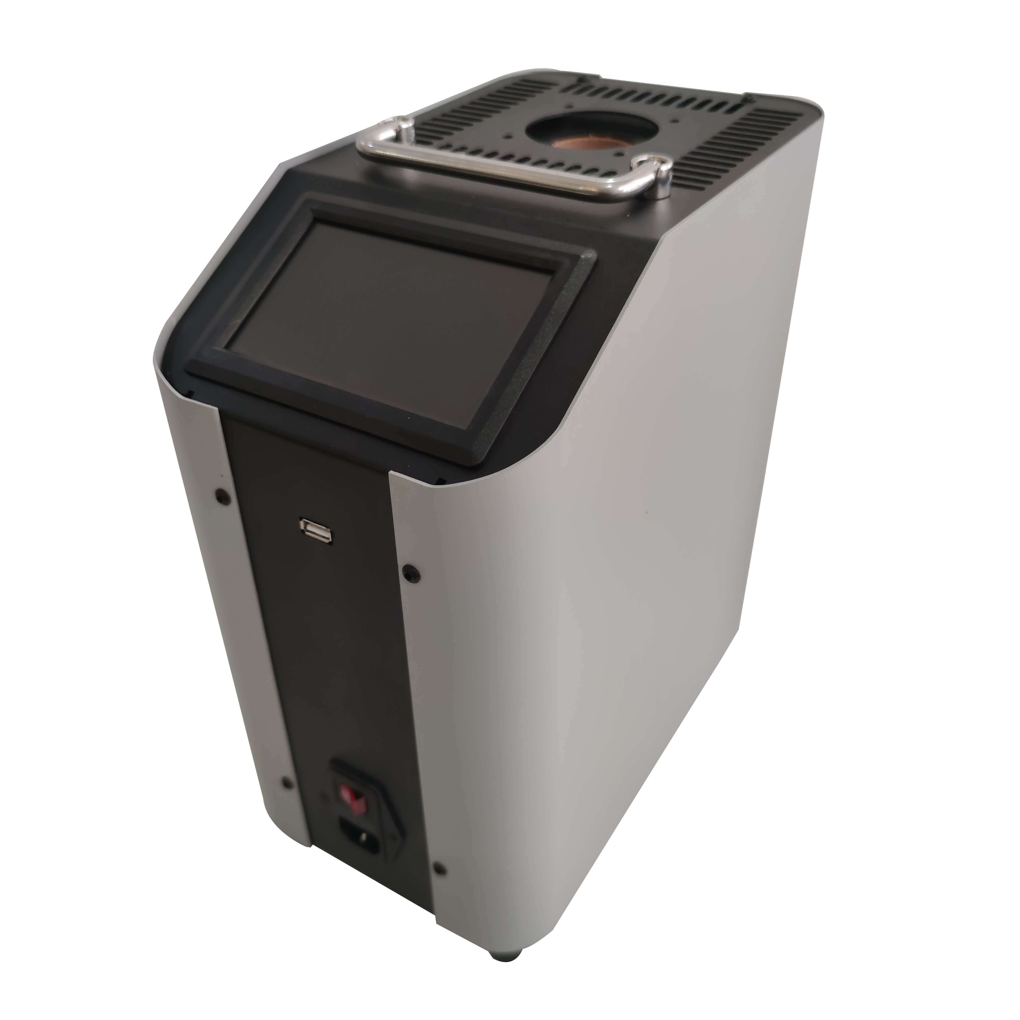

Huazheng Electric Manufacturing (Baoding) Co., Ltd

Dear user:
Thank you for choosing HZWD3081-650 Dry Block Temperature Calibrator.
We hope that this instrument can make your work easier and more enjoyable, so that you can get the feeling of office automation in the test and analysis work.
Before using the instrument, please read this manual, and operate and maintain the instrument according to the manual to prolong its service life.
"Just a light press, the test will be completed automatically" is the operating characteristics of this instrument.
If you are satisfied with this instrument, please tell your colleagues; if you are not satisfied with this instrument, please call (0312) 6775656 to tell you to serve you at all times-Baoding Huazheng Electric Manufacturing Co., Ltd., our company will definitely make you satisfied !
Contents

I. Safety Precautions 1
II. Brief Introduction 2
III. Quick Reference 3
3.1 Display Interface 3
3.2 Start Dry Block Calibrator 4
3.3 Ready to Use 5
IV. Operation Instructions 5
4.1 Menu 5
4.2 System Setting 6
4.3 Parameter Output Settings 7
4.4 Temperature Control Setting 9
4.5 Temperature Calibration Mode 10
4.6 Temperature Correction 11
4.7 File Recording 12
4.8 Temperature Control Data 14
4.9 Temperature Conversion 16
4.10 System Information 17
V. Technical Index 17
VI. General Technical Specifications 18
VII. Maintenance 18
VIII. Packing List 19

Safety Precautions

1.1 Safety information
Please use the instrument in accordance with this manual. Otherwise the protective function of the instrument may be affected. See the security information in the warning and attention sections below.
The following definitions apply to the terms "warning" and "attention."
"Warning" indicates conditions and actions that may endanger users.
"Caution" indicates conditions and actions that may damage the instrument used.

warning
To avoid personal injury, follow these guidelines.
Summary
Please do not Use this instrument for other applications other than calibration. The instrument is designed for temperature calibration. Any other use can cause unpredictable harm to users.
Please do not Place the instrument under a cabinet or other object. Space needs to be left at the top so that probes can be inserted and taken out safely and easily.
Special care should be taken when using this instrument for a long time at high temperature. No monitoring is recommended during operation at high temperature. There may be safety problems.
Do not use any other direction equipment except vertical. Tilting instruments or pulling them back may cause a fire.
Watch out for burns
Please do not Touch the thermostat with your hand while working.
Please do not Use instruments near combustible materials.
Attention should be paid when using this instrument for a long time at high temperature
In constant temperature higher than 100 ℃, the screen will display the high temperature warning icon and text. Do not remove plug-ins to avoid personal injury or fire, whether the instrument is working or not.
Do not shut down the instrument when temperature higher than 100 ℃. This can lead to dangerous situations. Choose the set point is below 100 ℃, and close the output, and let it cool before shut down the instrument.

Brief Introduction
The Dry Block Temperature Calibrator is a convenient and efficient temperature calibration instrument., which is easy to use. It can be extensively applied in machinery, chemical industry, food, medicine and other industries.
At present, there is a problem of disadvantage of slow heating and slow temperature in the field of dry type calibration furnace in China, which will take a long time for users to calibrate. The latest generation of dry well furnace is designed with the advanced heating principle in the world, which has the characteristics of fast heating, fast temperature and fast cooling, and it greatly improves the existing calibration efficiency.
With the assistance of high -precision sensor and reliable temperature control circuit, our dry block temperature calibrator provides higher precision than others in China, and its technology has reached international standard.

2.1 Main Features
- Small volume, light weight, easy to carry;
- Multiple types of inserted into the pipe and can meet different size, the number of sensor test and calibration. And can customize according to the special needs of users;
- Good level temperature filed and vertical temperature field;
- The insert depth of sensors is deeper than other manufacturers.
- 5.0 -inch TFTLCD touch-screen, 16 bit true color image, simple and intuitive to use;
- Fast cooling, easy setting, good temperature control stability;
- Soaking block can be replaced;
- With load short circuit, load circuit, sensor protection, and other functions.
- With functions of load short circuit, load cut-off circuit and sensor protection.

Quick Reference

3.1 Display Interface
Display Interface: digital display mode and graphic display mode, showed as Fig 3.1.1 and Fig 3.1.2
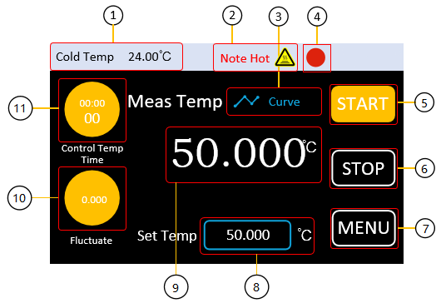
Fig 3.1.1Digital Display Mode
- Cold end Temperature: Refresh the cold end temperature of the thermocouple inside the dry furnace in real time
- High temperature warning: when the thermostat temperature is over 100 ℃， the flickering words “Note Hot” and warning icon will be displayed.
- Real-time graph:digital display mode can be switched to real- time graph mode.
- Main output indicator light: indicates whether the heating module is working or not, gray means not working, red means working;
- Start button: start instrument.
- Stop button: when the instrument is working(heating), press it and stop working.
- Menu button: enter into menu interface.
- Temperature setting: enter into temperature setting interface, setting range: 35～650
- Temperature measurement: Real-time refresh the measured temperature of the thermocouple inside the dry body furnace, that is, the inner field temperature of the dry body furnace;
- Temperature fluctuation: refresh the measured temperature difference between the maximum and minimum in a period of time in real time;
- Temperature control time: the time consumed in the current temperature control process is updated in real time from the start heating to the end of heating.
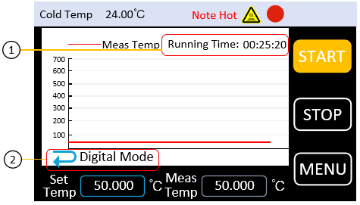
Fig 3.1.2 Graph Display Mode
A complete graph can show a maximum of 600 temperature points which is refreshing with frequency of 3 seconds/ time. Full screen curve will be a scrolling display.
- Running time: refresh the time period from starting the furnace in a real time.
- Digital Display Mode: switch from the graph display mode to digital display mode

3.2 Start Dry Block Calibrator
- Connect AC power
Use the power cord provided in the attachment to connect the dry furnace to the 220V ac power supply.
- Turn on switch
Turn on the front power switch
3.If the equipment is not starting successfully, please check according to the following steps:
- check whether the power line is in well connection
- if the instrument does not start still after checking, please check whether the power fuse has been fused, if necessary,Please replace the fuse.
- if the instrument does not work after the above inspection, please contact the relevant department.

3.3 Ready to Use
Follow these steps to quickly use:
- Set the target temperature
As shown in figure 3.1.1, click the setting temperature input box under the main interface, pop up the temperature window, enter the target temperature, click "confirm" button, return to the main interface, and the temperature setting is successful.
- Start heating
Click 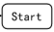 to run the instrument . The button color will turn to orange and the output indicator light will flash at a specific time interval.
- Stop working
Click to stop working.

Operation Instructions
Menu Structure:
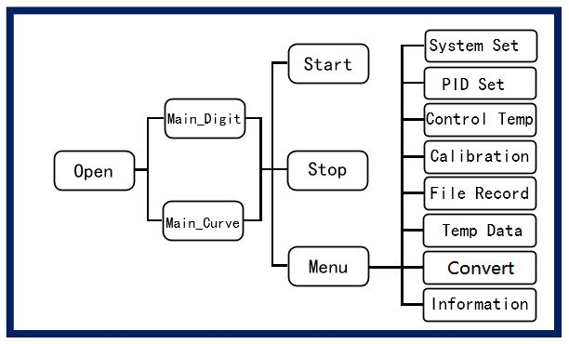
Fig 4.1 Menu Structure

4.1 Menu
The menu interface is mainly divided into 8 functional modules, which are system setting, output parameter setting, temperature control setting, temperature correction, file recording, temperature control data, convert, system information, showed as Fig4.2

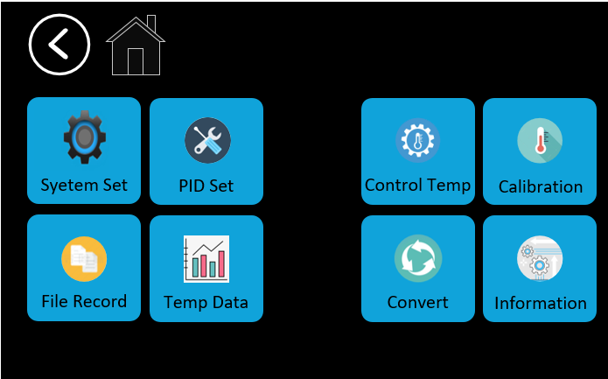
Fig 4.2 Menu Interface

4.2 System Setting
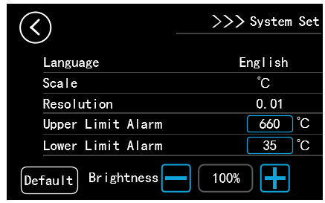
Fig 4.3 System Setting Interface
System Settings: general setting items, including Language, Scale, Resolution rate, Brightness, Temperature Upper and Lower Limit Alarm,showed as Fig 4.3.
Click , will restore the system settings to factory settings.
- Language Setting

Support Chinese and English for option. Click the corresponding area on the screen to set.
- Scale setting

Support degrees Celsius ℃ and Fahrenheit ℉ two system scales. Click the corresponding area on the screen to set.
- Resolution Rate Setting

Support 0.01 and 0.001 resolution rate for options. Click the corresponding area on the screen to set.
- Upper Limit Alarm

Used to set alarm upper limit. When the output is turned on, if the temperature of the thermostat block exceeds the alarm upper limit, the system will pop up the temperature

alarm window, the buzzer will beep, and the output will be forcibly closed. The setting range is 35℃~660℃, and cannot be upper than the upper limit alarm .
5. Lower Limit Alarm
Used to set alarm lower limit. When the output is turned on, if the temperature of the thermostat block is below the alarm lower limit, the system will give a warning information. The setting range is35℃~660℃, and cannot be lower than the lower alarm limit.
6.Brightness setting
Percentage value setting, a total of 5 stalls, respectively 20%, 40%, 60%, 80%, 100%, click the "+/-" button to adjust the brightness .

4.3 Parameter Output Settings
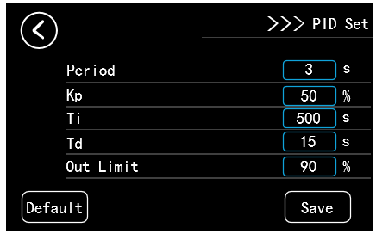
Fig 4.4 Parameter Output Setting
Parameter Output Setting: In the process of heating and cooling, PID control is adopted to control the temperature field of dry body furnace. On this screen, users can customize PID output parameters to meet the on-site requirements. Before delivery, the system presets a set of PID parameters made by manufacturer, as shown in Figure 4.4.
Press the  button to restore PID output parameters to factory defaults.

1. PID cycle setting
The adjustment operation period of the meter, is in seconds, ranges from 1 to100.The preset value is 3. This parameter has a great influence on the quality,of regulation, and an appropriate value can solve the overshoot and oscillation phenomenon perfectly, and obtain a better response speed. We suggest modify the value based on the preset value.

2.PID proportional coefficient setting
The proportional coefficient P in PID, in %, ranges from 1 to 9999. The preset value is 50. The scale factor determines the size of the scale band. The smaller the proportional band is, the stronger the regulating effect is (equivalent to increasing the amplification coefficient); On the contrary, the larger the proportion band, the weaker the regulating effect. You are advised to change the value based on the preset value.

3.PID integral time setting
PID integral time I, unit: s, set range: 1~9999, system preset is 500. Integration time determines the intensity of integration. If the integration time is short, the integration effect is strong and the time to eliminate the static difference is short. However, if the integration time is too strong, the oscillation may occur when the temperature is stable. On the contrary, the integration effect is weak when the integration time is long, but it takes a long time to eliminate the static difference. We suggest modify the value based on the preset value.

4.PID differential time setting
PID integral time D, unit: s, set range: 1~9999, system preset is 15. Differential time determines the intensity of differential action. The longer differential timei is, the stronger differential effect is. Being sensitive to temperature change, it can reduce temperature overshoot. However too strong differential effect may increase the temperature oscillation amplitude and lengthen the stability time.

5.Power limit
The unit is %. The setting range is from 1 to 100. The system preset value is 90. A larger value indicates a higher output power and faster heating rate, which may adversely affect the service lifetime of the heating module.
Note: click the  button after setting, the setting value will be saved, otherwise it will be failed actions.

4.4 Temperature Control Setting
Temperature control setting: Used to determine whether the temperature control reaches the stable state. As shown in Figure 4.5, taking the parameters in the figure as an example, when the measured temperature reaches to setting temperature point within the deviation of ±0.50℃ and the fluctuation is less than or equal to ±0.05℃ for 3 minutes, the system will determine that the temperature control is stable. At this moment, the users can collect the measured data of the sensor under inspection.
When the system determines that the temperature is stable, the buzzer rings, and the words "PV" on the main interface will be displayed in green.
Users can also modify the temperature control parameters based on their own requirements. The smaller the temperature fluctuation and target deviation are, the larger the stability time is, the more stringent the conditions for determining the temperature control stability are, and the longer the time is needed to achieve the stability. We suggest modify the parameters based on the preset value.
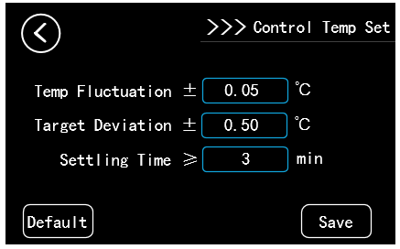
Fig 4.5 System System Interface

1.Temperature Fluctuation
The measured temperature difference between the maximum and minimum within a period, is used to reflect the stability of the measurement temperature.

2.Target Deviation
The difference between the measured temperature and the set temperature reflects the deviation between the measured temperature and the target temperature.

3. Stability time
Time duration of temperature measurement between the defined temperature fluctuation and target deviation.
Note: click  button after setting, the setting value will be saved, otherwise it will be faild actions.
Note: The temperature stability criteria of the system are for reference only.

4.5 Temperature Calibration Mode
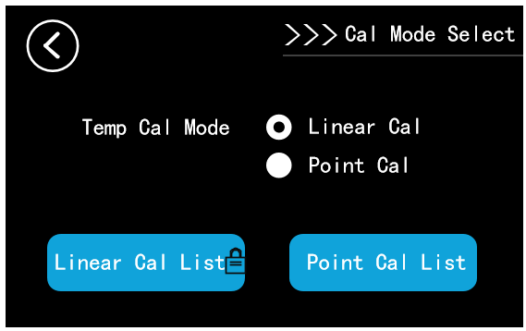
Fig 4.6 Temp Correction Mode
Temperature calibration selection: used to select temperature correction mode, including linear correction mode and point correction mode, as shown in Figure 4.6.

1. Liner Calibration
Linear correction ensures the accuracy and reliability of the data in the whole range by establishing multiple linear equation in two unknowns using calibration data. For example: already correct the point 300 ℃ and 400℃ in this mode, all temperature points between 300℃ and 400℃ are corrected.

2. Point Calibration
The point correction only corrects the error of the fixed set temperature point. The set value and correction value in the "fixed point correction table" can be changed. For example, if temperature points 300℃ and 400℃ are corrected in this mode, only two temperature points 300℃ and 400℃ are corrected, and other temperature points between 300℃ and 400℃ are not corrected.

4.6 Temperature Correction
Temperature correction: Used to correct the measured temperature value. When the temperature measurement accuracy of the main interface is poor, users can use the temperature correction interface to correct it. In the interface of temperature correction mode, press the key of "" or "" to enter the interface of temperature correction, as shown in FIG. 4.7 and 4.8.
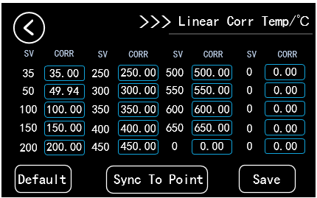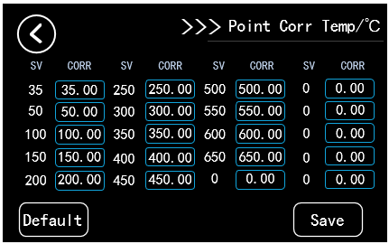
Fig 4.7Temp Liner Cor Interface Fig4.8Temp Point Cor Interface
The system provides 20 temperature points. When there is an error between the measured temperature and the real temperature, modify the correction value to correct the current measured temperature value.
Principle of modification: the user needs to provide a reference standard temperature sensor. When the temperature control reaches stability, the difference between the measured temperature of the dry body furnace and the real temperature measured by the standard sensor is added on the basis of the original modified value corresponding to the set value. For example, the temperature of the dry furnace is set at 50℃, and when the temperature control reaches stability, the measured temperature on the main interface of the dry furnace is displayed as 49.97℃, and the real temperature measured by the standard sensor is 50.03℃, so the difference between the two is -0.06℃. In the correction interface, the correction value in the blue box corresponding to the set value of 50℃ is currently 50.00℃, which is changed to 49.94℃. it means modify to , and click ..Then return to the main interface and wait for the temperature control to stabilize again. If the temperature measurement accuracy is still not ideal, it can be repaired again with the same method on the basis of the correction value of 59.94℃ until the correction of temperature point 50℃ is completed.
Restore default: Added the option to restore the temperature value to the factory value state and restore it to the uncalibrated state, as shown in Figure 4.9. If modifying the temperature value by misoperation, users can restore the temperature value to the factory default value. If "c" has no effect, modify any temperature value and try again.
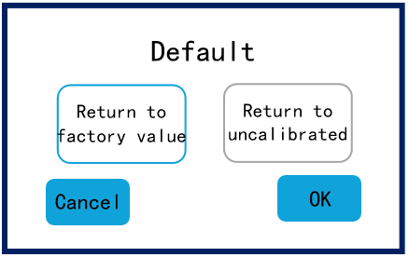
Fig 4.9 Restore Default Interface
Note: click the button after setting, the setting value will be saved, otherwise it will be failed actions.

4.7 File Recording
File recording list: File directory. A total of 10 data files can be saved. On the file list page, the name of each file, the time and date of the last file modification are displayed. If the file is empty, nothing is displayed. See Figure 4.10.
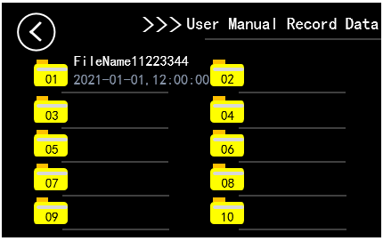
Fig 4.10 File Recording List Interface
File recording: Provides users with the function of manually recording and saving data, as shown in Figure 4.11.
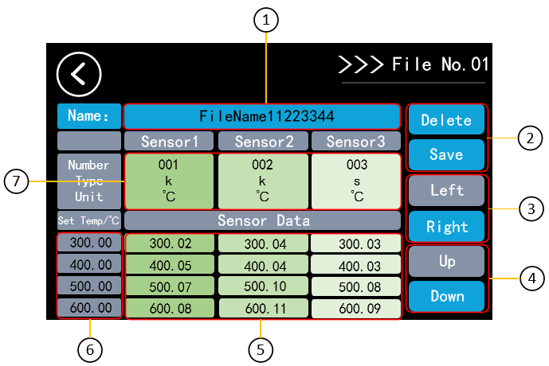
Fig 4.11 Files Record Interface
- File name: a maximum of 16 Characters (one Chinese character equals two English characters). The file name will be displayed in the file record list at the same time. The file name must be entered, otherwise save action is invalid;
- Delete and save: delete or save all input information in the file;
- Left and right page turning: a file can save up to 6 sensor information, turn the right page will display sensor 4 sensor 5, sensor 6;
- Up and down page turning: a sensor can save up to 10 temperature setting and measurement data;
- Sensor measurement data: click the corresponding area input;
- Sensor setting temperature: click the corresponding area input;

Sensor property editing: Click this area to enter the sensor property editing interface, including editing number, indexing number and data unit, as shown in Figure 4.12.
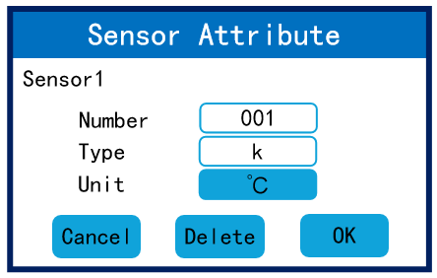
Fig 4.12 Sensor Property Editing
- Number: a maximum of 4 English characters, click the corresponding area to input;
- Indexing sign: a maximum of 8 English characters, click the corresponding area to input;
- Data units: including ℃ to ℉, Ω , mV to ℉.
- Delete: Deletes all information about the current sensor.

4.8 Temperature Control Data
Temperature control file list: file directory. A total of 50 data files can be saved. The name , data, time of each file are displayed in the temperature control file list. If the file is empty, nothing is displayed. See Figure 4.13.

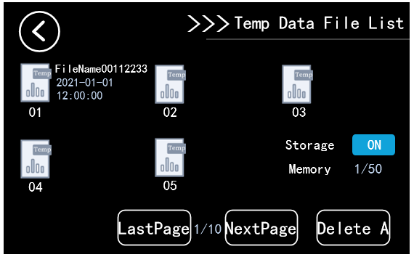
4.13 Temp Control List Interface
- Storage function: When the storage function is enabled, the system will pop up a dialog box whether to store temperature control data every time the heating operation is started. If storage is enabled, temperature control data is stored at a frequency of 3 seconds per time. If the storage function is disabled, no prompt is displayed (the configuration cannot be changed during the temperature control process).
- up and down page turning: you can view the first five or the last five temperature control data files;
- Delete all: Press the "" button to delete all 50 temperature control data files at a time. It takes a long time, please wait patiently.
Temperature control file: Displays the file name, file number, date and time,temperature setting, number of temperature points, total temperature control time, and time when the temperature control reaches stability. If the file is empty, nothing is displayed. See Figure 4.14.
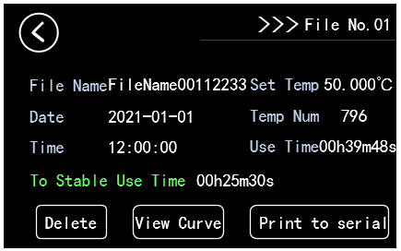
Fig 4.14 Temperature Control Files
- Delete files: Deletes one current file. Other files are not affected. Empty files will give no response when clicking.
- Graph viewing: File for empty point press no response; The date of temperature control in the files is displayed as curve graph, that is, historical curves, as shown in Figure4.15. Empty files will give no response when clicking.

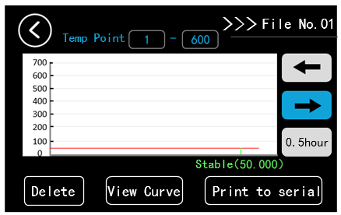
Fig 4.15 Viewing Curve Graph
In this interface, a graph screen can display a maximum of 600 temperature control data. Based on the storage frequency of temperature control data of 3 seconds per time, a graph screen takes 0.5 hours. Users can view the following temperature control data by turning to the right.
When temperature control reaches stability, the current measured temperature will be displayed in green as shown in Fig 4.15
- Print to the serial port: Send all the information in the temperature control data file to the serial port tool. Connect the USB communication interface of the dry body furnace to the PC, and the effect is shown in Figure 4.16. Empty files will have no response when clicking.(USB communication Function is optional with extra charge, please contact manufacturer if necessary)
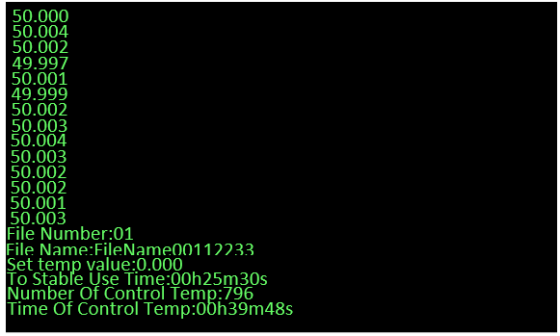
Fig 4.16 Serial Port Interface

4.9 Temperature Conversion
Temperature Conversion: It is used to convert the relationship between electrical parameters, Celsius, Kelvin and Fahrenheit about different temperature sensor types.
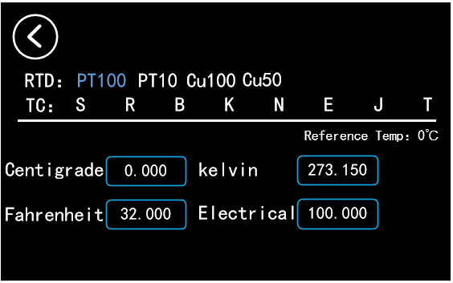
Fig 4.17 Temperature Conversion Interface
The temperature sensor type at the top of interface can be selected arbitrarily. If the data in any input box is changed, the data in other input boxes will be converted automatically.

4.10 System Information
System information: display the basic information of dry furnace, including serial number, software version number, file function and communication function, as shown in Figure 4.18.
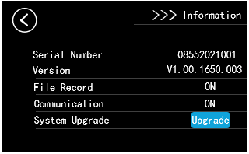
Fig 4.18 System Information Interface

Technical Index
Note: This technical index shall be effective under the environment of 23±5℃ and the product shall be stable for 10 minutes after reaching the set temperature:
● Temperature range：50-650℃，122-1202℉；
● Resolution rate：0.01 or 0.001℃；
● Scale unit：℃、℉；
● Display Accuracy：Temperature stability：≤400℃：≤±0.35℃；
400℃~650℃：≤±0.5℃；
● Temperature stability: 0-650℃：±0.05℃；
● Vertical temperature field0-650℃ ：The deviation in the range of 30mm calculated from the bottom of the hole of the soaking block is 1℃
● Horizontal Temperature Field：55-650℃：±0.05℃；
● Insert Depth：150mm；
● Heating Speed：50℃~300℃：7mins（15mins for stability），50℃~650℃：30mins（40mins for stability）；
● Cooling Speed：650℃~50℃：235mins；
● Communication Port：USB Device（optional ）

General Technical Specifications
● Environment temperature ranges：0~50℃（32-122℉）；
● Environmental humidity ranges：0%-90%（No condensation）；
● Dimension：250mm×150mm×310mm（L×W×H）
● Net Weight：11kg；
● Working voltage：220V.AC±10%,Optional 110V.AC±10%，45-65Hz；
● Power：1200W。

Maintenance

1.General maintenance
1） the instrument should be rectified for 1 year or so, so as to ensure the indicator of the instrument meets the requirements.

2. Replace fuse tube
The fuse tube is installed under the power socket switch.
Specification of fuse tube:
20A L 250V the type of fuse Φ5x20mm
Operation steps:
- Turn off the power and unplug the power cord.
- Find the location of the fuse and remove the blown fuse according to the device.
- Replace the new fuse tube and reload it.

Packing List
No. | Item | Qty
1 | Main engine | 1
2 | Instrument aluminum alloy box | 1
3 | Equal heat block | 1
4 | Power line | 1
5 | Operating manual | 1
6 | Qualification certificate, | 1
7 | Warranty card | 1

