HZ-1000XS
Fluorescence Sulfur Analyzer

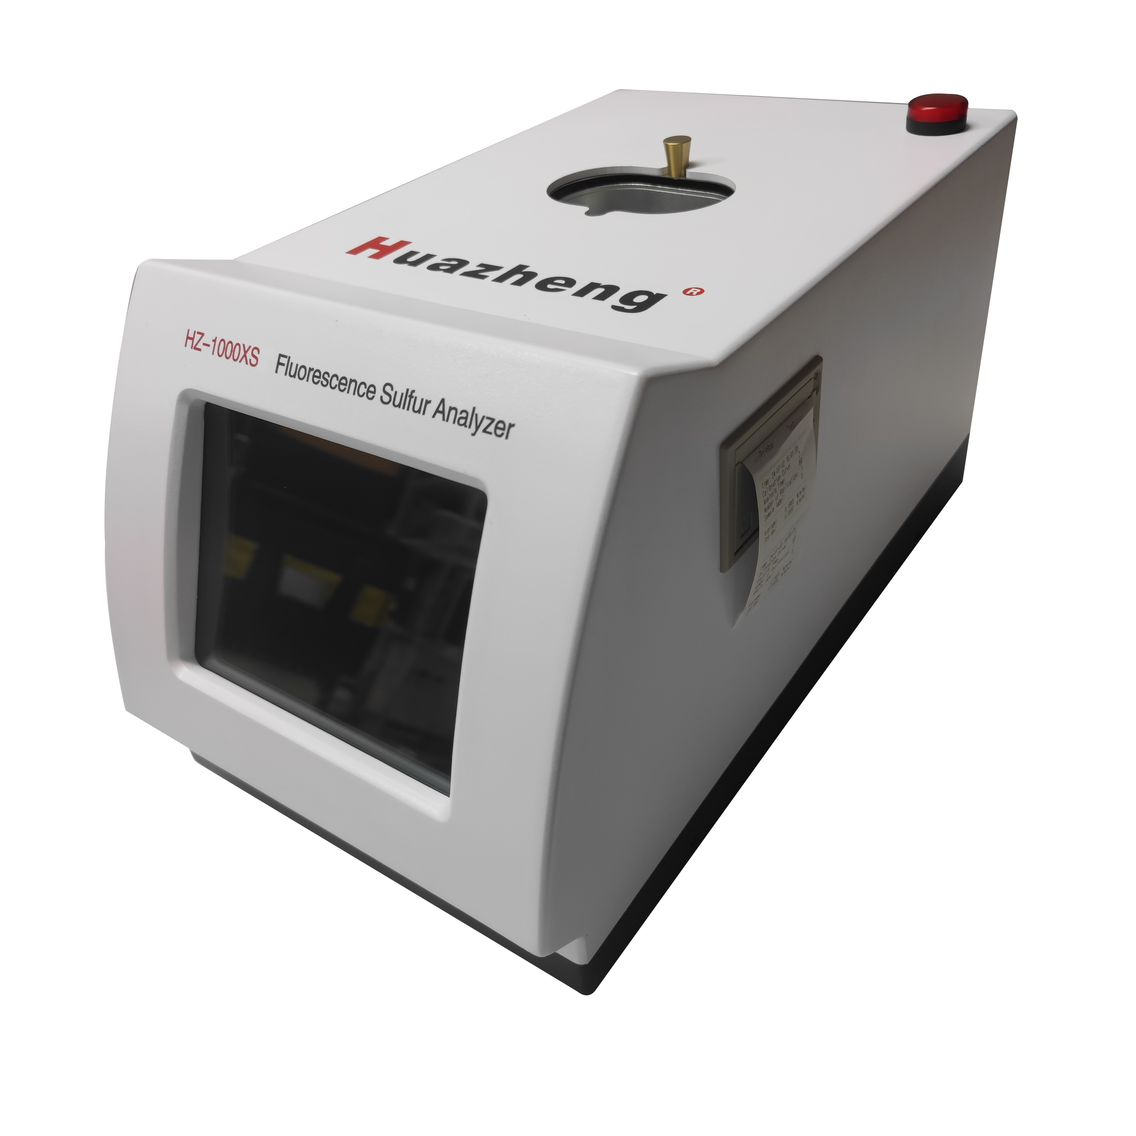

Huazheng Electric Manufacturing (Baoding) Co., Ltd

Dear user:
Thank you for choosing HZ-1000XS Fluorescence Sulfur Analyzer. We hope that this instrument can make your work easier and more enjoyable, so that you can get the feeling of office automation in the test and analysis work.
Before using the instrument, please read this manual, and operate and maintain the instrument according to the manual to prolong its service life.
"Just a light press, the test will be completed automatically" is the operating characteristics of this instrument.
If you are satisfied with this instrument, please tell your colleagues; if you are not satisfied with this instrument, please call (0312) 6775656 to tell you to serve you at all times-Baoding Huazheng Electric Manufacturing Co., Ltd., our company will definitely make you satisfied !
Contents

I. Instrument Introduction 1
II. Main Unit And Accessories 3
III. Operation methods 3
IV. Sample determination 14
V. Data search 19
VI. Instrument management 20
VII. Attention 21
VIII. Packing List 22
Appendix A 22

I. Instrument Introduction
1. Summary
Environment pollution is attracting more and more governments and public concern. The cry for ecological environment and atmospheric environment protection is increasingly louder. The key culprit to atmospheric destruction and pollution is discharge of CO₂ and SO₂, which are from combustion of power fuels. Lowering down the sulfur content in the gasoline, diesel oil, heavy oils used in vehicles, ships, and airplanes will highly reduce pollution to atmosphere. Europe and our government have promulgated a series of standards on sulfur content of petroleum products to restrict its production and discharge. SO₂ may also cause catalyst poisoning in petrochemical industry and form acid rain in the atmosphere.
The instrument is specially designed to determine sulfur content in the petroleum products. Adopts energy-dispersive principle, and with electrical, mechanical and microprocessor integration design, so it is rapid and accurate. It can meet the requirements of National Standard GB/T 17040 and GB/T11140 on repeatability and reproducibility. It provides a measure to determine sulfur content during petroleum or petrochemical production process.
2. Purpose
(1) It can be used to determine mass% of total sulfur in the crude petroleum, petroleum, heavy oil, diesel oil, gasoline, and naphtha.
(2) It can be used to determine total sulfur content in the products of coal chemical industry, such as primary benzene.
(3) It can be used to determine total sulfur or sulfide in other liquid or solid powder samples.
3. Instrument characteristics
(1) With electrical, mechanical and microprocessor integration design, so it is compact and beautiful;
(2) It can determine various products and in a wide measurement range. It is rapid for analysis and it only need little standard sample.
(3) Adopts fluorescence intensity ratio analysis methods, it can make correction to temperature and pressure automatically .
(4) 8-inch (1024*768)capacitive touch screen;
(5) It can determine its working state and electric parameters by making repeatability test and spectrum scan using reference samples.
(6) It takes disposable sample cell with Mylar film, so it can avoid cross contamination. Sample cell is made by a multifunction pressure shaping device, so it is rapid and convenient.
(7) The sample holder is installed on a slide rail,It is convenient and it can avoid any contamination to detection system.
(8) It can save large quantity of test data. You can browse test data and calibration curves at any time.
(9) It uses a thermal printer, so it is easy to replace printing paper.
(10) Tightly protection measures to avoid oil leakage. The sample cell is placed on the leakage protection device. The sample cell can enter into the detection system together with the leakage protection device only during sample analysis procedures.
(11) Its safe X-ray protection measures can keep people from injury of X-ray radiation.
4. Main technical specification and parameters
(1) Measurement range: 10ppm to 5%;
(2) Repeatability (r): ＜0.4347 X^{0.6446};
(3) Reproducibility (R): ＜1.9182 X^{0.6446};
(4) Detection limit: 10 ppm;
(5) Oil sample quantity: 5 ml~ 6ml;
(6) Measurement time: it can be set to 60s or 120s or 180s ;
(7) It can make determination automatically for single sample. Replication times can set 1,2, 3, 5, 10 at random; it will show average value and standard deviation at end of measurement.
(8) Calibration curve numbers: it can save 10 calibration curves.
(9) Working condition:
a. Ambient temperature: 10～30℃;
b. Relative humidity: ≦85% (30 ℃);
(10) Power supply: AC 220V±20V, 50 Hz/60Hz; Rated power: 50 W;
(11) Size and weight: 460mm×260mm×260mm; 12 kg;

II. Main Unit And Accessories
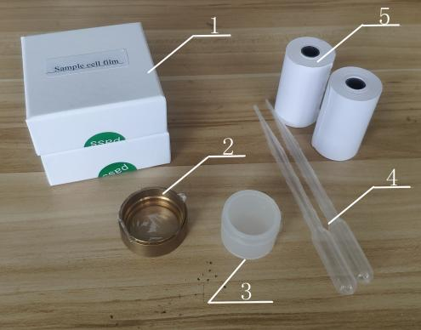
Main unit (1) cell film (2) Leakage protection device
- Sample cell (4) Pipet
(5) Printing paper
Fig.1 Main unit and accessories

III. Operation methods
1. Instrument installation
Please read the Operation Manual at first after you get the instrument. Install and operate the instrument as per the Operation Manual in the later. Next, check the amount of main unit and accessories as per item 1 in the section II of Operation Manual. If there is any parts lose or damage, please contact us immediately.
Take out of the instrument from package after these procedures mentioned above. Please handle the instrument gently to avoid any damage to it.
The instrument should be placed in a clean room without any corrosive gas. A room with an air conditioner is better to lower down damage to the instrument by corrosive gas and affect to analysis accuracy by ambient temperature and humidity changes.
The power supply of the instrument is AC 220V, so please make sure it is fine grounded.

2. Operation procedures
(1) For new users, please debug the instrument as procedures described as follows:
Turn on the instrument → Warm up → repeatability test and spectrum scan → System set (Calibration) → Sample determination
(2) For users using calibrated instruments, please operate the instrument as follows:
Turn on the instrument → Warm up → repeatability test and spectrum scan → Sample determination.
For users using a running instrument, it is not necessary to do the first two steps, “turn on the instrument” and “warm up”. For example, when shift relief or you have doubts on the analysis results. In general, you can make sample determination directly.
3. Turn on the instrument
Press the Power switch at the back of the instrument after instrument installation. Then the indication light of power switch is on. It indicates the instrument gets power. Company name and logo will be shown on the LCD, see Fig.2.
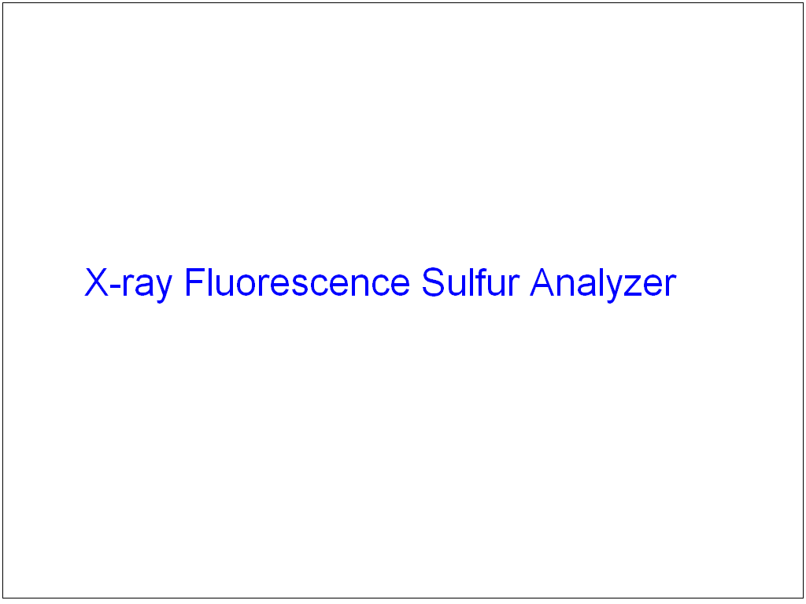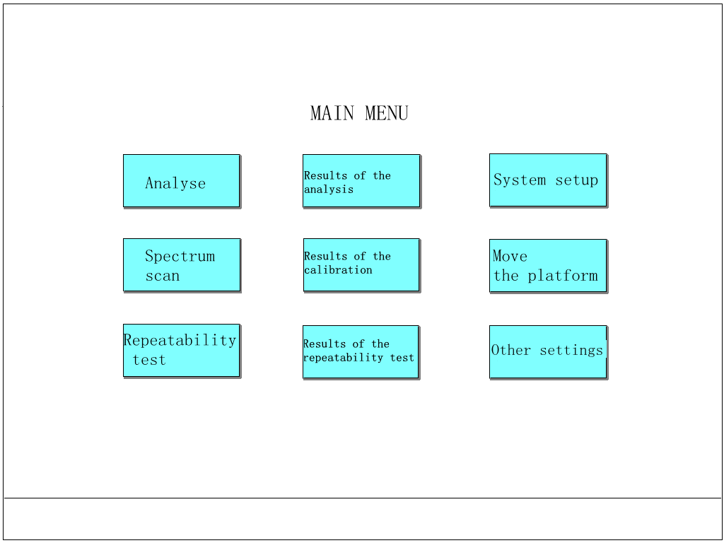
Fig.2 Fig.3
The screen will change to the interface shown as Fig.3 after a few seconds.
4. Warm up
You should warm-up the instrument for 30 minutes after you turn on the instrument. The warm-up time is automatically controlled by the instrument. The instrument can not make sample determination during warm up procedure.
There are words “ Warm up 30 minutes” at the lower section of the interface for prompt. These words will disappear after 30 minutes. The warm-up procedure is over. If the instrument enters into the main menu 30 minutes after you turn on the instrument, and then there will no prompt words appear in the interface, but it still indicates the instrument has been warmed up.
5. Flow chart of the software
When operate the instrument, the flow chart is shown as follows. The flow chart is suitable for users using a calibrated instrument. For new users, please operate the instrument as per the bottom right of flow chart. Please measure spectrum scan at first, measure repeatability test next, and then make instrument calibration. Please carefully read the flow chart. When you understand the flow chart, you may know how to operate it. It is better for you to debug and use the instrument. The functions of each item will be described as per the operation procedures for a new user.
Flow chart
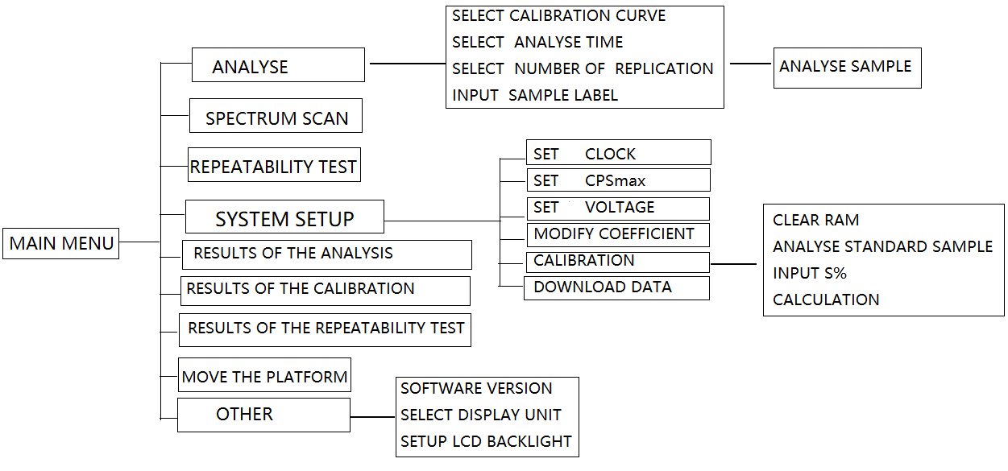
- SYSTEM SETUP: SET CLOCK
Click the 【system setup】,the interface is shown as Fig.4. Input the password “6666”, and the interface is shown as Fig.5. Click 【Set Clock】, Input the correct number to modify the value. Click 【Enter】 button to confirm after modification. Press【Esc】 button to abandon modification.
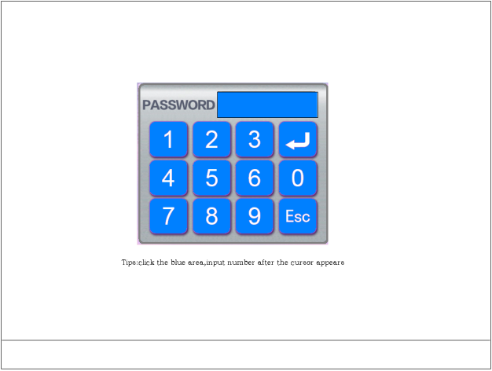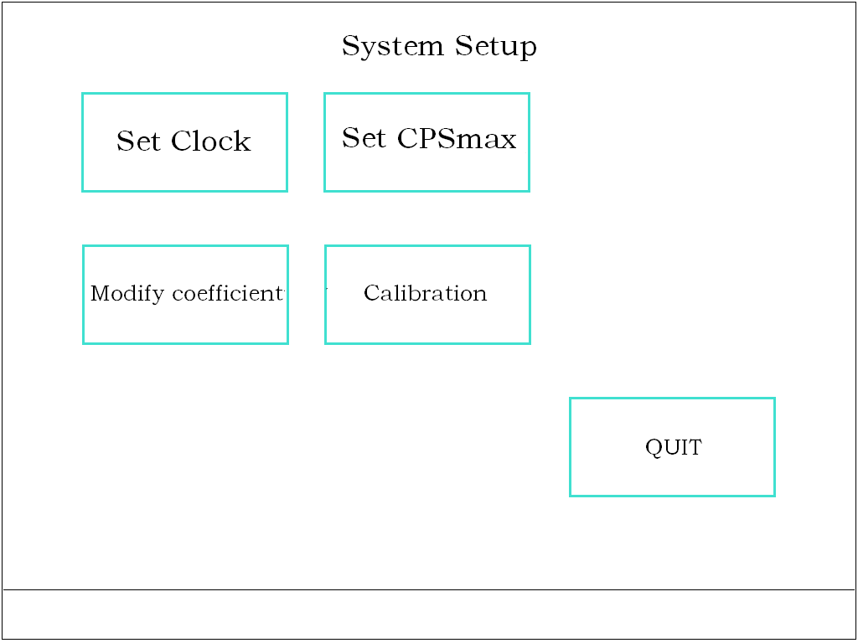
Fig.4 Fig.5
- Spectrum Scan
The spectrum scan item is used to ensure analysis accuracy, and as the first auxiliary function to check electric parameters of the instrument. The instrument will run automatically after the instrument enters the spectrum scan function. The operation methods are described as follows: When the interface is shown as Fig.3 and the reference sample is in the measurement position, click【Spectrum Scan】, the interface is shown as Fig.6 , then click【START】 button. The beginning of the display countdown in the upper right corner. Then you can browse CPS of each threshold value. The threshold value with a maximum CPS is the peak position. In normal, the peak position is a threshold value in the range of 0.9 to 1.1 V.
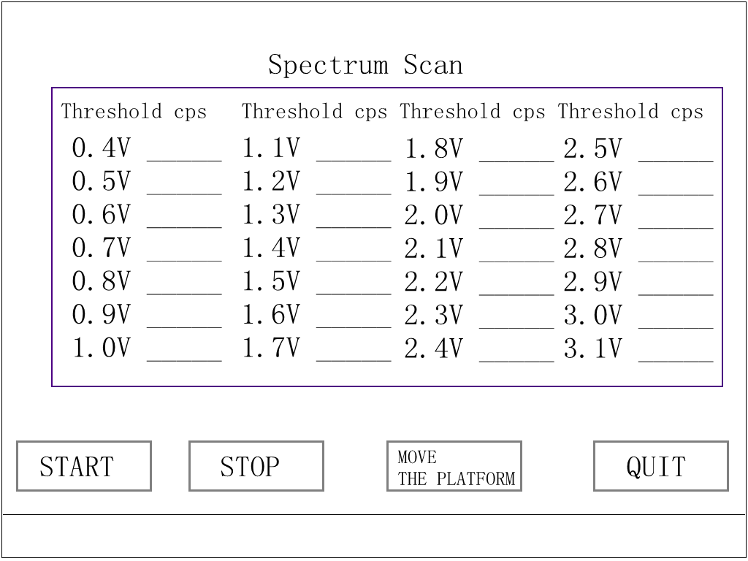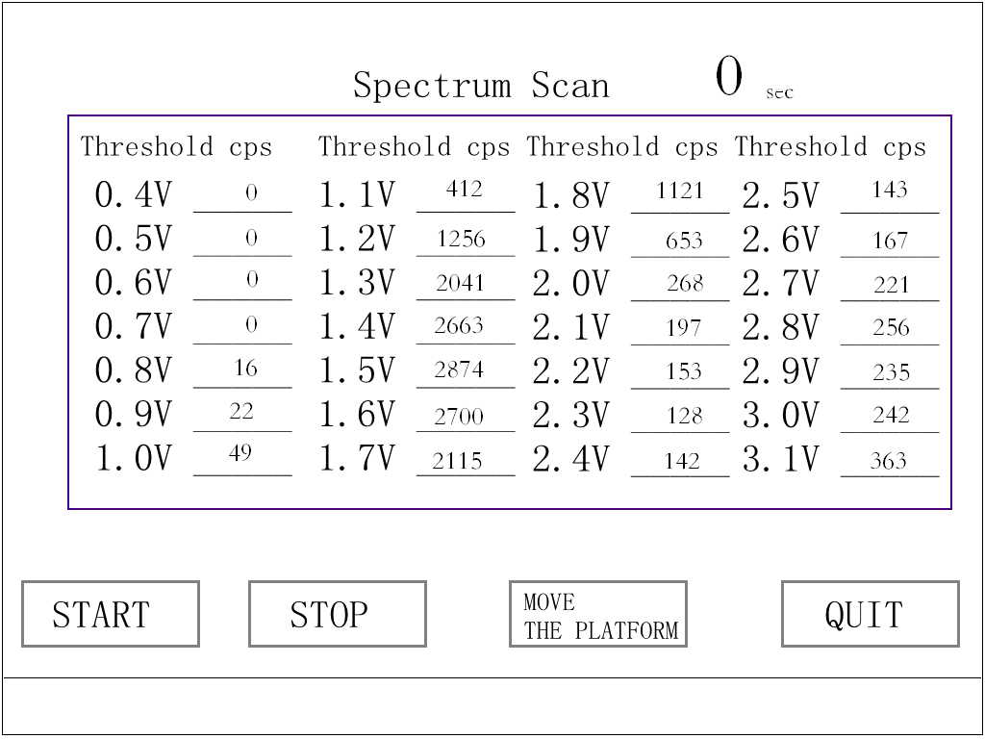
Fig.6 Fig.6a
8. Repeatability test
The Repeatability test item is used to ensure analysis accuracy and as the second auxiliary function to check the electronics system. The Repeatability test should be done 30 minutes after turning on the instrument. It is used to check whether these counting numbers meet principle of statistics. The operation procedure is described as follows: When the interface is shown as Fig.3, and the reference sample is in the measurement position, click【Repeatability test】 , and then the interface is shown as Fig.7. Then click【START】 button, It will make counting measurement 11 times for each group.
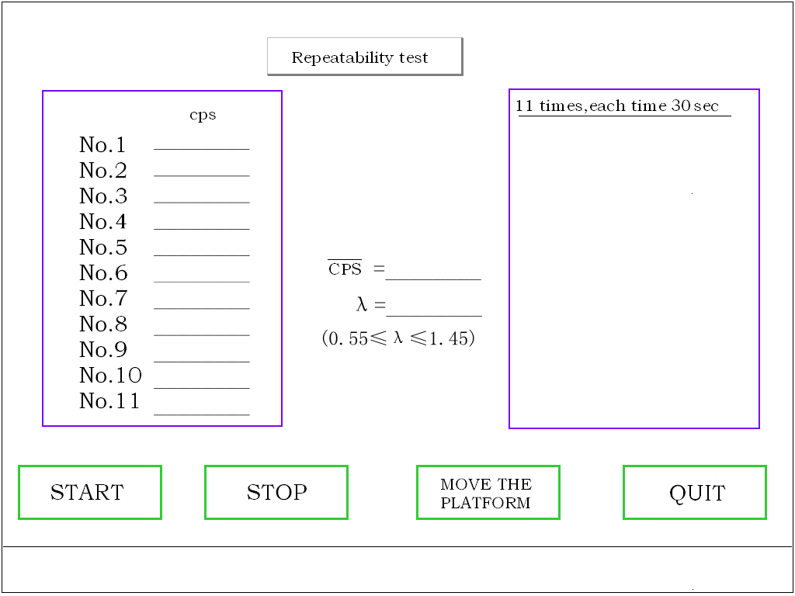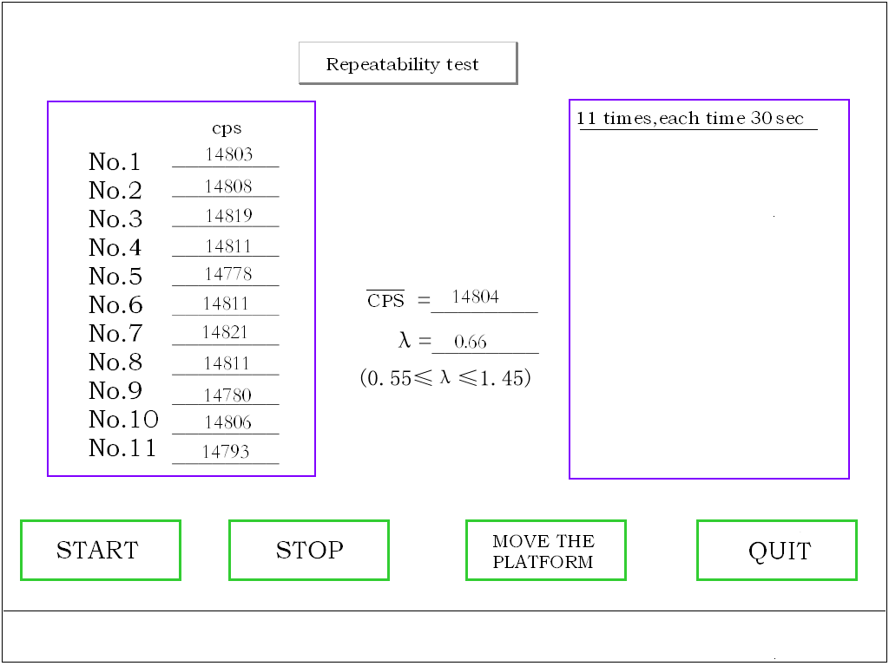
Fig.7 Fig.8
The interface is shown as Fig.8 after counting measurement.
The value of CPS is the average value of these 11 counting values. The λ value is the statistics value of these 11 counting values. When the degree confidence is 95%, and the degree of freedom m-1 is 10, the λ value should meet:
0.55 ≤ λ ≤ 1.45
If the λ value does not meet the requirement, please make measurement for 6 times more. If these values meet the requirement, it indicates that the counting function is in normal. Or it indicates that the electrics system is in trouble.
9. System setup: Calibration
Calibration is the necessary procedure to determine sulfur content in the sample. It is indispensable for every X-ray Fluorescence Sulfur Tester all over the world. As the same, the instrument should be calibrated before use or after use the instrument for a period of time, or great changes in the components of measurement matrix and H/C ratio.
(1) The intention of calibration procedure
The intention of calibration procedure is the same as using several standard weights to calibrate a balance. Balance calibration is to find the corresponding scale line for each weight. Instrument calibration is to find the corresponding sulfur fluorescence counting ratio for sulfur content in each sample. The relationship between weight and scale of balance likes a straight line. However, the relationship between sulfur content S% (m/m) and sulfur fluorescence counting ratio likes a curve when sulfur content is in the range of ppm to 5%. It is described as Fig.9.

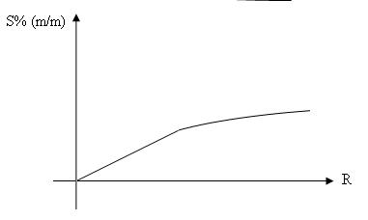
Fig.9
(2) Standard sulfur sample preparation and storage
a. Prepare di-n-butyl sulfide, molecular formula (C₄H₉)₂S, sulfur content is 21.91% (mm); and special write oil having sulfur content lower than 0.002%; Accurately weigh suitable quantity of white oil and di-n-butyl sulfide into a narrow-necked, brown glass container with a stopper. Mix thoroughly at room temperature. Then prepare standard sulfur sample with sulfur content (mass S%) at 5%,3%,2%, 1%, 0.5%, 0.3%, 0.1%, 0.05%, 0.02%, 0.01%, 0.005%. The sulfur content of each standard sulfur sample should be calculated to four decimal places.
b. Prepared and certified standard reference substance by some qualified Standard Institutes can be used as standard sulfur sample when its sulfur content is in the determination range of the instrument.
c. The standard sulfur sample should be stored in a narrow-necked, brown glass container with a stopper, and placed in a dark and cool area when it is not used. As soon as any sediment or change of concentration is observed, discard the standard.
(3) Sample cell and leakage protection device preparation
The sample cell is used to hold standard sulfur sample or oil sample to be determined. It is composed of inner cell, outer ring,, and high polymer film of 6 μm in thickness. Please keep sample cell clean and dry before use. Do not reuse a sample cell to avoid sample pollution.
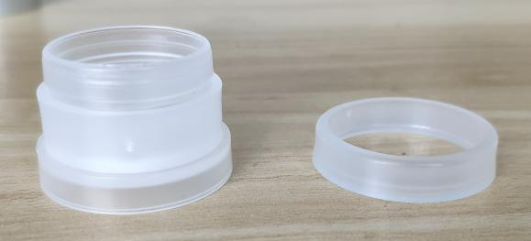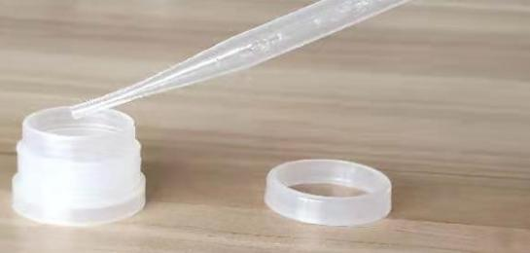
Fig10-1 Fig10-2
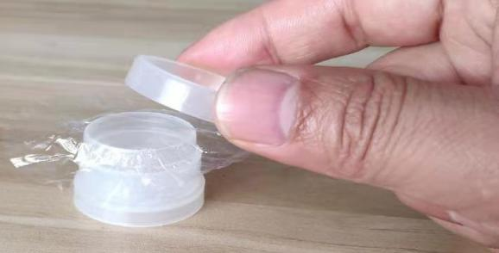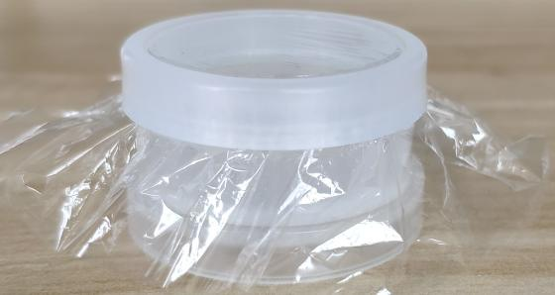
Fig10-3 Fig10-4
Fig.10 Sample cell preparation
A. sample cell preparation and filling procedure
1. Prepare the sample cell with opening upward…See Fig10-1
2. Put the sample into the sample cell with a pipette. See . Fig10-2
3. Put a polymer film on the sample cell. See Fig.10-3;
4. Press down the outer ring of sample cell with force.. See Fig.10-4;
B. Leakage protection device preparation
The leakage protection device is composed of inner ring, outer ring, and polymer film. It is used to stop sample in the sample cell leaking to the instrument probe.
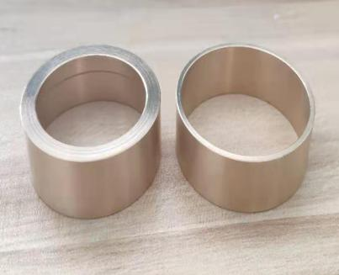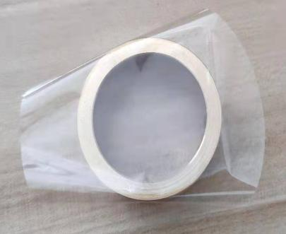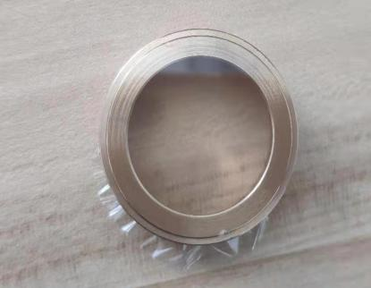
a b
Fig.15 Leakage protection device preparation
(4) Instrument calibration
Instrument calibration shall be carried out two hours after startup.
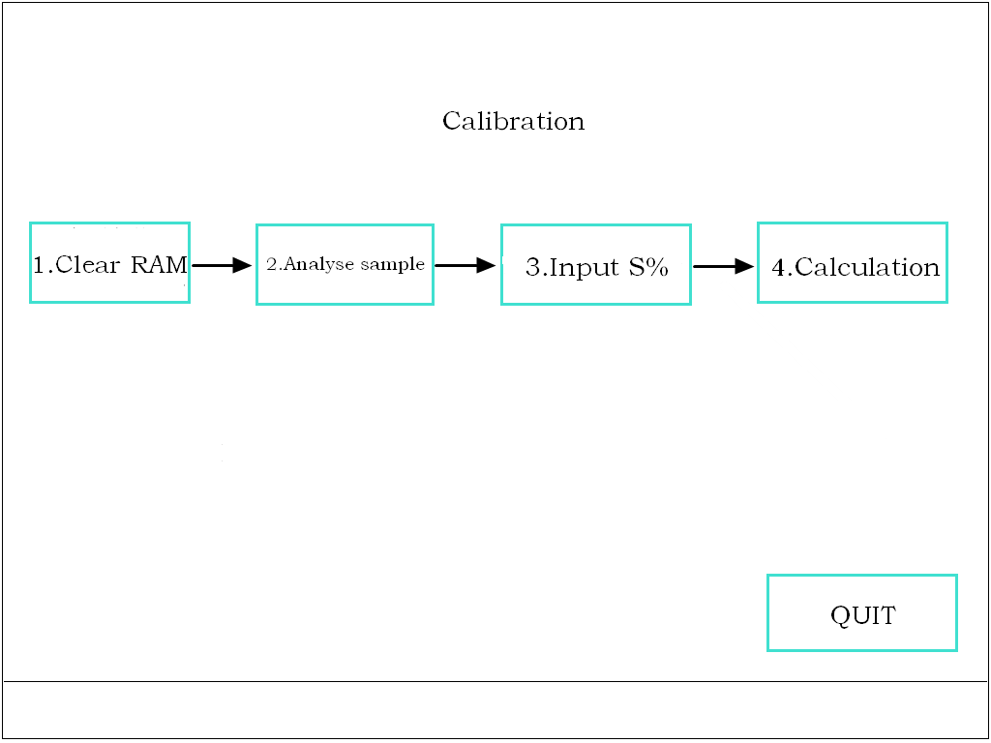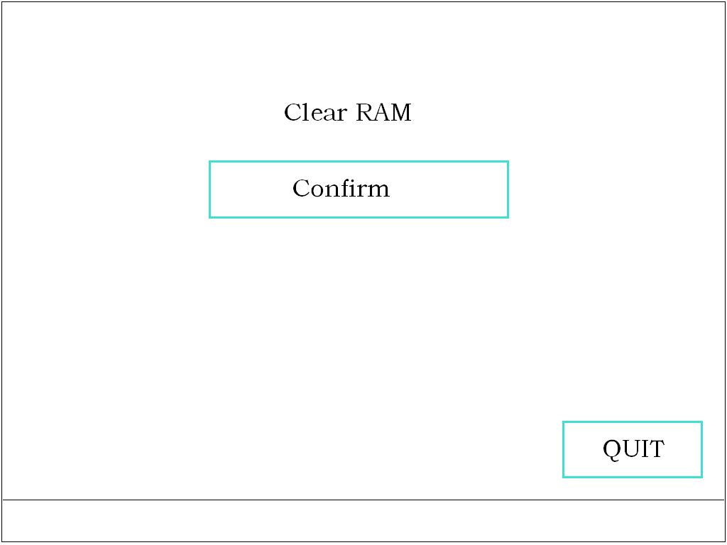
Fig.13 Fig.14
If the spectrum scan and the repeatability test are in normal, you can calibrate the instrument using a standard sulfur sample after the standard sulfur sample, sample cell, and leakage protection device are ready.
Please clear the data before calibration, so that the previous data will not affect the calibration.
When the interface is shown as Fig.13, click【CLEAR RAM】, and then the interface is shown as Fig.14. click【CONFIRM】to clear the ram used for calibration .
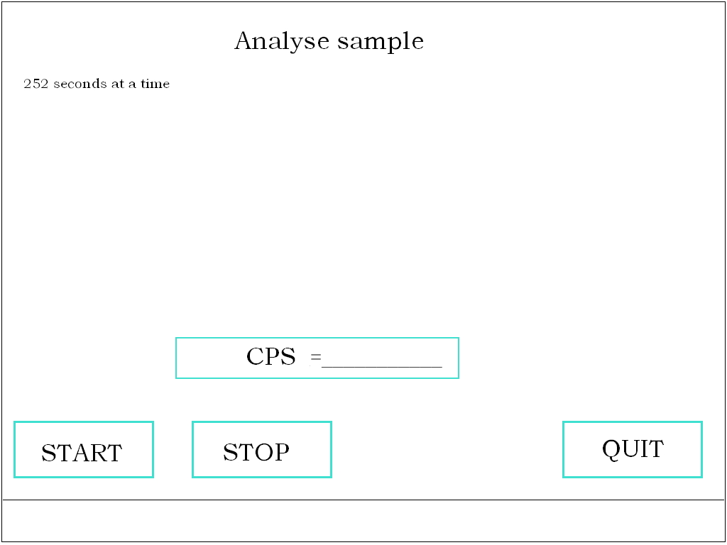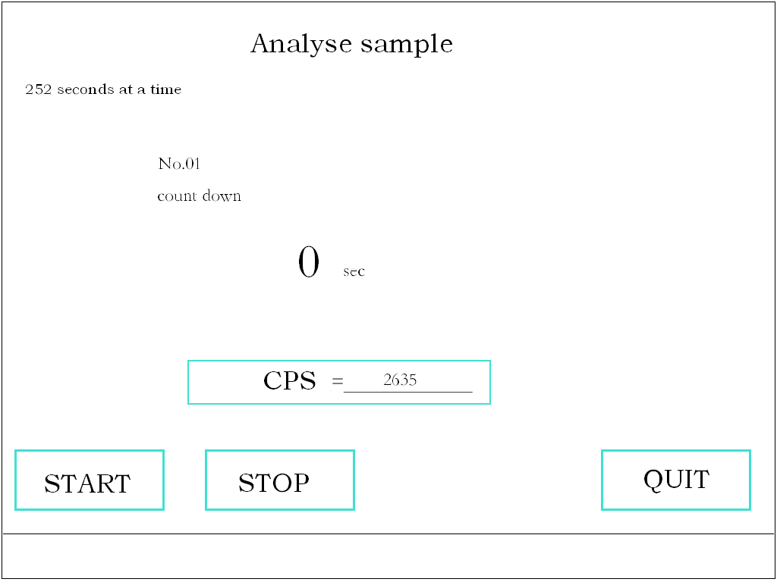
Fig.15 Fig.16
Put the leakage protection device in the hole on the sample holder, and place the No.1 standard sample in the leakage protection device. Then click【START】, the sample holder will take the sample to the measurement position. When the standard sample determination is completed,then the sample holder will extend out automatically. The interface is shown as Fig.16 after sample determination. The CPS of standard sample is shown in the interface.
In general, there are 11 pieces of standard samples in one group and they are numbered. The serial number in the interface shown as Fig16 is the serial number of the standard sample. After the first standard sample determination, you can make determinations for the second, third, and all other standard samples as per the procedures shown as Fig.15 to Fig.16. The maximum number of calibration sample should not be more than 12.
If the CPS(counting value) increases with the increasing of sulfur content, then you can input the sulfur content S% (m/m). When the interface is shown as Fig.13,click【INPUT S%】，the interface is sulfur content input interface and it is shown as Fig.17. Click on the display bar corresponding to the serial number，Enter the correct sulfur content.
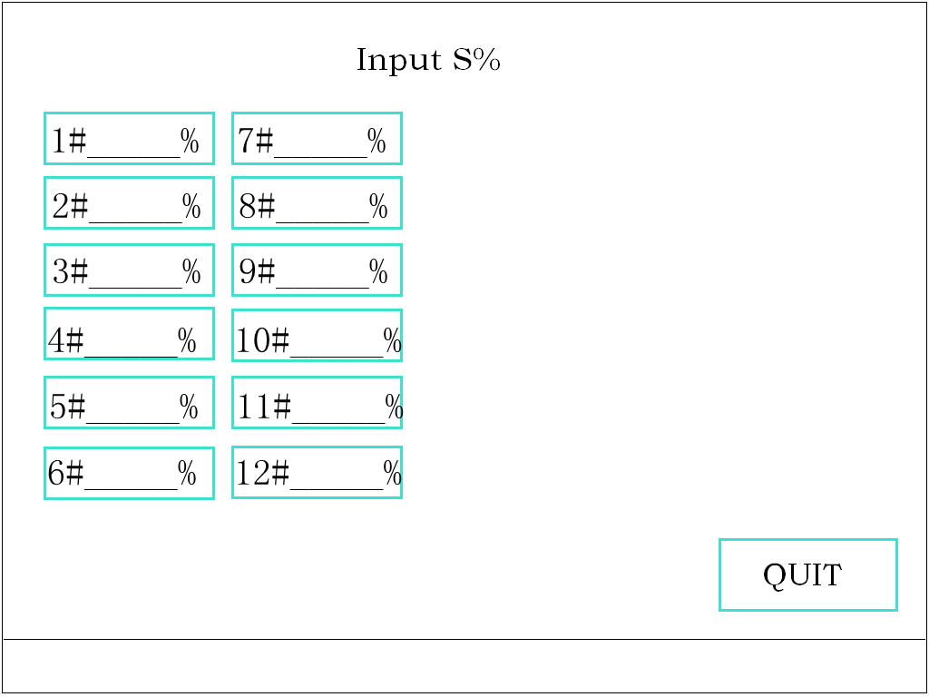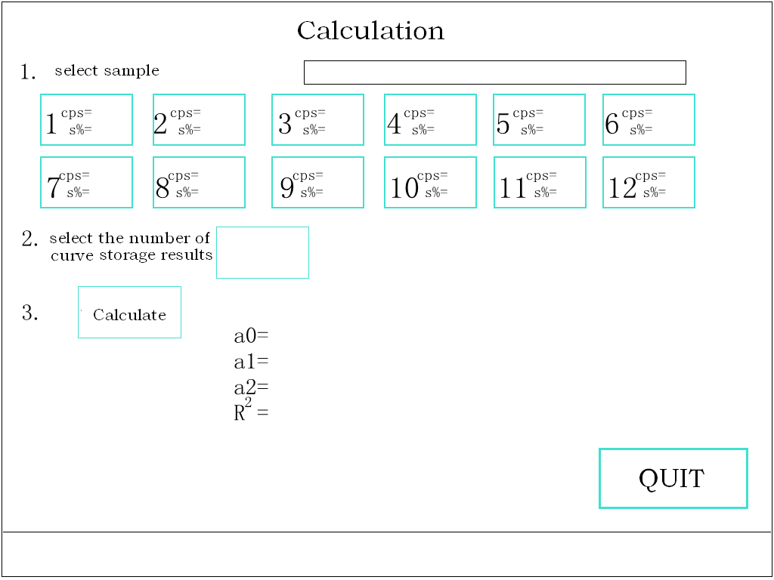
Fig.17 Fig.18
Finally calculate coefficient，When the interface is shown as Fig.13,click【Calculation】，the interface is shown as Fig.18. It will calculate a0 a1 and a2 value after sulfur content input. When the interface is shown as Fig.18, First select the sample number to be included in the calculation,then select the curve number stored in the calculation result,Fnally click [calculate].
For example,We use the No. 1 to No.6 samples to calculate the coefficient,this coefficient is used to measure samples with a sulfur content between 17ppm and 1000ppm.First .click No.1,No.2,No.3,No.4,No.5,then choose to store the calculated coefficient in curve No.1,Finally click [calculate], the interface is shown as Fig.19. Similarly, we can calculate the coefficients of curve 2 （No. 5 to No.8）and curve 3（No. 8 to No.11）,curve No.2 is used to measure samples with a sulfur content between 1000ppm and 10000ppm,curve No.3 is used to measure samples with a sulfur content between 10000ppm and 50000ppm.
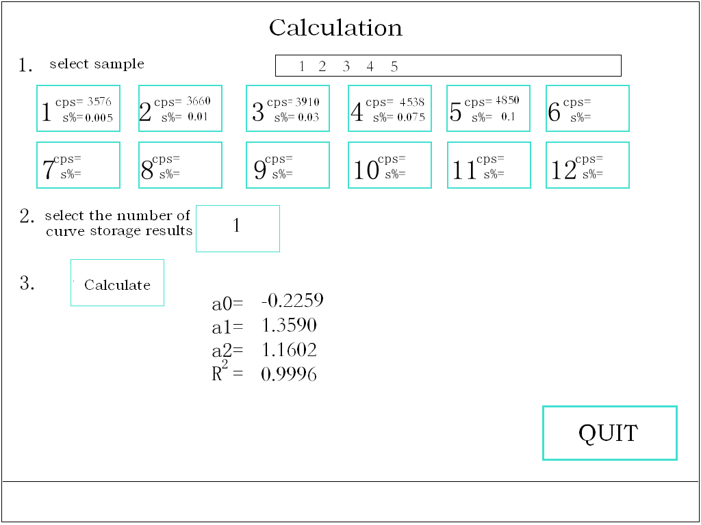
Fig.19
The values in the interface shown as Fig.19 are calculated using calibration data as per the least square methods. The R² value is the correlation coefficient. Its meaning is the relativity between the sulfur content (S% in mass) of calibration sample and the fluorescence counting ratio.
The requirement for it is as follows:
R² ≥ 0.999
(5)OTHERS
When the interface is shown【MAIN MENU】, click 【OTHER SETUP】, the interface is shown as Fig.20.
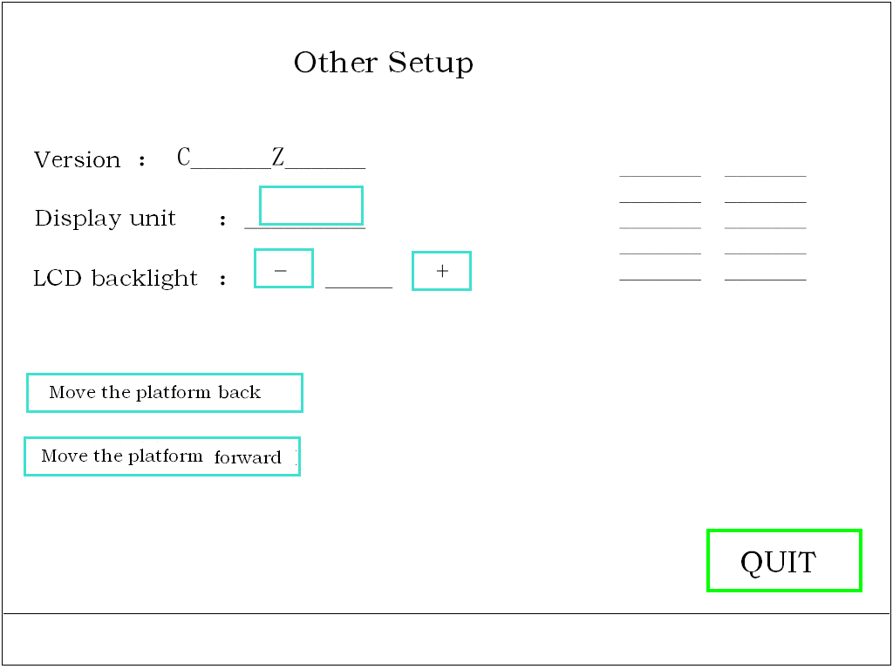
Fig.20
Users can switch display units and set the LCD backlight brightness.
(6) System setup: Modify coefficient
In general, the coefficient can be obtained directly by instrument calibration. But it can also be obtained after calculation and be input manually. Sometime you need to modify coefficient value , you should input them again.
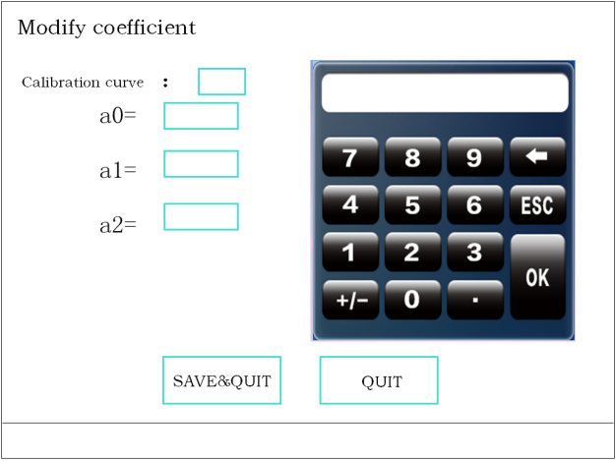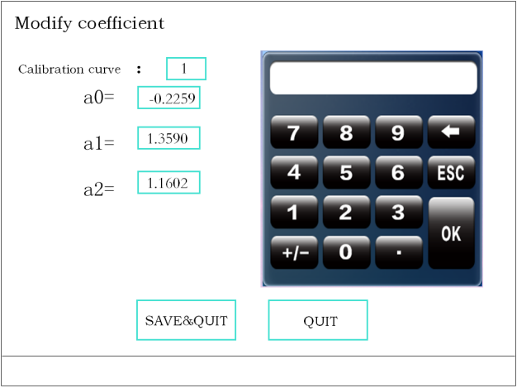
Fig.21 Fig.22
When the interface is shown as Fig.5, click【MODIFY COEFFICIENT】, and then the interface is shown as Fig.21.
Then input the serial number of the working curve, the coefficient values of which are to be modified. If you want to modify coefficient values of the No.1 working curve, please input 1 and click 【OK】and then curve No. 2 coefficients are displayed on the lcd. After entering data,Click 【SAVE&EXIT】to confirm that you want to modify values of the No.1 working curve.
Note: that only one curve can be modified at a time.
(7)System setup: Set CPSmax
When the interface is shown as Fig.5, click【Set CPSmax】, and then the interface is shown as Fig.25. When using the automatic curve selection function in content measurement,the system must set the maximum count value of the corresponding curve.When the measured value of the sample to be tested is less than the maximum count value of curve 1,The system automatically selects the coefficient of curve 1 for content calculation.When the measured value of the sample to be tested is less than the maximum count value of curve 2,The system automatically selects the coefficient of curve 2 for content calculation.
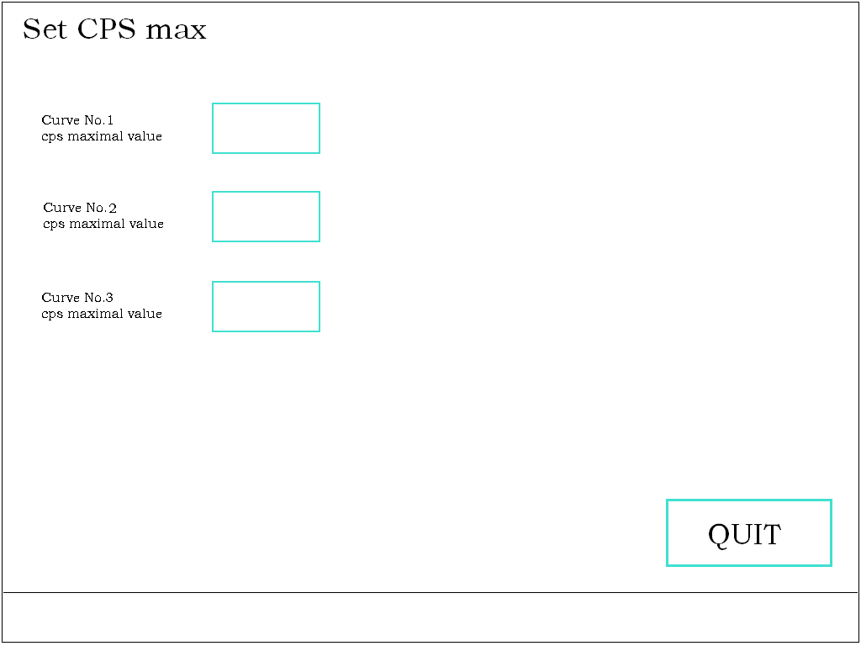
Fig.25

IV. Sample determination
It can be used for sulfur content determination of oil sample to be determined after calibration.
1. Requirements for oil sample to be determined
(1) The matrix and carbon hydrogen ratio (C/H) of oil sample to be determined should be the same as that of calibration sample. If the matrix and carbon hydrogen ratio (C/H) are different from that of standard sulfur sample, there will be error in the test results. The instrument can modify the carbon hydrogen ratio automatically, but if the difference is too large, it is better to calibrate the instrument using standard sulfur samples, which are similar to the oil sample to be determined.
(2) The oil sample to be determined should be clear and uniform. If there is any sediment appears, the test results will have greater error. In order to make an accurate determination, please make determination after filtering out the sediment.
(3) For oil sample having a sulfur content more than 5% (m/m), please dilute it to the analysis range of the instrument using white oil.
(4) For viscous oil sample, please heat it to flow using hot water at first. Then fill it into the sample cell.
(5) The oil sample in the sample cell should be 3 to 4 mm in depth. Please ensure that there is no bubble between the oil sample and the polymer film at the bottom of the sample cell.
(6) The oil sample containing high concentration of aromatic compounds may dissolve the polymer film, so please make determination quickly after fill them in the sample cell.
2. Relationship between determination time and determination precision
The determination precision of the instrument is defined as the standard deviation obtained by statistical analysis of results of 11 successive determinations for the same sample using the same instrument, and the same k and b values . It is indicated by σ. If the determination time is n times of origin time, the standard deviation will be 1/ of origin’s. If the σ₁ is calculated using one unit time, for example, 60 s, and the σ₂ is calculated using n unit time, for example, n=2, then the relationship can be expressed as: σ₂ =σ₁ /. The instrument can preset 60s, 120s, 180s for determination time. The longer the determination time is, the less the fluctuation of the determination result S% (m/m) is. It is recommended to take 60 s as determination time when determining oil sample.
3. Sample determination procedures
When the interface is shown【MAIN MENU】, click 【ANALYSE】 enter into the sample determination function. The interface is shown as Fig.27. Then you should pay more attention to these six considerations:
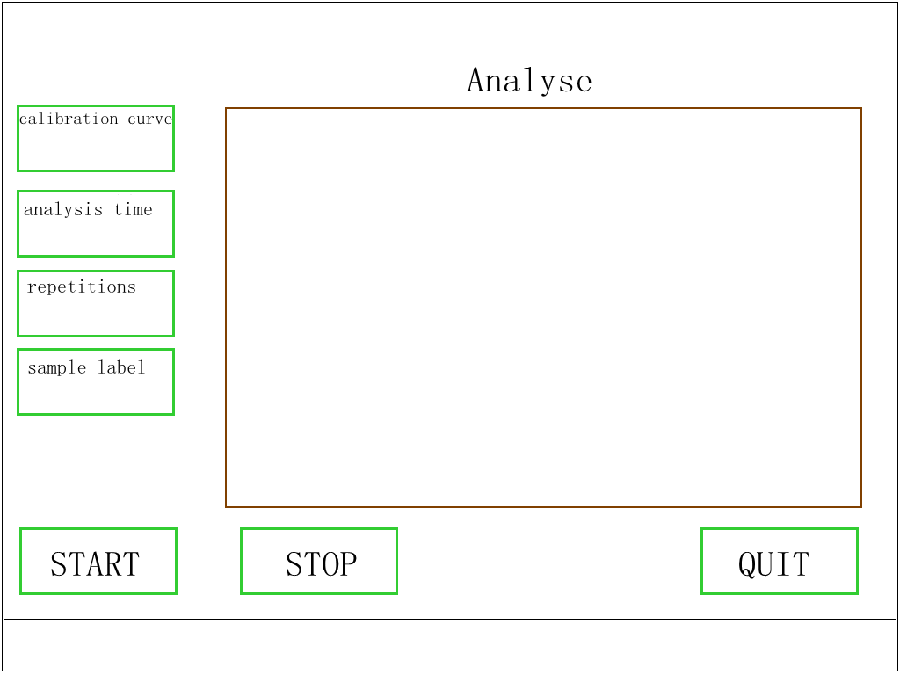
Fig.27
a. Instrument warm up: there are words “warm up 30 minutes ” at the lower section of the display. Please wait until these words disappear.
b. Sampling state: Please wait until words “Need Ref. Data!” at the lower section of the display disappear. If there are words appear, the instrument will sample reference sample automatically after sample determination. This will take 3.5 minutes to complete sampling procedure.
c. Calibration curve selection: In order to accurately determine the oil sample, which is similar to the calibration sample, you should select the calibration curve got from calibration procedures. The calibration curve is shown at the upper left corner of the display. It has 1 to 10 pieces in total.
If the instrument is turned off or the power is suddenly cut off, the instrument will be in the initial state after turning on the instrument. The serial number of calibration curve is “Auto”, so please pay more attention to the working curve selected.See system setup[set CPSmax] page 19.
d. Analysis time selection: The user can select a analysis time as per the test requirement. The analysis time60s,120s and 180s will appear circularly. Then you can select a analysis time from them. If the instrument is turned off or the power is suddenly cut off, the instrument will be in the initial state when you turn on the instrument again. The analysis time is 60 s at this time, so the user should reset analysis time as test requirements.
e. The replication times selection: Turn on the instrument, and then the instrument is in the initial state. The replication is 3 times. The user can set replication times as per the test requirements.the repetition times 1,2, 3, 5, 10 will appear circularly. The user can select a number from them.
F.Sample label: User can enter 9-digit sample number.If you do not enter, the default number is 0.
Sample determination
After complete these six considerations, please push open protective stainless steel cover,put the sample cell with oil sample in the leakage protection device on the sample holder,pull protective stainless steel cover. Then the instrument is ready for sample determination.
Just click 【START】,The sample is moved to measurement position ,it will start sample determination. The determination time displayed in the interface shown as Fig.28 is counting down. If you want to stop analysis during sample determination procedure, please click 【STOP】.
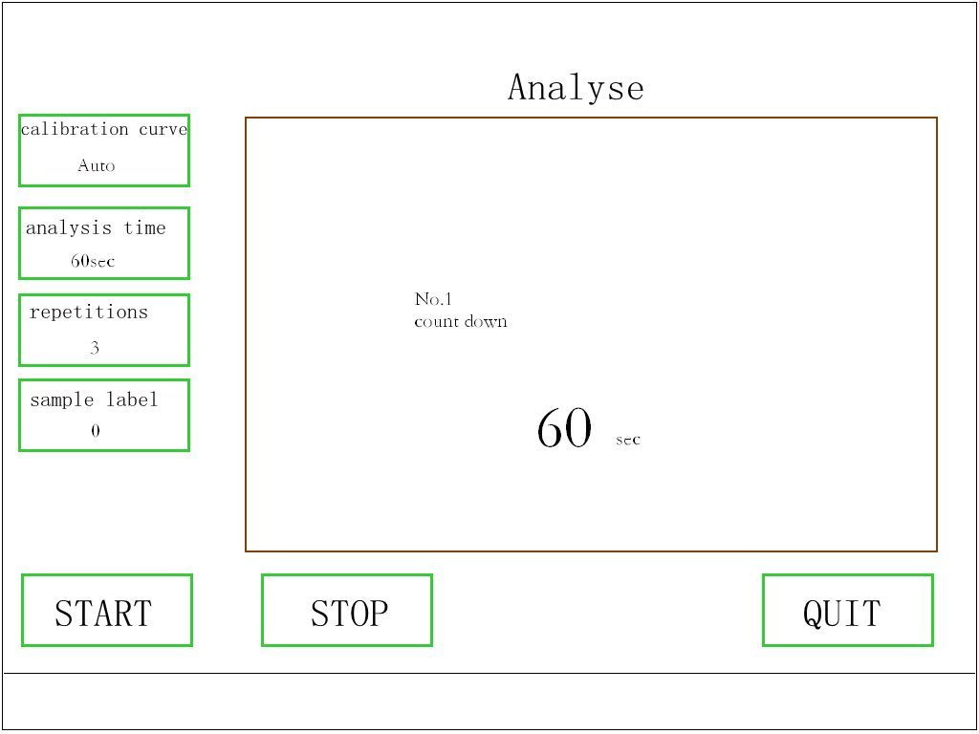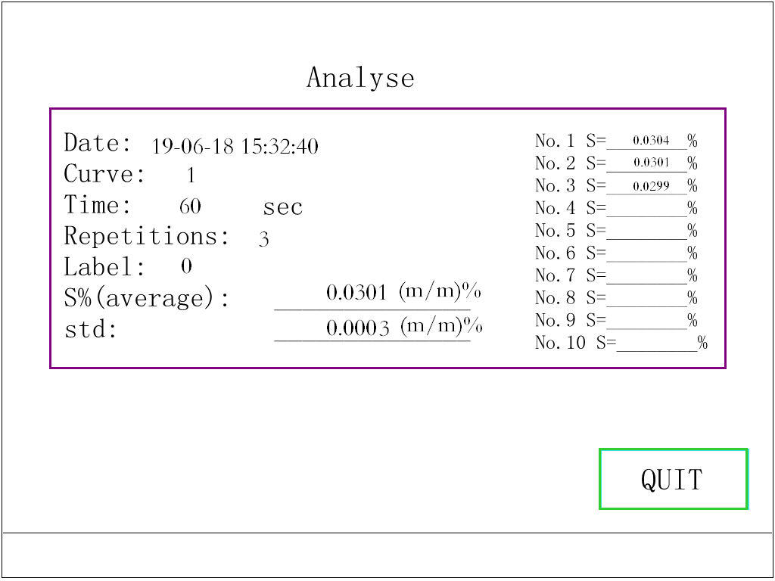
Fig.28 Fig.29
The result will be displayed on the display and printed out after sample determination. The interface is shown as Fig.29.
Then the result will be saved in the instrument. It will not lose even the power is cut off. When search test data, you can find date, time, working curve used, analysis time,replication times,sample
label and sulfur content of the sample.
Points should be described for sample determination
A. Scientific use of the X-ray fluorescence intensity ratio relative comparison methods
In order to avoid any affects to the analysis results caused by X fluorescence tube fatigue, electric parameters drift, ambient temperature change and dust, the instrument adopts the X-ray fluorescence intensity ratio relative comparison methods for sample determination. There is a special reference sample installed on the sample holder. For sample determination, it should be like instrument calibration procedures. You should make determination for the sample once, and then make determination for the reference sample once, so that to get the X-ray fluorescence intensity ratio of corresponding compound and calculate the sulfur content of oil sample. Now, the instrument scientifically uses the X-ray fluorescence intensity ratio. It successively determines the reference sample for five times and calculates their average value. The value can be used in half an hour. Then you can determine the oil sample directly for sulfur content analysis. This not only improves the measurement accuracy, but also reduces the sample analysis time. It also simplifies the sample analysis procedures. Just put the oil sample on the sample holder and press the Start button, you can get the results even you leave the instrument alone during sample determination procedures. You can make determination for oil sample continuously in half an hour. After half an hour, you should make determination for the reference sample again. Then the word “Need Ref. Data!” will be displayed at the lower section of the display. It will complete sampling after 5 minutes. Then you can make determination continuously for about 7 pieces oil sample again (Measurement time is 60 s and the number of repetition is 3).
B. Position of sample holder
The reference sample and the oil sample are placed on the same sample holder. When the sample holder extends out, the reference sample is in the determination position. Then there are words “Ref.” displayed at the lower right corner of display. When the sample holder backs to the instrument, the oil sample is in the determination position. Then there are words “sample” displayed at the lower left corner of the display.
Note1: the sample can only in the reference sample determination position or oil sample determination position. It could not be in any other middle positions. The instrument will make an alarm if the sample holder is in any other positions and it can not work normally.
Note2: When there are words “Ref. ” displayed at the lower left corner of the display, the instrument will sample reference sample. It will use the average value of the latest seven test data for sample determination. The instrument is in the waiting state all the time, so it can make sample determination when you put oil sample on the sample holder.
C. Two cases that the instrument could not make sample determination:
The instrument could not make sample determination at two cases:
a. The instrument is in the warm up state;
b. The instrument is sampling;
After complete warm up, sampling, and the oil sample is placed on the sample holder, the instrument will be in the sample determination state. Then you can start sample determination.

V. Data search
1. Sample determination data search
When the interface is shown as Fig.3, click【RESULTS OF THE ANALYSIS】, and then the interface is shown as Fig.30.
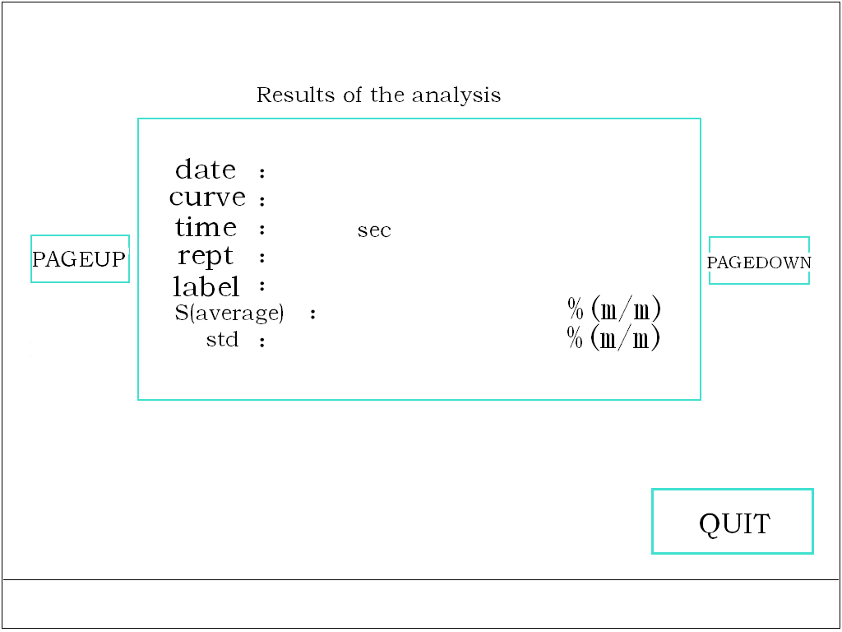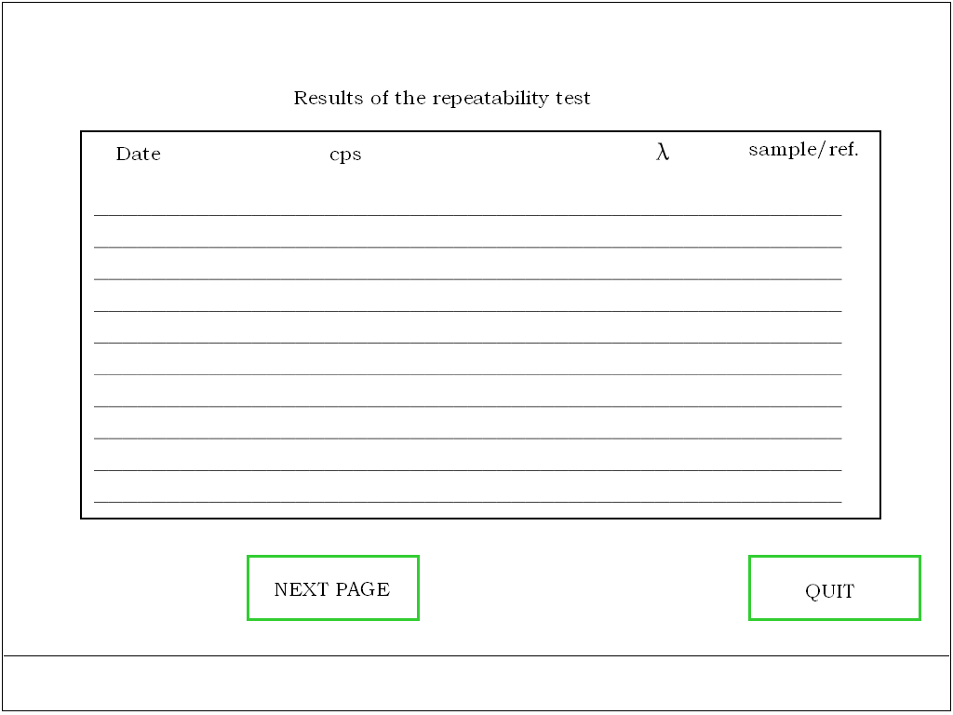
Fig.30 Fig.31
When the interface is shown as Fig.30, CLICK 【Pageup】【Pagedown】, you can browse all sample determination data, including time, serial number of working curve, and repetition times. You can browse 2048 pieces of the latest sample determination data at most.
2. Repeatability test data search
When the interface is shown as Fig.3, click【RESULTS OF repeatability test 】, and then the interface will change to the repeatability test data search interface shown as Fig.31.
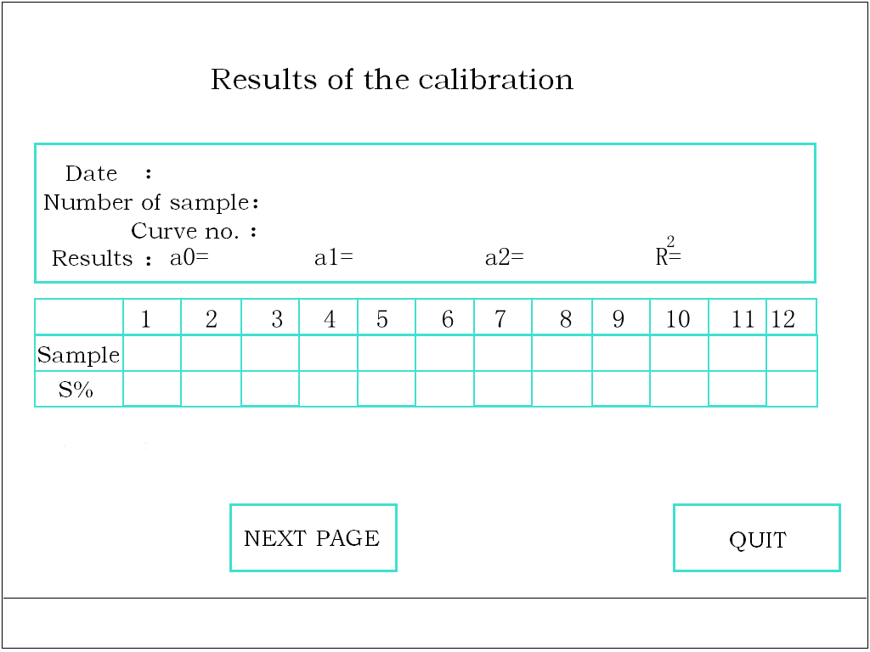
Fig.32
3. Calibration data search
When the interface is shown as Fig.3, click【RESULTS OF CALIBRATION 】, and then the interface will change to the calibration data search interface shown as Fig.32.
You can browse 16 pieces of the latest calibration data at most.

VI. Instrument management
1. Calibration sample storage
The calibration sample is the standard sulfur sample used to calibrate the instrument. Because of much more work for standard samples preparation, expensive standard samples price, and the need to calibrate instrument after transport and repair, please store the remaining standard sample in a brown ground bottle with stopper and put a label marking the type, serial number, total sulfur content (mass%), and preparation date on the bottle for later use, so that to avoid sample confusion and volatilization.
2. Reproducibility R
The difference between the determination results made using the instrument and the determination results for the same sample in the other laboratory should not exceed the requirements on reproducibility ︱S₁-S₂︱≤1.9182 X^{0.6446}. If the difference does not meet the requirements on reproducibility, please check whether the k and b values used are suitable for the sample. This may be caused by that the matrix and carbon hydrogen ratio (C/H) are different from that of calibration sample or the sulfur content of the sample is not within the analysis range of the instrument. Then you should calibrate the instrument using calibration samples which are similar to the sample to be determined.
What’s more, it can be used to ascertain the correctness of analysis results made by other laboratory.
4. Trouble shooting
If the result is incorrect, or there is great deviation between successive determination results for the same sample, the instrument may be in trouble.
(1) Check spectrum scan results: Make spectrum scan as the procedures described before and check its peak position to make sure it meets the requirements.
(2) Check reaptability test results: Make reaptability test as the procedures described before, and then check the λ_{S} value of the eleven measurement results of the Ns to ascertain whether it meets the requirements 0.55<λ_{S}<1.45, or check the counting data to make sure whether each group of counting data can meet the requirements 0.55<λ_{S}<1.45.
In general, if there is any trouble appears, it may be caused by at least one point of these two points. The users should tell us the condition of these two points when you ask us to repair it, so that we can solve the problem quickly.

VII. Attention
1. Safe use of electricity
The users should make sure that the power supply is 220 V, 50 Hz and the power supply socket of three cores is in accord with the power supply plug of the instrument. Please note that, if the power supply socket is a socket of two cores, or the power supply socket of three cores is bad grounded, or the phase line and zero line are wrongly connected, it may be unsafe. We are not liable for any damage or loss caused by this.
In general, it is not needed to connect a voltage stabilized device. But if the power supply may be cut off frequently or the voltage is unstable, the user should connect the instrument to the power supply through an alternate current protection device and a voltage stabilized device, or an uninterruptible power supply.
2. Notes during operation procedures
(1) The instrument should warm up for about 30 minute before oil sample determination. Please select different determination parameters for different samples.
(2) Fill sample from the center of the sample cell. Do not fill sample along the wall of sample cell, especially spill any sample out of the sample cell.
(3) The sample should be placed in the leakage protection device on the sample holder for sample determination.
(4) In order to avoid any pollution to the leakage protection device caused by the oil leaking from the sample cell and any affect to the analysis for next oil sample, please take off the sample cell immediately after sample determination.
(5) In order to avoid the leakage protection device is polluted by dust, please pull stainless steel cover on the leakage protection device when it is not used for sample determination.
(6) The sample cell is disposable. If there is any oil sample on the film of the leakage protection device, please replace the film of the leakage protection device.
(7) It is forbidden to let the oil sample, especially the combustible liquids leak into the instrument.
(8) In normal, it is not needed to turn off the power supply of the instrument. The instrument can run continuously for 24 hours. If it is not used for a long time, please take off the leakage protection device from the sample holder and keep it in good condition. Then turn off the power supply.
3. Notices for instrument maintenance
It is forbidden to disassemble the instrument by the user. If the probe of the instrument is in trouble, please contact us immediately. There are high voltage and X-ray devices in the instrument and the probe has been sealed. If the user disassemble the probe, we are not liable for any damage or loss caused by this.

VIII. Packing List
No. | Item | Qty
1 | Main unit | 1
2 | Power supply wire | 1
3 | Sample cell | 200
4 | Sample cell film (6μm Mylar) | 200
5 | Leakage protection device (two parts) | 1
6 | Printing paper (57 mm in width; Φ30mm) | 3
7 | Pipet | 200
8 | Standard sample for calibration | 1
9 | Multifunctional pressure shaping device (two parts) | 1

Appendix A
Operation Manual for WH-AA Heat Sensitivity Printer
I. There is an indication light, which is also taken as the LF button, at the upper right corner of the printer panel. Turn on the instrument, and the indication light will be on. If there is no printing paper in the printer, the light will glitter and the printer could not receive any data.
II. Turn on the instrument, the printer will get power. If there is enough printing paper in the printer, the indication light can be taken as a LF (paper moving button) button. Press the indication light, the printing paper will start moving for printing test data.
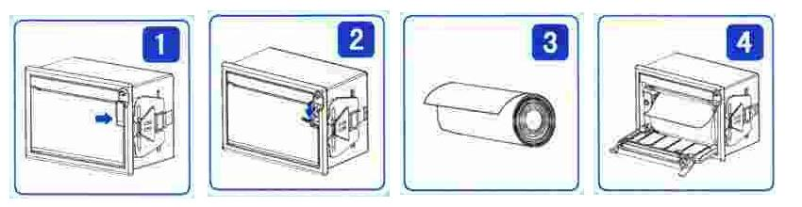
Fig.39
III. Install printing paper
The paper used is heat sensitivity paper, see Fig.39-3. It is 57 mm in width, and 30 mm in diameter. Please install a new roll when the printing paper has been used up.
The procedures to install printing paper are described as follows:
1. Pull out the Rotation handle at the arrow position shown as Fig.39-1. Then it is shown as Fig.39-2.
2. Rotate the handle, and then the paper moving axle of the printing head will be separated from the printing head. Open the cover of the printing paper chamber.
3. Put the printing paper in the chamber, and pull out a length of paper trough the toothed opening. Please note that the paper should be placed in order and the surface of paper having liquid medicine (smooth surface) should upwards, see Fig.39-4.
4. Close the paper chamber and align the paper moving axle of printing head with the printing paper. Then press down the paper moving axle to let it back to the printing head. Push the rotation handle back to its initial position.
5. Let the printer get power and let the printing head rotate. Then check the paper to make sure it moves in a straight line. Turn off the power supply or let it in the sleep state.
IV. Clean and maintenance
There may be some dirty on the heat sensitivity head and the roller after it has been used for a period of time. If you do not clean it, it will affect the useful life of the printer. So please clean the printer regularly.
Open the printing paper chamber. Clean the heat sensitivity head and the roller gently using a cotton rod with alcohol.
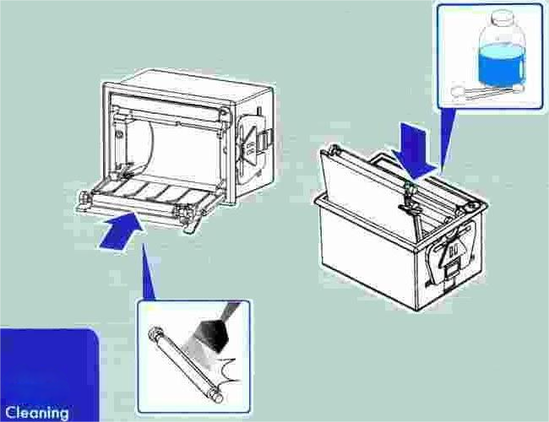
Fig.40

