HZQB2612
Automatic Voltage Tester

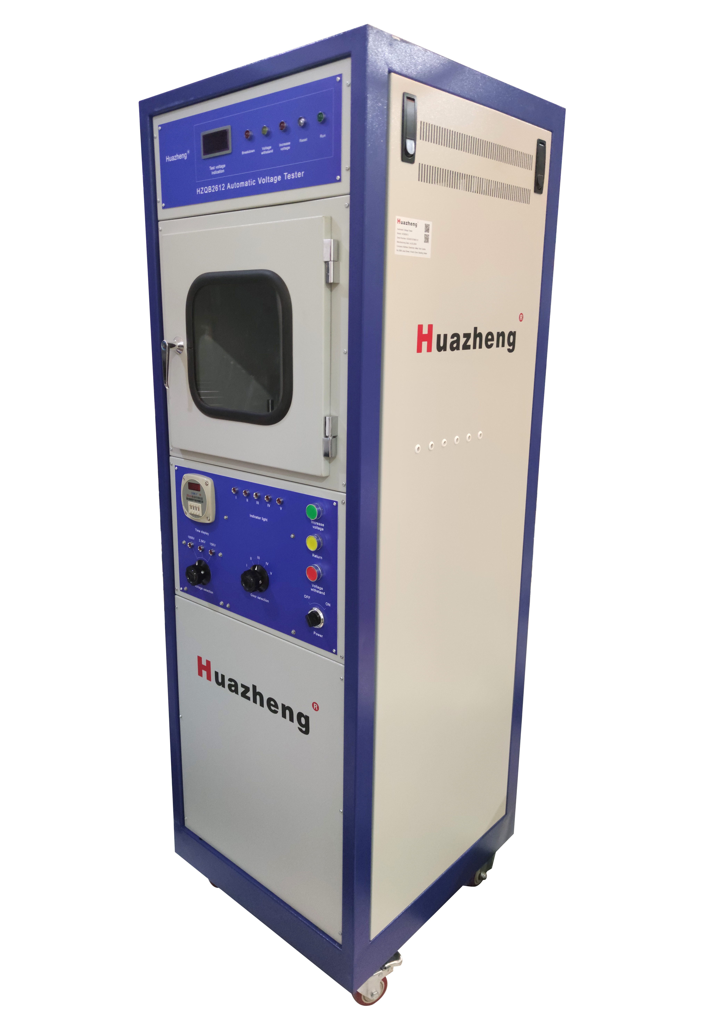

Huazheng Electric Manufacturing (Baoding) Co., Ltd

Dear user:
Thank you for choosing HZQB2612 Automatic Voltage Tester.
We hope that this instrument can make your work easier and more enjoyable, so that you can get the feeling of office automation in the test and analysis work.
Before using the instrument, please read this manual, and operate and maintain the instrument according to the manual to prolong its service life.
"Just a light press, the test will be completed automatically" is the operating characteristics of this instrument.
If you are satisfied with this instrument, please tell your colleagues; if you are not satisfied with this instrument, please call (0312) 6775656 to tell you to serve you at all times-Baoding Huazheng Electric Manufacturing Co., Ltd., our company will definitely make you satisfied !

Please read the instructions in detail before using the instrument

Contents

I. Use 1
II. Main Technical Indicators Of The Instrument 1
III. Working Principle And Characteristics Of The Instrument 2
IV. The Operating Steps Of The Instrument 3
V. Note For Using The Instrument 4
VI. Common Faults And Troubleshooting Methods Of The Instrument 4
VII. Packing List 5

I. Use
Type HZQB2612 automatic voltage tester is a multi-purpose AC voltage test instrument designed according to GB/T4074.5-2008 and IEC60851-5:2004 standards.
1.1 The breakdown voltage test of electromagnetic wire (voltage 0~15000V) is used to detect the breakdown voltage performance of enameled round wire and enameled flat wire of 0.02mm and above at room temperature. It can carry out the following test methods: round rod method: diameter 0.1mm and below the enameled round line; twisted twisted method: diameter 0.1mm above 2.5mm and below the enameled round line, steel bead method: winding flat line and diameter 2.5mm above the enameled round line.
1.2 It can be used for withstand test of electrical products and instruments, with withstand time 0~999S。

II. Main Technical Indicators Of The Instrument
2.1 Test voltage: the nominal voltage is 50 HZ approximate sinusoidal waveform AC voltage, the peak coefficient is 2 ± 5%, 0~15000V is optional, the test voltage value error is ± 3%.
2.2 When a 5±0.5mA current is passed through the high voltage loop, the instrument sends out a high voltage breakdown signal, and displays the breakdown voltage value, and the test voltage drop is not more than 2%.
2.3 The boost speed of the test voltage is shown in Table (I), and the boost speed error is ± 10%。
punch through voltage V |  | rate of rise  V/S
over | And the following | rate of rise  V/S
— | 1000 | 20
1000 | 2500 | 100
2500 | 15000 | 500

2.4 The capacity of test transformer> 500VA and load short circuit current> 50 mA.
2.5 The voltage holding time of the withstand voltage test ranges from 0 to 999 S seconds, and the error is less than 1 second.
2.6 Others:
Working environment: (1) the temperature is 0~40℃
(2) Relative humidity is 85%
External power supply: 220V ± 5%, 50 HZ
The instrument must be powered by an AC stationary power supply.(Steady power supply power 2 KVA) and reliable grounding, otherwise it will affect the test accuracy and service life of the instrument。
2.7 Power consumption: <1000W
2.8 Overall dimensions: 5456501700mm
2.9 Weight: about 100kg

III. Working Principle And Characteristics Of The Instrument
3.1 Working Principle:
The instrument uses the AC high voltage method to measure the breakdown voltage value or the sample withstand voltage value. According to the selected test voltage, the instrument outputs the AC voltage at both ends of the sample at a certain boost speed. Once the sample breakdown or the high voltage circuit reaches 5±0.5mA current, the high voltage will be automatically cut off, the instrument emits sound and light alarm, the digital voltmeter shows the breakdown voltage value and keeps it for a period of time, the voltage will automatically drop and the instrument will reset。
3.2 Feature:
The instrument can hold five groups of samples at a time, and can complete the breakdown or pressure withstand test of any sample one by one or separately according to the selected sample. The instrument is equipped with current detection in the primary and secondary circuits of the test voltage, and the comparison device, so the action current is sensitive and accurate. The test box door of the instrument has the safety interlock device and the indication, and has the reliable safety protection measures. It can be matched with the external temperature box and can conduct high temperature breakdown and pressure test.
The instrument has simple operation, stable performance and reliable performance. Using aluminum alloy instrument cabinet, beautiful appearance。

IV. The Operating Steps Of The Instrument
4.1 Voltage selection and schematic value reading：
4.1.1 Turn on the power supply, reset the instrument automatically, the test voltage indicator should show a low value, and the work indicator light is on.
4.1.2 Select a certain test voltage according to the test standard. If the test voltage indicator light is on, the boost speed is the corresponding boost speed shown in Table (I)。
4.1.3 When the test voltage range is 500V (or 2500V, 15000V), the test voltage indication (digital voltmeter) is indicated in the left first position as thousand or (10 thousand) respectively.
For example: 1000V, the voltmeter shows 04858, at this time, the test voltage is 485.8V.
For example: 2500V and 15000V, the voltmeter shows 01658, at this time, the test voltage is 1658V.
4.2 Breakdown voltage test:
4.2.1 Open the door of the test box and insert a group (or 5 groups) sample into the high voltage electrode according to different test methods (torsion twist method, round rod method or steel bead method). For the twist test, insert the sample directly into the two holes of the high voltage electrode and close the test box door, otherwise the test cannot be conducted。
4.2.2 Push the sample switch to the first sample, press the boost key, and boost the instrument at the corresponding speed according to the selected voltage range. When the sample is broken, the instrument sounds an alarm and the breakdown indicator is on. Record the test voltage value displayed. The instrument is automatically reset, and the reset indicator is on. After reset, the reset indicator is off.
Turn the sample selector to II and repeat the above until completion of one set (5 sets).5 high voltage electrodes in the test box, corresponding to 1,2,3,4,5 samples from left to right.
4.3 Pressure withstand test
4.3.1 Install the test sample and select the test voltage according to the breakdown voltage test method, and number the test sample.
4.3.2 According to the time of applying the test voltage to the sample, set the coding button of the JS 11 S time relay to the required time, with the time setting range from 0 to 999 seconds.
4.3.3 Press the boost button to start the boost of the instrument. When the test voltage indicates the required voltage, press the voltage button and the instrument is applied to the ends of the sample until the sample is penetrated or when the set test time is reached.

V. Note For Using The Instrument
5.1 Because the test voltage of the instrument is up to 15000V, the high voltage transformer, voltage regulator contact surface, high voltage line and high voltage electrode should be cleaned regularly, and absolute ethanol can be wiped. (note that the power supply of the instrument must be cut off in the process of the above operation).
5.2 The enclosure of the instrument shall be well grounded, the grounding resistance shall be small, and meet the grounding requirements of the enclosure of electrical equipment.
5.3 When the test of a group of samples is completed, the test box door must be opened and replace the sample only after the reset indicator light is extinguished.
5.4 In order to ensure the life safety of the operators, the door switch is not allowed for short-circuit use.
5.5 The main power supply of the instrument shall be connected by three-core plug, and the main power supply shall be supplied by AC voltage stabilizing power supply to ensure the normal operation of the instrument and the accuracy of the test results. The main engine power supply should be reliably connected to the ground wire, otherwise, the instrument will not work properly, and even damage the high-voltage transformer.
5.6 When conducting the high pressure test, the operation must be conducted strictly in accordance with the relevant test regulations of the high pressure test procedures。

VI. Common Faults And Troubleshooting Methods Of The Instrument
When the instrument fails, replace the fuse or open the box door for inspection, the power switch must be turned off and the power plug must be removed.
6.1 The whole machine is not working and the indicator light is not on. Please open the rear box door and check the main loop fuse located at the lowest level of the instrument, whose capacity is 10A.
6.2 If the instrument does not boost, the sample does not breakdown, and the instrument does not return after breakdown, open the side board of the chassis and replace the circuit board (to be purchased separately).
6.3 After replacing the circuit board, also check whether the main circuit relay is working properly。

VII. Packing List
No. | Item | Qty
1 | Product verification certificate | 1
2 | product specification;product manual;product descritption | 1
3 | Sample twisting device | 1
4 | protective tube (10A) | 5
5 | Stainless steel ball (Φ 2mm-about 400 grains） | 1(A small bag)

