HZ-1021
Grease Dropping Point Tester

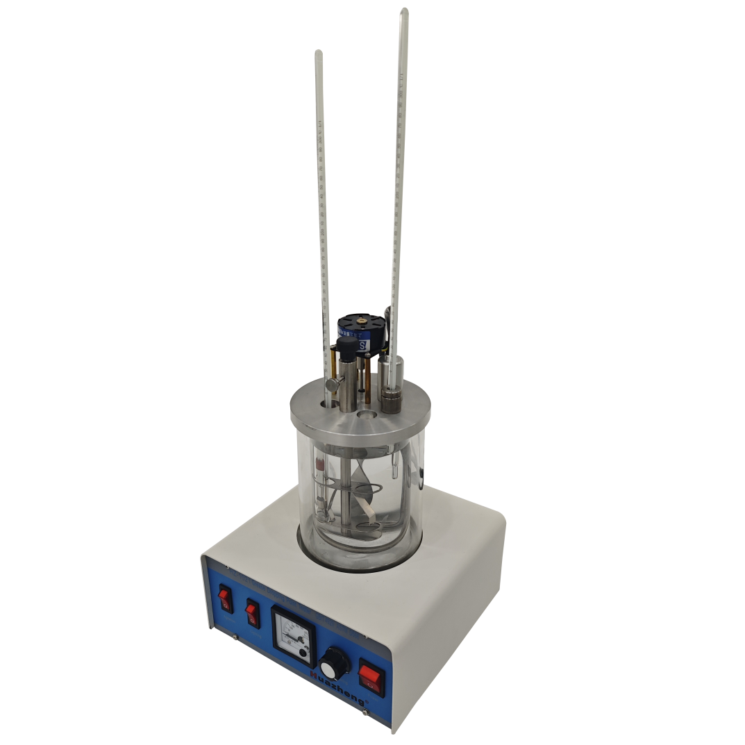

Huazheng Electric Manufacturing (Baoding) Co., Ltd

Contents

I. Overview 1
II. Instrument Structure 1
III. Technical Parameters 1
IV. Installation and Use 1
V. Fault Resolution 2
VI. Notes 3
VII. Packing List 4

Overview
HZ-1021 Dropping Point Tester for Lubricating Grease is designed and manufactured as per the standards of GB/T 4929 of National Standard of People’s Republic of China and ASTM D566. This instrument is uesd to determine the dropping point of lubricating grease, which is widely used in petrochemical, defense, scientific research and transportation industries.

Instrument Structure
HZ-1021 Dropping Point Tester for Lubricating Grease mainly consists of electric heating control system, oil bath, cuvette, thermometer clamps, lighting and agitating system, etc, with the advantages of reasonable structural design, easy to operate, compact and flexible.
Heating control system mainly consists of electric heating tube and the regulating circuit for the rate of temperature rise.
The heating tube is that internally heated heating tube, low energy consumption, high thermal efficiency. The regulating circuit for heating rate uses the solid-state relay as a control and action components, with the features of high integration, stable performance, reliable quality, small size, etc. The analog
voltage meter indicates the working voltage of the heating tube, intuitive and accurate.
The oil bath is double-deck (two cylinders) structure. The inside cylinder is a flask of 600ml, and the external cylinder has the functions of insulated and anti-leak. The cuvette holder is constituted by the two springs, firm and easy to install, by which the cuvette is fixed to insert the cuvette between the two pieces of spring.
The thermometer holder has two parts of the screws and nuts. There is an oil resistant rubber O-ring between the screw and nut. Put the thermometer into the O-ring, and tighten the screws to fix the O-ring to hold the thermometer. There is a rubber ring at the bottom of the thermometer to locate the thermometer. As a result of that way, it is very easy to install the thermometer, without any adjustment, that you can make it meet the standard.

Technical Parameters
(1) Heating power: 0~300W continuously adjustable
(2) Agitating rate: 375r/min
(3) Working power: AC 220V 50Hz
(4) Light: 12V 20W

Installation and Use
(1) After opening the wooden box of the instrument, examine the instrument and accessories whether they are well or not.
Note: If the accessories are not complete or are damaged, please contact us immediately.
(2) Pour the right amount of heating medium into the bath, and cover slowly the bath, so that the upper extreme of the bath(cylinder) can match up the groove of the cover, to make the two cylinders and the cover coaxial.
(3) Insert the cuvette filled with the oil sample into the hole in the cover, located by the V-shape metal block, fixed by the two springs. And the inserting depth is according to the standard.
(4) Thermometer installation: put the thermometer into the 0-ring at the right position. Make the screw and the nut of the thermometer holder tightened from the two ends of the thermometer, to tighten the 0-ring and lock the thermometer. In this way, the inserting depth and the location of the thermometer is supposed to meet the standard.
(5) Socket the load plug on the instrument, and connect the power plug. Turn on the power and then turn on the light switch and the agitation switch.
(6) Clockwise rotate slowly the temperature rise rate adjustment knob, and record the temperature rise rate in the bath through observing the thermometer in the bath.
Note: The temperature control system began to work after the power switch is turned on, so the bath must be filled with the heating medium before the power switch is turned on.

Fault Resolution
Under normal conditions, turn on the power switch, the power indicator is light; turn on the lighting switch, the light should be on; turn on the agitation switch, the motor began to work. To clockwise rotate the temperature rise rate adjustment knob, from the voltmeter, you can observe that the working voltage of the heating tube is continuously adjustable from 0 to 220V.
But if something is wrong with the instrument, the situations above-mentioned will be unnormal.
If one of the following faults has been discovered, please solve it referring to the table:
Phenomenon | Reason | Elimination
No power or the power indicator isn’t light | Fuse is bad | Change a good one
No power or the power indicator isn’t light | The main circuit is broken | Check it and connect it
No power or the power indicator isn’t light | Switch is bad | Change a good one
Agitation motor doesn’t work | Agitator bearing is too tight | Loose the screw and readjust it
Agitation motor doesn’t work | The motor is bad | Change a good one
Agitation motor doesn’t work | Motor circuit is broken | Check it and connect it
The light doesn’t work | The light is bad | Change a good one
The light doesn’t work | The ballast is bad | Change a good one
The light doesn’t work | Socket connector isn’t connecting well | Check it and connect it
Heating power is adjustable, but the voltmeter doesn’t work | The voltmeter is bad | Change a good one
Heating power is adjustable, but the voltmeter doesn’t work | Related circuit is broken | Check it and connect it
Heating power can not be adjusted, and the voltmeter only indicates 0V or 220V | Potentiometer circuit is broken | Check it and connect it
 | The solid-state relay is bad | Change a good one
 | Potentiometer circuit has short trouble | Check and eliminate it
The adjustable range of heating voltage is narrow | The solid-state relay is bad | Change a good one

Notes
(1)Keep the apparatus clean. Keep the electronic-controlled part from moisture and water. Keep the apparatus from the dirty things like oil sample.
(2)It must have good connection with ground to ensure the operator’s safety before operating.
(3) The amount of the heating medium must be suitable to avoid spilling out and dry-heating.
(4)When the fault appears, ask a professional person to handle, and forbit dismantling at will.
(5) This instrument has warranty of one year.

Packing List
No. | Item | Qty
1 | Certification & Specifications | 1each
2 | Main Part | 1
3 | Thermometer(-5～300℃) | 3
4 | Fuse (15A) | 2
5 | Rubber Plug | 2
6 | Grease Cup | 2
7 | Cuvette | 2
8 | Rubber Ring | 2
9 | Cylinder | 2
10 | Metal Stick(H=150mm) | 1

