HZJC-3
Contact Angle Measuring Device

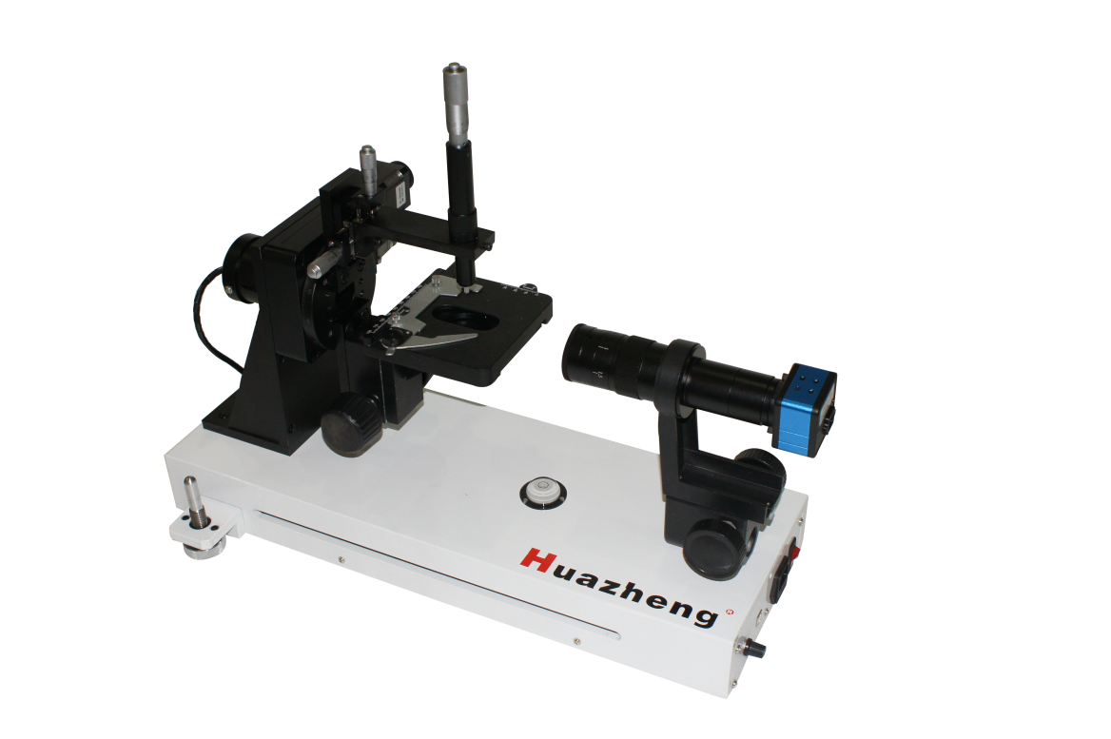

Huazheng Electric Manufacturing (Baoding) Co., Ltd

Contents

I. Overview 1
II. Main structure and technical index 1
1. Main structure 1
2. Performance and index of hardware 2
1) Industrial Camera 2
2) Microscope 2
3) Focusing frame 3
4) The stage below 3
5) The stage above 3
6) Sample injector 3
7) Backlight 3
3. Software function 3
1) Take pictures 3
2) Video recording and video analysis 4
3) Contact angle measurement 4
4) Surface energy calculation 4
5) Picture and data management 4
III. Contact angle overview 5
1. Wetting and contact angle 5
2. Wetting process 6
1) Adhesion 6
2) Immersion 7
3) Spreading 7
3. Contact angle and wetting equation 9
4. Determination of contact angle 10
4) Tangent angle measurement 11
5) Measuring height method 11
6) Angle measuring method 12
7) Automatic measurement method 12
8) Measurement of Advance Angle and Recession Angle by Droplet Volume Method 13
IV. Instrument installation 14
V. Instrument operation 14
1. Inspection before use 15
2. Software Installation and Start-up 15
3. Operation 17
1) Video image adjustment 17
2) Basic process of contact angle test 18
3) Video recording and timed photography 19
4) Video playback and capture 20
5) Contact angle analysis 21
4. Document management 28
1) Save Project 28
2) Open Project 29
3) Export Data 29
4) Add Picture 29
5) Save Picture 29
6) Delete Picture 29
5. Surface energy analysis 30
1) Fowkes equation 30
2) Owens equation 31
3) YGGF equation 32
VI. Precautions For Use 33
VII. Packing list 34

I. Overview
The contact angle measuring device is used to measure the contact angle formed between solid-liquid-gas three-phase interfaces, and then analyze the interaction between three-phase media, and thus analyze the surface energy of solids and other data. Contact angle measuring device is a necessary instrument for thermodynamics, physical chemistry and surface chemistry.
Our contact angle measuring device adopts a high-resolution industrial camera and a microscope lens, which obtains a clear interface image by photographing a solid-liquid-gas three-phase interface.
The camera provides a video recording function, which can record every moment of change for a high-speed changing interface, and then capture the key images of its changes for analysis through playback at any speed.
The software adopts the latest international contact angle measurement and surface energy calculation method. A variety of contact angle measurement methods and surface energy calculation methods can be directly compared in order to find the ideal measurement and calculation method in line with the interface.
The contact angle measuring device is widely used in petroleum, chemical industry, medicine, manufacturing, dyestuff and other areas, and is suitable for universities, research institutes, machinery, factories and other departments.

II. Main structure and technical index

Main structure
The instrument is mainly shown in Figure 1-1.
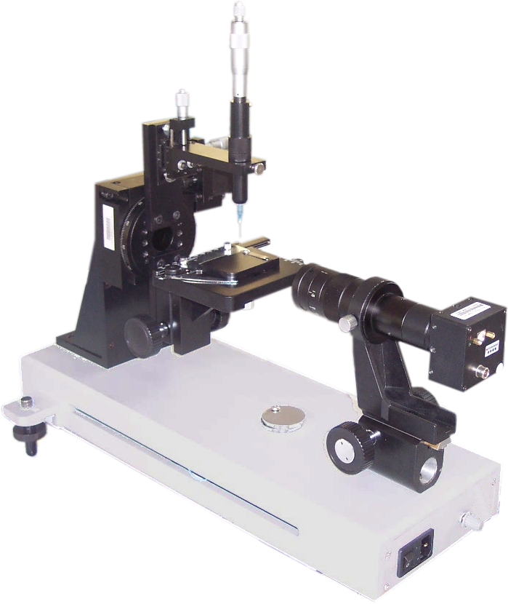
Dripper adjustment knob
Capillary needle tubing
Stage

Lifting handwheel of stage
Microscope lens
Industrial Camera
Focusing handwheel
Gradienter
Anchor screw
Sampler
Figure 1－1 Main structure of contact angle measuring device

Performance and index of hardware

Industrial Camera
Color mode: colorful
Maximum resolution:2048*1536 pixels
Minimum resolution: 640*480 pixels
Video frame rate: maximum frame rate 25FPS。

Microscope
Zoom ratio:0.7~4.5X
Magnification:30~130
Distance:95mm
Tube length:168mm
Angle of view:18mm

Focusing frame
F-type focusing frame
Adjustment range:60mm

The stage below
Modes of movement: Manual movement, smooth optical components
Stage dimensions:125*95mm
X direction (horizontal):80mm,precision0.1mm
Y direction (longitudinal):30mm,precision0.1mm
Z direction (up and down):50mm

The stage above
Size:70*45mm, fillet on one side

Sample injector
Minimum injection volume resolution:2.5μL
Adjustable upper and lower range:12mm
Adjustable left and right range:12mm
Sample injector capacity:5mL

Backlight
The light source is a semiconductor cold light source, and the measurement is continuously adjustable.

Software function

Take pictures
Single photo shooting and continuous photo shooting (the interval time can be set arbitrarily)
Photo resolution:1280*960、1024*768、800*600、640*480
Picture preview function
Image gain adjustment function, brightness adjustment function

Video recording and video analysis
Replay the video
Replay a snapshot
Capture photos frame by frame
It can play forward and backward in a single frame

Contact angle measurement
Automatic measurement method: pictures with obvious baseline position characteristics can be measured automatically, and pictures with no obvious baseline characteristics need to be manually marked with baseline position.
Measurement by measuring the height: draw the baseline rectangle of the droplet and calculate the contact angle automatically.
Measurement by measuring the angle: measured by protractor tool
Tangent method: a completely manual way to calculate the contact angle by drawing the base line and the tangent line

Surface energy calculation
Fowkes equation, Owens equation and YGGF equation are provided.

Picture and data management
After the picture is taken, enters the thumbnail list.
You can add an existing picture to the thumbnail list.
You can save the picture to disk separately, and you can select the test tool on which the picture is drawn.
Click the thumbnail to open the analysis interface for contact angle analysis.
Various contact angle analysis results are automatically added to the results list.
The list of results can be exported as an Excel table.
The analysis results can be saved to the project file as a whole and can be opened again for editing.

III. Contact angle overview

Wetting and contact angle
Wetting is the process by which one liquid replaces another immiscible fluid on a solid surface. Thus, wetting necessarily involves three phases, two of which are fluids. A common wetting phenomenon is the replacement of gas by liquid on a solid surface.
Wetting is one of the most common phenomena, and it is also an important process in human life and production. It is no exaggeration to say that without wetting, human beings will be difficult to survive. Because if there is no wetting effect, the life activities of animals and plants cannot be carried out (please imagine the consequences of water not wetting soil, animals and plants). In addition, wetting is the basis of many production processes. For example, mechanical lubrication, water injection and oil production, washing, printing and dyeing, welding and so on are all closely related to wetting. Of course, wetting is not always required in human life and production, but sometimes non-wetting is required. For example, mineral flotation often requires that useful minerals are not wetted by water; Rainproof cloth, waterproof and anti-adhesion coating are required to form a non- wetted surface.
Then, under what conditions can liquids wet solids, and how to change the wetting properties of liquids and solids to meet people's needs? It is necessary to study the contact characteristics between solids, liquids and gases.
In addition, because wetting phenomenon is the macroscopic expression of micro characteristics such as the structure and properties of solid surface, the properties of liquid surface and interface, and the interaction between solid and liquid molecules, the study of wetting phenomenon can provide useful knowledge for understanding the properties of solid surface that are not easy to obtain.
The wetting characteristics of liquid to solid can be measured by the contact angle of solid-liquid-gas three-phase, and the measurement of contact angle can also be used to analyze the surface energy, surface tension and many other characteristics of the solid surface, so it is inevitable to involve the measurement of contact angle when studying the wetting characteristics of liquid to solid and the surface characteristics of solid.

Wetting process
Wetting processes can be divided into three categories: adhesion, immersion, and spreading, each of which plays a role in different practical problems. The nature of these processes and the conditions under which they are automated are discussed separately below. The essence of these processes and the conditions for automatic implementation are discussed below.

Adhesion
Adhesion refers to the process in which liquid and solid change from no contact to contact, and liquid-gas interface and solid-gas interface change to solid-liquid interface (Figure 2-1). For example, can pesticide sprays be effectively attached to plant branches and leaves? Will the raindrops stick to the clothes? These are all questions about whether the adhesion can be automated.
Figure 2-1 Adhesion
The contact area formed is assumed to be one unit value, the free energy reduction (-△ G) of the system in this process should be:
（2－1）
In the formula，is the free energy of gas-solid interface; is the free energy of liquid surface; is the free energy of solid-liquid interface;is the work of adhesion, which is the maximum work that can be done to the outside in the adhesion, and is also the minimum work required to pull the solid and liquid in contact away from the outside from the junction. Obviously, the larger this value is, the stronger the combination of solid and liquid is. Therefore, reflects the binding capacity of the solid-liquid interface and the interaction force between the molecules of the two phases. According to the second law of thermodynamics, under the condition of constant temperature and pressure, the process of >0 is a natural process. This is the condition under which adhesion occurs.

Figure 2-2 Immersion

Immersion
Immersion refers to the process by which a solid is immersed in a liquid. Soaking clothes in water is the process of soaking. The essence of this process is that the solid-gas interface is replaced by the solid-liquid interface, while the liquid surface does not change in this process, as shown in Figure 2-2. When the Immersion area is one unit value, the free energy reduction of this process is:
（2－2）
is the work of immersion, which reflects the ability of liquid to replace gas (or another immiscible fluid) on the surface of solid,>0 is the criterion of whether the wetting process can be carried out automatically.

Spreading
Spreading processes are used in a variety of industries in order to uniformly form a thin layer of fluid on a solid substrate. At this time, it is not only required that the liquid can be attached to the plant branches and leaves to produce efficacy, but also can be spread by itself, so as to cover the largest area and achieve the best plant protection effect. The essence of the spreading process is to replace the gas-solid interface with the solid-liquid interface and expand the gas-liquid interface (Figure 2-3). When the spreading area is one unit value, the free energy of the system decreases to
（2－3）
S is called the spreading coefficient. At constant temperature and pressure, when S > 0, the liquid can automatically spread on the solid surface and continuously replace the gas from the solid surface. As long as the amount is sufficient, the liquid will spread itself over the solid surface. Combining Formula 2-2 and Formula 2-3 gives
L
G
S
a
b
Figure 2-3 Spreading liquid on solid铺展
If this equation is to show that the spreading system S>0, then must be greater than 。 is the surface tension of the liquid, characterizing the ability of the liquid to contract the surface. Correspondingly, represents the ability of adhesion between solid and liquid. Therefore, it is also called adhesion tension and is represented by the symbol A
（2－4）
The conditions under which the three wetting processes occur spontaneously can all be expressed in terms of adhesive tension.
（2－5）
（2－6）
（2－7）
Because the surface tension of the liquid is always a positive value, for the same system >>S, the system that can spread by itself, other wetting processes can be carried out automatically. Therefore, the spreading coefficient is often used as the wetting index of the system.
It can also be seen from equations 2－5, 2－6 and 2－7 that the influence of solid surface energy on the wetting characteristics of the system is exerted by the adhesion tension A. The common rule is that the greater the solid-gas interfacial energy and the smaller the solid-liquid interfacial energy, that is, the greater the adhesion tension, the more conducive to wetting. The effects of liquid surface tension on the three wetting processes are different: The largeris more favorable for adhesion, the smaller is more favorable for spreading, and the surface tension of the liquid is irrelevant for immersion.
A conclusion should be drawn from the above content: according to the value of the relevant interfacial energy, it can be judged whether the various wetting processes are carried out automatically, and then the required wetting effect can be achieved by changing the corresponding interfacial energy. But in fact, it is not so simple, it is not easy to change various interfaces at will, and the values of the interface energy are not all available. Of the three interfaces, only the liquid surface tension can be conveniently measured. Therefore, it is actually difficult to apply the above wetting judgment. However, in the case of solid-liquid contact with contact angle, the relationship between contact angle and interfacial energy has been found a long time ago, which provides convenience for the study of wetting phenomena.

Contact angle and wetting equation
When a drop of liquid is placed on a solid surface, the liquid either spreads over the solid surface or forms a drop that rests on it, as shown in Figure 2-4, depending on its nature. The shape of the formed droplet can be described by the contact angle. The contact angle is the angle from the solid-liquid interface through the inside of the liquid to the gas-liquid interface at the interface of solid-liquid-gas three phases, represented byθ. The relationship between the equilibrium contact angle and the three interfacial free energies is as follows:
（2－8）
θ
Figure 2-4 Sketch of contact angle
This equation was first proposed by T. Young in 1805 and is often called Young's equation. It is the basic formula of wetting, also known as the wetting equation. It can be seen as the result of the equilibrium of the three interfacial tensions at the triple junction. This relationship is applicable to the equilibrium system with solid-liquid and solid-gas continuous surfaces. Although the wetting equation derived by mechanical method is completely correct, due to the inhomogeneity of solid interface, the properties of solid-liquid and solid-gas interfacial tension are not easy to understand, and many thermodynamic methods have been used to derive the wetting equation. Here is one of them.
Assuming that a liquid drop stopping on a solid surface expands the solid-liquid interfacial area dA under equilibrium conditions, the corresponding increment of the gas-liquid interfacial area is dAcos(θ-dθ) (as shown in Figure 2-5), and the free energy change of the system is
In deriving this expression, the value of dθ is ignored because it is very small. Since this is a change under equilibrium conditions,△G=0, and the wetting equation is given by
θ
θ-dθ
dA·cos(θ-dθ)
dA
Figure 2-5 Contact angle and interfacial energy
Combining the wetting equation with Equations 2－1, 2－2, and 2－3 yields
（2－10）
（2－11）
（2－12）
Therefore, in principle, the values of adhesion work, adhesion tension and spreading coefficient can be obtained by measuring the surface tension and contact angle of the liquid, thus solving the difficulty of applying various wetting judgments. It is easy to see from Equations 2－10, 2－11, and 2－12 that the magnitude of the contact angle is a good wetting criterion. The smaller the contact angle, the better the wettability. It is customary to defineθ=90°as the criterion for wetness. θ>90° is non-wetting, θ<90°is wetting, and an equilibrium contact angle equal to 0 or there is no spreading.

Determination of contact angle
θ
Figure 2-6 Tangent angle measurement
There are many methods to measure the contact angle, which can be divided into four categories according to the physical quantity directly measured: static drop method (angle measurement method), length measurement method, force measurement method and penetration measurement method. The former three methods are suitable for continuous flat solid surface, and the latter method can be used for contact angle determination of powder solid surface. The instrument supports the following basic test method.

Tangent angle measurement
This is the most widely used and the most direct method. As shown in Figure 2－6, put a drop of liquid on the solid surface, take a picture through the instrument, and then regard the part of the liquid drop close to the solid surface as an arc. With the support of software, make a tangent line to the arc, and then measure the angle between the tangent line and the solid surface. The method has the advantages of simple process and convenient measurement, and can adapt to droplets with different angles. The disadvantage is that it is easy to produce large human errors.

Measuring height method
In order to avoid the difficulty of drawing a tangent line and eliminate the error of manual operation, a method for calculating the contact angle from the length measurement data is developed. It is based on the fact that for a small droplet, its shape can be regarded as a part of a sphere. The height of the droplet and the length of the bottom surface are measured on the picture of the droplet, as shown in Figure 2-7. The contact angle can be obtained according to the following formula.
Figure 2-7 Measuring height method
h
2r
or
The premise of this method is that the droplet is small enough that its gravitational effect can be neglected, when the droplet edge is part of the sphere under the action of surface tension. The premise of this method is that the
droplet is small enough that its gravitational effect can be neglected, when the droplet edge is part of the sphere under the action of surface tension.
A
B
C
Figure 2-8 Angular measurement steps

Angle measuring method
The angle measurement method is to use the software to simulate the square, and measure the tangent angle of the ball through the movement and rotation of the square. First, draw the right angle protractor so that it is tangent to the droplet circle, as shown in Figure 2-8 A. Then move the protractor downward so that its right-angle fixed point coincides with the fixed point of the droplet circle, as shown in Fig. 2-8 B. Rotate the protractor with the vertex of the right angle as the origin, so that one of its right-angle sides coincides with the adjacent three-phase junction point, and the contact angle can be calculated according to the rotation angle, as shown in Figure 2-8 C.
The characteristics of this method are the same as those of the chord height length method, and the advantages are that the measurement is more accurate and less artificial error. But that droplet need to be round and land on a flat surface.

Automatic measurement method
The automatic measurement method uses machine vision technology to extract the contour line of the droplet, and the shape characteristics of the droplet are obtained by analyzing the contour line. Because the droplet is affected by gravity, it will not maintain the ideal spherical crown shape, so the height measurement method and angle measurement method will form a larger error. After the automatic measurement and extraction of droplet characteristics, the quadratic equation of the droplet will be obtained according to the shape of the droplet, and the tangent equation of the triangular intersection point will be automatically calculated according to the baseline position. At present, it is a method with high accuracy.
Figure 2-9 Schematic diagram of automatic measurement

After the droplet contacts with the solid surface, the wetting degree will change with the passage of time, especially on the surface of rough objects. This phenomenon is more obvious. At this time, it is necessary to test its dynamic change process, which is generally expressed by its advance angle and retreat angle.

Measurement of Advance Angle and Recession Angle by Droplet Volume Method
θ_{a}
θ_{r}
Figure2-10 Advance angle and recession angle
Actual solid surfaces are generally non-ideal surfaces, and the hysteresis of contact angle always occurs. Therefore, it is generally necessary to simultaneously measure the advancing angle and the receding angle of the contact angle. As shown in Figure 2-10, the injector controls the volume of the droplet while taking continuous pictures. The advancing angle can be measured by increasing the droplet volume, and the receding angle can be measured by decreasing the droplet volume. It should be noted that the capillary tip is inserted into the droplet during the measurement.

IV. Instrument installation
After opening the equipment box, first check whether the accessories are complete according to the packing list. If the accessories are missing, please contact our company immediately.
Install the main machine of the contact angle measuring device on a stable and vibration free workbench, and adjust the equipment to a horizontal state according to the instructions of the level.
Install the accessories in the following order:
- Install the industrial camera and the microscope lens assembly on the focusing frame and ensure that they are installed firmly. The industrial camera should be in a horizontal position. If it is uncertain, it can be adjusted according to the baseline after the software is installed.
- Unscrew the injector assembly from the middle knurled position, use a syringe to suck the test liquid, then put it into the injector cartridge, adjust the position of the screw micrometer, and then install the injector. With the needle pointing upwards, rotate the micrometer head to expel the air from the needle tube. Install the sample injector on the sample injector rack and fasten it.
- Install the computer near the equipment, and then connect the contact angle measuring device to the computer according to the interface instructions in Figure 3－1. Both the contact angle measuring device and the computer use a single-phase three-wire power supply with reliable grounding protection.

V. Instrument operation

Inspection before use
- 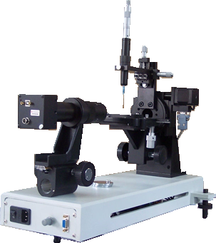All signals and control lines are connected correctly.
Digital video output interface connected to computer USB interface.
The power interface shall be of single-phase three-wire system with reliable grounding protection.
Light source brightness adjustment knob.
Figure 3－1 Interface description and wiring description
- The power supply of the computer and the instrument shall be reliably connected and well grounded.
- Check again if the instrument is horizontal.
- Turn on the power supply of the instrument host and adjust the backlight so that the brightness of the backlight is at a moderate position.
- Insert the camera signal cable into the host USB interface.

Software Installation and Start-up
Run the "JY _ PHbAngleSetup. Exe" "program in the accompanying software disk

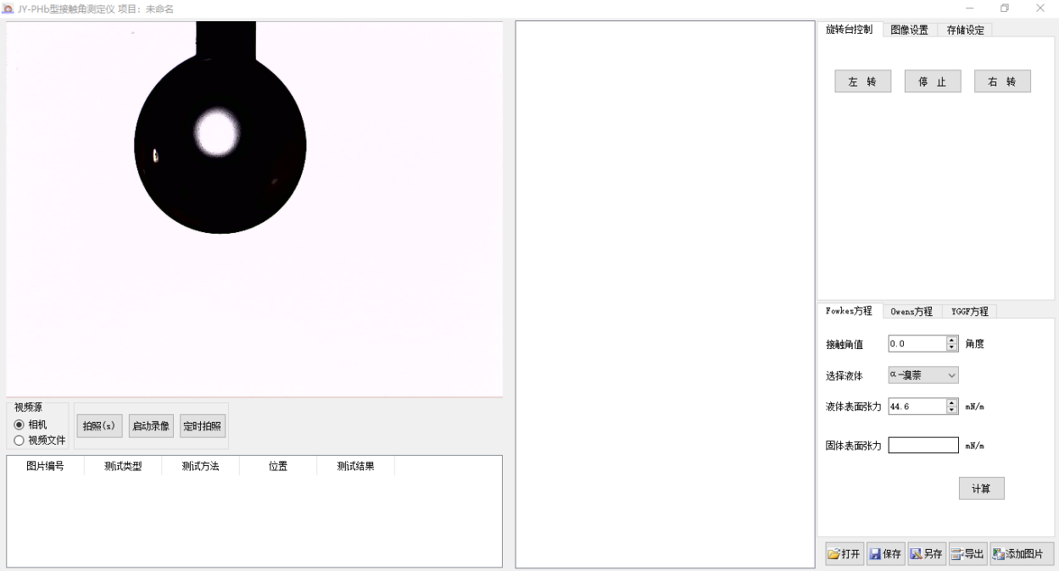
Main interface of the software
and click" Next "completely according to the default until the installation is completed. Double-click the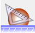icon to enter the software. The interface after entering the software is as shown in the figure below.
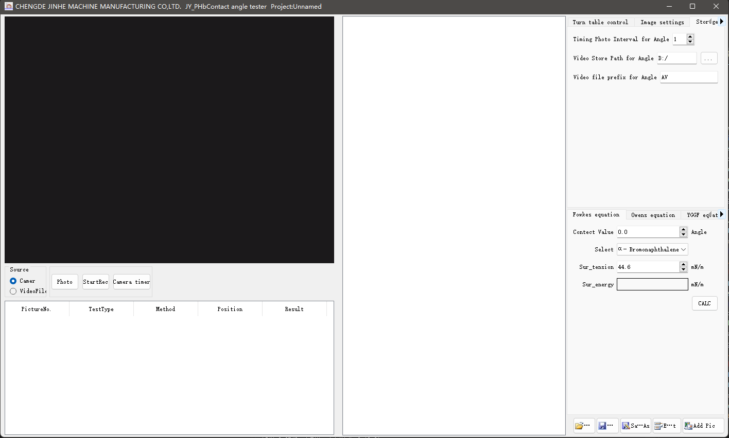
Add Pic
ProjSaveAs
OpenProject
ExportData
SaveProject
If the camera is not installed when starting the software, the following prompt will appear:
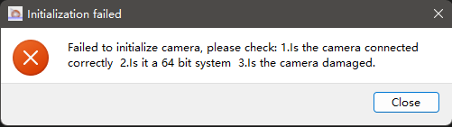
The camera is not installed correctly.
After confirmation, the software will exit automatically. Please reconnect the camera and enter again.

Operation

Video image adjustment
Install the injector and form a small drop on the needle for easy focusing.
Observe the droplet image in the preview window of the software. If the droplet image is not in the center of the image, move the image to the center of the picture by adjusting the micrometer screw at the bottom.
Adjust the zoom ring on the lens so that the droplet is in the right position, and adjust the focus knob on the lens bracket so that the droplet picture is in the best clear state. As shown in the following figure:
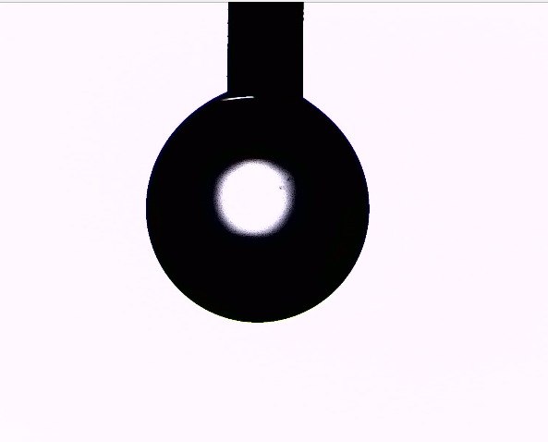
Ideal picture after adjustment
Picture background brightness adjustment
The image background is composed of backlight, brightness and contrast, and the backlight brightness knob is located at the main source, and the image brightness and contrast are at the upper right of the piece, as shown below:
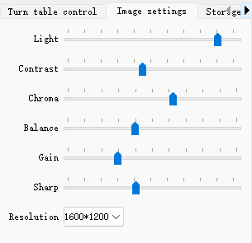
Image setting interface
The brightness, image brightness and contrast of backlight are properly adjusted to make the image reach the best.
The background is white. If the color is not correct, the chroma and white balance can be balanced to make the background color white.
The sharpness of the edges of the picture can be achieved by gain and adjusting the sharpness.
The resolution of an image can be adjusted to alter its resolution. If the computer screen resolution is low, 800*600 resolution is recommended, otherwise 1600*1200 image resolution is recommended.
In model JY_PHa/b, the backlight control is not valid.

Basic process of contact angle test
Functions such as video source, photo and video recording are under the video window, as shown in the following figure:
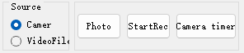
Camera operation interface
1）Place or fix the sample to be tested on the upper stage, and place the upper stage in the fixing clamp of the lower stage, so as to move the position. Be careful not to contaminate the surface of the sample when placing the sample, which will affect the test results.
2）Rotate the lifting handwheel of the stage to lift the stage, observe the position of the sample in the video, make the sample drop a little after contacting the droplet, make the droplet leave the injection needle, and form droplets on the sample.
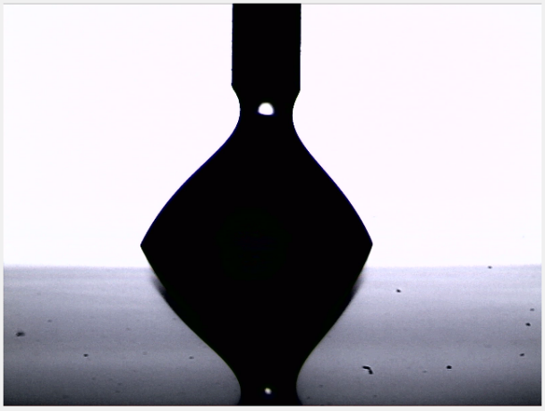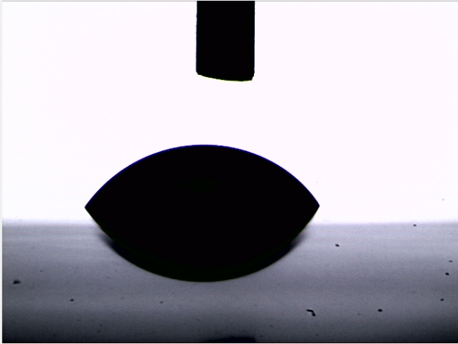
Droplet formation process during testing
3）Click the "Photo" button to take a photo. The photo appears in the thumbnail area and is numbered in order.
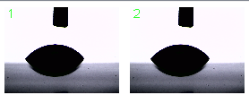
Thumbnail
4）Click the thumbnail or right click the thumbnail and select "Data Analysis" to enter the contact angle analysis interface for contact angle measurement.
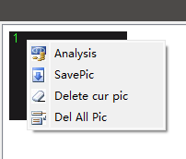

Video recording and timed photography
If there is a rapid change in the shape of the droplet after the liquid contacts the solid, or it is necessary to understand the formation and change of the droplet at every moment, you can click the "Start Video Recording" button during the dripping process to start video recording, or click the "Timing Photo" button to automatically take photos at intervals, and then operate the dripping process.
The settings of video file saving location and timing shooting are in the "Storage Settings" in the upper right corner of the software, as shown in the following figure:
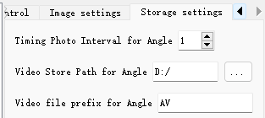
Storage Settings
"Contact angle timing photo interval", time unit is second.
"Contact Angle Video Storage Path" is the default storage location for the specified video, and is in fact the default working directory for the entire software.
"Contact angle video file prefix", the file name is automatically generated when the video file is recorded, and the character at the beginning of the file is set here; the system will start with the character specified here, add the current date and time, and finally add a random serial number of 2 digits to form a complete main file name. The file type is MP4.
Timed photos are placed in the internal storage. Due to the limitation of storage capacity, please do not take more than 100 pictures, otherwise the software may crash due to insufficient memory.

Video playback and capture
After recording, click "VideoFile" in the "Video Source" group to pop up a dialog box to open the video file. The name of the video file just recorded is composed of "prefix + date and time + 2 digits". Open the video after finding it. The video window is shown in the following figure:

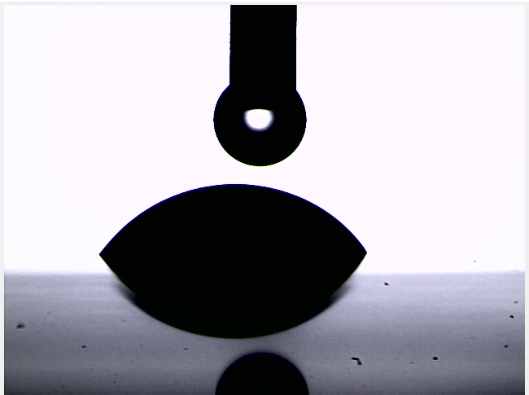
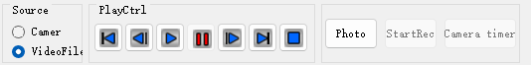
Video playback and capture
Playback control tools appear below the video, which are back to the beginning of the video, back one frame, normal play, pause, forward one frame, skip to the end of the video and exit video analysis.
Whether during video playback or when pausing, you can click the "take a picture" button to capture the current video picture. However, video recording and timing photography can no longer be started during video analysis.

Contact angle analysis
Click a picture to be analyzed to enter the contact angle analysis interface, as shown in the following figure:
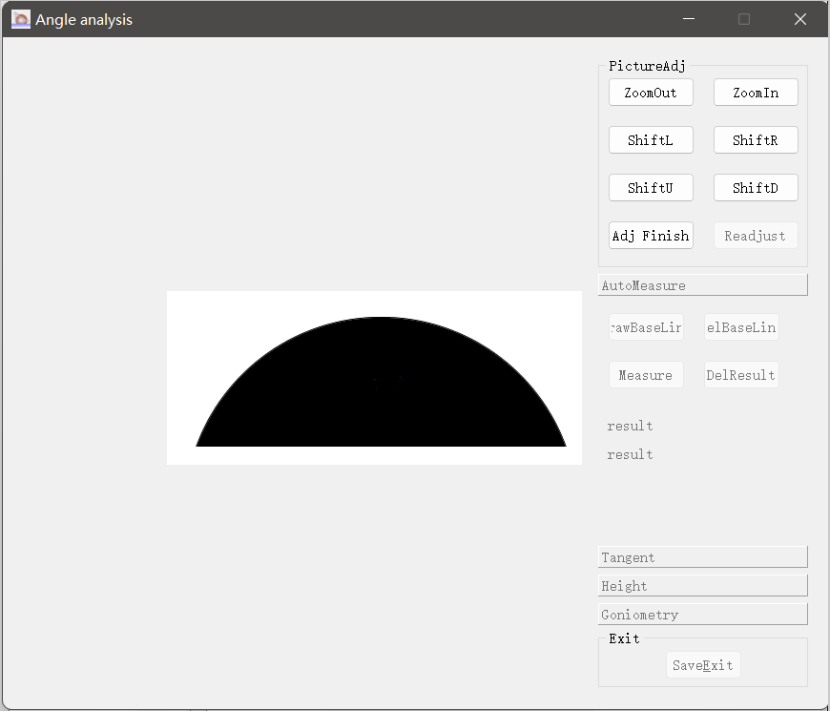
Main interface of contact angle analysis
If the screen is relatively small, but the picture taken is relatively large, the graphic preview area may not be fully displayed. Please use the adjustment tool on the right to adjust it. The adjustment tool is shown in the following figure:
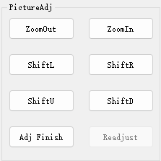
Picture adjustment tool
After the image is in the appropriate position, click "Adjustment Complete", and the analysis tool becomes available.
- Automatic measurement
When you select the automatic measurement tool group, the following tools are displayed:
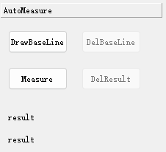
Automatic measuring tool
Directly click the "Measurement" button, and the measurement results will be displayed below. And the measurement tool will be drawn on the picture, as shown in the following figure:
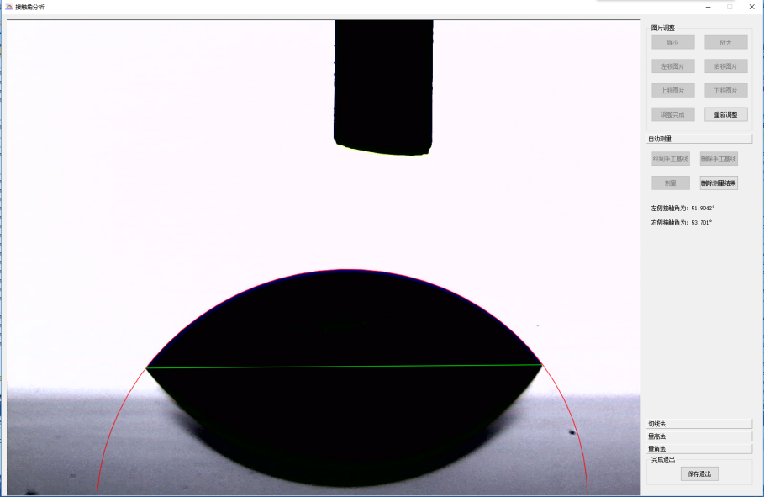
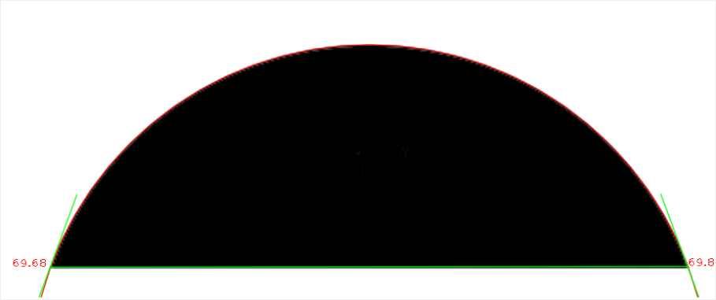
Automatic measurement results
Manual baselines need to be drawn in the following cases:
①If the contact angle is close to 90 degrees, the droplet image and the reflection form a nearly circular shape, and the computer vision system will not be able to distinguish the position of the baseline, then it is necessary to specify the manual baseline.
②If there are shadows or other interference factors at the baseline position, the baseline cannot be identified.
When drawing the baseline, click the "Draw Manual Baseline" button, press and drag the mouse on the image to draw a straight line, and then adjust the position of the straight line to make it coincide with the two three-phase junction points.
2）Tangent measurement
Click the Tangent Method tool group, and the following tools will be displayed:
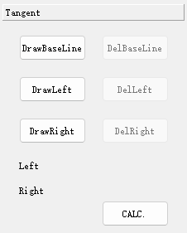
Tangent method tool
First, click the "Draw Baseline" button to mark the baseline position in the image, then click the "Draw Left Tangent" and "Draw Right Tangent" buttons respectively to draw the left and right tangents, and then click "Display Result" to complete the measurement.
Tangent method is the most traditional contact angle measurement method, which is flexible and convenient to use. However, the tangency between the line and the arc is completely identified by the operator in the operation, which is seriously affected by human factors.
If a tangent is not needed or needs to be redrawn, you can click the corresponding Delete button on the right to delete it. The graph of the test completion is shown in the following figure:
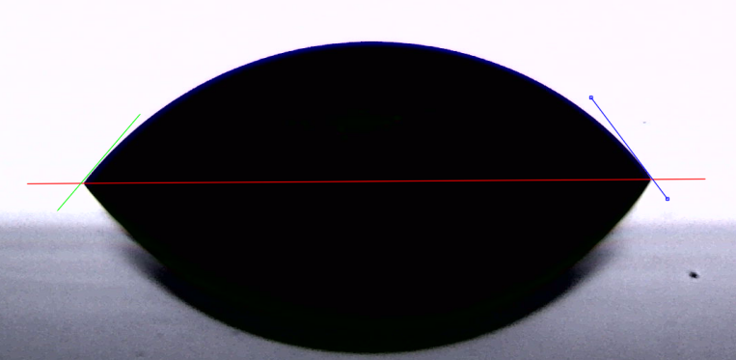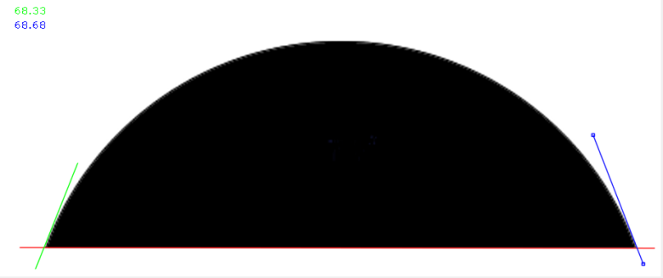
Drawing results by tangent method
3）Height measuring method
The height measurement method is based on the chord length and arc height, and the tangent angle is calculated according to trigonometric function. This method treats the droplet as a part of an ideal circle, so the droplet should be as small as possible to reduce the influence of gravity on the spherical cap.
The tool of the height measurement method is shown in the following figure:
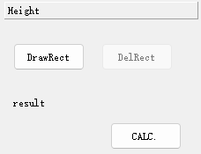
Height measuring method tool
Click the "Draw Rectangle" button, press and drag the mouse from the left triangular intersection point to the right triangular intersection point, then select the rectangle, adjust the upper edge of the rectangle to coincide with the highest point of the spherical crown, and then click "Display Result" to complete the measurement.
The measurement picture is shown in the figure below:
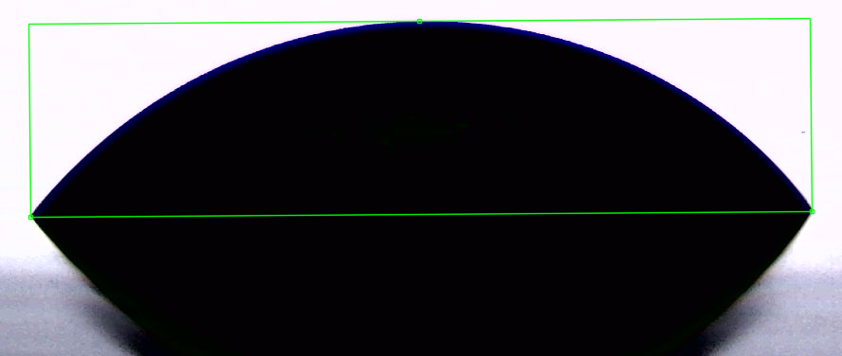
Results of height measuring method
4）Angle measurement
Angle measurement requires the use of a virtual protractor to measure the tangent angle by means of tangency, rotation, etc. Its basic principle is the same as the method of measuring height, which also regards the droplet as a part of a circle.
Click the tool group of angle measurement method, and the tool is as shown in the figure below:
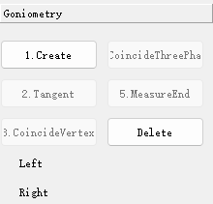
Angle measurement tool
The measurement process is divided into five steps, which are described as follows:
- Create protractor
Click the Create Protractor button to draw a line from left to right along the baseline to automatically form a right-angled isosceles triangle with the hypotenuse coinciding with the baseline. As shown in the following figure:
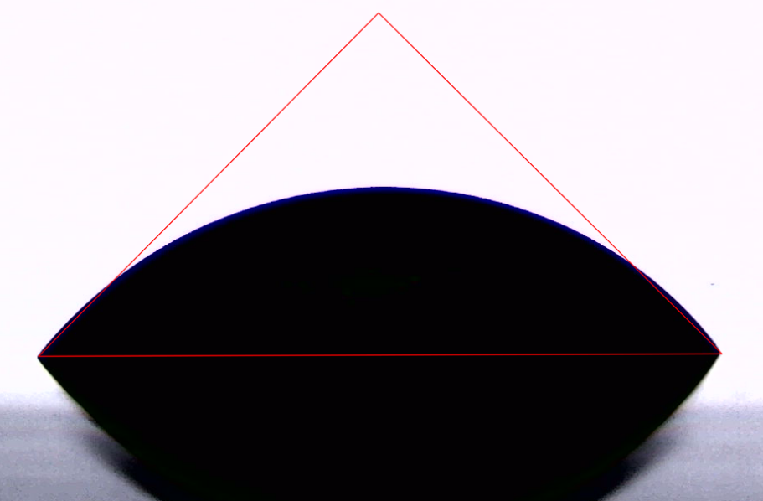
Drawing result of creating protractor
- Tangent to the outer circle
Click the "Tangent to Outer Circle" button to adjust the two right angle sides of the protractor to be tangent to the arc. As shown in the following figure:
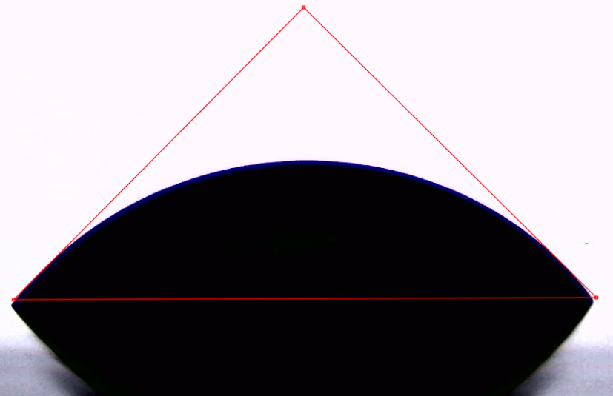
Tangent to the outer circle drawing result
- Coincide with vertex
Click the "coincide with vertex" button to adjust the right angle vertex of the protractor to coincide with the arc. At this time, the protractor can only move along a certain straight line. As shown in the following figure:
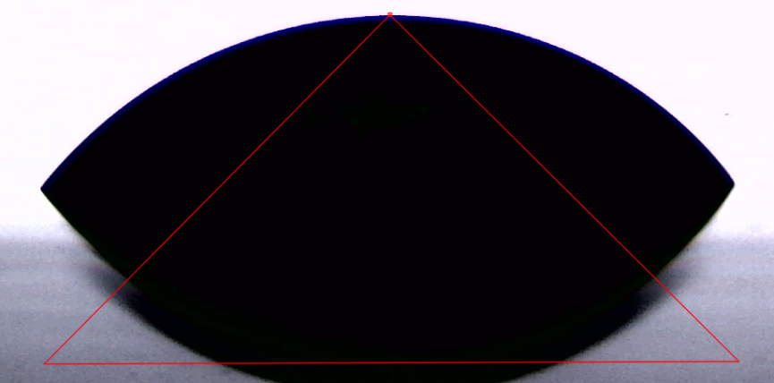
Drawing result of coincidence with vertex drawing result
- Coincidence of junction points
Click the "junction point coincidence" button, move the two endpoints of the triangle bevel to coincide with the three-phase junction points on the corresponding side. As shown in the following figure:
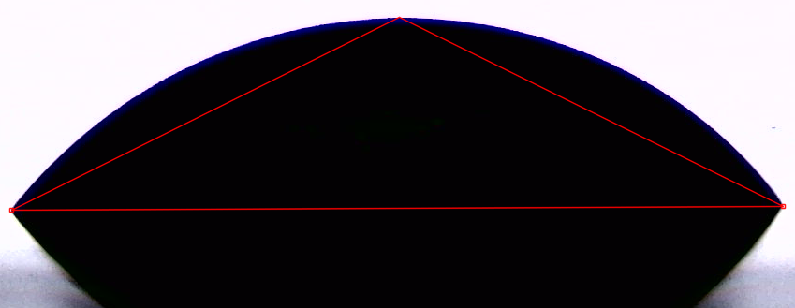
Drawing result of coincidence with three-phase junction point
Then click "5.MeasureEnd" to complete the measurement.
You can use only one method to analyze, or you can use multiple methods to analyze at the same time, and finally compare the results. After the analysis, click the "Save and Exit" button to exit the analysis window, and the analysis results will be added to the data table below the video window, as shown in the following figure:
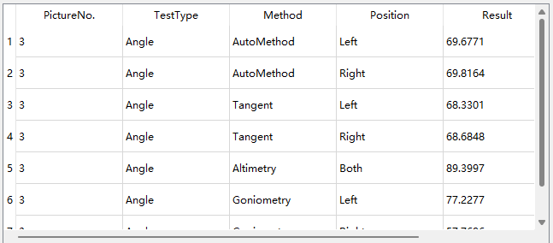
List of test data

Document management
The document management feature has two entries, a toolbar in the lower right corner of the main window, and a context menu for right-clicking on thumbnails. The toolbar is shown in the following figure:
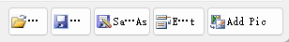
OpenProject
SaveProject
Add Pic
ExportData
ProjSaveAs

Main window toolbar

Save Project
The whole test result can be saved as a project, including test pictures, drawn test tools, test results and other data, which can be accessed and modified at any time after saving.
Click the "Save" button on the toolbar to pop up the save dialog box. Enter the file name and save it.
When you click Save again, you will not be prompted to enter the file name. If you need to change the name to save, please click the "Save As" button.

Open Project
Click the "Open" button in the toolbar to pop up the Open Project dialog box, and select a project to open. After the project is opened, you can still delete pictures, add pictures, and retest.

Export Data
The data in the result table can be saved in Excel format. Click the "Export" button in the toolbar to pop up the save dialog box. Enter the file name to save the test data as an Excel file.

Add Picture
Click the "Add Picture" button in the toolbar to add the existing picture to the project, and perform contact angle analysis like the picture taken from the camera.

Save Picture
Right click on the thumbnail and select "SavePic" to pop up a dialog box for selecting to save the picture. You can save the original picture and the picture drawn with various analysis tools respectively in the document for easy reference. The Save dialog box looks like this:
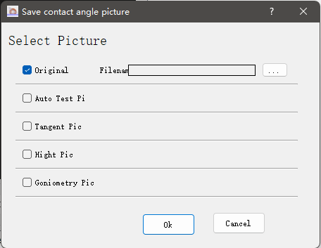
Save Picture dialog box
Select the corresponding analysis picture, enter the file name, and click OK.

Delete Picture
Right-click the thumbnail and select "Delete Current Picture" or "Delete All Pictures" to delete a picture from the project.

Surface energy analysis
This software provides Fowkes equation, Qwens equation and YGGF equation, which can calculate the surface energy of solids by inputting the parameters of these equations. It also provides the relevant parameters of typical liquids, which can be used selectively.

Fowkes equation
According to Fowkes equation, the surface tension can be composed of two parts: one is the London dispersive force $γ^{d}$, and the other is the non-dispersive force composed of dipole force, hydrogen bond and inductive force, and only the London dispersive force is considered to act on the liquid-solid interface. Assuming that the molecular distance and ionization energy of liquid and solid are similar, the adhesion work of liquid-solid interface can be expressed by geometric mean method as follows:
$$W_{sl}=2\sqrt{(γ_{sg}^{d} γ_{Lg}^{d})}$$
In the formula:
$γ_{sg}^{d}$：London Dispersion Force (Nonpolar Force) of Solid
$γ_{Lg}^{d}$：London Dispersion Force (Nonpolar Force) of Liquid
Combining with the Young-Dupre equation $W_{sl}=γ_{Lg}(cosθ+1)$, we obtain
$$cosθ=−1+\frac{2\sqrt{(γ_{sg}^{d} γ_{Lg}^{d})}}{γ_{Lg}}$$
In the formula:
$Θ$：Solid-liquid-gas three-phase contact angle
$γ_{sg}^{d}$：London Dispersion Force (Nonpolar Force) of Solid
$γ_{Lg}^{d}$：London Dispersion Force (Nonpolar Force) of Liquid
$γ_{Lg}$：Surface tension of liquid

For nonpolar solids $γ_{sg}=γ_{sg}^{d}$, and for nonpolar liquids, since $γ_{Lg}^{d}=γ_{Lg}$, then
$${γ_{sg}=γ}_{sg}^{d}=\frac{γ_{Lg}{(1+cosθ)}^{2}}{4}$$
$γ_{sg }$is the surface tension of the solid.
According to the assumptions of Fowkes' method, when this method is used to estimate the surface tension of a solid, it is necessary to determine the contact angle between the solid and a nonpolar liquid.
Commonly used non-polar test liquid
Name | London dispersion force $γ_{Lg}^{d}$
α-bromonaphthalene | 44.6
Hexadecane | 27.6

Owens equation
Fowkes method was developed by Owens and Wendt in 1969. They considered that besides the London dispersion force $γ^{d}$, there was also a polar interaction $γ^{p}$ including hydrogen bonding at the liquid-solid interface, thus obtaining the following expression
$$γ_{sl}=r_{sg}+r_{lg}−2\sqrt{γ_{sg}^{d}γ_{Lg}^{d}}−2\sqrt{γ_{sg}^{p}γ_{Lg}^{p}}$$
Combining this with the Young equation, we have
$$1+cosθ= 2\sqrt{γ_{sg}^{d}}\left[\frac{\sqrt{γ_{Lg}^{d}}}{r_{lg}}\right]+ 2\sqrt{γ_{sg}^{p}}\left[\frac{\sqrt{γ_{Lg}^{p}}}{r_{lg}}\right]$$
The deformation is:
$$r_{lg}\left(1+cosθ\right)= 2\sqrt{γ_{sg}^{d}γ_{Lg}^{d}}+ 2\sqrt{γ_{sg}^{p}γ_{Lg}^{p}}$$
In the formula:
$r_{lg}$：Liquid surface tension
$γ_{Lg}^{d}$：London Dispersion Force of Liquid
$γ_{Lg}^{p}$：Polar force of liquid
$γ_{sg}^{d}$：London Dispersion Force of Solid
$γ_{sg}^{p}$：Polar force of solid

It can be seen from the above formula that the formula contains two unknowns$γ_{sg}^{d}$ and $γ_{sg}^{p}$, which can be obtained by measuring at least the contact angles of two different liquids on the same solid surface. In the actual measurement evaluation, the two test liquids selected must satisfy the following conditions:
- The $γ_{Lg}^{d}/γ_{Lg}^{p}$ values of the two liquids should not be too close, and the larger the difference, the better.
- The two liquids should have different polarities, that is, one should be selected from the polar liquid and the non-polar liquid.
- The test liquid does not react with the solid surface.
Common test liquid of two-liquid method
Name | $$γ_{Lg}^{p}$$ | $$γ_{Lg}^{d}$$ | $$r_{lg}$$ | $$γ_{Lg}^{d}/γ_{Lg}^{p}$$ | Polarity
Water | 51 | 21.8 | 72.8 | 2.36 | Polarity
Glycerin | 26.4 | 37 | 63.4 | 0.71 | Polarity
Formamide | 18.7 | 39.5 | 58.2 | 0.47 | Polarity
Diiodomethane | 2.3 | 48.5 | 50.8 | 0.05 | Non-polarity
α-bromonaphthalene | 0 | 44.6 | 44.6 | 0 | Non-polarity
Hexadecane | 0 | 27.6 | 27.6 | 0 | Non-polarity

YGGF equation
Young Good Grifalco Fowkes equation, which contains a Lif shitz- van der Waals component $γ^{LW}$, a Lewis acid component $γ^{+ }$and a Lewis base component $γ^{−}$, the surface energy $γ_{s}$ of a solid and the surface energy $γ_{L}$ of a liquid can be expressed as:
$$γ_{s}=γ_{s}^{LW}+γ_{s}^{AB}=γ_{s}^{LW}+2\sqrt{γ_{s}^{+}γ_{s}^{−}}$$
$$γ_{L}=γ_{L}^{LW}+γ_{L}^{AB}=γ_{L}^{LW}+2\sqrt{γ_{L}^{+}γ_{L}^{−}}$$
The relationship between the interaction free energy of solid-liquid interface and the respective surface energy of solid and liquid can be expressed as
$$γ_{sL}={\left(\sqrt{γ_{s}^{LW}}−\sqrt{γ_{L}^{LW}}\right)}^{2}+2\left(\sqrt{γ_{s}^{+}γ_{s}^{−}}+\sqrt{γ_{L}^{+}γ_{L}^{−}}−\sqrt{γ_{S}^{+}γ_{L}^{−}}−\sqrt{γ_{L}^{+}γ_{S}^{−}}\right)$$
Substituting the Young equation, the relationship between the surface energy of solid, the surface energy of liquid and the equilibrium contact angle is obtained:
$$\left(γ_{L}^{LW}+2\sqrt{γ_{L}^{+}γ_{L}^{−}}\right)\left(1−cosθ\right)=2(\sqrt{γ_{s}^{LW}γ_{L}^{LW}}+\sqrt{γ_{S}^{+}γ_{L}^{−}}+\sqrt{γ_{L}^{+}γ_{S}^{−}})$$
It can be seen from the above formula that the surface energy of a solid can be calculated by measuring the contact angles of three liquids on the same solid.
YGGF equation common liquid
Name | $$γ_{L}$$ | $$γ_{L}^{LW}$$ | $$γ_{L}^{+}$$ | $$γ_{L}^{−}$$
Water | 72.8 | 21.8 | 25.5 | 25.5
Glycerin | 64 | 34 | 3.92 | 57.4
Formamide | 58 | 39 | 2.28 | 39.6
Diiodomethane | 50.8 | 50.8 | 0 | 0
Ethylene glycol | 48 | 29 | 1.92 | 47
Water-glycerin-diiodomethane, water-formamide-diiodomethane, and water-ethylene glycol-diiodomethane are three good combinations in the actual test.

VI. Precautions For Use
- Please do not touch the lens. If there is dust on the lens, please blow it off with a suction ball. Do not try to wipe it hard. After use, please close the lens cap.
- The optical precision displacement table of the sampler bracket is fragile. Please do not press the sampler with force. Do not hit the sampler and the beam with heavy objects, otherwise the optical displacement table will be damaged.
- The mechanical parts of the instrument are all precision optical devices. Please keep the instrument clean and dust-proof.

VII. Packing list

No. | Item | Qty
1 | Contact angle measuring device host | 1
2 | Lens | 1
3 | CCD camera | 1
4 | Droplet regulator | 1
5 | Injector | 2
6 | Small stage | 1
7 | Power cord | 1
8 | Data line | 2
9 | Instruction manual | 1
10 | Certificate | 1
11 | Packing list | 1

