HZJY-5K-I
Insulation Resistance Tester

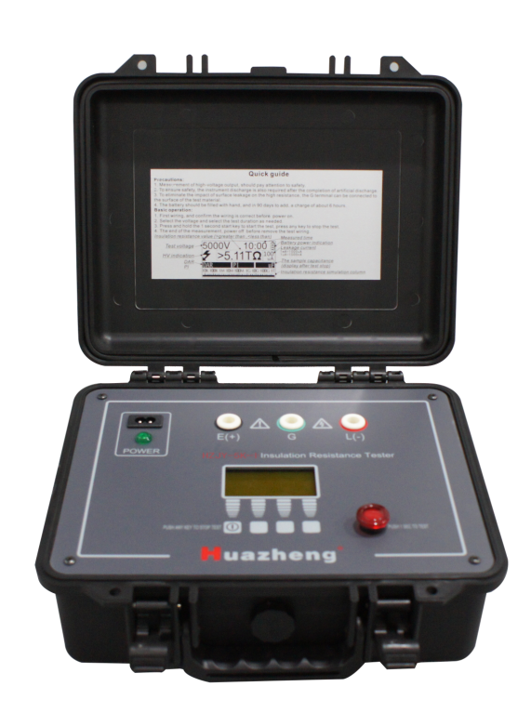

Huazheng Electric Manufacturing (Baoding) Co., Ltd
Dear user:
Thank you for choosing HZJY-5K-I Insulation Resistance Tester.
We hope that this instrument can make your work easier and more enjoyable, so that you can get the feeling of office automation in the test and analysis work.
Before using the instrument, please read this manual, and operate and maintain the instrument according to the manual to prolong its service life.
"Just a light press, the test will be completed automatically" is the operating characteristics of this instrument.
If you are satisfied with this instrument, please tell your colleagues; if you are not satisfied with this instrument, please call (0312) 6775656 to tell you to serve you at all times-Baoding Huazheng Electric Manufacturing Co., Ltd., our company will definitely make you satisfied !
Contents

I. Safe Use Items 1
II. Feature 2
III. Specification Parameter 3
IV. Introduction Of Instrument 4
V. Instrument Using 7
VI. Wiring Diagram 7
VII. Packing List 9
VIII. Appendix 9

I. Safe Use Items
Design and manufacture of the instrument and testing achieves IEC61010 safety standards (electronic measuring product safety requirements), this manual including the safety of the instrument use and ensure the safety of equipment state, users must follow the warnings and safety regulations Please read the following instructions before use.
 Warning
● Instrument output voltage, before use, read and understand the instructions of operational guidelines.
● Please take manual save you to check at any time.
● Must be instructed to use the instrument.
● Understand and comply with the safety operating instructions.
Must strictly abide by the above instructions.
If you don't comply, measurement may cause personal injury and equipment damage.

Dangerous (for improper operation can lead to serious or fatal damage)
● Before use, please wear insulated gloves.
● Please do not over AC/DC600V measurement circuit.
● Please do not test in flammable places, spark could cause an explosion.
● please do not hand wet or damp operators in instrument surface operation.
● Please don't charged the connection test line low.
● Low in the measurement, or do not touch the circuit being measured immediately after the test, may result in electric shock accidents.
● Low test line or port found easy to damage the insulation properties of dirt or carbon please stop test.
Warning (for improper operation exists the possibility of a severe or fatal damage)
● If the instrument is abnormal, please stop using it. For example: instrument damage or bare metal parts.
● Please do not install in the device replacement parts or any unauthorized modification, maintenance, please contact with me.
● Make sure all wires and instrument testing port connection is firm.
Note (for improper operation may cause personal injury or equipment damage)
- Squared before measurement, confirm the voltage selection in the appropriate value.
- If long time not to use, the battery should be fully charge, and recharge in 3 months.
- Squared do not in high temperature, damp, places and condensation may be placed under direct sunlight for a long time.
- Please use a damp cloth or cleaner to clean the equipment enclosure, do not use abrasives or solvents.
- Instrument wet, please dry storage first.

II. Feature
High-voltage insulation resistance tester, with 5 range: 500V, 1000V, 2500V, 5000V, test up to 5TΩ.
● Strict accordance with the safety standards for design
● Insulation resistance range 5TΩ @ 5 kv
● Short circuit current can be adjusted, maximum 5 mA (Can be ordered as high as 10 ma, short circuit current products).
● Automatic display polarization index (PI), induced electric absorption test values than (DAR), and can test the leakage current and capacitance.
● Anti-jamming performance is superior, the interference current reaches 2 mA, still ensure accuracy of test instruments.
● Capacitive discharge rapidly, cable test, no need manual discharge, instruments and automatic discharge quickly.
● 2 methods for power: use of lithium ion batteries, battery life can be up to 6 hours (5000V @ 100MΩ).
● Insulation resistance simulation column.
● Digital filtering functions, external influence deviation display value causing mitigation point using filter function.
● Perfect protection function, and the spare fuse prompt functions.

III. Specification Parameter
● Safety Standard
IEC 61010-1 CAT.IV 600V Pollution degree 2
IEC 61326 EMC specification: test, control and electrical equipment for testing
IEC60529 IP64 （Outer closed state）
● AC Power：220V±10%， 50/60 HZ ，20 VA
● battery：16.8V Lithium ion rechargeable battery
● Battery Life：5000V@100M， 6 hour
● size（L x W x H）：26cm x 20cm x 16cm
● weight：3kg
● Test voltage accuracy: the nominal value 100% to 110%
● Voltage measurement accuracy：5%+3V
● Current test range：10mA
● current measure precision：5%+0.2nA
● short-circuit current：2 to 5mA, adjustable output (10mA short-circuit current can be customized)
● Capacitance test range：20uF
● Capacitance testing accuracy：15%+0.03uF
● Capacitor discharge rate： from 5000V to 10V，0.5S/µF
● Insulation resistance testing range and accuracy （T:23±5ºC ，RH :45 – 75%）

range  accuracy | 500V | 1000V | 2500V | 5000V
Unspecified | <100k | <100k | <100k | <100k
5% | 100k-10G | 100k-20G | 100k-100G | 100k-100G
20% | 10G -100G | 20G-200G | 100G-1T | 100G-1T
Unspecified | > 100G | > 200G | > 1T | > 1T

IV. Introduction Of Instrument
● The Front Panel Description
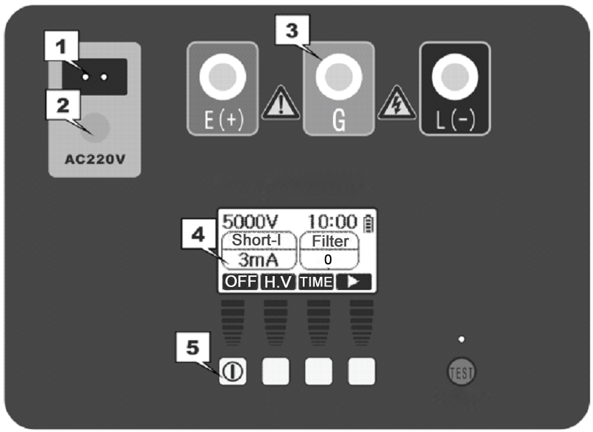

number | Description | number | Description
1 | AC plug | 2 | AC pilot lamp
3 | Test Port（E、G、L） | 4 | LCD display
5 | Key

- Key and function
Key numbered from left to right, the first for a total of five off down the power Key.
key number | Description
1 | Press the switch on button startup, shutdown condition
2、3、4 | functional key
5 | The TEST key, press and hold 1 s TEST, then stop (enter the Settings menu is invalid)

● Test setup interface
Set test voltage SetThe test time Battery Indicator
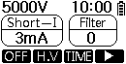

Set Short Current Set the filter
Button function tip

Soft key | Description
OFF | Power Off (No operation, 3 minutes automatic shutdown)
Voltage | Set test voltage: 500V、1000V、2500V、5000V
Duration | Automatically stop test time: 00:30→1:00→10:00 →30:00
     | Switching software keys to a new function, or from other function to return
Current | Set Short Current，1 mA step selection Usually according to the maximum, can also according to the regulations stipulated by the short circuit current value choice.
Filter | Set the filter:  Off ：without filtering; (no interference case recommended)  small：hardware low-pass filter; (applicable to most situations)  medium：software Low pass filter;High resistance (greater than 100G recommended choose)  large：hardware + software low-pass filter;  (high resistance is greater than 1T recommend choose)
Set up | Enter the system settings menu

- Battery Indicator： 、、、、
When the battery voltage shows just one more case should be timely charge, when the battery displaying flashing is automatically cut off the power at any time, should be recharged.
- charge：AC socket provided meet the requirements of the AC power supply for panel, you can recharge equipment charging, the power indicator, display the battery label, in turn, from (0) to (full) showed that when filled, displays (full).
- Contrast Settings interface: LCD display gray level change due to temperature changes, may affect the electronic contrast adjustment using the instrument Settings Follow these steps to set up:
- In shutdown state, hold key 2 (the 2 key).
- Press the 1 key (the power button), until into the contrast adjustment menu.
- Press 1 or 2 keys to adjust contrast, until the right .
- Press the 4 key save and exit, if you don't need to adjust the press 3 key to exit.
Soft key | Description
 | Move the cursor, also used to increase or decrease in contrast
 | Move the cursor, also used to increase or decrease in contrast
Back | Return to the main menu
OK | Confirm to enter the current menu function or to determine the current Settings and exit

- Help menu system
HELP ：Record the serial number of product, production date, version information.
● Insulation testing interface

Digital Insulation value ( > greater than; < less than) Measured time
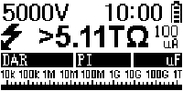
actual voltage
H.V warning Leakage current
1mA=1000uA

1uA =1000nA
DAR Capacitance
PI
Simulation column

When the test time or manual stopped, display shows as shown in the table of the soft keys.
Soft key | Description
OFF | Power Off (No operation, 3 minutes automatic shutdown)
Back | Return to the main menu
voltage | Set test voltage: 500V、1000V、2500V、5000V
Rt | Veiw 15S、30S、60S、600S Insulation value

V. Instrument Using
- measured DAR:
- Select more than 1 minute length measurement.
- Select the appropriate voltage and start.
- The instrument automatically record 15 s and 60 s resistance, and calculate the absorption than after 60 seconds.
Absorption ratio calculation method: DAR = R60 / R15;
- measured PI :
- Select more than 10 minute length measurement.
- Select the appropriate voltage and start.
- The instrument automatically record 15S, 60S and 600S resistance, and calculate the polarization index after 600 seconds.
Polarization index calculation method : PI= R600/R60;
- test connection points for attention
1. Tested to confirm product safety grounding, try not charged.
2. Confirm the instrument E end (ground) have been grounded.
3. The use of G terminal (protection ring) (this machine is of low voltage side of the screen)
When measuring high insulation resistance, the sample should be in the position a conductor surface protection between the two measuring end ring, and the conductor protection ring is connected to the instrument with a test line G side, try to eliminate the measuring error caused by the surface leakage current, security testing is accurate.

VI. Wiring Diagram

1. Preparation of Transformer Wiring

(1) Short circuit the three ports on one side together with wires

(2) Short circuit the four ports on the secondary side together with wires

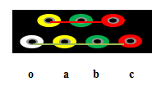

2. Wiring for measuring insulation resistance on the primary side of transformers

(1) Connect the L-terminal of the insulation resistance meter to the primary side of the transformer with a wire

(2) Connect the E-end of the insulation resistance meter with a wire to the ground wire

(3) Connect the secondary side of the transformer with a wire to the ground wire

(4) Connect the transformer casing with wires to the ground wire

(5) After the measurement is completed, discharge the transformer

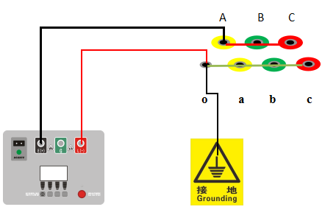

3. Wiring for measuring insulation resistance on the secondary side of transformers

(1) Connect the L-terminal of the insulation resistance meter to the secondary side of the transformer with a wire

(2) Connect the E-end of the insulation resistance meter with a wire to the ground wire

(3) Connect the primary side of the transformer with a wire to the ground wire

(4) Connect the transformer casing with wires to the ground wire

(5) After the measurement is completed, discharge the transformer

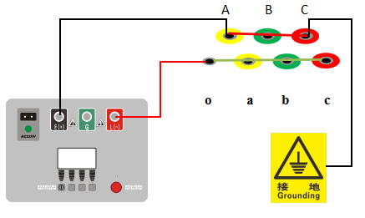

VII. Packing List
No. | Item | Qty
1 | High-voltage silicone test line (one red, one green, one black) | 3
2 | AC 220V power line | 1

VIII. Appendix
● Resistance dimension: 1000kΩ=1MΩ, 1000MΩ=1GΩ, 1000GΩ=1TΩ;
● Current tolerance: 1A=1000mA, 1mA=1000uA, 1uA=1000nA;

