HZJZ2080
Actual Colloid Tester(With Steam Generator)

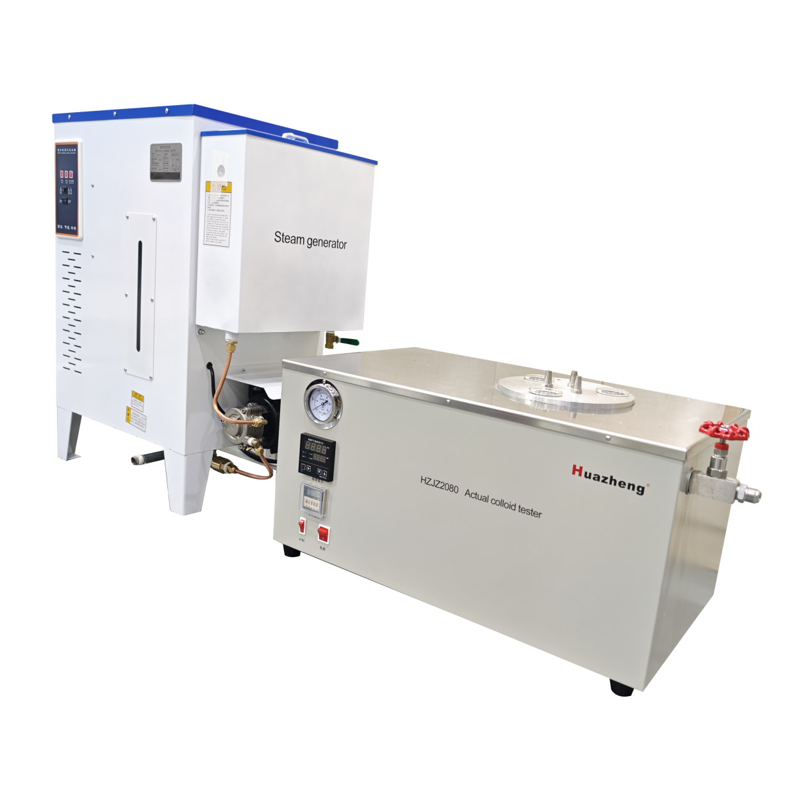

Huazheng Electric Manufacturing (Baoding) Co., Ltd

Contents

I. Overview 1
II. Main Technical Parameters And Performance 1
III. Main Structure 2
IV. Instrument Use And Operation 4
V. Precautions 5
VI. Packing List 6

This instrument is a high-temperature, precision testing device. Please read the instruction manual carefully before use and operate with caution to prevent accidents!

I. Overview
The Actual colloid testeris designed and manufactured in accordance with the requirements specified in the National Standard of the People's Republic of China GB/T 8019-2008 "Determination of Existent Gum in Fuels by Jet Evaporation". It is suitable for determining the existent gum content in aviation turbine fuels using the method of steam evaporation medium as stipulated in the GB/T 8019-2008 standard.
This instrument is a high-performance, versatile Actual colloid testerfully compliant with the GB/T 8019-2008 standard.

II. Main Technical Parameters And Performance

(I) Existent Gum Tester
- Power Supply: AC 220V ± 10%, 50 Hz, 2.4 kW.
- Evaporation Bath Type: Aluminum bath block.
- Number of Test Wells: 3.
- Test Well Dimensions:$ϕ51 mm×70 mm.$
- Operating Temperature: Steam bath: Test bath (232~246)°C; Test well (229~235)°C.
- Temperature Control Method: Automatic.
- Temperature Display: Digital display.
- Flow Display: Pressure gauge.
- Gas Source: External electric steam generator.
- Overall Dimensions:$600 mm×350 mm×360 mm.$

(II) Electric Steam Generator
- Model: LDR 0.013-0.7.
- Rated Evaporation Capacity: 13 kg/h.
- Rated Working Pressure: 0.7 Mpa.
- Power Supply: AC 380V three-phase, 50 Hz.
- Total Power: 9 kW.
- Overall Dimensions: $680 mm×400 mm×1050 mm.$
Note: For specific technical parameters, refer to the attached Electric Steam Generator Instruction Manual, which shall prevail.

III. Main Structure

1. Instrument Composition
- Main Unit: Existent Gum Tester.
- Steam Bath: LDR 0.013-0.7 Electric Steam Generator.

2. Actual colloid testerStructure
- Control Panel: See Control Panel section.
- Evaporation Wells: Three evaporation wells, with test cups and samples placed inside.
- Thermometer: (-5~400)°C glass thermometer, graduation ±1°C.
- Thermometer Bracket: For installing the thermometer.
- Jet Nozzle: Its flared nozzle directs steam onto the sample.

3. Control Panel and Pressure Gauge
- Timer Switch: Press this switch when the power is on to start the timer.
- ⑵ ⑶ ⑷ ⑸
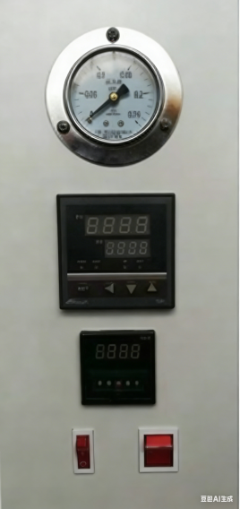
- Timer: Set timing via digital thumbwheel.
- Temperature Controller: Digital temperature controller for setting the control temperature and displaying the real-time bath temperature.
- Pressure Gauge: Displays the supply pressure of the external steam. Adjust the supply pressure by regulating the steam bath control valve and the steam outlet valve on the steam generator.
- Power Switch: When turned on, the temperature controller starts working.

4. Electric Steam Generator
Refer to the attached "Electric Steam Generator" Instruction Manual.

Gas Path Connection for Steam Bath Test
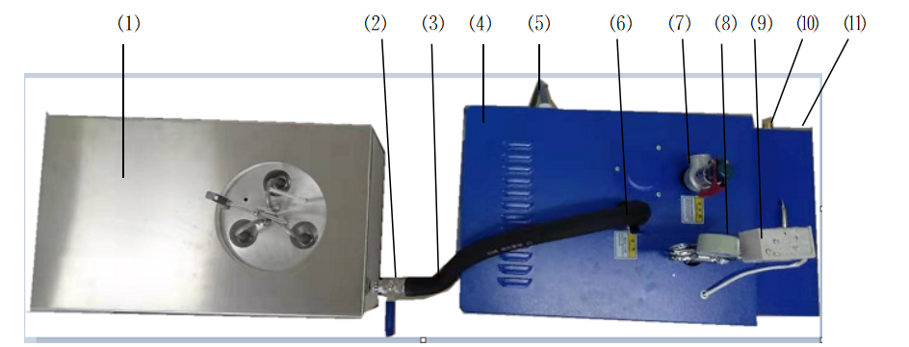
- Existent Gum Tester: Main test unit.
- Steam Inlet: Steam inlet, equipped with a control valve.
- Steam Pipe: Connects the steam outlet of the steam generator to the steam inlet of the existent gum tester. Note: Must use high-temperature and high-pressure resistant tubing.
- Steam Generator: Machine that generates steam.
- Steam Generator Power Supply: AC 380V three-phase, 50 Hz.
- Steam Generator Outlet: Steam outlet of the generator, equipped with an outlet control valve.
- Safety Valve: Safety protection device for the steam generator. When internal pressure exceeds the set point, it opens automatically to release pressure, protecting the boiler.
Warnings:
1. Periodically lift the safety valve handle for a blow-down test.
2. Increase pressure every 2-4 weeks for a blow-down test to verify the safety valve function.
3. Regularly calibrate the safety valve to ensure reliability.
4. Use the steam generator according to its instruction manual.
- Steam Generator Pressure Gauge: Displays internal pressure.
- Steam Generator Pressure Controller: Controls the generator's pressure.
- Steam Generator Water Tank Inlet: Connect tap water to the inlet via a water supply hose.
- Steam Generator Water Tank: Maintains a certain water level automatically when the inlet line is connected.
Note: Both steam and water inlet pipes are 1/2 inch pipes.

IV. Instrument Use And Operation

(I) Preparation Before Testing
- Read this manual carefully before use.
- Study the clauses in the Chinese National Standard GB/T 8019 regarding existent gum testing for aviation gasoline and motor gasoline to understand the preparations, steps, and requirements.
- Prepare all necessary testing apparatus and materials as per the standard.
- Connect the instrument's water supply and steam lines as required.
Note: Water and steam line installation must be performed by qualified personnel according to manual specifications to ensure reliability and safety.
- Check the instrument's condition meets the specified operating environment and conditions.
- Ensure both units are properly grounded.
- The "Existent Gum Tester" requires AC 220V ± 10%, 50 Hz, 2.4 kW. The "Steam Generator" requires AC 380V three-phase, 50 Hz, 9 kW. Provide a suitable power distribution box. The power cord must have a proper ground.
- Install the Actual colloid testeras described, check everything, then power on. It should operate normally.
- Install the Steam Generator as per its manual, check, then test. It should operate normally.

(II) During Steam Bath Test
- With both units operating correctly and lines connected, turn on the power. Set the temperature controller to 240°C. The bath heats automatically to the set point. Observe the bath thermometer to ensure the temperature is within$(232∼246)^{∘}C$.
- Temperature Controller Setting: Press "SET" to enter setpoint mode (SP displayed). Press < to select digit, use $∨or∧$ to change value. Press "SET" to exit, or it exits automatically after 20 seconds. Bath temperature is automatically controlled at the setpoint.
- Steam Flow Control: Adjust the steam bath control valve to regulate the steam flow. The total steam flow rate for the three wells should be 3000 ml/s, corresponding to a pressure gauge reading of 0.06 MPa (calibrated by condensing and measuring steam). This pressure indicates the required flow (pre-adjusted before shipment).
- Test Operation: Place test cups, jet nozzle, thermometer bracket, thermometer, etc. Heat the bath until operational. When temperature reaches 232°C, it is crucial to slowly introduce steam into the system by adjusting the steam bath control valve until the pressure gauge reads 0.06 MPa (steam flow is pre-set at factory, no user calibration needed). Maintain bath temperature between (232~246)°C and adjust the heater so the evaporation well temperature is (232±3)°C.
- Special Note: For detailed operation, refer to "GB/T 8019-2008".

V. Precautions
- This is a high-temperature, high-pressure instrument. Surfaces and internal parts become hot during operation. Gas lines are under high pressure. Always use protective tools when handling samples or components, or wait until the instrument is completely cool and all pressure is released to prevent accidents!
- The temperature controller has auto-tuning. If control precision is insufficient, first set the temperature, then long-press the $∧$ key until the AT light illuminates. The system auto-tunes for about 1.5 oscillation cycles, then the AT light turns off, enabling high-precision control. The instrument is pre-tuned before shipment; users typically do not need to adjust it.
Warnings:
- The steam boiler is a high-pressure steam generator. Use, maintain, service, and calibrate it strictly according to its instruction manual for safe operation.
- In case of malfunction, immediately cut off the power supply. Do not resume use until the instrument is completely cool, all high-pressure gas is released, and a qualified professional has inspected and repaired the fault to prevent accidents!
Notice to User: Product updates may cause changes to the manual and product without prior notice.

VI. Packing List
No. | Item | Qty
1 | Actual colloid tester | 1
2 | Steam Generator | I
3 | Gum Cup | 3
4 | Flared Nozzle | 3
5 | Thermometer Bracket | 1
6 | Thermometer(-5~400°C, graduation ±1°C) | 1
7 | Instruction Manual | 1
8 | Certificate of Conformity | 1
9 | Warranty Card | 1

